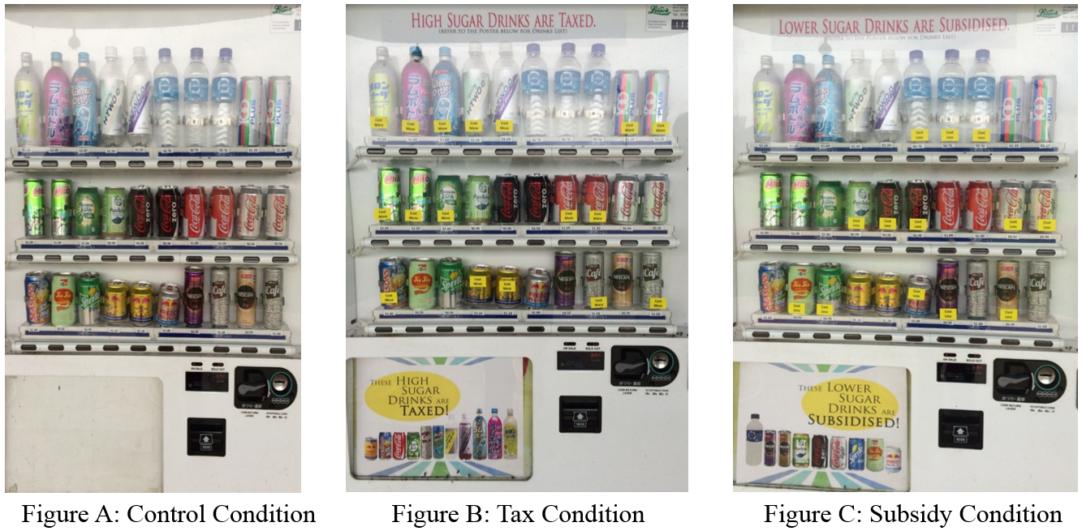
Supplementary Figure 1: Images of the machines during ‘control’, ‘tax’ and ‘subsidy’ message conditions

