Components of the physical activity monitoring system (wifi beacons, keyfobs and website)
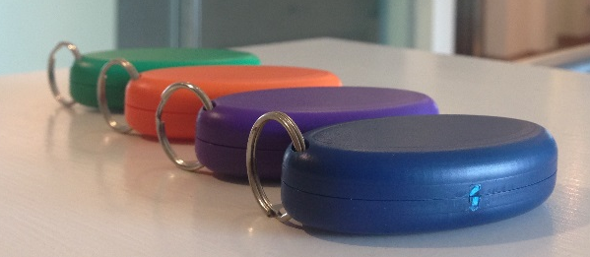
- Wifi beacons
b) Keyfobs

c) Website


