S3: Difference in means (min/day)

Results of fourteen studies were included in the current model. Two studies could not be included as no absolute information on the total time spent sedentary was provided.

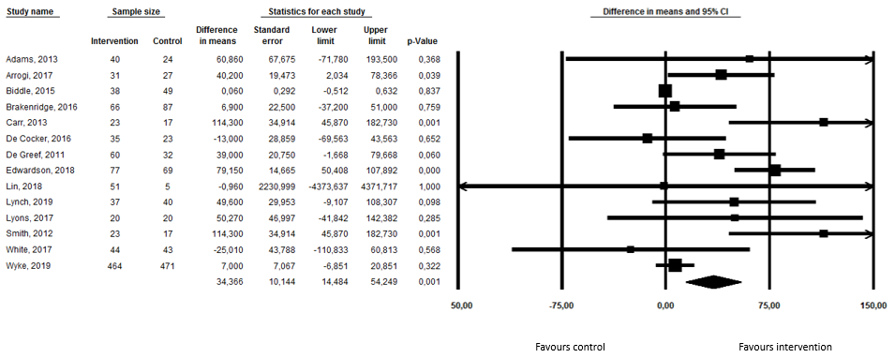
Figure 1: Forest plot for total sedentary behavior (difference in means)

