Additional file 1: Concept maps

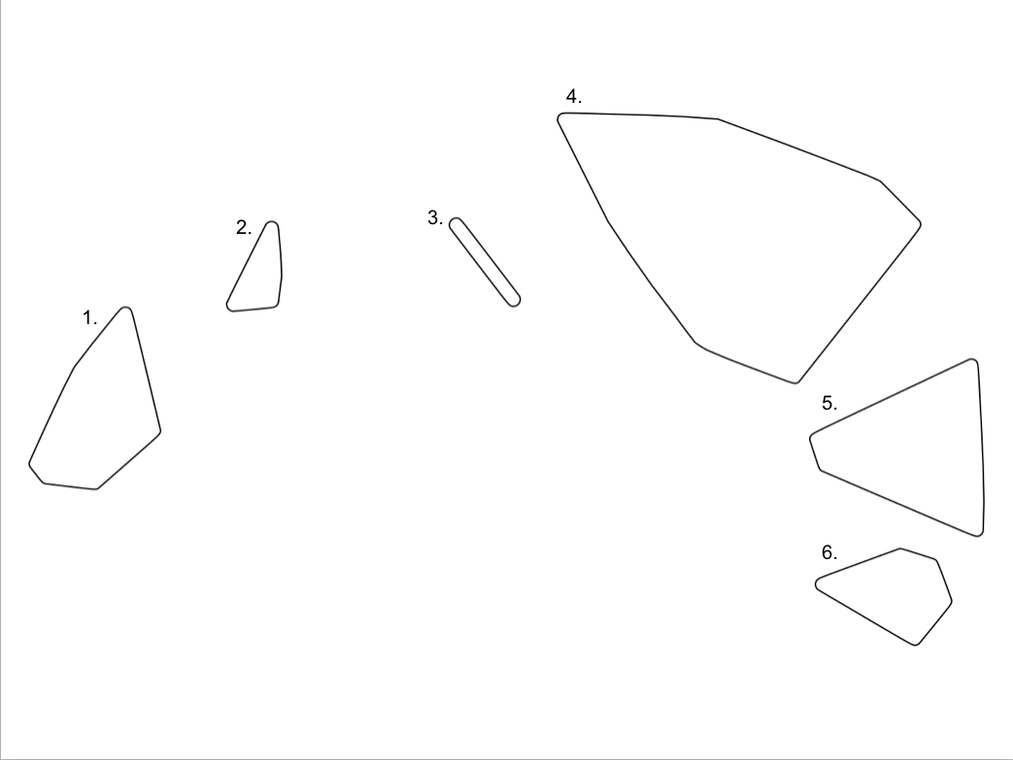

Figure 1. Concept map school 1
Note that clusters closer together on the map have a stronger relation than clusters further away from each other.
Cluster 1: Sports; Cluster 2: Hobbies; Cluster 3: Trips/getaways; Cluster 4: Playing (outside); Cluster 5: Walking/transport; Cluster 6: Chores and personal care.

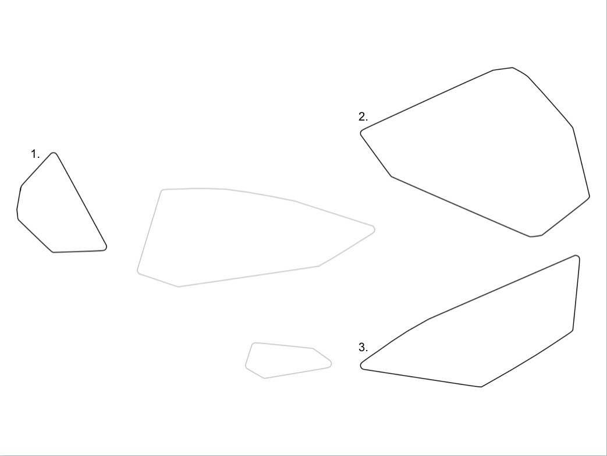

Figure 2. Concept map school 2
Note that clusters closer together on the map have a stronger relation than clusters further away from each other.
Cluster 1: Sports; Cluster 2: Hobbies, chores, personal care and walking/transport; Cluster 3: Playing outside and trips/getaways
Note that the light grey clusters has disappeared as a result of reallocation of statements.

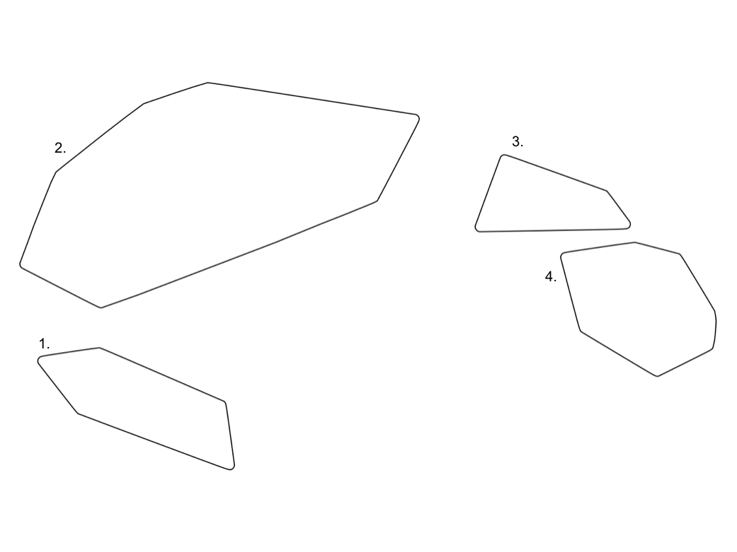
Figure 3. Concept map school 3
Note that clusters closer together on the map have a stronger relation than clusters further away from each other.
Cluster 1: Personal care and hobbies; Cluster 2: Chores, playing (outside) and trips/getaways; Cluster 3: Playing (outside); Cluster 4: Sports and walking/transport

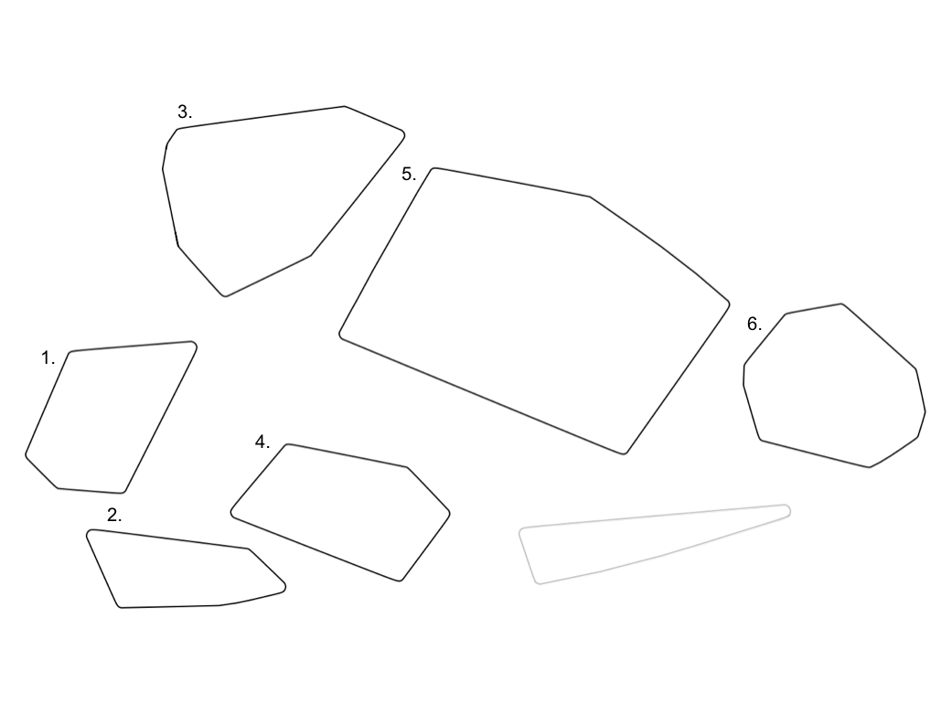

Figure 4. Concept map school 4
Note that clusters closer together on the map have a stronger relation than clusters further away from each other.
Cluster 1: Playing (outside); Cluster 2: Personal care and chores; Cluster 3: Playing (outside); Cluster 4: Transport/walking and hobbies; Cluster 5: Trips/getaways; Cluster 6: Sports
Note that the light grey cluster has disappeared as a result of reallocation of statements.

