Table S1. Items used in the two-parameter logistic item response theory model.
Domains | Presence or absence of difficulties | ALSA | ELSA | ENRICA | HRS | JSTAR | KLOSA | MHAS | SHARE
Cognition | Memory |  | x |  | x |  |  | x | x
Cognition | Immediate recall * |  | x |  | x | x |  | x | x
Cognition | Delayed recall * |  | x |  | x | x |  | x | x
Cognition | Verbal fluency * |  | x |  |  |  |  | x | x
Cognition | Orientation in time | x | x |  | x | x |  |  | x
Cognition | Processing speed |  | x |  |  |  |  | x
Cognition | Numeracy |  | x |  | x | x |  |  | x
Psychological symptoms | Sleeping | x | x | x | x | x | x | x | x
Vitality | Experiences in some degree of pain | x | x |  | x |  | x | x | x
Vitality | Having high level of energy | x | x | x | x | x |  | x | x
Vitality | Urine incontinence | x | x |  | x |  | x | x | x
Sensory | Near vision | x | x |  | x | x | x |  | x
Sensory | Far vision | x | x |  | x | x | x |  | x
Sensory | Eyesight using glasses or lens as usual | x | x |  | x | x | x | x | x
Sensory | Hearing in general | x | x |  | x | x | x | x | x
Sensory | Hearing in a conversation | x | x |  |  | x |  |  | x
Mobility | Stooping, kneeling or crouching | x | x | x | x | x |  | x | x
Mobility | Lifting or carrying weights | x | x | x | x | x |  | x | x
Mobility | Climbing stairs |  | x | x | x | x |  | x | x
Mobility | Getting up from sitting down |  | x |  | x | x |  | x | x
Mobility | Walking by yourself and without any equipment | x | x | x | x | x | x | x | x
Mobility | Pulling or pushing large objects | x | x |  | x | x |  | x | x
Mobility | Sitting for long periods | x | x |  | x | x |  | x | x
Mobility | Reaching or extending arms | x | x |  | x | x |  | x | x
Mobility | Walking speed * |  | x |  | x |  |  | x | x
Mobility | Dizziness when walking on a level surface | x | x |  | x |  |  |  | x
Mobility | Picking up things with fingers | x | x |  | x | x |  | x | x
Activities of daily living | Getting in or out of bed | x | x |  | x | x |  | x | x
Activities of daily living | Bathing or showering | x | x |  | x | x |  | x | x
Activities of daily living | Getting dressed | x | x |  |  | x |  | x | x
Activities of daily living | Moving around the home | x | x |  | x | x |  | x | x
Activities of daily living | Using the toilet | x | x |  | x | x | x | x | x
Activities of daily living | Eating | x | x |  | x | x |  | x | x
Instrumental activities of daily living | Doing housework | x | x | x | x | x | x |  | x
Instrumental activities of daily living | Shopping for groceries | x | x | x | x | x | x | x | x
Instrumental activities of daily living | Getting out of the house | x | x |  |  | x | x
Instrumental activities of daily living | Preparing meals | x | x | x | x |  | x | x | x
Instrumental activities of daily living | Using a map |  | x | x | x |  |  |  | x
Instrumental activities of daily living | Managing money, bills or expenses | x | x | x | x | x | x | x
Instrumental activities of daily living | Taking medications |  | x | x | x | x | x | x | x
Instrumental activities of daily living | Making telephone calls | x | x | x | x | x | x |  | x
Note. * Items dichotomised in the first quartile.

Table S2. Presence of the questions used in the aggregated variable on physical activity by study.
Variable | ALSA | ELSA | ENRICA | HRS | JSTAR | KLOSA | MHAS | SHARE
Frequency of vigorous exercise | x |  |  | x | x | x |  | x
Frequency of less vigorous exercise | x |  |  | x | x |  |  | x
Level of physical activity |  | x
Engagement in vigorous exercise during the last 2 weeks | x | x |  | x |  |  | x | x
Frequency of vigorous exercise activities in the last 2 weeks | x | x |  | x | x | x |  | x
Time spent doing vigorous exercise in the last 2 weeks | x |  | x |  | x | x

Table S3. Guidelines for Reporting on Latent Trajectory Studies (GRoLTS) Checklist.
Checklist item | Reported?
1. Is the metric of time used in the statistical model reported? | Yes
2. Is information presented about the mean and variance of time within a wave? | Yes (mean).  No (variance): not available.
3a. Is the missing data mechanism reported? | Yes
3b. Is a description provided of what variables are related to attrition/missing data? | Yes
3c. Is a description provided of how missing data in the analyses were dealt with? | Yes
4. Is information about the distribution of the observed variables included? | Yes
5. Is the software mentioned? | Yes
6a. Are alternative specifications of within-class heterogeneity considered (e.g., LGCA vs. LGMM) and clearly documented? If not, was sufficient justification provided as to eliminate certain specifications from consideration? | Yes
6b. Are alternative specifications of the between-class differences in variance–covariance matrix structure considered and clearly documented? If not, was sufficient justification provided as to eliminate certain specifications from consideration? | Yes
7. Are alternative shape/functional forms of the trajectories described? | Yes
8. If covariates have been used, can analyses still be replicated? | Yes
9. Is information reported about the number of random start values and final iterations included? | Yes
10. Are the model comparison (and selection) tools described from a statistical perspective? | Yes
11. Are the total number of fitted models reported, including a one-class solution? | Yes
12. Are the number of cases per class reported for each model (absolute sample size, or proportion)? | Yes
13. If classification of cases in a trajectory is the goal, is entropy reported? | Yes
14a. Is a plot included with the estimated mean trajectories of the final solution? | Yes
14b. Are plots included with the estimated mean trajectories for each model? | Yes
14c. Is a plot included of the combination of estimated means of the final model and the observed individual trajectories split out for each latent class? | No: the vast number of individual trajectories makes such a plot unfeasible to compute and interpret.
15. Are characteristics of the final class solution numerically described (i.e., means, SD/SE, n, CI, etc.)? | Yes
16. Are the syntax files available (either in the appendix, supplementary materials, or from the authors)? | Yes
Note. Checklist is available in Rens van de Schoot, Marit Sijbrandij, Sonja D. Winter, Sarah Depaoli & Jeroen K. Vermunt (2017) The GRoLTS-Checklist: Guidelines for Reporting on Latent Trajectory Studies, Structural Equation Modeling: A Multidisciplinary Journal, 24:3, 451-467, DOI: 10.1080/10705511.2016.1247646.

Figure S1. Linear trajectory of health from the Latent Growth Curve Model (1 class).
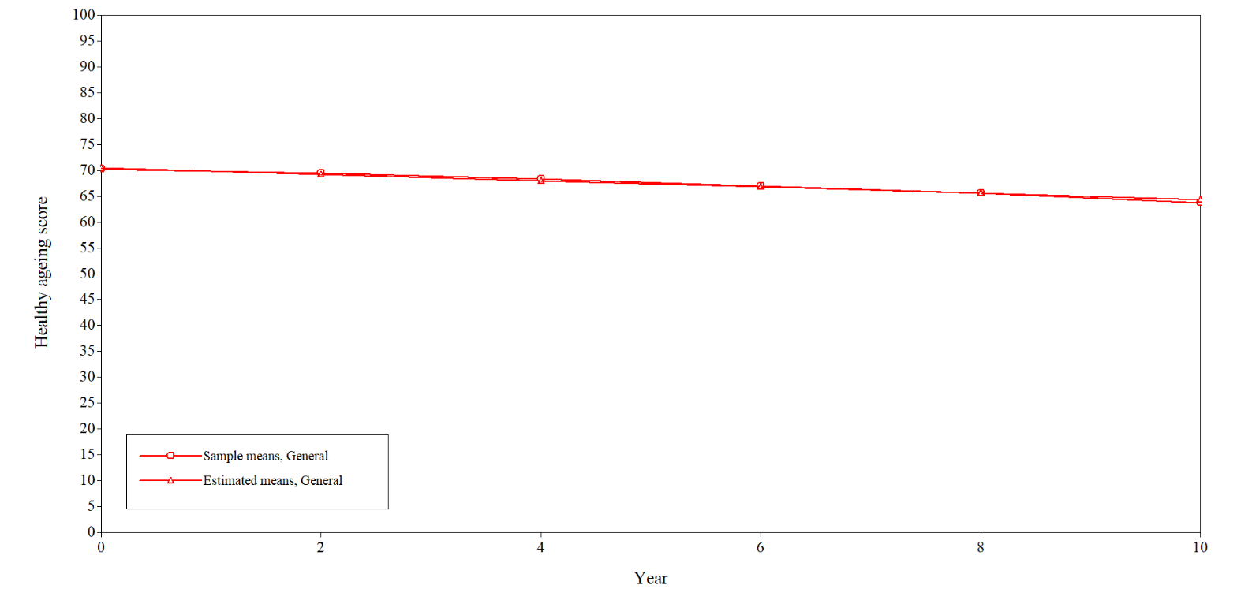
Figure S2. Linear trajectories of health from the Growth Mixture Model (2 classes).
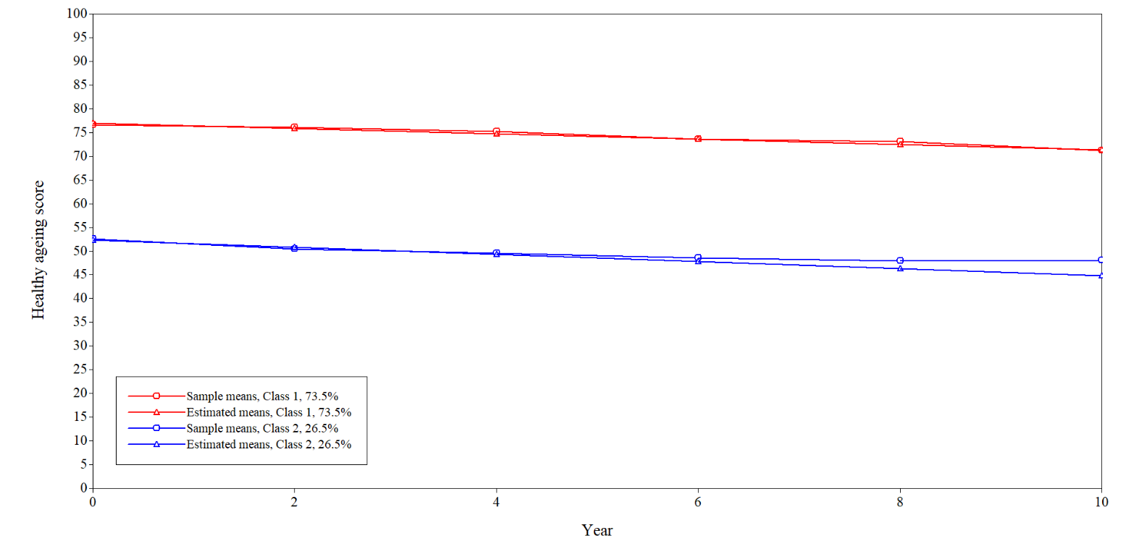

Figure S3. Linear trajectories of health from the Growth Mixture Model (3 classes).
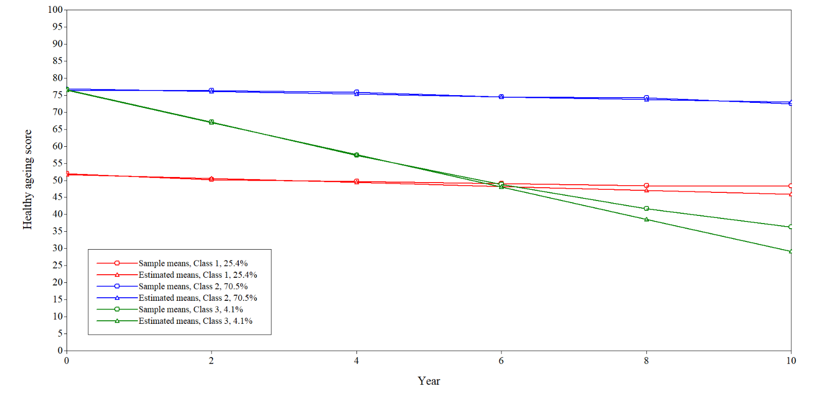
Figure S4. Linear trajectories of health from the Growth Mixture Model (4 classes).
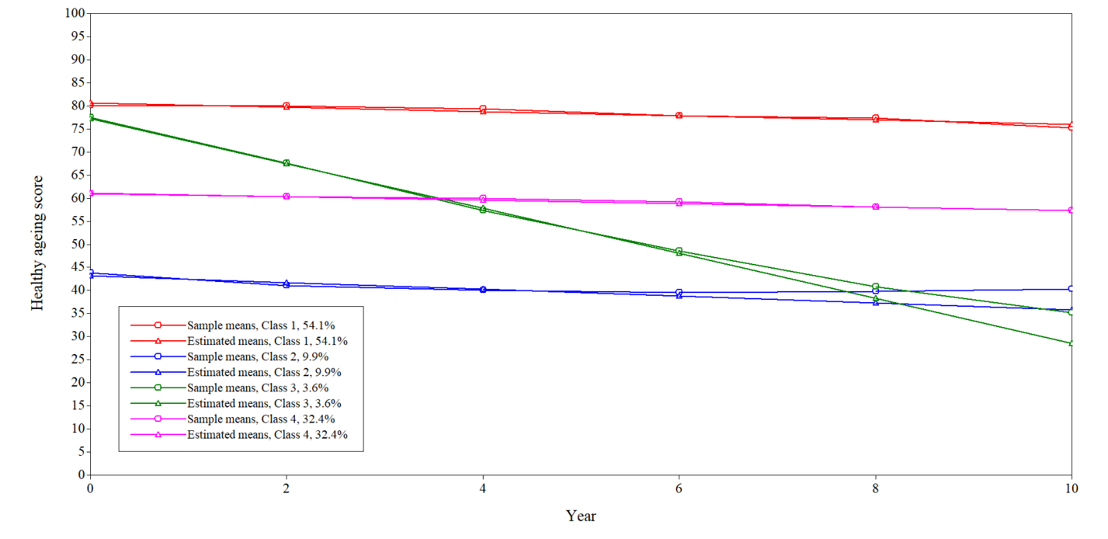
Figure S5. Linear trajectories of health from the Growth Mixture Model (5 classes).
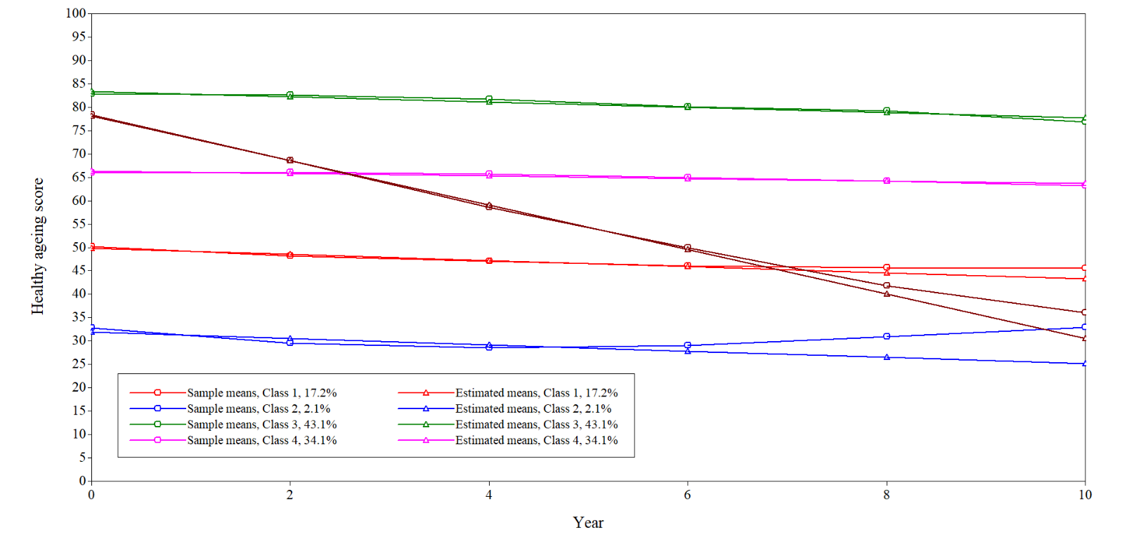
Figure S6. Quadratic trajectory of health from the Latent Growth Curve Model (1 class).
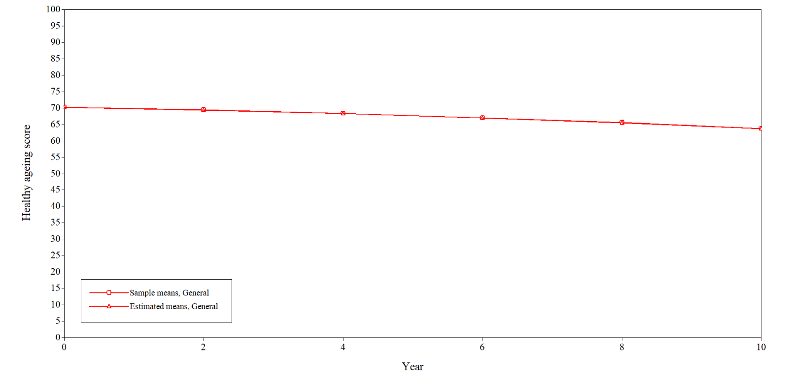

Figure S7. Quadratic trajectories of health from the Growth Mixture Model (2 classes).
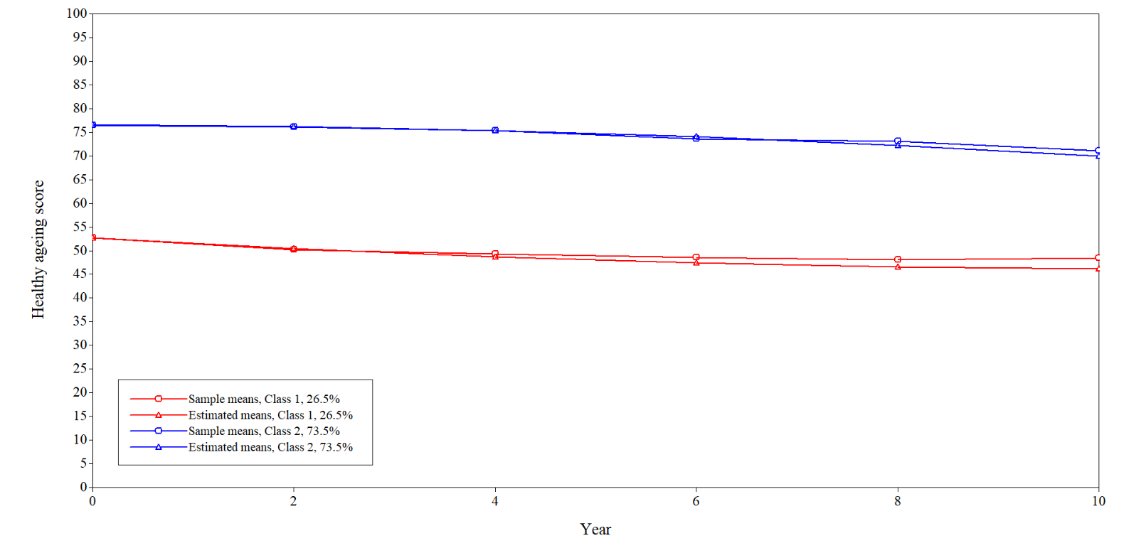
Figure S8. Quadratic trajectories of health from the Growth Mixture Model (3 classes).
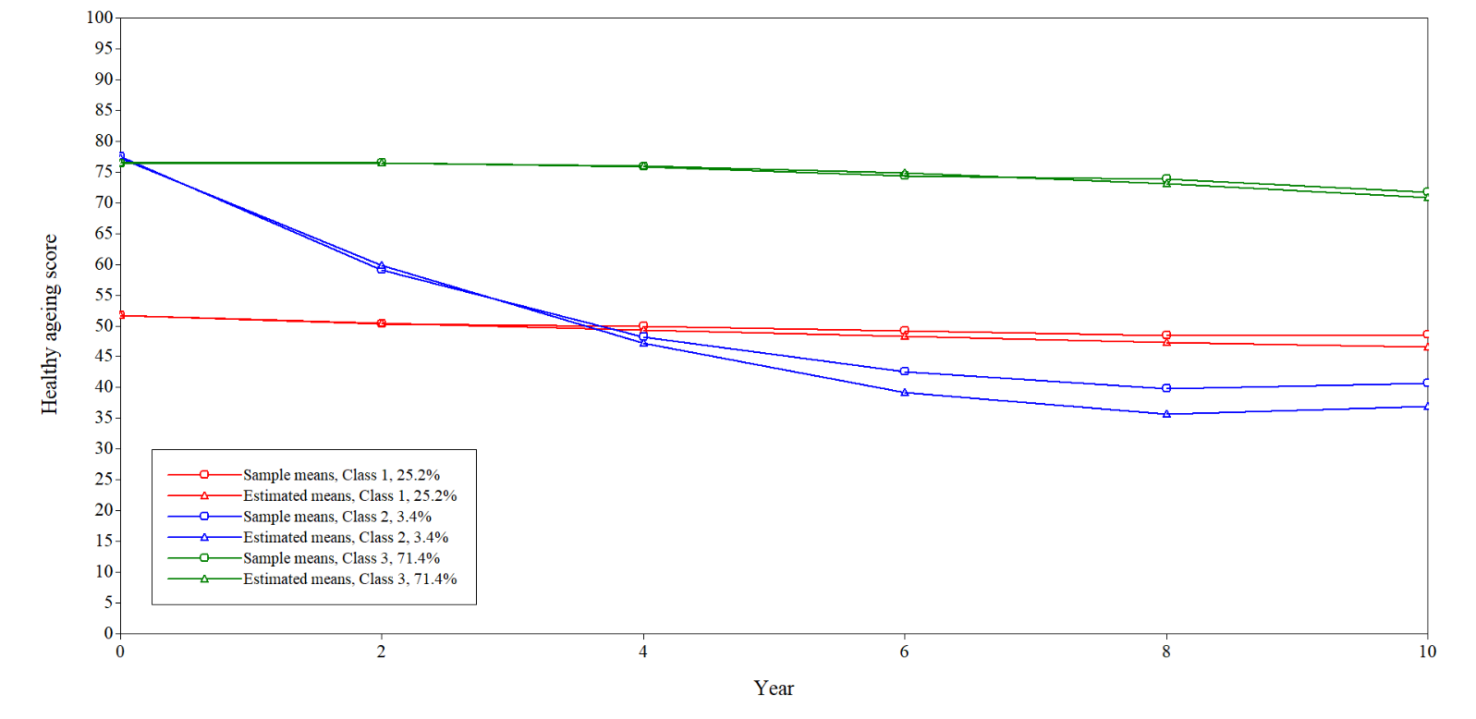

Figure S9. Quadratic trajectories of health from the Growth Mixture Model (4 classes).
