Supplementary file 6. Funnel plots with pseudo 95% confidence limits.
a) Breast cancer b) Ischemic heart disease
Egger’s test for small study effects: 0.787 Egger’s test for small study effects: <0.001

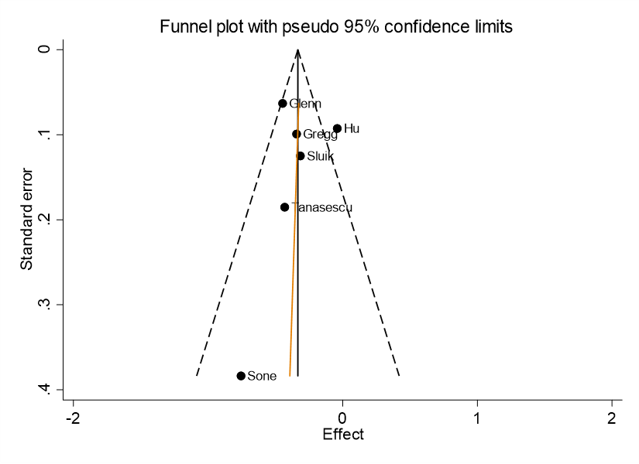
c) Type 2 diabetes
Egger’s test for small study effects: 0.826

