Additional File 3. Pooled effects of interventions to improve fruit and vegetable intake

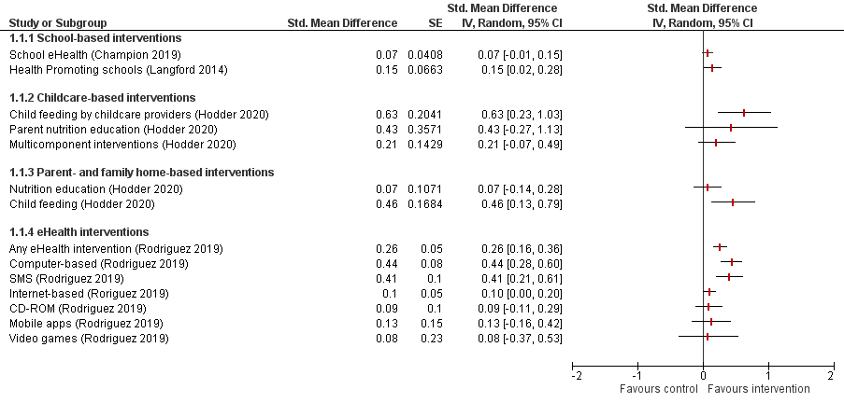

Note: The results presented in this plot are taken from separate systematic reviews that differ from each other in a number of ways and should not be used to draw conclusions about the relative effects of interventions assessed across different reviews

