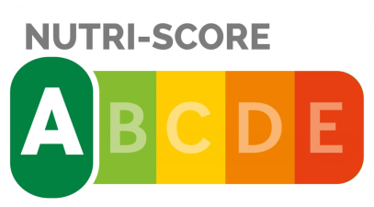
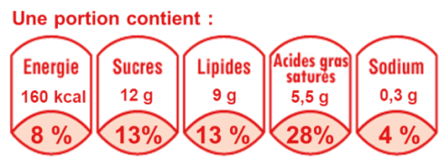

Supplemental Figure 2. Images of the Nutri-Score and the Reference Intakes labels used in the trials

