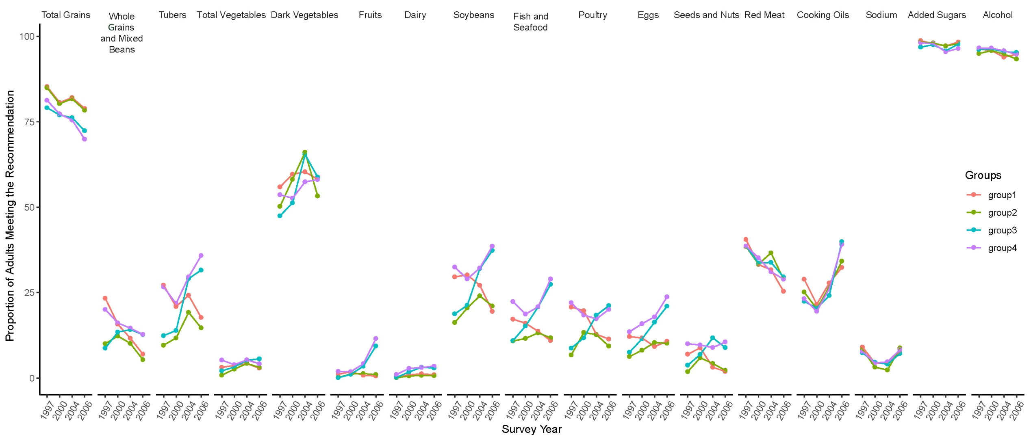

Supplemental Fig. 2 Proportion of Chinese adults meeting the dietary recommendations for food components by identified trajectory groups

