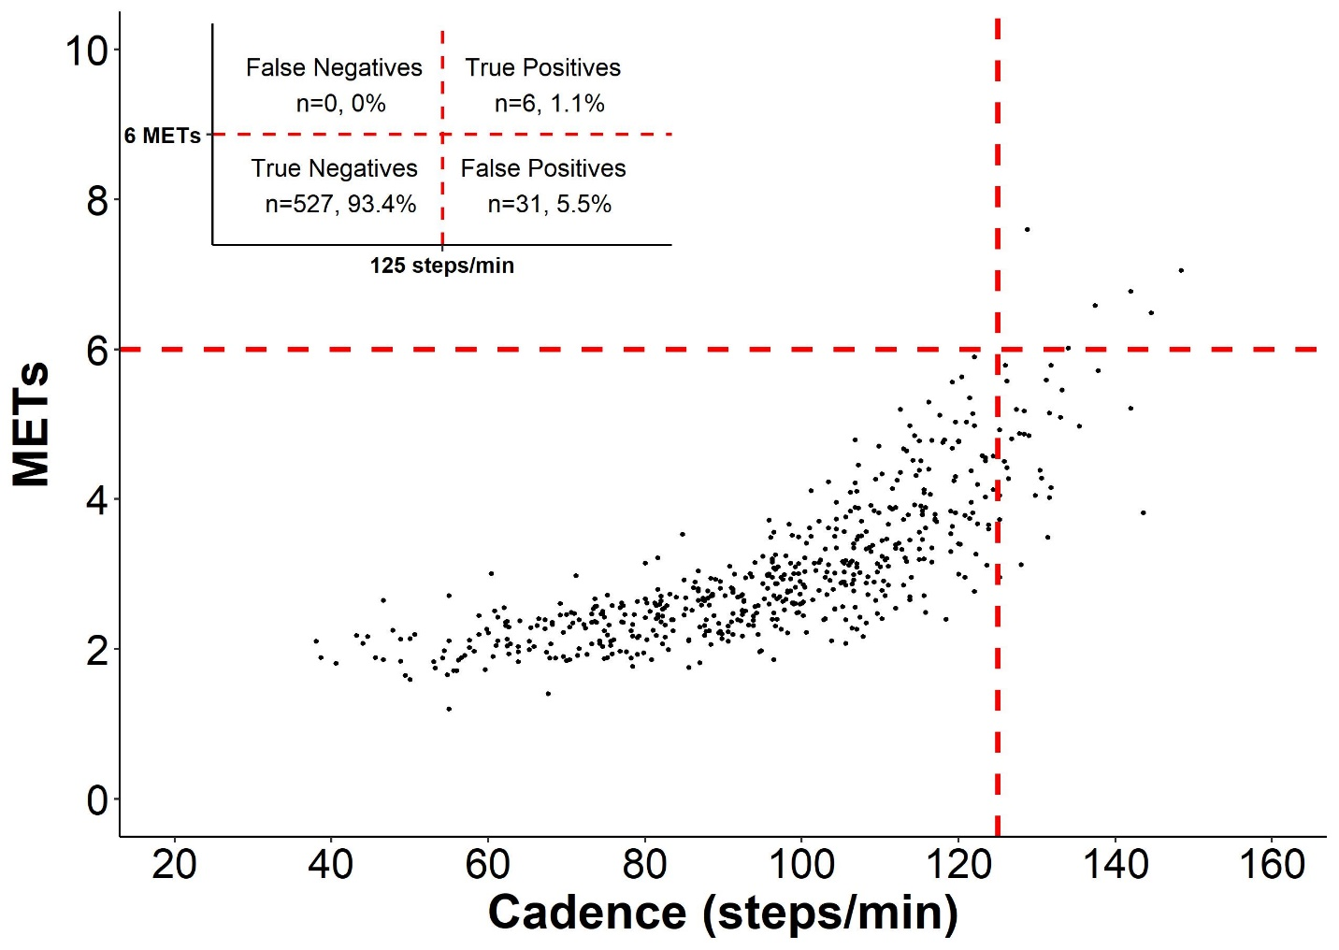
Additional file 4. Classification accuracy of ≥ 125 steps heuristic cadence thresholds and ≥ 6 METs).

