Examples of Adaptive Choice Based Conjoint Analysis survey questions

Example of question selecting preferred levels:
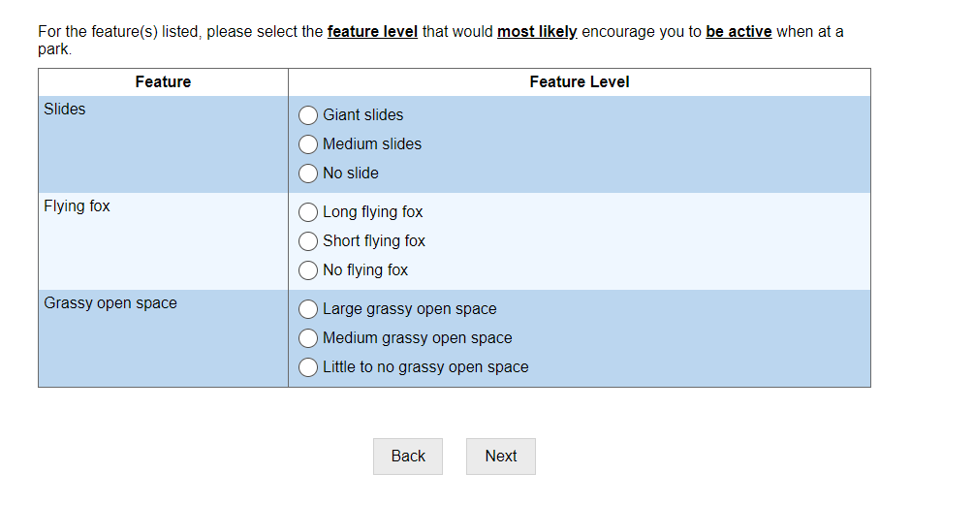

Example of a screener question:
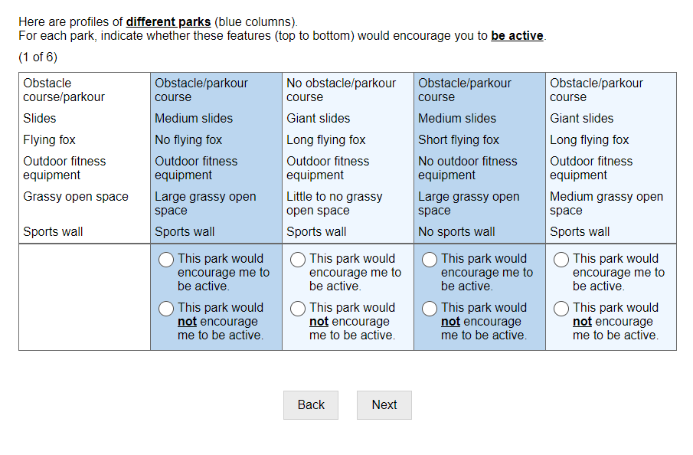

Example of question asking if any feature levels are totally unacceptable:
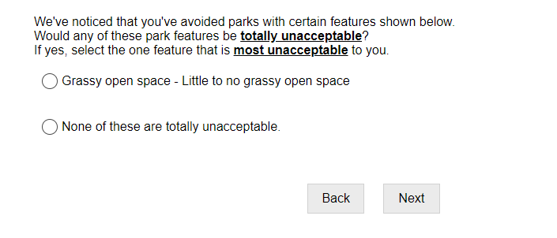

Example of a choice task:
