Television viewing time and all-cause mortality: Supplementary material
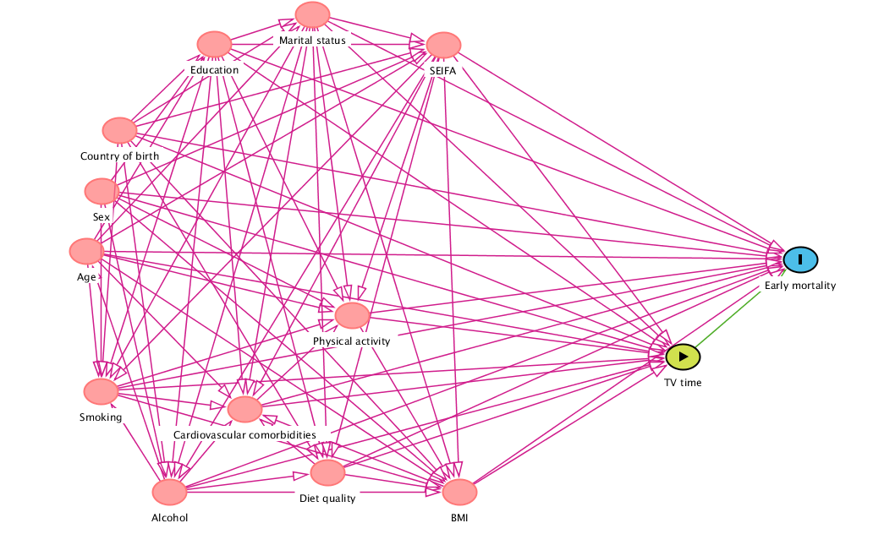
Supplementary figure 1: Directed acyclic graph for the main effects of TV time on all-cause mortality

Supplementary table 1: Comparison of baseline characteristics for included and excluded MCCS participants
 | Excluded | Included
Total n | 21,943 | 19,570
Baseline age, y (sd) | 56.5 (8.7) | 54 (8.5)
Female, n (%) | 12,622 (57) | 11,847 (61)
Country of Birth
Australia/ New Zealand, n (%) | 13,575 (62) | 14,939 (76)
Northern Europe n (%) | 1,256 (6) | 1,393 (7)
Southern Europe n (%) | 7,112 (32) | 3,238 (17)
Education
Primary school, n (%) | 5,801 (27) | 2,245 (12)
Some high school/ technical school, n (%) | 8,232 (38) | 7,621 (40)
Completed high school/ technical school, n (%) | 2,052 (9) | 2,071 (11)
Tertiary/ diploma/ degree, n (%) | 5,899 (27) | 7,633 (39)
Socioeconomic Index for Areas of Disadvantage
1st Quintile, n (%) | 4,849 (22) | 2,764 (14)
2nd Quintile, n (%) | 5,415 (25) | 3,306 (17)
3rd Quintile, n (%) | 3,618 (17) | 2,901 (15)
4th Quintile, n (%) | 3,509 (16) | 4,064 (21)
5th Quintile, n (%) | 4,301 (20) | 6,535 (33)
Marital Status
Married/ De Facto, n (%) | 14,457 (72) | 14,789 (76)
Single, n (%) | 1,980 (10) | 1,635 (8)
Divorced/ Separated, n (%) | 2,093 (10) | 1,935 (10)
Widowed, n (%) | 1,590 (8) | 1,211 (6)
Cardiometabolic Comorbidities
Yes, n (%) | 6,768 (31) | 4,398 (23)

