SUPPLEMENTAL FILE

eFigure 1. Directed acyclical graph depicting the study hypothesis
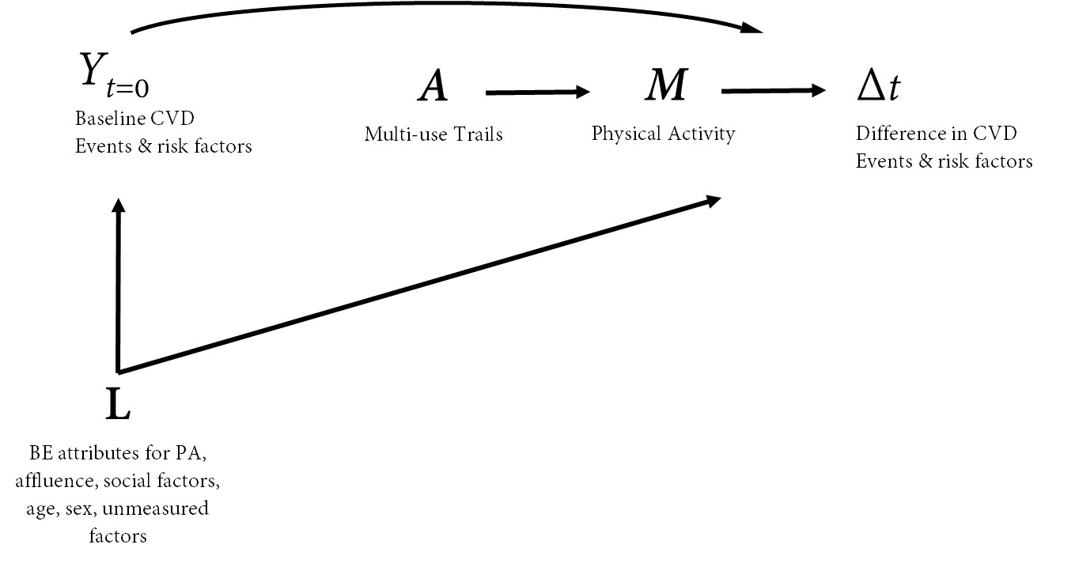

Y = outcomes of CVD events at baseline (2000-2010); A = intervention of receiving a multi-use trail (yes/no); L = measured and unmeasured factors that could influence baseline rates or changes in rates of CVD events and risk factors.
The following assumptions required for causal interpretation were included in the graph:
(1) The intervention of building multi-use trails (“A”) was well-defined within the City of Winnipeg (see appendix Figure 2 for visual representation) and the counterfactual of not building the recreational trails is observable;
(2) There are no common causes of building multi-use trails and the changes in CVD events/risk factors (Δt);
(3) the decision to build the trails in their specific locations were unrelated to baseline levels of CVD events/risk factors (i.e. no arrow from Y_{t=0}) in the city;
(4) there are no common causes of baseline CVD events/risk factors and building the recreational trails;
(5) few people moved from control areas to intervention areas and those who did, did so at random (exogeneity);
(6) any association between multi-use recreational trails and CVD events/risk factors is mediated through physical activity levels (“M”) of individuals within areas adjacent to the trails and
(7) the entire population of living with 400 – 1200 m of the trail had access to the recreational trail and those living beyond 400 to 1200m from the trail were less likely to use it.
eFigure 2. Trail areas before and after the intervention
Trail A
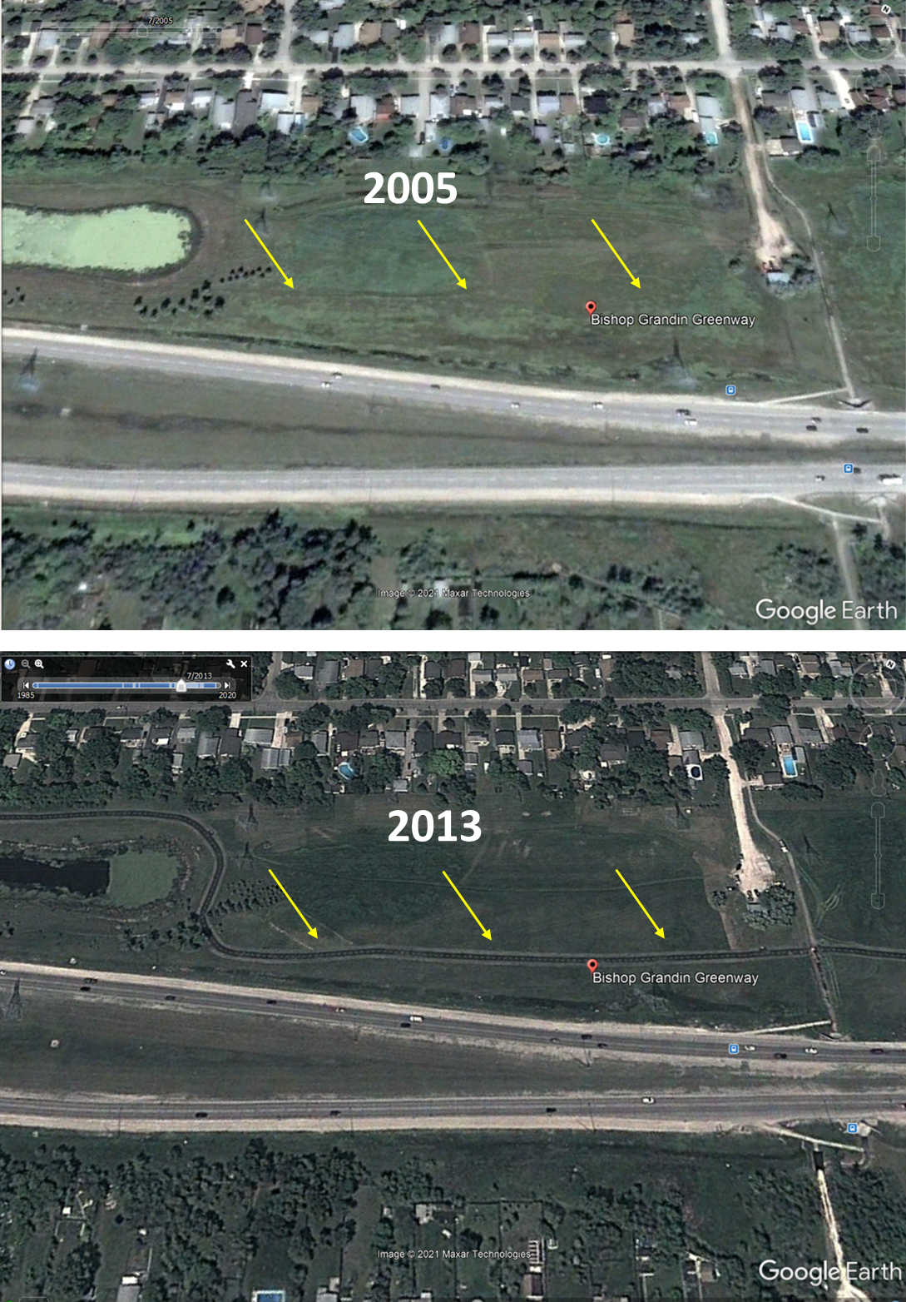

Trail B
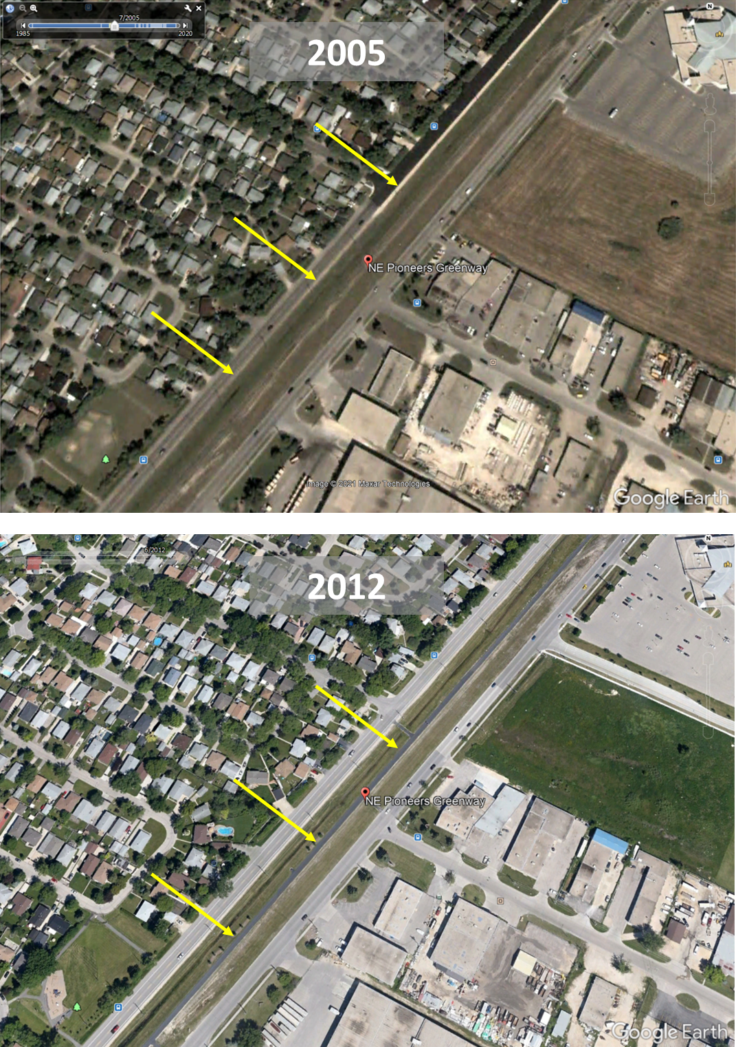

Trail C
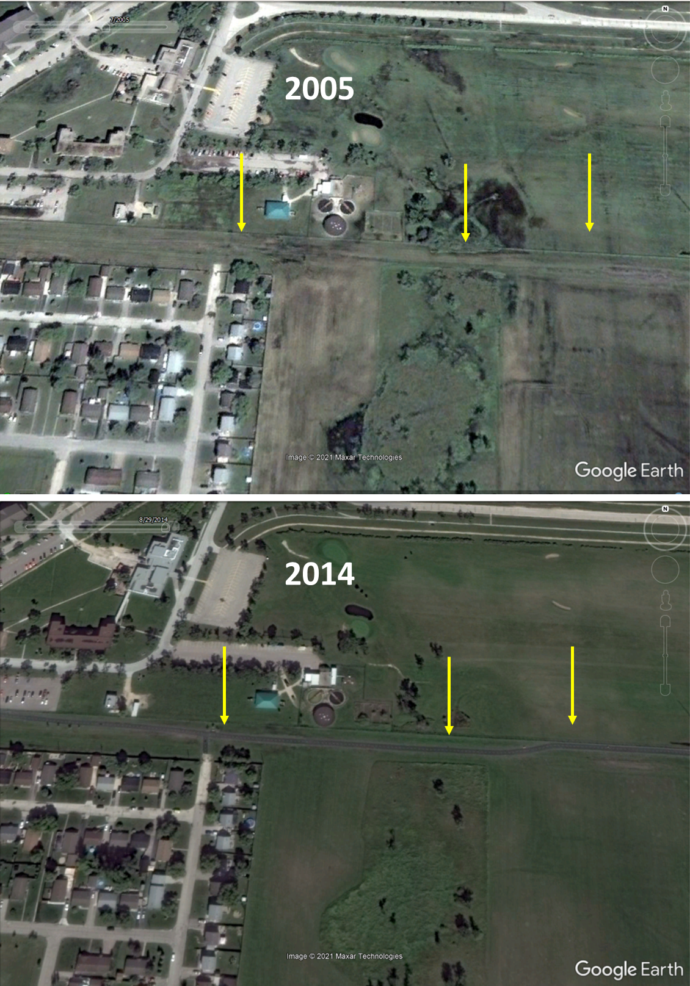
Trail D
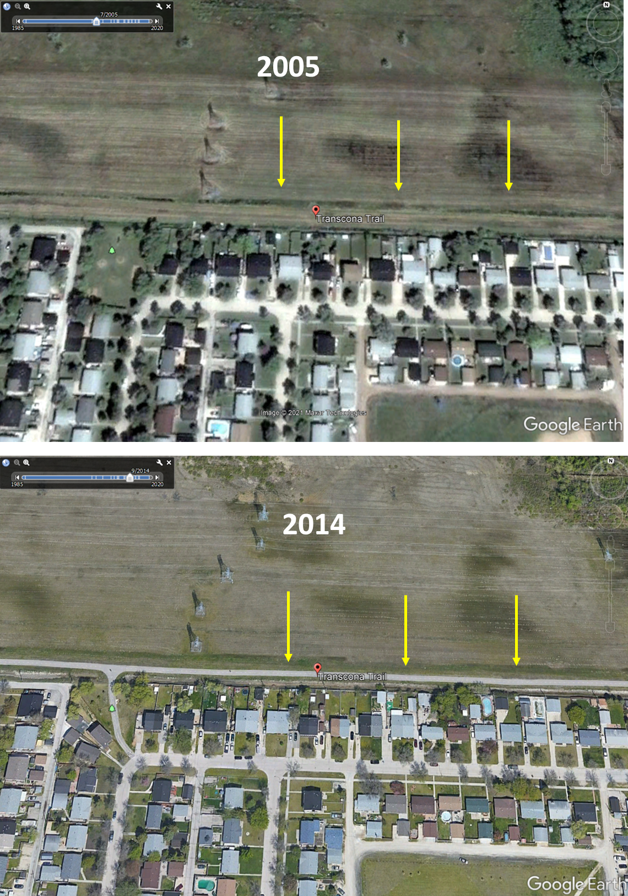

eFigure 3. Trail user profiles
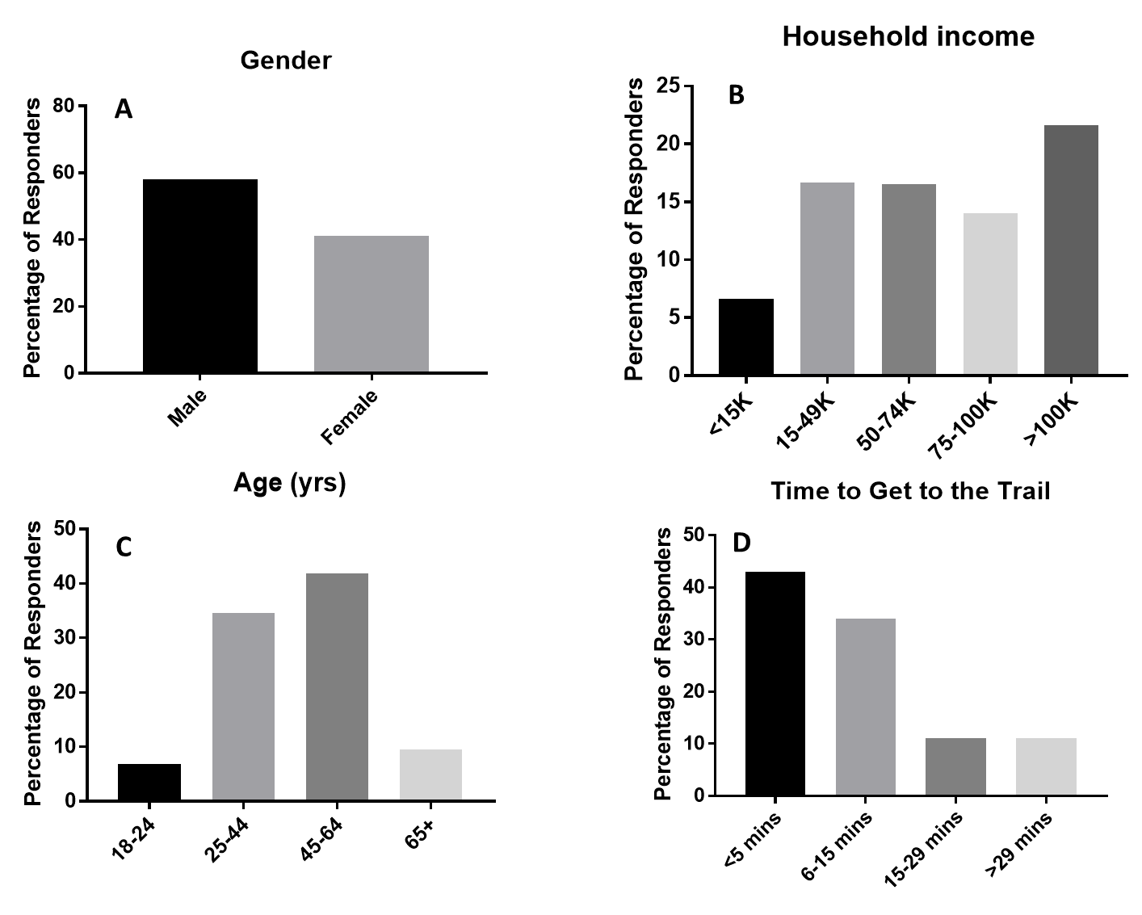
Trail users surveyed while using one of the four recreational multi-use trails were (A) mostly male, (B) over 75% reported a household income over $50,000 CAN; (C) over 50% were aged 45 years or older and (D) over 75% reported that they travelled for 15 minutes or less to use the trail they were surveyed on.
eFigure 4. Parallel trends in CVD events and CVD risk factors prior to the intervention
A
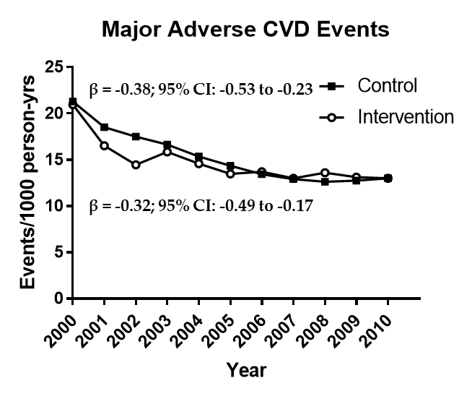
B
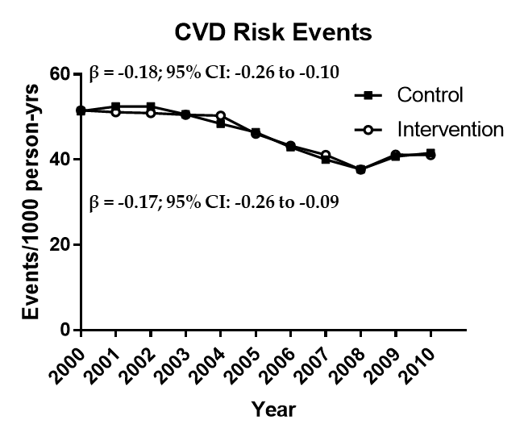

eFigure 5. Sex specific effects of multi-use trails on CVD events and CVD risk factors
A – CVD events
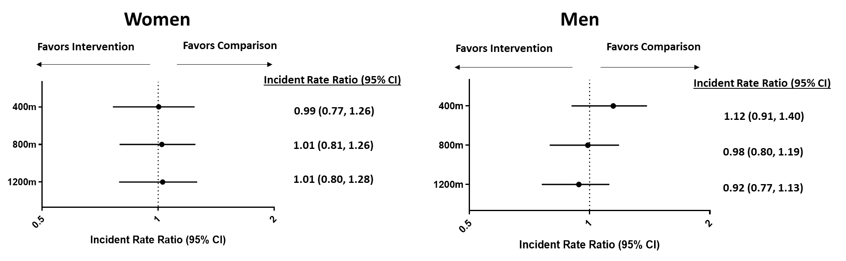

B – CVD risk factors
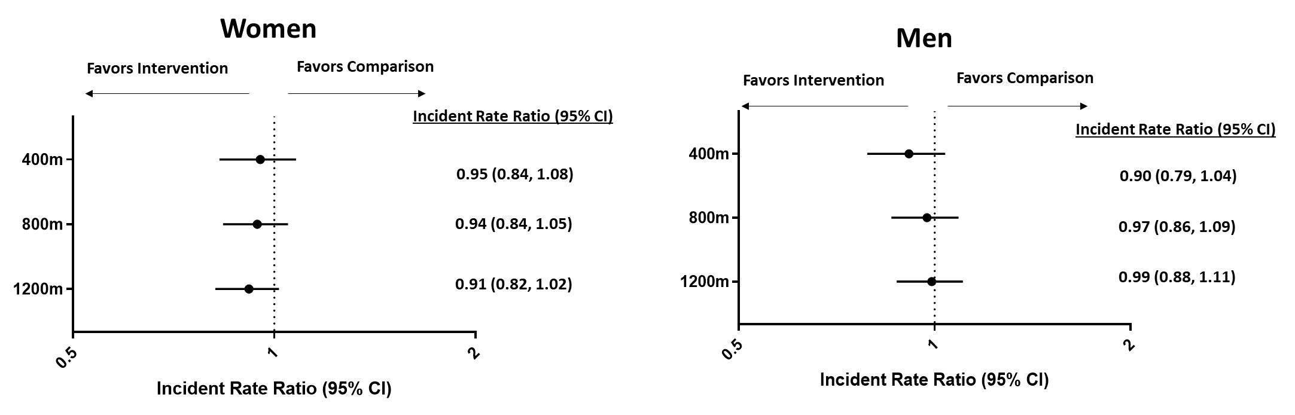

eFigure 6. Effects of multi-use trails in CVD events and CVD risk factors for the population restricted to 30- 65 years
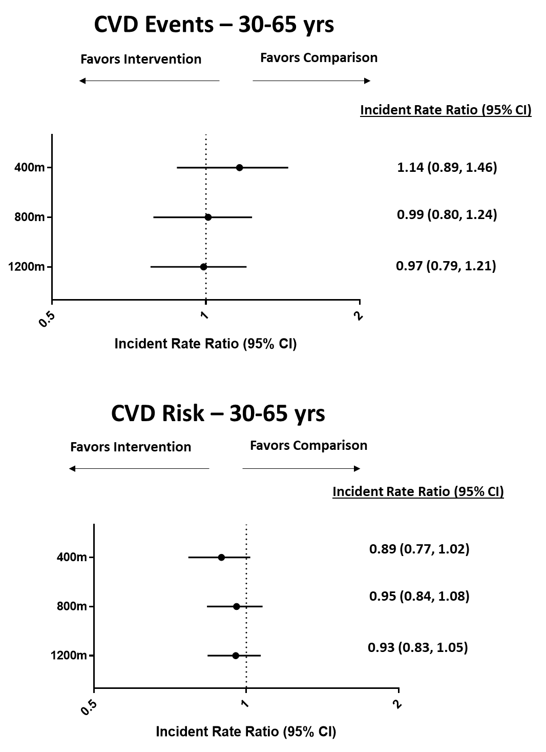

eFigure 7. Effects of multi-use trails on CVD events and CVD risk factors stratified by season
A - CVD Events
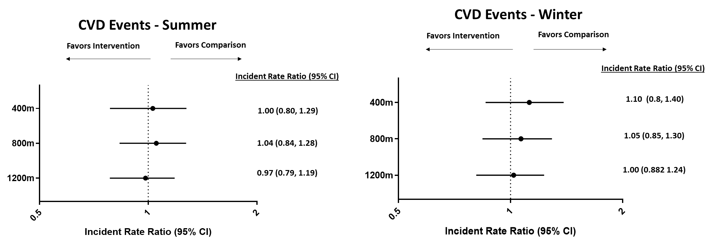
B- CVD Risk Factors
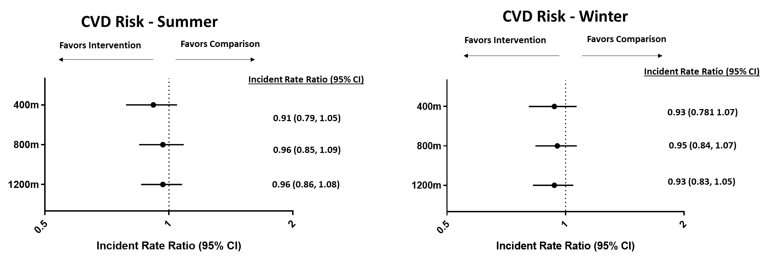

eTable 1. Details of the multi-use trails
Variable | Trail A | Trail B | Trail C | Trail D
Original Land Use | Paved grassland | Converted rail line | Paved grassland | Paved grassland / industrial re-appropriation
Const. Start Date | Summer ‘08 | Summer ‘07 | Summer ‘09 | Summer ‘10
Completion date | ~Autumn ‘10 | ~Autumn ‘12 | ~Autumn ‘11 | ~Autumn ‘10
Const. Start Date | Summer ‘08 | Summer ‘07 | Summer ‘09 | Summer ‘10
Completion date | ~Autumn ‘10 | ~Autumn ‘12 | ~Autumn ‘11 | ~Autumn ‘10
Distance of Trail | 8km | 6.5km | 5km | 6.7 km
Dissemination areas within 800m access | 60 | 80 | 32 | 35
Estimated pop. within 800m | 26,791 | 31,924 | 12,361 | 12,710
Immediate adjacent environment | Major roadway and neighbourhoods/ business parks | Trail located between two major roadways | Greenspace, neighbourhood, airport | Neighbourhood, grassland, business park
Mixed land use | High (homes, schools, shopping, parks) | High (homes, schools, shopping, recreation, parks) | Medium (homes, schools, parks) | Medium (homes, shopping, parks)

sTable 2. Cardiovascular disease events and cardiovascular disease risk factor classification and corresponding International Classification of Disease (ICD) codes, in alphabetical order.
Indication | ICD title | ICD 10 code | ICD 9 code
Diagnoses indicative of a cardiovascular disease endpoint – Primary outcome
Ischemic heart disease | Angina pectoris | I20 | 413
Ischemic heart disease | Acute myocardial infarction | I21 | 410, 434.91
Ischemic heart disease | Subsequent myocardial infarction | I22 | 412
Ischemic heart disease | Other acute ischaemic heart diseases | I24 | 411
Ischemic heart disease | Chronic ischaemic heart disease | I25 | 414
Cardiac arrest | Cardiac arrest | I46 | 427.5
Heart failure | Heart failure | I50 | 428
Cerebral infarction | Cerebral infarction | I63 | 433, 434, 435
Cerebral infarction | Stroke | I64 | 437.0, 437.1, 437.3
Diagnoses indicative of a cardiovascular disease risk factor – Secondary Outcome
Diabetes | Diabetes | E11 | 250
Hyperlipidemia | Dyslipidemia | E78 | 272.3, 272.5, 272.6
Hyperlipidemia | Pure hypercholesterolaemia | E78.0 | 272.0
Hyperlipidemia | Pure hyperglyceridaemia | E78.1 | 272.1
Hyperlipidemia | Mixed hyperlipidaemia | E78.2 | 272.2
Hyperlipidemia | Hyperlipidaemia, unspecified | E78.5 | 272.4
Hypertension | Essential (primary) hypertension | I10 | 401, 459.3
Hypertension | Hypertensive heart disease | I11 | 402
Hypertension | Hypertensive renal disease | I12 | 403
Hypertension | Hypertensive heart and renal disease | I13 | 404
Diagnoses leading to exclusion from the cohort
Cardiomyopathy | Endocardial fibroelastosis | I42.4 | 425.3
Cardiomyopathy | Endomyocardial disease | I42.3 | 425.0
Cardiomyopathy | Congenital cardiomyopathy | I42.8 | Not applicable
Cardiomyopathy | Familial cardiomyopathy | I42.9 | 425.9
Congenital malformation of circulatory system | Congenital malformations of the circulatory system | Q20 to Q28 | 745, 746, 747, 759.9
Cystic fibrosis | Cystic fibrosis | E84 | 277.0
Ineligible diagnoses (not considered as outcome, but did not warrant exclusion of the participant)
Other cardiovascular problems (eg cause is viral, genetic, alcoholic, etc.) | Other cardiovascular problems | E78.7, E78.8 | 424.9, 425.2, 425.5, 425.7, 425.8, 425.9
Arrhythmia* | Cardiac dysrhythmias | I49 | 427 excluding 427.5 (see Cardiac arrest)
Arrhythmia* | Abnormalities of heart beat | R00 to 03 | 785.3
*Arrhythmias were ineligible because their definition in administrative databases has not yet been validated and a local pediatric cardiologist informed us that most dysrhythmia diagnoses or referrals would not be considered cardiovascular disease or risk.

sTable 3. Definitions and sources of data to define cardiovascular disease events and cardiovascular disease risk factors
Category | Variable | Outcome | Definition | Source
Primary | Major adverse cardiovascular events (MACE) - Composite | CVD-related mortality | Death in vital statistics mortality data with most responsible cause of death coded as CHF, IHD or stroke. | Vital statistics mortality
Primary | Major adverse cardiovascular events (MACE) - Composite | Ischemic heart disease | -1+ Inpatient Hospitalizations  -2+ Physician visits in 5 years  -1 Physician Visit & 2+ Rx in 5 years | Hospital abstracts, Medical claims, DPIN prescription dispensations
Primary | Major adverse cardiovascular events (MACE) - Composite | Congestive heart failure | -1+ inpatient visits or 2+ physician visits | Hospital abstracts, Medical claims
Primary | Major adverse cardiovascular events (MACE) - Composite | Cerebrovascular event | - 1+ Inpatient Hospitalizations  - death in hospital | Hospital abstracts
Secondary | CVD-related risk factors - Composite | Hypertension | -1+ Inpatient Hospitalizations  -2+ Physician visits in 2 years | Hospital abstracts,  Medical claims
Secondary | CVD-related risk factors - Composite | Diabetes | -1+ Inpatient Hospitalizations  -2+ Physician visits in 3 years  -2+ Rx for glucose lowering agents in 3 years, | Hospital abstracts,  Medical claims, Prescription dispensations
Secondary | CVD-related risk factors - Composite | Dyslipidemia | -1+ Hospitalization  -2+ Physician visits in 3 years  -2+ Rx for statins in 3 years | Hospital abstracts,  Medical claims, Prescription dispensations
Secondary | Trail use | Bicycle counts |  | Eco-Counter Magnetic Zelts located beneath greenways
Exploratory | Income | Household | Self-reported | Intercept surveys
Exploratory | Ethnicity |  | Self-reported | Intercept surveys
Exploratory | Gender | Male, female, other | Self-reported | Intercept surveys
Exploratory | Residence | Postal code | Self-reported | Intercept surveys
Exploratory | Weekly use | Visits/week | Self-reported | Intercept surveys
Exploratory | Time on trail | Minutes/use | Self-reported | Intercept surveys
CHF = congestive heart failure; CVD = cardiovascular disease; ICD = international classification code; IHD = ischemic heart disease, Rx = prescription.

eTable 4. Area-level descriptive variables for each multi-use trail.
 | Trail A | Trail B | Trail C | Trail D
Dissemination Areas* (DA) | 60 | 80 | 32 | 35
Female** (%) | 53.26% | 53.12% | 52.80% | 51.43%
Age** (years) | 53.00 | 54.00 | 52.95 | 50.81
Visible Minority* (%) | 15.60% | 10.82% | 6.88% | 6.37%
Immigrated last 10 years* (%) | 4.95% | 3.97% | 2.47% | 1.80%
Socioeconomic indicators
SEFI** | -0.6240 | -0.2165 | -0.3670 | -0.3108
Household income* | $78,903.78 | $67,918.18 | $64,027.56 | $68,255.49
Average Property Value† | $150,949.41 | $116,183.20 | $104,129.83 | $106,676.21
Population without high school graduation* (%) | 19.57% | 25.39% | 19.30% | 24.40%
Unemployment Rate* | 5.15% | 4.79% | 4.22% | 4.97%
Physical Activity indicators
Fitness/Recreation Centres within 5km† (2018 only) | 96.20 | 100% | 61.82% | 100%
Average Distance to greenspace† (m) | 192.65 | 154.89 | 162.92 | 160.99
Walkability Score‡ | -0.0798 | 0.4680 | 0.0726 | -0.0366
Active commuting* (%) | 6.25% | 5.03% | 5.59% | 3.47%

