Additional File 10. Forest plots and funnel plots for sedentary behaviour outcomes
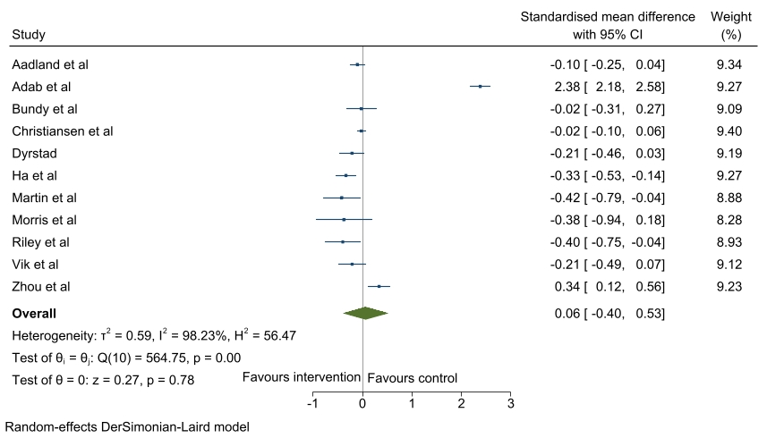
Figure 1. Forest plot of standardised mean difference of change in sedentary behaviour between intervention and control groups of school-based physical activity interventions

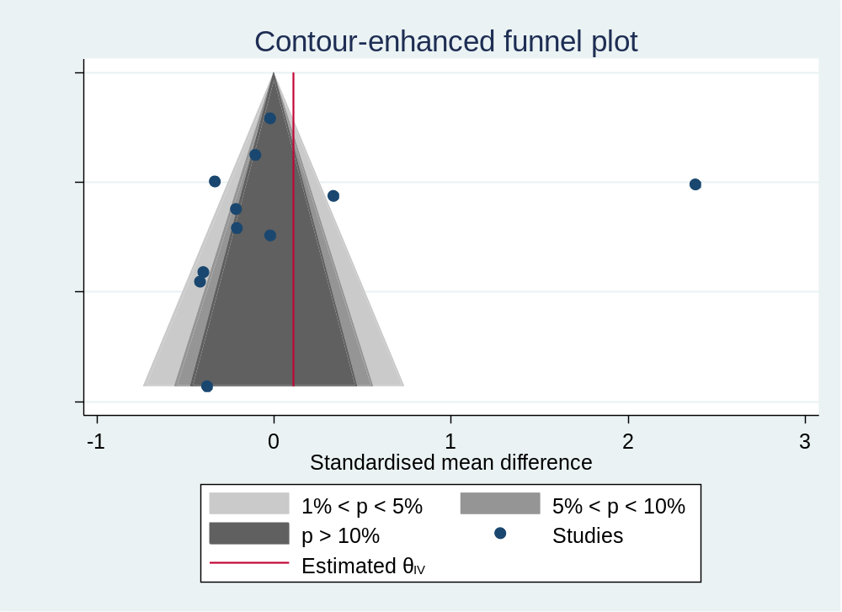
Figure 2. Funnel plot for sedentary behaviour outcomes

