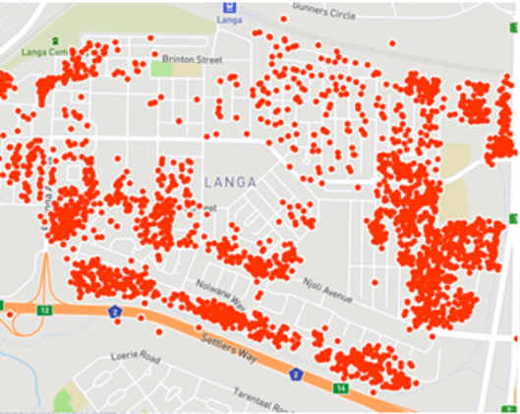
Additional File 2. Sampling map for Langa township created using geocodes from 24-hour diet recalls.

