Supplementary material.

Additional tables

Table S1. Covariance matrices for the daily time-use in movement behaviours.
 |  | VPA | MPA | LPA | SB | Sleep
Baseline (4 years old)
VPA |  |  | 0.22 | 0.34 | 0.47 | 0.35
MPA |  | 0.22 |  | 0.13 | 0.43 | 0.21
LPA |  | 0.34 | 0.13 |  | 0.21 | 0.09
SB |  | 0.47 | 0.43 | 0.21 |  | 0.19
Sleep |  | 0.35 | 0.21 | 0.09 | 0.19
 |  | VPA | MPA | LPA | SB | Sleep
Follow up (9 years old)
VPA |  |  | 0.17 | 0.35 | 0.44 | 0.37
MPA |  | 0.17 |  | 0.11 | 0.21 | 0.15
LPA |  | 0.35 | 0.11 |  | 0.09 | 0.04
SB |  | 0.44 | 0.21 | 0.09 |  | 0.03
Sleep |  | 0.37 | 0.15 | 0.04 | 0.03
Note: values close to 0 represent high covariance (dependence) between the variables.
VPA: vigorous physical activity, MPA: moderate physical activity, LPA: light physical activity, SB: sedentary behaviour.

Table S2. Comparison of baseline demographic characteristics (4 years old) of children included and not included in this study.
 |  | Included |  |  | Not included
 |  | n | Value |  |  | n | Value | P value
Age (yrs) |  | 201 | 4.5 (0.1) |  |  | 114 | 4.5 (0.1) | 0.950
Height (cm) |  | 201 | 107.4 (4.2) |  |  | 114 | 107.9 (4.3) | 0.302
Weight (kg) |  | 201 | 18.2 (2.5) |  |  | 114 | 18.5 (2.5) | 0.328
Weight status n (%) |  | 201 |  |  |  | 114 |  | 0.514
Underweight |  |  | 20 (9.9) |  |  |  | 7 (6.1)
Normal weight |  |  | 166 (82.6) |  |  |  | 94 (82.5)
Overweight |  |  | 13 (6.5) |  |  |  | 11 (9.6)
Obesity |  |  | 2 (1.0) |  |  |  | 2 (1.8)
Maternal education level n (%) |  | 201 |  |  |  | 114 |  | 0.034
University or higher |  |  | 151 (75.1) |  |  |  | 72 (63.2)
Below university |  |  | 50 (24.9) |  |  |  | 42 (36.8)
Body composition
FFMI (kg·m²) |  | 201 | 11.6 (1.0) |  |  | 102 | 11.6 (0.9) | 0.888
FMI (kg·m²) |  | 201 | 4.1 (0.9) |  |  | 102 | 4.2 (0.9) | 0.383
Physical fitness
Aerobic (laps) |  | 201 | 5.9 (2.7) |  |  | 106 | 5.7 (2.5) | 0.528
Speed-Agility (s) |  | 201 | 18.0 (1.9) |  |  | 114 | 18.3 (2.0) | 0.208
Upper-body strength (kg) |  | 201 | 6.4 (1.6) |  |  | 112 | 6.5 (1.6) | 0.545
Lower-body strength (cm) |  | 201 | 73.6 (16.0) |  |  | 113 | 67.9 (12.9) | 0.001
Data presented as mean (SD) unless otherwise stated.

Figure S1. Ternary plots for the daily time-use in the movement behaviours at 4 years old in the included children (A) and the dropouts (B). The crosshair marks represent the geometric mean of the awake time behaviours at 4 years old in the (A) included children (i.e., VPA: 10 min/day, MPA: 55 min/day, LPA: 348 min/day, SB: 512 min/day, Sleep: 515 min/day) and (B) 9 years old (i.e., VPA: 8.4 min/day, MPA: 51 min/day, LPA: 272 min/day, SB: 562 min/day, Sleep: 645 min/day). Concentric rings represent the 25%, 50% and 75% confidence regions. The difference in the time-use composition of VPA, MPA, LPA, SB, and sleep is not significantly different between the included children and the dropouts (P = 0.628).
MVPA: moderate-to-vigorous physical activity, VPA: vigorous physical activity, MPA: Moderate physical activity, LPA: light physical activity, SB: sedentary behaviour.

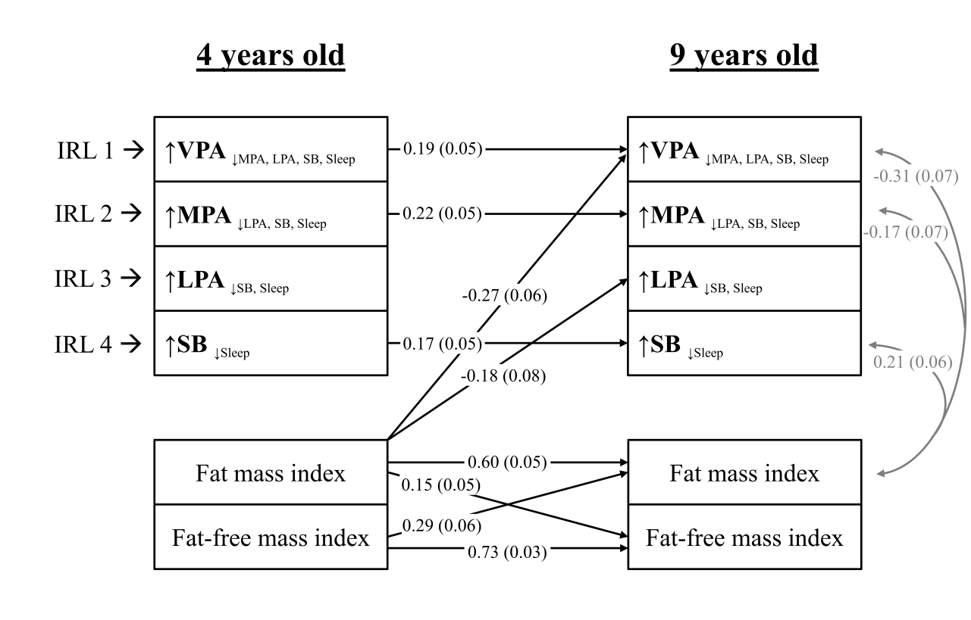
Figure S2. Lagged associations of the 24-h movement behaviour composition with body composition and concurrent relationships at 9 years old (n = 196). The model is adjusted for sex and age at baseline and follow up, group allocation, maternal education, and energy intake at baseline and follow up. Gray lines indicate shared covariance. Only statistically significant paths (P < 0.05) are shown. Model fit indices: CFI: 0.99, RMSA: 0.05, SRMR: 0.025. Data presented are standardized coefficients (standard error).

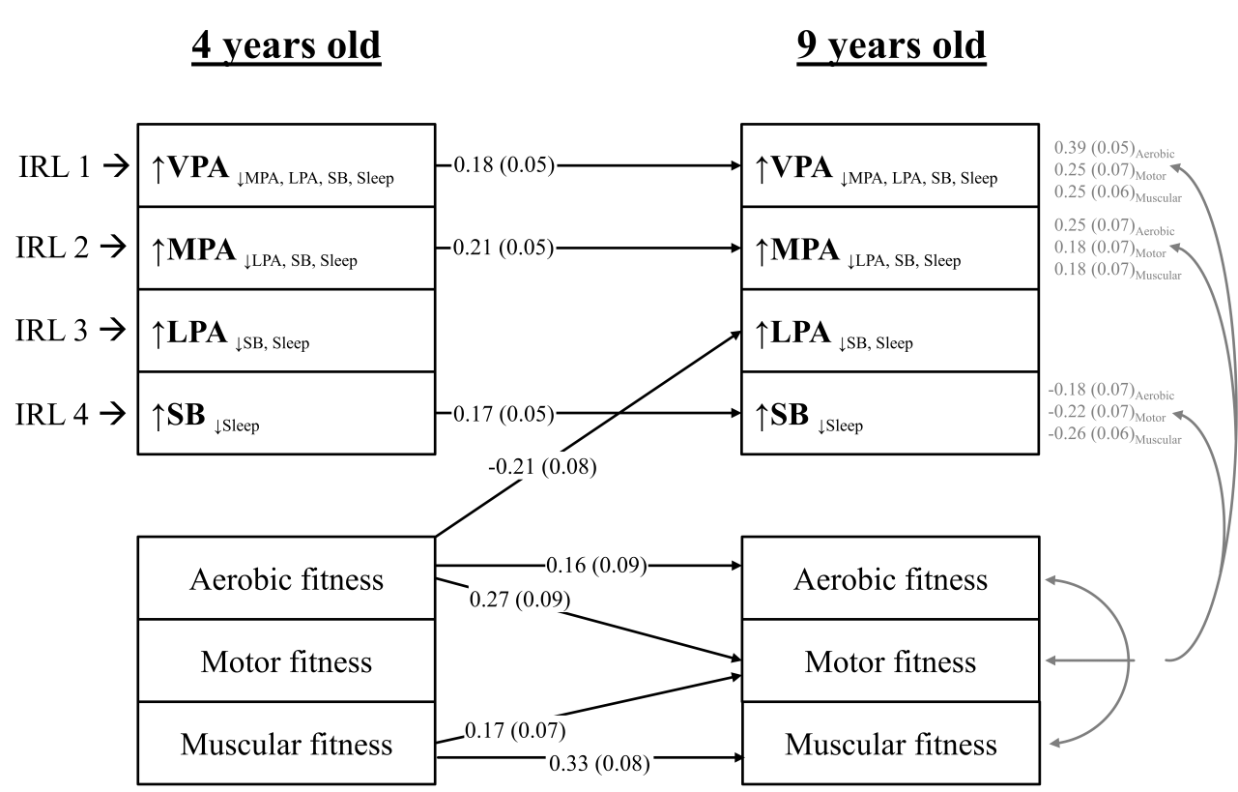
Figure S3. Lagged associations of the 24-h movement behaviour composition with physical fitness and concurrent relationships at 9 years old (n = 196). The model is adjusted for sex and age at baseline and follow up, group allocation, maternal education, and energy intake at baseline and follow up. Gray lines indicate shared covariance. Only statistically significant paths (P < 0.05) are shown. Model fit indices: CFI: 0.99, RMSA: 0.05, SRMR: 0.025. Data presented are standardized coefficients (standard error).

