Supplementary Material

Short and medium-term effects of the COVID-19 lockdowns on child and parent accelerometer-measured physical activity and sedentary time: a natural experiment

Russell Jago PhD^{1,2, 3,4*}, Ruth Salway¹, Danielle House¹, Robert Walker¹, Lydia Emm-Collison¹, Kate Sansum¹, Katie Breheny², Tom Reid^{1,2}, Sarah Churchward⁵, Joanna G Williams^{2, 6}, Charlie Foster¹, William Hollingworth^{2, 3}, Frank de Vocht^{2, 3}

Additional Figures
Figure S1: Children’s MVPA and sedentary time modelled change over time, with no seasonality adjustment
Figure S2: Children’s MVPA and sedentary time modelled change over time, with interaction by child gender
Figure S3: Children’s MVPA and sedentary time modelled change over time, with interaction by highest household education

Additional Tables
Table S1: Missing data
Table S2 Further model details and model fit for GAMM change over time models.
Table S3 Further model details and model fit for GAMM change over time models with interactions for gender and household education.

Figure S1: Children’s MVPA and sedentary time modelled change over time, with no seasonality adjustment
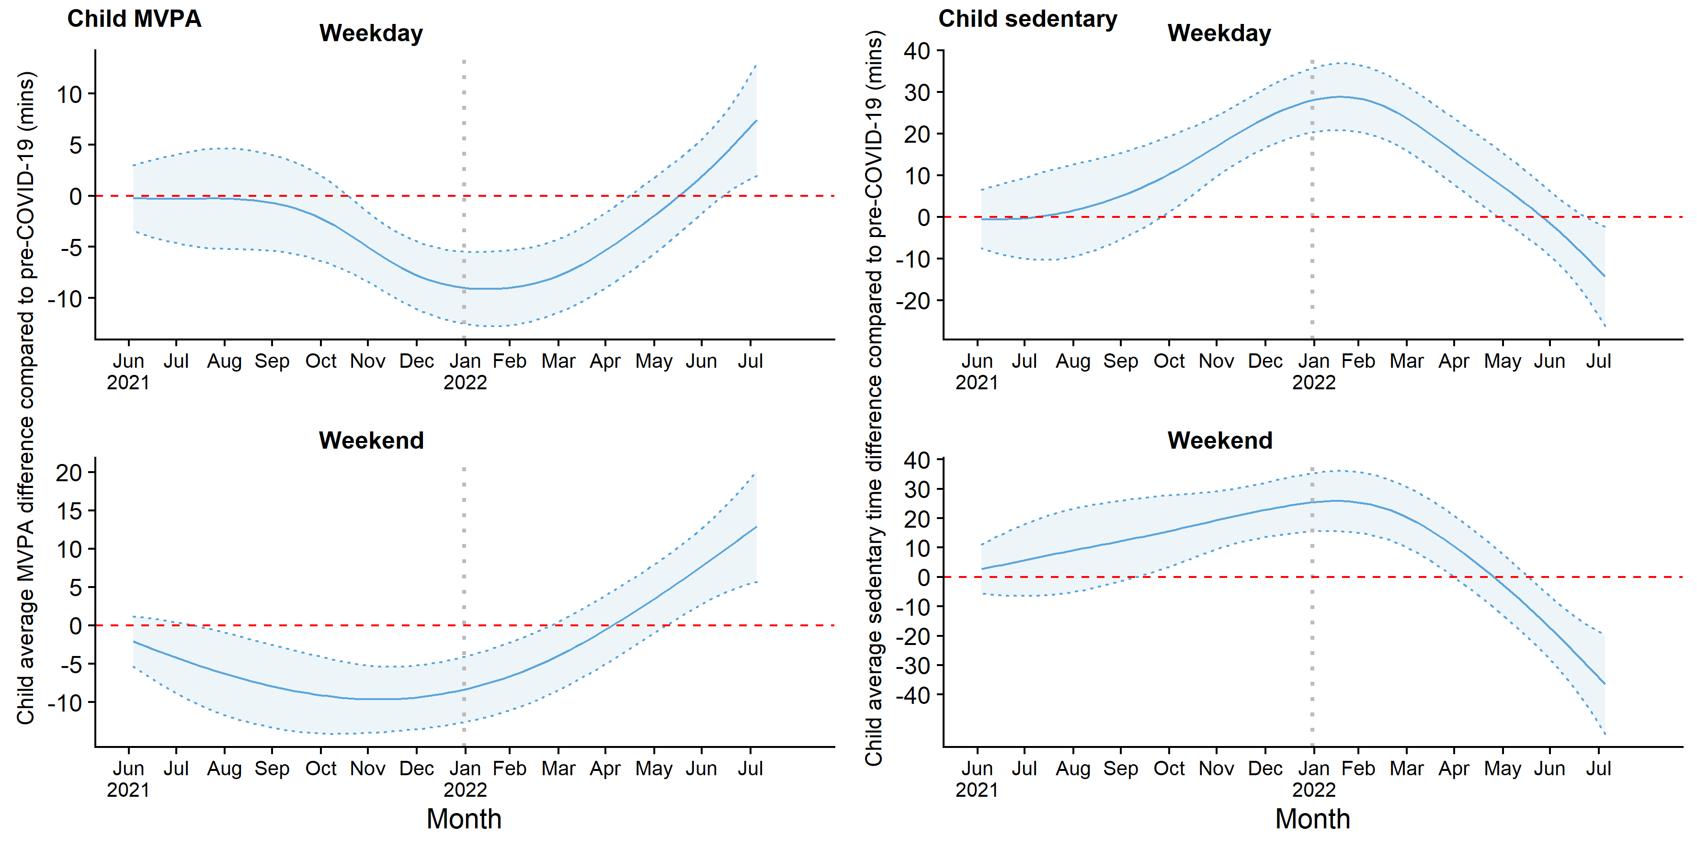
MVPA=moderate-to-vigorous physical activity
Shaded area is 95% confidence band
Figure S2: Children’s MVPA and sedentary time modelled change over time, with interaction by child gender
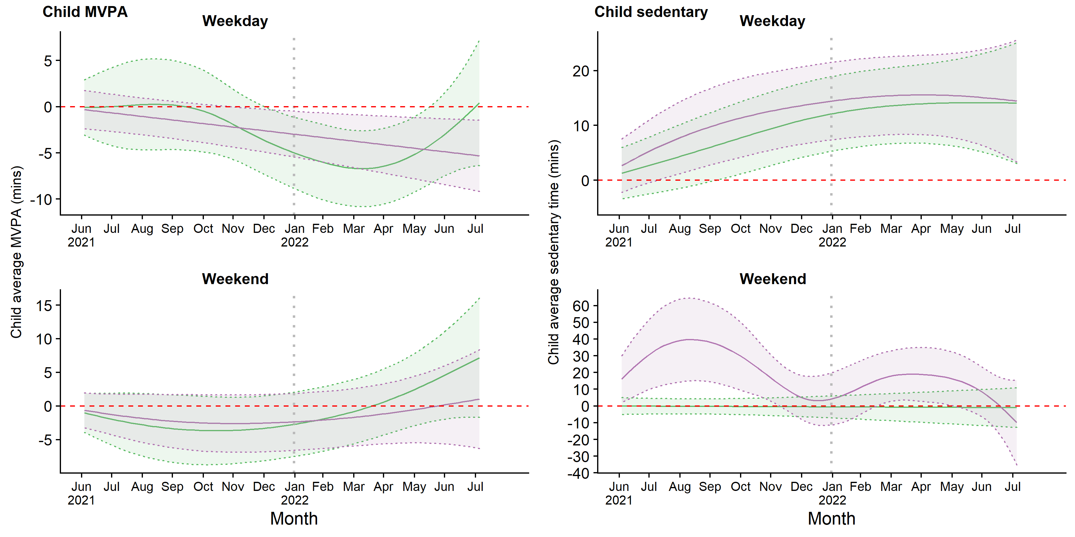
green=boys; purple=girls
MVPA=moderate-to-vigorous physical activity
Shaded areas are 95% confidence bands
Figure S3: Children’s MVPA and sedentary time modelled change over time, with interaction by highest household education
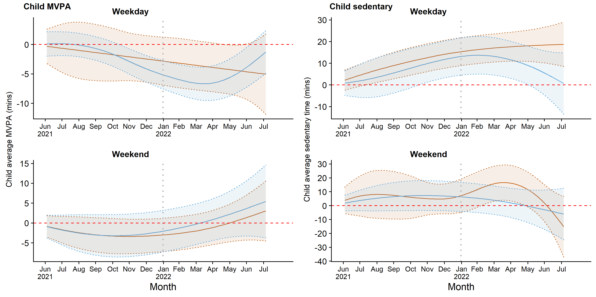

blue= highest household education is up to A level or equivalent qualification at age 18); orange=highest household education is degree or higher
MVPA=moderate-to-vigorous physical activity
Shaded areas are 95% confidence bands
Table S1: Missing data
 | Wave 0  Mar 2017-May 2018  N=1296 |  | Wave 1  Jun 2021-Dec 2021  N=393 |  | Wave 2  Jan 2022-Jul 2022  N=463
 | N | % | N | % | N | %
Child
Age | 0 | 0% | 0 | 0% | 0
Gender | 0 | 0% | 0 | 0% | 0
Weekday accelerometer data | 173 | 13% | 37 | 9% | 42 | 10%
Weekend accelerometer data | 332 | 26% | 102 | 25% | 119 | 27%
Parent
Age | 233 | 18% | 5 | 1% | 7 | 2%
Gender | 208 | 16% | 5 | 1% | 7 | 2%
Household education | 105 | 8% | 5 | 1% | 7 | 2%
Ethnicity | 213 | 16% | 30 | 8% | 43 | 10%
Weekday accelerometer data | 270 | 21% | 62 | 16% | 75 | 17%
Weekend accelerometer data | 313 | 24% | 99 | 25% | 124 | 28%

Table S2: Model details and model fit for GAMM change over time models.

 | MVPA |  |  |  | Sedentary time
 | Estimated  df | p-value¹ | AIC² | Change in AIC² | Estimated df | p-value¹ | AIC² | Change in AIC²
Child – not adjusted for seasonality
Weekday | 4.1 | <0.001 | 15642 |  | 4.3 | <0.001 | 18484
Weekend | 2.9 | <0.001 | 14324 |  | 3.7 | <0.001 | 16459
Child – adjusted for seasonality
Weekday | 4.8 | 0.001 | 15627 | -15 | 2.2 | <0.001 | 18465 | -19
Weekend | 2.4 | 0.111 | 14302 | -22 | 4.3 | 0.013 | 16420 | -39
Parent - not adjusted for seasonality
Weekday | 1.0 | 0.103 | 14883 |  | 1.5 | 0.108 | 17335
weekend | 2.1 | <0.001 | 14069 |  | 2.1 | 0.056 | 15968
Parent - adjusted for seasonality
Weekday | 1.0 | 0.140 | 14884 | 1 | 1.0 | 0.178 | 17337 | 2
weekend | 1.0 | 0.001 | 14070 | 1 | 2.0 | 0.086 | 15970 | 2
GAMM=Generalised Additive Mixed Model; MVPA=moderate-to-vigorous physical activity; df=degrees of freedom; AIC=Akaike Information Criterion
¹ p-value for a hypothesis test of linearity i.e. estimated df=1
² Change reported for seasonality vs no seasonality adjustment. Lower AIC indicates better model fit. Change in AIC of 5 or less generally considered to indicate no improvement in model fit.

Table S3 Further model details and model fit for child GAMM change over time models with interactions for gender and household education.
 | MVPA |  |  |  | Sedentary time
 | Est.  df | P-value¹ | AIC² | Change in AIC² | Est.  df | P-value¹ | AIC² | Change in AIC²
Gender
Weekday
Boys | 3.3 |  |  |  | 1.9
Girls | 1.0 | 0.893 | 15630 | 3 | 1.9 | 0.945 | 18468 | 3
Weekend
Boys | 2.0 |  |  |  | 1.0
Girls | 1.5 | 0.592 | 14305 | 3 | 5.3 | 0.202 | 16416 | -4
Household education
Weekday
No degree | 2.8 |  |  |  | 2.4
Degree | 1.0 | 0.686 | 15631 | 4 | 1.9 | 0.104 | 18464 | -1
Weekend
No University degree | 1.7 |  |  |  | 1.7
University degree | 1.9 | 0.677 | 14306 | 4 | 3.8 | 0.513 | 16419 | -1
GAMM=Generalised Additive Mixed Model; MVPA=moderate-to-vigorous physical activity; df=degrees of freedom; AIC=Akaike Information Criterion

¹ p-value for a hypothesis test of no difference between gender/education
² Lower AIC indicates better model fit. Change in AIC compared to model with no interaction (Table S2); a change of 5 or less generally considered to indicate no improvement in model fit.
³ or equivalent qualifications.

