Supplementary file 7. Sensitivity analysis excluding trials counted drinks-only as meals
Weight change
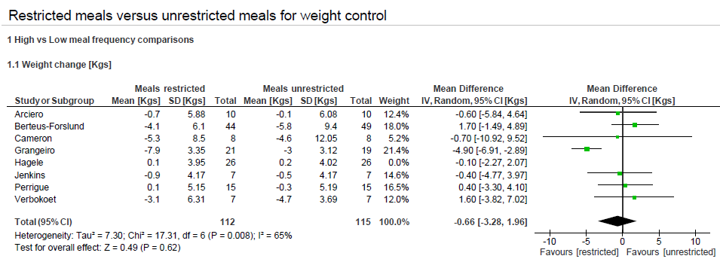

Fat-mass
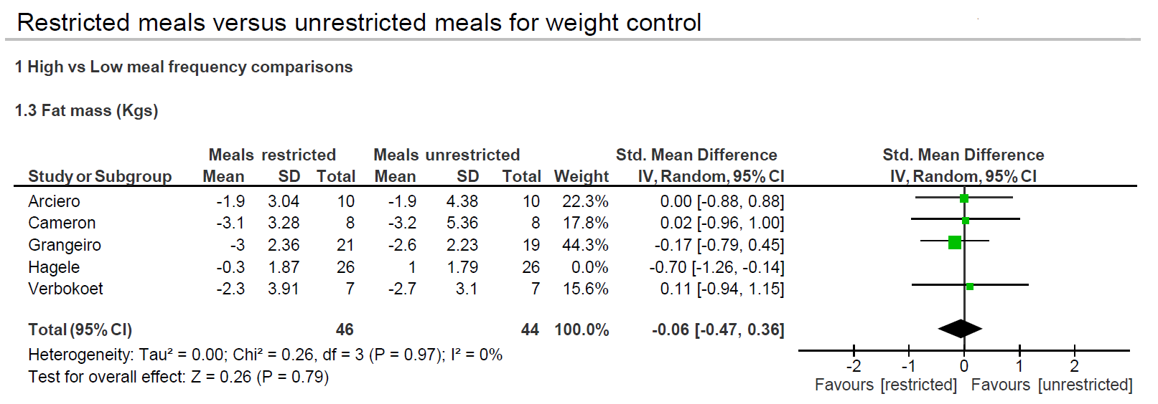

Triglycerides
