Supplementary table 1. Complete list of variables
Variable name | Question or measure | Response options or categories
Country of birth
 | In which country were you born? | Australia
 |  | United Kingdom
 |  | Italy
 |  | Greece
 |  | New Zealand
 |  | Vietnam
 |  | Other (Please specify)
Area of residence
 | Accessibility/Remoteness Index of Australia plus [1]  (derived from post code and geographic location of participant’s address). | Major city of Australia
 |  | Inner regional Australia
 |  | Outer regional Australia
 |  | Remote
 |  | Very remote Australia
Educational attainment
 | What is the highest qualification you have completed? | School Certificate
 | What is the highest qualification you have completed? | Higher school certificate
 |  | Trade/Apprenticeship
 |  | Certificate/Diploma
 |  | University degree
 |  | Higher degree
Marital status
 | What is your present marital status? | Married
 |  | Defacto (opposite sex)
 |  | Defacto (same sex)
 |  | Separated
 |  | Divorced
 |  | Widowed
 |  | Single
Ability to manage on income
 | How do you manage on the income you have available? | Easy
 |  | Not too bad
 |  | Difficult sometimes
 |  | Difficult always
 |  | Impossible
Hours worked per week
 | How many hours do you normally spend in your paid work each week? | None
 |  | 1-15 h/wk
 |  | 16-24 h/wk
 |  | 25-34 h/wk
 |  | 35-40 h/wk
 |  | 41-48 h/wk
 |  | ≥49 h/wk
Living with children age <18
 | How many people live with you now? | None
 | Children under 16 years  Children 16-18 years | One
 | Children under 16 years  Children 16-18 years | Two
 |  | Three or more
Provision of care for grandchildren
 | Do you regularly provide (unpaid) care for grandchildren? | Never
 |  | Occasionally
 |  | Weekly
 |  | Daily
 |  | Never
Provision of care for someone requiring care
 | Do you regularly provide care or assistance (eg personal care, transport) to any other person because of their long-term illness, disability or frailty? | Occasionally
Weekly
Daily
Menopause status
 | Combination of hysterectomy, ovaries removed, hormone replacement therapy (HRT), oral contraceptive pill (OCP), menstrual bleeding, and irregular bleeding [2] | Hysterectomy only
 |  | Bilateral oophorectomy only
 |  | Hysterectomy and bilateral oophorectomy
 |  | HRT use
 |  | OCP use
 |  | Pre-menopausal
 |  | Peri-menopausal
 |  | Post-menopausal
BMI
 | Weight (kg) divided by the square of reported height (metres) [3]. BMI was classified based on WHO recommendations [4] | Underweight
 |  | Normal
 |  | Overweight
 |  | Obese
Physical function
 | Physical component summary score from the SF-36 [5] | Continuous variable; categorised into quartiles
Mental health | Physical component summary score from the SF-36 [5]
 | Mental component summary score from the SF-36 [5] | Continuous variable; categorised into quartiles
Chronic conditions | Mental component summary score from the SF-36 [5]
 | Have you ever been told by a doctor that you have?  Type 2 diabetes, heart disease, hypertension, stroke, low iron level, asthma, bronchitis/emphysema, osteoporosis, breast cancer, cervical cancer, skin cancer, depression, and anxiety | Never
 |  | Last 2 years
 |  | >2 years ago
Smoking status
 | Frequency and history of smoking [6] | Never-smoker
 |  | Ex-smoker
 |  | Smoker <10 cigarettes /day
 |  | Smoker 10-19 cigarettes /day
 |  | Smoker ≥20 cigarettes /day
 |  | Smoker unknown cigarettes/day
Alcohol status
 | Frequency and quantity of alcohol consumed [7] | Low risk drinker
 | Frequency and quantity of alcohol consumed [7] | Non-drinker
 |  | Rarely drinks
 |  | Risky drinker
 |  | High risk drinker
Refenreces
1. Australian Longitudinal Study on Women’s Health. ARIA Scores: Index of accessibility/remoteness. Available from: https://alswh.org.au/wp-content/uploads/2020/08/DDSSection5ARIA.pdf. Accessed September 2023.
2. Australian Longitudinal Study on Women’s Health. Menopausal status Available from: https://alswh.org.au/wp-content/uploads/2020/08/DDSSection2.2Menopause.pdf. Accessed September 2023.
3. Australian Longitudinal Study on Women’s Health. Estimated Height – Young and Mid-aged. Available from: https://alswh.org.au/wp-content/uploads/2020/08/DDSSection3Height.pdf. Accessed September 2023.
4. Australian Longitudinal Study on Women’s Health. Body mass index – Young and Mid-aged. Available from: https://alswh.org.au/wp-content/uploads/2020/08/DDSSection3BMI.pdf. Accessed September 2023.
5. Mishra GD, Hockey R, Dobson AJ. A comparison of SF-36 summary measures of physical and mental health for women across the life course. Quality of Life Research. 2014;23(5):1515-21. doi:10.1007/s11136-013-0586-3.
6. Australian Longitudinal Study on Women’s Health. Smoking Status. Available from: https://alswh.org.au/wp-content/uploads/2021/01/DDS_section2_5SmokingStatus.pdf. Accessed September 2023.
7. Australian Longitudinal Study on Women’s Health. Alcohol Intake and Pattern of Alcohol Consumption. Available from: https://alswh.org.au/wp-content/uploads/2020/08/DDSSection2.5AlcIntake.pdf. Accessed September 2023.

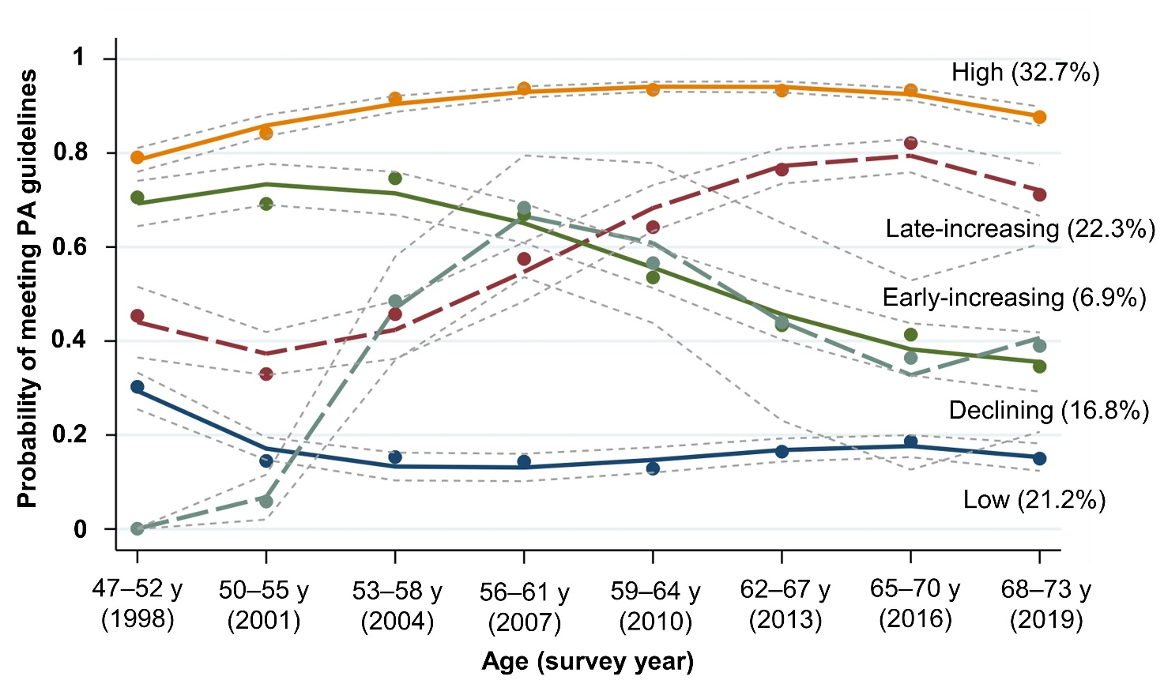
Supplementary figure 1. Trajectories of probability of meeting physical activity recommendation
Group-based trajectory model; ≥500 MET.minutes/week categorized as meeting physical activity recommendation.
PA, physical activity; y, year

Supplementary table 2. Goodness-of-fit and adequacy of the model (probability of meeting physical activity recommendation)
Group | Polynomial | BIC | AIC | Log-likelihood | Trajectories | Estimated probability of group membership | Average posterior probabilities | Odds of correct classification
2 | Linear | -43457.55 | -43439.43 | -43434.43 | - | - | - | -
2 | Quadratic | -43312.33 | -43286.96 | -43279.96 | - | - | - | -
2 | Cubic | -43278.65 | -43246.04 | -43237.04 | - | - | - | -
3 | Linear | -43156.03 | -43127.04 | -43119.04 | - | - | - | -
3 | Quadratic | -42988.19 | -42948.33 | -42937.33 | - | - | - | -
3 | Cubic | -42962.36 | -42911.64 | -42897.64 | - | - | - | -
4 | Linear | -42957.8 | -42917.94 | -42906.94 | - | - | - | -
4 | Quadratic | -42860.37 | -42806.02 | -42791.02 | - | - | - | -
4 | Cubic | -42817.45 | -42748.61 | -42729.61 | - | - | - | -
5 | Linear | -42933.24 | -42882.51 | -42868.51 | - | - | - | -
5 | Quadratic | -42818.85 | -42750.01 | -42731.01 | - | - | - | -
5 | Cubic | -42781.04 | -42694.08 | -42670.08 | Low | 21.2 | 0.768 | 12.33
 |  |  |  |  | Declining | 16.8 | 0.643 | 8.92
 |  |  |  |  | Early-increasing | 6.9 | 0.508 | 13.85
 |  |  |  |  | Late-increasing | 22.3 | 0.603 | 5.29
 |  |  |  |  | High | 32.7 | 0.802 | 8.3
BIC, Bayesian information criterion; AIC, Akaike information criterion
Five trajectories of the cubic polynomials model were selected.

Supplementary table 3. Goodness-of-fit and adequacy of the model (total physical activity)
Group | Polynomial | BIC | AIC | Log-likelihood | Trajectories | Estimated probability of group membership | Average posterior probabilities | Odds of correct classification
2 | Linear | -509324.9 | -509303.1 | -509297.1 | - | - | - | -
2 | Quadratic | -509297.1 | -509112.8 | -509104.8 | - | - | - | -
2 | Cubic | -509112.2 | -509076.0 | -509066.0 | - | - | - | -
3 | Linear | -509066.0 | -507758.9 | -507749.9 | - | - | - | -
3 | Quadratic | -507583.0 | -507539.6 | -507527.6 | - | - | - | -
3 | Cubic | -507549.4 | -507495.1 | -507480.1 | - | - | - | -
4 | Linear | -507480.1 | -507309.0 | -507297.0 | - | - | - | -
4 | Quadratic | -507129.2 | -507071.2 | -507055.2 | - | - | - | -
4 | Cubic | -507095.5 | -507023.0 | -507003.0 | - | - | - | -
5 | Linear | -506941.0 | -506886.6 | -506871.6 | - | - | - | -
5 | Quadratic | -506687.3 | -506614.8 | -506594.8 | - | - | - | -
5 | Cubic | -506650.0 | -506559.4 | -506534.4 | Low-stable | 13.3 | 0.825 | 30.51
 |  |  |  |  | Moderate-stable | 50.4 | 0.844 | 5.32
 |  |  |  |  | Moderate-increasing | 22.0 | 0.785 | 12.96
 |  |  |  |  | High-declining | 7.7 | 0.741 | 34.25
 |  |  |  |  | High-stable | 6.6 | 0.865 | 90.25
BIC, Bayesian information criterion; AIC, Akaike information criterion
Five trajectories of the cubic polynomials model were selected.

