Comparative analysis between Evenson and Troiano cut-points in young adulthood
This analysis compares using the Evenson cut-points[1] with using the Troiano cut-points[2] in young adulthood, and how this choice affects the results in the paper. The Evenson cut-points are used at ages 9 and 15 years in both analyses. The thresholds for defining different physical activity intensities for both sets of cut-points are shown below:
 | Evenson cut-points | Troiano cut-points
Intensities | Counts per minute | Counts per minute
Sedentary | 0-100 | 0-99
Light physical activity | 101-2295 | 100-2019
Moderate physical activity | 2296-4011 | 2020-5998
Vigorous physical activity | >4012 | >5999

Summary of results
Table 1 displays the estimated marginal means, extracted from the linear mixed models, of time spent (min/day) sedentary, and in light physical activity (LPA), moderate physical activity (MPA), vigorous physical activity (VPA), and moderate-to-vigorous physical activity (MVPA). Time spent sedentary and in LPA remains similar regardless of which cut-points are being used in young adulthood, but a substantial difference occurs in time spent in MPA and VPA – where use of the Troiano cut-points leads to an increase in MPA and decrease in VPA at age 24 mainly due to the higher threshold for classifying movement as VPA with the Troiano cut-points. Smaller changes are seen for MVPA, with somewhat more minutes spent in MVPA with the Troiano cut-points due to a lower threshold for MPA. Figure 1 visualises this, where a spike in time spent in MPA and a substantial drop in VPA at age 24 years become evident with the Troiano cut-points.
Figure 2 shows how MVPA changes from age 9 to 24 years within subgroups, with a comparison between the use of the Evenson cut-points and Troiano cut-points at age 24 years. While time spent in MVPA is slightly higher at in general with the use of the Troiano cut-points, the trends and patterns remain similar regardless of choice of cut-points in young adulthood.
The tracking of MVPA and total physical with use of both the Evenson and Troiano cut-points in young adulthood can be found in Table 2. In these analyses, both the stability coefficients and odds ratios remain almost identical between the two sets of cut-points.

Tables

Table 1. Time (min/day) spent in each device-measured intensity at each time point, comparing the Evenson cut-points and Troiano cut-points in young adulthood, respectively. The estimated marginal means are extracted from the linear mixed models, and adjusted for sex, mean wear time of the accelerometer, wear month, a weekday/weekend wear day ratio, and a nested random intercept on an individual level within school clusters at age 9 years.
 | Evenson cut-points in young adulthood |  | Troiano cut-points in young adulthood
Intensities | Estimated marginal means (95% CI) | Change (95% CI) | Estimated marginal means (95% CI) | Change (95% CI)
Sedentary (min/day)
Age 9 years | 442.1 (435.2, 448.9) |  | 442.1 (435.3, 449.0)
Age 15 years | 591.6 (584.9, 598.3) | 149.5 (141.8, 157.3) | 591.6 (584.8, 598.3) | 149.5 (141.7, 157.1)
Age 24 years | 581.3 (573.9, 588.8) | −10.3 (−18.5, −2.1) | 581.0 (573.5, 588.4) | −10.6 (−18.8, −2.4)
LPA (min/day)
Age 9 years | 286.4 (281.0, 291.9) |  | 286.3 (280.9, 291.7)
Age 15 years | 161.6 (156.2, 166.9) | −124.8 (130.9, 118.8) | 161.5 (156.2, 166.8) | −124.8 (−130.8, −118.8)
Age 24 years | 172.3 (166.4, 178.2) | 10.7 (4.3, 17.2) | 166.7 (160.8, 172.5) | 5.2 (−1.2, 11.6)
MPA (min/day)
Age 9 years | 45.8 (44.2, 47.5) |  | 45.5 (43.6, 47.5)
Age 15 years | 29.6 (27.9, 31.3) | −16.2 (−18.1, −14.3) | 29.2 (27.3, 31.2) | −16.3 (−18.5, −14.0)
Age 24 years | 26.0 (24.2, 27.9) | −3.6 (−5.6, −1.5) | 51.2 (49.1, 53.4) | 22.0 (19.6, 24.4)
VPA (min/day)
Age 9 years | 30.1 (28.2, 32.7) |  | 30.9 (28.8, 33.0)
Age 15 years | 22.0 (19.8, 24.2) | −8.5 (−10.8, −6.2) | 22.4 (20.4, 24.5) | −8.5 (−10.5, −6.4)
Age 24 years | 25.2 (22.8, 27.6) | 3.2 (0.7, 5.7) | 6.1 (3.8, 8.3) | −16.3 (−18.6, −14.2)
MVPA (min/day)
Age 9 years | 76.3 (72.9, 79.7) |  | 76.4 (72.9, 79.8)
Age 15 years | 51.6 (48.2, 55.0) | −24.7 (−28.3, −21.2) | 51.7 (48.3, 55.1) | −24.7 (−28.3, −21.1)
Age 24 years | 51.2 (47.5, 54.9) | −0.4 (−4.2, 3.4) | 57.2 (53.5, 60.9) | 5.5 (1.6, 9.4)
LPA: Light physical activity; MPA: Moderate physical activity; VPA: Vigorous physical activity; MVPA: Moderate-to-vigorous physical activity

 | Crude models |  |  |  |  | Adjusted models
 | Evenson cut-points in young adulthood |  | Troiano cut-points in young adulthood |  |  | Evenson cut-points |  | Troiano cut-points
Tracking age | MVPA | Total PA | MVPA | Total PA |  | MVPA | Total PA | MVPA | Total PA
9-24 (n=640) | Estimate (95% CI) | Estimate (95% CI) | Estimate (95% CI) | Estimate (95% CI) |  | Estimate (95% CI) | Estimate (95% CI) | Estimate (95% CI) | Estimate (95% CI)
Stability Coefficient | 0.22 (0.14, 0.29) | 0.22 (0.14, 0.29) | 0.22 (0.15, 0.29) | 0.22 (0.14, 0.29) |  | 0.18 (0.09, 0.26) | 0.16 (0.08, 0.24) | 0.18 (0.09, 0.26) | 0.16 (0.08, 0.24)
Odds Ratio
Lowest Quartile | 1.92 (1.33, 2.76) | 2.10 (1.46, 3.01) | 1.92 (1.34, 2.76) | 2.08 (1.45, 3.00) |  | 1.88 (1.23, 2.86) | 1.87 (1.21, 2.87) | 1.87 (1.22, 2.85) | 1.86 (1.21, 2.86)
Highest Quartile | 1.44 (0.99, 2.08) | 1.38 (0.97, 1.97) | 1.40 (0.96, 2.03) | 1.40 (0.98, 2.00) |  | 1.07 (0.69, 1.66) | 1.15 (0.75, 1.76) | 1.02 (0.65, 1.58) | 1.17 (0.76, 1.79)
9-15 (n=458)
Stability Coefficient | 0.29 (0.21, 0.37) | 0.28 (0.20, 0.36) | 0.29 (0.21, 0.37) | 0.28 (0.20, 0.36) |  | 0.24 (0.15, 0.33) | 0.23 (0.13, 0.32) | 0.24 (0.15, 0.33) | 0.23 (0.13, 0.32)
Odds Ratio
Lowest Quartile | 2.23 (1.47, 3.39) | 2.65 (1.75, 4.03) | 2.23 (1.47, 3.39) | 2.65 (1.75, 4.03) |  | 2.18 (1.34, 3.55) | 2.41 (1.47, 3.96) | 2.18 (1.34, 3.55) | 2.41 (1.47, 3.96)
Highest Quartile | 1.83 (1.17, 2.85) | 1.67 (1.10, 2.55) | 1.83 (1.17, 2.85) | 1.67 (1.10, 2.55) |  | 1.23 (0.73, 2.08) | 1.40 (0.85, 2.30) | 1.23 (0.73, 2.08) | 1.40 (0.85, 2.30)
15-24 (n=163)
Stability Coefficient | 0.00 (−0.15, 0.15) | 0.06 (−0.09, 0.21) | −0.01 (−0.16, 0.14) | 0.06 (−0.09, 0.21) |  | −0.05 (−0.22, 0.12) | 0.04 (−0.14, 0.21) | −0.05 (−0.22, 0.12) | 0.04 (−0.14, 0.21)
Odds Ratio
Lowest Quartile | 1.54 (0.74, 3.22) | 1.72 (0.86, 3.47) | 1.58 (0.76, 3.27) | 1.77 (0.88, 3.57) |  | 1.78 (0.68, 4.68) | 1.92 (0.79, 4.69) | 1.93 (0.74, 5.03) | 2.03 (0.83, 4.97)
Highest Quartile | 0.80 (0.39, 1.67) | 1.75 (0.90, 3.41) | 0.80 (0.38, 1.65) | 1.81 (0.93, 3.54) |  | 0.86 (0.34, 2.16) | 1.74 (0.74, 4.08) | 0.84 (0.33, 2.10) | 1.82 (0.77, 4.30)
MVPA: Moderate and vigorous physical activity; PA: Physical activity
Table 2. Tracking of device-measured physical activity from 9 to 24 years of age, comparing the use of Evenson and Troiano cut-points in young adulthood.

Figures
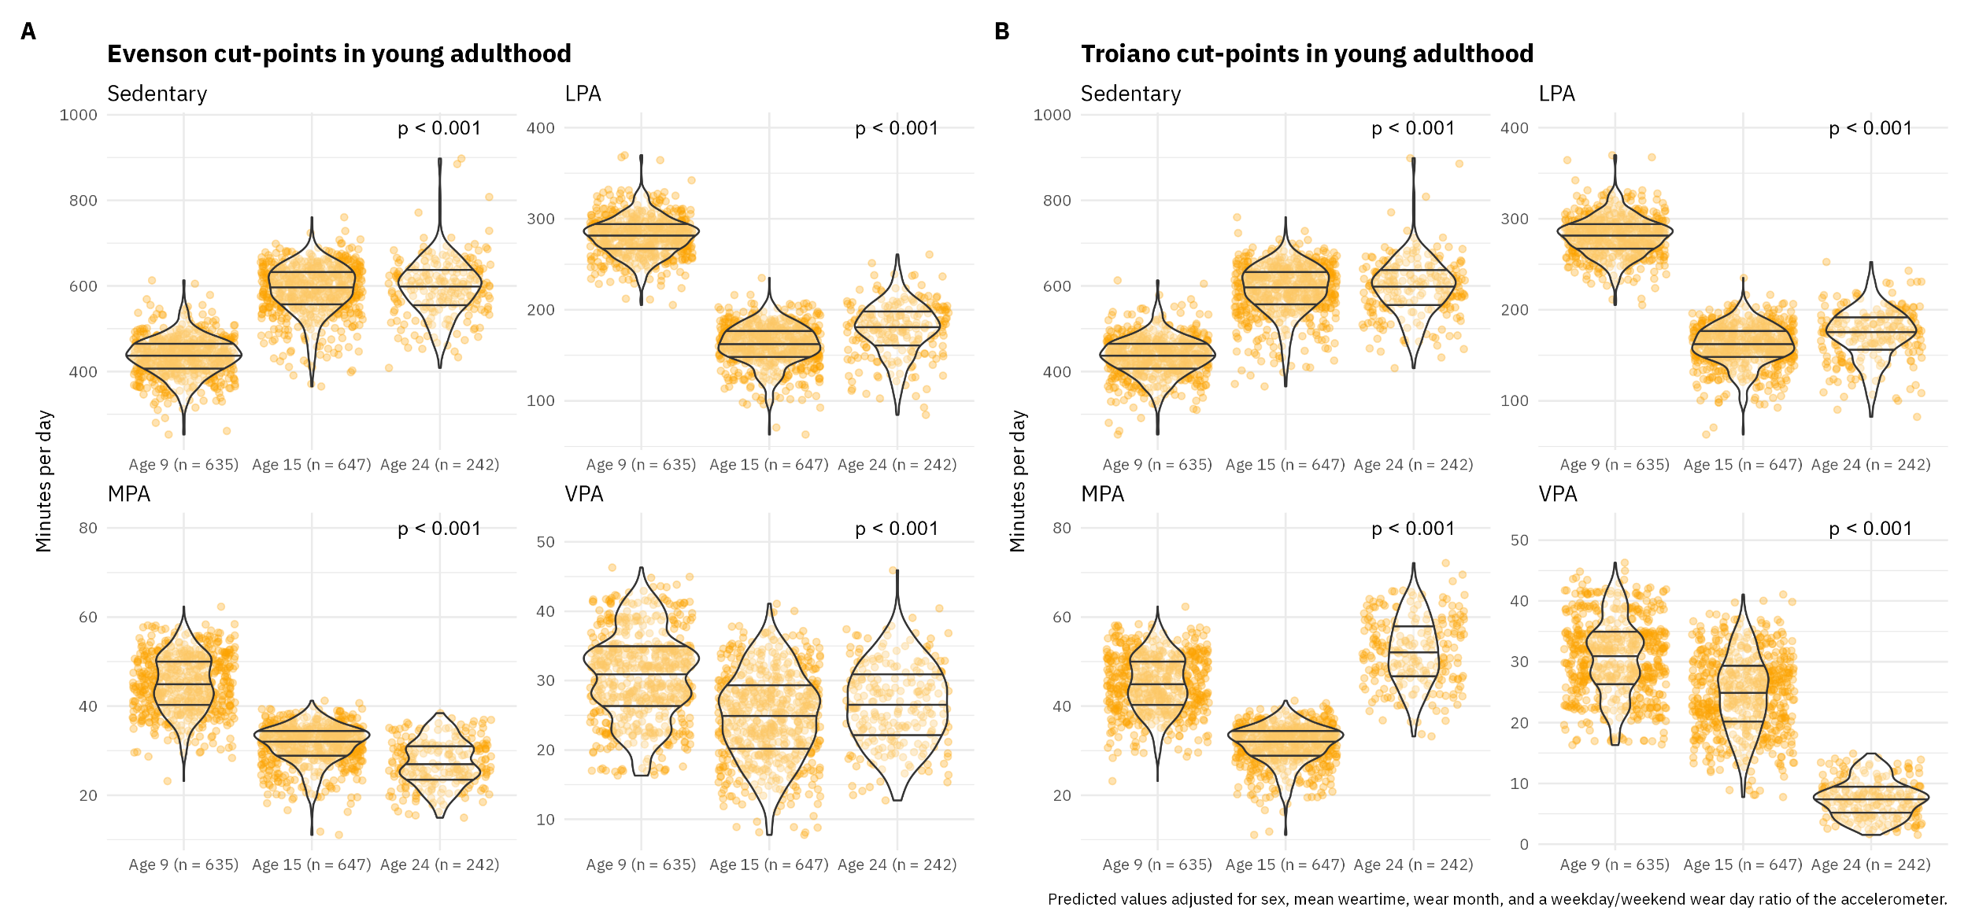
Figure 1. Violin plot of average daily time spent sedentary and in different physical activity intensities from 9 to 24 years of age, where A) displays changes with the use of Evenson cut-points in young adulthood, and B) displays changes with the use of Troiano cut-points in young adulthood. LPA: Light physical activity; MPA: Moderate physical activity; VPA: Vigorous physical activity.
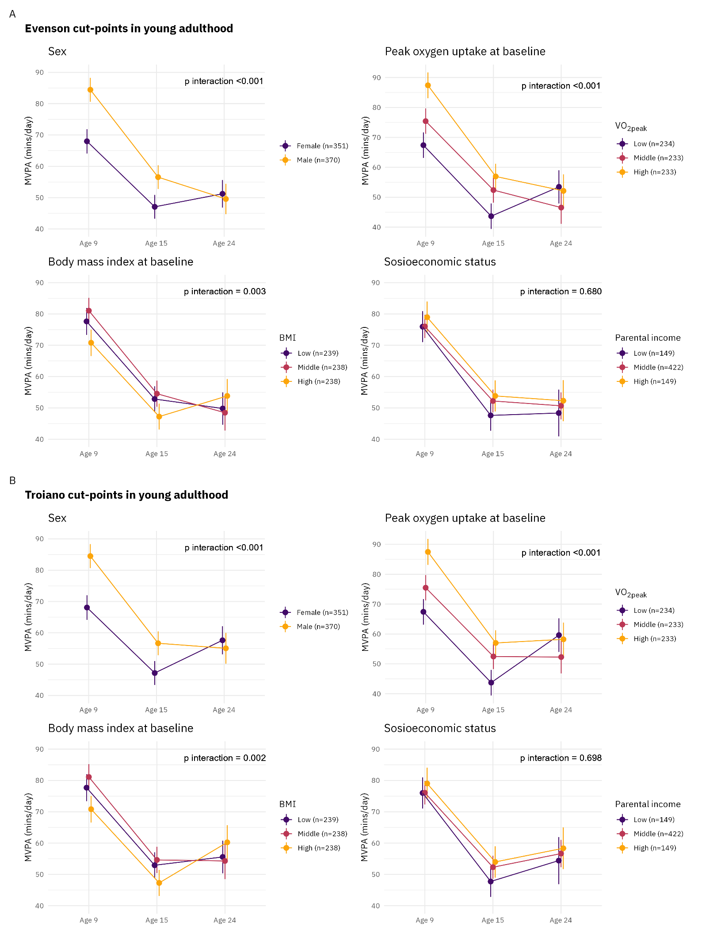
Figure 2. Changes in daily moderate-to-vigorous physical activity (MVPA) from 9 to 24 years, by subgroups of sex, VO_{2peak} at baseline, body mass index at baseline, and parental income. Figure A displays the changes with use of the Evenson cut-points in young adulthood, while the Troiano cut-points are used in young adulthood in Figure B.

References
1. Evenson KR, Catellier DJ, Gill K, Ondrak KS, McMurray RG. Calibration of two objective measures of physical activity for children. J Sports Sci [Internet]. 2008;26:1557–65. Available from: http://dx.doi.org/10.1080/02640410802334196
2. Troiano RP, Berrigan D, Dodd KW, Mâsse LC, Tilert T, McDowell M. Physical activity in the United States measured by accelerometer. Med Sci Sports Exerc [Internet]. 2008;40:181–8. Available from: http://dx.doi.org/10.1249/mss.0b013e31815a51b3

