Additional file 10. Meta-analysis of randomized trials comparing enhanced with standard PARS for specific physical activity outcomes
A) Forest plots
Total PA
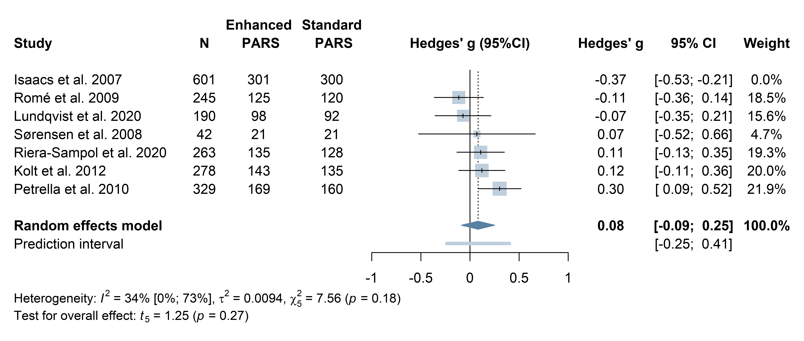
Including the outlier Isaacs et al. 2007, g = -0.00 [-0.21; 0.21], p = 0.98, I² = 79.4% [57.8%; 89.9%]
Meeting PA recommendations
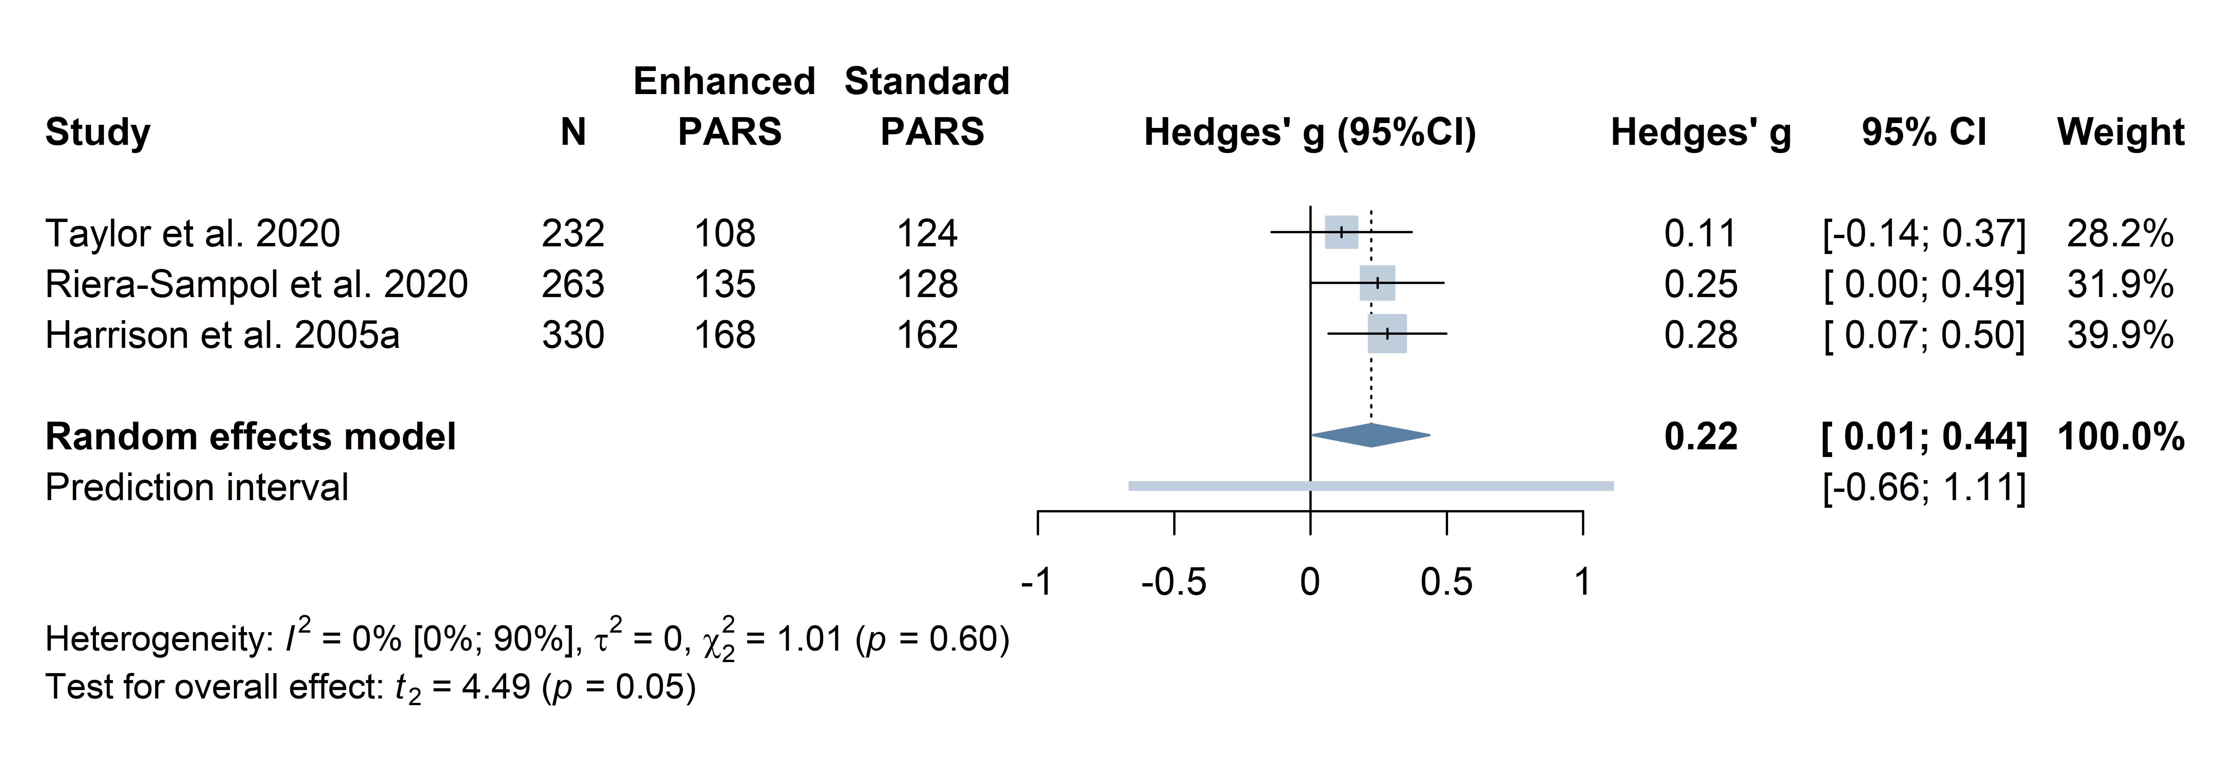
Moderate to vigorous PA
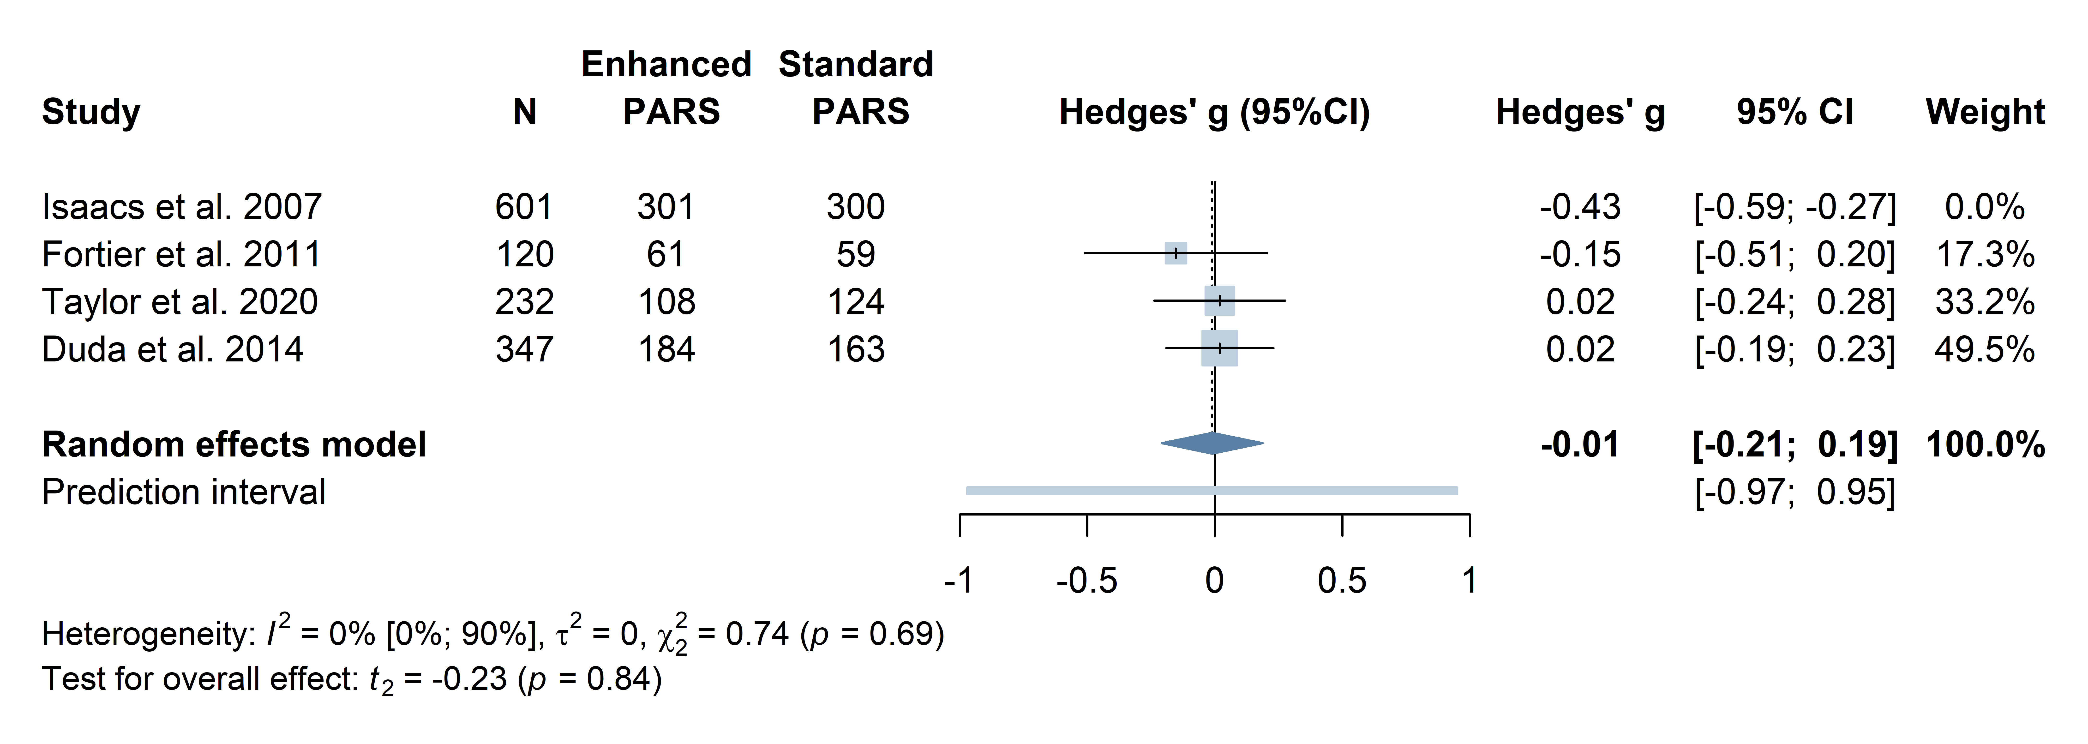

B) Funnel plots
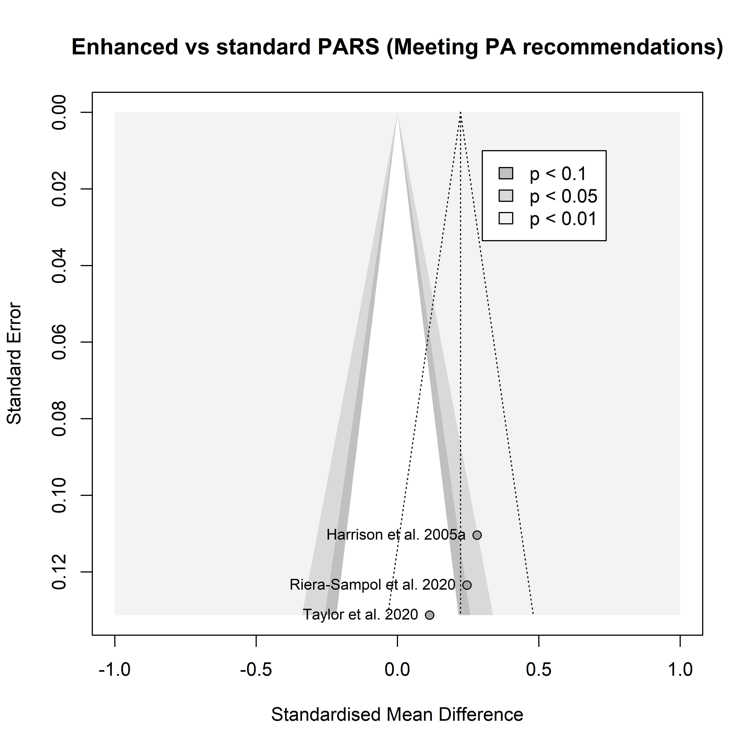 | 