Additional file 11. Meta-analysis of 12 non-experimental studies for physical activity level
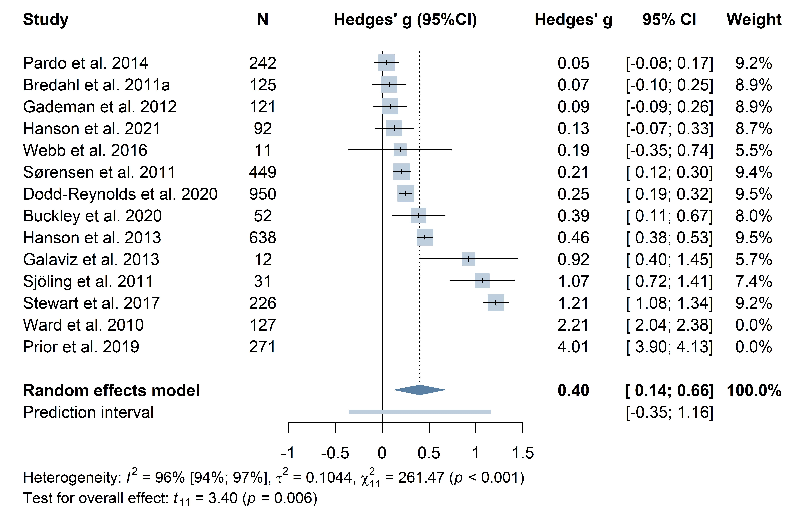
Outliers not pooled: Ward et al. 2010, Prior et al. 2019. Including outliers (k=14): g = 0.81, 95%CI: 0.16 to 1.45, p = 0.02;
I² = 99.7%, τ² = 1.38 [0.68; 4.11]

Eggers’ test: intercept ^β0 = 1.176, 95% CI: -4.25 to – 6.6, t = 0.425, p = 0.68

