Additional file 9. Forest and funnel plots of PARS effect on various physical activity outcomes as compared to usual care or physical activity advice (RCTs)
A) PARS vs usual care
Total PA
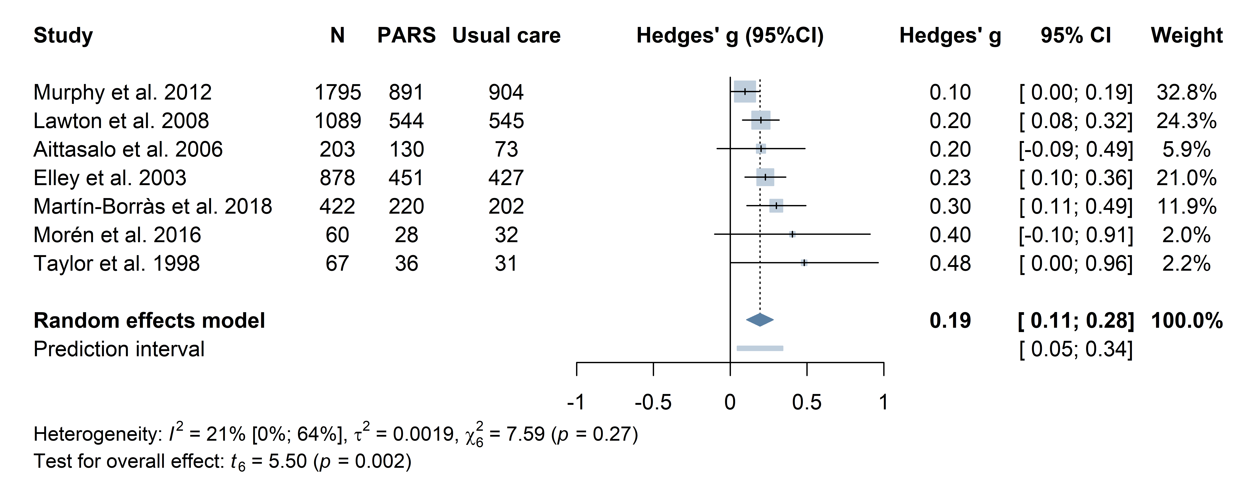
Moderate to vigorous PA
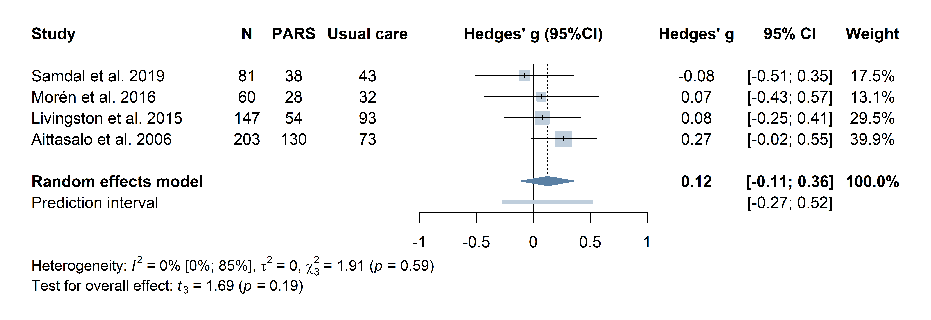
Vigorous PA
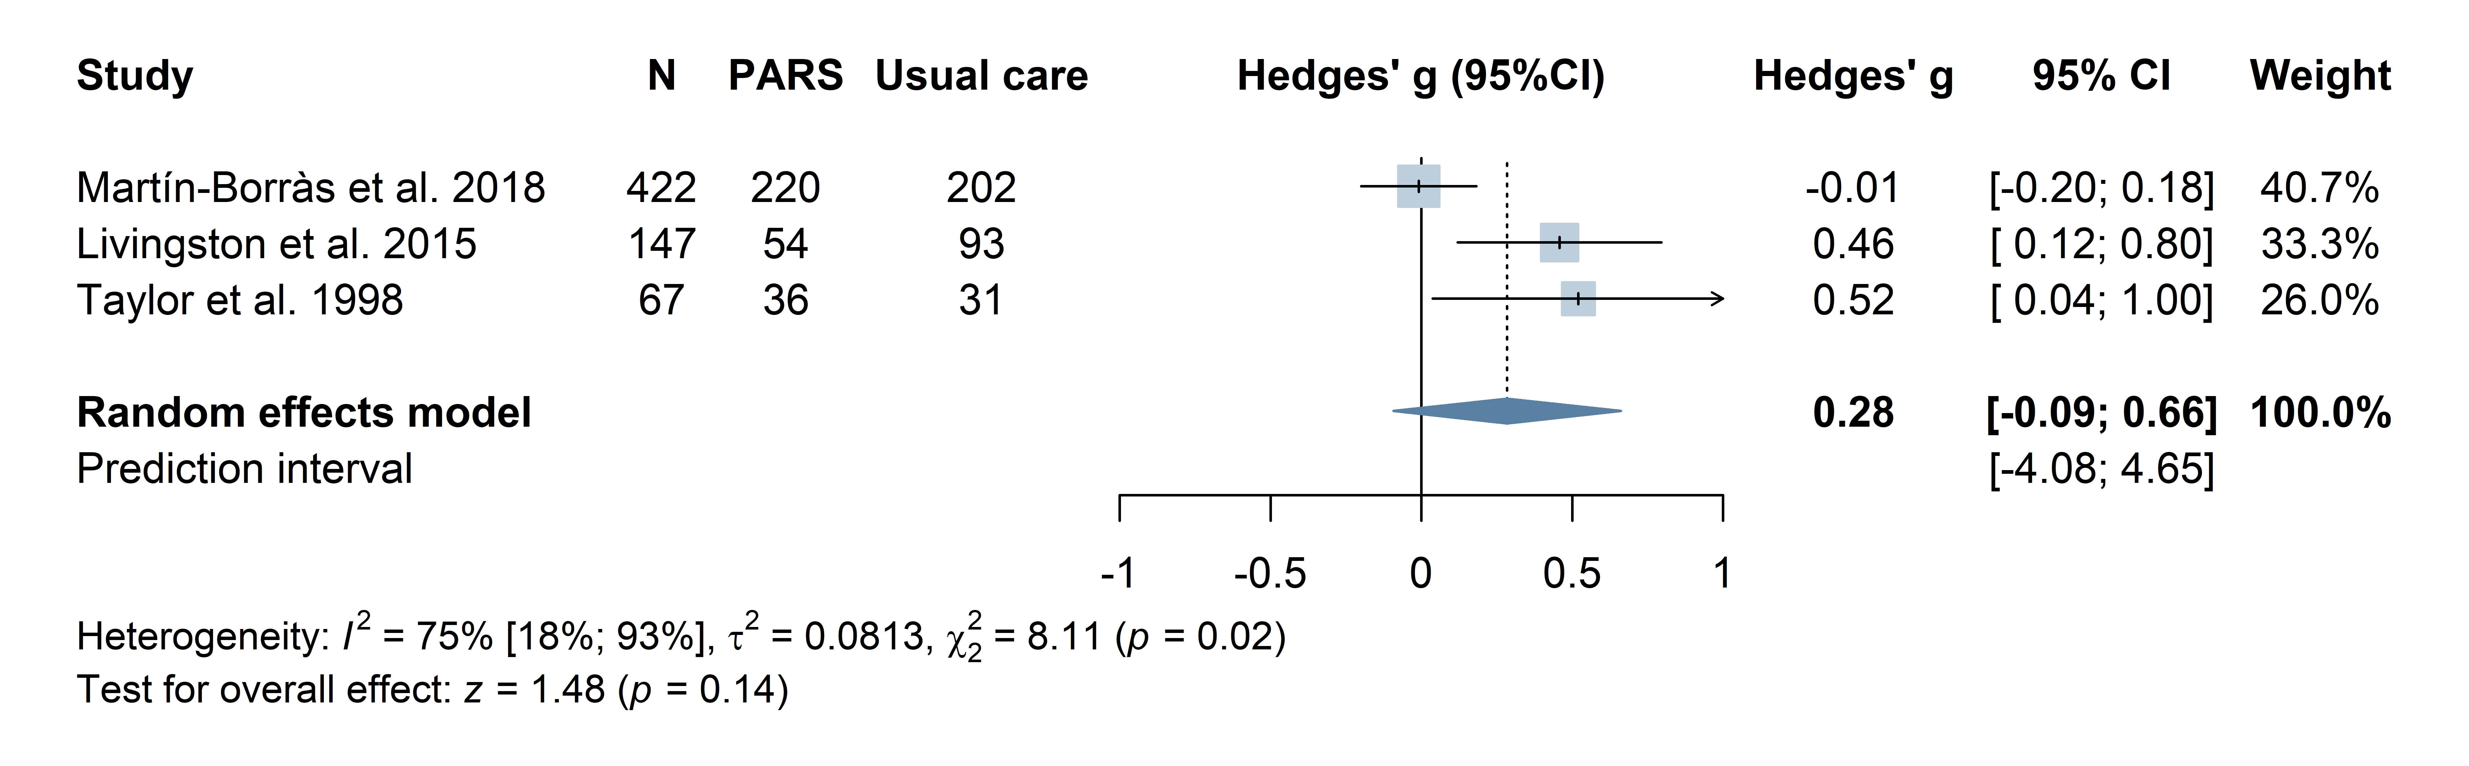
Influential case: Omitting Martín-Borràs et al. 2018, g=0.06, 95%CI -0.21 to 0.34, p=0.64

Moderate PA
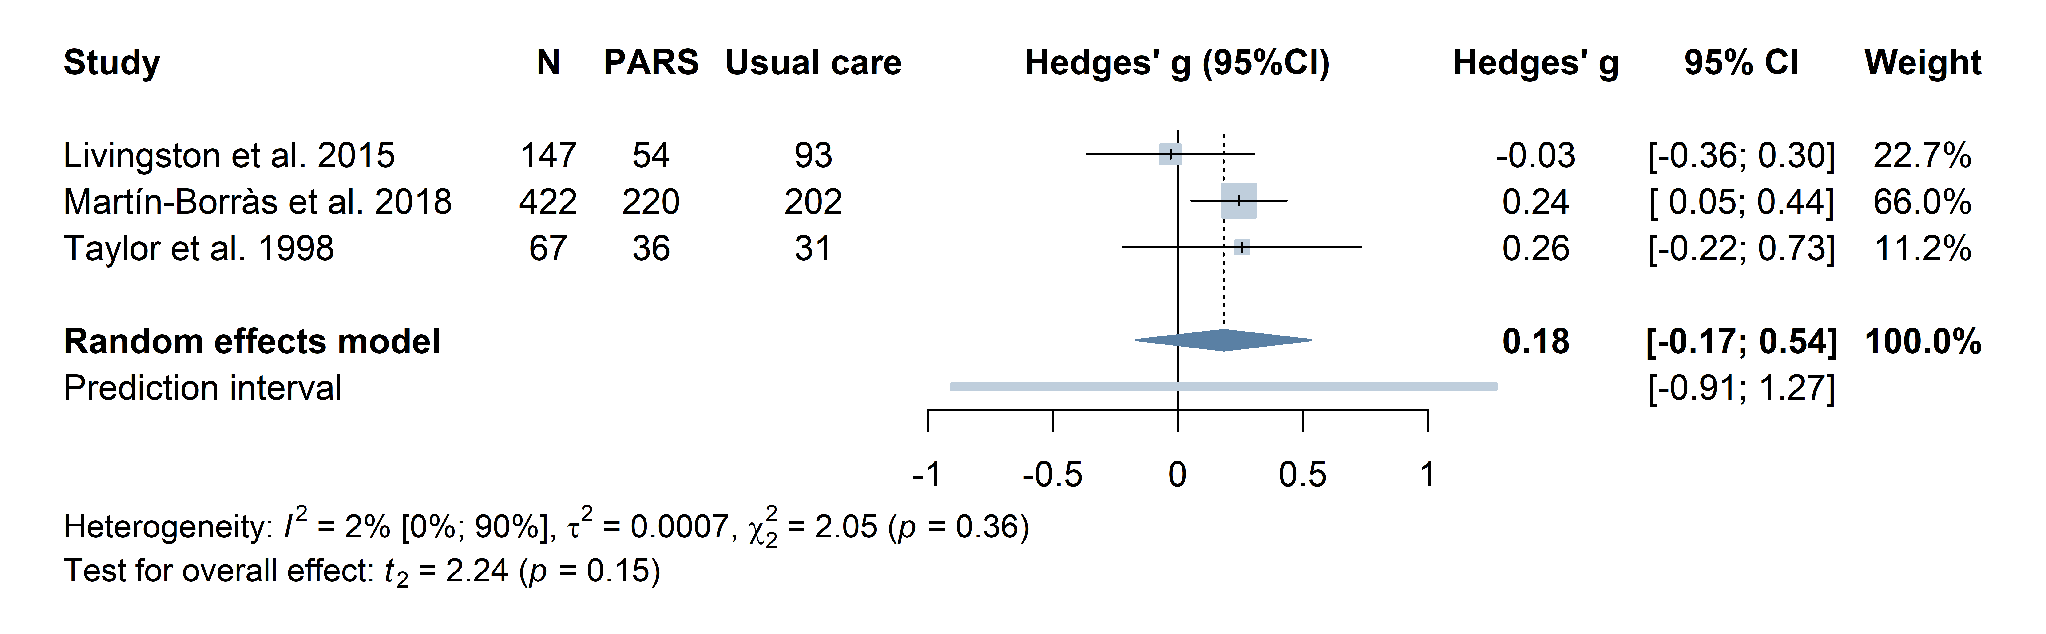
Walking
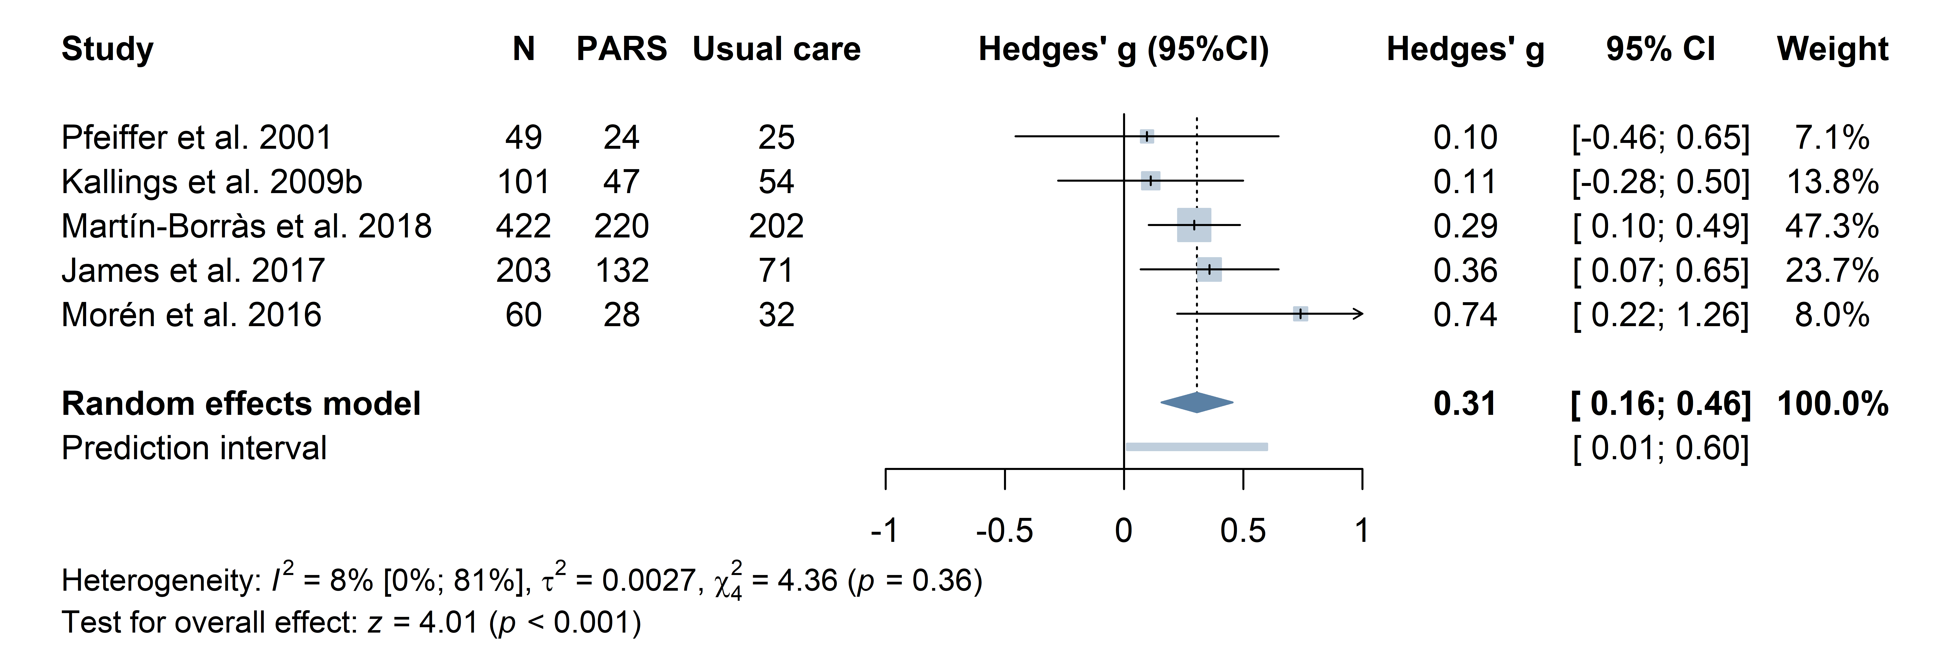
B) PARS vs physical activity advice
Meeting physical activity recommendations
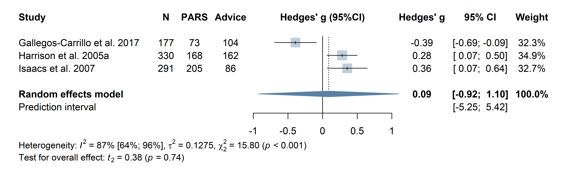

C) Funnel plots

