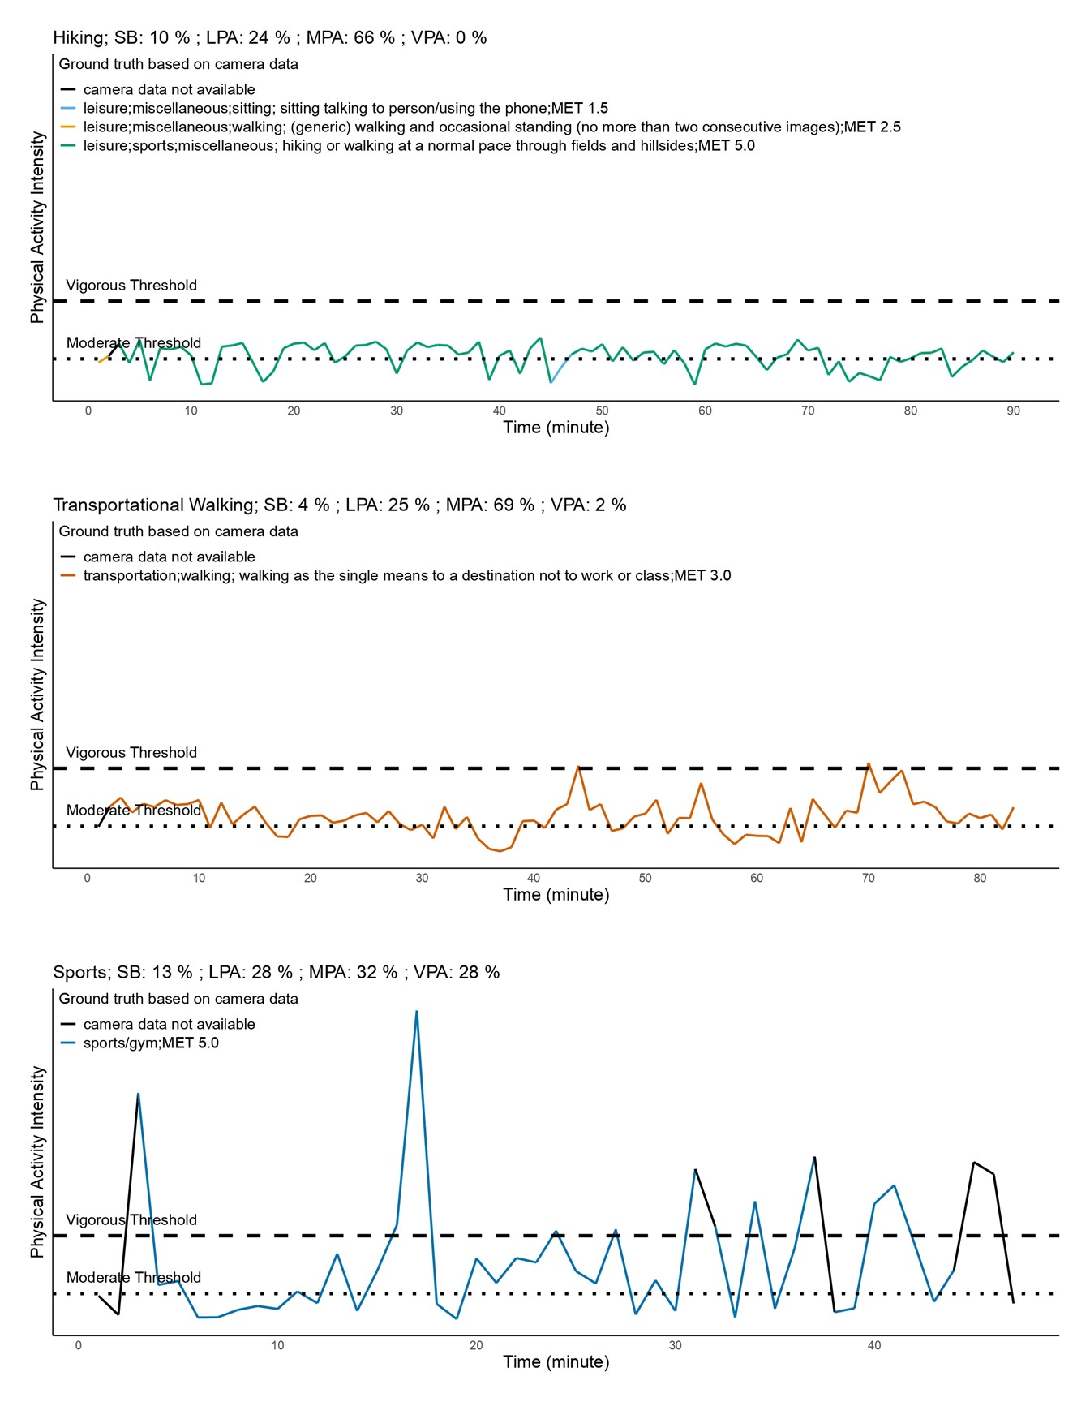
Additional Figure 2. Three sessions of MVPA that were captured by the proposed algorithm but not captured by the traditional algorithm.

