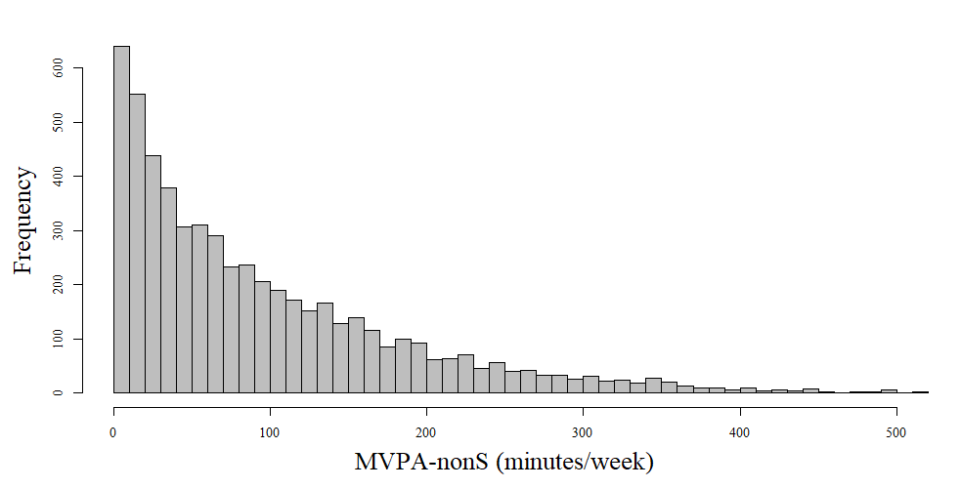
Additional Figure 4. Histogram of MVPA-nonS.

