Table S1: Baseline and Follow-up population comparison

 | Total population | Cross-sectional analysis population | p-value comparing populations
n | 19392 | 7074
Sex (men) | 7916 (40.8) | 2908 (41.1) | 0.69
Age (mean (SD)) | 57.40 (7.31) | 50.80 (7.01) | <0.01
High education (%) | 7244 (37.4) | 3538 (50.0) | <0.01

Table S2: Comparison on mean time of meal-timings and bedtime between weekdays and weekends, GCAT study(N=7074)

 | Meal-timings (time of the day)
 | Weekday | Weekend
Wake-up time (mean (SD)) | 6:57h (0:55) | 8:32h (1:15)
Time of first meal (mean (SD)) | 8:29 (1:38) | 9:22h (1:19)
Eating midpoint (mean (SD)) | 14:49 (0:57) | 15:24h (0:50)
Time of last meal (mean (SD)) | 21:08 (0:45) | 21:26h (0:52)
Sleep time (mean (SD)) | 23:30 (0:50) | 00:07h (1:02)

Table S3A: Multicollinearity test for model 1ª

Variable | GVIF
Age | 1.22
Sex | 1.09
rMEDScore | 1.08
Studies | 1.07
Employment | 1.19
Mental Health Score | 1.02
Tobacco consumption | 1.04
Physical activity | 1.01
Time of first meal | 5.47
Nighttime fasting hours | 5.72
Number of eating occasions | 1.18

Table S3B: Multicollinearity test for model 2^{b}

Variable | GVIF
Age | 1.23
Sex | 1.09
rMEDScore | 1.09
Studies | 1.08
Employment | 1.21
Mental Health Score | 1.08
Tobacco consumption | 1.04
Physical activity | 1.01
Time of first meal | 6.73
Nighttime fasting hours | 6.79
Number of eating occasions | 1.18
Sleep dissatisfaction | 1.07
Sleep time | 1.27

a: Model 1 includes the following variables: age, sex, adherence to Mediterranean diet, education, employment, mental health, smoking habit, physical activity, time of first meal, fasting hours, number of eating occasions, energy intake and baseline BMI.
b: Model 2 includes variables in model 1 + sleep dissatisfaction and bedtime.
GVIF: Generalized variance inflation factors.

Table S4: Multiple linear regression models assessing the relationship between meal and sleep timing variables and BMI, stratified by time of first meal (GCAT study, cross-sectional analysis)
 | Exposures ª
 | Time of first meal | Fasting hours | Eating occasions | Sleep dissatisfaction | Sleep time
Overall
First meal before 8:30 (n=4326)
Model 1 ^{b} | 0.17 [-0.07, 0.40) | -0.15 [-0.33, 0.02] | -0.04 [-0.28, 0.19]
Model 2 ^{c} | 0.08 [-0.18, 0.34] | -0.10 [-0.29, 0.09] | -0.03 [-0.27, 0.20] | 0.24 [-0.15, 0.63] | 0.13 [-0.05, 0.31]
First meal after 8:30. (N=2838)
Model 1 ^{b} | 0.42 [0.17, 0.66] | -0.44 [-0.67, -0.21] | 0.28 [-0.02, 0.59]
Model 2 ^{c} | 0.31 [0.05, 0.58] | -0.34 [-0.59, -0.09] | 0.30 [0.00, 0.61] | 0.11 [-0.38, 0.59] | 0.20 [-0.01, 0.41]
Men
First meal before 8:30 (N=1710)
Model 1 ^{b} | 0.17 [-0.16, 0.50] | -0.16 [-0.41, 0.09] | -0.03 [-0.37, 0.31]
Model 2 ^{c} | 0.08 [-0.28, 0.45] | -0.10 [-0.37, 0.17] | -0.01 [-0.35, 0.34] | 0.34 [-0.24, 0.93] | 0.15 [-0.10, 0.41]
First meal after 8:30 (N=1198)
Model 1 ^{b} | 0.28 [-0.05, 0.61] | -0.23 [-0.54, 0.07] | -0.02 [-0.42, 0.45]
Model 2 ^{c} | 0.26 [-0.09, 0.61] | -0.22 [-0.54, 0.11] | -0.01 [-0.43, 0.44] | 0.43 [-0.29, 1.16] | 0.03 [-0.25, 0.31]
Women
First meal before 8:30 (N=2526)
Model 1 ^{b} | 0.15 [-0.18, 0.47] | -0.16 [-0.40, 0.09] | -0.05 [-0.37, 0.27]
Model 2 ^{c} | 0.05 [-0.32, 0.43] | -0.11 [-0.37, 0.16] | -0.05 [-0.37, 0.28] | 0.21 [-0.31, 0.72] | 0.13 [-0.13, 0.38]
First meal after 8:30 (N=1640)
Model 1 ^{b} | 0.48 [0.13, 0.84] | -0.60 [-0.93, -0.27] | 0.48 [0.07, 0.89]
Model 2 ^{c} | 0.32 [-0.07, 0.71] | -0.45 [-0.81, -0.09] | 0.51 [0.10, 0.92] | -0.03 [-0.68, 0.61] | 0.30 [0.00, 0.61]
N: sample size. Bold: statistically significant. ª Values are coefficients [95% confidence interval]. Coefficients should be interpreted as difference in BMI for 1 hour increase for each time exposure; for eating occasions it should be interpreted as an increase in 1 eating occasion. Outcome: BMI (kg/m2).
^{b} Model 1 includes the following variables: age, sex, adherence to Mediterranean diet, education, employment, mental health, smoking habit, physical activity, time of first meal, fasting hours, number of eating occasions and energy intake.
^{c} Model 2 includes variables in Model 1 + sleep dissatisfaction and bedtime.
Table S5: Main characteristics of the participants included in the longitudinal analyses (GCAT study, N = 3,128)
 | Overall | Strata: Sex |  |  | Strata: BMI
 | Overall | Women | Men | p | Normal | Overweight | Obese | p
n | 3128 | 1890 | 1238 |  | 1200 | 1312 | 616
Age (mean (SD)) | 50.85 (6.92) | 50.01 (6.67) | 52.13 (7.11) | <0.001 | 49.49 (6.83) | 51.69 (6.91) | 51.68 (6.72) | <0.001
Sex (men) | 1238 (39.6) |  |  |  | 326 (27.2) | 642 (48.9) | 270 (43.8) | <0.001
Menopause |  | 1093 (57.8) |  |  | 463 (52.9) | 417 (62.2) | 213 (61.6) | <0.001
Diet quality: Buckland_rMEDScore (%) |  |  |  | <0.001 |  |  |  | 0.011
Low adherence | 702 (22.4) | 339 (17.9) | 363 (29.3) |  | 242 (20.2) | 310 (23.6) | 150 (24.4)
Medium adherence | 1524 (48.7) | 909 (48.1) | 615 (49.7) |  | 576 (48.0) | 634 (48.3) | 314 (51.0)
High adherence | 902 (28.8) | 642 (34.0) | 260 (21.0) |  | 382 (31.8) | 368 (28.0) | 152 (24.7)
Energy intake (kcal/day) | 2003.30 (580.52) | 1950.96 (562.36) | 2083.21 (598.66) | <0.001 | 2007.05 (574.73) | 1995.19 (567.11) | 2013.30 (619.42) | 0.783
Education (university) | 1669 (53.4) | 1017 (53.8) | 652 (52.7) | 0.555 | 715 (59.6) | 649 (49.5) | 305 (49.5) | <0.001
Employment status |  |  |  | <0.001 |  |  |  | <0.001
Paid or self-employed | 2451 (79.4) | 1482 (79.4) | 969 (79.6) |  | 995 (83.8) | 1001 (77.7) | 455 (74.8)
Retired | 234 (7.6) | 98 (5.2) | 136 (11.2) |  | 60 (5.1) | 122 (9.5) | 52 (8.6)
In charge of the house/family | 100 (3.2) | 96 (5.1) | 4 (0.3) |  | 36 (3.0) | 43 (3.3) | 21 (3.5)
In a situation of unemployment | 300 (9.7) | 191 (10.2) | 109 (8.9) |  | 97 (8.2) | 123 (9.5) | 80 (13.2)
Chronotype |  |  |  | <0.001 |  |  |  | 0.01
Clearly morning | 807 (26.3) | 454 (24.5) | 353 (29.1) |  | 335 (28.4) | 346 (26.9) | 126 (20.9)
More morning than evening | 1099 (35.8) | 644 (34.8) | 455 (37.4) |  | 421 (35.7) | 465 (36.2) | 213 (35.3)
More evening than morning | 854 (27.8) | 537 (29.0) | 317 (26.1) |  | 313 (26.6) | 350 (27.2) | 191 (31.6)
Clearly evening | 308 (10.0) | 218 (11.8) | 90 (7.4) |  | 109 (9.3) | 125 (9.7) | 74 (12.3)
Poor mental health¹ | 809 (25.9) | 562 (29.7) | 247 (20.0) | <0.001 | 304 (25.3) | 318 (24.2) | 187 (30.4) | 0.014
Alcohol g (mean (SD)) | 7.92 (10.64) | 5.38 (7.15) | 11.80 (13.54) | <0.001 | 6.72 (8.23) | 8.64 (10.85) | 8.72 (13.72) | <0.001
Smoking habit (%) |  |  |  | 0.226 |  |  |  | 0.002
Current | 413 (13.2) | 263 (13.9) | 150 (12.1) |  | 168 (14.0) | 164 (12.5) | 81 (13.1)
Ex-smoker | 1392 (44.5) | 846 (44.8) | 546 (44.1) |  | 490 (40.8) | 592 (45.1) | 310 (50.3)
Never | 1323 (42.3) | 781 (41.3) | 542 (43.8) |  | 542 (45.2) | 556 (42.4) | 225 (36.5)
Physical activity - mets per week (mean (SD)) | 62.3 [40.8, 94.2] | 62.8 [42.5, 92.0] | 60.8 [38.2, 97.1] | 0.038 | 65.0 [44.1, 95.7] | 63.3 [40.9, 97.0] | 55.2 [32.8, 83.3] | <0.001
Breakfast consumption (%) | 3046 (97.4) | 1857 (98.3) | 1189 (96.0) | <0.001 | 1170 (97.5) | 1279 (97.5) | 597 (96.9) | 0.725
First meal before 8:30h (%) | 1938 (62.0) | 1176 (62.2) | 762 (61.6) | 0.733 | 777 (64.8) | 795 (60.6) | 366 (59.4) | 0.035
Time of first meal (median [IQR]) | 8:00 [7:15, 9:15] | 8:00 [7:15, 9:30] | 8:00 [7:20, 9:14] | 0.771 | 8:00 [7:15, 9:15] | 8:00 [7:15, 9:00] | 8:00 [7:25, 9:30] | 0.155
Time of last meal (mean (SD)) | 21:08 (0:46) | 21:07 (0:45) | 21:10 (0:47) | 0.059 | 21:05 (0:44) | 21:14 (0:47) | 21:09 (0:46) | <0.001
Fasting hours (median [IQR]) | 11:00 [10:00, 12:00] | 11:00 [10:00, 12:07] | 11:00 [10:00, 12:00] | 0.385 | 11:00 [10:00, 12:00] | 11:00 [10:00, 12:00] | 11:00 [10:00, 12:10] | 0.892
Hours between wake up and first meal (median [IQR]) | 1:00 [0:30, 2:30] | 1:00 [0:25, 2:15] | 1:00 [0:30, 2:30] | 0.187 | 0:50 [0:25, 2:30] | 1:00 [0:30, 2:20] | 1:00 [0:30, 2:30] | 0.569
Hours between last meal and sleep (mean (SD)) | 2:17 (0:53) | 2:16 (0:52) | 2:18 (0:53) | 0.252 | 2:16 (0:47) | 2:16 (1:01) | 2:17 (0:53) | 0.75
Eating midpoint (mean (SD)) | 14:47 (0:56) | 14:46 (0:55) | 14:50 (0:59) | 0.096 | 14:44 (0:56) | 14:52 (0:58) | 14:48 (0:56) | 0.021
Number of eating occasions (mean (SD)) | 3.42 (0.58) | 3.50 (0.59) | 3.30 (0.56) | <0.001 | 3.41 (0.58) | 3.47 (0.61) | 3.40 (0.58) | 0.069
Wake-up time (mean (SD)) | 6:57 (0:52) | 6:58 (0:51) | 6:56 (0:55) | 0.499 | 6:55 (0:51) | 6:59 (0:58) | 6:59 (0:50) | 0.155
Bedtime (mean (SD)) | 23:30 (0:50) | 23:28 (0:50) | 23:35 (0:50) | 0.001 | 23:27 (0:46) | 23:35 (0:58) | 23:32 (0:50) | 0.001
Sleep dissatisfaction² (%) | 394 (12.6) | 264 (14.0) | 130 (10.5) | 0.005 | 148 (12.3) | 152 (11.6) | 94 (15.3) | 0.072
Sleep duration in hours (mean (SD)) | 7:26 (0:52) | 7:29 (0:51) | 7:22 (0:53) | <0.001 | 7:28 (0:49) | 7:24 (0:56) | 7:26 (0:52) | 0.24
BMI³ 2018 (median [IQR] | 26.13 [23.73, 29.14] | 25.36 [23.05, 28.71] | 26.91 [24.91, 29.54] | <0.001 | 23.10 [21.83, 24.11] | 27.00 [26.01, 28.36] | 32.61 [31.16, 34.96] | <0.001
BMI³ 2023 (mean (SD)) | 25.88 [23.51, 28.80] | 25.31 [22.84, 28.73] | 26.37 [24.35, 28.91] | <0.001 | 23.04 [21.72, 24.24] | 26.63 [25.37, 28.30] | 32.04 [29.73, 34.69] | <0.001
BMI change (median [IQR] | -0.26 [-1.34, 0.79] | -0.10 [-1.22, 1.04] | -0.43 [-1.47, 0.40] | <0.001 | 0.02 [-0.75, 0.88] | -0.37 [-1.45, 0.73] | -0.96 [-2.57, 0.72] | <0.001

N, sample size; SD, standard deviation; IQR, interquartile range. 1 Poor mental health is defined as a Mental Health Inventory score <60. 2 Sleep dissatisfaction: frequency of participants that answer “no” to the question “are you satisfied with sleep?” in the follow-up questionnaire of the GCAT cohort. 3 BMI: Classified as Normal if BMI < 25, overweight if BMI >=25 & <30, Obese if BMI ≥ 30 kg/m.
Table S6: Multiple linear regressions models assessing the relationship between meal and sleep timing variables and BMI, stratified by time of first meal (GCAT study, longitudinal analyses)
 | Exposures ª
 | Time of first meal | Fasting hours | Eating occasions | Sleep dissatisfaction | Sleep time
Overall
First meal before 8:30 (n=1938)
Model 1 ^{b} | 0.16 [-0.02, 0.33] | -0.14 [-0.27, -0.01] | -0.06 [-0.24, 0.11]
Model 2 ^{c} | 0.09 [-0.11, 0.29] | -0.10 [-0.24, 0.04] | -0.05 [-0.23, 0.12] | 0.18 [-0.12, 0.48] | 0.09 [-0.04, 0.23]
First meal after 8:30. (N=1190)
Model 1 ^{b} | 0.12 [-0.07, 0.30] | -0.07 [-0.24, 0.10] | 0.13 [-0.10, 0.36]
Model 2 ^{c} | 0.25 [0.05, 0.45] | -0.19 [-0.38, -0.01] | 0.09 [-0.14, 0.32] | 0.00 [-0.38, 0.38] | -0.26 [-0.42, -0.09]
Men
First meal before 8:30 (N=762)
Model 1 ^{b} | 0.22 [-0.03, 0.47] | -0.13 [-0.32, 0.06] | -0.19 [-0.46, 0.08]
Model 2 ^{c} | 0.20 [-0.07, 0.48] | -0.12 [-0.32, 0.08] | -0.18 [-0.46, 0.09] | -0.07 [-0.55, 0.40] | 0.02 [-0.17, 0.22]
First meal after 8:30 (N=476)
Model 1 ^{b} | 0.25 [0.02, 0.49] | -0.23 [-0.44, -0.01] | -0.13 [-0.45, 0.20]
Model 2 ^{c} | 0.40 [0.15, 0.65] | -0.35 [-0.59, -0.12] | -0.15 [-0.47, 0.17] | 0.74 [0.18, 1.31] | -0.30 [-0.52, 0.08]
Women
First meal before 8:30 (N=1176)
Model 1 ^{b} | 0.12 [-0.12, 0.36] | -0.15 [-0.33, 0.03] | 0.01 [-0.22, 0.24]
Model 2 ^{c} | -0.01 [-0.27, 0.29] | -0.09 [-0.29, 0.10] | 0.02 [-0.21, 0.25] | 0.31 [-0.07, 0.70] | 0.14 [-0.04, 0.32]
First meal after 8:30 (N=714)
Model 1 ^{b} | 0.01 [-0.26, 0.28] | 0.04 [-0.20, 0.29] | 0.24 [-0.08, 0.55]
Model 2 ^{c} | 0.15 [-0.15, 0.44] | -0.08 [-0.35, 0.18] | 0.21 [-0.10, 0.53] | -0.31 [-0.81, 0.19] | -0.26 [-0.49, -0.02]
N: sample size. Bold: statistically significant.
ª Values are coefficients [95% confidence interval]. Coefficients should be interpreted as change in BMI over time for 1 hour increase for each time exposure; for eating occasions it should be interpreted as an increase in 1 eating occasion.
^{b}Model 1 includes the following variables: age, sex, adherence to Mediterranean diet, education, employment, mental health, smoking habit, physical activity, time of first meal, fasting hours, number of eating occasions, energy intake and baseline BMI.
^{c}Model 2 includes variables in Model 1 + sleep dissatisfaction, bedtime.
Figure S1: Flow-chart of participants included in the study.

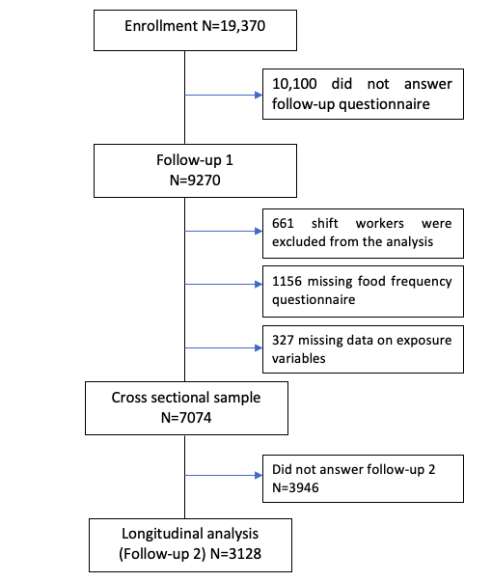
Figure S2A: Correlation between meal and sleep timing variables on weekdays and weekends (GCAT study, N=7074)

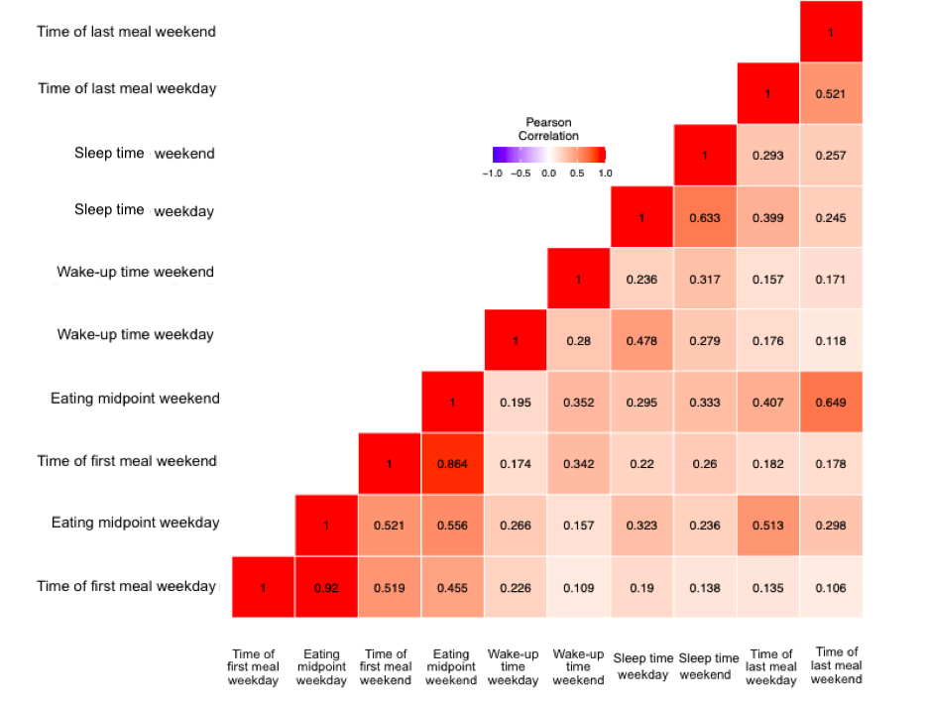

Figure S2B: Correlation between meal and sleep timing variables on weekdays, (GCAT study, N=7074)

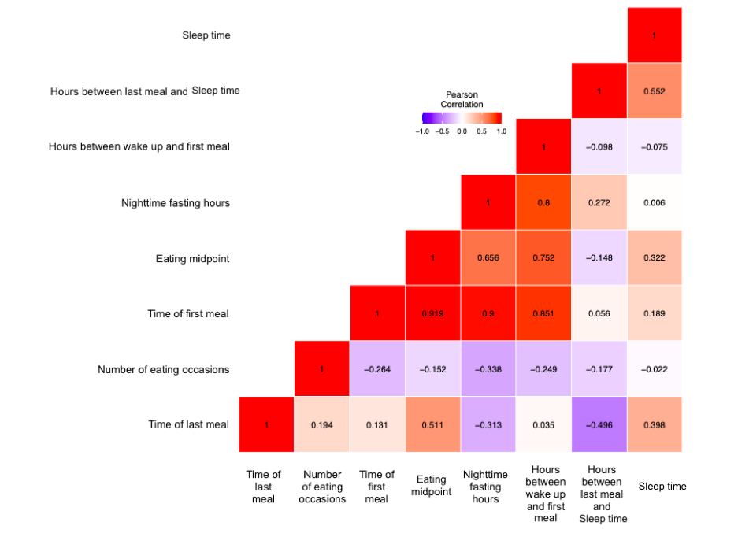

Figure S3: DAG – Chrono-nutritional patterns and their relationship with Body Mass Index

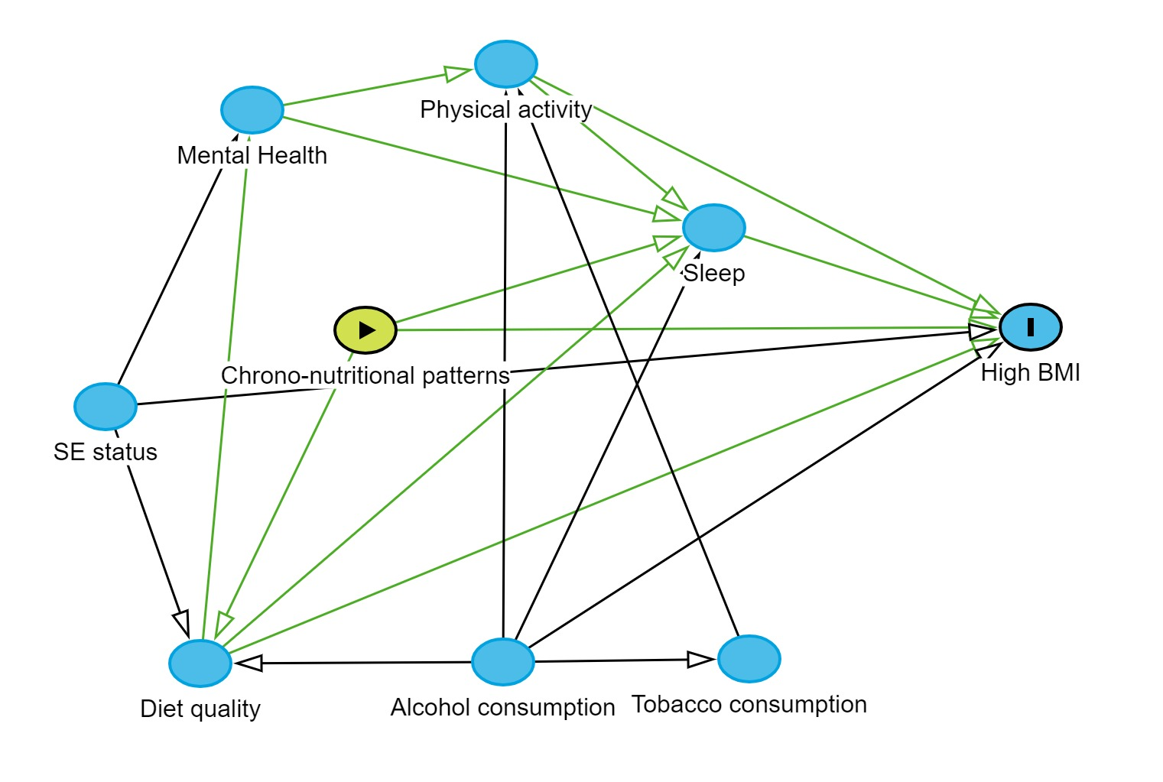

Figure S4A: Silhouette Width for Women
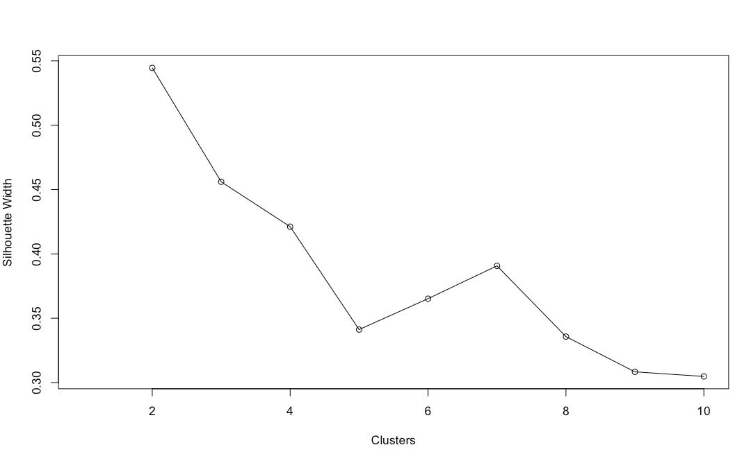

Figure S4B: Silhouette Width for Men
