Do personality profiles contribute to patterns of physical activity and sedentary behavior in adulthood? A prospective cohort study

Additional File 2

Table S3. Goodness-of-fit indices for latent profile analysis (LPA) of personality profiles at ages 33–61.
No of profiles | BIC | SABIC | AIC | Log-likelihood: H0 Value | Log-likelihood: H0 Scaling Correction Factor for MLR | Entropy | Profile sizes based on their most likely latent class membership | Profile sizes based on estimated posterior probabilities
1 | 7384.2 | 7257.4 | 7235.2 | –3577.6 | 1.0213 |  | 307 | 307.0
2 | 6842.1 | 6648.6 | 6614.8 | –3246.4 | 1.2011 | 0.764 | 121/186 | 119.4/187.6
3 | 6679.1 | 6419.0 | 6373.5 | –3104.7 | 1.1544 | 0.805 | 162/93/52 | 159.1/95.6/52.3
4 | 6568.5 | 6241.8 | 6184.6 | –2989.3 | 1.1672 | 0.802 | 94/75/38/100 | 95.0/75.4/39.6/97.0
5 | 6513.5 | 6120.2 | 6051.4 | –2901.7 | 1.2608 | 0.821 | 30/43/125/62/47 | 33.0/44.0/117.8/65.9/46.2
6 | 6493.4 | 6033.5 | 5953.0 | –2831.5 | 1.2006 | 0.821 | 39/22/77/32/77/60 | 39.1/22.7/75.6/33.7/76.4/59.5
7 | 6485.2 | 5958.7 | 5866.5 | –2767.3 | 1.1712 | 0.836 | 21/39/108/29/34/50/26 | 25.2/40.0/99.2/31.5/35.7/49.6/25.8
8 | 6481.3 | 5888.2 | 5784.4 | –2705.2 | 1.2069 | 0.830 | 33/36/60/28/12/50/37/51 | 34.0/35.6/59.3/29.1/12.2/49.4/39.1/48.4
Note. BIC = Bayesian Information Criterion, SABIC = Sample-size adjusted BIC, AIC = Akaike Information Criterion. Lo-Mendell-Rubin likelihood ratio test indicated a better model-fit until two profile solution. Bootstrapped likelihood ratio test indicated a better model-fit until eight profile solution.

Table S4. The associations of personality profiles with multiple metrics of physical behavior based on analysis of variance (ANOVA).
 |  | Model 1ª | Model 2^{b} | Model 3^{c}
Ratio of MVPA to SB |  | F(4, 136) = 0.828, p = 0.509
MVPA
 | Daily amount (min/d) | F(4, 136) = 1.546, p = 0.192 | F(4, 136) = 1.440, p = 0.224 | F(4, 136) = 1.197, p = 0.315
 | Usual bout duration (min) | F(4, 136) = 2.315, p = 0.061, 1 > 3, 4 (p = 0.026; 0.014) | F(4, 136) = 2.339, p = 0.058, 1 > 3, 4 (p = 0.024; 0.017) | F(4, 136) = 2.042, p = 0.092, 1 > 4 (p = 0.018)
 | Number of bouts (n/d) | F(4, 136) = 1.405, p = 0.236, 2 < 4, 5 (p = 0.034; 0.033) | F(4, 136) = 1.189, p = 0.319, 2 < 4 (p = 0.044) | F(4, 136) = 1.569, p = 0.186, 2 < 4 (p = 0.033)
SB
 | Daily amount (min/d) | F(4, 136) = 0.547, p = 0.702 | F(4, 136) = 0.693, p = 0.598 | F(4, 136) = 0.357, p = 0.839
 | Usual bout duration (min) | F(4, 136) = 1.684, p = 0.157, 1 > 5 (p = 0.015) | F(4, 136) = 1.667, p = 0.161, 1 > 5 (p = 0.019) | F(4, 136) = 1.358, p = 0.252
 | Number of bouts (n/d) | F(4, 136) = 2.060, p = 0.089, 1 < 5 (p = 0.009) | F(4, 136) = 2.691, p = 0.034, 1 < 2, 5 (p = 0.006; 0.012) | F(4, 136) = 1.728, p = 0.148, 1 < 2, 5 (p = 0.021; 0.043)
Note. Ratio of MVPA to SB, MVPA daily amount and number of bouts square rooted, usual MVPA and SB bout durations cube rooted to obtain normal distribution. 1 = resilient, 2 = brittle, 3 = overcontrolled, 4 = undercontrolled, 5 = ordinary. Pairwise comparisons based on LSD-method.
ª Model 1: unadjusted
^{b} Model 2: adjusted for wear-time
^{c} Model 3: adjusted for wear-time, gender, educational status, occupational status and self-rated health

Table S5. Spearman correlations between personality traits and indicators of physical activity and sedentary behavior (n = 141)
 | 1. | 2. | 3. | 4. | 5. | 6. | 7. | 8. | 9. | 10. | 11.
1. MVPA: daily amount | 1 | .48** | .75** | –.46** | –.46** | .23** | –0.01 | 0.15 | 0.04 | 0.09 | –0.05
2. MVPA: usual bout duration |  | 1 | –0.11 | 0.04 | 0.01 | –0.05 | –.17* | 0.14 | 0.09 | 0.16 | 0.13
3. MVPA: number of bouts |  |  | 1 | –.59** | –.57** | .32** | 0.09 | 0.13 | –0.05 | 0.04 | –0.12
4. SB: daily amount |  |  |  | 1 | .68** | –.20* | –0.14 | –0.12 | 0.04 | 0.02 | 0.05
5. SB: usual bout duration |  |  |  |  | 1 | –.73** | –.17* | 0.02 | 0.13 | 0.01 | 0.03
6. SB: number of bouts |  |  |  |  |  | 1 | 0.08 | –0.09 | –0.13 | 0.01 | –0.05
7. Neuroticism |  |  |  |  |  |  | 1 | –.41** | –.34** | –.34** | –.20*
8. Extraversion |  |  |  |  |  |  |  | 1 | .39** | .41** | 0.07
9. Openness |  |  |  |  |  |  |  |  | 1 | .36** | 0.10
10. Agreeableness |  |  |  |  |  |  |  |  |  | 1 | .19*
11. Conscientiousness |  |  |  |  |  |  |  |  |  |  | 1
Note. MVPA = moderate-to-vigorous physical activity, SB = sedentary behavior. * p < 0.05, ** p < 0.01. Personality traits based on the participant’s latest measurement (ages 33, 42, 50 or 61).

Figure S1. Probability distribution of MVPA bouts per bout length.
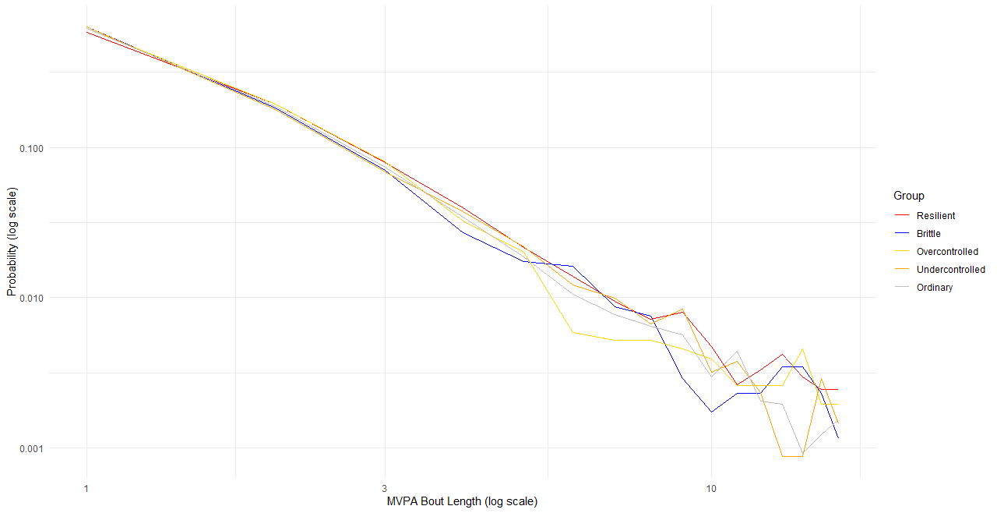

Figure S2. Probability distribution of sedentary bouts per bout length.
