Additional File 1
Contents
Appendix 1. 3
Supplementary Table 1. Summary of basket sizes containing soda, fresh fruits, and fresh vegetables. Grocery loyalty card member data in Montréal, Canada. 2015-2017 4
Supplementary Table 2 – Residential socio-demographic and economic characteristics of 15,000 sampled cardholders and all cardholders, compared with the same characteristics in the island of Montreal, 2016 Canadian Census 5
Supplementary Figure 1. Top 25 food categories co-purchased with soda, ordered by the value of lift 6
Supplementary Figure 2. Top 25 food categories co-purchased with fresh vegetables, ordered by the value of lift 7
Supplementary Figure 3. Top 25 food categories co-purchased with fresh fruits, ordered by lift. 8
Supplementary Table 3. Main effects and interaction between soda and area-level income and education 9
Supplementary Table 4. Main effects and interaction between fresh vegetables and area-level income and education 10
Supplementary Table 5. Main effects and interaction between fresh fruits and area-level income and education 11
Supplementary Figure 4. Results of association rule mining applied to purchasing data among non-cardholders, showing the risk ratio of top 10 food categories associated with soda. The corresponding risk ratios estimated from cardholder’s baskets in the main analysis are also shown 12
Supplementary Figure 5. Results of association rule mining applied to purchasing data among non-cardholders, showing risk ratio of top 10 food categories associated with fresh vegetables. The corresponding risk ratios estimated from cardholder’s baskets in the main analysis are also shown 13
Supplementary Figure 6. Results of association rule mining applied to purchasing data among non-cardholders, showing risk ratio of top 10 food categories associated with fresh fruits. The corresponding risk ratios estimated from cardholder’s baskets in the main analysis are also shown 14
Supplementary Figure 7. Top 25 food categories co-purchased with soda among a subset of loyal cardholders whose recorded monthly expenditure was greater than 514 Canadian dollars in the target retail chain 15
Supplementary Figure 8. Top 25 food categories co-purchased with fresh vegetables among a subset of loyal cardholders whose recorded monthly expenditure was greater than 514 Canadian dollars in the target retail chain 16
Supplementary Figure 9. Top 25 food categories co-purchased with fresh fruits among a subset of loyal cardholders whose recorded monthly expenditure was greater than 514 Canadian dollars in the target retail chain 17

Appendix 1.
Minimum support is the threshold frequency (support) of the combination of food categories among baskets, which is used to exclude infrequently occurring co-purchasing combinations from the computational process of association mining. The other parameter, minimum confidence, is the threshold for the strength of co-purchasing associations, below which ARM does not estimate and rank co-purchasing associations. Confidence represents the conditional probability of item X appearing in a basket given the presence of another item Y, thus P(X|Y). Thus, setting a lower value for minimum confidence results in ARM estimating weak co-purchasing associations, with the cost of an increased computational time. We set minimum support to 1% i.e., excluding category combinations whose prevalence among baskets is below 1%. Such low values comprehensively search associations, even though relatively infrequent associations with less public health importance would be reported. Minimum confidence was set to 5%, indicating that ARM will select category pairs with P(X|Y) greater than 0.05, where Y indicates one of our target food categories: soda, fresh vegetables, and fresh fruits. The low value of confidence allowed searching co-purchasing pairs that are potentially important for public health with a slightly increased computational time.

Supplementary Table 1. Summary of basket sizes containing soda, fresh fruits, and fresh vegetables. Grocery loyalty card member data in Montréal, Canada. 2015-2017
 | Soda |  |  | Fresh fruits |  |  | Fresh vegetables
Basket summary | Median | IQR |  | Median | IQR |  |  | Median | IQR
Number of categories ª | 8 | (4, 14) |  | 7 | (4, 12) |  |  | 8 |  | (5, 12)
product  quantities ^{b} | 12 | (6, 24) |  | 16 | (7, 40) |  |  | 19 |  | (8, 52)
Dollar  spending | 43.5 | (20.3, 88.0) |  | 41.8 | (21.9, 76.8) |  |  | 43.1 |  | (23.1, 78.2)

Abbreviation: IQR, interquartile range
ª Number of distinct categories within baskets
^{b} Number of purchased food products within baskets
Basket represents a list of items purchased in a single transaction (shopping trip)

Supplementary Table 2 – Residential socio-demographic and economic characteristics of 15,000 sampled cardholders and all cardholders, compared with the same characteristics in the island of Montreal, 2016 Canadian Census
 | Sample of cardholders |  |  | All cardholders |  |  | Census population
Population Characteristics | Median | IQR |  | Median | IQR |  | Median | IQR
Education ª | 13.5 | 8.2 - 20.4 |  | 13.5 | 8.1 - 20.7 |  | 16.2 | 9.8 - 24.0
Median family income (in 10,000 Canadian dollars) | 51.5 | 42.5 - 67.0 |  | 51.5 | 42.4 - 65.8 |  | 52.4 | 43.3 - 67.4
% employment | 59.7 | 52.9 - 66.7 |  | 59.7 | 52.8-66.7 |  | 58.5 | 52.0-65.3
% immigrant | 26.6 | 18.3 - 38.4 |  | 26.8 | 18.3 - 38.7 |  | 31.4 | 20.6 - 44.9
Mean age | 39.8 | 37.0 - 43.0 |  | 39.8 | 37.0 - 43.0 |  | 39.7 | 37.1 - 42.6
Mean family size | 2.8 | 2.6-3.0 |  | 2.8 | 2.6-3.0 |  | 2.9 | 2.7-3.1
Abbreviation: IQR, interquartile range
Variables represent aggregated census characteristics of census dissemination areas in which cardholders lived, thus being ecological (area-level) characteristics
ª % of residents without high-school diploma or certificate among age greater than 25
^{b} % of residents with part- or full-time work among those classified as labor force

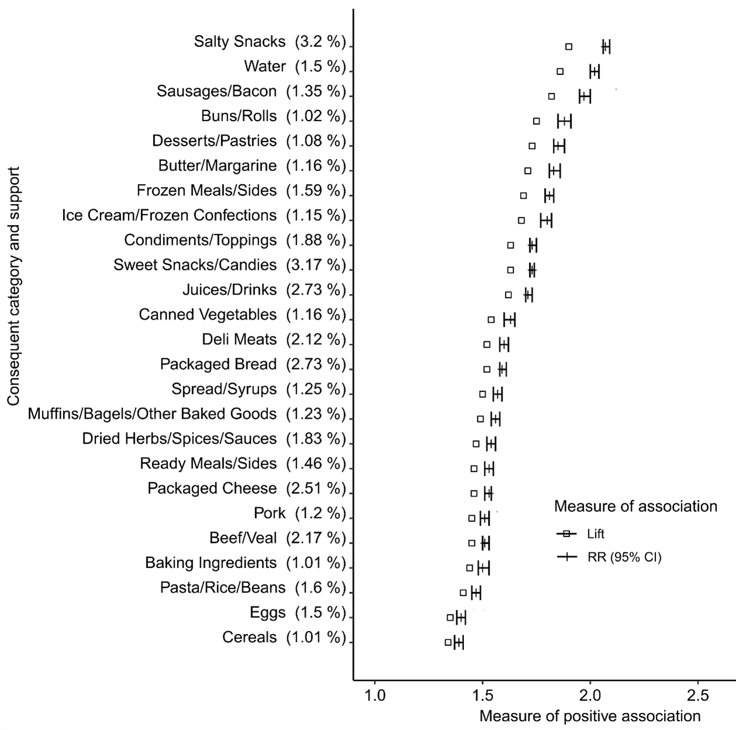

Supplementary Figure 1. Top 25 food categories co-purchased with soda, ordered by the value of lift

Abbreviations: RR; Risk Ratio, CI; Confidence Interval

Support indicates the percent joint frequency of the antecedent (soda) and each of the consequents

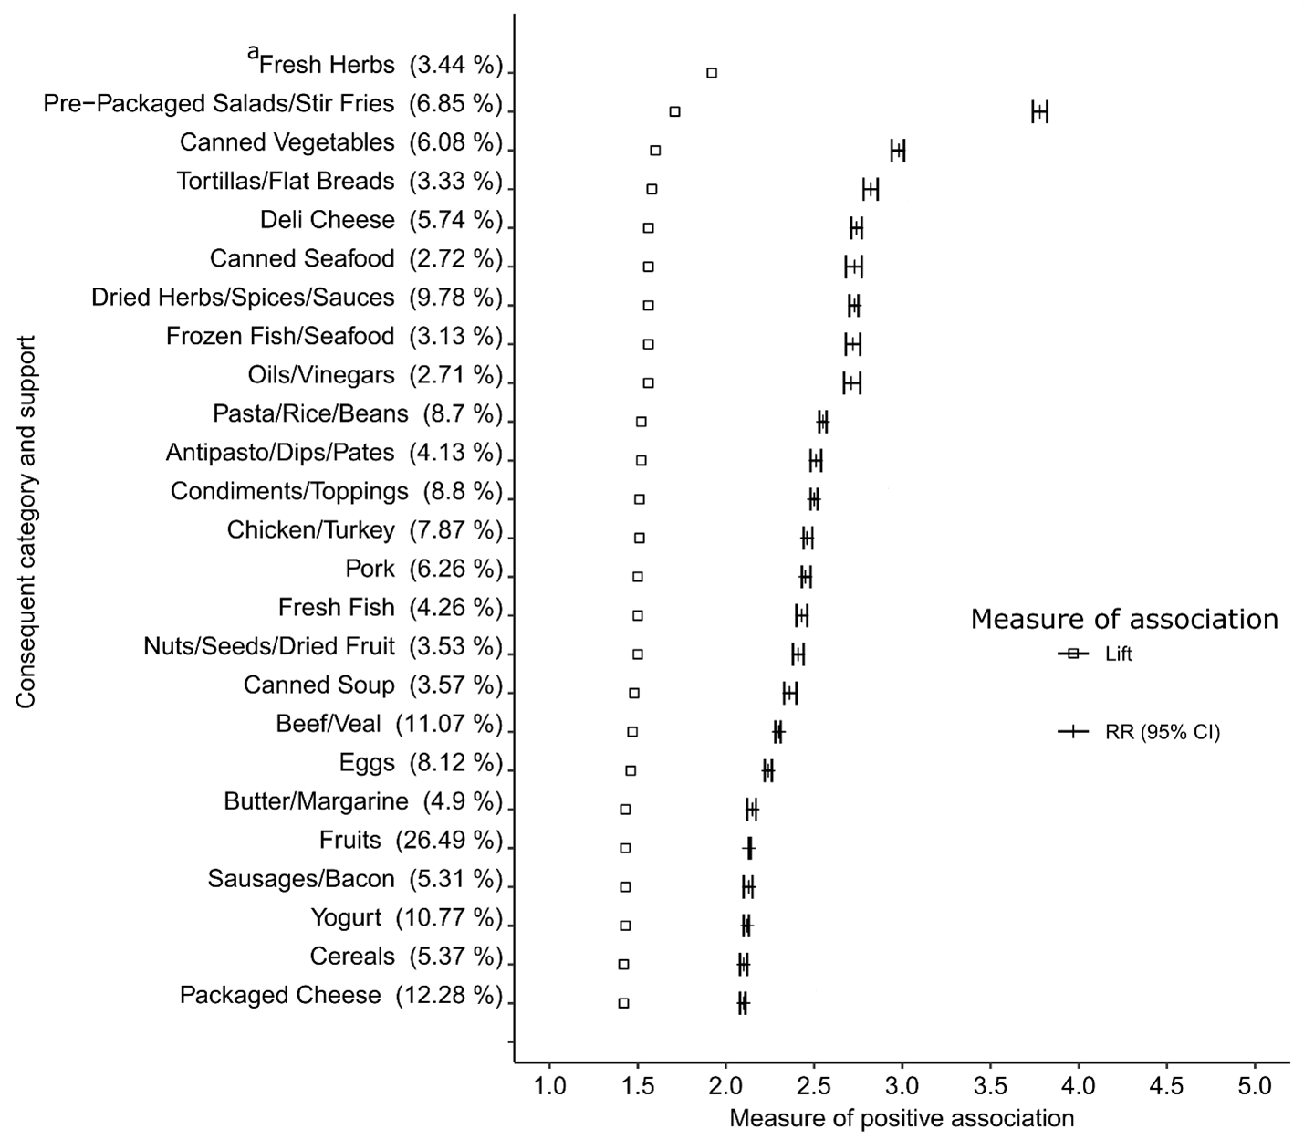

Supplementary Figure 2. Top 25 food categories co-purchased with fresh vegetables, ordered by the value of lift

ª RR and its 95%CI of the Fresh Herbs category is not displayed, as the estimates (RR=6.56, 95%CI;6.43-6.70) is outside the scale of the x-axis

Support indicates the percent joint frequency of the antecedent (fresh vegetable) and each of the consequents

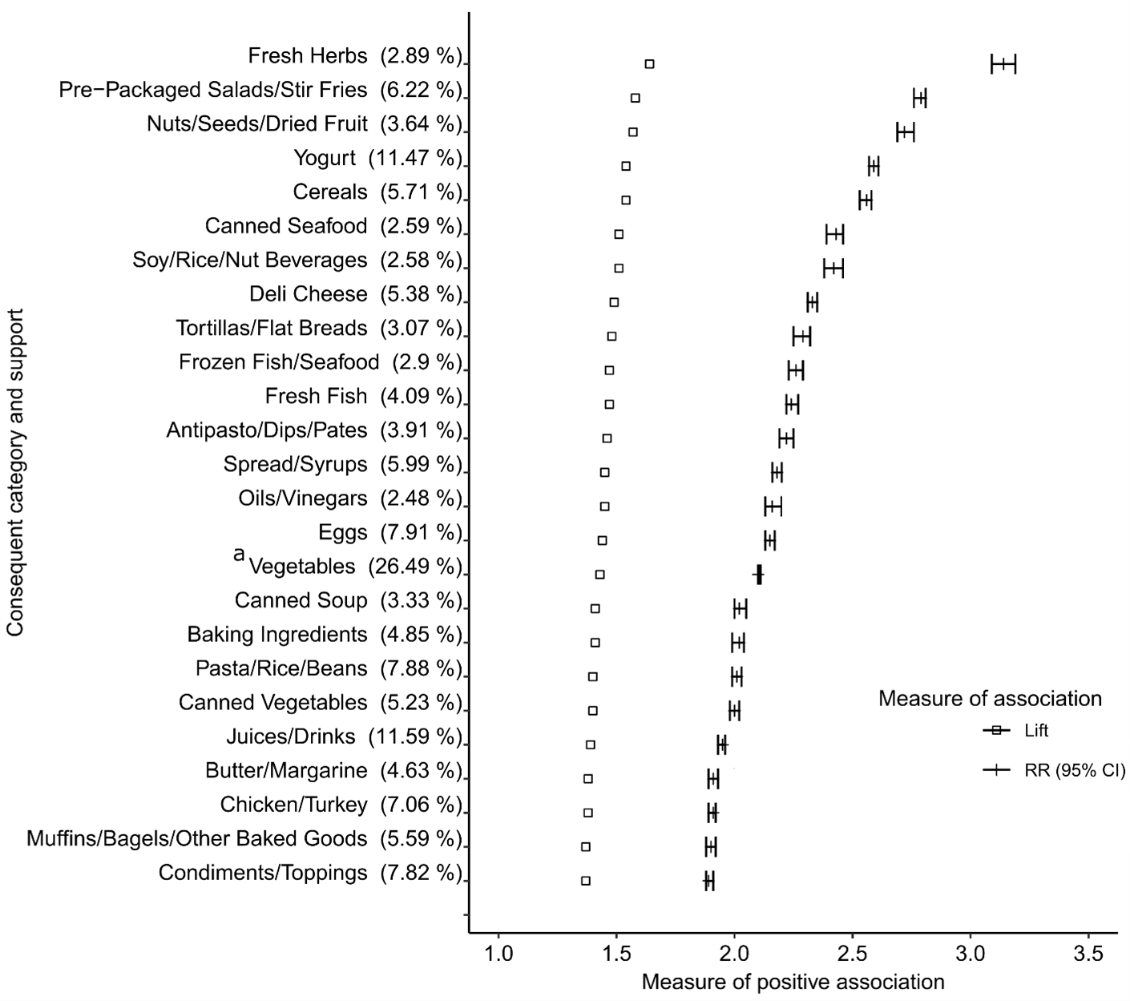

Supplementary Figure 3. Top 25 food categories co-purchased with fresh fruits, ordered by lift.
Abbreviations: RR; Risk Ratio, CI; Confidence Interval
Support indicates the joint frequency of antecedent (fresh fruits) and each of the consequents, in percent

Supplementary Table 3. Main effects and interaction between soda and area-level income and education
Outcome | Interaction or main effect ª | OR  (95% CI)^{b} | P-value
Salty Snacks | Soda X Income | 0.99 (0.97, 1.02) | 0.608671
Salty Snacks | Soda X Education | 1.00 (0.98, 1.03) | 0.755664
Salty Snacks | Soda* | 2.00 (1.98, 2.05) | <1.00E-10
Salty Snacks | Income* | 1.07 (1.04, 1.10) | 4.93E-08
Salty Snacks | Education | 0.99 (0.96,1.02) | 0.583591
Sweet snacks and candies | Soda X Income | 1.01 (0.99, 1.03) | 0.289531
Sweet snacks and candies | Soda X Education* | 1.04 (1.03, 1.06) | 0.000022
Sweet snacks and candies | Soda* | 1.34 (1.32, 1.36) | <1.00E-10
Sweet snacks and candies | Income | 1.02 (0.99, 1.05) | 0.174374
Sweet snacks and candies | Education* | 1.04 (1.00, 1.06) | 0.012549
Juices and drinks | Soda X Income* | 1.05 (1.04, 1.08) | 0.000001
Juices and drinks | Soda X Education* | 1.03 (1.02, 1.05) | 0.000657
Juices and drinks | Soda* | 1.47 (1.44, 1.50) | <1.00E-10
Juices and drinks | Income | 0.98 (0.95, 1.01) | 0.195162
Juices and drinks | Education* | 0.91 (0.88, 0.93) | <1.00E-10
Abbreviations: OR, Odds Ratio; 95% CI, 95% Confidence Interval
ª “X” indicates interaction
* Statistically conclusive result (p-value is less than the critical value of 0.05, and 95% confidence interval not crossing the null value of OR=1.0)

Income and education variables are aggregated census measures at the level of the census dissemination area in which cardholders resided. These measures represent median family income and the proportion of residents without a high-school diploma, respectively. Both continuous variables are standardized: mean centered and scaled by 1-unit standard deviation. The variables “Soda” is the binary indicator of soda purchasing.

Supplementary Table 4. Main effects and interaction between fresh vegetables and area-level income and education
Outcome | Interaction or main effectª | OR  (95% CI)^{b} | P-value
Pre-Packaged Salads/Stir Fries | Fresh vegetables X Income * | 1.02 (1.01, 1.04) | 0.007912
Pre-Packaged Salads/Stir Fries | Fresh vegetables X Education * | 0.96 (0.94, 0.98) | 0.000010
Pre-Packaged Salads/Stir Fries | Fresh vegetables * | 2.63 (2.59 2.68) | <1.00E-10
Pre-Packaged Salads/Stir Fries | Income * | 1.15 (1.12 1.20) | <1.00E-10
Pre-Packaged Salads/Stir Fries | Education * | 0.89 (0.86 0.92) | <1.00E-10
Canned Vegetables | Fresh vegetables X Income | 0.99 (0.97, 1.01) | 0.331972
Canned Vegetables | Fresh vegetables X Education* | 0.98 (0.96, 1.00) | 0.019090
Canned Vegetables | Fresh vegetables* | 1.86 (1.83 1.90) | <1.00E-10
Canned Vegetables | Income * | 0.97 (0.94 1.00) | 0.028298
Canned Vegetables | Education | 1.02 (0.99 1.05) | 0.164189
Deli Cheese | Fresh vegetables X Income | 1.02 (1.00, 1.03) | 0.083309
Deli Cheese | Fresh vegetables X Education* | 0.97 (0.95, 0.99) | 0.007549
Deli Cheese | Fresh vegetables* | 1.61 (1.59 1.64) | <1.00E-10
Deli Cheese | Income * | 1.10 (1.07 1.14) | <1.00E-10
Deli Cheese | Education* | 0.87 (0.83 0.90) | 3.98E-08
Abbreviations: OR, Odds Ratio; 95% CI, 95% Confidence Interval
ª “X” indicates interaction
* Statistically conclusive result (p-value is less than the critical value of 0.05, and 95% confidence interval not crossing the null value of OR=1.0)

Income and education variables are aggregated census measures at the level of the census dissemination area in which cardholders resided. These measures represent median family income and the proportion of residents without a high-school diploma, respectively. Both continuous variables are standardized: mean centered and scaled by 1-unit standard deviation. The variables “Fresh vegetables” is the binary indicator of fresh vegetable purchasing.

Supplementary Table 5. Main effects and interaction between fresh fruits and area-level income and education
Outcome | Interaction or main effect ª | OR  (95% CI) ^{b} | P-value
Pre-Packaged Salads/Stir Fries | Fresh fruits X Income* | 1.02 (1.00, 1.04) | 0.019330
Pre-Packaged Salads/Stir Fries | Fresh fruits X Education* | 0.97 (0.95, 0.99) | 0.000264
Pre-Packaged Salads/Stir Fries | Fresh fruits* | 1.89 (1.86 1.93) | <1.00E-10
Pre-Packaged Salads/Stir Fries | Income* | 1.17 (1.13 1.21) | <1.00E-10
Pre-Packaged Salads/Stir Fries | Education* | 0.88 (0.85 0.92) | <1.00E-10
Nuts/Seeds/Dried Fruit | Fresh fruits X Income* | 1.02 (1.01, 1.04) | 0.001851
Nuts/Seeds/Dried Fruit | Fresh fruits X Education* | 1.03 (1.02, 1.05) | 0.000033
Nuts/Seeds/Dried Fruit | Fresh fruits | 1.93 (1.91 1.96) | <1.00E-10
Nuts/Seeds/Dried Fruit | Income | 1.02 (1.00 1.06) | 0.133996
Nuts/Seeds/Dried Fruit | Education* | 0.81 (0.78 0.84) | <1.00E-10
Yogurt | Fresh fruits X Income* | 1.02 (1.00, 1.04) | 0.014930
Yogurt | Fresh fruits X Education | 1.02 (1.00, 1.04) | 0.064431
Yogurt | Fresh fruits* | 1.62 (1.60 1.65) | <1.00E-10
Yogurt | Income | 1.00 (0.96 1.04) | 0.965686
Yogurt | Education* | 0.87 (0.83 0.90) | <1.00E-10
Abbreviations: OR, Odds Ratio; 95% CI, 95% Confidence Interval
ª “X” indicates interaction
* Statistically conclusive result (p-value is less than the critical value of 0.05, and 95% confidence interval not crossing the null value of OR=1.0)

Income and education variables are aggregated census measures at the level of the census dissemination area in which cardholders resided. These measures represent median family income and the proportion of residents without a high-school diploma, respectively. Both continuous variables are standardized: mean centered and scaled by 1-unit standard deviation. The variables “Fresh fruits” is the binary indicator of fresh fruits purchasing.

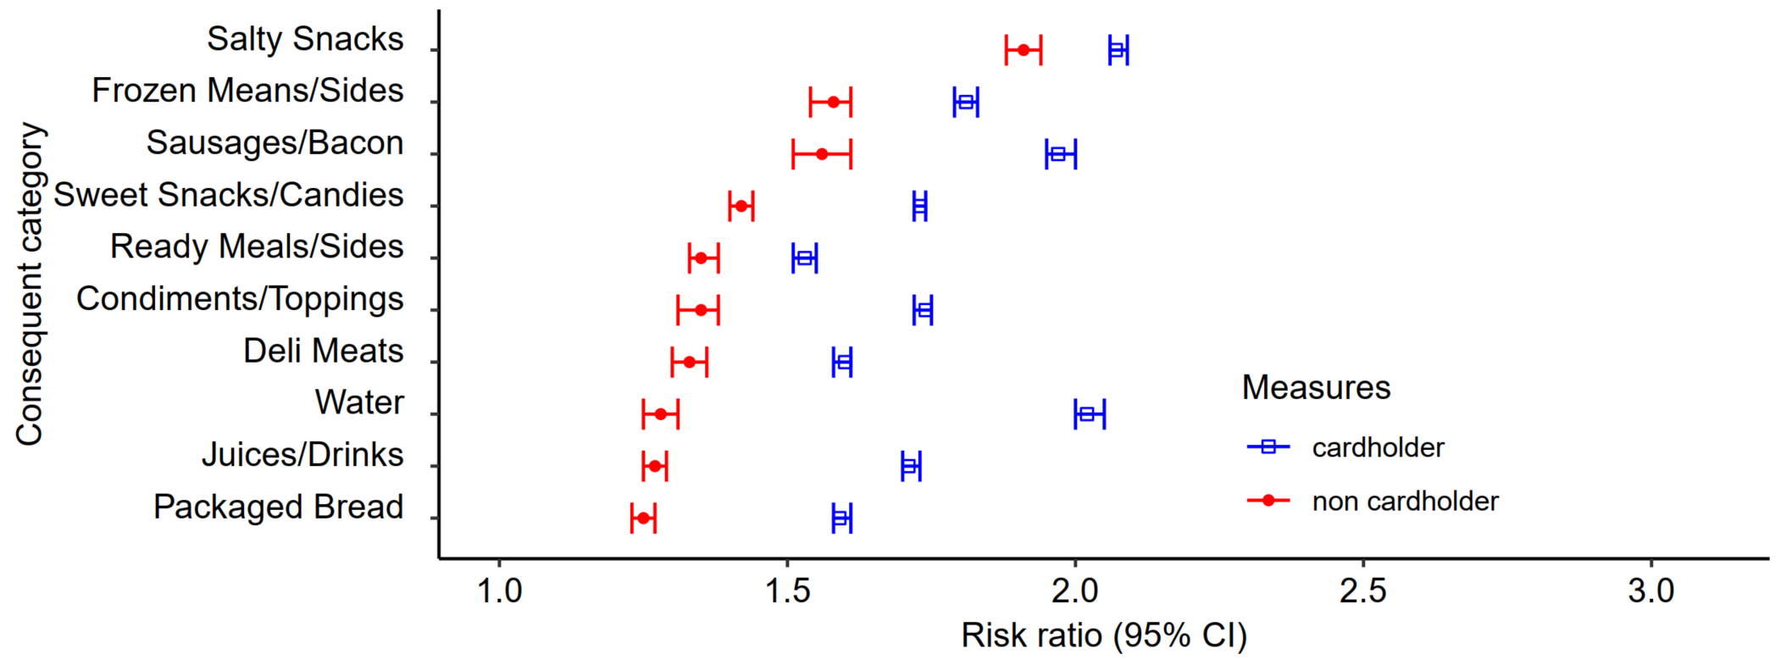

Supplementary Figure 4. Results of association rule mining applied to purchasing data among non-cardholders, showing the risk ratio of top 10 food categories associated with soda. The corresponding risk ratios estimated from cardholder’s baskets in the main analysis are also shown

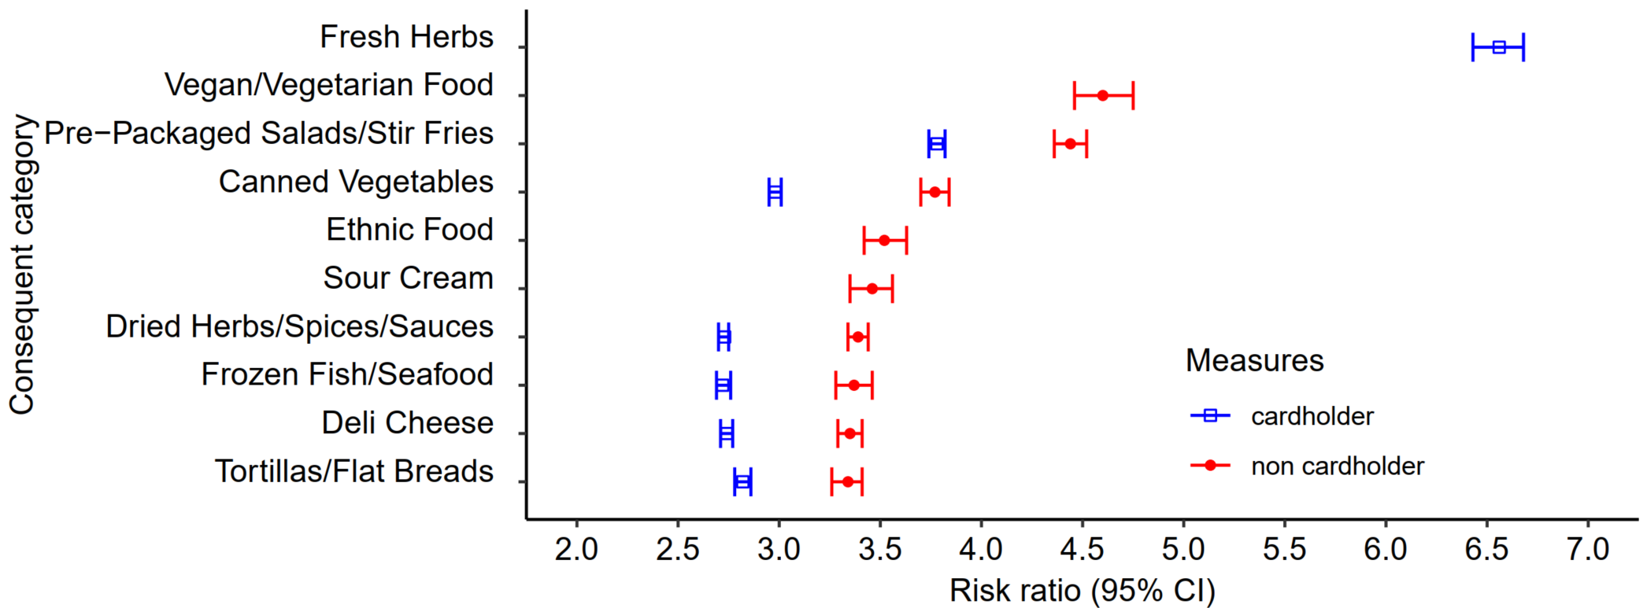

Supplementary Figure 5. Results of association rule mining applied to purchasing data among non-cardholders, showing risk ratio of top 10 food categories associated with fresh vegetables. The corresponding risk ratios estimated from cardholder’s baskets in the main analysis are also shown

Missing estimates from cardholders for vegan/vegetarian food, ethnic food, and sour cream indicate that these categories are not raked to the top 25 categories of cardholders in the main analysis

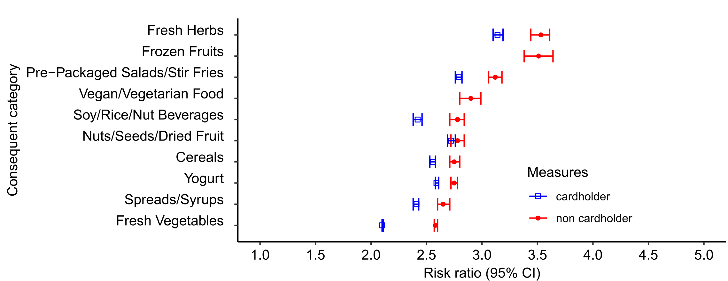

Supplementary Figure 6. Results of association rule mining applied to purchasing data among non-cardholders, showing risk ratio of top 10 food categories associated with fresh fruits. The corresponding risk ratios estimated from cardholder’s baskets in the main analysis are also shown

Missing estimates from cardholders for frozen fruits and began/vegetarian food indicate that these categories are not raked to the top 25 categories of cardholders

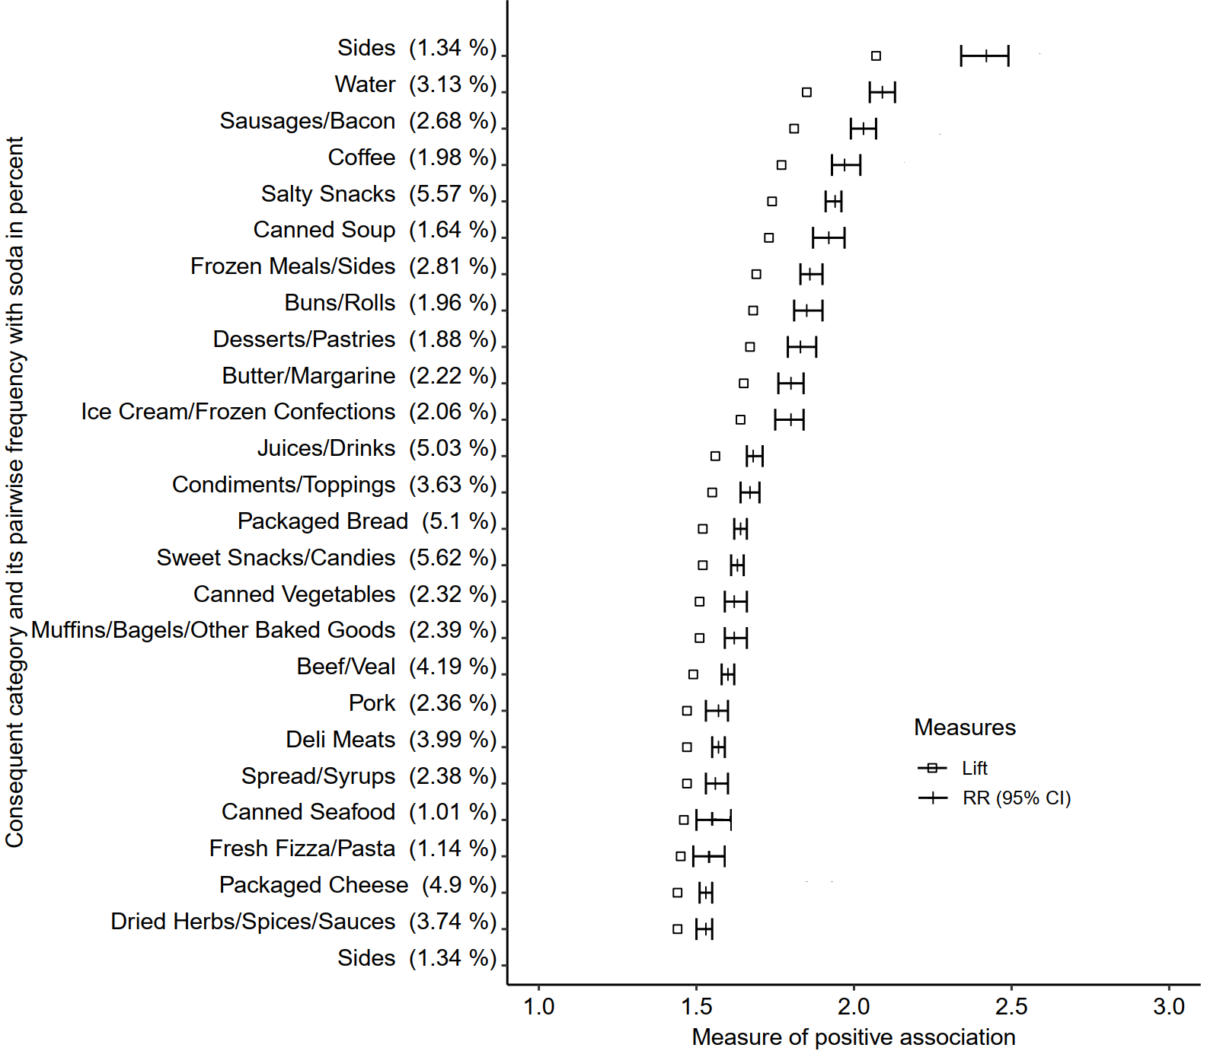
Supplementary Figure 7. Top 25 food categories co-purchased with soda among a subset of loyal cardholders whose recorded monthly expenditure was greater than 514 Canadian dollars in the target retail chain
Abbreviations: RR; Relative Risk, CI; Confidence Interval

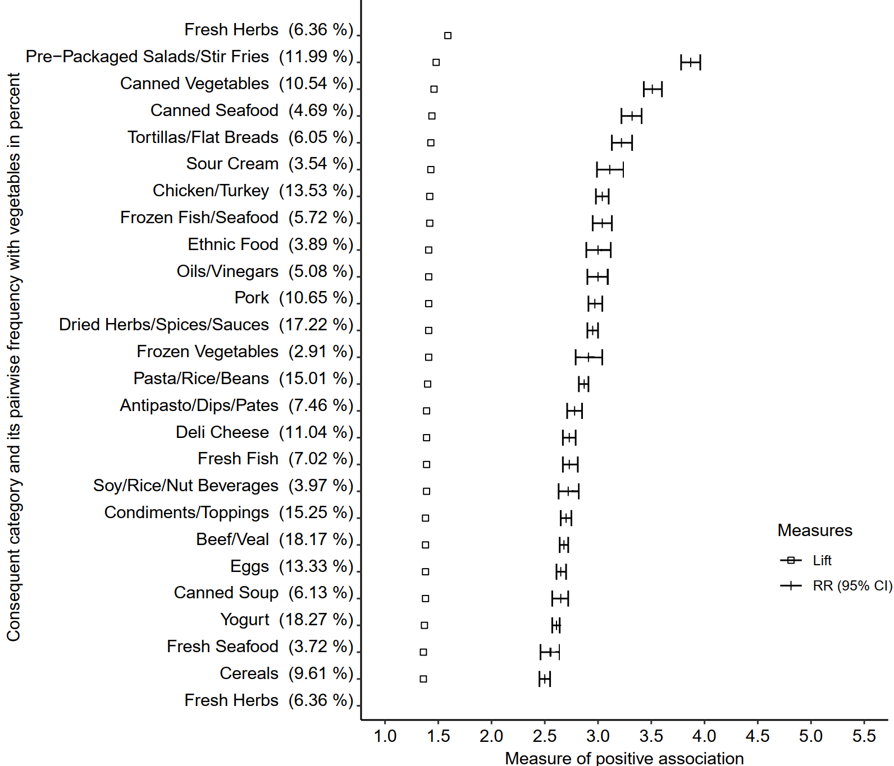

Supplementary Figure 8. Top 25 food categories co-purchased with fresh vegetables among a subset of loyal cardholders whose recorded monthly expenditure was greater than 514 Canadian dollars in the target retail chain
Abbreviations: RR; Relative Risk, CI; Confidence Interval

RR and their 95%CI of the Fresh Herbs category are not displayed, as the estimate (RR=6.49, 95%CI;6.24-6.76) are outside the scale of the x-axis

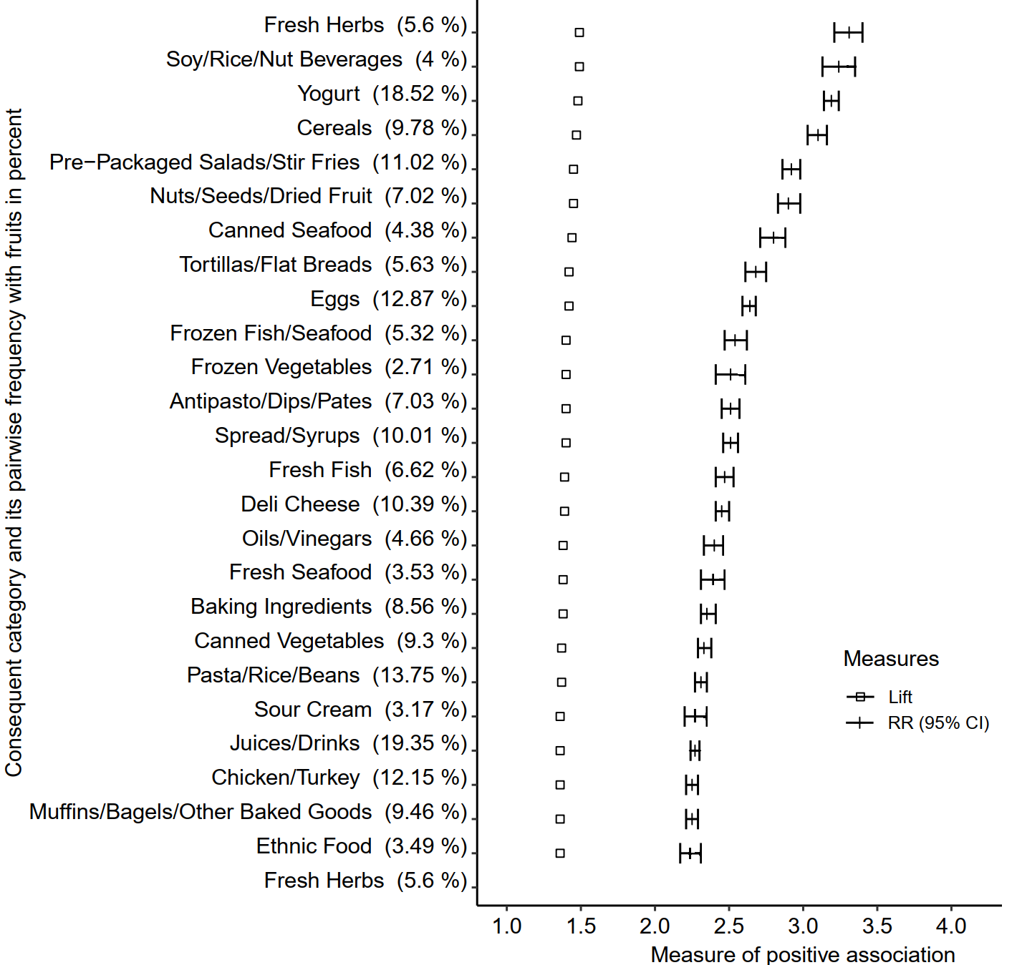

Supplementary Figure 9. Top 25 food categories co-purchased with fresh fruits among a subset of loyal cardholders whose recorded monthly expenditure was greater than 514 Canadian dollars in the target retail chain

Abbreviations: RR; Relative Risk, CI; Confidence Interval

