SUPPLEMENTARY MATERIAL
Comparative effectiveness of physical activity interventions on cognitive functions in children and adolescents with Neurodevelopmental Disorders: a systematic review and network meta-analysis of randomised controlled trials

Ruiyuan Tao¹, Yijian Yang¹, Mark Wilson², Jeremy R. Chang³, Chang Liu⁴, Cindy H.P. Sit¹

- Department of Sports Science and Physical Education, The Chinese University of Hong Kong, Shatin, Hong Kong Special Administrative Region, China
- Department of Public Health and Sports Sciences, Faculty of Health and Life Sciences, University of Exeter, Heavitree Road, Exeter, EX1 2LU, Devon, UK
- Department of Rehabilitation Sciences, The Hong Kong Polytechnic University, Hong Kong SAR, China
- Vanke School of Public Health, Tsinghua University, Beijing, China

Corresponding author: Prof. Cindy H.P. Sit, Department of Sports Science and Physical Education, The Chinese University of Hong Kong, Shatin, Hong Kong Special Administrative Region, China. Email: sithp@cuhk.edu.hk. Phone: +852 3943 4126

Index of supplementary material
Supplementary 1 PRISMA checklist 3
Supplementary 2 Search strategy 6
Supplementary 3 General characteristics of included studies 7
Supplementary 4 Cochrane risk-of-bias assessment results 8
Supplementary 5 Pairwise meta-analyses between PA interventions and usual care 9
Supplementary 6 Assessment of transitivity 11
Supplementary 7 Assessment of inconsistency 11
Supplementary 8 Assessment of heterogeneity 14
Supplementary 9 Network plot for acceptability 15
Supplementary 10 League table for acceptability 15
Supplementary 11 SUCRA results and ranking plots 16
Supplementary 12 Comparison-adjusted funnel plots 18
Supplementary 13 League tables for specific NDDs 20
Supplementary 14 Sensitivity Analyses 22
Supplementary 15 Meta-regression and subgroup analyses 24
Supplementary 16 Grading the evidence of the network meta-analysis using CINeMA 27
Reference 30

Supplementary 1 PRISMA checklist
Section/Topic | Item # | Checklist Item | Reported  on Page #
TITLE
Title | 1 | Identify the report as a systematic review incorporating a network meta-analysis (or related form of meta-analysis). | 1
ABSTRACT
Structured summary | 2 | Provide a structured summary including, as applicable:  - Background: main objectives  - Methods: data sources; study eligibility criteria, participants, and interventions; study appraisal; and synthesis methods, such as network meta-analysis.  - Results: number of studies and participants identified; summary estimates with corresponding confidence/credible intervals; treatment rankings may also be discussed. Authors may choose to summarize pairwise comparisons against a chosen treatment included in their analyses for brevity.  - Discussion/Conclusions: limitations; conclusions and implications of findings.  - Other: primary source of funding; systematic review registration number with registry name. | 2
INTRODUCTION
Rationale | 3 | Describe the rationale for the review in the context of what is already known, including mention of why a network meta-analysis has been conducted. | 4-5
Objectives | 4 | Provide an explicit statement of questions being addressed, with reference to participants, interventions, comparisons, outcomes, and study design (PICOS). | 5
METHODS
Protocol and registration | 5 | Indicate whether a review protocol exists and if and where it can be accessed (e.g., Web address); and, if available, provide registration information, including registration number. | 5
Eligibility criteria | 6 | Specify study characteristics (e.g., PICOS, length of follow-up) and report characteristics (e.g., years considered, language, publication status) used as criteria for eligibility, giving rationale. Clearly describe eligible treatments included in the treatment network, and note whether any have been clustered or merged into the same node (with justification). | 5-6
Information sources | 7 | Describe all information sources (e.g., databases with dates of coverage, contact with study authors to identify additional studies) in the search and date last searched. | 5
Search | 8 | Present full electronic search strategy for at least one database, including any limits used, such that it could be repeated. | 5, Supplementary 2
Study selection | 9 | State the process for selecting studies (i.e., screening, eligibility, included in systematic review, and, if applicable, included in the meta-analysis). | 5-7
Data collection process | 10 | Describe method of data extraction from reports (e.g., piloted forms, independently, in duplicate) and any processes for obtaining and confirming data from investigators. | 7
Data items | 11 | List and define all variables for which data were sought (e.g., PICOS, funding sources) and any assumptions and simplifications made. | 5-7
Geometry of the network | S1 | Describe methods used to explore the geometry of the treatment network under study and potential biases related to it. This should include how the evidence base has been graphically summarized for presentation, and what characteristics were compiled and used to describe the evidence base to readers. | 7-8
Risk of bias within individual studies | 12 | Describe methods used for assessing risk of bias of individual studies (including specification of whether this was done at the study or outcome level), and how this information is to be used in any data synthesis. | 7
Summary measures | 13 | State the principal summary measures (e.g., risk ratio, difference in means). Also describe the use of additional summary measures assessed, such as treatment rankings and surface under the cumulative ranking curve (SUCRA) values, as well as modified approaches used to present summary findings from meta-analyses. | 7-8
Planned methods of analysis | 14 | Describe the methods of handling data and combining results of studies for each network meta-analysis. This should include, but not be limited to:  - Handling of multi-arm trials;  - Selection of variance structure;  - Selection of prior distributions in Bayesian analyses; and  - Assessment of model fit. | 7-8
Assessment of Inconsistency | S2 | Describe the statistical methods used to evaluate the agreement of direct and indirect evidence in the treatment network(s) studied. Describe efforts taken to address its presence when found. | 8
Risk of bias across studies | 15 | Specify any assessment of risk of bias that may affect the cumulative evidence (e.g., publication bias, selective reporting within studies). | 7
Additional analyses | 16 | Describe methods of additional analyses if done, indicating which were pre-specified. This may include, but not be limited to, the following:  - Sensitivity or subgroup analyses;  - Meta-regression analyses;  - Alternative formulations of the treatment network; and  - Use of alternative prior distributions for Bayesian analyses (if applicable). | 8
RESULTS†
Study selection | 17 | Give numbers of studies screened, assessed for eligibility, and included in the review, with reasons for exclusions at each stage, ideally with a flow diagram. | 8-9, Fig. 1
Presentation of network structure | S3 | Provide a network graph of the included studies to enable visualization of the geometry of the treatment network. | Fig. 2, Supplementary 9
Summary of network geometry | S4 | Provide a brief overview of characteristics of the treatment network. This may include commentary on the abundance of trials and randomized patients for the different interventions and pairwise comparisons in the network, gaps of evidence in the treatment network, and potential biases reflected by the network structure. | 10-11,  Supplementary 10, 13
Study characteristics | 18 | For each study, present characteristics for which data were extracted (e.g., study size, PICOS, follow-up period) and provide the citations. | 8, Supplementary 3
Risk of bias within studies | 19 | Present data on risk of bias of each study and, if available, any outcome level assessment. | 13, Supplementary 4
Results of individual studies | 20 | For all outcomes considered (benefits or harms), present, for each study: 1) simple summary data for each intervention group, and 2) effect estimates and confidence intervals. Modified approaches may be needed to deal with information from larger networks. | 10-12, Supplementary 6-16
Synthesis of results | 21 | Present results of each meta-analysis done, including confidence/credible intervals. In larger networks, authors may focus on comparisons versus a particular comparator (e.g. placebo or standard care), with full findings presented in an appendix. League tables and forest plots may be considered to summarize pairwise comparisons. If additional summary measures were explored (such as treatment rankings), these should also be presented. | 8-12, Supplementary 6-16
Exploration for inconsistency | S5 | Describe results from investigations of inconsistency. This may include such information as measures of model fit to compare consistency and inconsistency models, P values from statistical tests, or summary of inconsistency estimates from different parts of the treatment network. | 9-10, Supplementary 7
Risk of bias across studies | 22 | Present results of any assessment of risk of bias across studies for the evidence base being studied. | 13, Supplementary 16
Results of additional analyses | 23 | Give results of additional analyses, if done (e.g., sensitivity or subgroup analyses, meta-regression analyses, alternative network geometries studied, alternative choice of prior distributions for Bayesian analyses, and so forth). | 13, Supplementary 14-15
DISCUSSION
Summary of evidence | 24 | Summarize the main findings, including the strength of evidence for each main outcome; consider their relevance to key groups (e.g., healthcare providers, users, and policy-makers). | 13-15
Limitations | 25 | Discuss limitations at study and outcome level (e.g., risk of bias), and at review level (e.g., incomplete retrieval of identified research, reporting bias). Comment on the validity of the assumptions, such as transitivity and consistency. Comment on any concerns regarding network geometry (e.g., avoidance of certain comparisons). | 15-16
Conclusions | 26 | Provide a general interpretation of the results in the context of other evidence, and implications for future research. | 16
FUNDING
Funding | 27 | Describe sources of funding for the systematic review and other support (e.g., supply of data); role of funders for the systematic review. This should also include information regarding whether funding has been received from manufacturers of treatments in the network and/or whether some of the authors are content experts with professional conflicts of interest that could affect use of treatments in the network. | 17
Abbreviation: PICOS = Population, Intervention, Comparators, Outcomes, Study design.
* Text in italics indicates wording specific to reporting of network meta-analyses that has been added to guidance from the PRISMA statement.
† Authors may wish to plan for use of appendices to present all relevant information in full detail for items in this section.

Supplementary 2 Search strategy
1. AB=neurodevelopmental disorder*
2. AB=(“attention-deficit hyperactivity disorder*” or ADHD or “attention-deficit disorder*” or ADD or autism or autism spectrum disorder* or ASD or autistic or “communication disorder*” or “intellectual disabilit*” or “learning disabilit*” or “developmental coordination disorder*” or DCD)
3. #2 OR #1
4. AB=( child* or adolescent or teen* or youth* or school or student)
5. #4 AND #3
6. AB=(“physical activity” or exercise or training or sport or motor or “physical fitness” or aerobic or endurance or resistance or strength or HIIT or exergaming or gymnastics or running or cycling or ball or racket or treadmill or swimming or “martial arts” or mind-body or danc*)
7. AB=(cogniti* or “cognitive function*” or neurocogniti* or neuropsycholog*)
8. AB= (attention or “attentional control” or concentration or vigilance or memory or “executive function*” or “executive dysfunction*” or reasoning or “problem solving” or “executive control” or inhibit* or “impulse control” or “interference control” or “cognitive control” or self-control or “cognitive flexibility” or “mental flexibility” or shifting or switching or updating or “decision making” or planning or accuracy or “reaction time”)
9. #8 OR #7
10. TS=(random* or “random* controlled trial” or RCT)
11. #10 AND #9 AND #6 AND #5 (Limiters: Human, English)

Supplementary 3 General characteristics of included studies
Characteristics | Studies (n=31)  Arms (n=66)
Total participants at baseline, n | 1, 403
Age of participants (year), mean±SD | 10.0±1.9
% of male participants, mean | 83.2±16.1
NDDs Category, n (% of studies)
ADHD | 18 (58.1)
ASD | 10 (32.3)
DCD | 2 (6.4)
SLD | 1 (3.2)
Continent, n (% of studies)
Africa | 3 (9.7)
Asia | 20 (64.5)
Europe | 5 (16.1)
North America | 2 (6.4)
South America | 1 (3.2)
Treatment, n (% of arms)
AE | 7 (10.6)
Exergaming | 5 (7.6)
MBE | 6 (9.1)
MPA | 19 (28.8)
NF | 3 (4.5)
RT | 1 (1.5)
UC | 27 (40.9)
Outcome measures, n (% of studies)
Attention | 2 (6.4)
Memory | 1 (3.2)
Executive functions | 14 (45.2)
Attention & Memory | 2 (6.4)
Attention & Executive Functions | 3 (9.7)
Memory & Executive Functions | 6 (19.4)
Attention & Memory & Executive Functions | 3 (9.7)
ADHD attention-deficit/hyperactivity disorder, ASD autism spectrum disorder, DCD developmental coordination disorder, SLD specific learning disorder; Y yes, N no, NI no information; IQR Interquartile Range; AE aerobic exercise, MBE mind-body exercise, MPA multicomponent physical activity, RT relaxation techniques, NF neurofeedback, UC usual care.

Supplementary 4 Cochrane risk-of-bias assessment results
Fig. S4.1 Risk of bias assessment for the included studies
 | Randomization process | Deviations from intended interventions | Mising outcome data | Measurement of the outcome | Selection of the reported result | Overall Quality
Ahmed & Mohamed (2011) | Some concerns | Some concerns | Low | High | Some concerns | High
Benzing & Schmidt (2019) | Low | Some concerns | Low | Low | Low | Some concerns
Borgi et al. (2016) | Some concerns | Some concerns | Low | Low | Some concerns | Some concerns
Bustamante et al. (2016) | Some concerns | Some concerns | Low | Low | Some concerns | Some concerns
Chan et al. (2013) | Low | Some concerns | Low | Low | Some concerns | Some concerns
Chang et al. (2022) | Low | Some concerns | Low | Low | Low | Some concerns
Choi et al. (2015) | Some concerns | Some concerns | Some concerns | Low | Some concerns | Some concerns
Damanpak & Sabzi (2022) | Some concerns | Some concerns | Low | High | Some concerns | High
Emami Kashfi et al. (2019) | Some concerns | Some concerns | Low | Low | Some concerns | Some concerns
Geladé et al. (2017) | Low | Some concerns | Low | Low | Some concerns | Some concerns
Greco & De Ronzi (2020) | Low | Some concerns | Low | High | Some concerns | High
Hashemi et al. (2022) | Low | Low | Low | Some concerns | Some concerns | Some concerns
Hattabi et al. (2019) | Some concerns | Some concerns | Low | Low | Some concerns | Some concerns
Ji & Yang (2022) | Some concerns | High | High | Low | Some concerns | High
Ji et al. (2023) | Some concerns | Some concerns | Some concerns | Some concerns | Low | Some concerns
Kadri et al. (2019) | Some concerns | Some concerns | Low | Low | Some concerns | Some concerns
Lee et al. (2017) | Some concerns | Some concerns | Some concerns | Low | Some concerns | Some concerns
Liang et al. (2022) | Low | Some concerns | Low | Low | Some concerns | Some concerns
Ludyga et al. (2022) | Low | Some concerns | Low | Low | Some concerns | Some concerns
Memarmoghaddam et al. (2016) | Some concerns | Some concerns | Low | Low | Some concerns | Some concerns
Nejati & Derakhshan (2021) | Some concerns | Some concerns | Low | Low | Some concerns | Some concerns
Pan et al. (2016) | Some concerns | Some concerns | Low | Low | Some concerns | Some concerns
Pan et al. (2017) | Some concerns | Some concerns | Low | Low | Some concerns | Some concerns
Phung & Goldberg (2019) | Some concerns | Some concerns | Low | Low | Some concerns | Some concerns
Rafiei Milajerdi et al. (2021) | Some concerns | Low | Low | Low | Some concerns | Some concerns
Rezaei et al. (2018) | Some concerns | Some concerns | Low | Low | Some concerns | Some concerns
Sani et al. (2022) | Some concerns | Some concerns | High | Low | Some concerns | High
Silva et al. (2020) | Some concerns | Some concerns | Some concerns | Low | Some concerns | Some concerns
Tse et al. (2019) | Some concerns | Some concerns | Low | Low | Some concerns | Some concerns
Tse et al. (2021) | Some concerns | Some concerns | Low | Low | Some concerns | Some concerns
Tse et al. (2023) | Some concerns | Some concerns | Low | Low | Some concerns | Some concerns

Fig. S4.2 Aggregate results
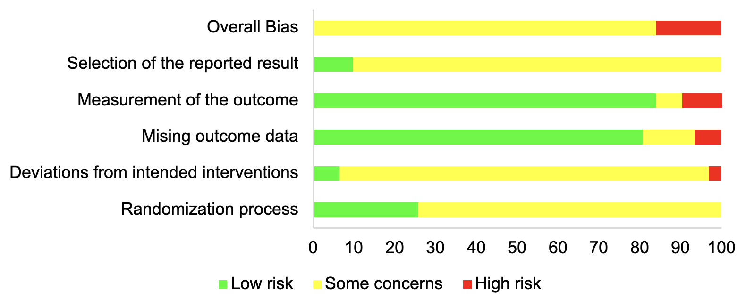

Supplementary 5 Pairwise meta-analyses between PA interventions and usual care
Treatment 1 | Treatment 2 | Outcome | N of  comparisons | Hedges’ g | 95%CI | I² (%)
Four types of PA interventions | Usual care | Attention | 7 | 1.263 | (0.435, 2.090) | 90.36
Four types of PA interventions | Usual care | Memory | 10 | 0.463 | (0.068, 0.858) | 71.38
Four types of PA interventions | Usual care | Executive functions | 24 | 0.798 | (0.466, 1.131) | 80.16
Four types of PA interventions | Usual care | Outcome | N of  comparisons | Odds ratio | 95%CI | I² (%)
Four types of PA interventions | Usual care | Acceptabilitys | 28 | 0.883 | (0.527, 1.480) | 11.30

Table S5.1 Pairwise meta-analyses for attention
Treatment 1 | Treatment 2 | N of Studies | Hedges' g | 95% CI | I² (%)
AE | NF | 1 | -0.171 | (-0.671, 0.330) | N/A
AE | UC | 1 | 0.496 | (0.066, 0.926) | N/A
Exergaming | AE | 1 | 0.121 | (-0.588, 0.820) | N/A
Exergaming | UC | 1 | 2.283 | (1.577, 2.988) | N/A
MBE | NF | 1 | 1.207 | (0.129, 2.285) | N/A
MBE | UC | 2 | 1.836 | (-0.267, 3.940) | 89.8
MPA | NF | 1 | 0.894 | (0.255, 1.532) | N/A
MPA | UC | 3 | 0.819 | (-0.363, 2.002) | 87.7
NF | UC | 1 | 0.116 | (-0.866, 1.098) | N/A

Table S5.2 Pairwise meta-analyses for memory
Treatment 1 | Treatment 2 | N of Studies | Hedges' g | 95% CI | I² (%)
AE | MPA | 2 | -0.657 | (-1.440, 0.126) | 62.8
AE | NF | 1 | 0.058 | (-0.387, 0.503) | N/A
AE | UC | 2 | 0.032 | (-0.415, 0.478) | 0.0
Exergaming | UC | 2 | 0.990 | (-0.560, 2.539) | 92.1
MBE | NF | 1 | -0.053 | (-1.034, 0.928) | N/A
MBE | UC | 2 | 0.496 | (0.024, 0.967) | 2.1
MPA | UC | 4 | 0.365 | (-0.218, 0.949) | 69.9
NF | UC | 1 | 1.061 | (0.005, 2.118) | N/A

Table S5.3 Pairwise meta-analyses for executive functions
Treatment 1 | Treatment 2 | N of Studies | Hedges' g | 95% CI | I² (%)
AE | MPA | 3 | -0.767 | (-1.192, -0.341) | 17.8
AE | NF | 1 | -0.114 | (-0.581, 0.353) | N/A
AE | UC | 2 | 0.067 | (-0.379, 0.514) | 0.0
Exergaming | AE | 1 | 0.927 | (0.191, 1.664) | N/A
Exergaming | MPA | 1 | -0.546 | (-1.225, 0.133) | N/A
Exergaming | UC | 4 | 0.870 | (0.064, 1.676) | 83.8
MBE | RT | 1 | 0.533 | (-0.093, 1.159) | N/A
MBE | UC | 3 | 0.934 | (-0.132, 2.000) | 84.8
MPA | AE | 1 | 0.379 | (-0.222, 0.981) | N/A
MPA | UC | 15 | 0.856 | (0.419, 1.294) | 82.5

Supplementary 6 Assessment of transitivity
Table S6 General characteristics of treatment nodes
Nodes | N of arms  (%) | N of participants  (%) | Mean age  (SD) | Mean percentage  of male (SD) | Mean treatment length  (weeks, SD) | Mean treatment dose  (minutes, SD)
AE | 7 (10.6) | 179 (12.8) | 10.1 (1.5) | 75.7 (8.9) | 5.9 (3.6) | 1155 (876.3)
Exergaming | 5 (7.6) | 110 (7.8) | 9.1 (1.0) | 90.1 (7.4) | 8.0 (2.8) | 1008 (649.6)
MBE | 6 (9.1) | 109 (7.8) | 10.63 (2.1) | 86.6 (14.7) | 21.2 (28.0) | 2155 (2789)
MPA | 19 (28.8) | 390 (27.8) | 9.7 (2.1) | 85.4 (18.7) | 8.3 (3.4) | 1444 (707.3)
NF | 3 (4.5) | 71 (5.1) | 8.8 (1.3) | 71.0 (8.4) | 8.0 (1.0) | 1063 (205.5)
RT | 1 (1.5) | 23 (1.6) | 12.4 | 85.0 | 4.0 | 360
UC | 27 (40.9) | 521 (37.1) | 10.1 (2.1) | 83.2 (18.2) | 12.1 (14.0) | 1747 (1433)
Total/Mean | 66 | 1,403 | 10.0 (1.9) | 83.5 (16.3) | 10.6 (12.4) | 1526.2 (1310.1)
Q1 |  |  | 8.7 | 75.4 | 6.0 | 720.0
Q2 |  |  | 9.5 | 86.0 | 8.0 | 1215.0
Q3 |  |  | 10.4 | 100.0 | 12.0 | 1680.0
AE=aerobic exercise, MBE=mind-body exercise, MPA= multicomponent physical activity, RT=relaxation techniques, NF=neurofeedback, UC=usual care; Q1=first quartile, Q2=second quartile, Q3=third quartile.
Number of studies that are unavailable for analysis: gender (n=2).

Supplementary 7 Assessment of inconsistency
Table S7.1 Estimated global inconsistency in networks
Outcomes | Chi square | Prob>Chi2
Attention | Chi2 (4) = 3.47 | Prob>Chi2 = 0.482
Memory | Chi2 (5) = 1.03 | Prob>Chi2 = 0.960
Executive functions | Chi2 (6) = 1.68 | Prob>Chi2 = 0.947
Acceptability | Chi2 (9) = 6.28 | Prob>Chi2 = 0.712

Table S7.2 Estimated local inconsistency for each pairwise comparison (side-splitting)
Table S7.2a Estimated local inconsistency for attention
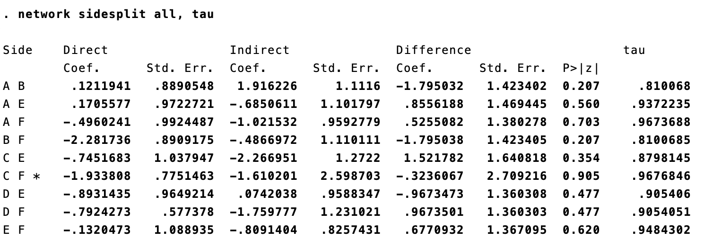

Table S7.2b Estimated local inconsistency for memory
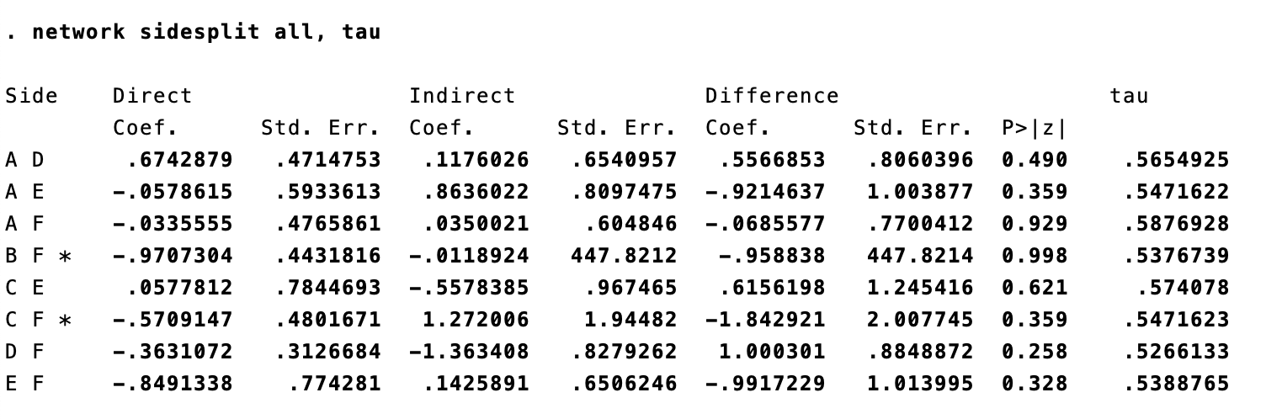

Table S7.2c Estimated local inconsistency for executive functions
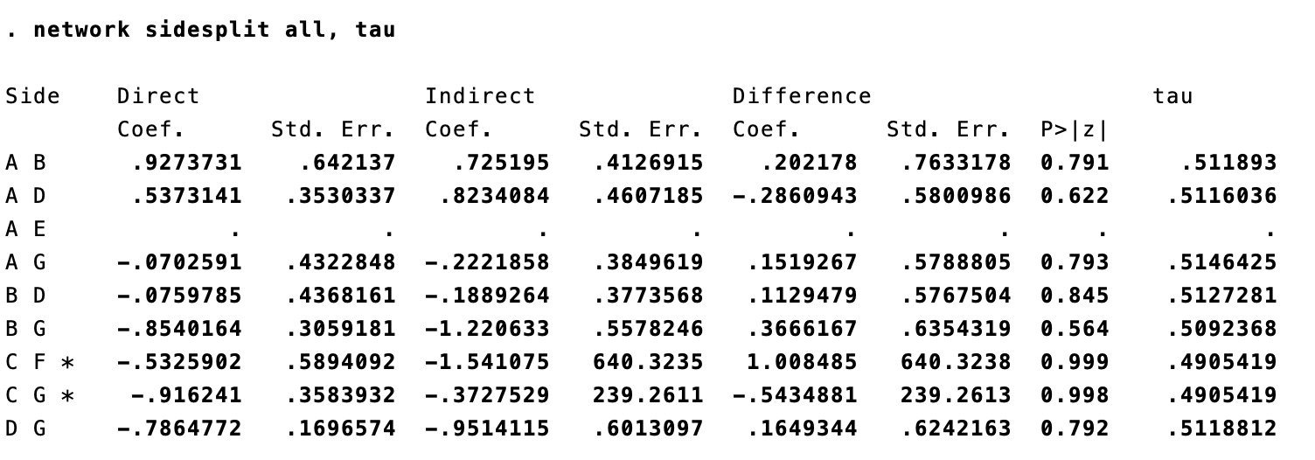

Table S7.2d Estimated local inconsistency for acceptability
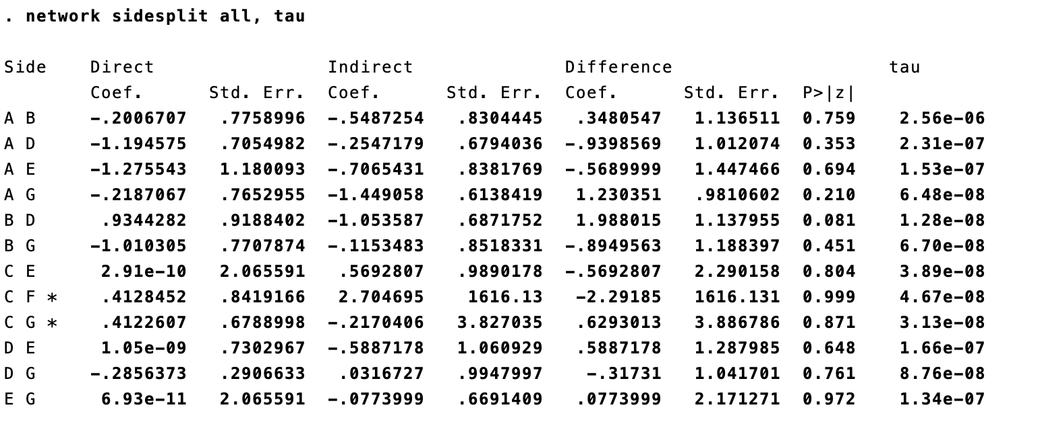

Supplementary 8 Assessment of heterogeneity
The heterogeneity of entire NMA models was estimated by a common heterogeneity variance (τ²), which was compared with empirical distributions for continuous [1] and for dichotomous data [2]. Heterogeneity was quantified as low (from 0.01 to 0.025), moderate (>0.025 to 1.0), and high (>1.0) [3].
Table S8.1 Continuous outcomes
Continuous Outcome | Between study variance  (τ²) | Outcome types  used as comparator | Predictive distribution of  τ² Median (95%CI)
Attention | 0.681 | Mental health outcome | 0.058 (0.001, 2.58)
Memory | 0.317 | Mental health outcome | 0.058 (0.001, 2.58)
Executive Functions | 0.277 | Mental health outcome | 0.058 (0.001, 2.58)

Table S8.2 Dichotomous outcome
Dichotomous outcomes | Between study variance  (τ²) | Outcome types used  as comparator | Predictive distribution of  τ² Median (95%CI)
Acceptability | 0.084 | Withdrawals | 0.12 (0.08, 0.16)

Supplementary 9 Network plot for acceptability
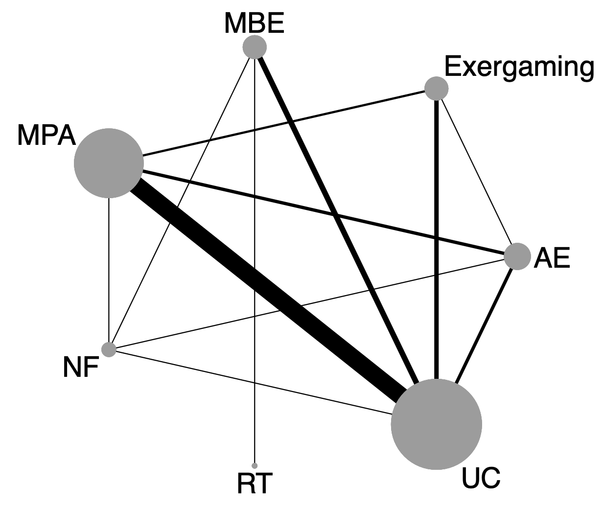
Each node represents a treatment. Connecting lines between two nodes represent one or more RCTs in which the two nodes have been compared directly. Size of each node indicates the number of participants. Thickness of the lines indicates the number of RCTs that directly compared the treatments it connected. AE aerobic exercise, MBE mind-body exercise, MPA multicomponent physical activity, RT relaxation techniques, NF neurofeedback, UC usual care.

Supplementary 10 League table for acceptability
MBE
0.67 (0.18,2.50) | UC
0.63 (0.11,3.62) | 0.93 (0.27,3.25) | NF
0.66 (0.13,3.45) | 0.98 (0.12,8.06) | 1.05 (0.10,11.64) | RT
0.52 (0.13,2.13) | 0.77 (0.45,1.33) | 0.83 (0.25,2.69) | 0.79 (0.09,6.88) | MPA
0.37 (0.07,2.00) | 0.55 (0.19,1.61) | 0.59 (0.13,2.71) | 0.56 (0.05,5.91) | 0.71 (0.24,2.10) | Exergaming
0.26 (0.05,1.27) | 0.38 (0.15,0.97) | 0.41 (0.11,1.56) | 0.39 (0.04,3.85) | 0.49 (0.20,1.24) | 0.70 (0.23,2.11) | AE
AE aerobic exercise, MBE mind-body exercise, MPA multicomponent physical activity, RT relaxation techniques, NF neurofeedback, UC usual care. Results are presented as odds ratio (OR) and 95% confidence intervals. OR values less than 1.00 favor the column-defining treatment node for the NMA results. Estimates in bold denote significance at p<0.05.

Supplementary 11 SUCRA results and ranking plots
Table S11 SUCRA results
 | Attention | Memory | Executive Functions | Acceptability
AE | 41.7 | 22.3 | 26.0 | 12.0
Exergaming | 72.3 | 88.0 | 80.6 | 30.3
MBE | 83.4 | 59.2 | 78.1 | 79.1
MPA | 55.2 | 64.3 | 70.2 | 47.1
NF | 40.7 | 45.9 | 37.1 | 59.2
RT | N/A | N/A | 42.7 | 55.0
UC | 6.6 | 20.3 | 15.3 | 67.3
AE aerobic exercise, MBE mind-body exercise, MPA multicomponent physical activity, RT relaxation techniques, NF neurofeedback, UC usual care. SUCRA surface under the cumulative ranking curve, N/A not applicable. SCURA in bold denotes ranked as the first effective treatment for each outcome.

Fig. S11 Ranking plots
AE aerobic exercise, MBE mind-body exercise, MPA multicomponent physical activity, RT relaxation techniques, NF neurofeedback, UC usual care.
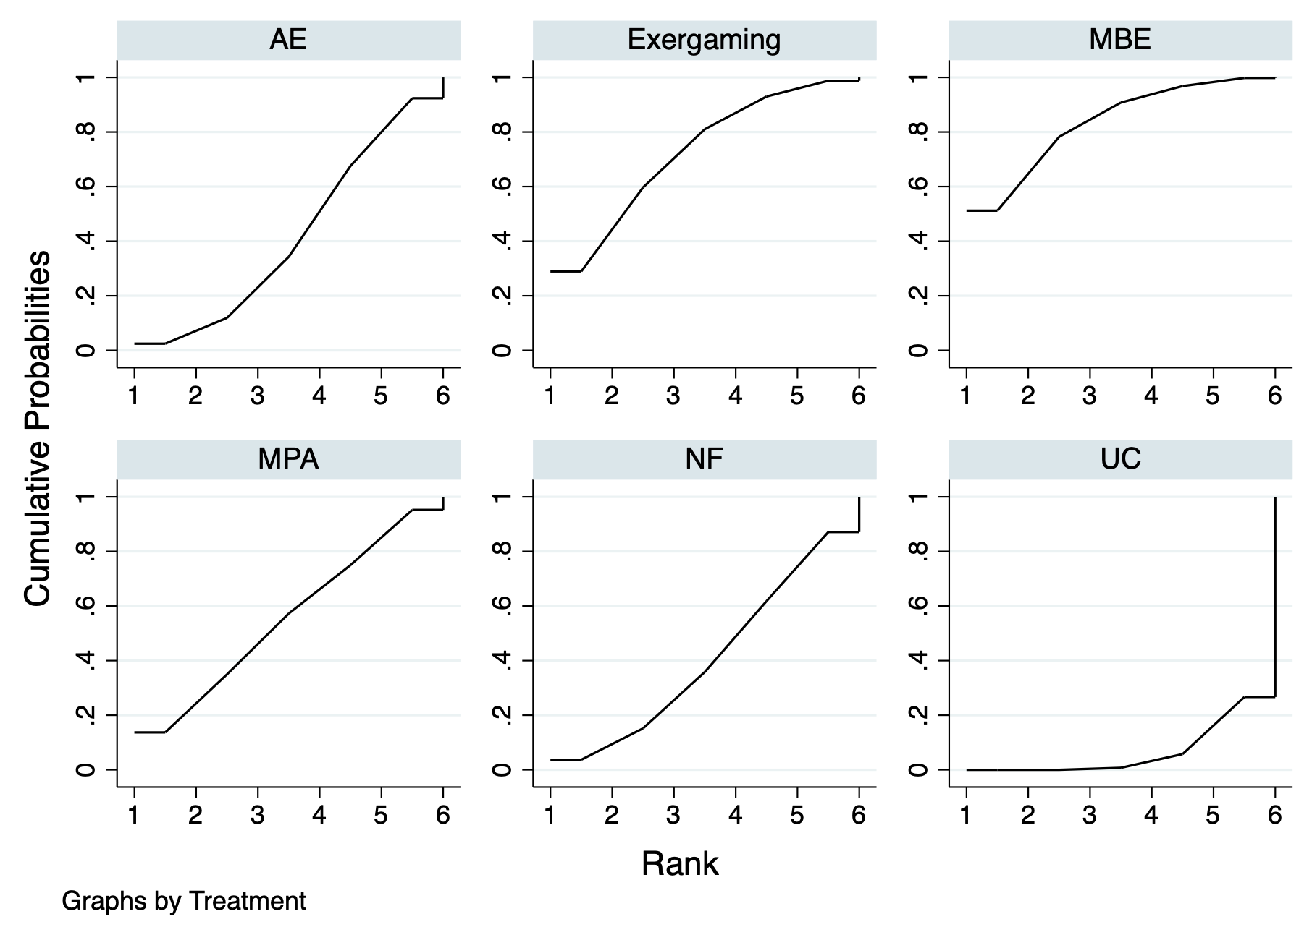
Fig. S11.1 Ranking plot for attention
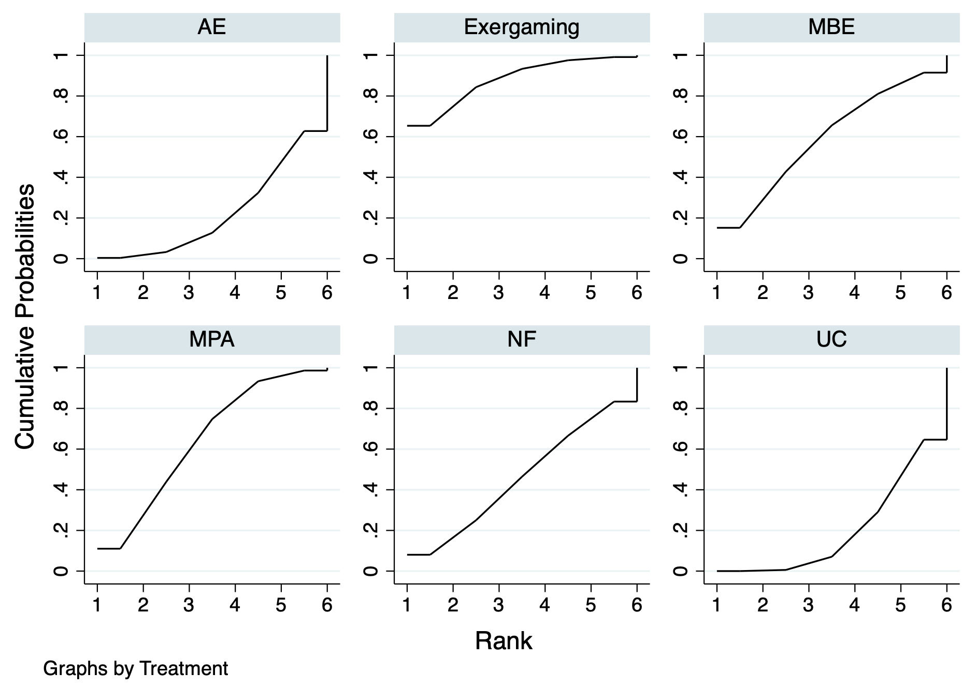
Fig. S11.2 Ranking plot for memory

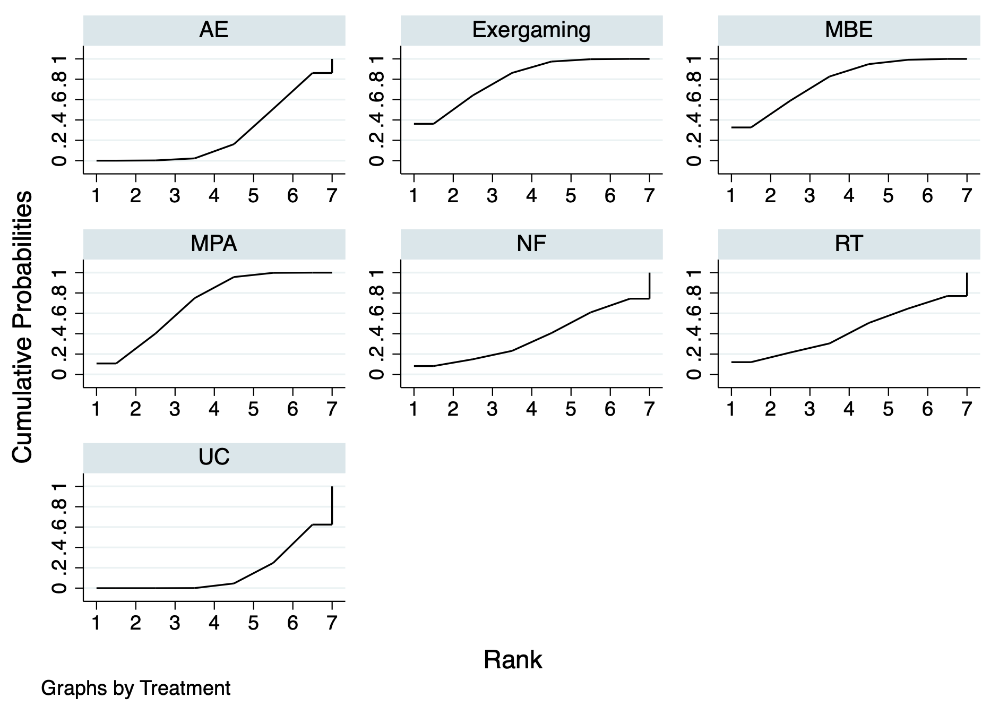
Fig. S11.3 Ranking plot for executive functions

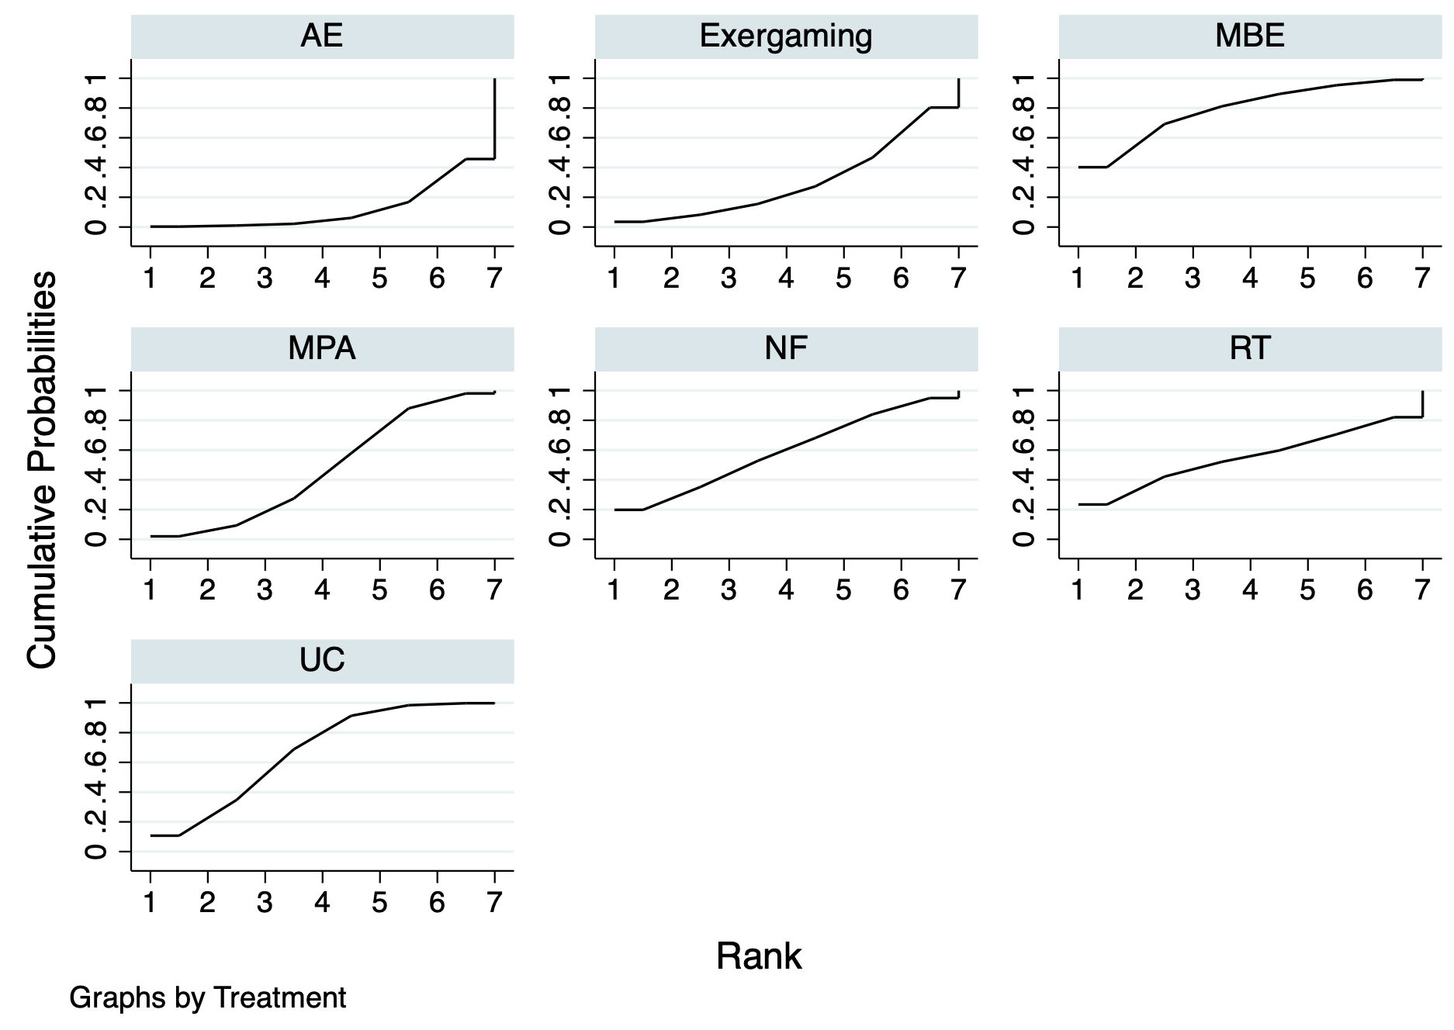
Fig. S11.4 Ranking plot for acceptability

Supplementary 12 Comparison-adjusted funnel plots
Given that no studies evaluating memory were classified as having a high risk of bias, sensitivity analysis for memory was not performed.
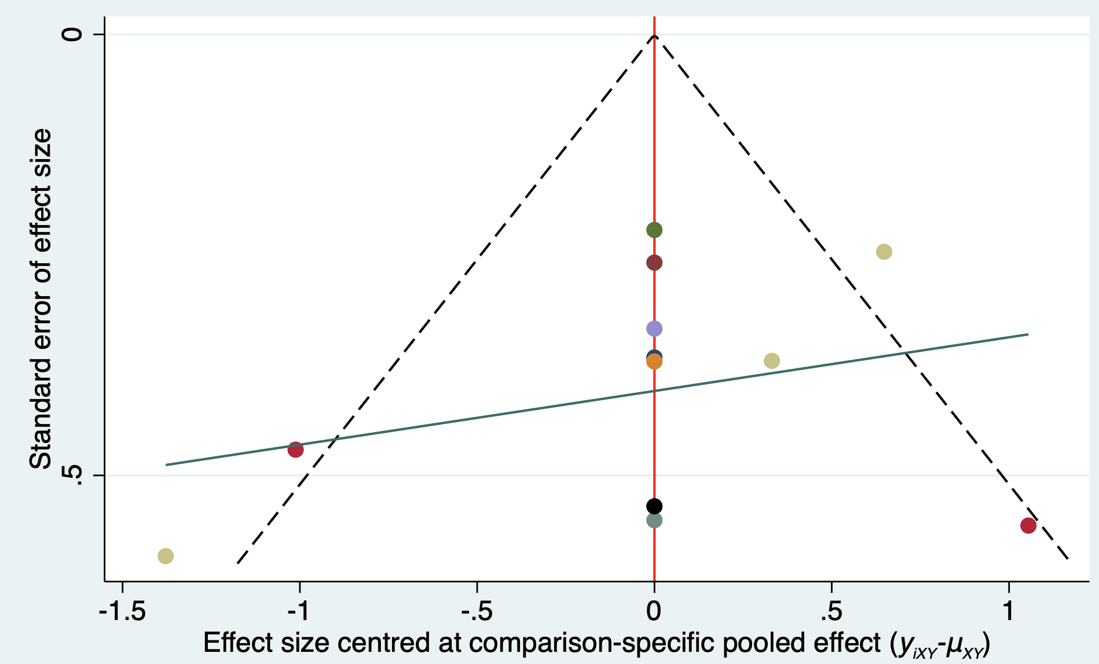
Fig. S12.1 Comparison-adjusted funnel plots for attention (Egger test: p = 0.304)
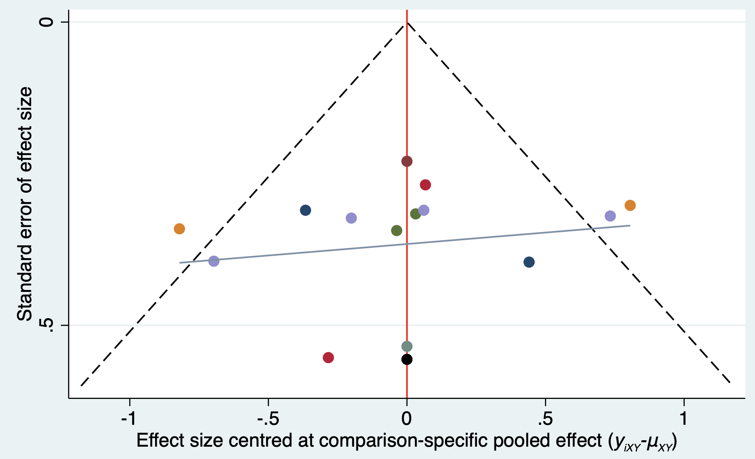
Fig. S12.2 Comparison-adjusted funnel plots for memory (Egger test: p = 0.585)
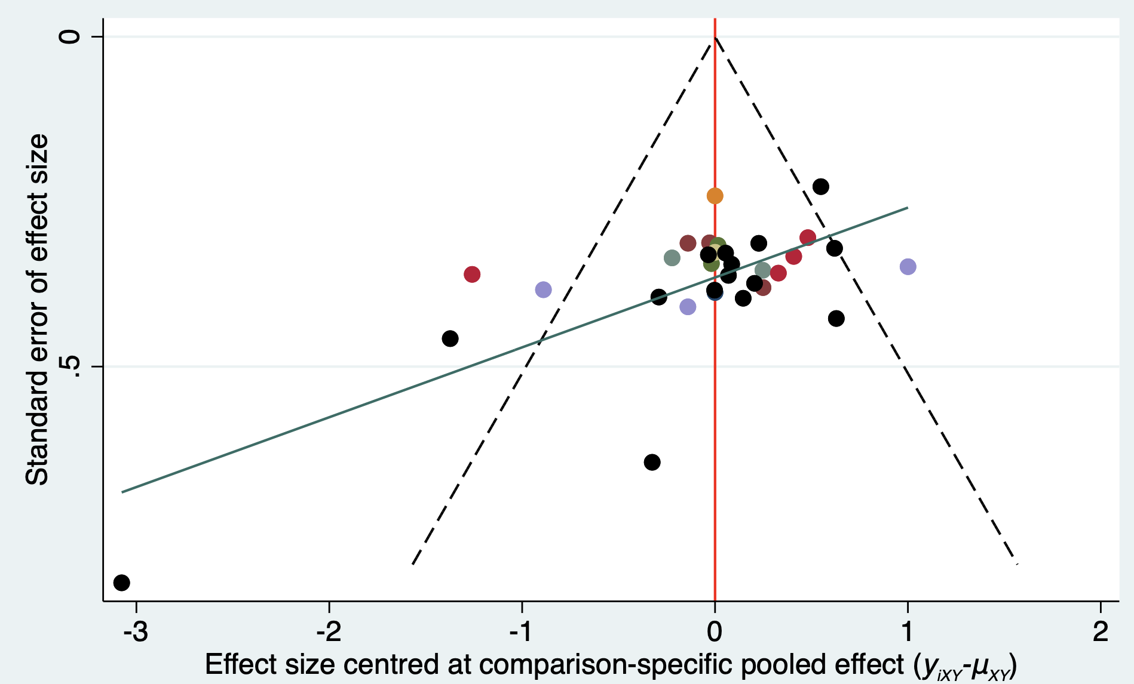
Fig. S12.3 Comparison-adjusted funnel plots for executive functions (Egger test: p = 0.003)
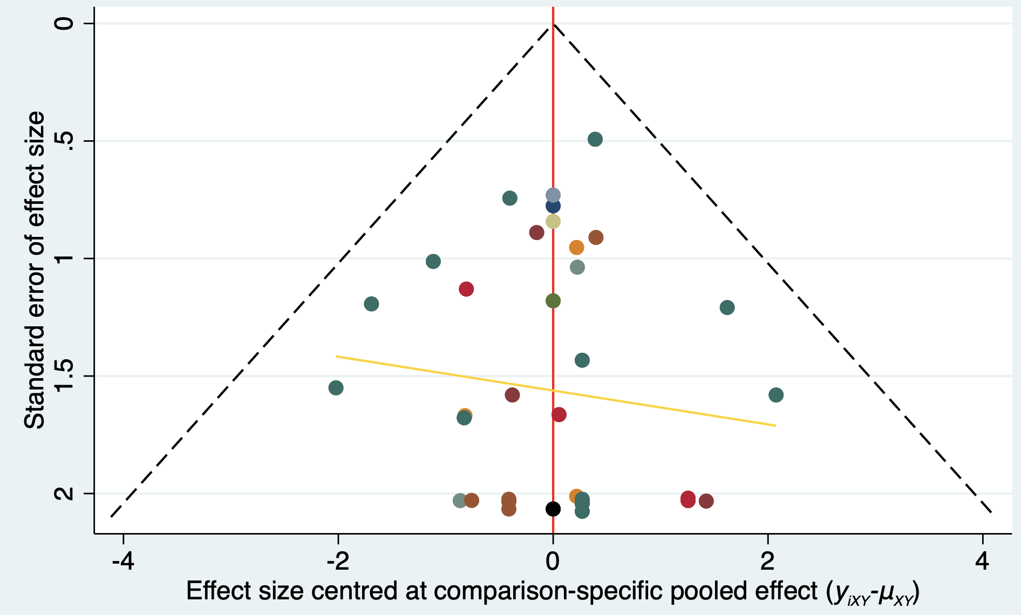
Fig. S12.4 Comparison-adjusted funnel plots for acceptability (Egger test: p = 0.386)

Supplementary 13 League tables for specific NDDs
Table S13.1 League table for attention in children with ADHD
MBE
0.13 (-1.45,1.70) | MPA
1.20 (-0.11,2.52) | 1.08 (-0.10,2.26) | NF
1.32 (-0.74,3.37) | 1.19 (-0.87,3.25) | 0.12 (-1.71,1.94) | Exergaming
1.44 (-0.01,2.89) | 1.31 (-0.15,2.77) | 0.24 (-0.86,1.33) | 0.12 (-1.33,1.58) | AE
2.00 (0.89,3.10) | 1.87 (0.61,3.14) | 0.80 (-0.26,1.85) | 0.68 (-1.14,2.50) | 0.56 (-0.53,1.65) | UC
AE aerobic exercise, MBE mind-body exercise, MPA multicomponent physical activity, NF neurofeedback, UC usual care. Results are presented as standardized mean differences (SMD) and 95% confidence intervals. SMD values more than 0.00 favor the column-defining treatment node for the NMA results. Estimates in bold denote significance at p<0.05.
Table S13.4 League table for memory in children with ADHD
MPA
0.38 (-0.35,1.11) | MBE
0.63 (-0.22,1.48) | 0.25 (-0.56,1.06) | Exergaming
0.66 (-0.11,1.42) | 0.28 (-0.52,1.07) | 0.03 (-0.94,0.99) | NF
0.74 (0.14,1.35) | 0.36 (-0.31,1.04) | 0.11 (-0.71,0.93) | 0.09 (-0.49,0.66) | AE
0.81 (0.24,1.38) | 0.43 (-0.07,0.93) | 0.18 (-0.45,0.82) | 0.16 (-0.57,0.88) | 0.07 (-0.45,0.59) | UC
AE aerobic exercise, MBE mind-body exercise, MPA multicomponent physical activity, NF neurofeedback, UC usual care. Results are presented as standardized mean differences (SMD) and 95% confidence intervals. SMD values more than 0.00 favor the column-defining treatment node for the NMA results. Estimates in bold denote significance at p<0.05.

Table S13.3 League table for executive functions in children with ADHD
MBE
1.08 (0.12,2.05) | MPA
1.26 (0.24,2.27) | 0.17 (-0.36,0.71) | Exergaming
1.80 (0.56,3.04) | 0.72 (-0.16,1.59) | 0.54 (-0.36,1.44) | NF
1.82 (0.93,2.71) | 0.74 (0.36,1.12) | 0.57 (0.08,1.06) | 0.02 (-0.84,0.89) | UC
1.91 (0.87,2.95) | 0.83 (0.26,1.40) | 0.66 (0.06,1.25) | 0.11 (-0.56,0.78) | 0.09 (-0.45,0.63) | AE
AE aerobic exercise, MBE mind-body exercise, MPA multicomponent physical activity, NF neurofeedback, UC usual care. Results are presented as standardized mean differences (SMD) and 95% confidence intervals. SMD values more than 0.00 favor the column-defining treatment node for the NMA results. Estimates in bold denote significance at p<0.05.
Table S13.4 League table for executive functions in children with ASD
MPA
-0.04 (-1.10,1.02) | Exergaming
0.20 (-0.80,1.21) | 0.25 (-1.13,1.62) | MBE
0.48 (-0.30,1.26) | 0.52 (-0.77,1.81) | 0.28 (-0.94,1.49) | AE
0.74 (-0.81,2.29) | 0.78 (-1.03,2.59) | 0.53 (-0.65,1.71) | 0.26 (-1.44,1.95) | RT
0.67 (0.18,1.17) | 0.71 (-0.35,1.78) | 0.47 (-0.41,1.34) | 0.19 (-0.65,1.04) | -0.06 (-1.53,1.41) | UC
AE aerobic exercise, MBE mind-body exercise, MPA multicomponent physical activity, RT relaxation techniques, UC usual care. Results are presented as standardized mean differences (SMD) and 95% confidence intervals. SMD values more than 0.00 favor the column-defining treatment node for the NMA results. Estimates in bold denote significance at p<0.05.

Supplementary 14 Sensitivity Analyses
Given that no studies evaluating memory were classified as having a high risk of bias, sensitivity analysis was not performed for memory.
Table S14.1 League tables for attention after removing studies with high risk of bias
MBE
0.35 (-1.73,2.42) | Exergaming
0.79 (-1.29,2.87) | 0.44 (-1.72,2.60) | MPA
1.10 (-0.76,2.97) | 0.76 (-0.81,2.32) | 0.32 (-1.70,2.33) | AE
1.13 (-0.66,2.92) | 0.78 (-1.20,2.76) | 0.34 (-1.81,2.49) | 0.02 (-1.51,1.56) | NF
1.99 (0.54,3.45) | 1.64 (0.08,3.21) | 1.20 (-0.27,2.68) | 0.89 (-0.49,2.26) | 0.87 (-0.69,2.42) | UC
AE aerobic exercise, MBE mind-body exercise, MPA multicomponent physical activity, RT relaxation techniques, NF neurofeedback, UC usual care. Results are presented as standardized mean differences (SMD) and 95% confidence intervals. SMD values more than 0.00 favor the column-defining treatment node. Estimates in bold denote significance at p<0.05
Table S14.2 League tables for executive functions after removing studies with high risk of bias
Exergaming
0.10 (-0.95,1.15) | MBE
0.13 (-0.45,0.71) | 0.03 (-0.93,0.99) | MPA
0.63 (-0.98,2.25) | 0.53 (-0.69,1.76) | 0.50 (-1.05,2.06) | RT
0.67 (-0.68,2.01) | 0.57 (-1.00,2.13) | 0.54 (-0.74,1.82) | 0.03 (-1.96,2.02) | NF
0.78 (0.08,1.48) | 0.68 (-0.39,1.75) | 0.65 (0.09,1.22) | 0.15 (-1.48,1.77) | 0.11 (-1.03,1.26) | AE
0.95 (0.40,1.49) | 0.85 (-0.05,1.74) | 0.82 (0.48,1.16) | 0.32 (-1.20,1.83) | 0.28 (-1.01,1.57) | 0.17 (-0.41,0.75) | UC
AE aerobic exercise, MBE mind-body exercise, MPA multicomponent physical activity, RT relaxation techniques, NF neurofeedback, UC usual care. Results are presented as standardized mean differences (SMD) and 95% confidence intervals. SMD values more than 0.00 favor the column-defining treatment node. Estimates in bold denote significance at p<0.05

Table S14.3. League tables for acceptability after removing studies with high risk of bias
MBE
0.81 (0.08,8.47) | NF
0.63 (0.16,2.53) | 0.78 (0.10,6.11) | UC
0.66 (0.13,3.45) | 0.82 (0.05,14.50) | 1.05 (0.12,9.13) | RT
0.39 (0.08,1.81) | 0.48 (0.06,3.91) | 0.62 (0.31,1.22) | 0.59 (0.06,5.60) | MPA
0.32 (0.05,1.85) | 0.39 (0.04,3.53) | 0.51 (0.17,1.52) | 0.48 (0.04,5.36) | 0.82 (0.27,2.51) | Exergaming
0.23 (0.04,1.21) | 0.28 (0.04,2.01) | 0.36 (0.14,0.96) | 0.34 (0.03,3.59) | 0.59 (0.22,1.58) | 0.71 (0.23,2.19) | AE
AE aerobic exercise, MBE mind-body exercise, MPA multicomponent physical activity, RT relaxation techniques, NF neurofeedback, UC usual care. Results are presented as standardized mean differences (SMD) and 95% confidence intervals. SMD values more than 0.00 favor the column-defining treatment node. Estimates in bold denote significance at p<0.05

Supplementary 15 Meta-regression and subgroup analyses
Because undertaking subgroup analysis requires a minimum of ten studies [4], we restricted this analysis to memory and executive functions.
Table S15.1a Meta-regression analysis for attention
 | k | Coef. (SE) | 95% CI | I² (%) | p
Sample size | 7 | -0.014 (0.019) | (-0.050, 0.023) | 90.44 | 0.463
Total length (week) | 7 | 0.028 (0.015) | (-0.002, 0.058) | 87.47 | 0.064
Total dose (min) | 7 | 0.000 (0.000) | (-0.00, 0.001) | 89.01 | 0.123
k=number of data points, coef.=regression coefficient, SE=standard error.

Table S15.1b Meta-regression analysis for memory
 | k | Coef. (SE) | 95% CI | I² (%) | p
Sample size | 10 | 0.008 (0.019) | (-0.029, 0.045) | 73.10 | 0.665
Total length (week) | 10 | -0.003 (0.060) | (-0.121, 0.114) | 73.72 | 0.959
Total dose (min) | 10 | -0.000 (0.000) | (-0.001, 0.000) | 73.39 | 0.787
k=number of data points, coef.=regression coefficient, SE=standard error.

Table S15.1c Meta-regression analysis for excutive functions
 | k | Coef. (SE) | 95% CI | I² (%) | p
Sample size | 24 | -0.006 (0.136) | (-0.324, 0.021) | 79.90 | 0.677
Total length (week) | 24 | 0.003 (0.012) | (-0.020, 0.026) | 80.62 | 0.805
Total dose (min) | 24 | 0.000 (0.000) | (-0.000, 0.000) | 80.45 | 0.562
k=number of data points, coef.=regression coefficient, SE=standard error.

Table S15.2a Subgroup analyses for memory
 | k | Hedges’ g | 95% CI | I² (%) | Test of heterogeneity
 |  |  |  |  | Q | df | p
NDDs category |  |  |  |  | 24.16 | 3 | 0.000
ADHD | 5 | 0.358 | (0.047, 0.668) | 15.45
ASD | 3 | -0.060 | (-0.522, 0.402) | 25.49
DCD | 1 | 1.810 | (1.159, 2.461) | .
SLD | 1 | 1.057 | (0.311, 1.803) | .
Duration |  |  |  |  | 0.11 | 1 | 0.735
≤ 50min | 4 | 0.571 | (-0.349, 1.490) | 86.02
> 50min | 6 | 0.401 | (0.058, 0.745) | 38.52
Frequency |  |  |  |  | 4.94 | 2 | 0.084
< 3 session/week | 2 | 0.051 | (-0.711, 0.812) | 72.25
3 sessions/week | 5 | 0.860 | (0.296, 1.424) | 69.16
> 3 sessions/week | 3 | 0.116 | (-0.296, 0.527) | 1.68
Length |  |  |  |  | 1.84 | 1 | 0.175
≤ 8 weeks | 6 | 0.676 | (0.115, 1.237) | 72.08
> 8 weeks | 4 | 0.184 | (-0.251, 0.620) | 52.52
Intensity |  |  |  |  | 0.05 | 2 | 0.973
LMPA | 2 | 0.145 | (-0.384, 0.675) | 3.65
Moderate | 3 | 0.216 | (-0.355, 0.787) | 65.30
MVPA | 2 | 0.133 | (-0.303, 0.569) | 0.21
ADHD attention-deficit/hyperactivity disorder, ASD autism spectrum disorder, DCD developmental coordination disorder, LD learning disorder, LMPA light-to-moderate physical activity; MVPA moderate-to-vigorous physical activity.

Table S15.2b. Subgroup analyses for executive functions
 | k | Hedges’ g | 95% CI | % | Test of heterogeneity
 |  |  |  |  | Q | df | p
NDDs category |  |  |  |  | 2.19 | 3 | 0.535
ADHD | 13 | 0.779 | (0.444, 1.114) | 67.69
ASD | 8 | 0.566 | (0.055, 1.077) | 72.84
DCD | 2 | 2.391 | (-0.244, 5.025) | 67.69
LD | 1 | 0.567 | (-0.144, 1.278) | .
Duration |  |  |  |  | 2.64 | 1 | 0.104
≤ 50min | 10 | 0.527 | (0.246, 0.809) | 37.65
> 50min | 14 | 1.023 | (0.496, 1.551) | 85.79
Frequency |  |  |  |  | 6.96 | 2 | 0.031
< 3 session/week | 8 | 0.827 | (0.416, 1.238) | 61.53
3 sessions/week | 14 | 0.905 | (0.394, 1.416) | 85.24
> 3 sessions/week | 2 | 0.071 | (-0.420, 0.563) | 0.00
Length |  |  |  |  | 0.95 | 1 | 0.330
≤ 8 weeks | 12 | 0.641 | (0.111, 1.171) | 85.58
> 8 weeks | 12 | 0.975 | (0.562, 1.338) | 71.82
Intensity |  |  |  |  | 6.18 | 2 | 0.046
LMPA | 4 | 0.057 | (-0.311, 0.425) | 0.40
Moderate | 3 | 1.163 | (0.218, 2.108) | 80.72
MVPA | 5 | 0.674 | (0.031, 1.316) | 79.00
ADHD attention-deficit/hyperactivity disorder, ASD autism spectrum disorder, DCD developmental coordination disorder, LD learning disorder, LMPA light-to-moderate physical activity; MVPA moderate-to-vigorous physical activity.

Supplementary 16 Grading the evidence of the network meta-analysis using CINeMA
We used the CINeMA (Confidence in Network Meta-Analysis) framework, implemented in the web application CINeMA (https://cinema.ispm.unibe.ch/), to assess the certainty of evidence for cognitive functions [5,6]. The CINeMA framework consists of six domains that affect the level of evidence in the estimates of NMA: within‐study bias, reporting bias, indirectness, imprecision, heterogeneity, and incoherence.
To evaluate each network estimate, we used the following criteria:
- Within-study bias: We assessed overall risk of bias using the Cochrane risk of bias tool 2. Within-study bias for each pairwise comparison was classified as “no concerns”, “some concerns”, or “major concerns” based on the weighted average overall risk of bias according to the contribution matrix.
- Reporting bias: We inspected publication bias by comparison-adjusted funnel plots and Egger test results. We cannot completely rule out the possibility that some studies are still missing, and we carefully assumed some comparisons as “some concerns” according to funnel plot.
- Indirectness: We evaluated whether populations, interventions, outcomes, and study settings represented the specific research questions. No clear evidence of violations of the transitivity assumption was found in this network, and meta-regression showed that potential modifiers did not significantly impact the primary result. Thus, indirectness was not downgraded.
- Imprecision: We set a cutoff threshold of SMD 0.5 for clinical effectiveness [7] and assessed precision using treatment effects included in the 95% confidence interval relative to potentially clinically important differences for each pairwise comparison.
- Heterogeneity: We considered heterogeneity based on the relationship between the 95% confidence intervals and the 95% prediction intervals with the clinically important differences defined above in the domain of imprecision.
- Incoherence: We used the design-by-treatment model and did not detect any global inconsistency (p>0.05). We used side-splitting approach and did not detect any local inconsistency (p>0.05). Thus, incoherence was not downgraded.
We classified the overall judgment on the confidence in the NMA estimate for each comparison as “very low,” “low,” “moderate,” and “high.” The starting point for certainty was high, and it could be downgraded to one level for a rating of “some concerns” and two levels for a rating of “major concerns.” It is recommended to consider judgments on different domains jointly rather than in isolation, as imprecision, incoherence, and heterogeneity are interconnected.
In this NMA, the evidence was downgraded primarily due to within-study bias, imprecision, and heterogeneity concerns. Within-study bias was attributed to factors such as open-label studies, unblinded assessors, and improper handling of missing data, resulting in a rating of “some concern”. After excluding studies with high risk of bias assessed by the risk of bias tool 2, the results remained consistent, indicating the stability of the outcomes. Regarding imprecision, comparisons rated with “some concerns” did not contribute significantly to the findings in the league tables. Moderate heterogeneity, as observed in this study, might result in somewhat different conclusions but had a lesser impact on decision-making [5].

Table S16.1 CINeMA assessment for attention
Comparison | N of  studies | Within-study bias | Reporting bias | Indirectness | Imprecision | Heterogeneity | Incoherence | Confidence rating
AE:Exergaming | 1 | Some concerns | Low risk | No concerns | Some concerns | No concerns | No concerns | Low
AE:NF | 1 | Some concerns | Low risk | No concerns | Some concerns | No concerns | No concerns | Low
AE:UC | 1 | Some concerns | Low risk | No concerns | No concerns | Some concerns | No concerns | Low
Exergaming:UC | 1 | Some concerns | Low risk | No concerns | No concerns | Major concerns | No concerns | Very low
MBE:NF | 1 | Some concerns | Low risk | No concerns | No concerns | Some concerns | No concerns | Low
MBE:UC | 2 | Some concerns | Some concerns | No concerns | No concerns | Major concerns | No concerns | Very low
MPA:NF | 1 | Major concerns | Low risk | No concerns | Some concerns | No concerns | No concerns | Very low
MPA:UC | 3 | Major concerns | Some concerns | No concerns | No concerns | Major concerns | No concerns | Very low
NF:UC | 1 | Some concerns | Low risk | No concerns | Some concerns | No concerns | No concerns | Low
AE:MBE | 0 | Some concerns | Low risk | No concerns | No concerns | Some concerns | No concerns | Low
AE:MPA | 0 | Some concerns | Low risk | No concerns | Some concerns | No concerns | No concerns | Low
Exergaming:MBE | 0 | Some concerns | Low risk | No concerns | Some concerns | No concerns | No concerns | Low
Exergaming:MPA | 0 | Some concerns | Low risk | No concerns | Some concerns | No concerns | No concerns | Low
Exergaming:NF | 0 | Some concerns | Low risk | No concerns | Some concerns | No concerns | No concerns | Low
MBE:MPA | 0 | Some concerns | Low risk | No concerns | Some concerns | No concerns | No concerns | Low

Table S16.2 CINeMA assessment for memory
Comparison | N of  studies | Within-study bias | Reporting bias | Indirectness | Imprecision | Heterogeneity | Incoherence | Confidence rating
AE:MPA | 2 | Some concerns | Low risk | No concerns | No concerns | Some concerns | No concerns | Low
AE:NF | 1 | Some concerns | Low risk | No concerns | Some concerns | No concerns | No concerns | Low
AE:UC | 2 | Some concerns | Low risk | No concerns | Some concerns | No concerns | No concerns | Low
Exergaming:UC | 2 | Some concerns | Low risk | No concerns | No concerns | Major concerns | No concerns | Very low
MBE:NF | 1 | Some concerns | Low risk | No concerns | Some concerns | No concerns | No concerns | Low
MBE:UC | 2 | Some concerns | Low risk | No concerns | No concerns | Some concerns | No concerns | Low
MPA:UC | 4 | Some concerns | Low risk | No concerns | No concerns | Some concerns | No concerns | Low
NF:UC | 1 | Some concerns | Low risk | No concerns | Some concerns | No concerns | No concerns | Low
AE:Exergaming | 0 | Some concerns | Low risk | No concerns | No concerns | Some concerns | No concerns | Low
AE:MBE | 0 | Some concerns | Low risk | No concerns | Some concerns | No concerns | No concerns | Low
Exergaming:MBE | 0 | Some concerns | Low risk | No concerns | Some concerns | No concerns | No concerns | Low
Exergaming:MPA | 0 | Some concerns | Low risk | No concerns | Some concerns | No concerns | No concerns | Low
Exergaming:NF | 0 | Some concerns | Low risk | No concerns | Some concerns | No concerns | No concerns | Low
MBE:MPA | 0 | Some concerns | Low risk | No concerns | Some concerns | No concerns | No concerns | Low
MPA:NF | 0 | Some concerns | Low risk | No concerns | Some concerns | No concerns | No concerns | Low

Table S16.3 CINeMA assessment for executive functions
Comparison | N of  studies | Within-study bias | Reporting bias | Indirectness | Imprecision | Heterogeneity | Incoherence | Confidence rating
AE:Exergaming | 1 | Some concerns | Low risk | No concerns | No concerns | Some concerns | No concerns | Low
AE:MPA | 3 | Some concerns | Low risk | No concerns | No concerns | Major concerns | No concerns | Very low
AE:NF | 1 | Some concerns | Low risk | No concerns | Some concerns | No concerns | No concerns | Low
AE:UC | 2 | Some concerns | Low risk | No concerns | No concerns | Some concerns | No concerns | Low
Exergaming:MPA | 2 | Some concerns | Low risk | No concerns | No concerns | Some concerns | No concerns | Low
Exergaming:UC | 4 | Some concerns | Some concerns | No concerns | No concerns | Some concerns | No concerns | Very low
MBE:RT | 1 | Some concerns | Low risk | No concerns | Some concerns | No concerns | No concerns | Low
MBE:UC | 3 | Some concerns | High risk | No concerns | No concerns | Some concerns | No concerns | Very low
MPA:UC | 15 | Some concerns | Low risk | No concerns | No concerns | Some concerns | No concerns | Low
AE:MBE | 0 | Some concerns | Low risk | No concerns | No concerns | Some concerns | No concerns | Low
AE:RT | 0 | Some concerns | Low risk | No concerns | Some concerns | No concerns | No concerns | Low
Exergaming:MBE | 0 | Some concerns | Low risk | No concerns | Some concerns | No concerns | No concerns | Low
Exergaming:NF | 0 | Some concerns | Low risk | No concerns | Some concerns | No concerns | No concerns | Low
Exergaming:RT | 0 | Some concerns | Low risk | No concerns | Some concerns | No concerns | No concerns | Low
MBE:MPA | 0 | Some concerns | Low risk | No concerns | Some concerns | No concerns | No concerns | Low
MBE:NF | 0 | Some concerns | Low risk | No concerns | Some concerns | No concerns | No concerns | Low
MPA:NF | 0 | Some concerns | Low risk | No concerns | Some concerns | No concerns | No concerns | Low
MPA:RT | 0 | Some concerns | Low risk | No concerns | Some concerns | No concerns | No concerns | Low
NF:RT | 0 | Some concerns | Low risk | No concerns | Some concerns | No concerns | No concerns | Low
NF:UC | 0 | Some concerns | Low risk | No concerns | Some concerns | No concerns | No concerns | Low
RT:UC | 0 | Some concerns | Low risk | No concerns | Some concerns | No concerns | No concerns | Low

Reference
- Rhodes KM, Turner RM, Higgins JPT. Predictive distributions were developed for the extent of heterogeneity in meta-analyses of continuous outcome data. J Clin Epidemiol 2015; 68(1): 52-60. https://doi.org/10.1016/j.jclinepi.2014.08.012.
- Turner RM, Davey J, Clarke MJ, Thompson SG, Higgins JP. Predicting the extent of heterogeneity in meta-analysis, using empirical data from the Cochrane Database of Systematic Reviews. Int J Epidemiol 2012; 41(3): 818-27. https://doi.org/10.1093/ije/dys041.
- Ge L, Sadeghirad B, Ball GDC, et al. Comparison of dietary macronutrient patterns of 14 popular named dietary programmes for weight and cardiovascular risk factor reduction in adults: systematic review and network meta-analysis of randomised trials. BMJ 2020; 369: m696. https://doi.org/10.1136/bmj.m696.
- Deeks JJ, Higgins JPT, Altman DG. Analysing data and undertaking meta-analyses. Cochrane Handbook for Systematic Reviews of Interventions; 2019: 241-84.
- Nikolakopoulou A, Higgins JP, Papakonstantinou T, et al. CINeMA: an approach for assessing confidence in the results of a network meta-analysis. PLoS med 2020; 17(4): e1003082. https://doi.org/10.1371/journal.pmed.1003082.
- Papakonstantinou T, Nikolakopoulou A, Higgins JP, Egger M, Salanti G. CINeMA: software for semiautomated assessment of the confidence in the results of network meta‐analysis. Campbell Syst Rev 2020; 16(1): e1080. https://doi.org/10.1002/cl2.1080.
- Guyatt GH, Oxman AD, Kunz R, et al. GRADE guidelines 6. Rating the quality of evidence—imprecision. J Clin Epidemiol 2011; 64(12): 1283-93. https://doi.org/10.1016/j.jclinepi.2011.01.012.

