Additional File

Supplemental Method 1: Computation of dietary scores

Supplemental Figure 1: Study sample selection

Supplemental Method 2: Construction of OHH consumption typology

Supplemental Table 1: Values of OOH-typology constructing variables

Supplemental Figure 2: Food group consumption across clusters

Supplemental Method 1: Computation of dietary scores
The PNNS-GS2 (National Nutrition Health Guidelines Score) is a score aiming to measure the adherence of individuals’ diets to the official French dietary recommendations. For calculation, 13 dietary components are considered. 7 are considered beneficial (fruits and vegetables, nuts, legumes, whole grains, milk and dairy products, fish and seafood, and added fats), and 6 are deemed unfavourable (red meat, processed meat, sweets, sweetened beverages, alcoholic beverages, and salt). For each positive component, scores ranging from 0 to 2 are assigned, while negative components are scored from 0 to -2, based on average French portion sizes. Additionally, the consumption of organic foods is considered for certain categories (fruits, vegetables, legumes, and whole-grain foods). Adherence to the recommendations is assessed by assigning scores to the intake of each food group. Weighting factors are applied to food groups based on their health impact. The score is penalised on energy intake if an energy intake of more than 105% of energy expenditure is detected, which means that the score is reduced by the same proportion. The total score can range from -∞ to 14.25, with higher scores indicating better dietary quality (1).
The PANDiet (Diet Quality Index based on the Probability of Adequate Nutrient Intake) score measures nutrient adequacy. A total of 28 nutrients are used for calculation, building two sub-scores, the Adequacy Sub-score (AS) and the Moderation Sub-score (MS). The AS presents the adequacy for 28 nutrients (protein, total fat, Linolenic acid, α-Linolenic acid, Eicosapentaenoic acid, Docosahexaenoic acid, fibre, vitamins (A, B1, B2, B3, B5, B6, B9, B12, C, D and E), calcium, copper, iodine, bioavailable iron, magnesium, manganese, bioavailable zinc, phosphorus, potassium, selenium) whose intake should meet a certain reference while the MS concerns the average adherence probability for 6 nutrients (protein, total fat, sugars, saturated fatty acids, cholesterol, and sodium) that should not exceed a certain value. The latter includes 12 penalty values if the limits are exceeded. Computed values range between 0 and 100, higher value indicates better dietary quality (2).
The cDQI (Comprehensive Diet Quality Index) comprises the plant-based diet quality index (pDQI) and the animal-based diet quality index (aDQI). The computation is based on 17 food groups (11 plant-based foods and 6 animal-based foods). Different food groups are considered depending on their healthful or unhealthy contribution. Healthful plant-based food groups include wholegrain products, vegetables (excluding potatoes), fruits, nuts, seeds, legumes, vegetable oils, coffee and tea, while unhealthy components include fruit juices, refined grains, potatoes, sugar-sweetened beverages, sweets and desserts. Fish, seafood, dairy and poultry are considered animal-based healthful food groups. Processed meat, red meat and eggs are counted as unhealthy animal-based components. Depending on their consumption quantity, scores from 0 to 5 per food group are assigned. The score increases (for favourable components) and decreases (for unfavourable components) proportionally using quintiles from no consumption to maximum consumption. Thus, the calculated score ranges from 0 to 85, a higher score indicates higher dietary quality of both animal-based and plant-based components (3).

The ELD-I (EAT-Lancet Diet Index) represents the dietary adherence to the EAT-Lancet diet. This diet promotes increased quantities of plant-based foods in diets with positive impacts on human and planet health (4). It comprises the following 14 food groups: potatoes and tubers, fruits, vegetables, whole grains, dairy, beef/lamb/pork, chicken and other poultry, eggs, fish, legumes, nuts, saturated oil, unsaturated oils, and added sugar. The score is calculated based on consumed quantities of the respective food groups and is displayed as continuous values that can be negative or positive. The higher the values, the higher the adherence to the EAT-Lancet diet (5).

Supplemental Figure 1: Study sample selection
N = 40,680
N = 29,140
Had no missing data on OOH variables
Questionnaire on eating practices, attitudes and motivations
Organic Food-Frequency-Questionnaire
Final sample
N = 37,685
Completed the questionnaire
N = 37,307
Had no missing covariates
N = 35,196
Were not under/over reporters
N = 34,453
Were not living overseas
N = 29,210
Had available data for investigated indicators

Supplemental Method 2: Construction of OHH consumption typology

Scree plot as decision criterion for number of dimensions to retain in MFA:
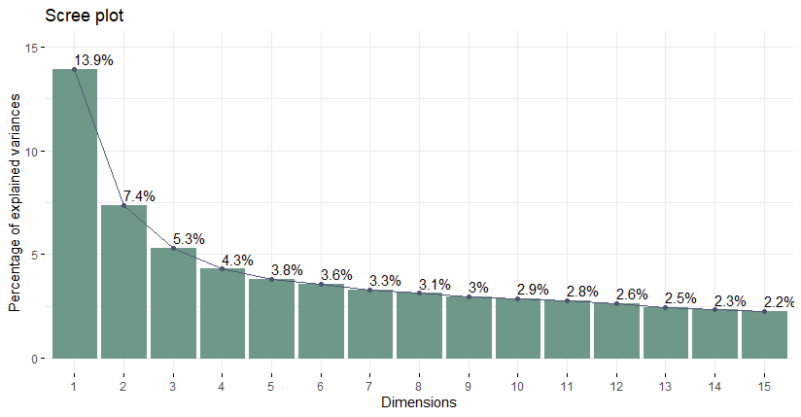
Factor Loadings of quantitative variables
Description | Variable | Dim.1 | Dim.2 | Dim.3
Number of times per week eating OOH at lunchtime on weekdays | num_hd_midi_sem | 1.0979349 | -1.3495018 | -0.6989206
Number of times per week eating OOH in the evening on weekdays | num_hd_soir_sem | 0.3819118 | 0.22706 | -0.1851816
Number of times per week eating OOH on weekends | num_hd_we | 0.4601147 | 0.2833144 | -0.2369407

Factor Loadings of qualitative variables (per category)
Description of each variable |  |  | Variable | Dim.1 | Dim.2 | Dim.3
Frequently | Self-prepared meals | At lunchtime on weekdays | mi_sem_prep_fré | 0.91652301 | -0.80416848 | -0.420736219
Never | Self-prepared meals | At lunchtime on weekdays | mi_sem_prep_jam | -0.65400096 | 0.4032676 | 0.059511818
Sometimes | Self-prepared meals | At lunchtime on weekdays | mi_sem_prep_par | 1.53020523 | -0.68624941 | 0.223883058
Frequently | Restaurant meals | At lunchtime on weekdays | mi_sem_rest_fré | 0.77427171 | -0.0401285 | 0.030920988
Never | Restaurant meals | At lunchtime on weekdays | mi_sem_rest_jam | -0.76110683 | 0.34296612 | 0.021088852
Sometimes | Restaurant meals | At lunchtime on weekdays | mi_sem_rest_par | 1.42700458 | -0.80203884 | -0.066511333
Frequently | Take-away meals | At lunchtime on weekdays | mi_sem_emp_fré | 1.03793615 | -0.65017111 | -0.206092341
Never | Take-away meals | At lunchtime on weekdays | mi_sem_emp_jam | -0.59653487 | 0.32104624 | 0.028114158
Sometimes | Take-away meals | At lunchtime on weekdays | mi_sem_emp_par | 1.48145726 | -0.7802272 | -0.040517713
Frequently | Delivery meals | At lunchtime on weekdays | mi_sem_liv_fré | 1.88826522 | -0.988284 | 0.927676608
Never | Delivery meals | At lunchtime on weekdays | mi_sem_liv_jam | -0.07186174 | 0.02583433 | -0.035266059
Sometimes | Delivery meals | At lunchtime on weekdays | mi_sem_liv_par | 2.53705136 | -0.88141581 | 1.244954376
Frequently | Canteen meals | At lunchtime on weekdays | mi_sem_can_fré | 0.74987836 | -0.72995996 | -0.71848131
Never | Canteen meals | At lunchtime on weekdays | mi_sem_can_jam | -0.34913919 | 0.25106871 | 0.129048182
Sometimes | Canteen meals | At lunchtime on weekdays | mi_sem_can_par | 1.53800554 | -0.82471763 | 0.082385324
Frequently | Meals at family/friends | At lunchtime on weekdays | mi_sem_fam_fré | 1.07404951 | 0.2859967 | -0.085712216
Never | Meals at family/friends | At lunchtime on weekdays | mi_sem_fam_jam | -0.40405359 | 0.0714327 | -0.026993118
Sometimes | Meals at family/friends | At lunchtime on weekdays | mi_sem_fam_par | 1.39152435 | -0.36366709 | 0.131894567
Frequently | Self-prepared meals | At evenings on weekdays or weekends | soir_we_prep_fré | 1.18601351 | 0.83106801 | -0.554457804
Never | Self-prepared meals | At evenings on weekdays or weekends | soir_we_prep_jam | -0.73200843 | -0.38758246 | 0.126569841
Sometimes | Self-prepared meals | At evenings on weekdays or weekends | soir_we_prep_par | 1.57193509 | 0.63949597 | 0.059884998
Frequently | Restaurant meals | At evenings on weekdays or weekends | soir_we_rest_fré | 0.94407139 | 0.6612226 | -0.332922961
Never | Restaurant meals | At evenings on weekdays or weekends | soir_we_rest_jam | -1.0660458 | -0.47472139 | 0.241735755
Sometimes | Restaurant meals | At evenings on weekdays or weekends | soir_we_rest_par | 1.39876372 | 0.42534414 | -0.219694563
Frequently | Take-away meals | At evenings on weekdays or weekends | soir_we_emp_fré | 1.17741524 | 0.8458355 | -0.699450171
Never | Take-away meals | At evenings on weekdays or weekends | soir_we_emp_jam | -0.39660721 | -0.17935077 | 0.0325419
Sometimes | Take-away meals | At evenings on weekdays or weekends | soir_we_emp_par | 1.69092433 | 0.73212147 | -0.076155824
Frequently | Delivery meals | At evenings on weekdays or weekends | soir_we_liv_fré | 1.65354593 | 0.67653946 | -0.6926557
Never | Delivery meals | At evenings on weekdays or weekends | soir_we_liv_jam | -0.14559055 | -0.03980267 | -0.00568255
Sometimes | Delivery meals | At evenings on weekdays or weekends | soir_we_liv_par | 2.11745506 | 0.55722473 | 0.155712983
Frequently | Canteen meals | At evenings on weekdays or weekends | soir_we_can_fré | 1.13231129 | 0.9971186 | -1.215189476
Never | Canteen meals | At evenings on weekdays or weekends | soir_we_can_jam | -0.09699374 | -0.06591158 | 0.000788183
Sometimes | Canteen meals | At evenings on weekdays or weekends | soir_we_can_par | 1.78591467 | 1.15308863 | 0.306078519
Frequently | Meals at family/friends | At evenings on weekdays or weekends | soir_we_fam_fré | 1.12353957 | 0.62687676 | -0.427255304
Never | Meals at family/friends | At evenings on weekdays or weekends | soir_we_fam_jam | -1.10034617 | -0.50111231 | 0.266687427
Sometimes | Meals at family/friends | At evenings on weekdays or weekends | soir_we_fam_par | 1.25352342 | 0.44707911 | -0.137312011
Frequently | Self-prepared meals organic | At lunchtime on weekdays | midi_sem_prep_bio_fré | 1.33066054 | -0.90647592 | 0.45467207
Never | Self-prepared meals organic | At lunchtime on weekdays | midi_sem_prep_bio_jam | -0.44888183 | 0.24353317 | -0.097139953
Sometimes | Self-prepared meals organic | At lunchtime on weekdays | midi_sem_prep_bio_par | 1.70389992 | -0.84141858 | 0.293750631
Frequently | Restaurant meals organic | At lunchtime on weekdays | midi_sem_rest_bio_fré | 1.80079375 | -0.27663873 | 1.625758565
Never | Restaurant meals organic | At lunchtime on weekdays | midi_sem_rest_bio_jam | -0.22572971 | 0.05857231 | -0.15503679
Sometimes | Restaurant meals organic | At lunchtime on weekdays | midi_sem_rest_bio_par | 2.36580056 | -0.62429415 | 1.603638727
Frequently | Take-away meals organic | At lunchtime on weekdays | midi_sem_emp_bio_fré | 1.36007416 | -1.07533557 | 0.97232525
Never | Take-away meals organic | At lunchtime on weekdays | midi_sem_emp_bio_jam | -0.22489377 | 0.08432246 | -0.138950433
Sometimes | Take-away meals organic | At lunchtime on weekdays | midi_sem_emp_bio_par | 2.51320735 | -0.90094115 | 1.543124218
Frequently | Delivery meals organic | At lunchtime on weekdays | midi_sem_livr_bio_fré | 2.38036752 | -2.11709951 | 3.065471865
Never | Delivery meals organic | At lunchtime on weekdays | midi_sem_livr_bio_jam | -0.0314375 | 0.01018592 | -0.039381842
Sometimes | Delivery meals organic | At lunchtime on weekdays | midi_sem_livr_bio_par | 4.16682572 | -1.24704304 | 5.213395387
Frequently | Self-prepared meals organic | At evenings on weekdays or weekends | soir_we_prep_bio_fré | 1.66257925 | 1.0566712 | 0.318138717
Never | Self-prepared meals organic | At evenings on weekdays or weekends | soir_we_prep_bio_jam | -0.4388197 | -0.22933019 | -0.059404619
Sometimes | Self-prepared meals organic | At evenings on weekdays or weekends | soir_we_prep_bio_par | 1.87480542 | 0.94893597 | 0.238510237
Frequently | Restaurant meals organic | At evenings on weekdays or weekends | soir_we_rest_bio_fré | 2.04816298 | 0.81997477 | 1.020974006
Never | Restaurant meals organic | At evenings on weekdays or weekends | soir_we_rest_bio_jam | -0.27631441 | -0.10344825 | -0.135697952
Sometimes | Restaurant meals organic | At evenings on weekdays or weekends | soir_we_rest_bio_par | 2.33312255 | 0.8704076 | 1.144919869
Frequently | Take-away meals organic | At evenings on weekdays or weekends | soir_we_emp_bio_fré | 1.67972556 | 1.50237679 | 0.223825216
Never | Take-away meals organic | At evenings on weekdays or weekends | soir_we_emp_bio_jam | -0.15200213 | -0.07254448 | -0.091750018
Sometimes | Take-away meals organic | At evenings on weekdays or weekends | soir_we_emp_bio_par | 2.83900806 | 1.33226256 | 1.73922794
Frequently | Delivery meals organic | At evenings on weekdays or weekends | soir_we_livr_bio_fré | 1.43982394 | 2.30714573 | -0.286908282
Never | Delivery meals organic | At evenings on weekdays or weekends | soir_we_livr_bio_jam | -0.03560199 | -0.01377432 | -0.036120654
Sometimes | Delivery meals organic | At evenings on weekdays or weekends | soir_we_livr_bio_par | 4.42980201 | 1.66061622 | 4.547527675

Scree plot as decision criterion for the optimal number of clusters:
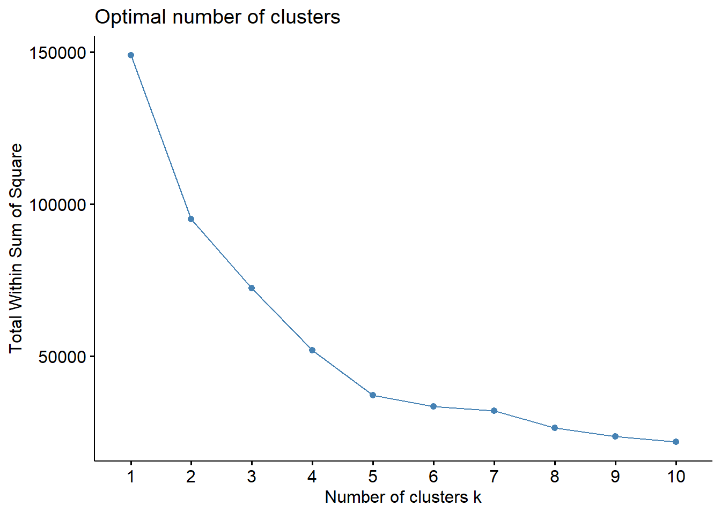

Supplemental Table 1: Values of OOH-typology constructing variables NutriNet-Santé study (2014, n = 29,140)¹
 |  | Cluster 1 |  | Cluster 2 |  | Cluster 3 |  | Cluster 4 |  | Cluster 5
 |  | Weekday-only eaters |  | Frequent weekday and weekend eaters |  | Organic eaters |  | Weekend and evening eaters |  | Home-only eaters
N |  | 5598 |  | 6999 |  | 1820 |  | 5540 |  | 9183
% |  | 19.21 |  | 24.02 |  | 6.25 |  | 19.01 |  | 31.51
 |  | Mean | 95% CI | Mean | 95% CI | Mean | 95% CI | Mean | 95% CI | Mean | 95% CI
Absolute number of times of eating OOH (times per week)
At lunchtime on weekdays |  | 3.81 | 3.77 ; 3.85 | 3.63 | 3.59 ; 3.66 | 2.84 | 2.76 ; 2.92 | 0.3 | 0.29 ; 0.32 | 0.13 | 0.12 ; 0.14
In the evening on weekdays |  | 0.02 | 0.02 ; 0.02 | 0.83 | 0.8 ; 0.85 | 0.89 | 0.85 ; 0.92 | 0.63 | 0.61 ; 0.65 | 0.01 | 0.01 ; 0.01
On weekends |  | 0.05 | 0.04 ; 0.05 | 1.16 | 1.15 ; 1.17 | 1.1 | 1.07 ; 1.12 | 1.03 | 1.02 ; 1.05 | 0.02 | 0.01 ; 0.02
 |  | Cluster 1 |  | Cluster 2 |  | Cluster 3 |  | Cluster 4 |  | Cluster 5
N |  | 5598 |  | 6999 |  | 1820 |  | 5540 |  | 9183
% |  | 19.21 |  | 24.02 |  | 6.25 |  | 19.01 |  | 31.51
Type of meal at lunchtime on weekdays when eating OOH
Summarised frequency in %
Self-prepared
 | Frequently | 36.42 |  | 36.29 |  | 22.36 |  | 3.01 |  | 1.55
 | Sometimes | 27.63 |  | 31.72 |  | 52.47 |  | 2.56 |  | 0.59
 | Never | 35.94 |  | 31.99 |  | 25.16 |  | 94.42 |  | 97.87
Canteen
 | Frequently | 28.87 |  | 31.23 |  | 13.19 |  | 2.38 |  | 1.12
 | Sometimes | 17.17 |  | 19.49 |  | 27.25 |  | 0.97 |  | 0.27
 | Never | 53.97 |  | 49.28 |  | 59.56 |  | 96.64 |  | 98.61
Restaurant
 | Frequently | 14.13 |  | 17.42 |  | 26.43 |  | 15.00 |  | 5.58
 | Sometimes | 41.25 |  | 52.49 |  | 63.35 |  | 3.86 |  | 1.05
 | Never | 44.62 |  | 30.09 |  | 10.22 |  | 81.14 |  | 93.38
Delivery
 | Frequently | 0.41 |  | 0.36 |  | 1.26 |  | 0.04 |  | 0.01
 | Sometimes | 2.59 |  | 4.66 |  | 14.40 |  | 0.20 |  | 0.03
 | Never | 97.00 |  | 94.99 |  | 84.34 |  | 99.77 |  | 99.96
Take away
 | Frequently | 8.13 |  | 8.52 |  | 8.57 |  | 1.59 |  | 0.71
 | Sometimes | 40.46 |  | 51.36 |  | 65.22 |  | 3.16 |  | 0.81
 | Never | 51.41 |  | 40.12 |  | 26.21 |  | 95.25 |  | 98.49
At family / friends
 | Frequently | 3.70 |  | 7.20 |  | 10.82 |  | 5.83 |  | 1.27
 | Sometimes | 22.49 |  | 35.46 |  | 51.92 |  | 9.01 |  | 2.86
 | Never | 73.81 |  | 57.34 |  | 37.25 |  | 85.16 |  | 95.86
Type of meal in the evening on weekdays or on weekends when eating OOH
Summarised frequency in %
Self-prepared
 | Frequently | 0.61 |  | 33.25 |  | 24.34 |  | 37.49 |  | 0.32
 | Sometimes | 0.46 |  | 33.69 |  | 53.08 |  | 32.56 |  | 0.20
 | Never | 98.93 |  | 33.06 |  | 22.58 |  | 29.95 |  | 99.49
Canteen
 | Frequently | 0.05 |  | 2.70 |  | 0.88 |  | 2.36 |  | 0.01
 | Sometimes | 0.09 |  | 6.84 |  | 14.34 |  | 9.55 |  | 0.05
 | Never | 99.86 |  | 90.46 |  | 84.78 |  | 88.09 |  | 99.93
Restaurant
 | Frequently | 3.20 |  | 35.31 |  | 34.34 |  | 49.95 |  | 1.66
 | Sometimes | 2.18 |  | 56.34 |  | 59.51 |  | 42.33 |  | 0.65
 | Never | 94.62 |  | 8.36 |  | 6.15 |  | 7.73 |  | 97.69
Delivery
 | Frequently | 0.02 |  | 1.40 |  | 1.04 |  | 0.90 |  | 0.00
 | Sometimes | 0.14 |  | 13.10 |  | 22.31 |  | 7.38 |  | 0.01
 | Never | 99.84 |  | 85.50 |  | 76.65 |  | 91.71 |  | 99.99
Take away
 | Frequently | 0.20 |  | 3.60 |  | 2.69 |  | 3.92 |  | 0.04
 | Sometimes | 0.32 |  | 34.38 |  | 49.89 |  | 32.31 |  | 0.14
 | Never | 99.48 |  | 62.02 |  | 47.42 |  | 63.77 |  | 99.81
At family / friends
 | Frequently | 2.34 |  | 47.66 |  | 41.92 |  | 53.45 |  | 0.79
 | Sometimes | 2.48 |  | 46.95 |  | 51.37 |  | 41.61 |  | 1.03
 | Never | 95.18 |  | 5.39 |  | 6.70 |  | 4.95 |  | 98.17
Type of meal at lunchtime on weekdays when eating OOH (organic)
Summarised frequency in %
Self-prepared
 | Frequently | 14.33 |  | 9.64 |  | 23.19 |  | 0.83 |  | 0.51
 | Sometimes | 27.37 |  | 27.39 |  | 52.64 |  | 0.34 |  | 0.04
 | Never | 58.31 |  | 62.97 |  | 24.18 |  | 98.83 |  | 99.44
Restaurant
 | Frequently | 0.54 |  | 0.19 |  | 3.30 |  | 0.27 |  | 0.16
 | Sometimes | 11.65 |  | 4.90 |  | 70.16 |  | 2.08 |  | 0.52
 | Never | 87.82 |  | 94.91 |  | 26.54 |  | 97.65 |  | 99.31
Delivery
 | Frequently | 0.16 |  | 0.00 |  | 0.38 |  | 0.00 |  | 0.00
 | Sometimes | 0.16 |  | 0.00 |  | 10.93 |  | 0.00 |  | 0.01
 | Never | 99.68 |  | 100.00 |  | 88.68 |  | 100.00 |  | 99.99
Take away
 | Frequently | 1.39 |  | 0.36 |  | 2.69 |  | 0.20 |  | 0.07
 | Sometimes | 12.43 |  | 6.37 |  | 62.14 |  | 0.31 |  | 0.08
 | Never | 86.17 |  | 93.27 |  | 35.16 |  | 99.49 |  | 99.86
Type of meal in the evening on weekdays or on week-ends when eating OOH (organic)
Summarised frequency in %
Self-prepared
 | Frequently | 0.09 |  | 3.83 |  | 10.05 |  | 5.97 |  | 0.03
 | Sometimes | 0.07 |  | 26.09 |  | 63.90 |  | 32.80 |  | 0.01
 | Never | 99.84 |  | 70.08 |  | 26.04 |  | 61.23 |  | 99.96
Restaurant
 | Frequently | 0.04 |  | 0.51 |  | 3.85 |  | 1.08 |  | 0.02
 | Sometimes | 0.32 |  | 8.66 |  | 71.98 |  | 17.96 |  | 0.05
 | Never | 99.64 |  | 90.83 |  | 24.18 |  | 80.96 |  | 99.92
Delivery
 | Frequently | 0.00 |  | 0.01 |  | 0.05 |  | 0.09 |  | 0.00
 | Sometimes | 0.00 |  | 0.07 |  | 11.59 |  | 0.25 |  | 0.00
 | Never | 100.00 |  | 99.91 |  | 88.35 |  | 99.66 |  | 100.00
Take away
 | Frequently | 0.02 |  | 0.13 |  | 0.71 |  | 0.43 |  | 0.00
 | Sometimes | 0.00 |  | 2.44 |  | 43.02 |  | 9.01 |  | 0.00
 | Never | 99.98 |  | 97.43 |  | 56.26 |  | 90.56 |  | 100.00
¹ Values are means (SD) for continuous variables and percentages for categorical variables.

P-values are based on type III ANOVA test or χ2 test, as appropriate, all P-values < 0.0001
Data is unadjusted.

Supplemental Figure 2: Food group consumption across clusters (g/d)
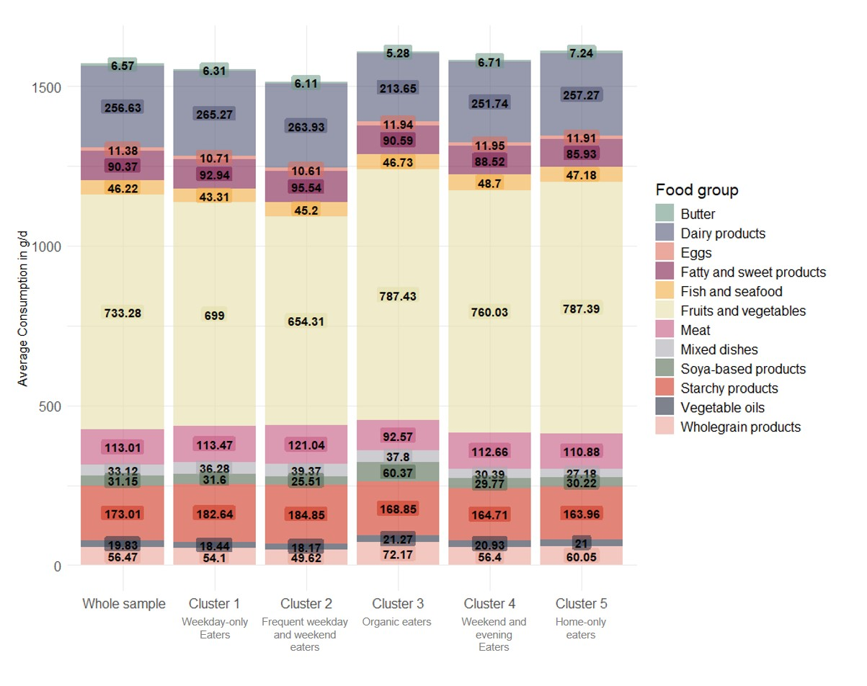
Values are energy-adjusted means of intakes (g/d) derived from ANCOVA. Food groups are constructed as follows: Butter includes all forms of butter; Dairy products include milk, yogurts, fresh cheese, cheese; Eggs include all forms of eggs; Fatty and sweet products include milky desserts, cookies, sweets, croissants, pastries, chocolate, biscuits, ice cream, honey and marmalade, cakes, chips, salted oilseeds, salted biscuits, dressings; Fish includes fish and seafood; Fruits and vegetables include all vegetables, soups, fresh fruits, fruit juice, compote, dried fruits; Meat includes all types of meat (pork, beef, poultry, offal, etc.) and processed meat; Mixed dishes include sandwich, prepared foods such as pizza, hamburger, ravioli, panini, salted pancake, etc.; Soya-based products include tofu, soya-based meat substitute and vegetable patties, soya-based yogurt, soya-based milk; Starchy products include legumes, grains, potatoes, cereals, bread; Vegetable oils include different types of plant-based oils; Wholegrain products include wholegrain pasta, rice, bread. Drinks are excluded.

Supplemental Material References
1. Kesse-Guyot E, Chaltiel D, Fezeu LK, Baudry J, Druesne-Pecollo N, Galan P, et al. Association between adherence to the French dietary guidelines and the risk of type 2 diabetes. Nutrition. 2021 Apr;84:111107.
2. Gavelle E de, Huneau JF, Mariotti F. Patterns of Protein Food Intake Are Associated with Nutrient Adequacy in the General French Adult Population. Nutrients. 2018 Feb 17;10(2):226.
3. Keaver L, Ruan M, Chen F, Du M, Ding C, Wang J, et al. Plant- and animal-based diet quality and mortality among US adults: a cohort study. British Journal of Nutrition. 2021 Jun;125(12):1405–15.
4. EAT. The Planetary Health Diet [Internet]. [cited 2024 Jul 24]. Available from: https://eatforum.org/eat-lancet-commission/the-planetary-health-diet-and-you/
5. Kesse-Guyot E, Rebouillat P, Brunin J, Langevin B, Allès B, Touvier M, et al. Environmental and nutritional analysis of the EAT-Lancet diet at the individual level: insights from the NutriNet-Santé study. Journal of Cleaner Production. 2021 May;296:126555.
6. Francois Husson, Julie Josse, Sebastien Le, Jeremy Mazet. FactoMineR: Multivariate Exploratory Data Analysis and Data Mining [Internet]. 2006 [cited 2024 Jul 24]. p. 2.11. Available from: https://CRAN.R-project.org/package=FactoMineR

