Additional file 4. Mean Absolute SHAP values for instances at one eating occasion, one day, one individual, and all individuals.
Local Feature Importance Example (continue) - Predicting Discretionary Food Intakes
When investigating factor importance in predicting the occurrence of discretionary food consumption, the top five factors for a single eating occasion were meal preparation, place of consumption, age, activity at consumption, and cooking confidence. At the daily level, the top factors were physical activity, food barriers, presence of others at consumption, perceived time barriers, and meal preparation. At the individual level, the top five factors influencing the prediction of discretionary food consumption for participant ID 161 were country of birth, gender, food availability, place of consumption, and level of income (Additional file 4, Table 4.6).
When discretionary food consumption occurred, the top five factors influencing the amount consumed were the presence of others at consumption, place of purchase, self-efficacy, cooking confidence, and gender. At the daily level, the top factors were physical activity, smoking status, level of income, place of consumption, and gender. At the individual level, the top five factors for participant ID 161 were place of purchase, smoking status, place of consumption, food barriers, and social support from family (Additional file 4, Table 4.6).
Case Study Example (continue) - Predicting Daily Diet Quality
For predicting the daily diet quality of participant ID 161, the top five factors for one observation day were level of income, level of education, SEIFA, place of consumption, and smoking status. When assessing overall factor importance for predicting the diet quality of participant ID 161, the top five factors were age, food barriers, food availability, perceived time barriers, and self-efficacy (Additional file 4, Table 4.7).

Table A4.1 Mean Absolute SHAP values to assess predictors impact for predicting fruit consumption. (Results presented were randomly chosen. Values extracted from eating occasion = lunch, Day = 3, ID = 161, All = All IDs)).
Contextual factors | Eating Occasion | Day | Individual | All
Person-level: Intrapersonal factors
Age | 0.0058 | 0.0020 | 0.0014 | 0.0003
Sex | 0.0003 | 0.0010 | 0.0015 | 0.0004
Country of birth | 0.0005 | 0.0023 | 0.0005 | 0.0003
Income | 0.0001 | 0.0032 | 0.0021 | 0.0004
Education | 0.0023 | 0.0023 | 0.0030 | 0.0003
Smoking status | 0.0024 | 0.0031 | 0.0044 | 0.0003
Self-efficacy | 0.0014 | 0.0011 | 0.0009 | 0.0005
Meal Preparation behaviour (food involvement) | 0.0005 | 0.0003 | 0.0026 | 0.0003
Cooking confidence | 0.0114 | 0.0004 | 0.0021 | 0.0005
Perceived time scarcity | 0.0064 | 0.0004 | 0.0015 | 0.0004
Food choice barriers | 0.0014 | 0.0013 | 0.0006 | 0.0005
Physical activity | 0.0026 | 0.0056 | 0.0011 | 0.0004
Person-level: Socio-environmental factors
Social support from family | 0.0028 | 0.0033 | 0.0040 | 0.0005
Social support from friends/colleagues | 0.0025 | 0.0011 | 0.0021 | 0.0003
Person-level: Physical environmental factors
Proximity and access to food destinations | 0.0031 | 0.0005 | 0.0028 | 0.0003
Food availability | 0.0032 | 0.0025 | 0.0001 | 0.0005
Living situation | 0.0012 | 0.0045 | 0.0004 | 0.0004
Area-level socio-economic position (SEIFA) | 0.0031 | 0.0028 | 0.0030 | 0.0003
Eating occasion-level: Environmental factors
Place of consumption | 0.0113 | 0.0023 | 0.0027 | 0.0004
Location of purchase | 0.0143 | 0.0026 | 0.0035 | 0.0004
Eating occasion-level: Social factors
Presence of others | 0.0138 | 0.0010 | 0.0015 | 0.0004
Activity at consumption | 0.0005 | 0.0006 | 0.0010 | 0.0004

Table A4.2 Mean Absolute SHAP values to assess predictors impact for predicting vegetable consumption (Results presented were randomly chosen. Values extracted from eating occasion = lunch, Day = 3, ID = 161, All = All IDs)).
Contextual factors | Eating Occasion | Day | Individual | All
Person-level: Intrapersonal factors
Age | 0.0110 | 0.0063 | 0.0099 | 0.0033
Sex | 0.0069 | 0.0111 | 0.0013 | 0.0033
Country of birth | 0.0039 | 0.0088 | 0.0050 | 0.0031
Income | 0.0069 | 0.0121 | 0.0060 | 0.0035
Education | 0.0065 | 0.0063 | 0.0040 | 0.0032
Smoking status | 0.0055 | 0.0136 | 0.0095 | 0.0031
Self-efficacy | 0.0011 | 0.0006 | 0.0047 | 0.0030
Meal Preparation behaviour (food involvement) | 0.0115 | 0.0092 | 0.0068 | 0.0030
Cooking confidence | 0.0047 | 0.0001 | 0.0008 | 0.0031
Perceived time scarcity | 0.0107 | 0.0125 | 0.0053 | 0.0033
Food choice barriers | 0.0096 | 0.0033 | 0.0083 | 0.0030
Physical activity | 0.0053 | 0.0074 | 0.0037 | 0.0032
Person-level: Socio-environmental factors
Social support from family | 0.0077 | 0.0040 | 0.0074 | 0.0034
Social support from friends/colleagues | 0.0029 | 0.0027 | 0.0040 | 0.0033
Person-level: Physical environmental factors
Proximity and access to food destinations | 0.0156 | 0.0248 | 0.0054 | 0.0034
Food availability | 0.0029 | 0.0034 | 0.0032 | 0.0030
Living situation | 0.0010 | 0.0041 | 0.0008 | 0.0031
Area-level socio-economic position (SEIFA) | 0.0158 | 0.0071 | 0.0029 | 0.0035
Eating occasion-level: Environmental factors
Place of consumption | 0.0121 | 0.0121 | 0.0116 | 0.0031
Location of purchase | 0.0060 | 0.0156 | 0.0094 | 0.0032
Eating occasion-level: Social factors
Presence of others | 0.0739 | 0.0014 | 0.0052 | 0.0031
Activity at consumption | 0.0020 | 0.0035 | 0.0050 | 0.0032

Figure A4.1 Mean Absolute SHAP values for dairy intakes.
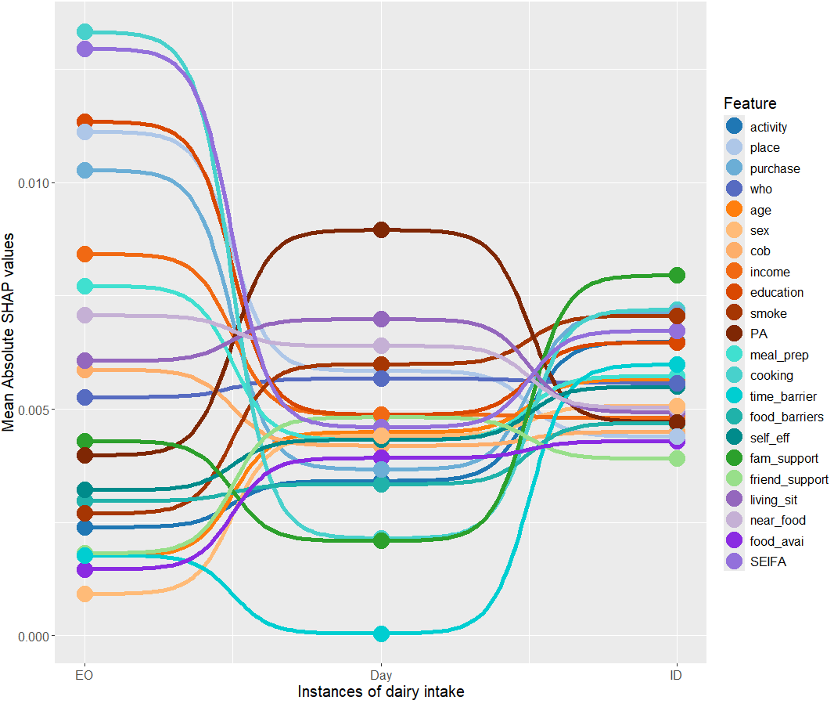

Table A4.3 Mean Absolute SHAP values to assess predictors impact for predicting dairy and its alternative consumption.
Contextual factors | Eating Occasion | Day | Individual | All
Person-level: Intrapersonal factors
Age | 0.0018 | 0.0045 | 0.0057 | 0.0010
Sex | 0.0009 | 0.0044 | 0.0051 | 0.0009
Country of birth | 0.0059 | 0.0042 | 0.0045 | 0.0011
Income | 0.0084 | 0.0049 | 0.0048 | 0.0010
Education | 0.0113 | 0.0049 | 0.0065 | 0.0012
Smoking status | 0.0027 | 0.0060 | 0.0071 | 0.0010
Self-efficacy | 0.0032 | 0.0043 | 0.0055 | 0.0009
Meal Preparation behaviour (food involvement) | 0.0077 | 0.0043 | 0.0057 | 0.0010
Cooking confidence | 0.0133 | 0.0021 | 0.0072 | 0.0010
Perceived time scarcity | 0.0018 | 0.0000 | 0.0060 | 0.0018
Food choice barriers | 0.0030 | 0.0033 | 0.0047 | 0.0011
Physical activity | 0.0040 | 0.0090 | 0.0047 | 0.0011
Person-level: Socio-environmental factors
Social support from family | 0.0015 | 0.0039 | 0.0043 | 0.0011
Social support from friends/colleagues | 0.0018 | 0.0048 | 0.0039 | 0.0011
Person-level: Physical environmental factors
Proximity and access to food destinations | 0.0071 | 0.0064 | 0.0050 | 0.0010
Food availability | 0.0015 | 0.0039 | 0.0043 | 0.0011
Living situation | 0.0061 | 0.0070 | 0.0049 | 0.0010
Area-level socio-economic position (SEIFA) | 0.0130 | 0.0046 | 0.0067 | 0.0009
Eating occasion-level: Environmental factors
Place of consumption | 0.0111 | 0.0058 | 0.0044 | 0.0010
Location of purchase | 0.0103 | 0.0037 | 0.0071 | 0.0010
Eating occasion-level: Social factors
Presence of others | 0.0053 | 0.0057 | 0.0056 | 0.0009
Activity at consumption | 0.0024 | 0.0034 | 0.0065 | 0.0010

Figure A3.2 Mean Absolute SHAP values for meats and alternative intakes.
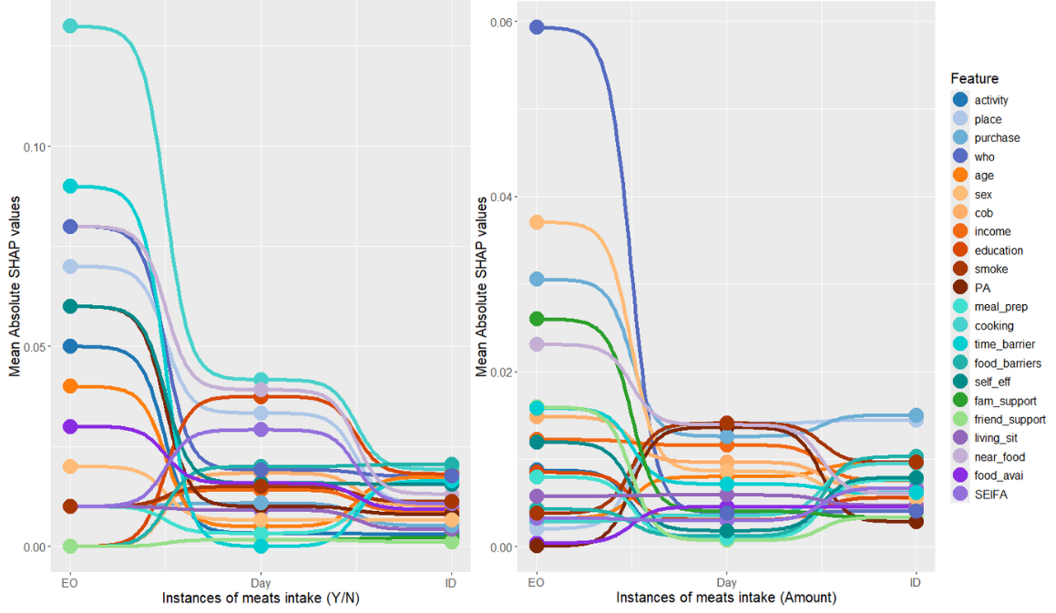

Table A4.4 Mean Absolute SHAP values to assess predictors impact for predicting meats and its alternatives consumption.
 |  | Mean Absolute SHAP values
Contextual factors |  | Binary outcome (consumption y/n) |  |  |  | Regression outcome (amount)
Type | Feature name | Eating Occasion | Day | Individual | All | Eating Occasion | Day | Individual | All
Person-level: Intrapersonal factors | Age | 0.0400 | 0.0050 | 0.0174 | 0.0004 | 0.0033 | 0.0080 | 0.0096 | 0.0011
Person-level: Intrapersonal factors | Sex | 0.0200 | 0.0067 | 0.0067 | 0.0004 | 0.0371 | 0.0087 | 0.0056 | 0.0012
Person-level: Intrapersonal factors | Country of birth | 0.0000 | 0.0183 | 0.0102 | 0.0008 | 0.0149 | 0.0097 | 0.0067 | 0.0012
Person-level: Intrapersonal factors | Income | 0.0100 | 0.0142 | 0.0088 | 0.0002 | 0.0122 | 0.0116 | 0.0076 | 0.0013
Person-level: Intrapersonal factors | Education | 0.0000 | 0.0375 | 0.0181 | 0.0008 | 0.0085 | 0.0031 | 0.0056 | 0.0012
Person-level: Intrapersonal factors | Smoking status | 0.0100 | 0.0150 | 0.0112 | 0.0003 | 0.0038 | 0.0141 | 0.0097 | 0.0014
Person-level: Intrapersonal factors | Self-efficacy | 0.0600 | 0.0158 | 0.0155 | 0.0006 | 0.0120 | 0.0018 | 0.0079 | 0.0013
Person-level: Intrapersonal factors | Meal Preparation behaviour (food involvement) | 0.0100 | 0.0033 | 0.0162 | 0.0008 | 0.0080 | 0.0010 | 0.0076 | 0.0012
Person-level: Intrapersonal factors | Cooking confidence | 0.1300 | 0.0417 | 0.0193 | 0.0010 | 0.0029 | 0.0036 | 0.0095 | 0.0013
Person-level: Intrapersonal factors | Perceived time scarcity | 0.0900 | 0.0000 | 0.0164 | 0.0001 | 0.0158 | 0.0072 | 0.0062 | 0.0011
Person-level: Intrapersonal factors | Food choice barriers | 0.0000 | 0.0200 | 0.0205 | 0.0009 | 0.0043 | 0.0012 | 0.0103 | 0.0013
Person-level: Intrapersonal factors | Physical activity | 0.0600 | 0.0100 | 0.0081 | 0.0002 | 0.0001 | 0.0137 | 0.0029 | 0.0013
Person-level: Socio-environmental factors | Social support from family | 0.0000 | 0.0017 | 0.0021 | 0.0000 | 0.0260 | 0.0041 | 0.0034 | 0.0011
Person-level: Socio-environmental factors | Social support from friends/colleagues | 0.0000 | 0.0017 | 0.0012 | 0.0004 | 0.0160 | 0.0007 | 0.0034 | 0.0011
Person-level: Physical environmental factors | Proximity and access to food destinations | 0.0800 | 0.0392 | 0.0131 | 0.0009 | 0.0231 | 0.0139 | 0.0061 | 0.0011
Person-level: Physical environmental factors | Food availability | 0.0300 | 0.0158 | 0.0093 | 0.0006 | 0.0004 | 0.0046 | 0.0046 | 0.0013
Person-level: Physical environmental factors | Living situation | 0.0100 | 0.0092 | 0.0043 | 0.0005 | 0.0058 | 0.0059 | 0.0047 | 0.0011
Person-level: Physical environmental factors | Area-level socio-economic position (SEIFA) | 0.0100 | 0.0292 | 0.0107 | 0.0002 | 0.0033 | 0.0030 | 0.0067 | 0.0011
Eating occasion-level: Environmental factors | Place of consumption | 0.0700 | 0.0333 | 0.0110 | 0.0002 | 0.0021 | 0.0141 | 0.0145 | 0.0012
Eating occasion-level: Environmental factors | Location of purchase | 0.0100 | 0.0108 | 0.0052 | 0.0002 | 0.0306 | 0.0126 | 0.0151 | 0.0014
Eating occasion-level: Social factors | Presence of others | 0.0800 | 0.0192 | 0.0176 | 0.0001 | 0.0593 | 0.0039 | 0.0041 | 0.0012
Eating occasion-level: Social factors | Activity at consumption | 0.0500 | 0.0033 | 0.0031 | 0.0004 | 0.0088 | 0.0011 | 0.0078 | 0.0012

Figure A4.3 Mean Absolute SHAP values for grains and alternative intakes.
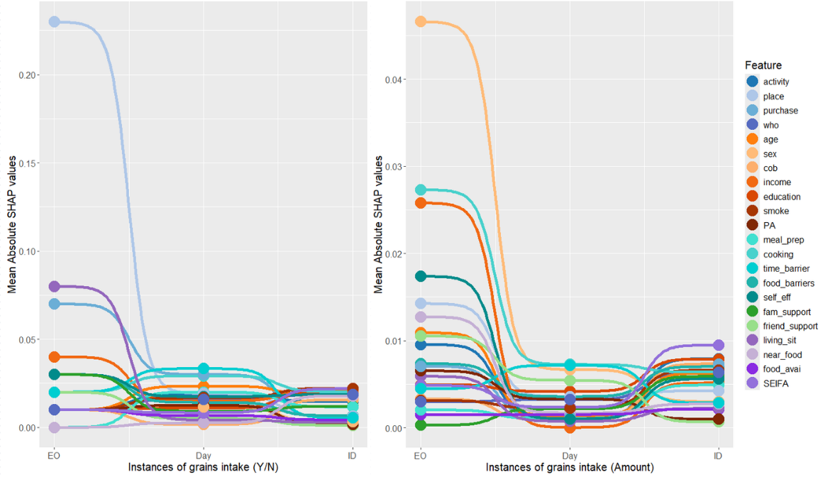

Table A4.5 Mean Absolute SHAP values to assess predictors impact for predicting grain consumption.
 |  | Mean Absolute SHAP values
Features/Predictors |  | Binary outcome (consumption y/n) |  |  |  | Regression outcome (amount)
Type | Feature name | Eating Occasion | Day | Individual | All | Eating Occasion | Day | Individual | All
Person-level: Intrapersonal factors | Age | 0.0100 | 0.0233 | 0.0181 | 0.0007 | 0.0109 | 0.0014 | 0.0063 | 0.0007
Person-level: Intrapersonal factors | Sex | 0.0100 | 0.0117 | 0.0033 | 0.0007 | 0.0466 | 0.0067 | 0.0030 | 0.0006
Person-level: Intrapersonal factors | Country of birth | 0.0100 | 0.0017 | 0.0157 | 0.0023 | 0.0033 | 0.0009 | 0.0073 | 0.0007
Person-level: Intrapersonal factors | Income | 0.0400 | 0.0150 | 0.0205 | 0.0016 | 0.0258 | 0.0000 | 0.0051 | 0.0005
Person-level: Intrapersonal factors | Education | 0.0100 | 0.0108 | 0.0202 | 0.0024 | 0.0050 | 0.0042 | 0.0079 | 0.0006
Person-level: Intrapersonal factors | Smoking status | 0.0100 | 0.0167 | 0.0221 | 0.0015 | 0.0031 | 0.0023 | 0.0066 | 0.0006
Person-level: Intrapersonal factors | Self-efficacy | 0.0300 | 0.0175 | 0.0186 | 0.0015 | 0.0174 | 0.0010 | 0.0056 | 0.0007
Person-level: Intrapersonal factors | Meal Preparation behaviour (food involvement) | 0.0000 | 0.0200 | 0.0117 | 0.0013 | 0.0020 | 0.0011 | 0.0049 | 0.0007
Person-level: Intrapersonal factors | Cooking confidence | 0.0200 | 0.0292 | 0.0202 | 0.0010 | 0.0273 | 0.0073 | 0.0064 | 0.0005
Person-level: Intrapersonal factors | Perceived time scarcity | 0.0200 | 0.0333 | 0.0055 | 0.0011 | 0.0045 | 0.0072 | 0.0028 | 0.0007
Person-level: Intrapersonal factors | Food choice barriers | 0.0300 | 0.0142 | 0.0067 | 0.0009 | 0.0073 | 0.0036 | 0.0070 | 0.0008
Person-level: Intrapersonal factors | Physical activity | 0.0100 | 0.0125 | 0.0017 | 0.0014 | 0.0065 | 0.0033 | 0.0010 | 0.0006
Person-level: Socio-environmental factors | Social support from family | 0.0300 | 0.0092 | 0.0119 | 0.0001 | 0.0003 | 0.0022 | 0.0059 | 0.0006
Person-level: Socio-environmental factors | Social support from friends/colleagues | 0.0200 | 0.0050 | 0.0012 | 0.0009 | 0.0105 | 0.0055 | 0.0007 | 0.0007
Person-level: Physical environmental factors | Proximity and access to food destinations | 0.0000 | 0.0025 | 0.0179 | 0.0015 | 0.0127 | 0.0017 | 0.0027 | 0.0007
Person-level: Physical environmental factors | Food availability | 0.0100 | 0.0067 | 0.0043 | 0.0023 | 0.0015 | 0.0015 | 0.0021 | 0.0006
Person-level: Physical environmental factors | Living situation | 0.0800 | 0.0042 | 0.0029 | 0.0011 | 0.0059 | 0.0008 | 0.0022 | 0.0008
Person-level: Physical environmental factors | Area-level socio-economic position (SEIFA) | 0.0100 | 0.0083 | 0.0219 | 0.0016 | 0.0049 | 0.0023 | 0.0095 | 0.0007
Eating occasion-level: Environmental factors | Place of consumption | 0.2300 | 0.0192 | 0.0062 | 0.0019 | 0.0143 | 0.0036 | 0.0042 | 0.0006
Eating occasion-level: Environmental factors | Location of purchase | 0.0700 | 0.0300 | 0.0057 | 0.0022 | 0.0071 | 0.0012 | 0.0073 | 0.0007
Eating occasion-level: Social factors | Presence of others | 0.0100 | 0.0158 | 0.0186 | 0.0017 | 0.0030 | 0.0032 | 0.0064 | 0.0006
Eating occasion-level: Social factors | Activity at consumption | 0.0100 | 0.0183 | 0.0145 | 0.0030 | 0.0096 | 0.0012 | 0.0079 | 0.0006

Figure A4.4 Feature importance based on mean absolute SHAP values for best predicting model for discretionary foods intake (Hurdle Random Forest) at eating occasion. Results presented were randomly chosen to show changes in importance of features/predictors at different level of instance (random state = 30820); EO included one eating occasion, Day included all eating occasion in one day, and ID included all eating occasions recorded by one individual (ID = 161). The mean absolute value of each feature over all instances (all eating occasions recorded from all individuals) is not presented but reported in Additional file 3. A feature/predictor with a higher mean absolute SHAP values contributes more significantly to the prediction on average.
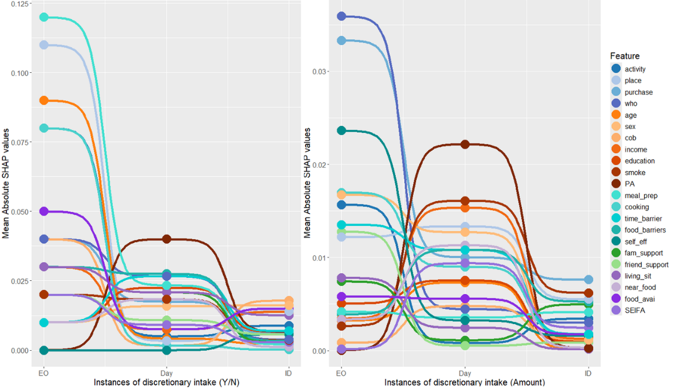

Table A4.6 Mean Absolute SHAP values to assess predictors impact for predicting discretionary foods consumption.
 |  | Mean Absolute SHAP values
Features/Predictors |  | Binary outcome (consumption y/n) |  |  |  | Regression outcome (amount)
Type | Feature name | Eating Occasion | Day | Individual | All | Eating Occasion | Day | Individual | All
Person-level: Intrapersonal factors | Age | 0.0900 | 0.0042 | 0.0024 | 0.0014 | 0.0032 | 0.0073 | 0.0002 | 0.0036
Person-level: Intrapersonal factors | Sex | 0.0100 | 0.0158 | 0.0162 | 0.0011 | 0.0167 | 0.0127 | 0.0012 | 0.0033
Person-level: Intrapersonal factors | Country of birth | 0.0400 | 0.0017 | 0.0179 | 0.0019 | 0.0008 | 0.0048 | 0.0012 | 0.0033
Person-level: Intrapersonal factors | Income | 0.0300 | 0.0075 | 0.0138 | 0.0009 | 0.0034 | 0.0154 | 0.0013 | 0.0032
Person-level: Intrapersonal factors | Education | 0.0100 | 0.0225 | 0.0067 | 0.0022 | 0.0051 | 0.0075 | 0.0010 | 0.0034
Person-level: Intrapersonal factors | Smoking status | 0.0200 | 0.0183 | 0.0036 | 0.0019 | 0.0026 | 0.0161 | 0.0062 | 0.0035
Person-level: Intrapersonal factors | Self-efficacy | 0.0000 | 0.0000 | 0.0057 | 0.0015 | 0.0236 | 0.0032 | 0.0016 | 0.0035
Person-level: Intrapersonal factors | Meal Preparation behaviour (food involvement) | 0.1200 | 0.0233 | 0.0021 | 0.0014 | 0.0042 | 0.0036 | 0.0041 | 0.0035
Person-level: Intrapersonal factors | Cooking confidence | 0.0800 | 0.0017 | 0.0002 | 0.0012 | 0.0170 | 0.0090 | 0.0018 | 0.0030
Person-level: Intrapersonal factors | Perceived time scarcity | 0.0100 | 0.0267 | 0.0069 | 0.0014 | 0.0135 | 0.0108 | 0.0018 | 0.0037
Person-level: Intrapersonal factors | Food choice barriers | 0.0300 | 0.0275 | 0.0033 | 0.0014 | 0.0039 | 0.0108 | 0.0053 | 0.0034
Person-level: Intrapersonal factors | Physical activity | 0.0000 | 0.0400 | 0.0067 | 0.0007 | 0.0000 | 0.0222 | 0.0003 | 0.0033
Person-level: Socio-environmental factors | Social support from family | 0.0300 | 0.0208 | 0.0029 | 0.0012 | 0.0074 | 0.0011 | 0.0050 | 0.0036
Person-level: Socio-environmental factors | Social support from friends/colleagues | 0.0200 | 0.0108 | 0.0057 | 0.0023 | 0.0128 | 0.0005 | 0.0009 | 0.0034
Person-level: Physical environmental factors | Proximity and access to food destinations | 0.0100 | 0.0183 | 0.0012 | 0.0021 | 0.0034 | 0.0113 | 0.0003 | 0.0036
Person-level: Physical environmental factors | Food availability | 0.0500 | 0.0075 | 0.0150 | 0.0008 | 0.0058 | 0.0056 | 0.0018 | 0.0032
Person-level: Physical environmental factors | Living situation | 0.0300 | 0.0208 | 0.0126 | 0.0006 | 0.0078 | 0.0025 | 0.0001 | 0.0035
Person-level: Physical environmental factors | Area-level socio-economic position (SEIFA) | 0.0200 | 0.0092 | 0.0029 | 0.0017 | 0.0002 | 0.0094 | 0.0025 | 0.0035
Eating occasion-level: Environmental factors | Place of consumption | 0.1100 | 0.0033 | 0.0140 | 0.0018 | 0.0122 | 0.0133 | 0.0055 | 0.0037
Eating occasion-level: Environmental factors | Location of purchase | 0.0400 | 0.0175 | 0.0062 | 0.0024 | 0.0333 | 0.0100 | 0.0076 | 0.0034
Eating occasion-level: Social factors | Presence of others | 0.0400 | 0.0267 | 0.0038 | 0.0013 | 0.0359 | 0.0044 | 0.0030 | 0.0034
Eating occasion-level: Social factors | Activity at consumption | 0.0800 | 0.0050 | 0.0088 | 0.0011 | 0.0157 | 0.0008 | 0.0034 | 0.0034

Figure A4.5 Feature importance based on mean SHAP values for best predicting model for daily diet quality (Random Forest). Results presented were randomly chosen to show changes in importance of features/predictors at different level of instance (random state = 30820); Day indicates daily diet quality (DGI score), ID included every daily diet quality (DGI score) recorded from one individual (ID = 161), and All included all daily diet quality recorded from all individuals. The mean absolute value of each feature over all instances is presented in Additional file 3. A feature/predictor with a higher mean absolute SHAP values contributes more significantly to the prediction on average.

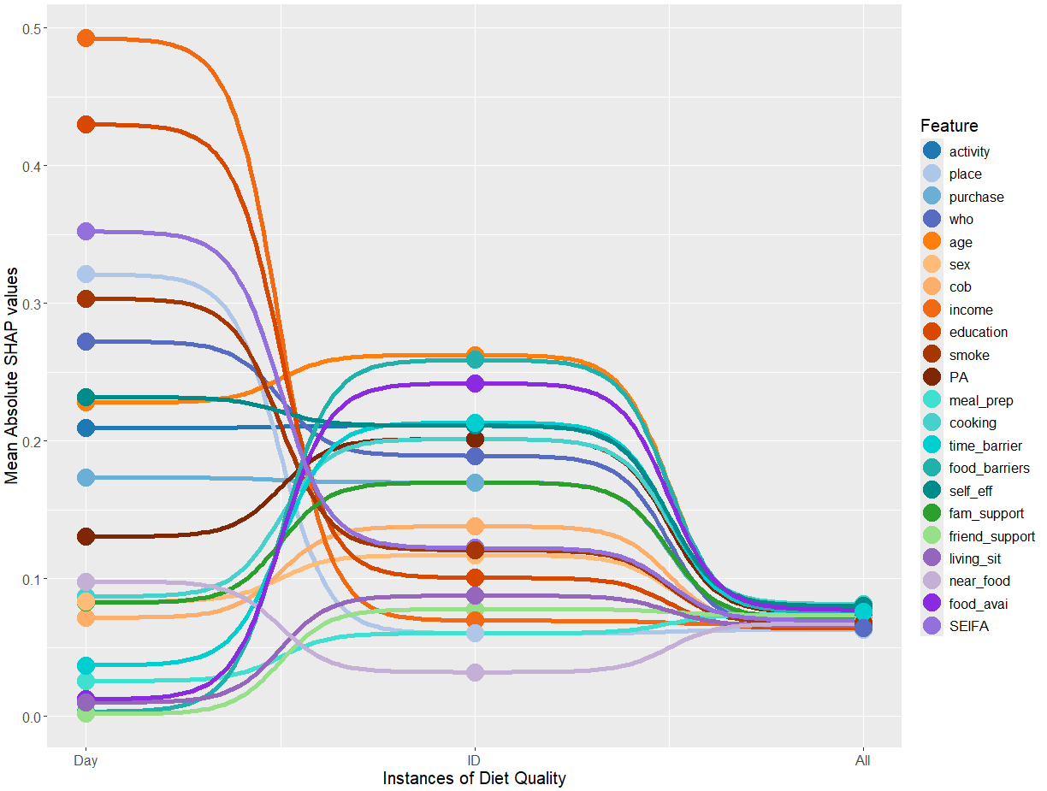

Table A4.7 Mean Absolute SHAP values to assess predictors impact for predicting daily diet quality
Contextual factors | Eating Occasion | Day | Individual | All
Person-level: Intrapersonal factors
Age | 0.2278 | 0.2624 | 0.0741 | 0.2278
Sex | 0.0833 | 0.1169 | 0.0689 | 0.0833
Country of birth | 0.0716 | 0.1379 | 0.0668 | 0.0716
Income | 0.4924 | 0.0693 | 0.0665 | 0.4924
Education | 0.4299 | 0.1005 | 0.0638 | 0.4299
Smoking status | 0.3033 | 0.1206 | 0.0678 | 0.3033
Self-efficacy | 0.2317 | 0.2111 | 0.0800 | 0.2317
Meal Preparation behaviour (food involvement) | 0.0256 | 0.0602 | 0.0741 | 0.0256
Cooking confidence | 0.0869 | 0.2013 | 0.0814 | 0.0869
Perceived time scarcity | 0.0369 | 0.2133 | 0.0760 | 0.0369
Food choice barriers | 0.0032 | 0.2588 | 0.0752 | 0.0032
Physical activity | 0.1304 | 0.2013 | 0.0752 | 0.1304
Person-level: Socio-environmental factors
Social support from family | 0.0824 | 0.1697 | 0.0714 | 0.0824
Social support from friends/colleagues | 0.0016 | 0.0777 | 0.0735 | 0.0016
Person-level: Physical environmental factors
Proximity and access to food destinations | 0.0979 | 0.0320 | 0.0673 | 0.0979
Food availability | 0.0122 | 0.2418 | 0.0772 | 0.0122
Living situation | 0.0100 | 0.0875 | 0.0658 | 0.0100
Area-level socio-economic position (SEIFA) | 0.3521 | 0.1221 | 0.0696 | 0.3521
Eating occasion-level: Environmental factors
Place of consumption | 0.3209 | 0.0601 | 0.0626 | 0.3209
Location of purchase | 0.1732 | 0.1699 | 0.0694 | 0.1732
Eating occasion-level: Social factors
Presence of others | 0.2722 | 0.1891 | 0.0642 | 0.2722
Activity at consumption | 0.2094 | 0.2110 | 0.0753 | 0.2094

