6-7 year old

Please complete the list below by placing a tick ✓ for your answer in the right box.
The question is: Do you ever eat or drink any of the foods/drinks on the list?
Example:
Do you ever eat or drink any of the foods/drinks on this list? |  |  |  | I’m not sure if I eat or drink this
 |  | Yes!  I sometimes eat or drink this | No!  No I never eat or drink this | I’m not sure if I eat or drink this
Baked beans | 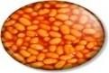 |  | ✓
Biscuits | 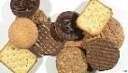 | ✓

PLEASE START ON NEXT PAGE!

Do you ever eat or drink any of the food/drinks on this list? |  | Yes!  I sometimes eat or drink this | No!  I never eat or drink this | I’m not sure if I eat or drink this
1. Fruit e.g. apples, grapes, bananas, strawberries and others | 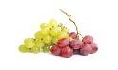  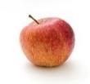  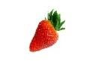  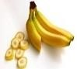
2. Vegetables e.g. broccoli, carrots, peas, sweetcorn, stir-fry, salad, baked beans,  others | 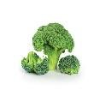  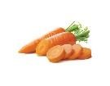  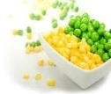  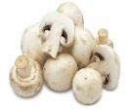  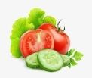

Do you ever eat or drink any of the food/drinks on this list? |  | Yes!  I sometimes eat or drink this | No!  I never eat or drink this | I’m not sure if I eat or drink this
3. Potatoes, mash, jacket potato, chips, waffles, potato faces | 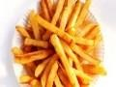  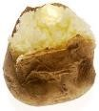
4. Rice/Pasta  (white/brown) | 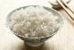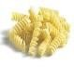
5. White/wholemeal bread | 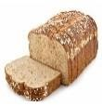  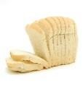
6. Porridge/Ready  Brek/Weetabix | 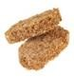  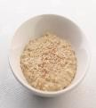
7. Other breakfast cereal | 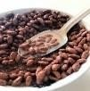  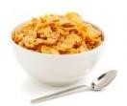

Do you ever eat or drink any of the food/drinks on this list? |  | Yes!  I sometimes eat or drink this | No!  I never eat or drink this | I’m not sure if I eat or drink this
8. Pancakes/scones/ fruit bread | 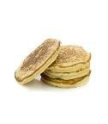
9. Milk to drink/on cereal | 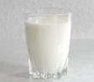  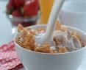
10. Cheese | 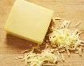
11. Yoghurts | 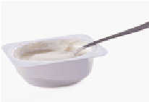
12. Ice cream/milky pudding e.g. custard. | 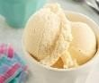
13. Chicken sliced (no sauce) | 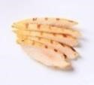
14. Chicken nuggets/burgers | 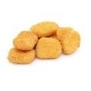
15. Beef (sliced, minced, chops, stew/casserole/c urry) | 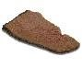  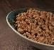

Do you ever eat or drink any of the food/drinks on this list? |  | Yes!  I sometimes eat or drink this | No!  I never eat or drink this | I’m not sure if I eat or drink this
16. Bacon/ham/ sausages | 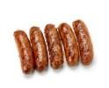  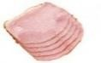
17. Lamb | 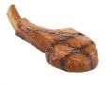
18. Eggs (scrambled, poached, boiled, fried) | 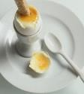
19. Fish fillet/tuna (salmon, cod, haddock) | 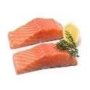
20. Fishfingers/fish in batter | 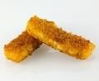
21. Crisps | 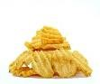
22. Biscuits/ chocolate | 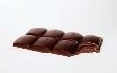  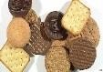
23. Sweets | 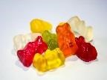
24. Nuts | 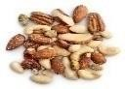
Do you ever eat or drink any of the food/drinks on this list? |  | Yes!  I sometimes eat or drink this | No!  I never eat or drink this | I’m not sure if I eat or drink this
25. Cakes/buns/muffins | 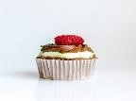
26. Water | 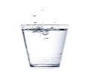
27. Juice  (dilutant, pure) | 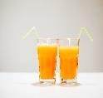
28. Fizzy drink | 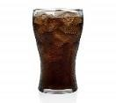
29. Milkshakes | 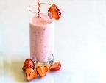

And finally……
Do you usually eat breakfast every morning?
 | THE END  Thanks for your help!  ☺
  No |  | Yes

10-11 year old

Please complete the list below by placing a tick ✓ for your answer in the right box.
The question is: Do you ever eat or drink any of the foods/drinks on the list AT HOME?
Example:
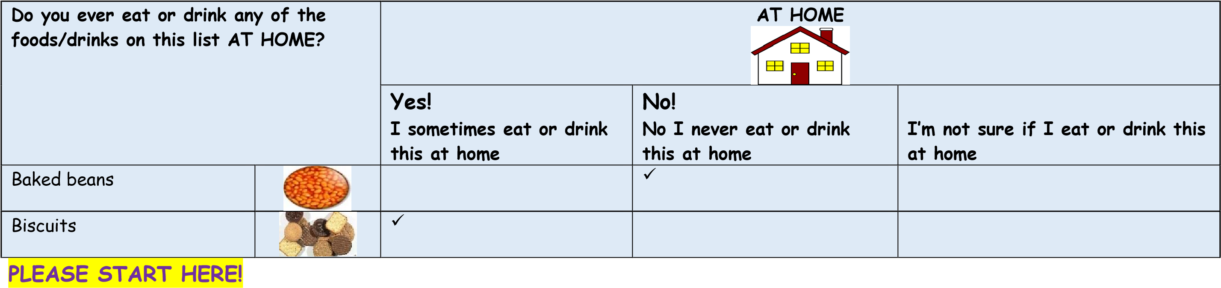
Do you ever eat or drink any of the foods/drinks on this list AT HOME? |  |  | AT HOME  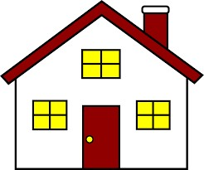
 |  | Yes!  I sometimes eat or drink this at home | No!  No I never eat or drink this at home | I’m not sure if I eat or drink this at home
FRUIT
1. Apples

Do you ever eat or drink any of the foods/drinks on this list AT HOME? |  | Yes!  I sometimes eat or drink this at home | No!  No I never eat or drink this at home | I’m not sure if I eat or drink this at home
2. Grapes | 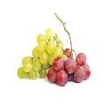
3. Bananas | 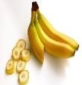
4. Strawberries
5. Pineapple | 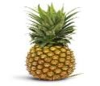
VEGETABLES
6. Mushrooms
7. Broccoli
8. Carrots
9. Peas/sweetcorn
10. Stir-fried vegetables | 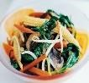

Do you ever eat or drink any of the foods/drinks on this list AT HOME? |  | Yes!  I sometimes eat or drink this at home | No!  No I never eat or drink this at home | I’m not sure if I eat or drink this at home
11. Salad (tomatoes, leaves OR cucumber)
12. Baked beans | 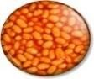
STARCHY CARBOHYDRATES
13. Potatoes
14. Chips/Potato Faces/Potato
Waffles
15. Rice/Pasta
(white/brown)
16. White bread
17. Brown/wholemeal bread
18. Porridge/Ready Brek
19. Cornflakes/Rice Krispies

Do you ever eat or drink any of the foods/drinks on this list AT HOME? |  | Yes!  I sometimes eat or drink this at home | No!  No I never eat or drink this at home | I’m not sure if I eat or drink this at home
20. Frosties/Cocopops | 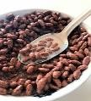
21. Weetabix/Bran Flakes | 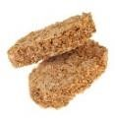
22. Pancakes/scones/ fruit bread
23. Crackers/breadst  icks | 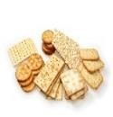
DAIRY
24. Milk to drink
25. Milk on cereal
26. Cheddar cheese
27. Cheese spread | 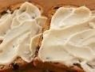
28. Margarine/butter on  toast/sandwiches | 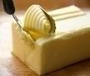
29. Yoghurts | 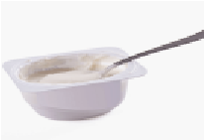

Do you ever eat or drink any of the foods/drinks on this list AT HOME? |  | Yes!  I sometimes eat or drink this at home | No!  No I never eat or drink this at home | I’m not sure if I eat or drink this at home
30. Ice cream/milky pudding e.g. custard.
MEAT/FISH/EGGS/
PULSES
31. Chicken sliced (no sauce)
32. Chicken nuggets/burgers
33. Beef (sliced, minced, chops, stew/casserole/c urry)
34. Bacon/ham | 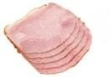
35. Sausages
36. Lamb
37. Meat in pastry (e.g. sausage rolls, meat pie) | 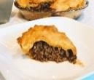
38. Eggs (scrambled, poached, boiled, fried)

Do you ever eat or drink any of the foods/drinks on this list AT HOME? |  | Yes!  I sometimes eat or drink this at home | No!  No I never eat or drink this at home | I’m not sure if I eat or drink this at home
39. Fish fillet (salmon, cod, haddock)
40. Tuna | 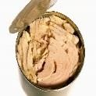
41. Fishfingers/fish in batter

SNACKS
42. Crisps
43. Biscuits (with/without chocolate)
44. Sweets (jelly/gums/ toffees)
45. Nuts
46. Chocolate
47. Cakes/buns/muffins
DRINKS
48. Water
Do you ever eat or drink any of the foods/drinks on this list AT HOME? |  | Yes!  I sometimes eat or drink this at home | No!  No I never eat or drink this at home | I’m not sure if I eat or drink this at home
49. Juice (dilutant, pure)
50. Fizzy drink (Cola, Fanta, sugar and sugar free
varieties)
51. Tea/coffee | 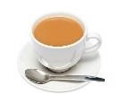
52. Milkshakes
PLEASE TURN OVER TO COMPLETE CHECKLIST FOR WHAT YOU EAT AT SCHOOL! ☺

The next question is: Do you ever eat or drink any of the foods/drinks on the list AT SCHOOL?
Do you ever eat or drink any of the foods/drinks on this list AT SCHOOL? |  |  | AT SCHOOL  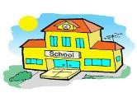
 |  | Yes!  I sometimes eat or drink this at school | No!  No I never eat or drink this at school | I’m not sure if I eat or drink this at school
FRUIT
1. Apples | 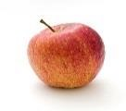
2. Grapes
3. Bananas | 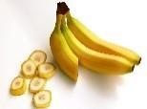
4. Strawberries | 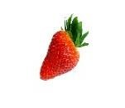
5. Pineapple | 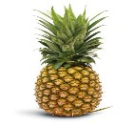
VEGETABLES
6. Mushrooms | 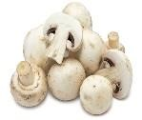
7. Broccoli | 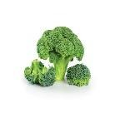

Do you ever eat or drink any of the foods/drinks on this list AT SCHOOL? |  | Yes!  I sometimes eat or drink this at school | No!  No I never eat or drink this at school | I’m not sure if I eat or drink this at school
8. Carrots | 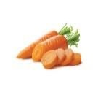
9. Peas/sweetcorn
10. Stir-fried vegetables | 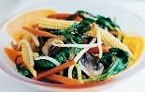
11. Salad (tomatoes, leaves OR cucumber) | 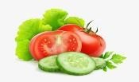
12. Baked beans | 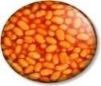
STARCHY CARBOHYDRATES
13. Potatoes | 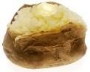
14. Chips/Potato Faces/Potato  Waffles | 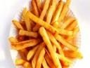
15. Rice/Pasta
(white/brown)
16. White bread | 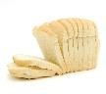
17. Brown/wholemeal bread

Do you ever eat or drink any of the foods/drinks on this list AT SCHOOL? |  | Yes!  I sometimes eat or drink this at school | No!  No I never eat or drink this at school | I’m not sure if I eat or drink this at school
18. Porridge/Ready Brek | 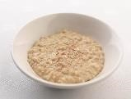
19. Cornflakes/Rice Krispies | 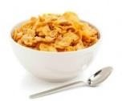
20. Frosties/Cocopops | 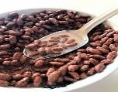
21. Weetabix/Bran Flakes | 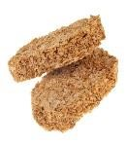
22. Pancakes/scones/ fruit bread | 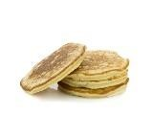
23. Crackers/ breadsticks | 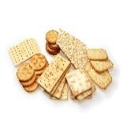
DAIRY
24. Milk to drink | 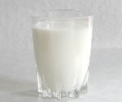
25. Milk on cereal | 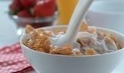
26. Cheddar cheese | 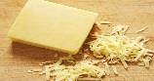

Do you ever eat or drink any of the foods/drinks on this list AT SCHOOL? |  | Yes!  I sometimes eat or drink this at school | No!  No I never eat or drink this at school | I’m not sure if I eat or drink this at school
27. Cheese spread | 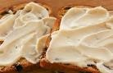
28. Margarine/butter on  toast/sandwiches | 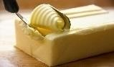
29. Yoghurts | 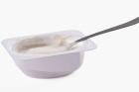
30. Ice cream/milky pudding | 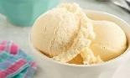
MEAT/FISH/EGGS/
PULSES
31. Chicken sliced (no sauce) | 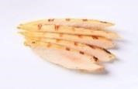
32. Chicken nuggets/burgers | 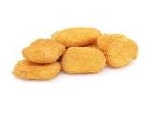
33. Beef (sliced, minced, chops, stew/casserole/ curry)
34. Bacon/ham | 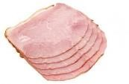
35. Sausages | 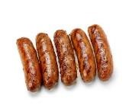

Do you ever eat or drink any of the foods/drinks on this list AT SCHOOL? |  | Yes!  I sometimes eat or drink this at school | No!  No I never eat or drink this at school | I’m not sure if I eat or drink this at school
36. Lamb | 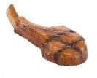
37. Meat in pastry (e.g. sausage rolls, meat pie) | 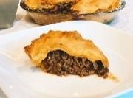
38. Eggs (scrambled, poached, boiled, fried) | 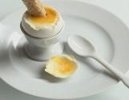
39. Fish fillet (salmon, cod, haddock) | 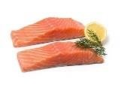
40. Tuna | 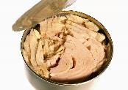
41. Fishfingers/fish in batter | 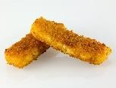
SNACKS
42. Crisps | 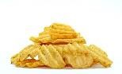
43. Biscuits (with/without chocolate) | 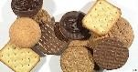
44. Sweets
(jelly/gums/toffe es)
Do you ever eat or drink any of the foods/drinks on this list AT SCHOOL? |  | Yes!  I sometimes eat or drink this at school | No!  No I never eat or drink this at school | I’m not sure if I eat or drink this at school
45. Nuts | 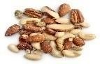
46. Chocolate | 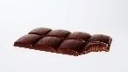
47. Cakes/buns/ Muffins
DRINKS
48. Water
49. Juice (dilutant, pure)
50. Fizzy drink (Cola, Fanta, sugar and sugar free  varieties) | 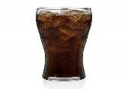
51. Tea/coffee | 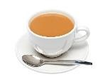
52. Milkshakes | 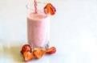

And finally……Please turn over the page for the last question!

Do you usually eat breakfast every morning?
 | No |  |  | Yes
THE END

Thanks for your help!

☺

