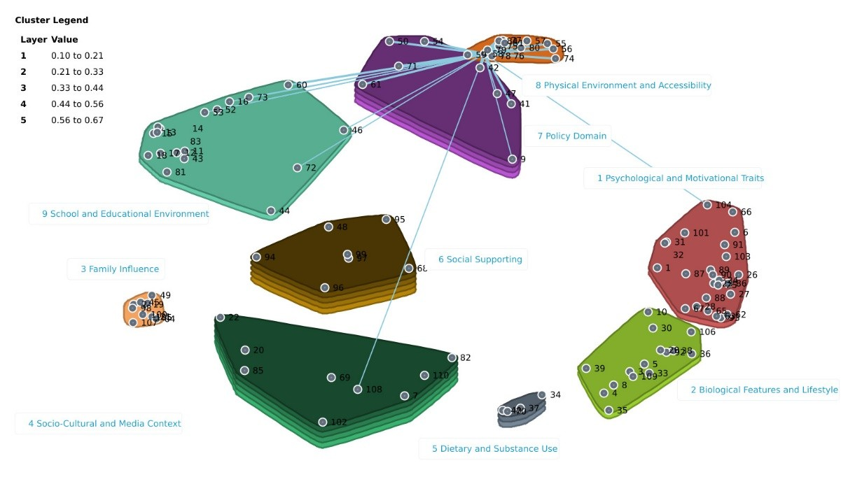
Figure S3. Spanning analysis of “Availability of indoor and outdoor physical activity facilities” as an anchor (bridge value 0.10) was sorted 74 times with “Indoor and outdoor sports facilities” within the same cluster and 55 times with “Sporting events accessibility” from Cluster 7.

