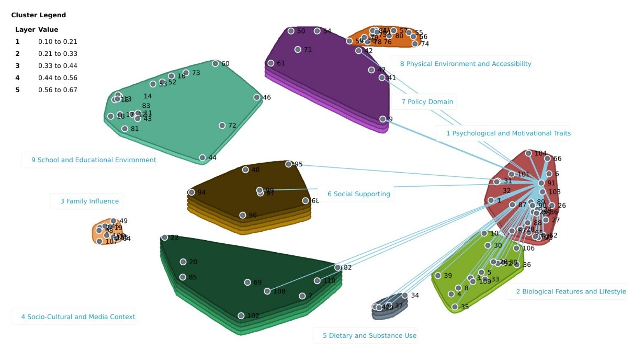
Figure S4. Spanning analysis of “Belief about physical activity”, as an anchor (bridge value 0.28) was sorted 60 times with “Physical activities perceived benefits” and “Perception of benefits of sport” within the same cluster and 34 times with “Physical well-being” from Cluster 2.

