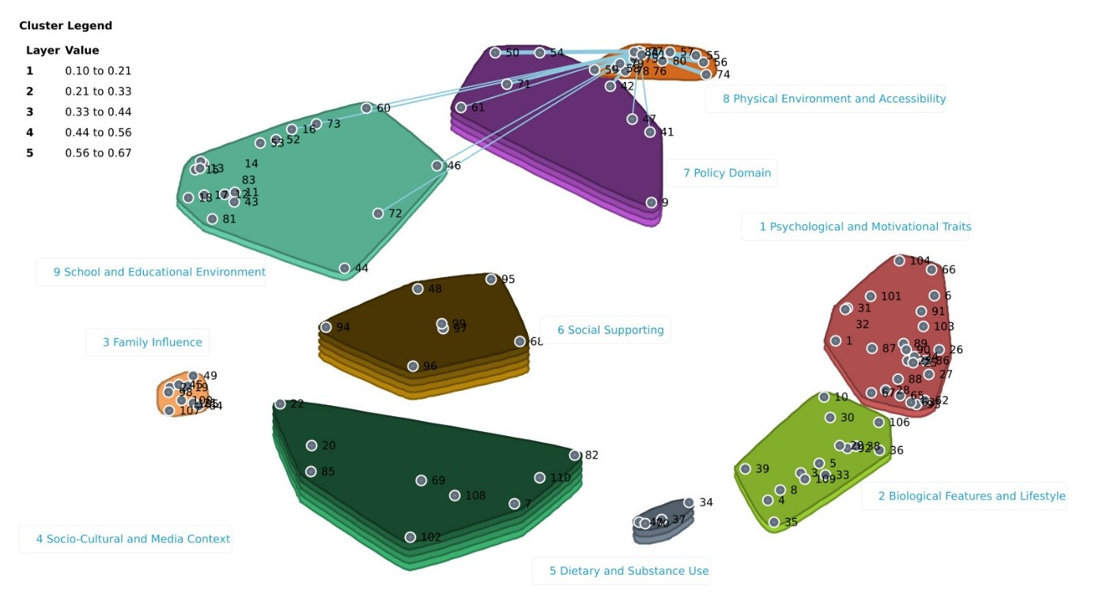
Figure S2. Spanning analysis of Cluster 8 “Physical Environment and Accessibility”. Example of an Anchor determinant “Walkability and safety of sidewalks/trails”.

