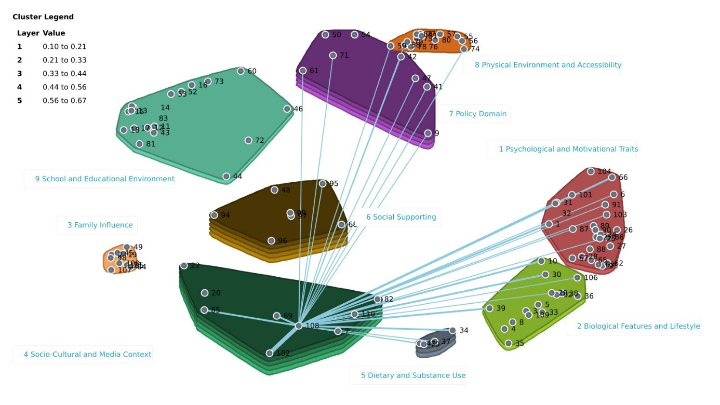
Figure S1. Spanning analysis of Cluster 4 “Socio-Cultural and Media Context”. Example of a Bridger determinant “Usage of fitness tracker devices”.

