Supplementary Materials

Supplementary Figure S1. Conceptual model supporting statistical analyses of the relationship between social inequalities and leisure-time and transport-related physical activity – ISA Study.
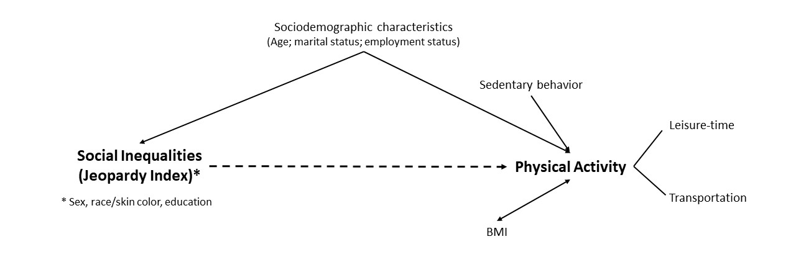

Supplementary Table S1. Pairwise associations between covariates and the Jeopardy Index assessed using Chi-square tests and Cramér’s V.

Variable 1 | Variable 2 | Chi² | p-value | Cramér’s V | Strength of association
Age | Marital status | 411.85 | 0.000 | 0.377 | Moderate
Age | Employment status | 383.20 | 0.000 | 0.362 | Moderate
Age | BMI | 160.56 | 0.000 | 0.169 | Weak
Age | Watching TV | 54.47 | 0.000 | 0.136 | Weak
Age | Jeopardy index | 160.44 | 0.000 | 0.169 | Weak
Marital status | Employment status | 2.15 | 0.142 | 0.027 | Very weak
Marital status | BMI | 3.75 | 0.154 | 0.037 | Very weak
Marital status | Watching TV | 0.67 | 0.415 | 0.015 | Very weak
Marital status | Jeopardy index | 14.98 | 0.005 | 0.073 | Very weak
Employment status | BMI | 32.67 | 0.000 | 0.108 | Weak
Employment status | Watching TV | 79.94 | 0.000 | 0.165 | Weak
Employment status | Jeopardy index | 209.41 | 0.000 | 0.273 | Weak to moderate
BMI | Watching TV | 26.17 | 0.000 | 0.097 | Weak
BMI | Jeopardy index | 43.70 | 0.000 | 0.090 | Very weak
Watching TV | Jeopardy index | 18.49 | 0.001 | 0.081 | Very weak

Note: Collinearity between covariates was assessed using the Variance Inflation Factor (VIF) in a linear model including all covariates. All VIF values were below 5 (mean VIF = 1.43), indicating no collinearity concerns.

Supplementary Table S2. Prevalence of leisure-time and transport-related physical activity according to Jeopardy Index categories over 10 years of follow-up (ISA Study).

Jeopardy Index | LTPA (%)* | TRPA (%)*
0 | 58.49 | 70.95
1 | 54.11 | 68.44
2 | 49.57 | 72.32
3 | 40.80 | 68.74
4 | 35.78 | 63.61
p for trend | <0.001 | 0.130

* Percentages are based on pooled person-wave observations across all study waves during the 10-year follow-up. P-values for trend refer to Pearson’s chi-square tests.

Supplementary Table S3. Descriptive distribution of leisure-time and transport-related physical activity according to covariates over 10 years of follow-up (ISA Study).
Covariate | LTPA (%) | p-value | TRPA (%) | p-value*
Age group
12 – 29 | 57.10 |  | 72.92
30 – 59 | 43.82 | <0.001 | 69.97 | <0.001
60+ | 43.34 |  | 64.49
Marital status
with a partner | 43.78 | 0.001 | 66.62 | 0.003
without a partner | 50.15 |  | 71.81
Employment status
employed | 45.41 | 0.250 | 64.96 | <0.001
unemployed | 47.55 |  | 71.74
BMI
Without overweight | 49.19 |  | 72.78
Overweight | 48.89 | <0.001 | 68.48 | <0.001
obesity | 38.75 |  | 64.67
Sedentary behavior (watching TV)
< 2 hours/day | 49.41 | 0.005 | 71.58 | 0.003
> 2 hours/day | 44.25 |  | 66.47

* Values are row percentages. P-values were obtained using the chi-square test.

