Dose–Response Relationship Between Physical Activity and Subjective Sleep Quality in Patients with Insomnia: A Systematic Review and Bayesian Meta-Analysis

Supplemental Materials

Table S1 Search strategy
#Step | Search Query | Database | Results
1 | TS=("Sleep Initiation and Maintenance Disorders" OR insomnia* OR "sleep disorder*" OR "sleep disturbance*" OR "sleep complaint*" OR "poor sleep") | Web of Science | 83942
2 | TI=("Exercise" OR "Physical Activity" OR exercise* OR "physical activit*" OR sport* OR training OR walking OR jogging OR running OR cycling OR swimming OR yoga OR "tai chi" OR resistance) | Web of Science | 964144
3 | TS=("Randomized Controlled Trial" OR "Controlled Clinical Trial" OR randomized OR placebo OR randomly OR trial) | Web of Science | 2120369
4 | #1 AND #2 AND #3 | Web of Science | 872
4 | #1 AND #2 AND #3 | PubMed | 2,872
3 | "Randomized Controlled Trial"[pt] OR "Controlled Clinical Trial"[pt] OR randomized[tiab] OR placebo[tiab] OR randomly[tiab] OR trial[tiab] OR groups[tiab] | PubMed | 4,379,908
2 | "Exercise"[Mesh] OR "Physical Activity"[tiab] OR exercise*[tiab] OR "physical activit*"[tiab] OR sport*[tiab] OR training[tiab] OR walking[tiab] OR jogging[tiab] OR running[tiab] OR cycling[tiab] OR swimming[tiab] OR yoga[tiab] OR "tai chi"[tiab] OR resistance[tiab] | PubMed | 2,579,710
1 | "Sleep Initiation and Maintenance Disorders"[Mesh] OR insomnia*[tiab] OR "sleep disorder*"[tiab] OR "sleep disturbance*"[tiab] OR "sleep complaint*"[tiab] OR "poor sleep"[tiab] | PubMed | 97,253
3 | ('insomnia':ti OR 'insomnia*':ti OR 'sleep disorder*':ti OR 'sleep disturbance*':ti OR 'sleep complaint*':ti OR 'poor sleep':ti) AND ('exercise':ab,ti OR 'physical activity':ab,ti OR 'exercise*':ab,ti OR 'physical activit*':ab,ti OR 'sport*':ab,ti OR 'training':ab,ti OR 'walking':ab,ti OR 'jogging':ab,ti OR 'running':ab,ti OR 'cycling':ab,ti OR 'swimming':ab,ti OR 'yoga':ab,ti OR 'tai chi':ab,ti OR 'resistance':ab,ti) AND ('randomized controlled trial':ti,ab,kw OR 'controlled clinical trial':ti,ab,kw OR 'randomized':ti,ab,kw OR 'placebo':ti,ab,kw OR 'randomly':ti,ab,kw OR 'trial':ti,ab,kw OR 'groups':ti,ab,kw) | Embase | 1212
2 | 'exercise'/exp OR 'physical activity':ti,ab,kw OR 'exercise*':ti,ab,kw OR 'physical activit*':ti,ab,kw OR 'sport*':ti,ab,kw OR 'training':ti,ab,kw OR 'walking':ti,ab,kw OR 'jogging':ti,ab,kw OR 'running':ti,ab,kw OR 'cycling':ti,ab,kw OR 'swimming':ti,ab,kw OR 'yoga':ti,ab,kw OR 'tai chi':ti,ab,kw OR 'resistance':ti,ab,kw | Embase | 3462076
1 | 'insomnia'/exp OR 'insomnia' OR 'insomnia*':ti,ab,kw OR 'sleep disorder*':ti,ab,kw OR 'sleep disturbance*':ti,ab,kw OR 'sleep complaint*':ti,ab,kw OR 'poor sleep':ti,ab,kw | Embase | 208519
1 | ('insomnia' OR 'insomnia*' OR 'sleep disorder*' OR 'sleep disturbance*' OR 'sleep complaint*' OR 'poor sleep'):ab | Cochrane Library | 29723
2 | ('exercise' OR 'physical activity' OR 'exercise*' OR 'physical activit*' OR 'sport*' OR 'training' OR 'walking' OR 'jogging' OR 'running' OR 'cycling' OR 'swimming' OR 'yoga' OR 'tai chi' OR 'resistance'):ab | Cochrane Library | 320057
3 | (Randomized Controlled Trial OR Randomized OR Random OR Placebo OR RCT OR Trial OR Clinical Trial):pt | Cochrane Library | 607670
4 | #1 AND #2 AND #3 | Cochrane Library | 3272
1 | summary('exercise' OR 'physical activity' OR 'exercise*' OR 'physical activit*' OR 'sport*' OR 'training' OR 'walking' OR 'jogging' OR 'running' OR 'cycling' OR 'swimming' OR 'yoga' OR 'tai chi' OR 'resistance') AND summary('insomnia' OR 'insomnia*' OR 'sleep disorder*' OR 'sleep disturbance*' OR 'sleep complaint*' OR 'poor sleep') AND summary('randomized controlled trial' OR 'controlled clinical trial' OR 'randomized' OR 'placebo' OR 'randomly' OR 'trial') | PsycINFO | 953

Table S2 Subgroup analysis
Subgroup variable | k | Hedges’g 95%CrI | I²_{within} | I²_{between} | R²
Age |  |  | 7.24% | 32.92% | 0.60
Adults | 8 | -1.00 [-1.36, -0.64]
Older Adults | 15 | -0.51 [-0.64, -0.38]
Diagnostic criteria |  |  | 7.95% | 35.78% | 0.58
Formal diagnostic criteria | 10 | -0.52 [-0.66, -0.38]
Questionnaire cut-off | 14 | -0.66 [-0.87, -0.46]
Baseline insomnia severity |  |  | 9.97% | 35.35% | 0.59
Mild | 10 | -0.46 [-0.63, -0.29]
Moderate | 17 | -0.65 [-0.81, -0.50]
Physical activity modalities |  |  | 8.35% | 42.21% | 0.61
Yoga | 2 | -0.68 [-1.21, -0.12]
Strength | 4 | -0.66 [-0.98, -0.35]
Aerobic exercise | 12 | -0.56 [-0.79, -0.32]
Traditional Chinese mind-body exercises | 6 | -0.56 [-0.70, -0.42]
Multicomponent | 6 | 0.47 [-0.64, -0.30]
Measurement instrument |  |  | 9.04% | 39.75% | 0.57
PSQI | 19 | -0.57 [-0.72, -0.43]
ISI | 12 | -0.56 [-0.74, -0.37]

Table S3 Predicted effects on sleep quality by dose
Dose | Hedges’g | Lower 95%CrI | Upper 95%CrI
0 | -0.085 | -0.285 | 0.114
50 | -0.162 | -0.36 | 0.035
100 | -0.228 | -0.42 | -0.019
150 | -0.311 | -0.521 | -0.1
200 | -0.379 | -0.6 | -0.158
250 | -0.442 | -0.672 | -0.212
300 | -0.498 | -0.734 | -0.262
350 | -0.545 | -0.783 | -0.308
400 | -0.584 | -0.818 | -0.35
450 | -0.614 | -0.841 | -0.387
500 | -0.635 | -0.853 | -0.417
550 | -0.648 | -0.857 | -0.439
600 | -0.652 | -0.858 | -0.449
650 | -0.653 | -0.858 | -0.449
700 | -0.648 | -0.858 | -0.438
750 | -0.64 | -0.859 | -0.421
800 | -0.63 | -0.859 | -0.402
850 | -0.62 | -0.858 | -0.383
900 | -0.61 | -0.855 | -0.366
950 | -0.601 | -0.851 | -0.351
1000 | -0.593 | -0.848 | -0.337
1050 | -0.584 | -0.847 | -0.322
1100 | -0.577 | -0.85 | -0.304
1150 | -0.57 | -0.858 | -0.281
1200 | -0.563 | -0.872 | -0.254
1250 | -0.556 | -0.891 | -0.222
1300 | -0.55 | -0.915 | -0.185

Table S4 Sensitivity analysis for overall effect
Model | Number of studies | Hedges’g | 95%CrI
Full model | 24 | -0.56 | [-0.68, -0.45]
Sensitivity model | 21 | -0.56 | [-0.68, -0.44]

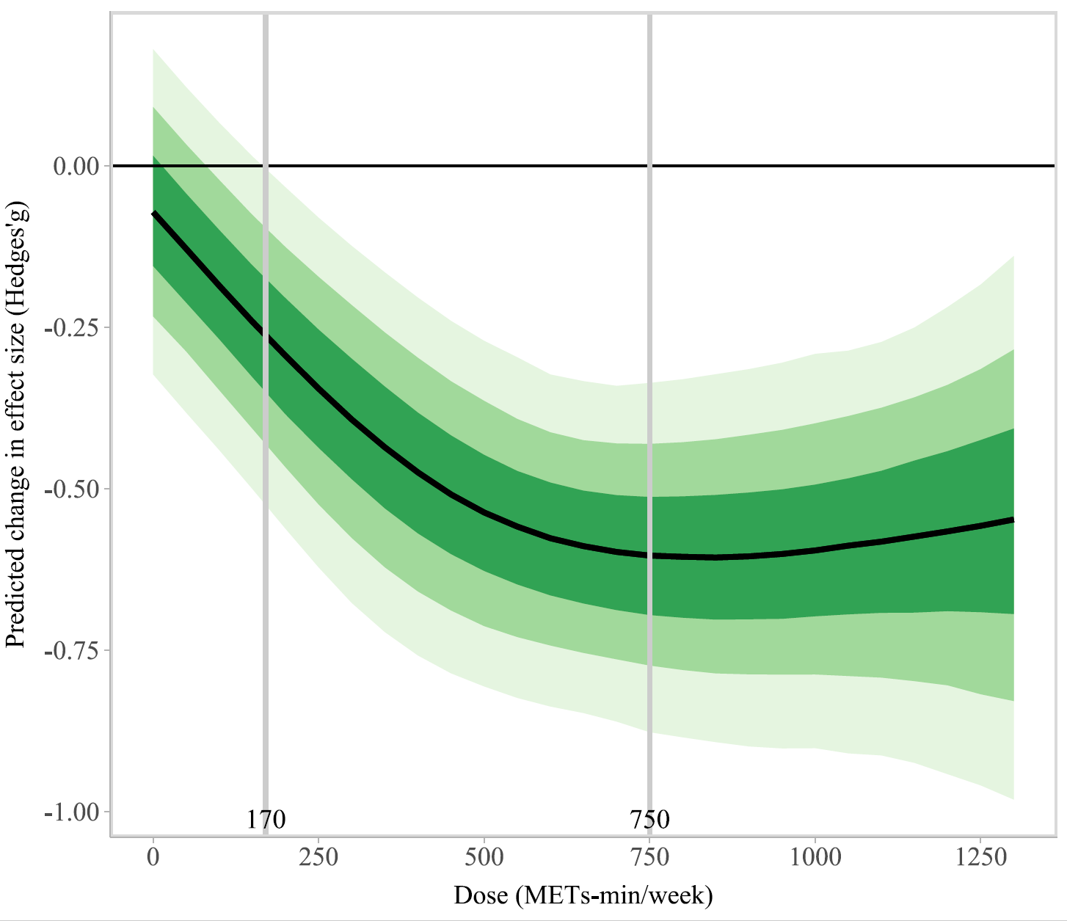
Figure S1 Sensitivity analysis for dose-response curve

Table S5: GRADE Summary of Findings
Outcome | Number of studies | Study design | GRADE Assessment |  |  |  |  | Effect (SMD [95% CrI]) | Certainty of Evidence
Outcome | Number of studies | Study design | Risk of bias | Inconsistency | Indirectness | Imprecision | Publication bias | Effect (SMD [95% CrI]) | Certainty of Evidence
sleep quality | 24 | Randomized trials | Serious | Not serious | Not serious | Serious | Not serious | -0.56 [-0.68 to -0.45] | ⨁⨁◯◯  Low
Risk of bias: Among the included studies, six (out of twenty) were rated as having "some concerns" or "high risk" of bias. This stemmed primarily from the unavoidable lack of blinding in behavioral interventions and potential performance or detection bias associated with subjective outcome measures. These systematic risks posed a serious threat to the validity of the effect estimate. Therefore, the certainty was downgraded by one level.
Inconsistency: Not downgraded. Although statistical heterogeneity across studies was high, this heterogeneity could be largely explained by variations in exercise dose between studies, which is precisely the issue the dose-response analysis aimed to address. Sensitivity analyses also indicated that the shape of the dose-response relationship was robust.
Indirectness: Not downgraded. The populations, interventions, comparators, and outcomes in the included studies directly corresponded to the PICOS question of this review.
Imprecision: Downgraded by one level. The dose-response curve and its 95% credible interval, as well as the estimate of the optimal dose, showed a concerning lack of precision. Beyond approximately 1200 METs, the shaded 95% CI region became very wide and even crossed the line of no effect. This indicates that the evidence is imprecise, particularly in the higher dose range.
Publication bias: Not downgraded. Formal statistical testing did not provide strong evidence for the presence of substantial publication bias.
*CI, credible interval; SMD, standardized mean difference

