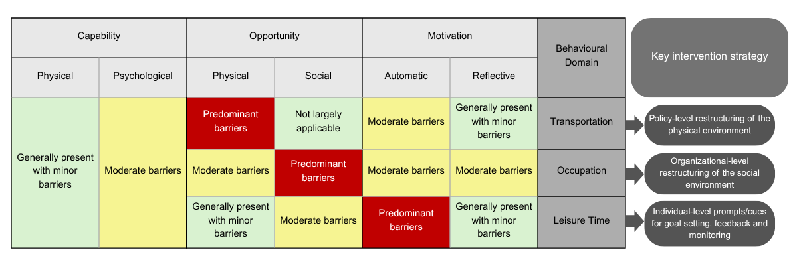
Appendix 4: Summary of behavioural determinants of reducing prolonged sedentary behaviour mapped to the COM-B model of behaviour, domains of sedentary behaviour, and resultant recommendations for intervention development

