Supplementary Material
Contents
Supplementary File A: Survey Development 2
Supplementary Figure 1 Histogram – frequency of percentage discretionary dollars spent of total dollars. 3
Supplementary Figure 2 Scatter plot of proportion of discretionary dollars over number of food and beverage items in transaction with linear regression fitted value line. 3
Supplementary Table 1: Participant discretionary purchasing per transaction, by treatment group and overall 4
Supplementary Table 2: Frequency, percentage, unadjusted and adjusted relative rate of having 0% discretionary dollars (vs. >0%) by customer-level factors (Poisson regression model) 5
Supplementary Table 3: Frequency, percentage, and adjusted relative rate of having 0% free sugar purchases (vs. >0%) by customer-level factors (Poisson regression model) 6
Supplementary Table 4: Interaction between intervention and customer level factors: adjusted relative rate of having 0% discretionary dollars (vs. >0%) (Poisson regression model) 7
Supplementary Table 5: Interaction between intervention and customer level factors: Adjusted Relative rate of 0% free sugar items (vs. >0%) (Poisson regression model). 8
References 9

Supplementary File A: Survey Development
The survey was developed by a working group with expertise in public health research, customer intercept surveys, Aboriginal culture and communication protocols, community engagement, marketing and business, and public health nutrition. Survey questions were developed and modified based on cultural, language and contextual appropriateness identified by working group members and in the pre-testing and pilot testing process. Survey questions relating to impulsive buying behaviour (Table 1) were adapted from Rook and Fisher [1]. The development of the final survey also involved pretesting with key informants and pilot testing in one remote community.
Impulsive buying behaviour survey questions
When shopping, do you…. | Shorthand Descriptor
Make up your mind quickly? | Quick minded
Buy things according to how you feel in the moment? | Buy in the moment
Carefully plan most of your purchases? | Carefully plan
Like to pick up extra things? | Buy extras
See something and just buy it? | See and buy
Survey question response options were ‘Yes’, ‘No’ and ‘Unsure’. Adapted from Rook and Fisher [1]
Survey Pre-Testing:
Survey pre-testing was carried out by EM and AR with a total of 11 Aboriginal and Torres Strait Islander; nine of whom lived in remote communities.
Survey Pilot-Testing:
Survey pilot testing was performed in an ALPA managed store , with permission from the community-elected store board, within a remote community in the NT that was not involved in the HS2020 trial. The purpose of the pilot testing was to check the delivery process and acceptability of the survey protocol with store staff, store management and remote community members; including the protocol around default receipt provision to store customers during survey windows, and to trial the survey with store customers using the iSurvey application.

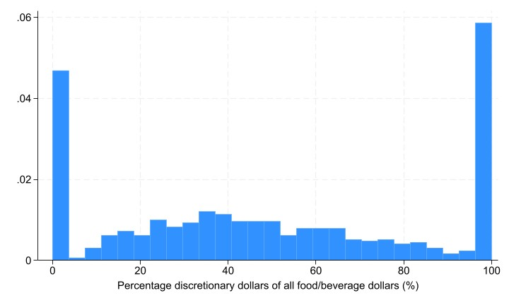

Supplementary Figure 1 Histogram – frequency of percentage discretionary dollars spent of total dollars.
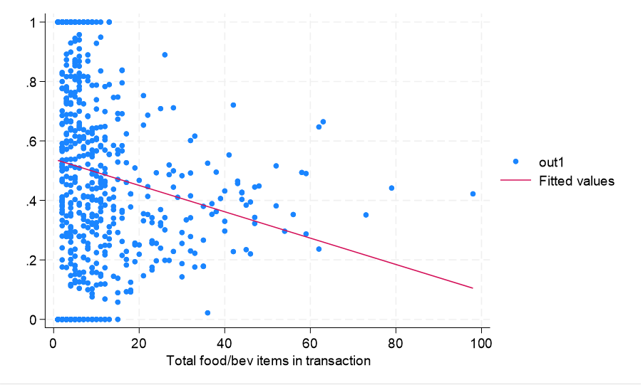

Supplementary Figure 2 Scatter plot of proportion of discretionary dollars over number of food and beverage items in transaction with linear regression fitted value line.

Supplementary Table 1: Participant discretionary purchasing per transaction, by treatment group and overall
 | Control (n=401) | HS2020 Strategy (n=382) | Total (n=783)
 | median (IQR)
Total dollars (AU$) | 22.4 (9.2-49.0) | 19.9 (9.4-53.9) | 21.5 (9.3-51.6)
Total items | 5 (2-11) | 5 (2-11) | 5 (2-11)
Discretionary dollars (AU$) | 10.6 (3.5-22.1) | 9.7 (2.9-24.6) | 9.9 (3.5-23.3)
Discretionary items | 2 (1-5) | 2 (1-5) | 2 (1-5)
% discretionary dollars (AU$) | 46.7 (22.7-81.7) | 44.9 (17.6-85.3) | 46.0 (20.2-83.6)
% discretionary items | 46.7 (25-80) | 50 (20-83.3) | 48.8 (22.2-80.0)
% discretionary dollars (AU$) grouped* | n (%)
0 | 62 (15.5) | 73 (19.1) | 135 (17.2)
1-25 | 48 (12.0) | 42 (11.0) | 90 (11.5)
26-50 | 102 (25.4) | 95 (24.9) | 197 (25.2)
51-75 | 72 (18.0) | 64 (16.8) | 136 (17.4)
76-99 | 33 (8.2) | 27 (7.1) | 60 (7.6)
100 | 84 (21.0) | 81 (21.2) | 165 (21.1)
% discretionary items grouped* | n (%)
0 | 62 (15.5) | 73 (19.1) | 135 (17.2)
1-25 | 45 (11.2) | 44 (11.5) | 89 (11.4)
26-50 | 140 (34.9) | 110 (28.8) | 250 (31.9)
51-75 | 51 (12.7) | 54 (14.1) | 105 (13.4)
76-99 | 16 (4.0) | 18 (4.7) | 34 (4.3)
100 | 87 (21.7) | 83 (21.7) | 170 (21.7)
n= number of participants; IQR=interquartile range; all differences between treatment groups were not statistically significant (p<0.01; Kruskal-Wallis equality of populations rank test); AU$=Australian dollars; *grouped by ranges of the percentage of discretionary dollars or items over total dollars or items spent/purchased.

Supplementary Table 2: Frequency, percentage, and adjusted relative rate of having 0% discretionary dollars (vs. >0%) by customer-level factors (Poisson regression model)
 | N (%) | RR | 95% CI
Total | 135 (17.2)
Treatment Group
Control | 62 (15.5)
HS2020 strategy | 73 (19.1) | 1.25 | 0.95, 1.66
Age group
<35 | 45 (13.6)
35+ | 90 (19.9) | 1.52* | 1.19, 1.95
Gender
Female | 86 (16.2)
Male | 48 (19.8) | 0.98 | 0.71, 1.35
Payment method
Card | 56 (13.5)
Cash | 79 (21.5) | 1.08 | 0.74, 1.59
Shopping with children
Yes | 16 (8.4)
No | 104 (21.3) | 1.68 | 1.06, 2.66
When shopping, do you like to pick up extra things?
Yes | 94 (15.7)
No | 35 (23.7) | 1.46* | 1.18, 1.80
Unsure | 6 (17.7)
When shopping, do you make up your mind quickly?
Yes | 73 (15.4)
No | 54 (20.8) | 1.41 | 1.06, 1.87
Unsure | 8 (16.3)
When shopping, do you buy things according to how you feel in the moment?
Yes | 87 (16.1)
No | 36 (18.4) | 1.09 | 0.81, 1.48
Unsure | 12 (26.1)
When shopping, do you carefully plan most of your purchases?
No | 23 (18.7)
Yes | 108 (17) | 0.96 | 0.70, 1.33
Unsure | 4 (18.1)
When shopping, do you see something and just buy it?
Yes | 69 (14.5)
No | 55 (20.6) | 1.37 | 1.05, 1.78
Unsure | 11 (27.5)
*p<0.01

Supplementary Table 3: Frequency, percentage, and adjusted relative rate of having 0% free sugar purchases (vs. >0%) by customer-level factors (Poisson regression model)
 | n (%) | RR | 95% CI
Treatment Group
Control | 47 (11.7)
HS2020 strategy | 64 (16.8) | 1.45 | 1.08, 1.95
Age group
<35 | 34 (10.3)
35+ | 77 (17) | 1.76* | 1.36, 2.26
Gender
Female | 71 (13.4)
Male | 39 (16.1) | 0.93 | 0.62, 1.38
Payment method
Card | 43 (10.3)
Cash | 68 (18.5) | 1.17 | 0.83, 1.64
Shopping with children
Yes | 14 (7.3)
No | 85 (17.4) | 1.51 | 0.92, 2.47
When shopping, do you like to pick up extra things?
Yes | 73 (12.2)
No | 32 (21.6) | 1.70* | 1.27, 2.29
Unsure | 6 (17.7)
When shopping, do you make up your mind quickly?
Yes | 60 (12.7)
No | 47 (18.1) | 1.51* | 1.11, 2.05
Unsure | 4 (8.2)
When shopping, do you buy things according to how you feel in the moment?
Yes | 76 (14.1)
No | 28 (14.3) | 0.97 | 0.68, 1.38
Unsure | 7 (15.2)
When shopping, do you carefully plan most of your purchases?
No | 17 (13.8)
Yes | 90 (14.2) | 1.09 | 0.76, 1.56
Unsure | 4 (18.2)
When shopping, do you see something and just buy it?
Yes | 60 (12.6)
No | 45 (16.9) | 1.29* | 1.01, 1.65
Unsure | 6 (15)
*p<0.01

Supplementary Table 4: Interaction between HS2020 strategy and customer level factors: adjusted relative rate of having 0% discretionary dollars (vs. >0%) (Poisson regression model)
 | n (%) | RR | 95% CI
Age group
<35 | 73 (19.1) | 1.53 | 0.99, 2.36
35+ | 43 (21.7) | 1.24 | 0.93, 1.66
Gender
Male | 26 (19.4) | 1.14 | 0.74, 1.75
Female | 46 (18.9) | 1.31 | 0.88, 1.94
Payment method
Card | 31 (14.6) | 1.12 | 0.61, 2.05
Cash | 42 (24.7) | 1.37 | 0.96, 1.96
Shopping with children
No | 55 (25.2) | 1.32 | 0.95, 1.84
Yes | 8 (7.9) | 1.04 | 0.53, 2.07
When shopping, do you like to pick up extra things?
No | 17 (25.8) | 1.24 | 0.74, 2.10
Yes | 52 (17.6) | 1.29 | 0.98, 1.71
When shopping, do you make up your mind quickly?
No | 29 (23.2) | 1.31 | 0.88, 1.94
Yes | 41 (18.2) | 1.38 | 0.93, 2.04
When shopping, do you buy things according to how you feel in the moment?
No | 21 (22.3) | 1.56 | 0.94, 2.61
Yes | 45 (17.4) | 1.20 | 0.88, 1.64
When shopping, do you carefully plan most of your purchases?
No | 12 (20.3) | 1.08 | 0.60, 1.94
Yes | 59 (19.2) | 1.35 | 0.96, 1.90
When shopping, do you see something and just buy it?
No | 30 (23.1) | 1.34 | 0.91, 1.98
Yes | 37 (16.5) | 1.30 | 0.84, 2.00
All p-values for differences between treatment groups were >0.01

Supplementary Table 5: Interaction between HS2020 strategy and customer level factors: Adjusted Relative rate of 0% free sugar items (vs. >0%) (Poisson regression model).
 | n (%) | RR | 95% CI
Age group
<35 (0) | 23 (12.5) | 1.60 | 1.06 | 2.242
35+ | 41 (20.7) | 1.54 | 1.06 | 2.25
Gender
Male (0) | 21 (15.67) | 1.13 | 0.66 | 1.95
Female | 42 (17.21) | 1.63 | 1.07 | 2.51
Payment method
Card | 25 (11.8) | 1.24 | 0.75 | 2.07
Cash (0) | 39 (22.9) | 1.62 | 1.09 | 2.39
Shopping with children
No | 49 (22.5) | 1.59 | 1.06 | 2.37
Yes | 8 (7.9) | 1.42 | 0.73 | 2.76
When shopping, do you like to pick up extra things?
No | 17 (25.8) | 1.48 | 0.83 | 2.65
Yes | 43 (14.6) | 1.50 | 1.05 | 2.01
When shopping, do you make up your mind quickly?
No | 25 (20.0) | 1.27 | 0.87 | 1.87
Yes | 37 (16.4) | 1.73 | 1.11 | 2.70
When shopping, do you buy things according to how you feel in the moment?
No | 16 (17.0) | 1.46 | 0.80 | 2.66
Yes | 43 (16.6) | 1.47 | 1.07 | 2.02
When shopping, do you carefully plan most of your purchases?
No | 9 (15.3) | 1.09 | 0.57 | 2.10
Yes | 53 (17.3) | 1.61* | 1.14 | 2.28
When shopping, do you see something and just buy it?
No | 26 (20.0) | 1.52 | 1.01 | 2.29
Yes | 34 (15.2) | 1.47 | 0.94 | 2.28
*p<0.01

References

1. Rook, D.W. and R.J. Fisher, Normative Influences on Impulsive Buying Behavior. Journal of Consumer Research, 1995. 22(3): p. 305–313.

