Supplementary material
Table of Contents
Contents | Page
Supplementary texts: Covariates | 2
Table S1. Definitions and operational criteria for healthy lifestyle components in the UK Biobank | 3-4
Table S2. Baseline characteristics of participants who completed versus did not complete both lifestyle assessments | 5-6
Table S3. Baseline characteristics by changes in healthy lifestyle score (ΔHLS) | 7-8
Table S4. Baseline characteristics by lifestyle change patterns | 9-10
Fig S1. Change in adherence to healthy lifestyle recommendations between baseline and repeat assessment | 11
Fig S2. Distribution of healthy lifestyle score (HLS) transition between baseline and repeat assessment. | 12
Fig S3. Associations of baseline lifestyle patterns with risk of depression and anxiety | 13
Fig S4. Cumulative incidence of depression and anxiety according to lifestyle change patterns | 14
Fig S5. Sensitivity analyses for changes in healthy lifestyle score (△HLS) with risk of depression and anxiety. | 15-16
Fig S6. Sensitivity analyses for dynamic lifestyle trajectories and depression | 17-18
Fig S7. Sensitivity analyses for dynamic lifestyle trajectories and anxiety risk. | 19-20
Supplementary texts: Covariates
We identified a set of confounders consistent with previous literature indicating that these factors may act as potential confounders of lifestyle behavior changes and depression and anxiety. All covariates were collected at baseline through standardized questionnaires and interviews. The covariates included sociodemographic characteristics, socioeconomic status, physical comorbidities, and methodological factors.
Sociodemographic factors included age at attendance of the assessment center, sex (male or female), self-reported ethnic groups. Due to the predominantly White composition of the UK Biobank cohort, ethnicity was categorized into White and non-White groups for analyses.
Socioeconomic status was assessed by education level, employment status, and Townsend Deprivation Index (TDI). Educational level was classified into three groups: high (a college or university degree), middle (A-levels or equivalent; O-level/GCSE or equivalent) and low (none of the above qualifications). Employment status was categorized into three categories: employed (in paid employment or self-employed), retired, others (unemployed, unable to work, homemaker, student or other non-working categories). The TDI was derived from national census data on employment, housing and social class and was linked to participants’ residential postcodes. A TDI value of 0 represents the national average, with positive values indicating higher deprivation (lower socioeconomic status) and negative values indicating lower deprivation (higher socioeconomic status).
Self-reported physician diagnosed comorbidities included hypertension, diabetes, cardiovascular disease (CVD), cancer, chronic bronchitis, emphysema, or chronic obstructive pulmonary disease (COPD). These conditions were included as binary variables.
To address potential left-truncation bias arising from differences in follow-up time, we calculated the time interval (in years) between baseline and repeat assessments and adjusted for it in all models.

Table S1. Definitions and operational criteria for healthy lifestyle components in the UK Biobank
Lifestyle component | Recommendations/ healthy criteria | Operationalization | Field ID
Smoking | Never smoking or <100 cigarettes lifetime | Includes light (<100 cigs lifetime) and never smokers | 2644, 20116,1249
Alcohol consumption | Never/rarely, or drink frequently but ≤2 drinks/day (men); ≤1 drink/day (women) | Based on consumption of wine (1568/1578), beer (1588), spirits (1598), fortified wine (1608); 1 UK unit = 8g/10 ml pure alcohol | 1558, 1568, 1578, 1588,1598,1608, 20117
Physical activity | Moderate ≥150 min/week or vigorous ≥75 min/week | Meeting WHO thresholds using MET-based activity (moderate:22038; vigorous: 22039) | 22038, 22039
Body mass index | 18.5–24.9 kg/m² | BMI within WHO normal range | 21001
Diet
Fruit | ≥3 servings/day | 1 piece= 1 serving (1309)  5 pieces= 1 serving (1319) | 1309, 1319
Vegetable | ≥3 servings/day | 3 heaped tablespoons= 1 serving | 1289, 1299
Whole grains | ≥3 servings/day | 1 slice/day= 1 serving (1438/1448)  1 bowl/day= 1 serving (1458/1468) | 1438, 1448, 1458, 1468
Fish (Shell) | ≥2 servings/week | once/week= 1 serving | 1329, 1339
Dairy | ≥2 servings/day | once/day per serving (1408)  1 glass/day per serving (100520) | 1408, 1418,100520, 6144
Vegetable oils | ≥2 servings/day | 1 serving/day (combined with at least 2 slices of bread) | 1428, 1438, 2654
Refined grains | ≤2 servings/day | 1 slice/day= 1 serving (1438/1448)  1 bowl/day=1 serving (1458/1468) | 1438, 1448, 1458, 1468
Processed meats | ≤1 serving/week | once/week=1 serving | 1349, 3680
Unprocessed meats | ≤2 servings/week | once/week=1 serving | 1359,1369, 1379, 1389, 3680
Sugar-sweetened beverages | Never consumes drinks containing sugar | 0 servings | 6144
Sleep
Chronotype preference | Early chronotype | Response "definitely a morning person" or "more morning than evening" | 1180
Sleep duration | 7-8 hours/day | Self-reported sleep duration | 1160
Insomnia | Never or rarely | Response "never/rarely" to insomnia symptoms | 1200
Snoring | No | No reported snoring by partner/friend | 1210
Daytime dozing | Never/rarely or sometimes | Response "never/rarely" or "sometimes" | 1220
Sedentary behavior | ≤ 3 hours/day | Time spent watching TV per day | 1070
Lifestyle components were assessed at both baseline (2006-2010) and the repeat assessment (2012-2013). Healthy criteria were based on World Health Organization recommendations, and validated lifestyle scores used in previous UK Biobank studies. Each lifestyle behavior was dichotomized as healthy/unhealthy, and summed to create a healthy lifestyle score (range 0-7).

Table S2. Baseline characteristics of participants who completed versus did not complete both lifestyle assessments
Characteristics | Completed both assessments (n=19,588) | Did not complete both assessments (n=482,362) | P value^{b}
Age, mean (SD) | 57.1 (7.4) | 56.5 (8.1) | <0.001
Sex, n (%) |  |  | <0.001
Female | 10,015 (51.1) | 257,067 (54.5)
Male | 9,573 (48.9) | 214,344 (45.5)
Ethnicity, n (%) |  |  | <0.001
White | 19,130 (97.9) | 442,703 (94.4)
Non-white | 419 (2.1) | 26,025 (5.6)
Educationª, n (%) |  |  | <0.001
High | 8,419 (44.0) | 148,988 (31.9)
Middle | 6,233 (32.6) | 155,990 (33.4)
Low | 4,486 (23.4) | 162,338 (34.7)
Employment status, n (%) |  |  | <0.001
Employed | 11,367 (58.0) | 269,122 (57.2)
Retired | 7,030 (35.9) | 156,213 (33.2)
Others | 1,191 (6.1) | 45,224 (9.6)
Lifestyle behaviors, n (%)
Non-smoking or light smoking | 11,875 (60.6) | 264,221 (56.4) | <0.001
Low-risk alcohol consumption | 19,216 (98.1) | 459,424 (97.8) | 0.002
Healthy diet | 13,924 (71.1) | 321,187 (68.3) | <0.001
Healthy BMI (18.5-24.9 kg/m²) | 7,101 (36.3) | 146,637 (31.3) | <0.001
Adequate physical activity | 15,480 (79.0) | 362,146 (77.0) | <0.001
Healthy sleep | 11,253 (57.4) | 256,785 (54.6) | <0.001
Low sedentary behavior | 15,151 (77.3) | 335,990 (70.4) | <0.001
Self-reported comorbidities, n (%)
Hypertension | 8,911 (45.5) | 225,148 (47.9) | <0.001
Diabetes | 1,775 (9.1) | 49,474 (10.5) | <0.001
CVD | 2,177 (11.1) | 57,790 (12.3) | <0.001
Cancer | 2,849 (14.6) | 71,932 (15.3) | 0.004
Chronic bronchitis, emphysema, COPD | 451 (2.3) | 12,214 (2.6) | 0.012
ª High educational level was defined as having a college or university degree; middle education level as A-levels or equivalent; O-level/GCSE or equivalent; and low educational level as having none of the above qualifications. ^{b} P values were obtained using chi-square tests for categorical variables and t tests for continuous variables. Abbreviations: SD, standard deviation; BMI, body mass index; CVD, cardiovascular disease; COPD, chronic obstructive pulmonary disease.

Table S3. Baseline characteristics by changes in healthy lifestyle score (ΔHLS)
Characteristics | Total (n=18,678) | Improved (n= 1,135) | Stable (n=11,796) | Deteriorated (n=5,747)
Age, mean (SD) | 57.2 (7.4) | 56.7 (7.6) | 57.1 (7.4) | 57.3 (7.4)
Sex
Female | 9491 (50.8) | 582 (51.3) | 6,012 (51.0) | 2,897 (50.4)
Male | 9187 (49.2) | 553 (48.7) | 5,784 (49.0) | 2,850 (49.6)
Ethnicity
White | 18276 (97.8) | 1,109 (97.7) | 11,548 (97.9) | 5,619 (97.8)
Non-white | 402 (2.2) | 26 (2.3) | 248 (2.1) | 128 (2.2)
Educationª
Low | 8252 (44.2) | 469 (41.3) | 5,396 (45.7) | 2,387 (41.5)
Middle | 6065 (32.5) | 376 (33.1) | 3,737 (31.7) | 1,952 (34.0)
High | 4361 (23.3) | 290 (25.6) | 2,663 (22.6) | 1,408 (24.5)
Occupation
Employed | 10845 (58.0) | 689 (60.7) | 6,841 (58.0) | 3,315 (57.7)
Retired | 6759 (36.2) | 385 (33.9) | 4,298 (36.4) | 2,076 (36.1)
Others | 1074 (5.8) | 61 (5.4) | 657 (5.6) | 356 (6.2)
Townsend Deprivation Index (TDI), Median (IQR)^{b} | -2.8 (-4.0, -0.8) | -2.7 (-3.9, -0.7) | -2.8 (-4.0, -0.9) | -2.8 (-4.0, -0.7)
Self-reported comorbidities
Hypertension | 8483 (45.4) | 532 (46.9) | 5,338 (45.3) | 2,613 (45.5)
Diabetes | 1677 (9.0) | 100 (8.8) | 1,043 (8.8) | 534 (9.3)
CVD | 2048 (11.0) | 117 (10.3) | 1,284 (10.9) | 647 (11.3)
Cancer | 2719 (14.6) | 165 (14.5) | 1,728 (14.6) | 826 (14.4)
Chronic bronchitis, emphysema, COPD | 431 (2.3) | 21 (1.9) | 281 (2.4) | 129 (2.2)
a High educational level was defined as having a college or university degree; middle education level as A-levels or equivalent; O-level/GCSE or equivalent; and low educational level as having none of the above qualifications. b A TDI value of 0 represents the national average; positive values indicate higher deprivation (lower socioeconomic status). ΔHLS cut-offs were determined using restricted cubic spline models and were categorized into three groups: improved (ΔHLS ≥ 2), stable (-1 < ΔHLS ≤ 1), and deteriorated (ΔHLS ≤ -1). Abbreviations: SD, standard deviation; TDI, Townsend Deprivation Index; IQR, interquartile range; CVD, cardiovascular disease; COPD, chronic obstructive pulmonary disease.

Table S4. Baseline characteristics by lifestyle change patterns
Characteristics | Ideal |  | Intermediate |  |  | Poor
Characteristics | Maintained | Deteriorated | Improved | Maintained | Deteriorated | Improved | Maintained
N | 4,118 | 1,978 | 1,698 | 6,406 | 1,466 | 1,286 | 1,726
Age, mean (SD) | 55.9 (7.6) | 56.7 (7.5) | 56.4 (7.7) | 57.5 (7.3) | 58.0 (7.2) | 57.9 (7.3) | 58.7 (6.9)
Sex
Female | 2,617 (63.6) | 1,142 (57.7) | 932 (54.9) | 3,014 (47.0) | 610 (41.6) | 563 (43.8) | 613 (35.5)
Male | 1,501 (36.4) | 836 (42.3) | 766 (45.1) | 3,392 (53.0) | 856 (58.4) | 723 (56.2) | 1,113 (64.5)
Ethnicity
White | 4,036 (98.0) | 1,936 (97.9) | 1,649 (97.1) | 6,272 (97.9) | 1,428 (97.4) | 1,262 (98.1) | 1,693 (98.1)
Non-white | 82 (2.0) | 42 (2.1) | 49 (2.9) | 134 (2.1) | 38 (2.6) | 24 (1.9) | 33 (1.9)
Education
Low | 606 (14.7) | 418 (21.1) | 360 (21.2) | 1,517 (23.7) | 445 (30.4) | 385 (29.9) | 630 (36.5)
Middle | 1,137 (27.6) | 649 (32.8) | 493 (29.0) | 2,175 (34.0) | 538 (36.7) | 437 (34.0) | 636 (36.8)
High | 2,375 (57.7) | 911 (46.1) | 845 (49.8) | 2,714 (42.4) | 483 (32.9) | 464 (36.1) | 460 (26.7)
Employment status
Employed | 2,542 (61.7) | 1,195 (60.4) | 1,044 (61.5) | 3,696 (57.7) | 822 (56.1) | 700 (54.4) | 846 (49.0)
Retired | 1,351 (32.8) | 682 (34.5) | 573 (33.7) | 2,393 (37.4) | 536 (36.6) | 508 (39.5) | 716 (41.5)
Others | 225 (5.5) | 101 (5.1) | 81 (4.8) | 317 (4.9) | 108 (7.4) | 78 (6.1) | 164 (9.5)
Townsend Deprivation Index (TDI), Median (IQR) | -2.96  (-4.09, 1.28) | -2.93  (-4.05, -1.06) | -2.81  (-4.05, -1.18) | -2.73  (-3.96, -0.81) | -2.45  ( -3.91, -0.17) | -2.65  (-3.86, -0.40) | -2.31  (-3.81,0.31)
Self-reported comorbidities
Hypertension | 1,546 (37.5) | 794 (40.1) | 708 (41.7) | 3,033 (47.3) | 764 (52.1) | 655 (50.9) | 983 (57.0)
Diabetes | 252 (6.1) | 158 (8.0) | 112 (6.6) | 592 (9.2) | 169 (11.5) | 151 (11.7) | 243 (14.1)
CVD | 331 (8.0) | 168 (8.5) | 163 (9.6) | 733 (11.4) | 209 (14.3) | 158 (12.3) | 286 (16.6)
Cancer | 584 (14.2) | 270 (13.7) | 235 (13.8) | 948 (14.8) | 228 (15.6) | 199 (15.5) | 255 (14.8)
Chronic bronchitis, emphysema, COPD | 97 (2.4) | 52 (2.6) | 38 (2.2) | 141 (2.2) | 21 (1.4) | 35 (2.7) | 47 (2.7)
a High educational level was defined as having a college or university degree; middle education level as A-levels or equivalent; O-level/GCSE or equivalent; and low educational level as having none of the above qualifications. b A TDI value of 0 represents the national average; positive values indicate higher deprivation (lower socioeconomic status). Abbreviations: SD, standard deviation; TDI, Townsend Deprivation Index; IQR, interquartile range; CVD, cardiovascular disease; COPD, chronic obstructive pulmonary disease.

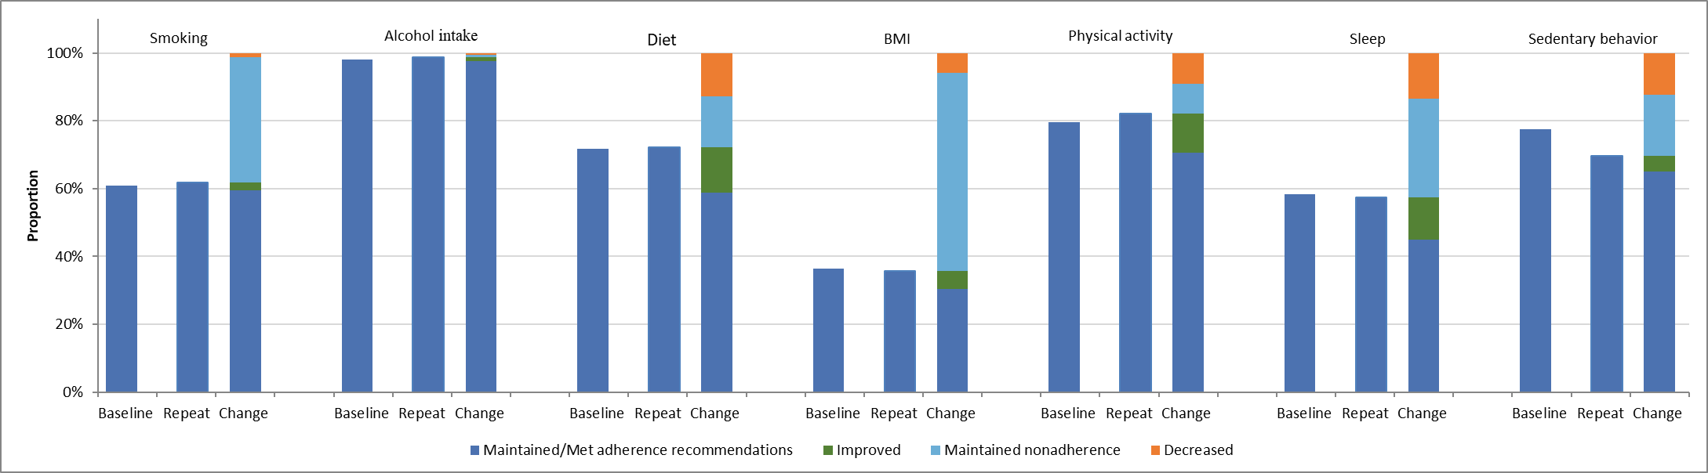
Fig S1. Changes in adherence to healthy lifestyle recommendations between baseline and repeat assessment. Abbreviations: BMI, body mass index.

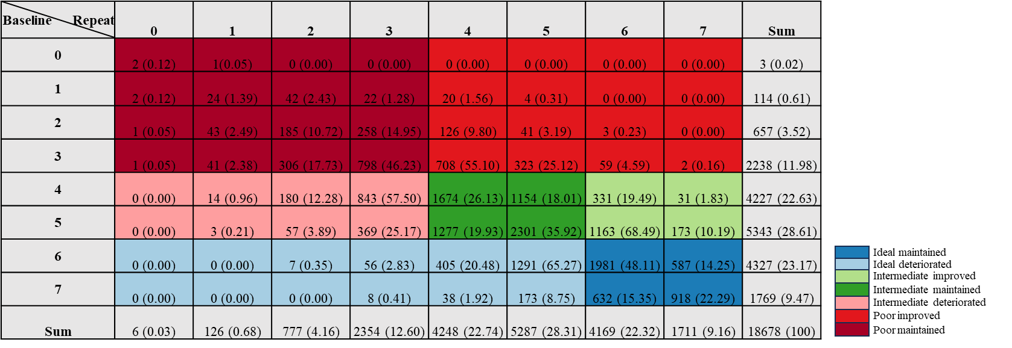
Fig S2. Distribution of healthy lifestyle score (HLS) transitions between baseline and repeat assessment. Rows indicate baseline HLS and columns indicate repeat HLS, with scores ranging from 0 to 7 (higher score indicate healthier lifestyles). Cell values represent the count of participants and percentages (%) within each lifestyle change pattern.

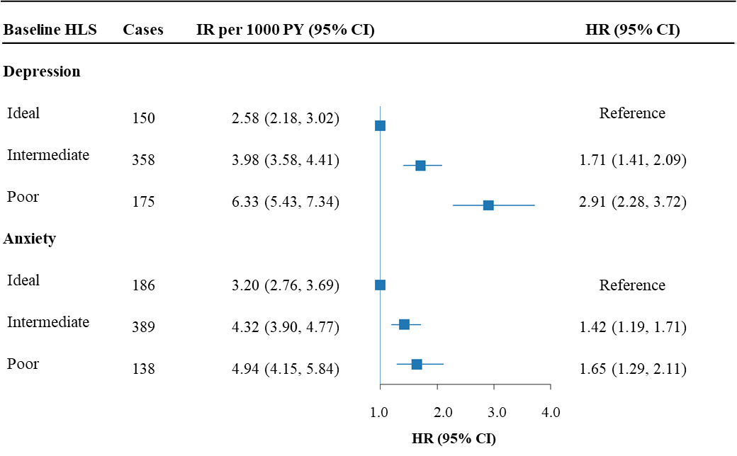
Fig S3. Associations of baseline lifestyle patterns with risk of depression and anxiety. Hazard ratios (HRs) and 95% confidence intervals (CIs) for incident depression and anxiety were estimated using Cox proportional hazards models. All models were adjusted for demographic factors (age, sex, and ethnicity), socioeconomic status (education, employment status, and Townsend Deprivation Index), comorbidities (hypertension, diabetes, cardiovascular disease, cancer, chronic bronchitis, emphysema, and COPD), as well as the time interval between baseline and repeat assessments. Incidence rates (IRs) are reported as events per 1000 person-years with 95% CIs. Abbreviations: HLS, healthy lifestyle score; COPD, chronic obstructive pulmonary disease; CVD, cardiovascular disease.
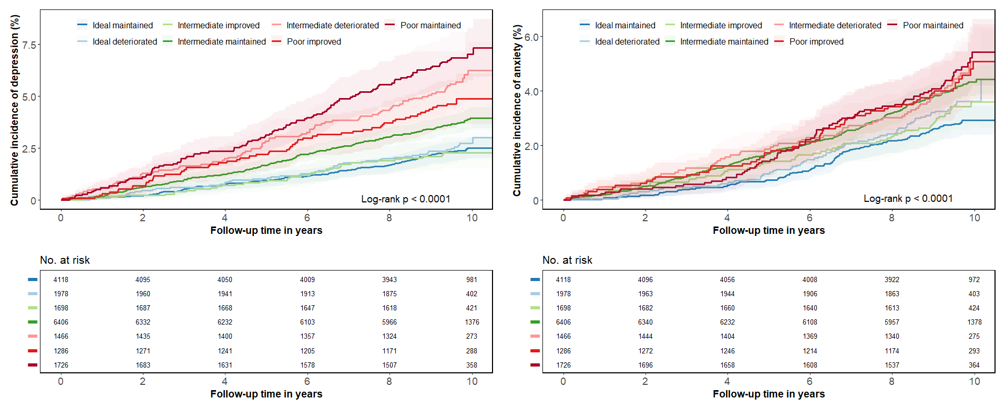 Fig S4. Cumulative incidence of depression and anxiety according to lifestyle change patterns. Curves show the cumulative incidence of depression (left) and anxiety (right) across lifestyle change patterns. Group differences were assessed using log-rank tests.
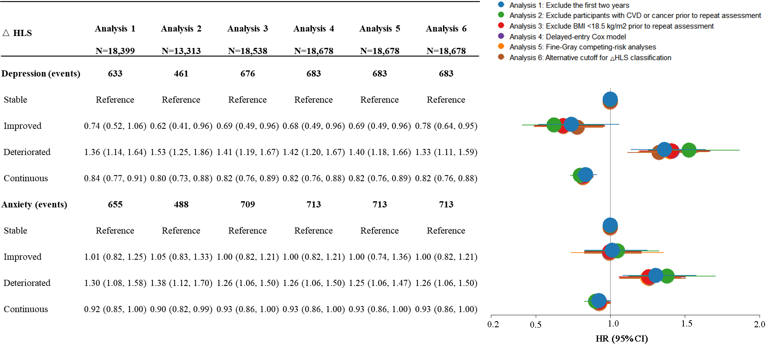
Fig S5. Sensitivity analyses for changes in healthy lifestyle score (ΔHLS) with risk of depression and anxiety. Plots show the adjusted hazard ratios (HRs) and 95% confidence intervals (CIs) for incident depression and anxiety. HRs were estimated using Cox proportional hazards models adjusted for demographic factors (age, sex, and ethnicity), socioeconomic status (education, employment status, and Townsend Deprivation Index), comorbidities (hypertension, diabetes, cardiovascular disease, cancer, chronic bronchitis, emphysema, and COPD), as well as the time interval between baseline and repeat assessments, and baseline HLS (continuous), as appropriate. Sensitivity analyses included: 1) exclusion of anxiety cases occurred within the first two years after the repeat assessment (2012-13); 2) exclusion of participants with CVD or cancer prior to repeat assessment; 3) exclusion of participants with BMI < 18.5kg/m² at either assessment; 4) delayed-entry Cox models using age at repeat assessment as entry time, and age at outcome, censoring, or end of follow-up as exit time; 5) Fine-Gray competing risk models accounting for death as a competing event; 6) an alternative classification of ΔHLS classification (deteriorated: ΔHLS ≤ -1, stable: ΔHLS = 0, and improved: ΔHLS ≥ 1). Abbreviations: HR, hazard ratio; CI, confidence interval; COPD, chronic obstructive pulmonary disease; CVD, cardiovascular disease; BMI, body mass index.

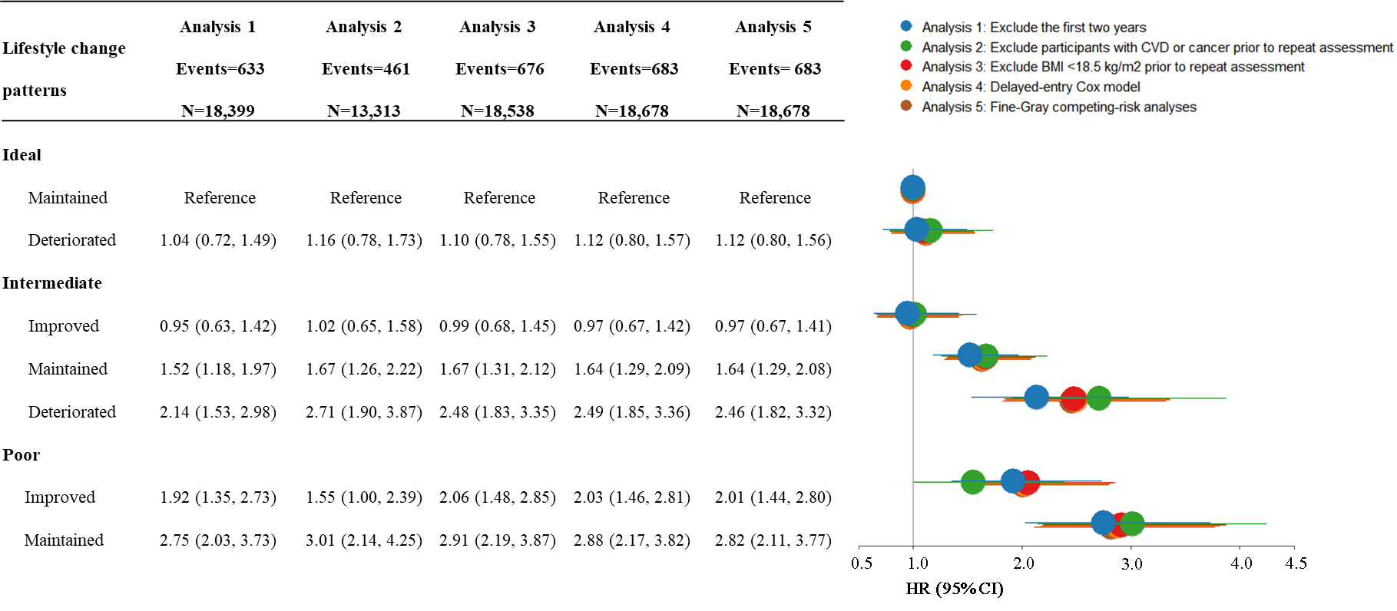 Fig S6. Sensitivity analyses for lifestyle change patterns and depression. Plots show the adjusted hazard ratios (HRs) and 95% confidence intervals (CIs) for incident depression. HRs were estimated using Cox proportional hazards models adjusted for demographic factors (age, sex, and ethnicity), socioeconomic status (education, employment status, and Townsend Deprivation Index), comorbidities (hypertension, diabetes, cardiovascular disease, cancer, chronic bronchitis, emphysema, and COPD), as well as the time interval between baseline and repeat assessments, as appropriate. Sensitivity analyses included: 1) exclusion of depression cases occurred within the first two years after the repeat assessment (2012-13); 2) exclusion of participants with CVD or cancer prior to repeat assessment; 3) exclusion of participants with BMI < 18.5kg/m² at either assessment; 4) delayed-entry Cox models using age at repeat assessment as entry time, and age at outcome, censoring, or end of follow-up as exit time; 5) Fine-Gray competing risk models accounting for death as a competing event. Abbreviations: HR, hazard ratio; CI, confidence interval; COPD, chronic obstructive pulmonary disease; CVD, cardiovascular disease; BMI, body mass index.

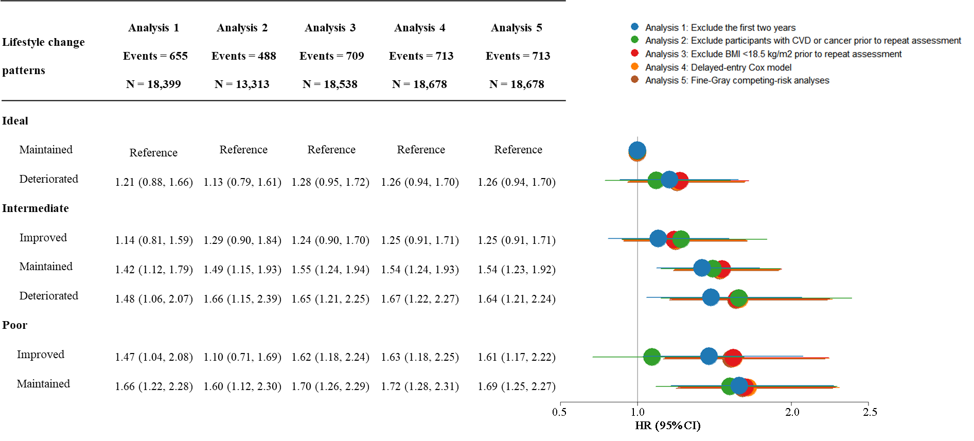 Fig S7. Sensitivity analyses for lifestyle change patterns and anxiety. Plots show the adjusted hazard ratios (HRs) and 95% confidence intervals (CIs) for incident anxiety. Models were adjusted for demographic factors (age, sex, and ethnicity), socioeconomic status (education, employment status, and Townsend Deprivation Index), comorbidities (hypertension, diabetes, cardiovascular disease, cancer, chronic bronchitis, emphysema, and COPD), as well as the time interval between baseline and repeat assessments, and the time interval between baseline and repeat assessments, as appropriate. Sensitivity analyses included: 1) exclusion of anxiety cases occurred within the first two years after the repeat assessment (2012-13); 2) exclusion of participants with CVD or cancer prior to repeat assessment; 3) exclusion of participants with BMI < 18.5kg/m² at either assessment; 4) delayed-entry Cox models using age at repeat assessment as entry time, and age at outcome, censoring, or end of follow-up as exit time; 5) Fine-Gray competing risk models accounting for death as a competing event. Abbreviations: HR, hazard ratio; CI, confidence interval; COPD, Chronic obstructive pulmonary disease; CVD, cardiovascular disease; BMI, body mass index.

