Supplementary material

Towards harmonised accelerometer-derived physical activity: A comparability study across wrist, thigh, and hip wear locations

Contents
Supplementary Methods………………………………………………………………................. 3

Table S1: Summary of devices, wear locations, and processing pipelines by study 4
Table S2: Calibration equations by subgroups of age, sex, and body mass index 5
Table S3: Sensitivity analyses of correlations across wear locations 6
Table S4: Participant characteristics in the CAP-24 study 7
Table S5: Descriptive statistics of physical activity and sedentary behaviour measures in the CAP-24 study, by wear location 8

Figure S1: Flowchart of participants included in the main analysis 9
Figure S2: Agreement of physical activity and sedentary behaviour measures across wear locations 10
Figure S3: Bland-Altman plots of physical activity and sedentary behaviour measures across wear locations 11
Figure S4: Equivalence of physical activity and sedentary behaviour measures across wear locations 12
Figure S5: Scatter plots and Bland-Altman plots of peak 30-minute cadence across wear locations 13
Figure S6: Scatter plot of overall activity in the Raine Study, comparing wrist Euclidean norm minus one (ENMO) and hip vector magnitude 14
Figure S7: Correlations across wear locations, by age subgroups 15
Figure S8: Correlations across wear locations, by sex 16
Figure S9: Correlations across wear locations, by body mass index subgroups 17
Figure S10: Scatter plots, correlations, and calibration equations of physical activity and sedentary behaviour measures across wear locations in the Raine Study, using full 24-hour data 18
Figure S11: Scatter plots and correlations of calibrated physical activity and sedentary behaviour measures across wear locations in the CAP-24 study 19
Figure S12: Bland-Altman plots of calibrated physical activity and sedentary behaviour measures across wear locations in the CAP-24 study 20
Figure S13: Agreement of calibrated physical activity and sedentary behaviour measures across wear locations in the CAP-24 study: sensitivity analysis using the dominant wrist 21
Figure S14: Bland-Altman plots of calibrated physical activity and sedentary behaviour measures across wear locations in the CAP-24 study: sensitivity analysis using the dominant wrist 22
Figure S15: Equivalence of calibrated physical activity and sedentary behaviour measures across wear locations in the CAP-24 study: sensitivity analysis using the dominant wrist 23

Supplementary Methods
GT3X accelerometer data processing
Hip-worn accelerometer recordings were converted to 60-second epoch data using the proprietary ActiLife software (v7.3.1), and activity intensities were classified using a custom R script (available at https://github.com/OxWearables/wear-location-comparability).

Raw data files provided by the Raine Study were originally generated with the low frequency extension (LFE) enabled, on devices running an older firmware version (v1.9.2) no longer supported by ActiLife. To address this, the R package read.gt3x (v1.2.0) was used to parse the raw .gt3x files, after which a metadata header was added to mimic the format of a raw .gt3x file converted to .csv by ActiLife. This allowed the .csv (raw) to .agd (epoch) conversion function in ActiLife to be used to regenerate epoch-level data without the LFE. Regenerated files were visually compared with the original LFE files to confirm correct parsing.

Non-wear time was identified using the wearingMarking function from the R package PhysicalActivity (v0.2-4), applied to 1-minute epoch triaxial vector magnitude data, implementing the Choi algorithm. Periods of at least 90 consecutive minutes of zero activity counts were classified as non-wear, with allowance for up to 2 minutes of non-zero counts provided they were contained within a 30-minute sub-window.

Main analyses were restricted to waking hours (hip-worn data only), approximated using a fixed window of 07:00–23:00. In an additional analysis, sleep periods were estimated from the full 24-hour recordings and removed to derive waking-hour behaviours. Sleep was scored in ActiLife using the Cole-Kripke algorithm applied to 60-second epoch data, with the sleep period window determined using the Tudor-Locke Sleep Period Detection method. Valid sleep periods were required to be between 160 and 1440 minutes in duration. Bedtime was defined as 5 minutes before the first sleep-scored epoch, and wake time as 10 minutes after the last.

Supplementary Tables
Table S1: Summary of devices, wear locations, and processing pipelines by study
Study | Wear location | Device (sampling frequency; dynamic range) | Processing software
SMART Work & Life | Non-dominant wrist | Axivity AX3 (100 Hz; ±8 g) | actinet, stepcount
SMART Work & Life | Thigh | activPAL3 micro (20 Hz; ±2 g) | PALbatch (CREA), actipy
Raine Study Gen1 | Non-dominant wrist | ActiGraph GT3X+ (30 Hz; ±6 g) | actinet, stepcount
Raine Study Gen1 | Hip | ActiGraph GT3X+ (30 Hz; ±6 g) | ActiLife, actipy
CAP-24 | Both wrists | GENEActiv (100 Hz; ±8 g) | actinet, stepcount
CAP-24 | Thigh | activPAL4 (20 Hz; ±4 g or ±2 g) | PALbatch (CREA), actipy
CAP-24 | Hip | ActiGraph GT3X+ or wGT3X-BT (100 Hz; ±6 g or ±8 g) | ActiLife, actipy

Table S2: Calibration equations by subgroups of age, sex, and body mass index
 | SMART Work & Life [wrist (X) vs. thigh (Y)]
 | Age |  | Sex |  | Body mass index
Measure | <40 years  (n = 214) | ≥40 years  (n = 438) | Men  (n = 176) | Women  (n = 476) | <25 kg/m²  (n = 318) | ≥25 kg/m²  (n = 332)
Overall activity, mg/day | Y = -4.09 + 0.894 X | Y = -2.44 + 0.876 X | Y = -3.86 + 0.996 X | Y = -1.74 + 0.804 X | Y = -1.87 + 0.829 X | Y = -4.6 + 0.958 X
Step count, steps/day | Y = 318 + 0.921 X | Y = -642 + 1.02 X | Y = -210 + 0.969 X | Y = -356 + 0.992 X | Y = -243 + 0.979 X | Y = -347 + 0.987 X
Peak 1-min cadence, steps/min | Y = -27.5 + 1.24 X | Y = -13.6 + 1.13 X | Y = -16.9 + 1.17 X | Y = -17.3 + 1.15 X | Y = -16.2 + 1.15 X | Y = -19.5 + 1.18 X
MVPA, minutes/day | Y = 3.58 + 0.685 X | Y = 5.68 + 0.733 X | Y = 0.41 + 0.676 X | Y = 4.65 + 0.788 X | Y = 5.0 + 0.73 X | Y = 4.59 + 0.712 X
Light physical activity, hours/day | Y = 0.463 + 0.927 X | Y = 0.272 + 1.03 X | Y = 0.565 + 0.99 X | Y = 0.0964 + 1.03 X | Y = 0.566 + 0.923 X | Y = -0.114 + 1.12 X
Sedentary behaviour, hours/day | Y = 0.496 + 0.881 X | Y = -0.348 + 0.948 X | Y = 0.187 + 0.903 X | Y = -0.182 + 0.937 X | Y = 0.539 + 0.882 X | Y = -0.951 + 0.994 X
 | Raine Study Gen1 [wrist (X) vs. hip (Y)]
 | Age |  | Sex |  | Body mass index
 | <60 years  (n = 649) | ≥60 years  (n = 246) | Men  (n = 382) | Women  (n = 515) | <25 kg/m²  (n = 267) | ≥25 kg/m²  (n = 628)
Overall activity, mg/day | Y = -4 + 0.824 X | Y = -2.15 + 0.738 X | Y = -2.56 + 0.771 X | Y = -4.26 + 0.828 X | Y = -3.44 + 0.788 X | Y = -3.69 + 0.816 X
Step count, steps/day | Y = -83 + 0.738 X | Y = -8.57 + 0.705 X | Y = -99.1 + 0.71 X | Y = -65.2 + 0.746 X | Y = 177 + 0.732 X | Y = -64.1 + 0.717 X
Peak 1-min cadence, steps/min | Y = -74.2 + 1.62 X | Y = -72.6 + 1.61 X | Y = -59.4 + 1.49 X | Y = -84.7 + 1.71 X | Y = -46.8 + 1.4 X | Y = -78.9 + 1.66 X
MVPA, minutes/day | Y = 12.7 + 0.929 X | Y = 6.65 + 1.03 X | Y = 11.9 + 0.844 X | Y = 9.56 + 1.11 X | Y = 8.33 + 1.06 X | Y = 12.3 + 0.891 X
Light physical activity, hours/day | Y = 1.85 + 0.774 X | Y = 1.66 + 0.815 X | Y = 1.76 + 0.785 X | Y = 1.85 + 0.781 X | Y = 2.25 + 0.725 X | Y = 1.69 + 0.797 X
Sedentary behaviour, hours/day | Y = 1.03 + 0.822 X | Y = 1.11 + 0.82 X | Y = 0.661 + 0.848 X | Y = 1.2 + 0.817 X | Y = 0.806 + 0.84 X | Y = 1.25 + 0.806 X
MVPA=Moderate-to-vigorous physical activity

Table S3: Sensitivity analyses of correlations across wear locations
 | Correlation coefficients (95% CI)
Measure | Main  analysis | Complete  8-day wear | Median  aggregation | Proportion  of wear time
 | SMART Work & Life (wrist vs. thigh)
Overall activity, mg/day | 0.71 (0.67, 0.75) | 0.73 (0.69, 0.77) | 0.67 (0.63, 0.71) | 0.71 (0.67, 0.74)
Step count, steps/day | 0.89 (0.88, 0.91) | 0.92 (0.90, 0.93) | 0.88 (0.86, 0.90) | 0.89 (0.88, 0.91)
Peak 1-min cadence, steps/min | 0.85 (0.83, 0.87) | 0.89 (0.87, 0.91) | 0.79 (0.76, 0.82) | 0.85 (0.83, 0.87)
MVPA, minutes/day | 0.78 (0.73, 0.81) | 0.76 (0.71, 0.81) | 0.76 (0.72, 0.80) | 0.78 (0.73, 0.81)
Light physical activity, hours/day | 0.79 (0.76, 0.82) | 0.82 (0.79, 0.85) | 0.74 (0.70, 0.77) | 0.79 (0.76, 0.82)
Sedentary behaviour, hours/day | 0.66 (0.61, 0.70) | 0.70 (0.65, 0.74) | 0.61 (0.56, 0.66) | 0.65 (0.61, 0.70)
 | Raine Study Gen1 (wrist vs. hip)
Overall activity, mg/day | 0.67 (0.63, 0.70) | 0.68 (0.63, 0.72) | 0.65 (0.61, 0.69) | 0.66 (0.62, 0.69)
Step count, steps/day | 0.90 (0.88, 0.91) | 0.90 (0.89, 0.92) | 0.88 (0.86, 0.89) | 0.89 (0.88, 0.91)
Peak 1-min cadence, steps/min | 0.87 (0.85, 0.89) | 0.87 (0.85, 0.89) | 0.84 (0.82, 0.86) | 0.87 (0.85, 0.89)
MVPA, minutes/day | 0.66 (0.61, 0.70) | 0.69 (0.64, 0.74) | 0.64 (0.60, 0.68) | 0.66 (0.62, 0.70)
Light physical activity, hours/day | 0.85 (0.83, 0.87) | 0.86 (0.83, 0.88) | 0.84 (0.82, 0.86) | 0.85 (0.84, 0.87)
Sedentary behaviour, hours/day | 0.71 (0.68, 0.74) | 0.73 (0.69, 0.77) | 0.71 (0.67, 0.74) | 0.71 (0.67, 0.74)
Pearson's correlation coefficients (r) shown, except for MVPA, where Spearman's (ρ) is reported. MVPA=Moderate-to-vigorous physical activity

Table S4: Participant characteristics in the CAP-24 study
Characteristic | CAP-24 study  (n = 42)
Age, years | 38.4 (11.1)
Women | 27 (64%)
Employment status
Not employed | 0 (0%)
Student | 11 (26%)
Employed | 31 (74%)
Education
Basic education | 0 (0%)
Further education | 5 (12%)
University degree | 37 (88%)
Body mass index, kg/m²
<24.9 | 22 (52%)
25-29.9 | 15 (36%)
≥30 | 5 (12%)
Mean (SD) shown for age. N (%) shown for categorical variables
Table S5: Descriptive statistics of physical activity and sedentary behaviour measures in the CAP-24 study, by wear location
 | CAP-24 study
Measure | Wrist-worn  GENEActiv | Thigh-worn  activPAL | Hip-worn  ActiGraph
Participants with ≥3 valid days of wear, % | 85.7 | 83.3 | 83.3
Wear time, hours/day | 24.0 (23.3-24.0) | 24.0 (24.0-24.0) | *16.0 (16.0-16.0)
Overall activity, mg/day | 28.7 (7.7) | 28.2 (12.3) | 20.0 (7.2)
Step count, steps/day | 10,960 (4,026) | 9,913 (3,471) | 8,817 (3,449)
Peak 1-min cadence, steps/min | 126.5 (15.2) | 126.2 (17.2) | 123.8 (23.4)
MVPA, minutes/day | 50 (36-78) | 48 (26-58) | 59 (39-78)
Light physical activity, hours/day | 4.9 (1.6) | 4.9 (1.5) | 5.3 (1.4)
Sedentary behaviour, hours/day | 10.4 (1.5) | 9.8 (1.6) | 9.4 (1.5)
Results are from the non-dominant wrist. Values are mean (SD) for approximately normally distributed variables and median (IQR) otherwise. *For the hip-worn ActiGraph, descriptive statistics are based on waking-hour data (07:00-23:00). Wear time from the full 24-hour data was 23.2 (21.7-24.0) hours/day. MVPA=Moderate-to-vigorous physical activity

Supplementary figures

Figure S1: Flowchart of participants included in the main analysis
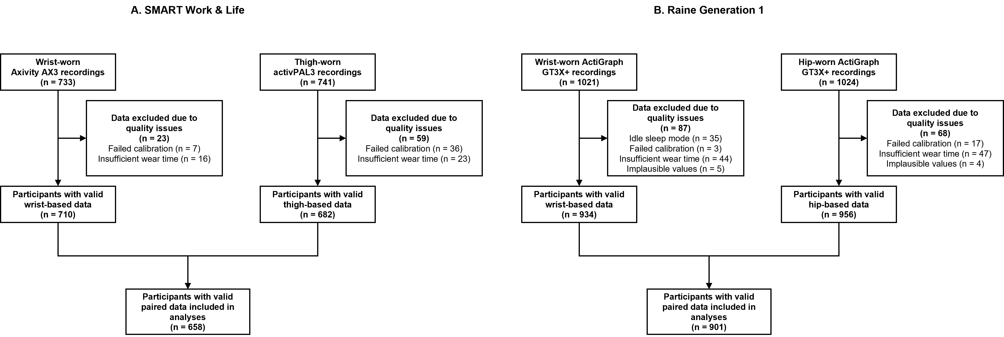
Quality issues refer to: (1) failed calibration of the acceleration signal to local gravity, (2) implausible acceleration values (wrist and thigh: >100 mg; hip: >70 mg or >2,690 cpm), and (3) insufficient wear time (wrist: <72 hours or incomplete coverage of the 24-hour period across included days; thigh and hip: <3 valid days). Two additional participants (one from each study) were excluded following visual inspection of the data, as their MVPA estimates were extreme outliers unsupported by other metrics from the same device or the concurrent wear location (we counted them as failed calibrations). Wrist-worn ActiGraph recordings in which idle sleep mode had been mistakenly activated were also excluded.
Figure S2: Agreement of physical activity and sedentary behaviour measures across wear locations
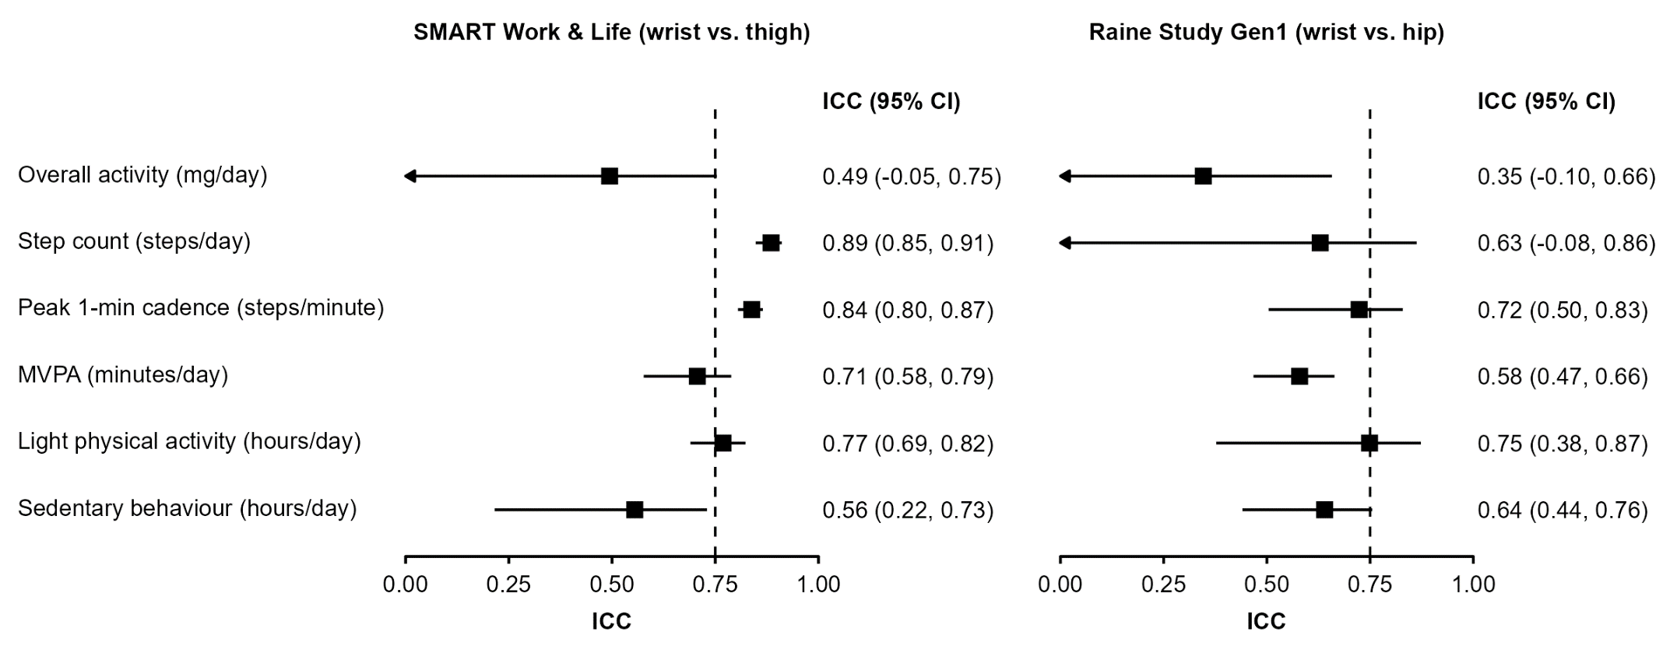
ICCs were calculated using a two-way mixed-effects model assessing absolute agreement. The dashed line represents an ICC of 0.75 indicating “good” agreement. ICC=Intraclass correlation coefficient; MVPA=Moderate-to-vigorous physical activity
Figure S3: Bland-Altman plots of physical activity and sedentary behaviour measures across wear locations
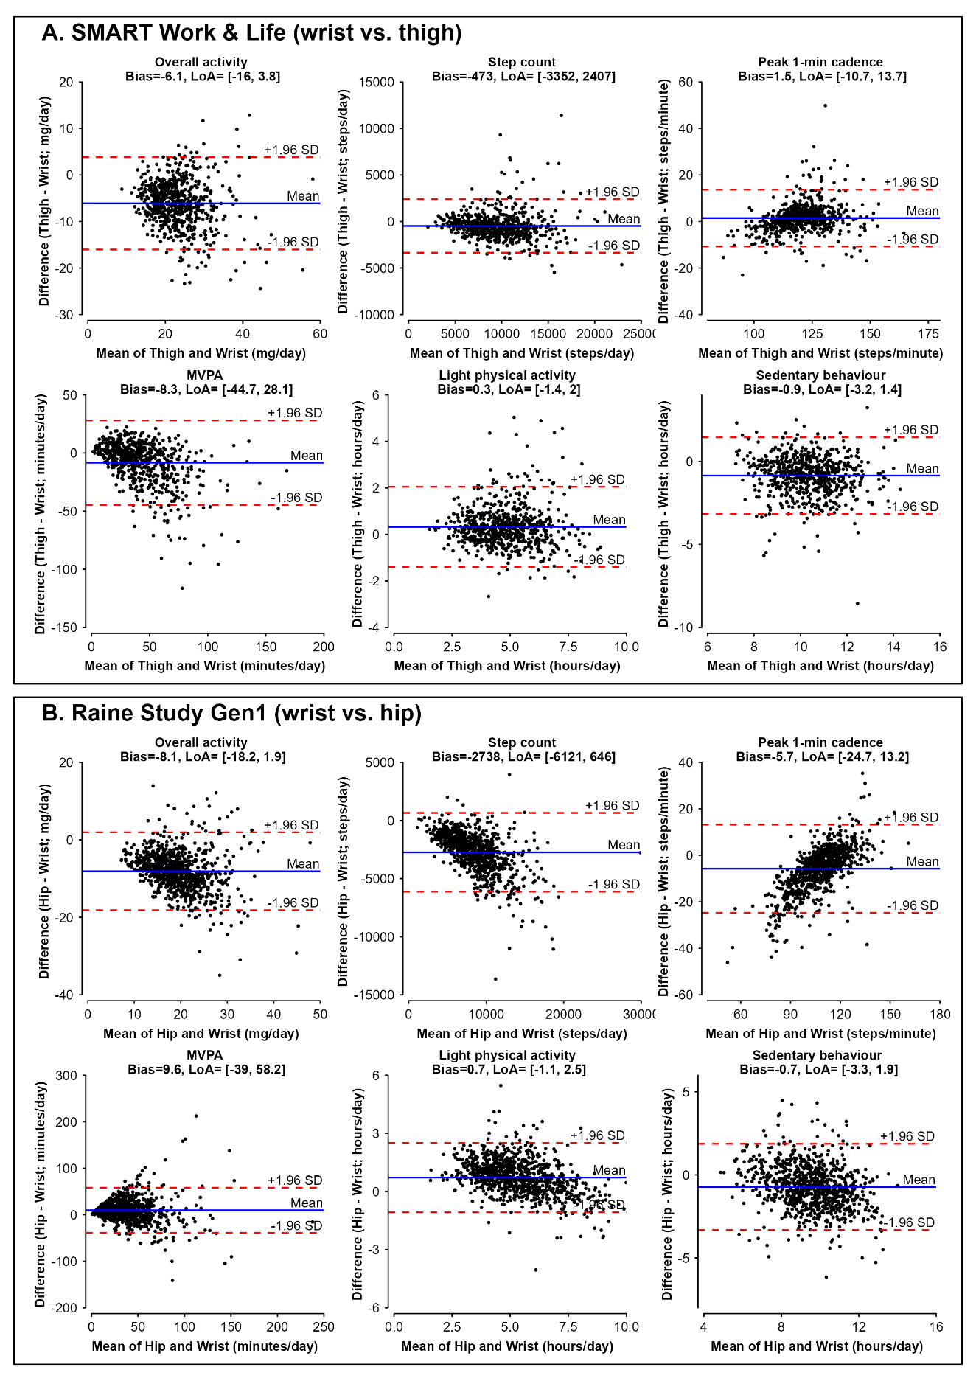
LoA=Limits of agreement; MVPA=Moderate-to-vigorous physical activity

Figure S4: Equivalence of physical activity and sedentary behaviour measures across wear locations
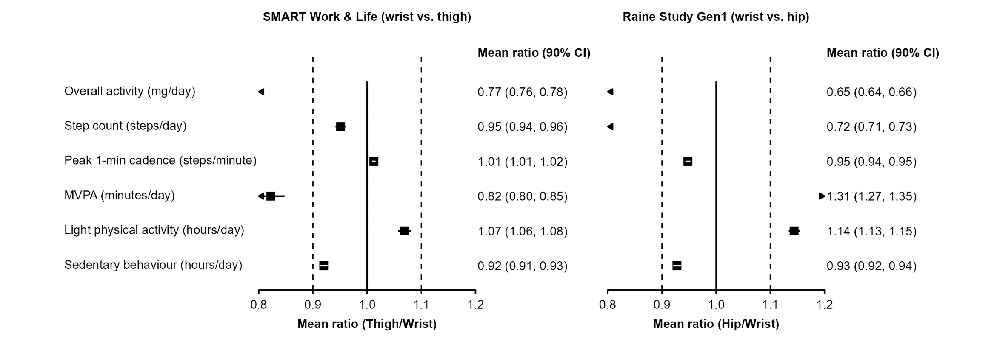
Methods and conventions as in Figure 3. MVPA=Moderate-to-vigorous physical activity
Figure S5: Scatter plots and Bland-Altman plots of peak 30-minute cadence across wear locations
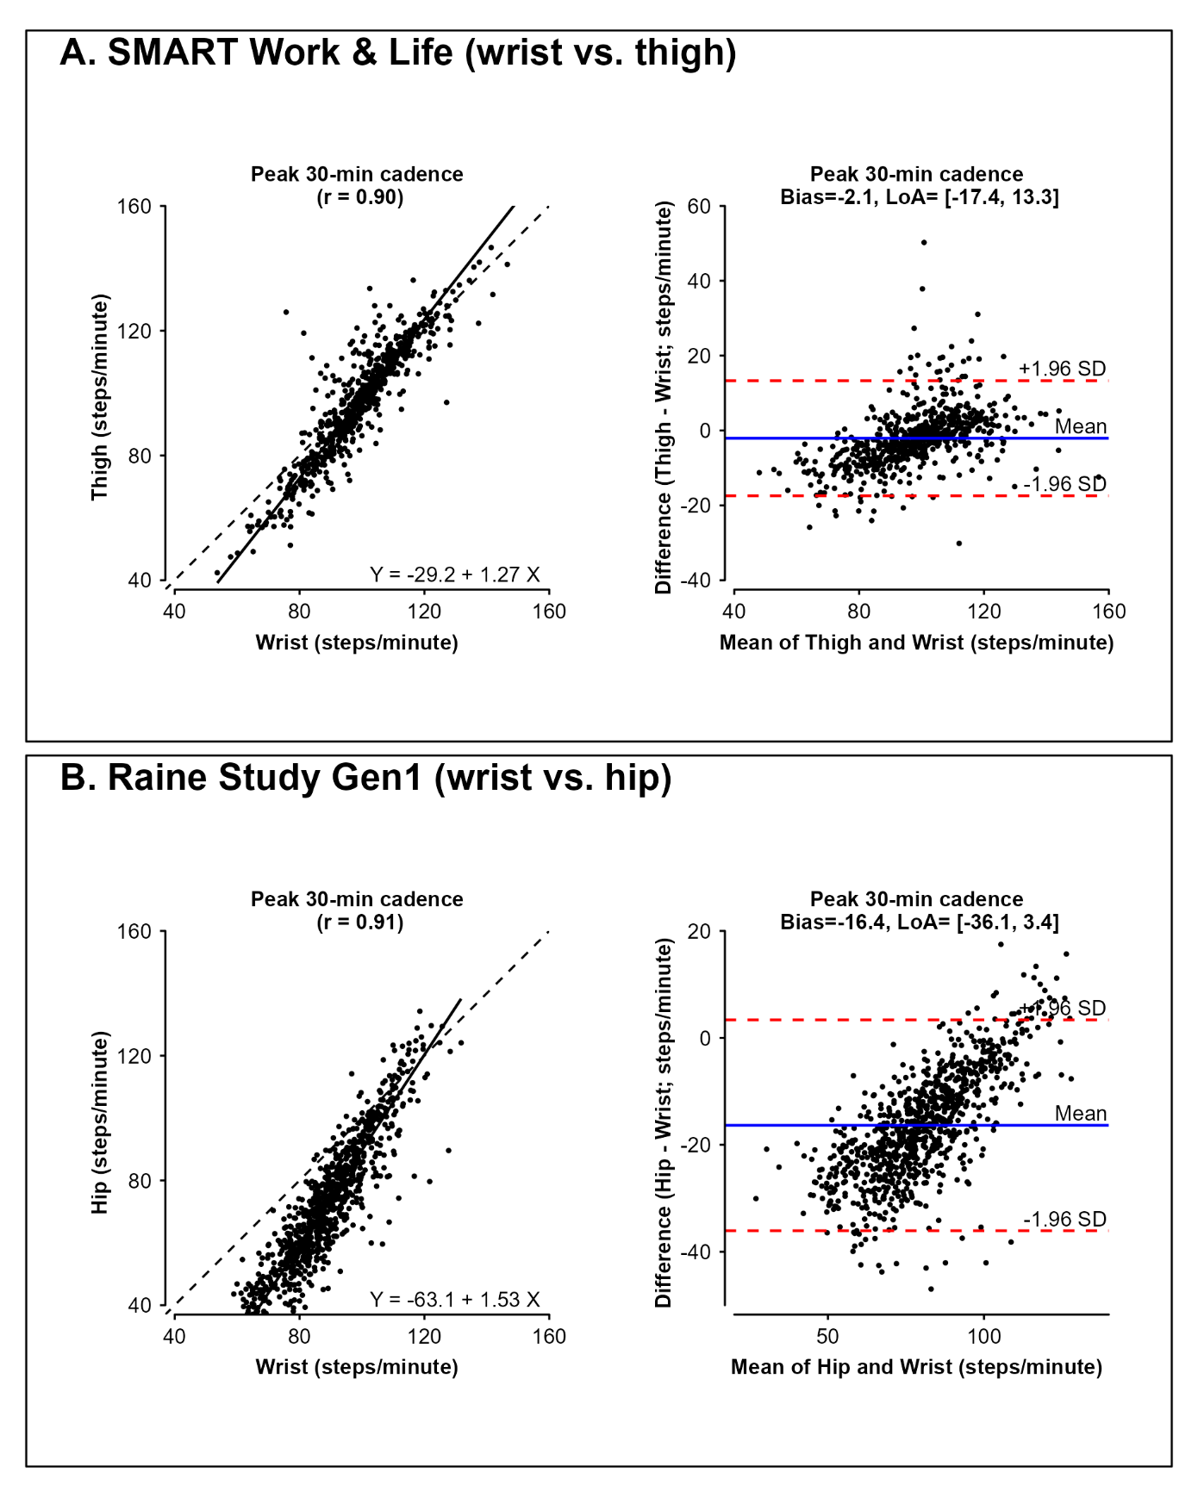
LoA=Limits of agreement

Figure S6: Scatter plot of overall activity in the Raine Study, comparing wrist Euclidean norm minus one (ENMO) and hip vector magnitude
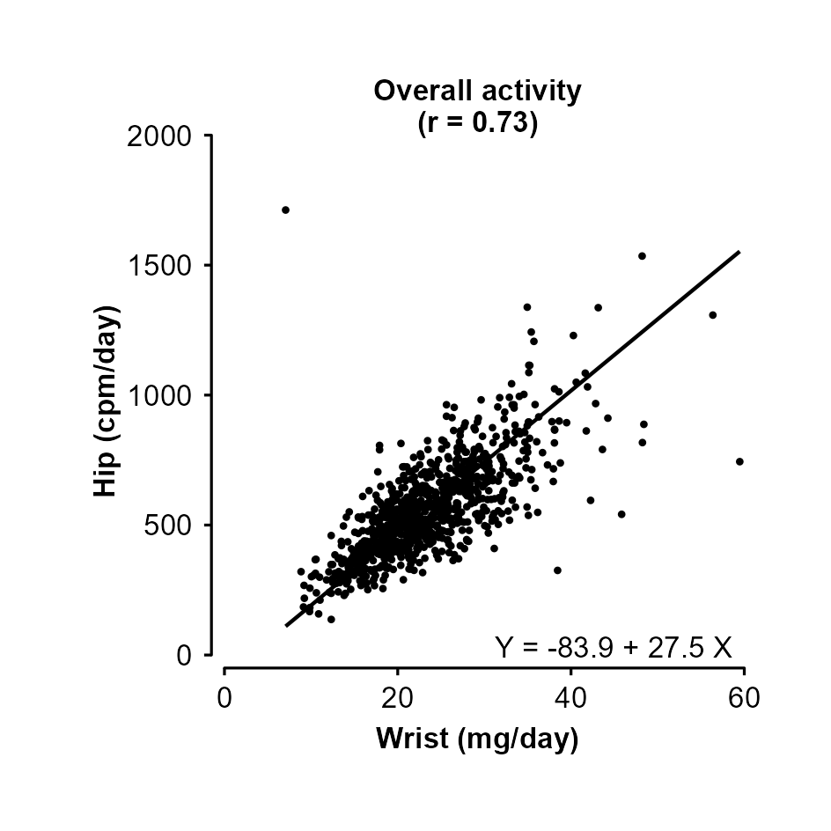

Figure S7: Correlations across wear locations, by age subgroups
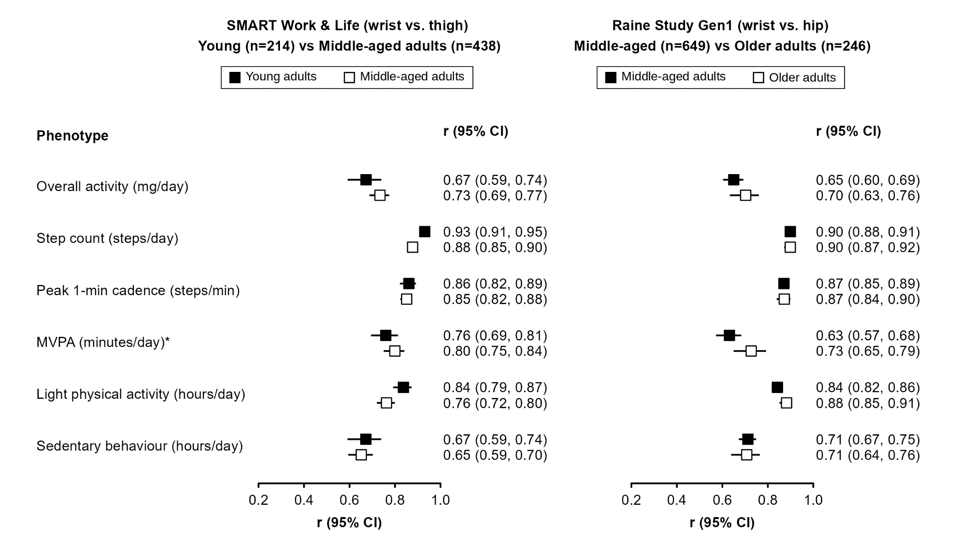
Pearson's correlation coefficients (r) shown, except for MVPA, where Spearman's (ρ) is reported. Age subgroups are <40 vs ≥40 years in SMART Work & Life, and <60 vs ≥60 years in the Raine Study Gen1. MVPA=Moderate-to-vigorous physical activity
Figure S8: Correlations across wear locations, by sex
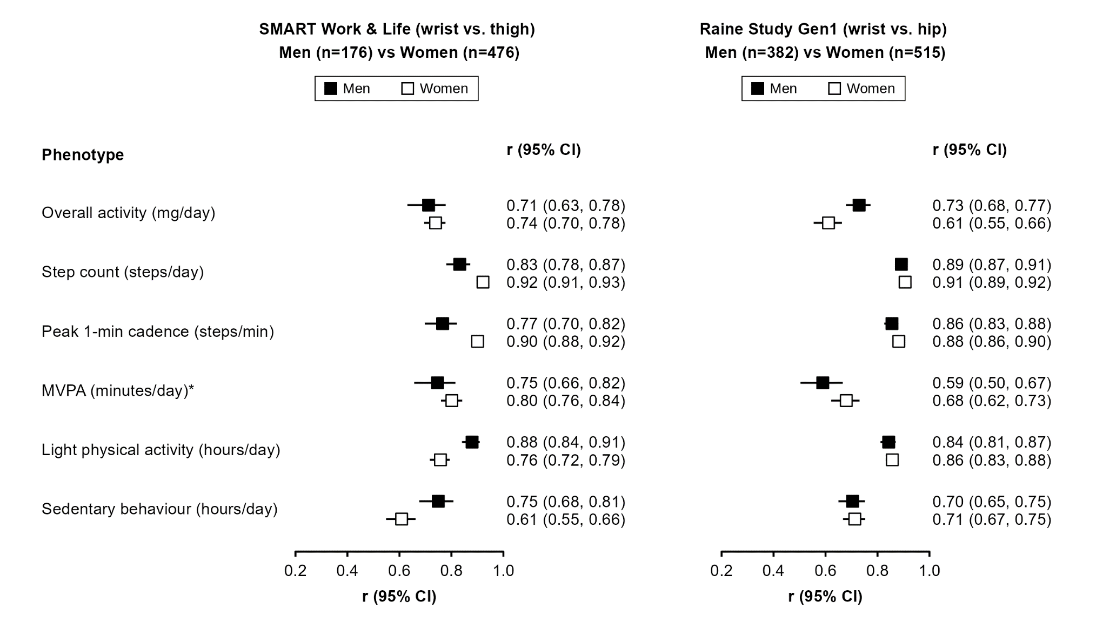
Methods and conventions as in Figure S7. MVPA=Moderate-to-vigorous physical activity
Figure S9: Correlations across wear locations, by body mass index subgroups
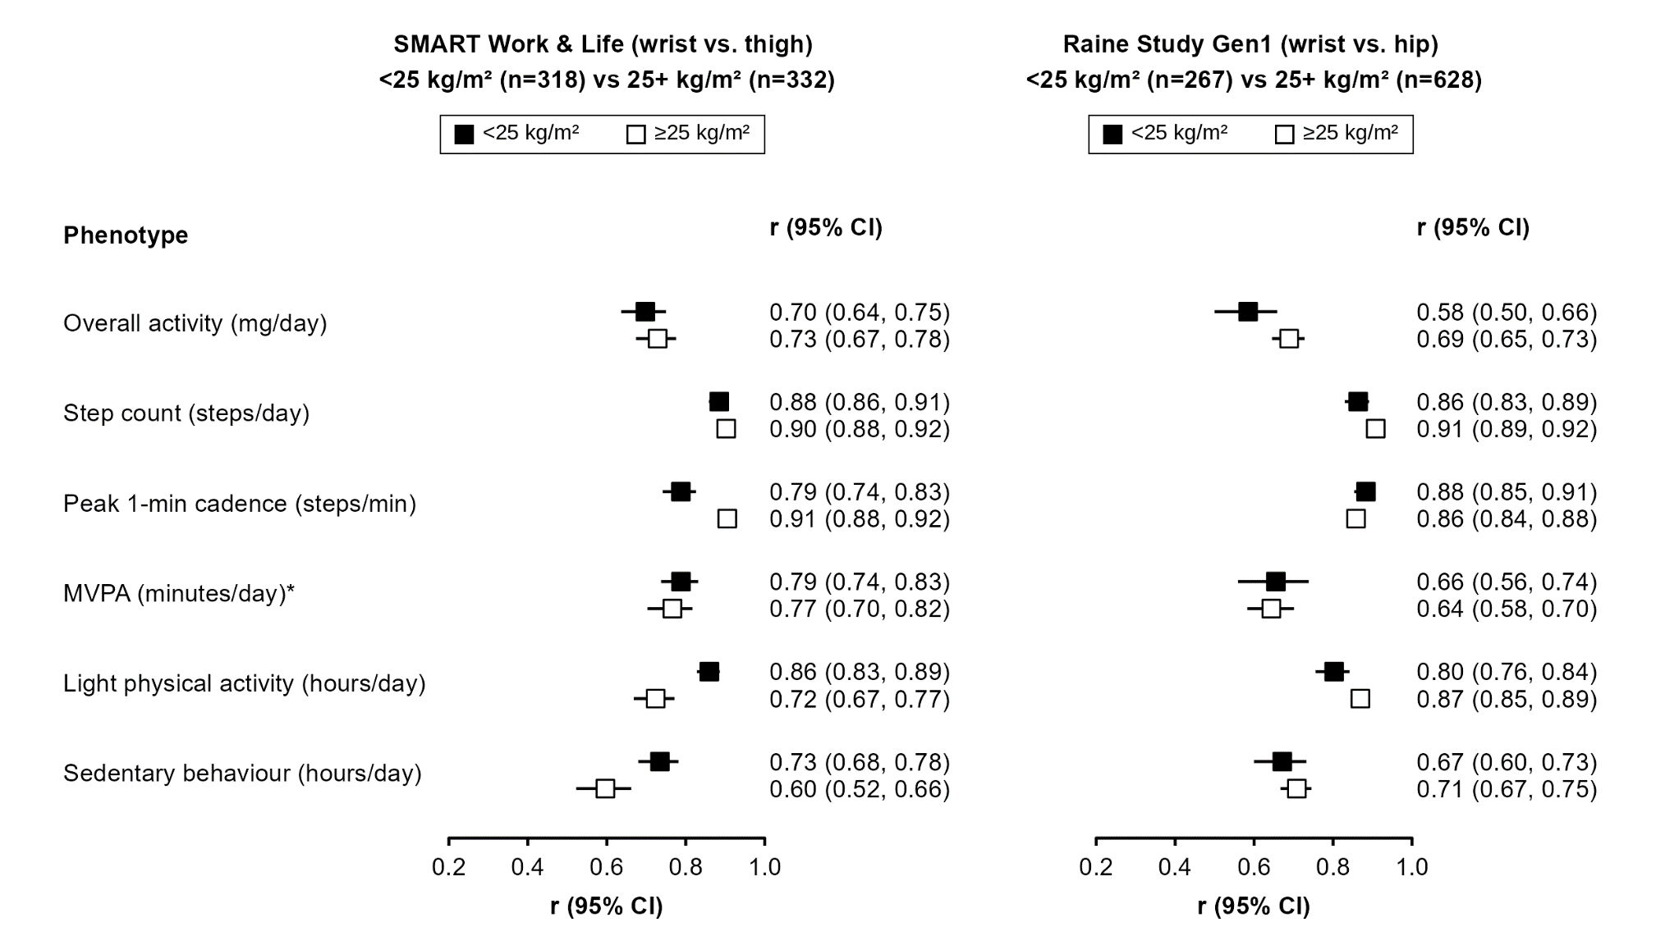
Methods and conventions as in Figure S7. MVPA=Moderate-to-vigorous physical activity
Figure S10: Scatter plots, correlations, and calibration equations of physical activity and sedentary behaviour measures across wear locations in the Raine Study, using full 24-hour data
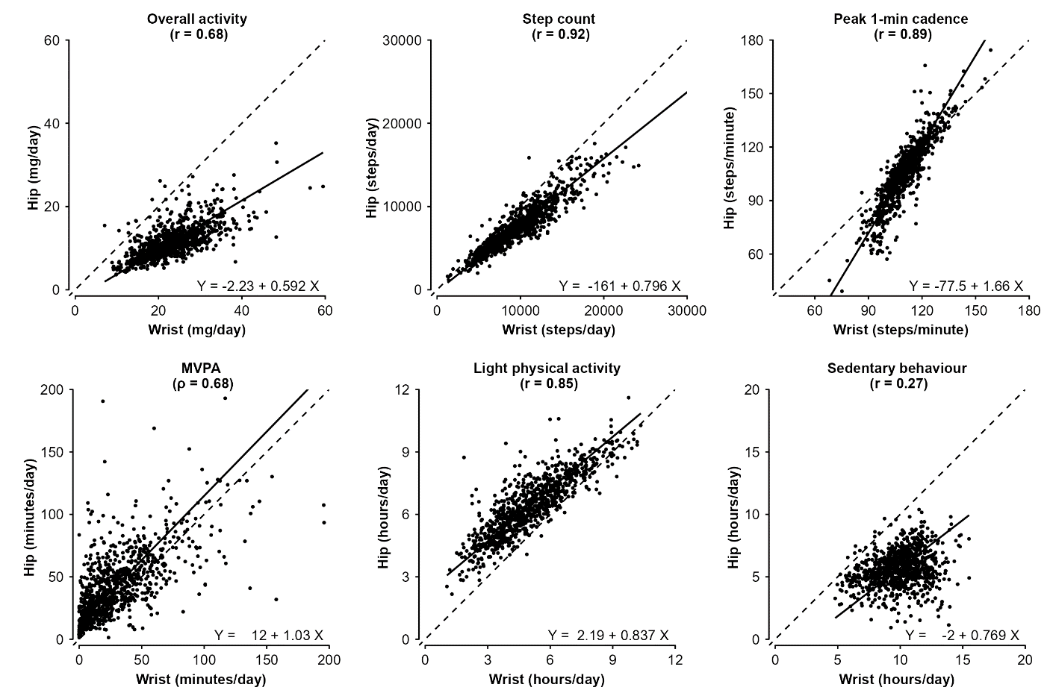
Methods and notations as in Figure 1. MVPA=Moderate-to-vigorous physical activity
Figure S11: Scatter plots and correlations of calibrated physical activity and sedentary behaviour measures across wear locations in the CAP-24 study
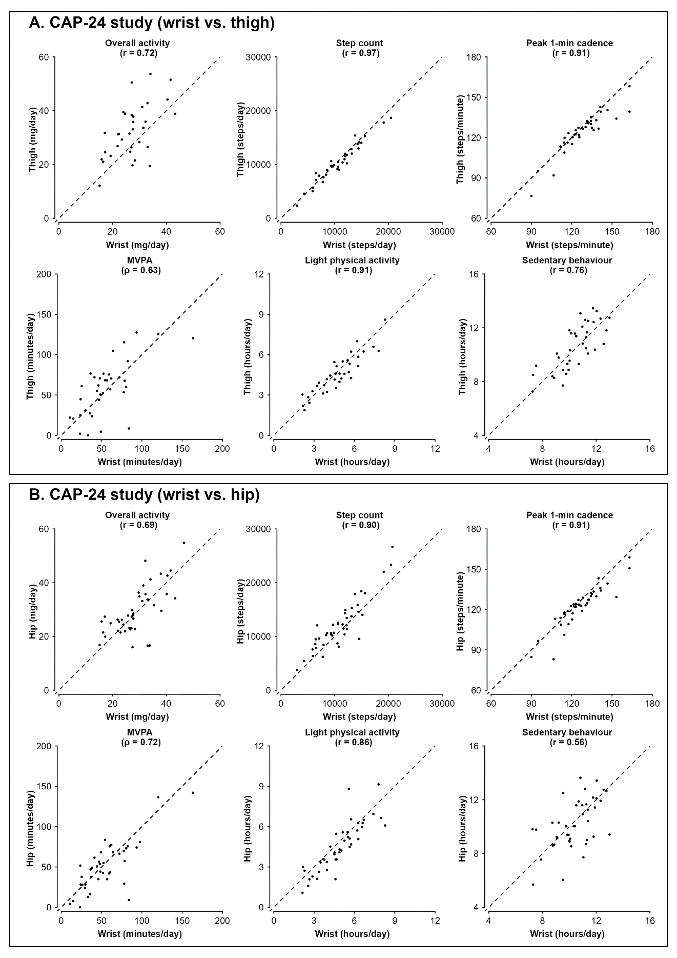
Results are from the non-dominant wrist. Pearson's correlation coefficients (r) shown, except for MVPA, where Spearman's (ρ) is reported. Dashed lines indicate lines of equality. MVPA=Moderate-to-vigorous physical activity
Figure S12: Bland-Altman plots of calibrated physical activity and sedentary behaviour measures across wear locations in the CAP-24 study
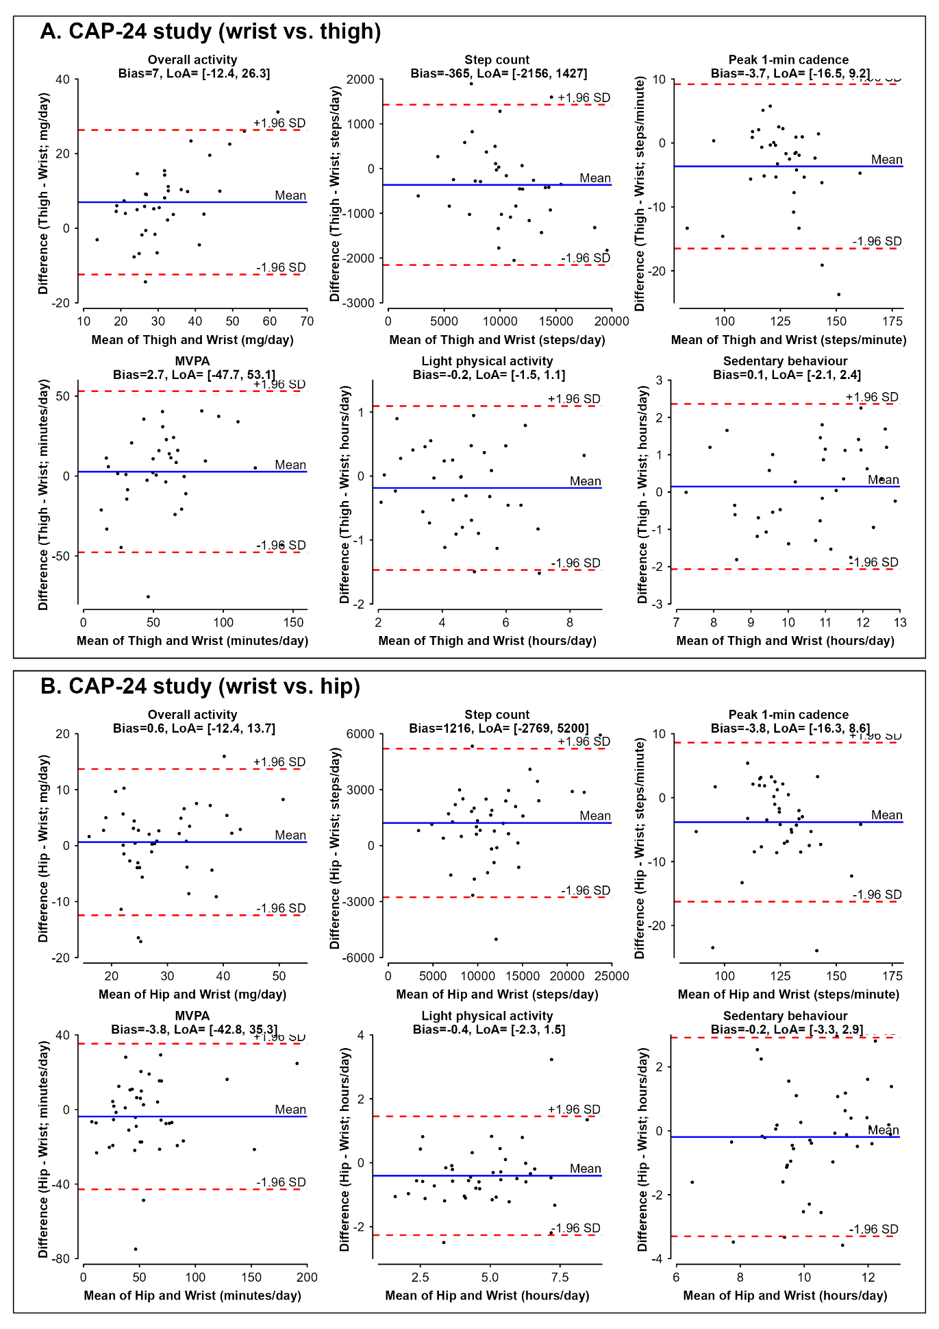
Results are from the non-dominant wrist. LoA=Limits of agreement; MVPA=Moderate-to-vigorous physical activity
Figure S13: Agreement of calibrated physical activity and sedentary behaviour measures across wear locations in the CAP-24 study: sensitivity analysis using the dominant wrist
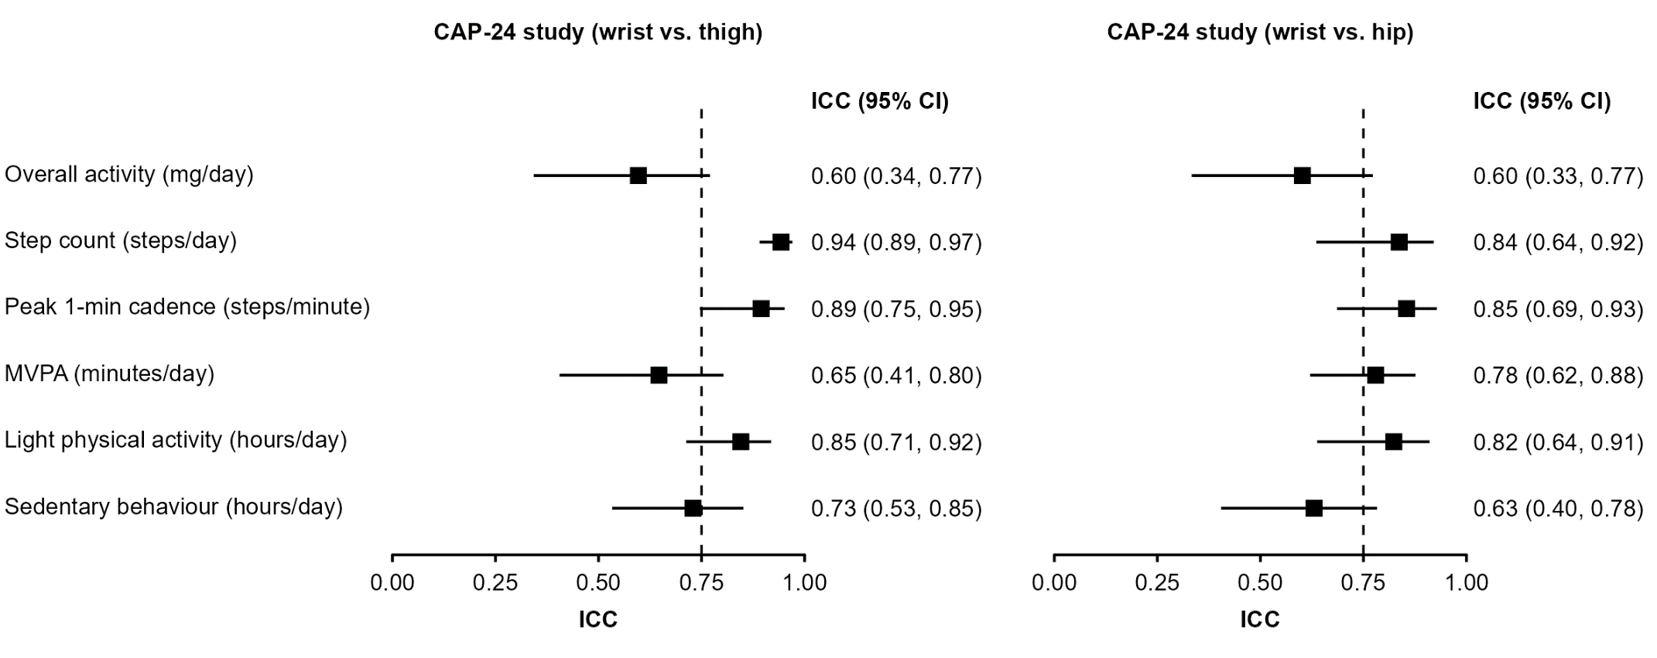
Results are from the dominant wrist. Methods and notations as in Figure 2. MVPA=Moderate-to-vigorous physical activity

Figure S14: Bland-Altman plots of calibrated physical activity and sedentary behaviour measures across wear locations in the CAP-24 study: sensitivity analysis using the dominant wrist
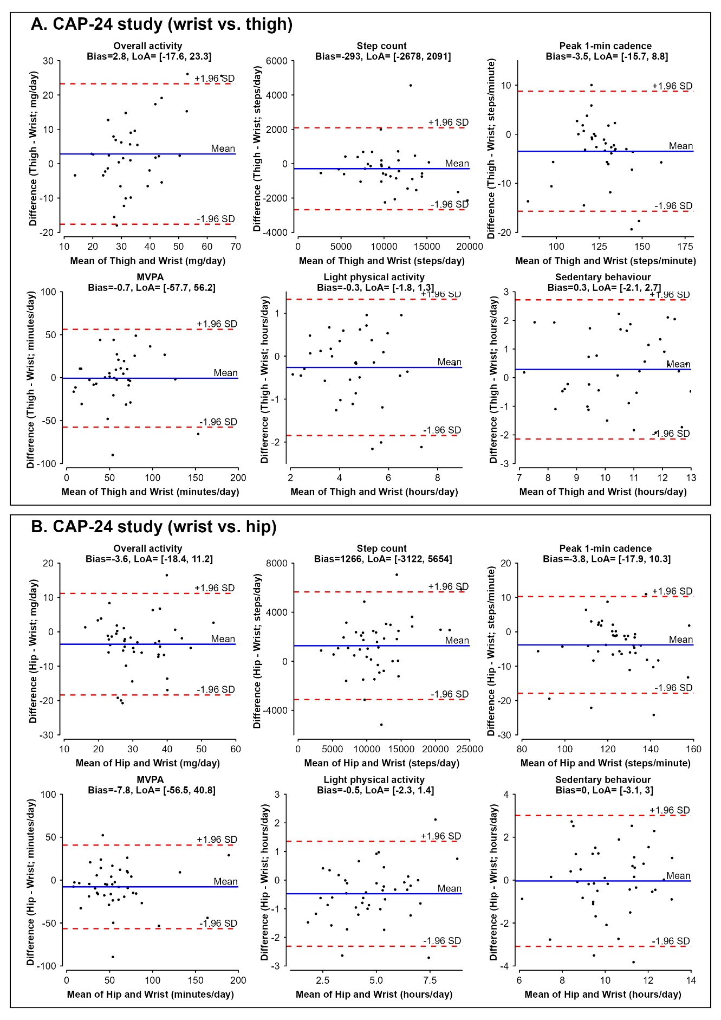
Results are from the dominant wrist. LoA=Limits of agreement; MVPA=Moderate-to-vigorous physical activity
Figure S15: Equivalence of calibrated physical activity and sedentary behaviour measures across wear locations in the CAP-24 study: sensitivity analysis using the dominant wrist
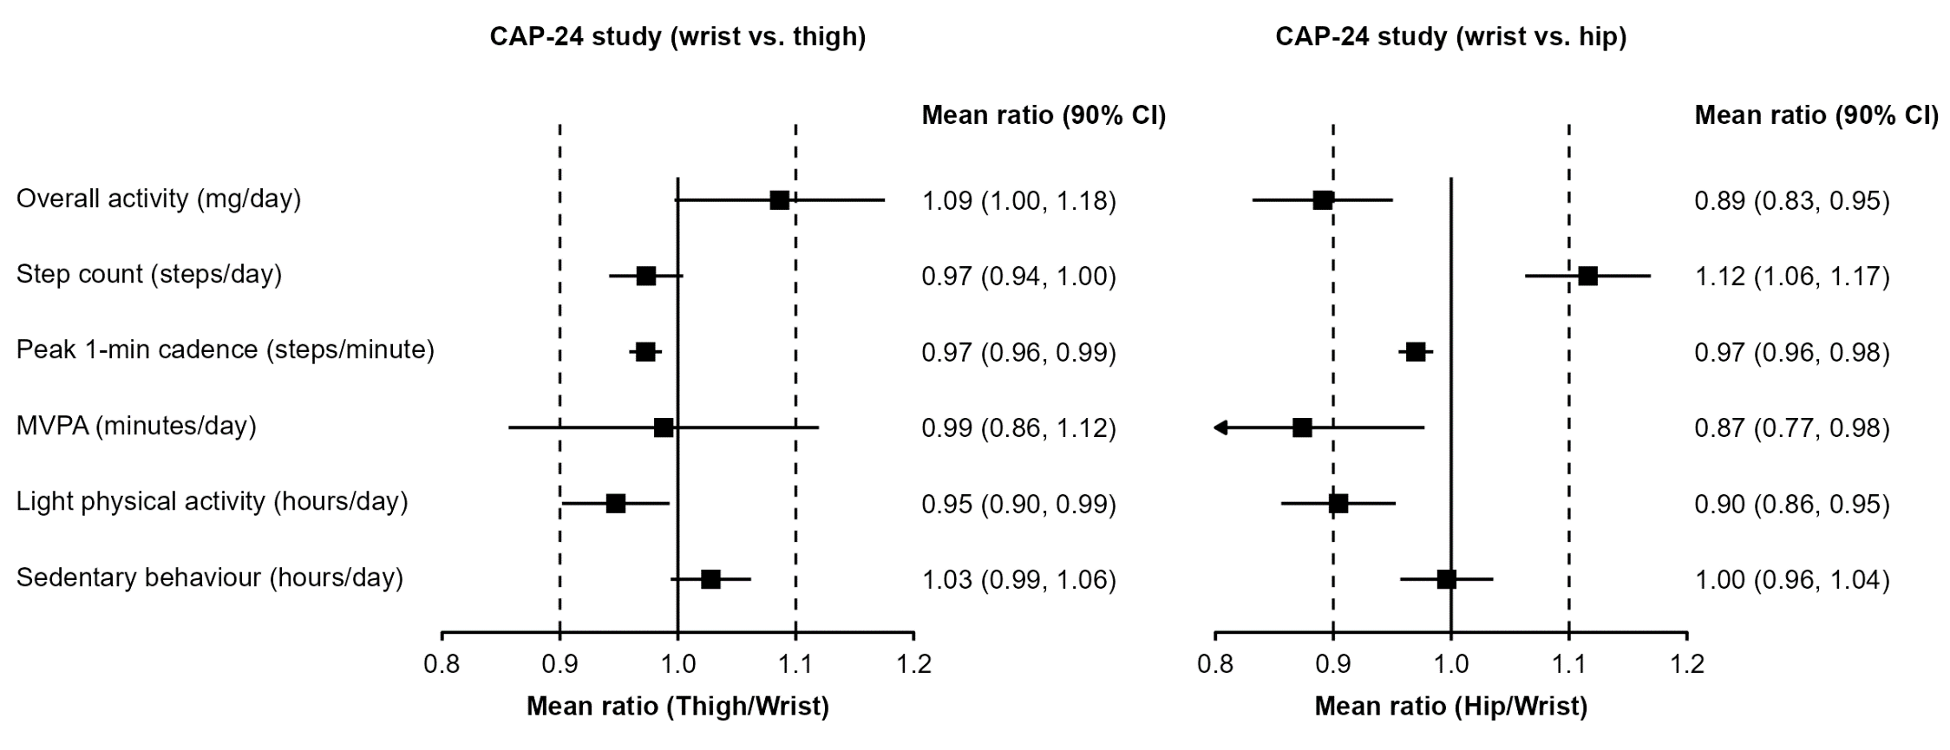
Results are from the dominant wrist. Methods and notations as in Figure 3. MVPA=Moderate-to-vigorous physical activity

