Supplemental Table 1: What to report when evaluating public playground interventions from Toftager et al. (2026).
Item | Description | Page number in Manuscript
Why | Describe the rationale / scope of your playground evaluation including relevant outputs and outcomes | 7-8
Where | Describe the context and setting where the playground intervention occurred, including any necessary infrastructure or relevant features. | 7-8
What and how | Describe the playground features (before and after renovation/building the new playground) and any other physical or informational materials used in the intervention, including those provided to participants or used in intervention delivery or in training of intervention providers. Provide information on where the materials can be accessed. Describe each of the procedures, activities, and/or processes used in the intervention, including any enabling or support activities. | 7-8
Who | Describe who provided the intervention and their role and expertise, and who was the target group | 7-8
Study design | Describe the study design, e.g., repeat cross-sectional, time series, cohort study, quasi-experimental, natural experiment | 9
Sampling and recruitment | Describe how participants were selected and recruited to the study | 9
Data collection and methods | Describe the methods used and the data collection, e.g., surveys, (systematic) observations, interviews, device-based measures and describe how procedures and measures were pilot tested to ensure validity | 11-12
When and how much | Describe the timeframe for data collection, and when the playground was built and over what period of time, including dose delivered as planned, and cost including costs for maintenance etc. | 7-8, 11
Modifications/ adaptation | If the playground intervention was modified during the course of the study, describe the changes (what, why, when, and how). | 7-8
How well | Planned: If intervention adherence or fidelity was assessed – was the playground build as planned, describe how and by whom, and if any strategies were used to maintain or improve fidelity, describe them.  Actual: If intervention adherence or fidelity was assessed, describe the extent to which the intervention was delivered as planned. | Not assessed
How | Describe how the intervention was delivered | 7-8
Effect | Describe the effect of the intervention on playground use, short-term outcomes, and potentially long-term outcomes | 16-18
Lessons learned | Describe the main lessons learned and assess how they could be implemented elsewhere, as well as implications for policy and practice. | 24-27

Supplemental Table 2. Multilevel negative binomial estimates of within-park changes park use, playground use, and MVPA over time, Baltimore, MD.
 |  | Unadjusted |  |  | Adjusted
Park | Wave | IRR | 95% CI | p-value | IRR | 95% CI | p-value
MVPA (<19 yrs) per hour (ref = wave 1 or baseline)
Control | 2 | 1.00 | (0.04, 24.22) | 0.998 | 0.17 | (0.00, 26.17) | 0.493
Control | 3 | 0.10 | (0.01, 1.74) | 0.113 | 0.02 | (0.00, 2.23) | 0.104
Control | 4 | 0.00 | (0.00, Inf) | 1.000 | 0.00 | (0.00, Inf) | 1.000
Intervention | 2 | 4.45 | (0.95, 20.78) | 0.057 | 2.92 | (0.69, 12.39) | 0.147
Intervention | 3 | 0.56 | (0.16, 2.05) | 0.385 | 0.53 | (0.16, 1.80) | 0.311
Intervention | 4 | 1.08 | (0.30, 3.92) | 0.911 | 0.98 | (0.29, 3.26) | 0.970
MVPA per hour (ref = wave 1 or baseline)
Control | 2 | 0.99 | (0.16, 6.03) | 0.988 | 0.57 | (0.10, 3.39) | 0.536
Control | 3 | 0.31 | (0.06, 1.55) | 0.154 | 0.17 | (0.03, 0.87) | 0.033
Control | 4 | 0.06 | (0.01, 0.31) | <.001 | 0.04 | (0.01, 0.22) | <.001
Intervention | 2 | 1.29 | (0.23, 7.22) | 0.770 | 0.80 | (0.13, 4.89) | 0.810
Intervention | 3 | 0.39 | (0.10, 1.51) | 0.174 | 0.31 | (0.08, 1.20) | 0.090
Intervention | 4 | 0.41 | (0.10, 1.62) | 0.203 | 0.28 | (0.07, 1.18) | 0.083
Playground use (<19 yrs) per hour (ref = wave 1 or baseline)
Control | 2 | 0.86 | (0.06, 13.29) | 0.911 | 0.35 | (0.01, 10.15) | 0.538
Control | 3 | 0.05 | (0.00, 0.65) | 0.021 | 0.03 | (0.00, 0.50) | 0.014
Control | 4 | 0.00 | (0.00, Inf) | 1.000 | 0.00 | (0.00, Inf) | 1.000
Intervention | 2 | 2.37 | (0.41, 13.58) | 0.332 | 1.44 | (0.26, 8.04) | 0.680
Intervention | 3 | 0.61 | (0.15, 2.45) | 0.491 | 0.53 | (0.14, 1.99) | 0.350
Intervention | 4 | 0.86 | (0.21, 3.51) | 0.829 | 0.73 | (0.19, 2.76) | 0.638
Total park use per hour (ref = wave 1 or baseline)
Control | 2 | 0.89 | (0.12, 6.45) | 0.912 | 0.55 | (0.08, 3.93) | 0.552
Control | 3 | 0.41 | (0.07, 2.36) | 0.321 | 0.23 | (0.04, 1.42) | 0.115
Control | 4 | 0.07 | (0.01, 0.40) | 0.003 | 0.05 | (0.01, 0.30) | <.001
Intervention | 2 | 1.23 | (0.20, 7.44) | 0.824 | 0.70 | (0.10, 4.68) | 0.713
Intervention | 3 | 0.61 | (0.15, 2.47) | 0.486 | 0.48 | (0.12, 1.92) | 0.302
Intervention | 4 | 0.54 | (0.13, 2.28) | 0.404 | 0.33 | (0.07, 1.54) | 0.160
Note: All models include an offset term for observation hours and a random intercept for day to account for clustering of hourly observations within measurement days at each park. Adjusted models include weekday vs. weekend

Supplemental Table 3. Multilevel negative binomial estimates of within-park changes park use, playground use, and MVPA over time, Rocky Mount, NC.
 | Unadjusted |  |  | Adjusted
Park | IRR | 95% CI | p-value | IRR | 95% CI | p-value
MVPA (<19 yrs) per hour, post-intervention (ref = pre-intervention)
Control | 0.42 | (0.15, 1.20) | 0.104 | 0.32 | (0.13, 0.81) | 0.015
Intervention | 5.41 | (2.22, 13.17) | <.001 | 8.21 | (2.18, 30.96) | 0.002
MVPA per hour, post-intervention (ref = pre-intervention)
Control | 0.19 | (0.08, 0.47) | <.001 | 0.16 | (0.07, 0.41) | <.001
Intervention | 5.15 | (1.52, 17.36) | 0.008 | 6.63 | (2.63, 16.69) | <.001
Playground use (<19 yrs) per hour, post-intervention (ref = pre-intervention)
Control | 0.31 | (0.12, 0.79) | 0.015 | 0.24 | (0.09, 0.63) | 0.004
Intervention | 4.42 | (1.82, 10.72) | 0.001 | 6.58 | (1.97, 21.98) | 0.002
Total park use per hour, post-intervention (ref = pre-intervention)
Control | 0.14 | (0.05, 0.37) | <.001 | 0.08 | (0.03, 0.24) | <.001
Intervention | 3.07 | (1.44, 6.57) | 0.004 | 3.84 | (1.68, 8.77) | 0.001
Note: All models include an offset term for observation hours and a random intercept for day to account for clustering of hourly observations within measurement days at each park. Adjusted models include weekday vs. weekend
Supplemental Figure 1: Case Study 1, Weekly Playground and Park Counts of Placer.ai data, 01-01-2017 to 12-31-2025, Baltimore, MD.
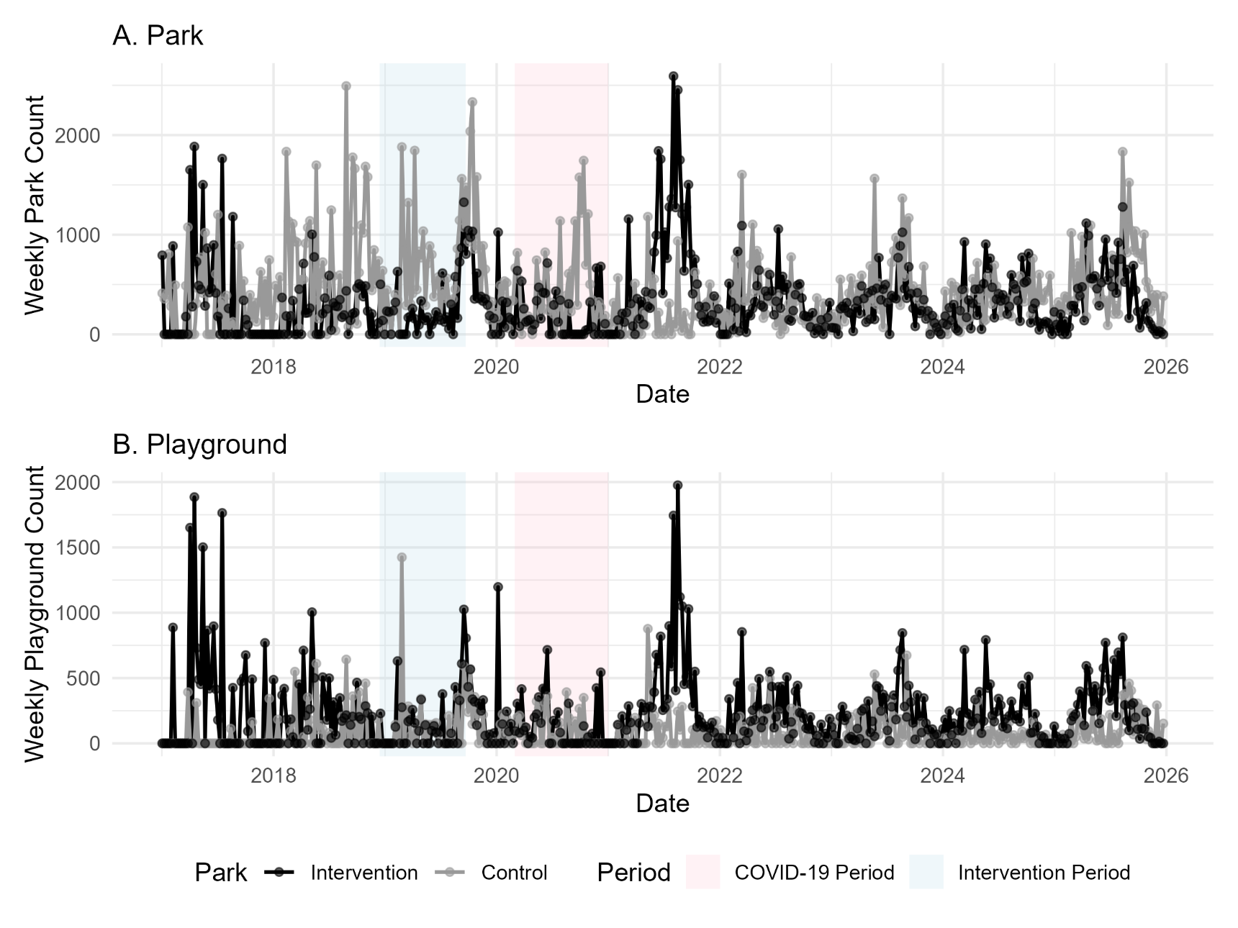
Supplemental Figure 2: Case Study 2, Weekly Playground and Park Counts of Placer.ai data, 01-01-2021 to 12-01-2025, Rocky Mount, NC.
