Intensity-specific physical activity and mortality in 147,414 adults: a pooled accelerometer analysis

Supplementary material

Supplementary Table 1. Crude baseline characteristics of participants of the German National Cohort and UK Biobank by tertiles of total physical activity
Supplementary Figure 1. Flowchart of participant inclusion
Supplementary Figure 2. Directed acyclic graph for confounder selection
Supplementary Figure 3. Correlation matrix for all physical activity exposures
Supplementary Figure 4. Exclusion of 1 to 5 years of follow-up
Supplementary Figure 5. Main results without adjustment for body mass index, grip strength, cardiovascular disease, diabetes, and cancer
Supplementary Figure 6. Main results after exclusion of prevalent cardiovascular disease, diabetes, and cancer
Supplementary Figure 7. Main results after restriction to participants who never smoked
Supplementary Figure 8. Main results with additional adjustment for season of accelerometer wear
Supplementary Figure 9. Main results under mutual adjustment for light, moderate, and vigorous physical activity

Corresponding author: Michael J. Stein, Tel.: +49 89 318748819, Mail: michael.stein@helmholtz-munich.de, Department of Epidemiology and Preventive Medicine, University of Regensburg, Regensburg, Germany

Crude baseline characteristics of participants of the German National Cohort and UK Biobank by tertiles of total physical activity
 | NAKO |  |  | UK Biobank
Characteristic | T1  N = 17,407 | T2  N = 17,407 | T3  N = 17,407 | T1  N = 31,488 | T2  N = 31,835 | T3  N = 31,870
Average acceleration (milli-g) | 8.7 (2.4) | 11.5 (2.6) | 14.3 (3.4) | 20.8 (4.5) | 27.7 (4.6) | 35.6 (7.1)
Light physical activity (min/week) | 1,251.6 (234.1) | 1,717.0 (186.1) | 2,351.2 (444.1) | 1,438.7 (238.0) | 1,808.5 (200.8) | 2,157.2 (288.2)
Moderate physical activity (min/week) | 271.0 (124.2) | 380.7 (138.1) | 494.7 (282.9) | 477.2 (173.0) | 718.5 (181.7) | 1,023.2 (284.1)
Vigorous physical activity (min/week) | 8.1 (25.9) | 14.1 (37.0) | 16.4 (40.7) | 15.3 (27.0) | 26.5 (35.7) | 40.6 (46.4)
Wear time (h/day) | 23.8 (0.4) | 23.8 (0.4) | 23.7 (0.4) | 22.8 (2.3) | 22.9 (2.1) | 22.8 (2.3)
Sex
Men | 8,574 (49.3%) | 7,927 (45.5%) | 8,631 (49.6%) | 16,886 (53.6%) | 13,557 (42.6%) | 11,017 (34.6%)
Women | 8,833 (50.7%) | 9,480 (54.5%) | 8,776 (50.4%) | 14,602 (46.4%) | 18,278 (57.4%) | 20,853 (65.4%)
Age (years) | 56.2 (8.7) | 54.7 (8.5) | 53.6 (8.2) | 62.9 (7.6) | 61.6 (7.7) | 60.5 (7.7)
Educational level
Highest | 10,020 (57.6%) | 10,269 (59.0%) | 9,064 (52.1%) | 13,574 (43.6%) | 14,139 (44.8%) | 13,304 (42.1%)
Intermediate | 6,872 (39.5%) | 6,721 (38.6%) | 7,820 (45.0%) | 7,488 (24.0%) | 7,401 (23.5%) | 7,446 (23.6%)
Lowest | 494 (2.8%) | 394 (2.3%) | 495 (2.8%) | 7,085 (22.7%) | 7,630 (24.2%) | 8,468 (26.8%)
Other | 9 (0.1%) | 14 (0.1%) | 14 (0.1%) | 3,003 (9.6%) | 2,381 (7.5%) | 2,359 (7.5%)
Missing | 12 | 9 | 14 | 338 | 284 | 293
Employment status
Employed | 11,669 (67.5%) | 13,338 (77.1%) | 14,158 (81.8%) | 18,972 (60.7%) | 21,157 (66.9%) | 22,311 (70.5%)
Unemployed | 675 (3.9%) | 366 (2.1%) | 296 (1.7%) | 463 (1.5%) | 345 (1.1%) | 369 (1.2%)
Not in labour force | 4,944 (28.6%) | 3,595 (20.8%) | 2,856 (16.5%) | 11,846 (37.9%) | 10,128 (32.0%) | 8,952 (28.3%)
Missing | 119 | 108 | 97 | 207 | 205 | 238
Socio-economic status | 51.6 (15.0) | 51.2 (15.1) | 47.1 (15.7) | -1.6 (2.9) | -1.8 (2.8) | -1.8 (2.8)
Missing | 734 | 624 | 519 | 46 | 38 | 24
Body mass index (kg/m²) | 27.9 (5.4) | 26.5 (4.5) | 26.2 (4.3) | 28.0 (5.0) | 26.6 (4.3) | 25.6 (4.0)
Missing | 431 | 334 | 320 | 113 | 56 | 44
Grip strength (kg) | 38.2 (11.5) | 38.5 (11.4) | 39.4 (11.7) | 34.5 (11.4) | 33.2 (11.0) | 32.0 (10.5)
Missing | 341 | 254 | 231 | 69 | 66 | 47
Sedentary behaviour (h/day) | 7.7 (3.8) | 6.6 (3.6) | 5.6 (3.4) | 4.9 (2.6) | 4.2 (2.3) | 3.8 (2.4)
Missing | 1,522 | 1,360 | 1,403 | 26 | 19 | 27
Sleep duration (h/day) | 7.9 (1.2) | 7.8 (1.1) | 7.6 (1.1) | 7.2 (1.1) | 7.2 (1.0) | 7.1 (0.9)
Missing | 2,168 | 1,929 | 2,464 | 118 | 75 | 90
Alcohol consumption (g/day) | 10.6 (16.8) | 10.9 (16.8) | 11.3 (16.8) | 16.9 (17.9) | 16.2 (16.1) | 15.5 (15.9)
Missing | 604 | 497 | 580 | 4,463 | 3,965 | 3,953
Smoking status
Never | 7,297 (43.2%) | 8,101 (47.6%) | 7,877 (46.5%) | 17,213 (54.8%) | 18,414 (58.0%) | 18,686 (58.8%)
Former | 6,224 (36.8%) | 6,103 (35.9%) | 6,138 (36.3%) | 11,549 (36.8%) | 11,348 (35.7%) | 11,118 (35.0%)
Current | 3,385 (20.0%) | 2,802 (16.5%) | 2,909 (17.2%) | 2,639 (8.4%) | 1,993 (6.3%) | 1,980 (6.2%)
Missing | 501 | 401 | 483 | 87 | 80 | 86
Cardiovascular diseases
No | 14,038 (80.7%) | 14,852 (85.3%) | 15,176 (87.2%) | 29,477 (93.6%) | 30,654 (96.3%) | 31,070 (97.5%)
Yes | 3,363 (19.3%) | 2,550 (14.7%) | 2,226 (12.8%) | 2,011 (6.4%) | 1,181 (3.7%) | 800 (2.5%)
Missing | 6 | 5 | 5 | 0 | 0 | 0
Diabetes
No | 15,772 (90.8%) | 16,423 (94.5%) | 16,567 (95.3%) | 30,879 (98.1%) | 31,575 (99.2%) | 31,714 (99.5%)
Yes | 1,600 (9.2%) | 954 (5.5%) | 811 (4.7%) | 609 (1.9%) | 260 (0.8%) | 156 (0.5%)
Missing | 35 | 30 | 29 | 0 | 0 | 0
Cancer
No | 15,748 (90.8%) | 16,006 (92.3%) | 16,254 (93.7%) | 29,192 (92.7%) | 29,761 (93.5%) | 29,844 (93.6%)
Yes | 1,596 (9.2%) | 1,343 (7.7%) | 1,099 (6.3%) | 2,296 (7.3%) | 2,074 (6.5%) | 2,026 (6.4%)
Missing | 63 | 58 | 54 | 0 | 0 | 0

Flowchart of participant inclusion
NAKO population with accelerometry
N = 72,553

UK Biobank population with accelerometry
N = 103,578
NAKO population for mortality assessment
N = 52,352

UK Biobank population for mortality assessment
N = 95,193
No follow-up data
N = 4 (NAKO)
Lost-to-follow-up before accelerometry (UK Biobank)
N = 4
Age <40 or >74 years
N = 12,766 (NAKO)
N = 1,397 (UK Biobank)
NAKO population with valid data
N = 65,122

UK Biobank population with valid data
N = 96,594
Poor accelerometry data
N = 7,431 (NAKO)

N = 6,984 (UK Biobank)

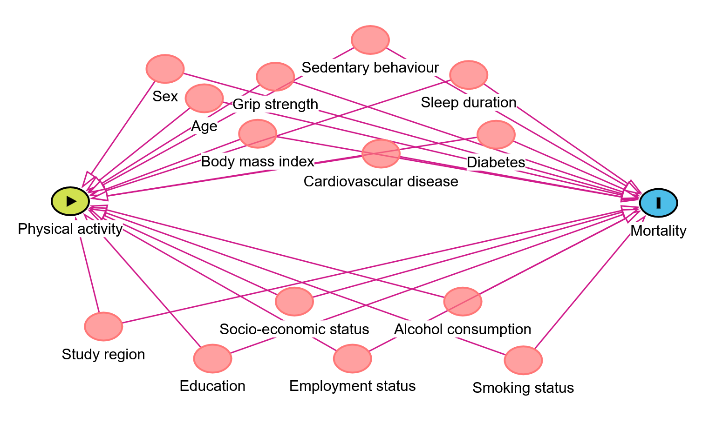
Directed acyclic graph for confounder selection

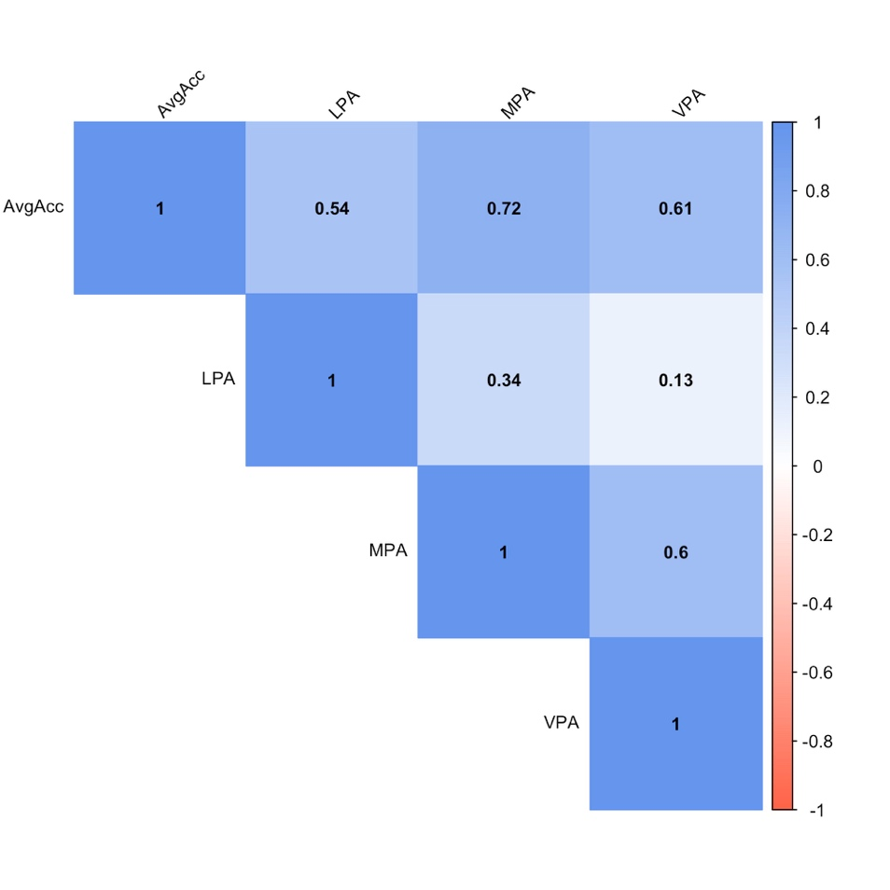
Correlation matrix for all physical activity exposures

AvgAcc: average acceleration (overall physical activity volume; milli-g); LPA: light physical activity (minutes per week); MPA: moderate physical activity (minutes per week); VPA: vigorous physical activity (minutes per week)

Exclusion of 1 to 5 years of follow-up
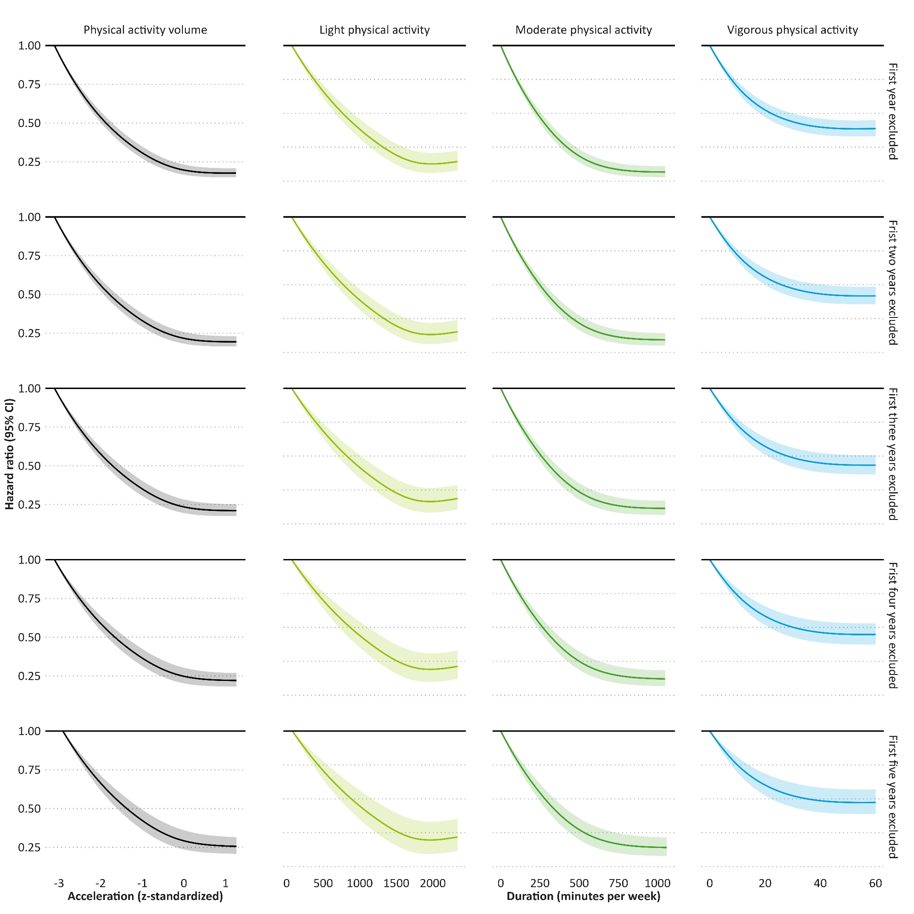

Main results without adjustment for body mass index, grip strength, cardiovascular disease, diabetes, and cancer
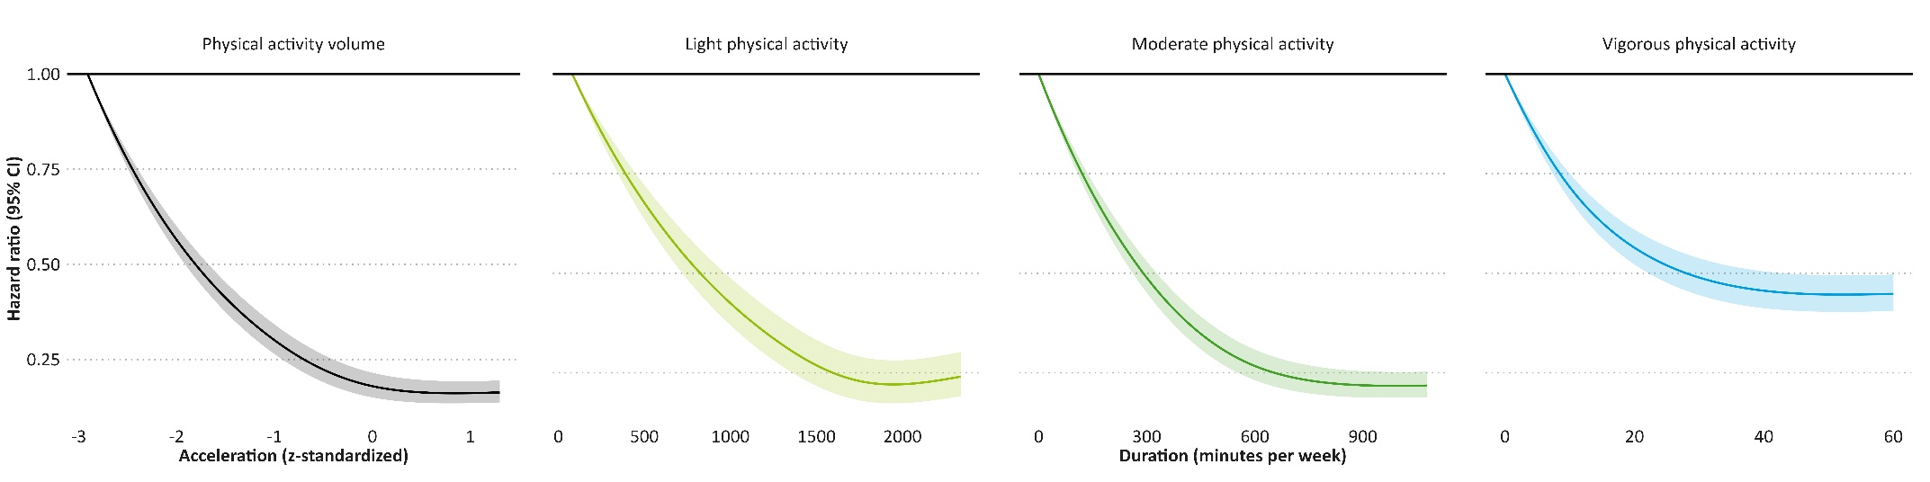

Main results after exclusion of prevalent cardiovascular disease, diabetes, and cancer

Main results after restriction to participants who never smoked
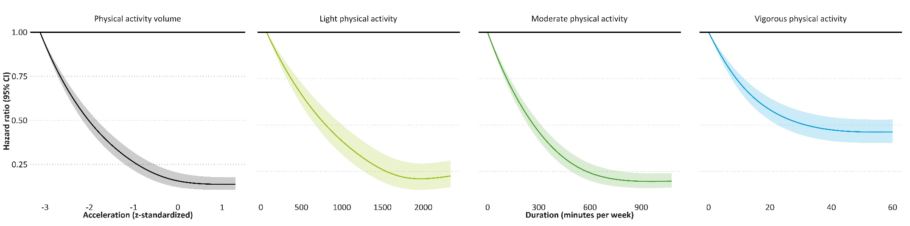

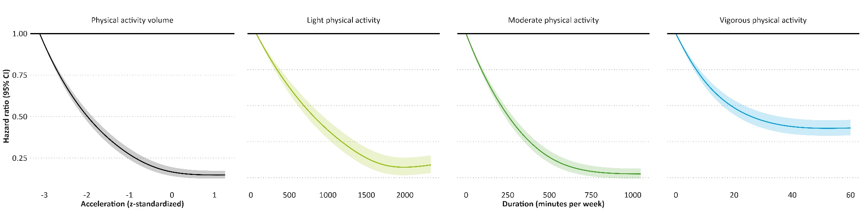
Main results with additional adjustment for season of accelerometer wear

Main results under mutual adjustment for light, moderate, and vigorous physical activity
