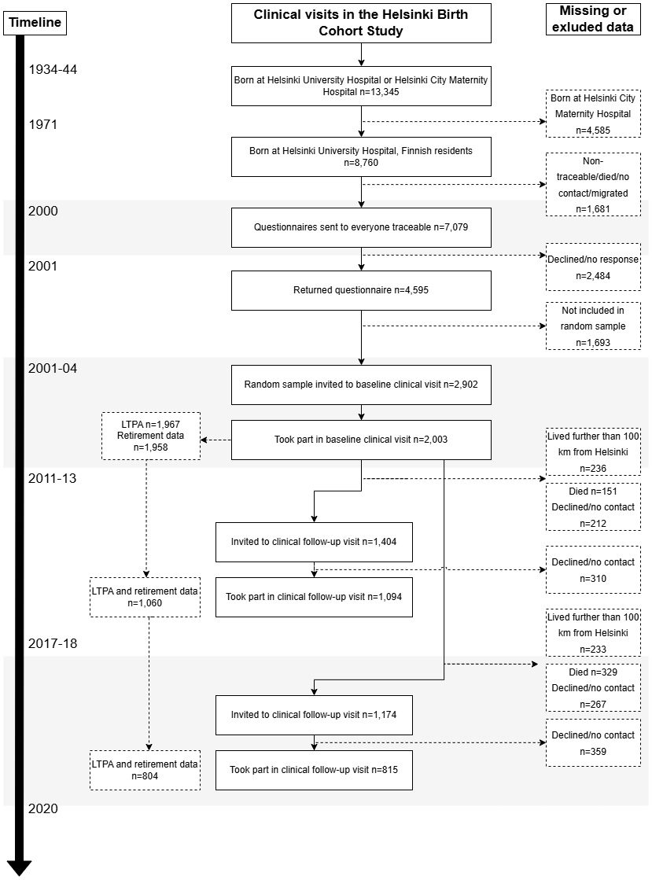
Figure S1. Flowchart of participant selection and follow-up in the Helsinki Birth Cohort Study (HBCS). The original cohort comprised 13,345 individuals born in Helsinki, Finland between 1934 and 1944. A subsample of individuals born at Helsinki University Central Hospital (n = 8,760) was targeted for clinical study, with 2,003 participants attending the baseline examination (2001–2004). Follow-up clinical examinations were conducted in 2011–2013 (n = 1,094) and 2017–2018 (n = 815) among participants living within 100 km of the study clinic. For the present study, analyses are based on participants with available leisure-time physical activity (LTPA) data at baseline (n = 1,967), of whom 1,958 also had data on retirement. During the 17-year follow-up, 721 participants contributed LTPA data at all three time points, 361 at two time points, and 876 at one time point. Flowchart modified from Haapanen et al. (2022).
Table S1. Characteristics of the study population across follow-up clinical examinations.
 | Men (n = 905) by type of retirement (n, %) |  |  |  |  | Women (n = 1,055) by type of retirement (n, %)
 | Old-age  342 (37.9) | Disability  211 (23.4) | Part-time  181 (20.0) | Unemployment  169 (18.7) | p | Old-age  457 (43.3) | Disability  230 (21.8) | Part-time  199 (18.9) | Unemployment  169 (16.0) | p
Education, years | 13.1 (3.8) | 11.1 (3.5) | 13.3 (3.7) | 12.2 (3.7) | <0.001* | 12.7 (3.7) | 11.3 (3.3) | 12.4 (3.5) | 10.9 (2.9) | <0.001*
Age at retirement, years | 61.9 (3.8) | 53.5 (6.7) | 58.4 (2.0) | 60.2 (1.0) | <0.001* | 62.1 (2.4) | 54.0 (5.9) | 58.1 (1.9) | 60.0 (0.8) | <0.001*
Occupational status, n (%)  Upper middle class  Lower middle class  Self-employed  Manual worker | 94 (26.9)  86 (24.5)  38 (10.9)  132 (37.7) | 23 (10.5)  47 (21.4)  19 (8.6)  131 (59.5) | 40 (21.7)  62 (33.7)  30 (16.3)  52 (28.3) | 24 (14.1)  59 (34.7)  9 (5.3)  78 (45.9) | <0.001§ | 59 (12.8)  259 (56.1)  50 (10.8)  94 (20.3) | 11 (4.7)  124 (52.5)  18 (7.6)  83 (35.2) | 25 (12.5)  115 (57.5)  17 (8.5)  43 (21.5) | 7 (4.1)  103 (60.2)  5 (2.9)  56 (32.7) | <0.001§
Second clinical examination 2011-2013, n = 1,069
Age, years | 70.8 (2.6) | 71.5 (2.6) | 70.1 (2.1) | 71.4 (2.6) | <0.001* | 71.0 (2.9) | 71.8 (3.0) | 70.6 (2.3) | 71.6 (2.8) | 0.004*
Total vol. of LTPA (METh/week) | 39.3 (2.2) | 37.2 (6.9) | 39.7 (3.6) | 42.2 (3.9) | 0.88* | 30.0 (2.2) | 31.4 (3.2) | 30.1 (2.2) | 25.8 (2.5) | 0.65*
BMI (kg/m²) | 26.5 (3.5) | 27.0 (4.3) | 27.1 (3.8) | 27.2 (4.1) | 0.32* | 27.2 (5.2) | 27.9 (5.2) | 26.9 (4.9) | 27.5 (4.6) | 0.46*
Smoking status, n (%)  Never  Former  Current | 65 (33.2)  104 (53.1)  27 (13.8) | 17 (25.0)  33 (48.5)  18 (26.5) | 30 (27.0)  69 (62.2)  12 (10.8) | 26 (28.9)  51 (56.7)  13 (14.4) | 0.096§ | 172 (61.6)  70 (25.1)  37 (13.3) | 59 (62.1)  29 (30.5)  7 (7.4) | 70 (56.5)  42 (33.9)  12 (9.7) | 50 (54.9)  28 (30.8)  13 (14.3) | 0.36§
Chronic diseases, n (%)  None  One  Two or more | 146 (73.7)  43 (21.7)  9 (4.5) | 35 (51.5)  16 (23.5)  17 (25.0) | 82 (73.2)  25 (22.3)  5 (4.5) | 59 (65.6)  21 (23.3)  10 (11.1) | <0.001§ | 205 (71.7)  65 (22.7)  16 (5.6) | 39 (40.6)  31 (32.3)  26 (27.1) | 83 (66.4)  35 (28.0)  7 (5.6) | 64 (68.1)  18 (19.1)  12 (12.8) | <0.001§
Third clinical examination 2017-2018, n = 804
Age, years | 75.7 (2.7) | 76.4 (2.7) | 75.3 (2.2) | 76.4 (2.5) | 0.030* | 75.8 (2.7) | 76.9 (3.2) | 75.6 (2.3) | 76.6 (2.9) | 0.004*
Total vol. of LTPA (METh/week) | 36.6 (2.2) | 25.9 (3.8) | 29.8 (2.3) | 33.5 (4.0) | 0.100* | 25.4 (1.5) | 26.0 (2.9) | 25.6 (2.4) | 25.0 (3.2) | 0.99*
BMI (kg/m²) | 26.5 (4.1) | 26.0 (4.0) | 26.8 (3.7) | 26.6 (3.8) | 0.74* | 27.1 (4.9) | 27.4 (5.2) | 27.4 (5.0) | 27.1 (4.2) | 0.95*
Smoking status, n (%)  Never  Former  Current | 56 (34.1)  101 (61.6)  7 (4.3) | 8 (22.9)  22 (62.9)  5 (14.3) | 26 (29.2)  58 (65.2)  5 (7.7) | 21 (32.3)  39 (60.0)  5 (7.7) | 0.37§ | 143 (64.4)  59 (26.6)  20 (9.0) | 42 (70.0)  16 (26.7)  2 (3.3) | 58 (59.8)  34 (35.1)  5 (5.2) | 43 (61.4)  23 (32.9)  4 (5.7) | 0.44§
Chronic diseases, n (%)  None  One  Two or more | 109 (66.5)  46 (28.0)  9 (5.5) | 19 (54.3)  9 (25.7)  7 (20.0) | 63 (70.8)  19 (21.3)  7 (7.9) | 46 (69.7)  15 (22.7)  5 (7.6) | 0.124§ | 154 (69.4)  57 (25.7)  11 (5.0) | 26 (42.6)  21 (34.4)  14 (23.0) | 65 (67.0)  26 (26.8)  6 (6.2) | 49 (70.0)  16 (22.9)  5 (7.1) | <0.001§
Note. Values are means (SD) unless otherwise indicated; categorical variables are presented as n (%). *p-values from ANOVA-test (One-way analysis of variance), § p-values from Chi square (x²-square) test. LTPA = leisure-time physical activity, MET = metabolic equivalent of task, BMI = body mass index.

Table S2. Non-response and mortality (n, %) in the clinical examinations from 2011 to 2018 by retirement type and sex.
 | Type of retirement
 | Old-age | Disability | Part-time | Unemployment | p§
MEN n=903 | n (%) | n (%) | n (%) | n (%)
II clinical examination  Participated  Non-response  Died before follow-up 2011- 2013 | 199 (58.2)  113 (33.0)  30 (8.8) | 72 (34.1)  91 (43.1)  48 (22.7) | 112 (61.9)  49 (27.1)  20 (11.0) | 91 (53.8)  59 (34.9)  19 (11.2) | <0.001
III clinical examination  Participated  Non-response  Died before follow-up 2017- 2018 | 164 (48.0)  122 (35.7)  56 (16.4) | 35 (16.6)  99 (46.9)  77 (36.5) | 89 (49.2)  62 (34.3)  30 (16.6) | 66 (39.1)  70 (41.4)  33 (19.5) | <0.001
WOMEN n=1,055
II clinical examination  Participated  Non-response  Died before follow-up 2011- 2013 | 288 (63.0)  150 (32.8)  19 (4.2) | 98 (42.6)  102 (44.3)  30 (13.0) | 126 (63.3)  59 (29.6)  14 (7.0) | 95 (56.2)  58 (34.3)  16 (9.5) | <0.001
III clinical examination  Participated  Non-response  Died before follow-up 2017-2018 | 222 (48.6)  191 (41.8)  44 (9.6) | 61 (26.5)  120 (52.2)  49 (21.3) | 97 (48.7)  76 (38.2)  26 (13.1) | 70 (41.4)  76 (45.0)  23 (13.6) | <0.001
Note. § p-values from Chi square test. The date of death was provided by Statistics Finland.

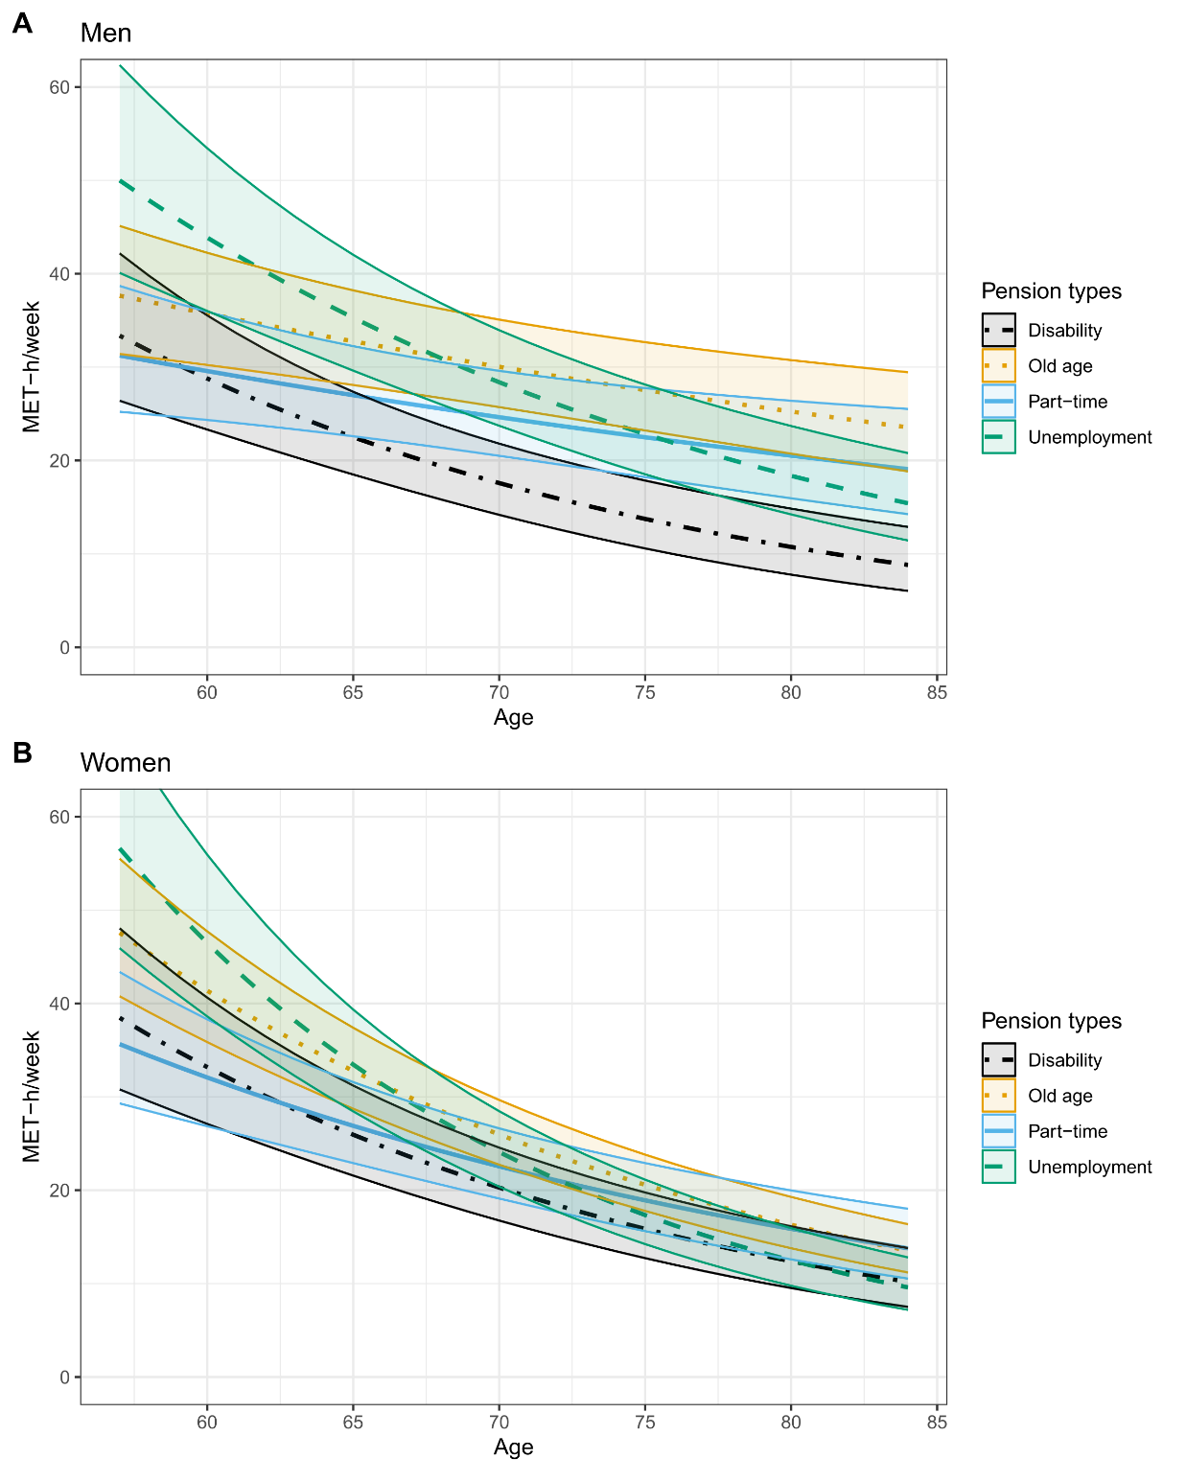
Figure S2. Predicted trajectories of leisure-time physical activity (LTPA) across older age by pension type and sex with 95% confidence intervals (CIs). Panels A and B illustrate changes in LTPA (measured in MET-hours/week) across older age among men (Panel A) and women (Panel B), stratified by pension type: part-time, disability, unemployment, and old age. Covariates were fixed to enable plotting: baseline age at 62 years, time in years between retirement and first LTPA assessment set to its sample mean, socioeconomic status in adulthood set to “manual workers,” smoking status as “former smoker,” BMI fixed at 27, and number of chronic diseases set to “none.” Each line represents a distinct pension type, illustrating age-related trends in physical activity engagement.

Table S3. Model-predicted LTPA levels (MET-h/week) and 95% confidence intervals (CIs)
at ages 62, 70, and 80 years by retirement type.
Men (n = 903) | Age 62 | Age 70 | Age 80
Old-age retirement | 33.0 (29.8 to 36.7) | 28.8 (26.2 to 31.7) | 24.2 (20.8 to 28.3)
Disability retirement | 25.0 (21.5 to 29.2) | 16.8 (14.1 to 20.0) | 10.3 (7.6 to 13.7)
Unemployment retirement | 38.5 (33.6 to 44.5) | 27.2 (23.7 to 31.1) | 17.6 (13.9 to 22.2)
Part-time retirement | 27.3 (23.9 to 31.1) | 23.6 (20.6 to 26.8) | 19.6 (15.7 to 24.4)
Women (n = 1,055)
Old-age retirement | 33.9 (30.9 to 37.0) | 23.3 (21.5 to 25.4) | 14.7 (13.0 to 16.8)
Disability retirement | 27.0 (23.4 to 31.5) | 18.2 (15.8 to 21.1) | 11.1 (8.9 to 13.9)
Unemployment retirement | 36.6 (31.7 to 42.5) | 21.6 (18.9 to 24.9) | 11.2 (9.0 to 14.0)
Part-time retirement | 26.9 (23.8 to 30.5) | 20.3 (18.0 to 23.0) | 14.3 (11.8 to 17.5)
Note. LTPA=leisure time physical activity expressed as volume of LTPA in metabolic equivalent of task
(MET)-hours per week.
Predicted LTPA values were estimated from linear mixed models including retirement type, age centered at
62 years, and the retirement type × age interaction, and adjusted for time in years between retirement and
first LTPA assessment, socioeconomic status in adulthood, time-varying smoking status, time-varying body
mass index, and number of chronic diseases at baseline. Estimates were obtained at ages 62, 70, and 80
years and back-transformed from the log scale to the original MET-h/week scale.

Table S4. Beta estimates and 95% confidence intervals (CIs) for the age × retirement type interaction effects on LTPA (METh) in men and women from sensitivity analyses including age × covariate interactions and baseline-only covariate adjustment.
 | Model 1:  Age x covariate interactions included |  |  | Model 2:  Covariates only at baseline
 | β estimate | 95% CI | p | β estimate | 95%CI | p
MEN (n = 903)
Age* x Old-age retirement | REF |  |  | REF
Age* x Disability retirement | -0.031 | -0.050, -0.011 | 0.002 | -0.031 | -0.050, -0.012 | 0.002
Age* x Unemployment retirement | -0.028 | -0.044, -0.011 | 0.001 | -0.026 | -0.042, -0.009 | 0.003
Age* x Part-time retirement | -0.001 | -0.017, 0.015 | 0.874 | -0.001 | -0.017, 0.016 | 0.947
WOMEN (n = 1,055)
Age* x Old-age retirement | REF |  |  | REF
Age* x Disability retirement | 0.004 | -0.013, 0.020 | 0.682 | -0.002 | -0.018, 0.014 | 0.782
Age* x Unemployment retirement | -0.017 | -0.034, -0.001 | 0.033 | -0.018 | -0.034, -0.002 | 0.026
Age* x Part-time retirement | 0.013 | -0.002, 0,028 | 0.079 | 0.011 | -0.003, 0.026 | 0.133
Note. *Age centered at 62 years. LTPA=leisure time physical activity expressed as volume of LTPA in metabolic equivalent of task (MET)-hours per week.
Model 1 included retirement type, age centered at 62 years, and the retirement type × age interaction and was adjusted for time in years between retirement and first LTPA assessment, socioeconomic status in adulthood, time-varying smoking status, time-varying body mass index, and number of chronic diseases at baseline. Interaction terms between age and all covariates were additionally included.
Model 2 included retirement type, age centered at 62 years and retirement type x age interaction and was adjusted for time in years between retirement and first LTPA assessment, socioeconomic status in adulthood, and smoking status, body mass index, and number of chronic diseases at baseline.

Table S5. Beta estimates and 95% confidence intervals (CIs) for LTPA (expressed as METh) across older age according to the type of retirement in men and women restricted those who were measured after the retirement.
 | Model 1 |  |  | Model 2
 | β estimate | 95% CI | p | β estimate | 95%CI | p
MEN (n = 583)
Intercept | 3.616 | 3.396, 3.836 | <0.001 | 3.743 | 3.433, 4.055 | <0.001
Age* | -0.001 | -0.013, 0.010 | 0.833 | -0.005 | -0.017, 0.007 | 0.375
Old-age retirement  Disability retirement  Unemployment retirement  Part-time retirement | REF  -0.337  -0.155  -0.312 | -0.820, 0.147  -0.428, 0.118  -0.613, -0.011 | 0.176  0.270  0.045 | REF  -0.286  -0.151  -0.295 | -0.773, 0.200  -0.423, 0.122  -0.593, 0.003 | 0.258  0.287  0.058
Age* x Old-age retirement | REF |  |  | REF
Age* x Disability retirement | -0.105 | -0.170, -0.039 | 0.002 | -0.100 | -0.165, -0.035 | 0.003
Age* x Unemployment retirement | -0.045 | -0.072, -0.019 | 0.001 | -0.045 | -0.072, -0.019 | 0.001
Age* x Part-time retirement | 0.011 | -0.017, 0.040 | 0.435 | 0.012 | -0.017, 0.040 | 0.425
WOMEN (n = 655)
Intercept | 3.395 | 3.207, 3.582 | <0.001 | 3.371 | 3.063, 3.680 | <0.001
Age* | -0.035 | -0.045, -0.025 | <0.001 | -0.036 | -0.046, -0.026 | <0.001
Old-age retirement  Disability retirement  Unemployment retirement  Part-time retirement | REF  -0.429  -0.099  -0.269 | -0.899, 0.042  -0.362, 0.165  -0.599, 0.060 | 0.076  0.465  0.112 | REF  -0.415  -0.055  -0.314 | -0.882, 0.051  -0.319, 0.209  -0.639, -0.010 | 0.086  0.688  0.062
Age* x Old-age retirement | REF |  |  | REF
Age* x Disability retirement | -0.036 | -0.090, 0.019 | 0.202 | -0.035 | -0.090, 0.020 | 0.213
Age* x Unemployment retirement | -0.017 | -0.043, 0.010 | 0.219 | -0.018 | -0.044, 0.009 | 0.195
Age* x Part-time retirement | 0.025 | -0.006, 0.055 | 0.117 | 0.026 | -0.005, 0.057 | 0.107
Note. *Age centered at 62 years. LTPA=leisure time physical activity expressed as volume of LTPA in metabolic equivalent of task (MET)-hours per week.
Model 1 included retirement type, age centered at 62 years, and retirement type x age interaction and was adjusted for time in years between retirement and first LTPA assessment.
Model 2 included retirement type, age centered at 62 years and retirement type x age interaction and was adjusted for time in years between retirement and first LTPA assessment, socioeconomic status in adulthood, time-varying smoking status, time-varying body mass index, and number of chronic diseases at baseline.

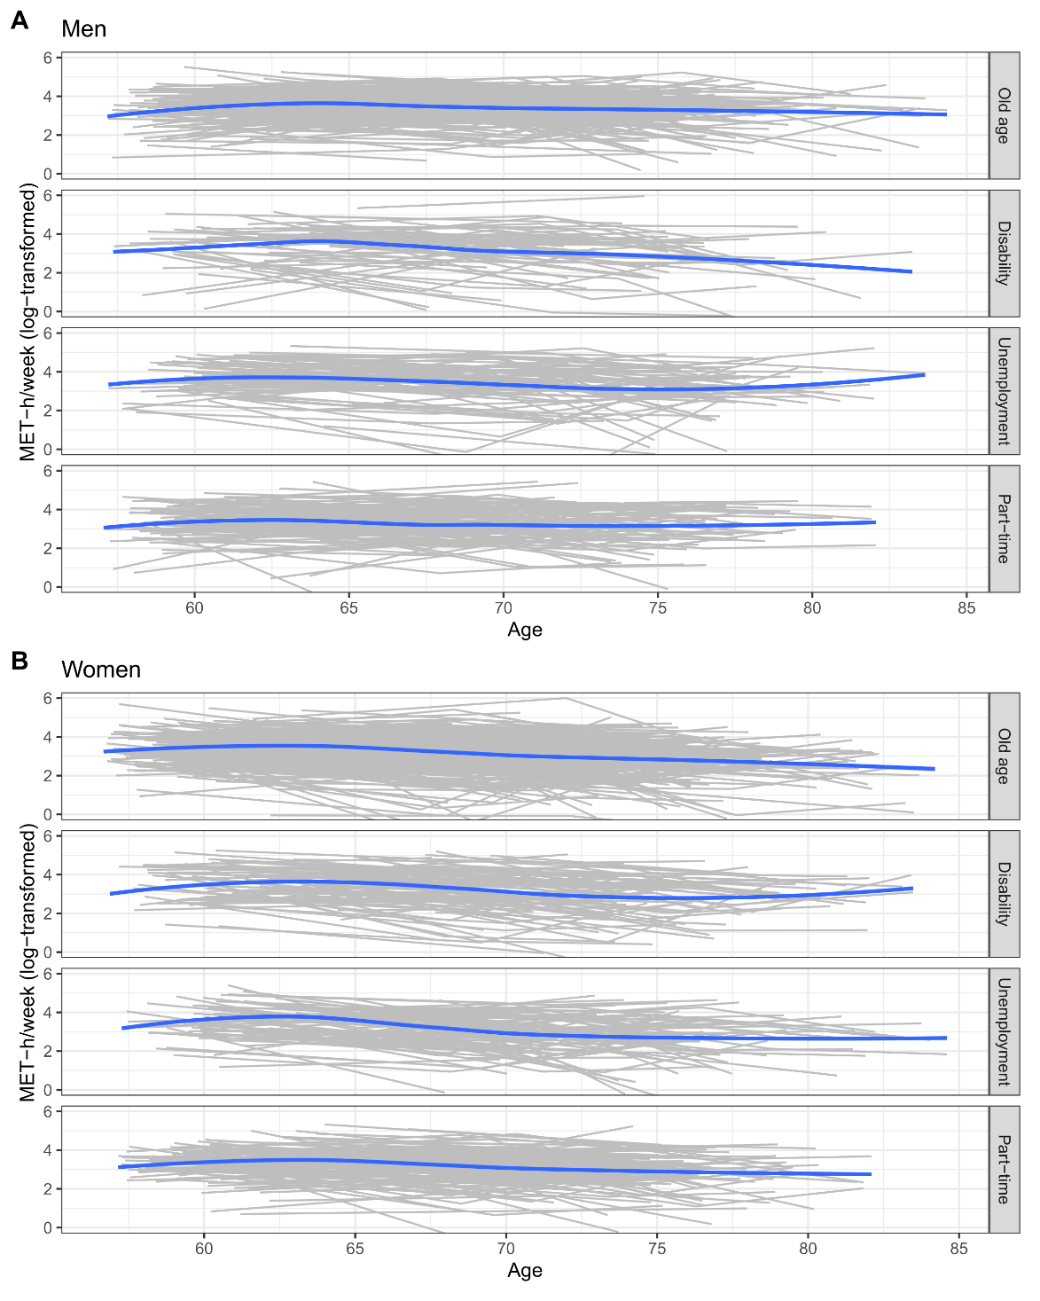

Figure S3. Spaghetti plots depicting individual trajectories of leisure-time physical activity (LTPA; MET-h/week log-transformed) across age by retirement type among men (A) and women (B). Each thin line represents one participant, and thicker lines indicate the average predicted trajectories from linear mixed models. The plots illustrate considerable within-person variability and differences in mean trajectories between retirement types.

