Data Supplement Content
Methods. Supplementary Methodology
Table S1 PRISMA Checklist
Table S2 Details Regarding the Processing or Adjustment of Information for the Meta-Analysis
Table S3 Characteristics of the Studies
Table S4 Sensitivity Analyses through Different Domains
Table S5 Meta-Regression Results of the Effect of Subgroup and Moderator Variables
Fig. S1 Forest Plot in Main Analysis
Fig. S2 Funnel Plots of Publication Bias
Methods. Supplementary Methodology
Search Strategy
The search strategy applied were as followed:
Section | Detailed Search Terms
Search term combination with truncations
Outcome | “physical* activ*” OR “physical* educat*” OR “physical* fit*” OR “exercis*” OR “sport*” OR “cardiovascular” OR “aerobic” OR “anaerobic” OR “body mass index” OR “BMI” OR “body weight” OR “body composition” OR “motor skill*” OR “movement skill*” OR “coordinat*” OR “locomotor” OR “object control” OR “motor proficiency” OR “object manipulation” OR “walk*” OR “fit*” OR “run*” OR “gallop*” OR “hop*” OR “leap*” OR “jump*” OR “strik*” OR “dribbl*” OR “catch*” OR “kick*” OR “agil*” OR “balanc*” OR “speed*” OR “strength” OR “react*” OR “ resistan*” OR “endur*” OR “flexibil*” OR “physical literacy” OR “physical* literate” OR “competence”; AND
Intervention | “interven*” OR “program*” OR “evaluat*” OR “workshop*” OR “trial*” OR “educat*” OR “train*” OR “impact*” OR “effect*” OR “efficacy” OR “experiment*” OR “serv*” OR “therap*” OR “curriculum” OR “instruct*”; AND
Population | “preschool*” OR “pre‐school*” OR “kindergarten” OR “toddl*” OR “young child*” OR child* OR “boy*” OR “girl*” OR “early childhood” OR “early years” OR “3 years” OR “4 years” OR “5 years” OR “6 years”.
Search term combination without truncations
Outcome | “physical activity” OR “physical activities” OR “physically active” OR “physically inactive” OR “physical education” OR “physically educated” OR “physical fitness” OR “physically fit” OR “exercise” OR “exercises” OR “sport” OR “sports” OR “cardiovascular” OR “aerobic” OR “anaerobic” OR “body mass index” OR “BMI” OR “body weight” OR “body composition” OR “body fat” OR “motor skill” OR “motor skills” OR “movement skill” OR “movement skills” OR “coordination” OR “coordinate” OR “fine motor skill” OR “fine motor skills” OR “gross motor skill” OR “gross motor skills” OR “fundamental motor skill” OR “fundamental motor skills” OR “non-locomotor” OR “locomotor” OR “object control” OR “motor proficiency” OR “object manipulation” OR “walk” OR “walking” OR “fit” OR “fitness” OR “run” OR “running” OR “gallop” OR “galloping” OR “hop” OR “hopping” OR “leap” OR “leaping” OR “jump” OR “jumping” OR “strike” OR “striking” OR “dribble” OR “dribbling” OR “catch” OR “catching” OR “kick” OR “kicking” OR “agile” OR “agility” OR “balance” OR “balancing” OR “speed” OR “speeding” OR “strength” OR “strong” OR “react” OR “reaction” OR “resistant” OR “resistance” OR “endurant” OR “endurance” OR “flexible” OR “flexibility” OR “physical literacy” OR “physically literate” OR “competence”; AND
Intervention | “intervention” OR “interventions” OR “program” OR “programme” OR “programs” OR “programmes” OR “evaluate” OR “evaluation” OR “workshop” OR “trial” OR “educate” OR “education” OR “training” OR “impact” OR “impacts” OR “effect” OR “effectiveness” OR “efficacy” OR “effective” OR “experiment” OR “experimental” OR “serve” OR “serving” OR “service” OR “services” OR “therapy” OR “curriculum” OR “instructing” OR “instruction”; AND
Population | “preschool” OR “preschool-aged” OR “pre‐school” OR “kindergarten” OR “toddler” OR “toddlers” OR “young child” OR “young children” OR “child” OR “children” OR “boy” OR “boys” OR “girl” OR “girls” OR “early childhood” OR “early years” OR “3 years” OR “4 years” OR “5 years” OR “6 years”.

Risk of Bias Assessment
The “Effective Public Health Practice Project Quality Assessment Tool for quantitative studies” (EPHPP) were used to assess the risk of bias of each eligible study. Ratings are based on 6 sections, namely selection bias, study design, confounding factors, blinding, data collection method, withdrawal and dropouts. Two reviewers will independently rate the study as strong, moderate and weak. All Disagreement will be discussed first, and if no agreement is reached, it will be adjudicated by a third person to form a consensus. The rating rules are: no weak rating for “strong” level; one weak rating for “medium” level, two or above weak rating for “weak” level [1].
Table S1 PRISMA Checklist [2]
Section and Topic | Item # | Checklist item | Location where item is reported
TITLE
Title | 1 | Identify the report as a systematic review. | Title
ABSTRACT
Abstract | 2 | See the PRISMA 2020 for Abstracts checklist. | Abstract
INTRODUCTION
Rationale | 3 | Describe the rationale for the review in the context of existing knowledge. | Introduction
Objectives | 4 | Provide an explicit statement of the objective(s) or question(s) the review addresses. | Introduction
METHODS
Eligibility criteria | 5 | Specify the inclusion and exclusion criteria for the review and how studies were grouped for the syntheses. | Eligibility Criteria
Information sources | 6 | Specify all databases, registers, websites, organisations, reference lists and other sources searched or consulted to identify studies. Specify the date when each source was last searched or consulted. | Search Strategy
Search strategy | 7 | Present the full search strategies for all databases, registers and websites, including any filters and limits used. | Search Strategy and  Methods
Selection process | 8 | Specify the methods used to decide whether a study met the inclusion criteria of the review, including how many reviewers screened each record and each report retrieved, whether they worked independently, and if applicable, details of automation tools used in the process. | Study Selection
Data collection process | 9 | Specify the methods used to collect data from reports, including how many reviewers collected data from each report, whether they worked independently, any processes for obtaining or confirming data from study investigators, and if applicable, details of automation tools used in the process. | Study Selection
Data items | 10a | List and define all outcomes for which data were sought. Specify whether all results that were compatible with each outcome domain in each study were sought (e.g. for all measures, time points, analyses), and if not, the methods used to decide which results to collect. | Data Extraction
Data items | 10b | List and define all other variables for which data were sought (e.g. participant and intervention characteristics, funding sources). Describe any assumptions made about any missing or unclear information. | Data Extraction
Study risk of bias assessment | 11 | Specify the methods used to assess risk of bias in the included studies, including details of the tool(s) used, how many reviewers assessed each study and whether they worked independently, and if applicable, details of automation tools used in the process. | Risk of Bias Assessment
Effect measures | 12 | Specify for each outcome the effect measure(s) (e.g. risk ratio, mean difference) used in the synthesis or presentation of results. | Data Extraction
Synthesis methods | 13a | Describe the processes used to decide which studies were eligible for each synthesis (e.g. tabulating the study intervention characteristics and comparing against the planned groups for each synthesis (item #5)). | Data Extraction
Synthesis methods | 13b | Describe any methods required to prepare the data for presentation or synthesis, such as handling of missing summary statistics, or data conversions. | Data Extraction
Synthesis methods | 13c | Describe any methods used to tabulate or visually display results of individual studies and syntheses. | Data Extraction
Synthesis methods | 13d | Describe any methods used to synthesize results and provide a rationale for the choice(s). If meta-analysis was performed, describe the model(s), method(s) to identify the presence and extent of statistical heterogeneity, and software package(s) used. | Data Synthesis and Statistical Analysis
Synthesis methods | 13e | Describe any methods used to explore possible causes of heterogeneity among study results (e.g. subgroup analysis, meta-regression). | Data Synthesis and Statistical Analysis
Synthesis methods | 13f | Describe any sensitivity analyses conducted to assess robustness of the synthesized results. | Data Synthesis and Statistical Analysis
Reporting bias assessment | 14 | Describe any methods used to assess risk of bias due to missing results in a synthesis (arising from reporting biases). | EPHPP Assessment Tool
Certainty assessment | 15 | Describe any methods used to assess certainty (or confidence) in the body of evidence for an outcome. | GRADE Assessment Tool
RESULTS
Study selection | 16a | Describe the results of the search and selection process, from the number of records identified in the search to the number of studies included in the review, ideally using a flow diagram. | Results and Fig. 1
Study selection | 16b | Cite studies that might appear to meet the inclusion criteria, but which were excluded, and explain why they were excluded. | Not Applicable
Study characteristics | 17 | Cite each included study and present its characteristics. | Results and Table S3
Risk of bias in studies | 18 | Present assessments of risk of bias for each included study. | Results and Table S5
Results of individual studies | 19 | For all outcomes, present, for each study: (a) summary statistics for each group (where appropriate) and (b) an effect estimate and its precision (e.g. confidence/credible interval), ideally using structured tables or plots. | Results and Fig. S1
Results of syntheses | 20a | For each synthesis, briefly summarise the characteristics and risk of bias among contributing studies. | Results
Results of syntheses | 20b | Present results of all statistical syntheses conducted. If meta-analysis was done, present for each the summary estimate and its precision (e.g. confidence/credible interval) and measures of statistical heterogeneity. If comparing groups, describe the direction of the effect. | Results
Results of syntheses | 20c | Present results of all investigations of possible causes of heterogeneity among study results. | Results, Table S6 and Fig. 4
Results of syntheses | 20d | Present results of all sensitivity analyses conducted to assess the robustness of the synthesized results. | Results, Table 3, S5
Reporting biases | 21 | Present assessments of risk of bias due to missing results (arising from reporting biases) for each synthesis assessed. | Results, Table 4 and Fig. 3
Certainty of evidence | 22 | Present assessments of certainty (or confidence) in the body of evidence for each outcome assessed. | Results and Table 2
DISCUSSION
Discussion | 23a | Provide a general interpretation of the results in the context of other evidence. | Discussion
Discussion | 23b | Discuss any limitations of the evidence included in the review. | Discussion
Discussion | 23c | Discuss any limitations of the review processes used. | Discussion
Discussion | 23d | Discuss implications of the results for practice, policy, and future research. | Discussion
OTHER INFORMATION
Registration and protocol | 24a | Provide registration information for the review, including register name and registration number, or state that the review was not registered. | Method
Registration and protocol | 24b | Indicate where the review protocol can be accessed, or state that a protocol was not prepared. | Method
Registration and protocol | 24c | Describe and explain any amendments to information provided at registration or in the protocol. | Not Applicable
Support | 25 | Describe sources of financial or non-financial support for the review, and the role of the funders or sponsors in the review. | Funding
Competing interests | 26 | Declare any competing interests of review authors. | Conflict of Interest Disclosures
Availability of data, code and other materials | 27 | Report which of the following are publicly available and where they can be found: template data collection forms; data extracted from included studies; data used for all analyses; analytic code; any other materials used in the review. | Data and Resource Availability

Table S2 Details Regarding the Processing or Adjustment of Information for the Meta-Analysis
Study | Outcome Indicator | Reason for further proceeding | Calculated values* | Data used in Meta Analysis
Adamo et al., 2016 [3] | GMS | Significant baseline differences:(p = 0.003)  IG(M±SD): 9.8±0.76 CG(M±SD): 10.3±0.75 | Adjusted effects for SMD 1.578 (previous biased effect: 0.92) | Adjustment of the CG mean (original: 10.51; adjusted: 10)
Adamo et al., 2016 [3] | Total GMS Score | Significant baseline differences:(p = 0.012)  IG(M±SD): 96.76±3.97 CG(M±SD): 98.99±3.94 | Adjusted effects for SMD 1.432 (previous biased effect: 0.87) | Adjustment of the CG mean (original: 97.46; adjusted: 95.2)
Adamo et al., 2017 [4] | MVPA | Significant baseline differences:(p = 0.005)  IG(M±SD): 3.7±1.1 CG(M±SD): 4.3±1.2 | Adjusted effects for SMD -0.171 (previous biased effect: -0.69) | Adjustment of the CG mean (original: 5.5; adjusted: 4.82)
Alesi et al., 2021 [5] | Interpersonal Skills | Significant baseline differences:(p < 0.001)  IG(M±SD): 26.05±0.4 CG(M±SD): 24.58±0.59 | Adjusted effects for SMD 1.035 (previous biased effect: 4.14) | Adjustment of the CG mean (original:27.58; adjusted: 30.19)
Alhassan et al., 2012 [6] | MVPA | Significant baseline differences:(p = 0.002)  IG(M±SD): 7.1±3.9 CG(M±SD): 10.7±4.8 | Adjusted effects for SMD 0.562 (previous biased effect: -0.28) | Adjustment of the CG mean (original: 8.9; adjusted: 5.89)
Ali et al., 2021 [7] | GMS | Significant baseline differences:(p = 0.040)  IG(M±SD): 11.3±3.3 CG(M±SD): 9.7±2.6 | Adjusted effects for SMD 0.863 (previous biased effect: 1.38) | Adjustment of the CG mean (original: 11; adjusted: 12.42)
Arufe-Giráldez, 2023 [8] | Coordination & Balance | Significant baseline differences:(p = 0.040)  IG(M±SD): 56.92±20.87 CG(M±SD): 60.76±26.61 | Adjusted effects for SMD -0.057 (previous biased effect: -0.22) | Adjustment of the CG mean (original: 65.84; adjusted: 62.00)
Basterfield et al., 2023 [9] | Total GMS Score | Significant baseline differences:(p < 0.001)  IG(M±SD): 72.7±15.7 CG(M±SD): 59.9±24.1 | Adjusted effects for SMD -0.318 (previous biased effect: 0.41) | Adjustment of the CG mean (original: 72.4; adjusted: 80.75)
Battaglia et al., 2019 [10] | GMS | Significant baseline differences:(p < 0.001)  IG(M±SD): 12.61±3.84 CG(M±SD): 7.07±3.19 | Adjusted effects for SMD 0.298 (previous biased effect: 1.8) | Adjustment of the CG mean (original: 7.66; adjusted: 12.81)
Branje et al., 2022 [11] | GMS | Significant baseline differences:(p = 0.042)  IG(M±SD): 24.66±8.2 CG(M±SD): 22.33±6.92 | Adjusted effects for SMD -0.149 (previous biased effect: 0.15) | Adjustment of the CG mean (original: 29.06; adjusted: 31.35)
Caldwell et al., 2023 [12] | TPA | Significant baseline differences:(p < 0.001)  IG(M±SD): 354±30 CG(M±SD): 374±34 | Adjusted effects for SMD 1.662 (previous biased effect: 1.01) | Adjustment of the CG mean (original: 395; adjusted: 372.6)
Caldwell et al., 2023 [12] | MVPA | Significant baseline differences:(p = 0.025)  IG(M±SD): 170±29 CG(M±SD): 180±34 | Adjusted effects for SMD -0.753 (previous biased effect: -1.03) | Adjustment of the CG mean (original: 203; adjusted: 195.5)
Callcott et al., 2015 [13] | Total MS Score | Significant baseline differences:(p = 0.005)  IG(M±SD): 10.02±2.55 CG(M±SD): 11.13±2.94 | Adjusted effects for SMD 0.623 (previous biased effect: 0.22) | Adjustment of the CG mean (original: 10.84; adjusted: 9.83)
Callcott et al., 2015 [13] | Total MS Score | Significant baseline differences:(p = 0.001)  IG(M±SD): 9.78±2.74 CG(M±SD): 11.13±2.94 | Adjusted effects for SMD 0.29 (previous biased effect: -0.181) | Adjustment of the CG mean (original: 10.84; adjusted: 9.62)
Callcott et al., 2015 [13] | Total MS Score | Significant baseline differences:(p = 0.011)  IG(M±SD): 10.13±2.53 CG(M±SD): 11.13±2.94 | Adjusted effects for SMD 0.384 (previous biased effect: 0.021) | Adjustment of the CG mean (original: 10.84; adjusted: 10.00)
Cardon et al., 2009 [14] | Step Counts | Significant baseline differences:(p = 0.015)  IG(M±SD): 569.8±244.5 CG(M±SD): 494.1±282.7 | Adjusted effects for SMD -0.332 (previous biased effect: -0.05) | Adjustment of the CG mean (original: 585.3; adjusted: 672.8)
Costa et al., 2015a [15] | Temporal Skills | Significant baseline differences:(p = 0.048)  IG(M±SD): 7.87±3.37 CG(M±SD): 6.63±2.61 | Adjusted effects for SMD 0.909 (previous biased effect:1.32) | Adjustment of the CG mean (original: 8.04; adjusted: 9.08)
Costa et al., 2015a [15] | Other Cognitive Skills | Significant baseline differences:(p = 0.001)  IG(M±SD): 11.6±2.36 CG(M±SD): 13.38±2.86 | Adjusted effects for SMD 0.768 (previous biased effect: 0.09) | Adjustment of the CG mean (original: 13.14; adjusted: 11.97)
Costa et al., 2015a [15] | Spatial Skills | Significant baseline differences:(p = 0.016)  IG(M±SD): 10.79±3.47 CG(M±SD): 12.34±2.88 | Adjusted effects for SMD 0.65 (previous biased effect: 0.16) | Adjustment of the CG mean (original: 12.8; adjusted: 11.31)
Costa et al., 2015a [15] | Temporal Skills | Significant baseline differences:(p = 0.042)  IG(M±SD):10.64±3.6 CG(M±SD): 12.42±5.06 | Adjusted effects for SMD 0.594 (previous biased effect: 0.19) | Adjustment of the CG mean (original: 13; adjusted: 11.36)
Costa et al., 2015a [15] | Coordination & Balance | Significant baseline differences:(p = 0.007)  IG(M±SD): 16.37±3.14 CG(M±SD): 14.84±3.07 | Adjusted effects for SMD 0.812 (previous biased effect: 1.31) | Adjustment of the CG mean (original: 15.16; adjusted: 16.63)
Costa et al., 2015a [15] | Spatial Skills | Significant baseline differences:(p = 0.032)  IG(M±SD): 14.48±3.58 CG(M±SD): 15.7±2.64 | Adjusted effects for SMD 0.616 (previous biased effect: 0.23) | Adjustment of the CG mean (original: 16.33; adjusted: 14.25)
Costa et al., 2015a [15] | Temporal Skills | Significant baseline differences:(p = 0.019)  IG(M±SD): 15.58±4.38 CG(M±SD): 17.39±4.15 | Adjusted effects for SMD 0.69 (previous biased effect: 0.27) | Adjustment of the CG mean (original: 17.47; adjusted: 15.85)
Costa et al., 2015b [16] | Coordination & Balance | Significant baseline differences:(p < 0.001)  IG(M±SD): 8.72±0.5 CG(M±SD): 7.85±0.4 | Adjusted effects for SMD 5.517 (previous biased effect: 7.44) | Adjustment of the CG mean (original: 9; adjusted: 9.79)
Costa et al., 2015b [16] | Other Cognitive Skills | Significant baseline differences:(p = 0.001)  IG(M±SD): 8.96±0.4 CG(M±SD): 9.23±0.4 | Adjusted effects for SMD 6.709 (previous biased effect: 6.03) | Adjustment of the CG mean (original: 9.96; adjusted: 9.72)
Costa et al., 2015b [16] | Lower Limb Strength | Significant baseline differences:(p < 0.001)  IG(M±SD): 19.74±0.4 CG(M±SD): 19.21±0.7 | Adjusted effects for SMD 2.576 (previous biased effect: 3.5) | Adjustment of the CG mean (original: 20.27; adjusted: 20.74)
Costa et al., 2015b [16] | Spatial Skills | Significant baseline differences:(p < 0.001)  IG(M±SD): 8.26±0.4 CG(M±SD): 8.71±0.4 | Adjusted effects for SMD 6.625 (previous biased effect: 5.5) | Adjustment of the CG mean (original: 9.52; adjusted: 9.18)
Costa et al., 2015b [16] | Temporal Skills | Significant baseline differences:(p < 0.001)  IG(M±SD): 7.87±0.5 CG(M±SD): 6.63±0.4 | Adjusted effects for SMD 6.663 (previous biased effect: 9.4) | Adjustment of the CG mean (original: 8.04; adjusted: 9.01)
Derri et al., 2001 [17] | GMS | Significant baseline differences:(p = 0.028)  IG(M±SD): 3.57±0.81 CG(M±SD): 3.03±1.13 | Adjusted effects for SMD 0.238 (previous biased effect: 0.79) | Adjustment of the CG mean (original: 3.27; adjusted: 3.7)
Dias Rodrigues et al., 2023 [18] | Emotional Competence | Significant baseline differences:(p = 0.043)  IG(M±SD): 2±1 CG(M±SD): 1.25±1 | Adjusted effects for SMD 0.18 (previous biased effect: 0.93) | Adjustment of the CG mean (original: 2; adjusted: 2.604)
Dias Rodrigues et al., 2023 [18] | Emotional Competence | Significant baseline differences:(p = 0.008)  IG(M±SD): 1.14±0.36 CG(M±SD): 1.28±0.36 | Adjusted effects for SMD 0.389 (previous biased effect: -0.86) | Adjustment of the CG mean (original: 1.28; adjusted: 1.09)
Dias Rodrigues et al., 2023 [18] | Total Score of Social Competence | Significant baseline differences:(p = 0.014)  IG(M±SD): 1.28±0.71 CG(M±SD): 1.86±0.2 | Adjusted effects for SMD 0.555 (previous biased effect: -0.59) | Adjustment of the CG mean (original: 1.57; adjusted: 0.738)
Dias Rodrigues et al., 2023 [18] | Interpersonal Skills | Significant baseline differences:(p = 0.001)  IG(M±SD): 2.83±0.83 CG(M±SD): 4.17±1.17 | Adjusted effects for SMD 1.591 (previous biased effect: 0.26) | Adjustment of the CG mean (original: 3.17; adjusted: 1.45)
Dias Rodrigues et al., 2023 [18] | Interpersonal Skills | Significant baseline differences:(p = 0.027)  IG(M±SD): 3.17±1.08 CG(M±SD): 4.17±1.17 | Adjusted effects for SMD 1.348 (previous biased effect: 0.46) | Adjustment of the CG mean (original: 3.17; adjusted: 2.21)
Donath et al., 2014 [19] | Agility | Significant baseline differences:(p = 0.010)  IG(M±SD): 17.2±3.2 CG(M±SD): 18.5±4.1 | Adjusted effects for SMD 0.486 (previous biased effect: 0.84) | Adjustment of the CG mean (original: 17.1; adjusted: 15.88)
Donath et al., 2014 [19] | Lower Limb Strength | Significant baseline differences:(p = 0.006)  IG(M±SD): 35.1±10.9 CG(M±SD): 32±3.5 | Adjusted effects for SMD 0.367 (previous biased effect: 0.75) | Adjustment of the CG mean (original: 38.3; adjusted: 42.13)
Donath et al., 2014 [19] | Coordination & Balance | Significant baseline differences:(p < 0.001)  IG(M±SD): 8.1±3.7 CG(M±SD): 6.2±3.8 | Adjusted effects for SMD -0.507 (previous biased effect: 0.00) | Adjustment of the CG mean (original: 8.2; adjusted: 10.53)
Draper et al., 2012 [20] | Fine MS | Significant baseline differences:(p = 0.011)  IG(M±SD): 7.5±1.9 CG(M±SD): 6.6±1.9 | Adjusted effects for SMD 0.149 (previous biased effect: 0.62) | Adjustment of the CG mean (original: 7.7; adjusted: 8.46)
Finch et al., 2014 [21] | Step Counts | Significant baseline differences:(p < 0.001)  IG(M±SD): 17.2±7.33 CG(M±SD): 13.78±5.61 | Adjusted effects for SMD -0.16 (previous biased effect: 0.361) | Adjustment of the CG mean (original: 13.87; adjusted: 17.12)
Frischen et al., 2019 [22] | Cognitive Flexibility/Shifting | Significant baseline differences:(p = 0.049)  IG(M±SD): 2.07±0.55 CG(M±SD): 1.83±0.39 | Adjusted effects for SMD 0 (previous biased effect: 0.499) | Adjustment of the CG mean (original: 2.13; adjusted: 2.41)
Fu et al., 2022 [23] | Total GMS Score | Significant baseline differences:(p = 0.035)  IG(M±SD): 70.47±3.09 CG(M±SD): 71.84±3.33 | Adjusted effects for SMD 2.93 (previous biased effect: 2.5) | Adjustment of the CG mean (original: 71.82; adjusted: 70.34)
Gao et al., 2019a [24] | Cognitive Flexibility/Shifting | Significant baseline differences:(p = 0.006)  IG(M±SD): 50.89±7.7 CG(M±SD): 59±7.65 | Adjusted effects for SMD 0.699 (previous biased effect: -0.36) | Adjustment of the CG mean (original: 62.36; adjusted: 53.57)
Giordano & Alesi, 2022 [25] | Inhibitory Control/Inhibition | Significant baseline differences:(p = 0.001)  IG(M±SD): -1.56±1.86 CG(M±SD): 0.09±1.13 | Adjusted effects for SMD 1.791 (previous biased effect: 0.719) | Adjustment of the CG mean (original: 0.32; adjusted: 0.69)
Giordano & Alesi, 2022 [25] | Inhibitory Control/Inhibition | Significant baseline differences:(p = 0.022)  IG(M±SD): 9.2±6.77 CG(M±SD): 5.08±5.47 | Adjusted effects for SMD 0.705 (previous biased effect: 1.375) | Adjustment of the CG mean (original: 9.67; adjusted: 6.18)
Goldfield et al., 2016 [26] | TPA | Significant baseline differences:(p < 0.001)  IG(M±SD): 148.8±5.3 CG(M±SD): 162.9±4.9 | Adjusted effects for SMD 4.295 (previous biased effect: 1.53) | Adjustment of the CG mean (original: 159.8; adjusted: 144.6)
Goldfield et al., 2016 [26] | MVPA | Significant baseline differences:(p < 0.001)  IG(M±SD): 29.9±2.2 CG(M±SD): 35.3±1.7 | Adjusted effects for SMD 3.272 (previous biased effect: 0.51) | Adjustment of the CG mean (original: 40.6; adjusted: 34.67)
Hacke et al., 2019 [27] | TPA | Significant baseline differences:(p = 0.041)  IG(M±SD): 54.4±82.3 CG(M±SD): 116.3±184.5 | Adjusted effects for SMD -0.093 (previous biased effect: -0.592) | Adjustment of the CG mean (original: 106.9; adjusted: 61.1)
Hacke et al., 2019 [27] | Agility | Significant baseline differences:(p < 0.001)  IG(M±SD): 6.2±0.9 CG(M±SD): 5.5±0.6 | Adjusted effects for SMD 0.672 (previous biased effect: -0.316) | Adjustment of the CG mean (original: 5.6; adjusted: 4.97)
Hacke et al., 2019 [27] | Coordination & Balance | Significant baseline differences:(p = 0.033)  IG(M±SD): 12.5±4.8 CG(M±SD): 14.4±4.7 | Adjusted effects for SMD -0.152 (previous biased effect: -0.55) | Adjustment of the CG mean (original: 19.5; adjusted: 17.19)
Hacke et al., 2019 [27] | Total MS Score | Significant baseline differences:(p = 0.001)  IG(M±SD): -0.1±0.8 CG(M±SD): 0.3±0.5 | Adjusted effects for SMD 0.067 (previous biased effect: -0.49) | Adjustment of the CG mean (original: 0.3; adjusted: -0.052)
Johnson et al., 2019 [28] | GMS | Significant baseline differences:(p = 0.022)  IG(M±SD): 17.3±9.1 CG(M±SD): 20.2±7.8 | Adjusted effects for SMD 1.032 (previous biased effect: 0.692) | Adjustment of the CG mean (original: 28.9; adjusted: 26.54)
Klein et al., 2010 [29] | Lower Limb Strength | Significant baseline differences:(p = 0.001)  IG(M±SD): 22.8±8.5 CG(M±SD): 20.5±9.1 | Adjusted effects for SMD 0.002 (previous biased effect: 0.26) | Adjustment of the CG mean (original: 24.7; adjusted: 27.28)
Klein et al., 2010 [29] | Flexibility | Significant baseline differences:(p < 0.001)  IG(M±SD): 1.7±4.9 CG(M±SD): 4.2±4.5 | Adjusted effects for SMD 0.35 (previous biased effect: -0.18) | Adjustment of the CG mean (original: 3.3; adjusted: 0.6)
Lee et al., 2020 [30] | Step Counts | Significant baseline differences:(p < 0.001)  IG(M±SD): 3139.3±751.71 CG(M±SD): 1677±1013.7 | Adjusted effects for SMD -0.136 (previous biased effect: 1.49) | Adjustment of the CG mean (original: 1462.6; adjusted: 3337)
Lee et al., 2020 [30] | Emotional Competence | Significant baseline differences:(p = 0.026)  IG(M±SD): 4±0.68 CG(M±SD): 4.5±0.72 | Adjusted effects for SMD 1.118 (previous biased effect: 0.405) | Adjustment of the CG mean (original: 4.5; adjusted: 4.15)
Lobo & Winsler, 2006 [31] | Total Score of Social Competence | Significant baseline differences:(p = 0.029)  IG(M±SD): 103.29±38.95 CG(M±SD): 130.16±35.94 | Adjusted effects for SMD 0.961 (previous biased effect: 0.247) | Adjustment of the CG mean (original: 132.21; adjusted: 111.16)
Madić et al., 2018 [32] | Flexibility | Significant baseline differences:(p = 0.004)  IG(M±SD): 40.23±7.01 CG(M±SD): 34.38±7.69 | Adjusted effects for SMD 0.025 (previous biased effect: 0.82) | Adjustment of the CG mean (original: 36.19; adjusted: 42.34)
Martin et al., 2009 [33] | GMS | Significant baseline differences:(p = 0.024)  IG(M±SD): 22.06±8.01 CG(M±SD): 27.89±10.06 | Adjusted effects for SMD 0.538 (previous biased effect: -0.127) | Adjustment of the CG mean (original: 32.9; adjusted: 27.88)
Martínez-Vizcaíno et al., 2020 [34] | Cardiorespiratory Fitness | Significant baseline differences:(p = 0.001)  IG(M±SD): 49.43±4.97 CG(M±SD): 48.07±5.91 | Adjusted effects for SMD -0.204 (previous biased effect: 0.042) | Adjustment of the CG mean (original: 49.21; adjusted: 50.74)
Mavilidi et al., 2015 [35] | Memory | Significant baseline differences:(p = 0.001)  IG(M±SD): 0.98±0.81 CG(M±SD): 0.31±0.62 | Adjusted effects for SMD 0.048 (previous biased effect: 0.966) | Adjustment of the CG mean (original: 1.19; adjusted: 2.56)
Mavilidi et al., 2015 [35] | Memory | Significant baseline differences:(p = 0.002)  IG(M±SD): 1.81±1.38 CG(M±SD): 0.71±1.15 | Adjusted effects for SMD 0.174 (previous biased effect: 1.033) | Adjustment of the CG mean (original: 3.15; adjusted: 5.2)
Mulvey et al., 2018 [36] | Total EF Score | Significant baseline differences:(p = 0.009)  IG(M±SD): 12.31±1.45 CG(M±SD): 13.04±1.36 | Adjusted effects for SMD 3.243 (previous biased effect: 2.72) | Adjustment of the CG mean (original: 14.88; adjusted: 14.08)
Mulvey et al., 2018 [36] | Total GMS Score | Significant baseline differences:(p < 0.001)  IG(M±SD): 38.21±1.38 CG(M±SD): 36.673±1.38 | Adjusted effects for SMD 8.717 (previous biased effect: 9.83) | Adjustment of the CG mean (original: 42.68; adjusted: 44.46)
Nagpal et al., 2021 [37] | Global Physical Performance | Significant baseline differences:(p = 0.047)  IG(M±SD): 90.7±12.5 CG(M±SD): 93.5±7.3 | Adjusted effects for SMD 0.283 (previous biased effect: 0.04) | Adjustment of the CG mean (original: 91.2; adjusted: 89.28)
Navarro-Patón et al., 2021 [38] | GMS | Significant baseline differences:(p = 0.006)  IG(M±SD): 7.94±2.92 CG(M±SD): 6.6±3.03 | Adjusted effects for SMD 0.391 (previous biased effect: 0.84) | Adjustment of the CG mean (original: 7.89; adjusted: 8.96)
Navarro-Patón et al., 2024 [39] | Fine MS | Significant baseline differences:(p < 0.001)  IG(M±SD): 23.11±6.79 CG(M±SD): 29.15±5.81 | Adjusted effects for SMD 0.668 (previous biased effect: -0.3) | Adjustment of the CG mean (original: 27.1; adjusted: 20.38)
Navarro-Patón et al., 2024 [39] | Coordination & Balance | Significant baseline differences:(p = 0.003)  IG(M±SD): 29.93±5.36 CG(M±SD): 33.25±5.11 | Adjusted effects for SMD 0.373 (previous biased effect: -0.26) | Adjustment of the CG mean (original: 34.17; adjusted: 31.42)
Navarro-Patón et al., 2024 [39] | Total MS Score | Significant baseline differences:(p = 0.006)  IG(M±SD): 71±12.63 CG(M±SD): 79.97±11.09 | Adjusted effects for SMD 0.539 (previous biased effect: -0.23) | Adjustment of the CG mean (original: 78.76; adjusted: 69.78)
Okely et al., 2020 [40] | TPA | Significant baseline differences:(p < 0.001)  IG(M±SD): 15.34±0.32 CG(M±SD): 15.24±0.34 | Adjusted effects for SMD -0.331 (previous biased effect: -0.464) | Adjustment of the CG mean (original: 16.62; adjusted: 16.57)
Okely et al., 2020 [40] | MVPA | Significant baseline differences:(p = 0.001)  IG(M±SD): 7.74±0.21 CG(M±SD): 7.68±0.23 | Adjusted effects for SMD -0.317 (previous biased effect: -0.044) | Adjustment of the CG mean (original: 8.42; adjusted: 8.48)
Ozturk & Unver, 2022 [41] | Coordination & Balance | Significant baseline differences:(p < 0.001)  IG(M±SD): 12.61±4.1 CG(M±SD): 19.2±7.43 | Adjusted effects for SMD 0.771 (previous biased effect: 1.89) | Adjustment of the CG mean (original: 9.97; adjusted: 16.24)
Ozturk & Unver, 2022 [41] | Flexibility | Significant baseline differences:(p = 0.048)  IG(M±SD): 9.23±3.9 CG(M±SD): 6.8±5.8 | Adjusted effects for SMD -0.012 (previous biased effect: 0.47) | Adjustment of the CG mean (original: 6.57; adjusted: 9.23)
Ozturk & Unver, 2022 [41] | Upper Limb Strength | Significant baseline differences:(p = 0.003)  IG(M±SD): 3.19±2.2 CG(M±SD): 1.71±1.45 | Adjusted effects for SMD -0.059 (previous biased effect: 0.74) | Adjustment of the CG mean (original: 1.37; adjusted: 3.27)
Ozturk & Unver, 2022 [41] | Agility | Significant baseline differences:(p = 0.024)  IG(M±SD): 29.68±3.51 CG(M±SD): 31.68±3.5 | Adjusted effects for SMD -0.446 (previous biased effect: 0.12) | Adjustment of the CG mean (original: 27.77; adjusted: 29.06)
Ozyurek et al., 2015 [42] | Interpersonal Skills | Significant baseline differences:(p < 0.001)  IG(M±SD): 39.47±11.19 CG(M±SD): 54.47±9.1 | Adjusted effects for SMD 0.684 (previous biased effect: -0.787) | Adjustment of the CG mean (original: 58.47; adjusted: 46.99)
Ozyurek et al., 2015 [42] | Interpersonal Skills | Significant baseline differences:(p < 0.001)  IG(M±SD): 34.8±10.27 CG(M±SD): 54.71±7.74 | Adjusted effects for SMD 1.117 (previous biased effect: -1.073) | Adjustment of the CG mean (original: 54.33; adjusted: 41.98)
Ozyurek et al., 2015 [42] | Interpersonal Skills | Significant baseline differences:(p < 0.001)  IG(M±SD): 37.52±9.55 CG(M±SD): 59.47±9.6 | Adjusted effects for SMD 1.415 (previous biased effect: -0.878) | Adjustment of the CG mean (original: 63.81; adjusted: 45.5)
Ozyurek et al., 2015 [42] | Emotional Competence | Significant baseline differences:(p < 0.001)  IG(M±SD): 24.19±8.35 CG(M±SD): 53.57±8.95 | Adjusted effects for SMD 2.416 (previous biased effect: -0.978) | Adjustment of the CG mean (original: 58.76; adjusted: 25.55)
Ozyurek et al., 2015 [42] | Total Score of Social Competence | Significant baseline differences:(p < 0.001)  IG(M±SD): 34±9.63 CG(M±SD): 55.55±8.74 | Adjusted effects for SMD 1.91 (previous biased effect: -0.434) | Adjustment of the CG mean (original: 55.55; adjusted: 34.48)
Piek et al., 2013 [43] | Total MS Score | Significant baseline differences:(p < 0.001)  IG(M±SD): 51.57±9.11 CG(M±SD): 54.43±8.77 | Adjusted effects for SMD 0.226 (previous biased effect: -0.094) | Adjustment of the CG mean (original: 54.55; adjusted: 51.76)
Popović et al., 2020 [44] | Cardiorespiratory Fitness | Significant baseline differences:(p < 0.001)  IG(M±SD): 26.82±6.81 CG(M±SD): 17.67±6.29 | Adjusted effects for SMD -0.429 (previous biased effect: 0.97) | Adjustment of the CG mean (original: 22.08; adjusted: 33.85)
Popović et al., 2020 [44] | Upper Limb Strength | Significant baseline differences:(p = 0.018)  IG(M±SD): 4.75±1.08 CG(M±SD): 4.05±1.38 | Adjusted effects for SMD -0.358 (previous biased effect: 0.21) | Adjustment of the CG mean (original: 4.81; adjusted: 5.54)
Popović et al., 2020 [44] | Upper Limb Strength | Significant baseline differences:(p = 0.024)  IG(M±SD): 241.86±51.23 CG(M±SD): 216.41±43.19 | Adjusted effects for SMD -0.247 (previous biased effect: 0.29) | Adjustment of the CG mean (original: 242.31; adjusted: 267)
Popović et al., 2020 [44] | Upper Limb Strength | Significant baseline differences:(p = 0.022)  IG(M±SD): 17.47±18.4 CG(M±SD): 9.29±10.59 | Adjusted effects for SMD 0.655 (previous biased effect: 1.2) | Adjustment of the CG mean (original: 5.7; adjusted: 15.19)
Popović et al., 2020 [44] | Agility | Significant baseline differences:(p < 0.001)  IG(M±SD): 5.03±0.48 CG(M±SD): 5.45±0.46 | Adjusted effects for SMD 0.230 (previous biased effect: 1.12) | Adjustment of the CG mean (original: 4.84; adjusted: 5.2)
Popović et al., 2020 [44] | Agility | Significant baseline differences:(p < 0.001)  IG(M±SD): 17.01±1.21 CG(M±SD): 15.55±1.09 | Adjusted effects for SMD 0.984 (previous biased effect: -0.29) | Adjustment of the CG mean (original: 15.18; adjusted: 13.72)
Ramah, 2014 [45] | Spatial Skills | Significant baseline differences:(p = 0.000)  IG(M±SD): 5.08±0.11 CG(M±SD): 6.01±0.22 | Adjusted effects for SMD 7.308 (previous biased effect: 1.387) | Adjustment of the CG mean (original: 6.07; adjusted: 3.47)
Razak et al., 2018 [46] | MVPA | Significant baseline differences:(p = 0.001)  IG(M±SD): 58.53±21.19 CG(M±SD): 51.72±17.39 | Adjusted effects for SMD -0.002 (previous biased effect: 0.355) | Adjustment of the CG mean (original: 52.21; adjusted: 58.74)
Razak et al., 2018 [46] | TPA | Significant baseline differences:(p = 0.007)  IG(M±SD): 113.49±32.19 CG(M±SD): 104.99±26.77 | Adjusted effects for SMD -0.01 (previous biased effect: 0.281) | Adjustment of the CG mean (original: 106.63; adjusted: 114.85)
Reilly et al., 2006 [47] | TPA | Significant baseline differences:(p < 0.001)  IG(M±SD): 732±163 CG(M±SD): 809±209 | Adjusted effects for SMD -0.04 (previous biased effect: -0.45) | Adjustment of the CG mean (original: 899; adjusted: 817)
Robinson et al., 2016 [48] | Self-Regulation/Control | Significant baseline differences:(p = 0.038)  IG(M±SD): 3.8±0.38 CG(M±SD): 3.57±0.66 | Adjusted effects for SMD 0.34 (previous biased effect: 0.79) | Adjustment of the CG mean (original: 3.08; adjusted: 3.48)
Rocha et al., 2017 [49] | Total GMS Score | Significant baseline differences:(p = 0.001)  IG(M±SD): 117.45±11.6 CG(M±SD): 98.36±11.33 | Adjusted effects for SMD 2.902 (previous biased effect: 4.567) | Adjustment of the CG mean (original: 99.18; adjusted: 115.79)
Sánchez-López et al., 2019 [50] | Logic Skills | Significant baseline differences:(p = 0.023)  IG(M±SD): 11.17±8.38 CG(M±SD): 8.68±7.17 | Adjusted effects for SMD 0.866 (previous biased effect: 1.193) | Adjustment of the CG mean (original: 2.6; adjusted: 4.95)
Sánchez-López et al., 2019 [50] | Verbal Skills | Significant baseline differences:(p < 0.001)  IG(M±SD): 5.33±4.26 CG(M±SD): 0.81±6.47 | Adjusted effects for SMD 0.43 (previous biased effect: 1.208) | Adjustment of the CG mean (original: 0.77; adjusted: 3.71)
Sánchez-López et al., 2019 [50] | Other Cognitive Skills | Significant baseline differences:(p < 0.001)  IG(M±SD): 11.94±8.97 CG(M±SD): 7.61±7.73 | Adjusted effects for SMD 0.499 (previous biased effect: 1.029) | Adjustment of the CG mean (original: 3.96; adjusted: 8.07)
Sánchez-López et al., 2019 [50] | Spatial Skills | Significant baseline differences:(p < 0.001)  IG(M±SD): 6.41±7.28 CG(M±SD): 2.76±6.81 | Adjusted effects for SMD 0.576 (previous biased effect: 1.099) | Adjustment of the CG mean (original: -1.44; adjusted: 2.29)
Sánchez-López et al., 2019 [50] | Other Cognitive Skills | Significant baseline differences:(p < 0.001)  IG(M±SD): 23.68±15.38 CG(M±SD): 11.18±13.9 | Adjusted effects for SMD 0.681 (previous biased effect: 1.548) | Adjustment of the CG mean (original: 3.29; adjusted: 14.71)
Schmidt et al., 2020 [51] | Inhibitory Control/Inhibition | Significant baseline differences:(p = 0.007)  IG(M±SD): 2503±1251 CG(M±SD): 1913±972 | Adjusted effects for SMD -0.245 (previous biased effect: -0.766) | Adjustment of the CG mean (original: 2131; adjusted: 1722)
Shi et al., 2024 [52] | Total GMS Score | Significant baseline differences:(p = 0.049)  IG(M±SD): 61.68±0.69 CG(M±SD): 62.14±0.99 | Adjusted effects for SMD 18.218 (previous biased effect: 17.68) | Adjustment of the CG mean (original: 65.14; adjusted: 64.73)
Shi et al., 2024 [52] | GMS | Significant baseline differences:(p < 0.001)  IG(M±SD): 32.11±0.4 CG(M±SD): 32.75±0.66 | Adjusted effects for SMD 7.091 (previous biased effect: 5.92) | Adjustment of the CG mean (original: 34.29; adjusted: 33.63)
Shi et al., 2024 [52] | Flexibility | Significant baseline differences:(p = 0.001)  IG(M±SD): 9.26±0.88 CG(M±SD): 9.9±0.46 | Adjusted effects for SMD 5.143 (previous biased effect: 4.23) | Adjustment of the CG mean (original: 10.43; adjusted: 10.06)
Shi et al., 2024 [52] | Lower Limb Strength | Significant baseline differences:(p = 0.009)  IG(M±SD): 9.41±0.51 CG(M±SD): 9.82±0.61 | Adjusted effects for SMD 1.519 (previous biased effect: 2.25) | Adjustment of the CG mean (original: 8.15; adjusted: 8.4)
Shoval et al., 2018 [53] | Logic Skills | Significant baseline differences:(p = 0.015)  IG(M±SD): 24.81±22.63 CG(M±SD): 39.11±32.46 | Adjusted effects for SMD 0.507 (previous biased effect: -0.012) | Adjustment of the CG mean (original: 37.78; adjusted: 22.04)
St. Laurent et al., 2018 [54] | Reaction | Significant baseline differences:(p < 0.001)  IG(M±SD): 11.6±1.8 CG(M±SD): 15.2±1.9 | Adjusted effects for SMD 1.371 (previous biased effect: -0.574) | Adjustment of the CG mean (original: 20.2; adjusted: 3.94)
St. Laurent et al., 2018 [54] | Reaction | Significant baseline differences:(p < 0.001)  IG(M±SD): 29.91±12.87 CG(M±SD): 32±6.02 | Adjusted effects for SMD -0.23 (previous biased effect: -0.438) | Adjustment of the CG mean (original: 28.9; adjusted: 26.39)
Stupar et al., 2017 [55] | Coordination & Balance | Significant baseline differences:(p < 0.001)  IG(M±SD): 13.3±0.25 CG(M±SD): 14.9±0.35 | Adjusted effects for SMD 6.757 (previous biased effect: 1.47) | Adjustment of the CG mean (original: 16; adjusted: 14.196)
Stupar et al., 2017 [55] | Lower Limb Strength | Significant baseline differences:(p < 0.001)  IG(M±SD): 102.6±1.68 CG(M±SD): 98.1±2.4 | Adjusted effects for SMD 3.984 (previous biased effect: 6.17) | Adjustment of the CG mean (original: 103.9; adjusted: 108.26)
Stupar et al., 2017 [55] | Upper Limb Strength | Significant baseline differences:(p < 0.001)  IG(M±SD): 19.6±0.69 CG(M±SD): 18±0.86 | Adjusted effects for SMD 2.321 (previous biased effect: 4.38) | Adjustment of the CG mean (original: 17.2; adjusted: 18.66)
Sun et al., 2022 [56] | Self-Regulation/Control | Significant baseline differences:(p = 0.023)  IG(M±SD): 2.485±1.302 CG(M±SD): 2.757±0.983 | Adjusted effects for SMD 0.34 (previous biased effect: -0.292) | Adjustment of the CG mean (original: 2.811; adjusted: 2.57)
Sun et al., 2022 [56] | Self-Regulation/Control | Significant baseline differences:(p < 0.001)  IG(M±SD): 1.576±1.146 CG(M±SD): 1.162±1.143 | Adjusted effects for SMD -0.121 (previous biased effect: 0.24) | Adjustment of the CG mean (original: 1.432; adjusted: 1.74)
Tortella et al., 2016 [57] | Coordination & Balance | Significant baseline differences:(p = 0.005)  IG(M±SD): 12.46±6.42 CG(M±SD): 14.47±2.8 | Adjusted effects for SMD 1.049 (previous biased effect: 0.668) | Adjustment of the CG mean (original: 17.15; adjusted: 15.25)
Tortella et al., 2016 [57] | Fine MS | Significant baseline differences:(p = 0.013)  IG(M±SD): 22.79±4.43 CG(M±SD): 21.41±2.79 | Adjusted effects for SMD 0.43 (previous biased effect: 0.04) | Adjustment of the CG mean (original: 22.18; adjusted: 20.25)
Tortella et al., 2016 [57] | Coordination & Balance | Significant baseline differences:(p = 0.006)  IG(M±SD): 35.12±23.57 CG(M±SD): 27.22±14 | Adjusted effects for SMD 1.743 (previous biased effect: 1.314) | Adjustment of the CG mean (original: 24.19; adjusted: 6)
Tortella et al., 2022 [58] | Total MS Score | Significant baseline differences:(p = 0.013)  IG(M±SD): 149.66±44.94 CG(M±SD):125.11±46.51 | Adjusted effects for SMD -0.578 (previous biased effect: -0.04) | Adjustment of the CG mean (original: 154.33; adjusted: 176.87)
Tortella et al., 2022 [58] | Total MS Score | Significant baseline differences:(p = 0.015)  IG(M±SD): 149.88±40.42 CG(M±SD):125.11±46.51 | Adjusted effects for SMD -0.614 (previous biased effect: -0.04) | Adjustment of the CG mean (original: 154.33; adjusted: 172.43)
Tucker et al., 2017 [59] | MVPA | Significant baseline differences:(p = 0.02)  IG(M±SD): 5.38±2.12 CG(M±SD): 5.96±2.32 | Adjusted effects for SMD 0.537 (previous biased effect: 0.27) | Adjustment of the CG mean (original: 6.33; adjusted: 5.64)
Vazou & Mavilidi, 2021 [60] | Self-Regulation/Control | Significant baseline differences:(p = 0.009)  IG(M±SD): 2.49±0.61 CG(M±SD): 2.67±0.49 | Adjusted effects for SMD 0.06 (previous biased effect: -0.27) | Adjustment of the CG mean (original: 2.66; adjusted: 2.476)
Veldman et al., 2017 [61] | GMS | Significant baseline differences:(p = 0.022)  IG(M±SD): 0.11±0.38 CG(M±SD): 0.94±1.29 | Adjusted effects for SMD 2.487 (previous biased effect: 1.399) | Adjustment of the CG mean (original: 0.94; adjusted: -1.64)
Wadsworth et al., 2017 [62] | MVPA | Significant baseline differences:(p < 0.001)  IG(M±SD): 19.58±1.68 CG(M±SD): 3.25±1.4 | Adjusted effects for SMD 0.466 (previous biased effect: 11.55) | Adjustment of the CG mean (original: 4.97; adjusted: 28.03)
Wasenius et al., 2018 [63] | Total GMS Score | Significant baseline differences:(p < 0.001)  IG(M±SD): 94.5±1.9 CG(M±SD): 99.4±2 | Adjusted effects for SMD 1.296 (previous biased effect: -1.23) | Adjustment of the CG mean (original: 104.2; adjusted: 100.71)
Wasenius et al., 2018 [63] | GMS | Significant baseline differences:(p < 0.001)  IG(M±SD): 20.6±2.1 CG(M±SD): 25.1±1.3 | Adjusted effects for SMD 1.116 (previous biased effect: -1.3) | Adjustment of the CG mean (original: 31.9; adjusted: 27.88)
Wasenius et al., 2018 [63] | GMS | Significant baseline differences:(p < 0.001)  IG(M±SD): 15.7±0.6 CG(M±SD): 16.8±1.3 | Adjusted effects for SMD 0.404 (previous biased effect: -0.76) | Adjustment of the CG mean (original: 20.3; adjusted: 19.38)
Wasenius et al., 2018 [63] | Total GMS Score | Significant baseline differences:(p < 0.001)  IG(M±SD): 94.4±1.8 CG(M±SD): 99.4±2 | Adjusted effects for SMD 2.019 (previous biased effect: -0.61) | Adjustment of the CG mean (original: 104.2; adjusted: 99.43)
Wasenius et al., 2018 [63] | GMS | Significant baseline differences:(p < 0.001)  IG(M±SD): 18.6±1.8 CG(M±SD): 25.1±1.3 | Adjusted effects for SMD 1.693 (previous biased effect: -2.11) | Adjustment of the CG mean (original: 31.9; adjusted: 24.98)
Wasenius et al., 2018 [63] | GMS | Significant baseline differences:(p < 0.001)  IG(M±SD): 15.5±0.7 CG(M±SD): 16.8±1.3 | Adjusted effects for SMD -0.021 (previous biased effect: -1.26) | Adjustment of the CG mean (original: 20.3; adjusted: 18.92)
Wick et al., 2021 [64] | Lower Limb Strength | Significant baseline differences:(p < 0.001)  IG(M±SD): 73.8±15.6 CG(M±SD): 93.0±17.2 | Adjusted effects for SMD 1.063 (previous biased effect: -0.12) | Adjustment of the CG mean (original: 87.8; adjusted: 68.7)
Wick et al., 2021 [64] | Coordination & Balance | Significant baseline differences:(p = 0.003)  IG(M±SD): 10.1±8.1 CG(M±SD): 17.2±8.2 | Adjusted effects for SMD 0.281 (previous biased effect: -0.59) | Adjustment of the CG mean (original: 19.1; adjusted: 11.13)
Wick et al., 2021 [64] | Coordination & Balance | Significant baseline differences:(p = 0.012)  IG(M±SD): 11.6±7.0 CG(M±SD): 16.7±7.1 | Adjusted effects for SMD -0.097 (previous biased effect: -0.82) | Adjustment of the CG mean (original: 18.1; adjusted: 13.07)
Wolfenden et al., 2019 [65] | MVPA | Significant baseline differences:(p = 0.003)  IG(M±SD): 62.23±22.12 CG(M±SD): 53.14±20.71 | Adjusted effects for SMD 0.12 (previous biased effect: 0.544) | Adjustment of the CG mean (original: 47.32; adjusted: 55.9)
Wolfenden et al., 2019 [65] | TPA | Significant baseline differences:(p = 0.003)  IG(M±SD): 123.52±32.95 CG(M±SD): 109.39±33.35 | Adjusted effects for SMD 0.135 (previous biased effect: 0.561) | Adjustment of the CG mean (original: 99.99; adjusted: 113.56)
Wolfenden et al., 2019 [65] | Cognitive Flexibility/Shifting | Significant baseline differences:(p = 0.029)  IG(M±SD): 5.95±3.61 CG(M±SD): 6.96±2.95 | Adjusted effects for SMD 0.276 (previous biased effect: -0.031) | Adjustment of the CG mean (original: 7.43; adjusted: 7.23)
Yanovich & Bar-Shalom, 2022 [66] | Coordination & Balance | Significant baseline differences:(p = 0.023)  IG(M±SD): 2.6±1.5 CG(M±SD): 2.0±1.0 | Adjusted effects for SMD 0.242 (previous biased effect: 0.71) | Adjustment of the CG mean (original: 2.9; adjusted: 3.56)
Yoshizawa et al., 1990 [67] | Agility | Significant baseline differences:(p < 0.001)  IG(M±SD): 190.0±12.9 CG(M±SD): 160.0±10.7 | Adjusted effects for SMD 0.307 (previous biased effect: 2.77) | Adjustment of the CG mean (original: 165.7; adjusted: 200.65)
Zach et al., 2015 [68] | Attention | Significant baseline differences:(p < 0.001)  IG(M±SD): 38.36±2.1 CG(M±SD): 48.7±7.29 | Adjusted effects for SMD -0.112 (previous biased effect: 0.05) | Adjustment of the CG mean (original: 48.35; adjusted: 38.65)
Zhang et al., 2020 [69] | Inhibitory Control/Inhibition | Significant baseline differences:(p < 0.001)  IG(M±SD): 0.96±0.04 CG(M±SD): 0.94±0.13 | Adjusted effects for SMD -0.059 (previous biased effect: 0.15) | Adjustment of the CG mean (original: 0.95; adjusted: 0.964)
Effect Sizes were computed via Psychometrica – Operation 3 for Pre-Post-Control Designs. SMD standardized mean difference, M Mean, SD standard deviation, MVPA Moderate-to-Vigorous Physical Activity, TPA Total Physical Activity, GMS Gross Motor Skills, Fine MS Fine Motor Skills.
Table S3. Characteristics of the Studies
No. | Ref (year), country | Sample size Int/Con | Gender M/F | Age M±SD | Type of child | Type of Intervention | Intervention activities | Type of Control | Facilitator(s) | St. (1)/Unst.(2) | Intervention exposure | Outcome(s) | PL domain(s) | Follow-up | Main findings | If from previous review
Randomized controlled trials (N=43)
1 | Alhassan & Robinson (2007), America [70] | 18/15 | 20/12 | 3.7±0.5 | DDC | PA | Added two daily 30-minute outdoor free play sessions weekly. | regular curriculum | Preschool Teachers | 2 | 60 min/session, 2 sessions/week, 12 weeks in total | PA | Behavioural | no | Increased outdoor free play did not elevate preschoolers’ physical activity levels. | No
2 | Alpert et al. (1990), America [71] | 12/12 | NR | 3.67±NR | TDC | aerobic exercise | Performed daily 30-minute aerobic exercise classes for 8 weeks. | free play | External teachers/coaches/researchers | 1 | 30 min/session, 5 sessions/week, 8 weeks in total | Agility, Health Knowledge, Self-Esteem, GMS | Physical, Cognitive, Affective | no | Aerobic exercise improved agility, self-esteem, and reduced heart rate workloads. | Yes, from [72]
3 | Anna et al. (2016), Greece [73] | 15/15 | 16/14 | 4.1±0.5 | TDC | mixed (Psycho+motor) | Joined psychomotor program integrating rhythm, drama, and team games. | regular curriculum | External teachers/coaches/researchers | 1 | 40 min/session, 2 sessions/week, 8 weeks in total | Motor Proficiency, Self-Perceptions | Physical, Affective | no | Motor performance improved in experimental group; self-perceptions remained unchanged. | Yes, from [74]
4 | Costa et al. (2015a), Portugal [15] | 81/81 | 49/46 | 3 to 5 years, NS | TDC | mixed (Psycho+motor) | Completed structured 24-week psychomotor-focused PE curriculum. | regular curriculum | External teachers/coaches/researchers | 1 | 45 min/session, 2 sessions/week, 24 weeks in total | Coordination and Balance, Body Schema, Laterality, Spatial Organization, Temporal Organization | Physical | no | Psychomotor growth was higher in experimental group with no gender differences. | No
5 | Costa et al. (2015b), Portugal [16] | 47/48 | 49/46 | 3 years, NS | TDC | PE | Repeated structured 24-week PE plan targeting psychomotor abilities. | regular curriculum | External teachers/coaches/researchers | 1 | 45 min/session, 2 sessions/week, 24 weeks in total | Coordination and Balance, Body Schema, Laterality, Spatial Organization, Temporal Organization | Physical | no | Psychomotor growth was higher in experimental group with no gender differences. | No
6 | Derri et al. (2001), Greece [17] | 35/33 | 35/33 | 5.43±0.55 | TDC | mixed (music+FMS) | Incorporated Orff/Dalcroze rhythmic education principles into movement. | free play | External teachers/coaches/researchers | 1 | 35-40 min/session, 2 sessions/week, 10 weeks in total | Running, Galloping, Hopping, Horizontal Jump, Sliding, Leaping, Skipping | Physical | no | Experimental group surpassed control in galloping, leaping, jumping, and skipping. | Yes, from [75]
7 | Donath et al. (2014), Switzerland [19] | 107/107 | 128/86 | 5.5±0.6 | TDC | PA | Used KIDZ-Box® cards for agility, balance, and endurance training. | no intervention | Preschool Teachers | 1 | 15 min/session, 5 sessions/week, 28 weeks in total | Agility, Jumping Performance, Dynamic Balance | Physical | no | Agility improvements linked to intervention; balance gains were insignificant. | No
8 | Elbasuony Elbanna et al. (2023), Egypt [76] | 15/15 | 13/17 | 4.99±0.67 | TDC | brain gym | Implemented Brain Gym exercises for cognitive-physical integration. | regular curriculum | External teachers/coaches/researchers | 1 | 15-30 min/session, 3 sessions/week, 8 weeks in total | Balance | Physical | no | Brain Gym exercises showed no significant balance benefits in preschoolers. | No
9 | Ellis et al. (2019), Australia [77] | 29/29 | 15/14 | 4.7±0.5 | TDC | PA | Reduced sitting time by 25% through standing activity substitution. | regular curriculum | Preschool teachers and External teachers/coaches/researchers | 1 | 150 min/session, 1 session/week, 1 week in total | Inhibition, Working Memory, Task Shifting, Change Minutes in MVPA | Cognitive, Behavioural | no | Reduced sitting time showed no significant EF or musculoskeletal health benefits. | Yes, from [78]
10 | Fischer et al. (2011), Germany [79] | 22/22 | 13/9 | 5±0.83 | TDC | mixed (Sensori-motor spatial training) | Practiced sensori-motor spatial training via digital dance mat tasks. | tick on the PC | External teachers/coaches/researchers | 1 | 10 to 15 min/session, 2 sessions/week, 3 weeks in total | Spatial Position of Estimates, Mental Number Line Representation | Cognitive | no | Spatial-numerical training improved math skills via mental number line enhancement. | Yes, from [80]
11 | Frischen et al. (2019), Germany [22] | 33/30 | 38/57 | 5.7±0.3 | TDC | music | Practiced 20-minute sound discrimination and vocal exercises weekly. | sport training | External teachers/coaches/researchers | 1 | 20 min/session, 3 sessions/week, 20 weeks in total | Inhibition | Cognitive | no | Rhythm group showed significant inhibition gains versus sports control group. | Yes, from [81]
12 | Fu et al. (2022), China [23] | 51/50 | 51/50 | 5-6 years, NS | TDC | MS | Participated in functional training program based on motor skills. | regular curriculum | Preschool Teachers | 1 | 40-50 min/session, once at week 1-8, twice at week 9-12, 12 weeks in total | Gross Motor, Standing Long Jump, Balance Beam Walking, Tennis Throwing, Sit and Reach, 10m Shuttle Run, Double Leg Timed Hop Test, Vestibular Function, Tactile Defensiveness, Proprioception, Learning Ability | Physical, Cognitive | no | 12-week motor-focused functional training enhanced gross motor skills and physical fitness. | No
13 | Gao et al. (2019a), America [24] | 18/14 | 16/16 | 4.72±0.73 | TDC | active video game | Used LeapTV exergaming system for home-based educational physical activities. | no intervention | parents | 1 | 30 min/session, 5 sessions/week, 12 weeks in total | Energy Expenditure, Cardiorespiratory Fitness, Cognitive Flexibility | Physical, Cognitive | no | Cognitive flexibility improved with time-group interaction, but energy expenditure remained unchanged. | No
14 | Gu et al. (2021), China [82] | 52/52 | 50/54 | 4.6±0.74 | TDC | table tennis | Completed 12-week table tennis program three times weekly. | no intervention | External teachers/coaches/researchers | 1 | 50 min/session, 3 sessions/week, 12 weeks in total | Total GMS Score Male, Total GMS Score Female | Physical | no | Intervention group demonstrated significant gains across multiple motor skill subtests. | No
15 | Hamilton & Liu (2018), America [83] | 74/75 | 75/74 | 4.6±0.28 | DDC | mixed (GMS+Fine MS) | Received 800 minutes of motor skills instruction targeting gross and Fine motor development. | play-based lessons | External teachers/coaches/researchers | 1 | 50 min/session, 1 session/week, 16 weeks in total | Stationary Subtest, Visual-Motor Subtest, GMS Score, Total MS | Physical | no | Significant improvements in stationary and visual-motor skills post 16-week intervention. | No
16 | Hao et al. (2023), China [84] | 31/32 | 63/63 | 4.26±0.41 | TDC | Functional physical training | Joined functional physical training intervention targeting movement proficiency. | no intervention | Preschool teachers and External teachers/coaches/researchers | 1 | 40 min/session, 3 sessions/week, 18 weeks in total | Standing Long Jump, Sit-and-Reach, Continuous Jump on Both Feet, 10-Meter Shuttle Run, Balance Beam Walk, Tennis Ball Throw, Simple Reaction Time, Attention, Spatial Location Memory Breadth | Physical, Cognitive | no | Mixed improvements: some groups enhanced fitness, reaction time, and cognitive metrics. | No
17 | Hashemi et al. (2012), Iran [85] | 30/30 | 30/30 | 3 to 6 years, NS | TDC | gymnastics | Completed gymnastics program with basic skills and warm-ups. | no intervention | External teachers/coaches/researchers | 1 | 60 min/session, 2 sessions/week, 12 weeks in total | Social Cooperation, Social Interaction, Social Independence, Social Skills Total | Social | no | Gymnastics intervention enhanced social skills in experimental group per parent reports. | Yes, from [74]
18 | Hu et al. (2020), China [86] | 52/56 | 135/154 | 3 years, NS | TDC | mixed (rhythmic + PA) | Engaged in Novel Rhythmic Physical Activities intervention program. | no intervention | External teachers/coaches/researchers | 1 | 30 min/session, 5 sessions/week, 24 weeks in total | Locomotor, Object Control, Total Score, Envelope Area of a Single Foot with Eyes Open (Static Balance), Dynamic Balance | Physical | no | Novel Rhythmic Physical Activities enhanced fundamental motor skills versus traditional. | No
19 | Hudson et al. (2021), America [87] | 27/26 | 31/22 | 4.3±0.6 | DDC | mixed (cognitively engaging + MS) | Joined cognitively challenging motor skills intervention program. | no intervention | External teachers/coaches/researchers | 1 | 30 min/session, 2 sessions/week, 8 weeks in total | Motor Competence, EF Composite, Inhibitory Control Composite, Working Memory Composite, Numeracy Skill | Physical, Cognitive | no | Treatment group improved motor skills, executive function, and numeracy significantly. | Yes, from [78]
20 | Jarraya et al. (2019), Tunisia [88] | 15/15 | 17/28 | 5.2±0.4 | TDC | yoga | Attended 24 Hatha yoga sessions for mind-body integration. | no intervention | External teachers/coaches/researchers | 1 | 30 min/session, 2 sessions/week, 12 weeks in total | Score of Visual Attention (Attention and EF), Score of Visuomotor Precision A (Sensorimotor Function), Score of Visuomotor Precision B (Sensorimotor Function) | Cognitive | no | Yoga improved visuomotor tasks and attention; PE reduced hyperactivity Behaviours. | Yes, from [80]
21 | Johnson et al. (2023), America [89] | 16/16 | 12/20 | 4.4±NR | TDC | FMS | Engaged in mastery climate intervention for fundamental motor skill development. | free play | External teachers/coaches/researchers | 1 | 30 min/session, 2 sessions/week, 36 weeks in total | Locomotor, Ball Skill | Physical | no | Both groups improved locomotor skills, but intervention group progressed faster. | No
22 | Jones et al. (2016), Australia [90] | 77/73 | 85/65 | 4±0.61 | TDC | GMS | Attended structured/unstructured educator-led physical activities with professional development. | regular curriculum | Preschool Teachers | 1 | 20 min/session, 3 sessions/week, 24 weeks in total | Total Score of GMS, Total PA, MVPA | Physical, Behavioural | no | No significant differences found, but intervention favored motor skills and activity outcomes. | No
23 | Latorre-Román et al. (2018), Spain [91] | 56/55 | 60/51 | 4.44±0.55 | TDC | mixed (aerobic & GMS) | Performed thrice-weekly 30-minute classroom aerobic games for 10 weeks. | regular curriculum | External teachers/coaches/researchers | 1 | 30 min/session, 3 sessions/week, 10 weeks in total | Endurance, Strength, Speed, Balance | Physical | no | Experimental group outperformed in horizontal jump, sprint, and endurance metrics. | No
24 | Lemos et al. (2012), Brazil [92] | 25/25 | 29/21 | 5.3±0.4 | TDC | PE | Attended weekly cooperative games and motor skill PE sessions. | free play | External teachers/coaches/researchers | 1 | 50 min/session, 1 session/week, an academic year in total | Locomotor and Object Control | Physical | no | PE group outperformed RE group in raw motor skill scores and motor age. | Yes, from [93]
25 | Liu et al. (2021), China [94] | 30/30 | 34/26 | 4-5 years, NS | TDC | diversified sports activity | Engaged in sports module integrating multiple intelligences theory components. | regular curriculum | External teachers/coaches/researchers | 1 | 30-45 min/session, 5 sessions/week, 16 weeks in total | Standing Long Jump, Double-feet Continuous Jump, Balancing on One Foot, Tennis Shot, Sit-and-Reach, 10m Repeated Run, Action Dt. (Psychological Health), Cognitive Dt., Language Dt., Social Dt., Living Habit Dt. | All (Physical/Cognitive/Affective/Social) | no | Intervention group excelled in physical and mental health metrics versus control. | No
26 | Lobo & Winsler (2006), America [31] | 21/19 | 20/20 | 4.2±0.62 | DDC | mixed (MS+dancing) | Completed 8-week creative dance program exploring movement concepts. | regular curriculum | External teachers/coaches/researchers | 1 | 35 min/session, 2 sessions/week, 8 weeks in total | Social Competence from Parents, Internalizing Behaviour from Parents, Externalizing Behaviour from Parents, Social Competence from Teachers, Internalizing Behaviour from Teachers, Externalizing Behaviour from Teachers | Social | no | Experimental group showed better social competence and Behavioural outcomes. | Yes, from [95]
27 | Mavilidi et al. (2015), Australia [35] | 31/26 | 64/61 | 4.94±0.56 | TDC | mixed (MS+gesture) | Learned vocabulary through enacting words via physical exercises. | sedentary activity | External teachers/coaches/researchers | 1 | 15 min/session, 2 sessions/week, 4 weeks in total | Free-Recall (Memory Performance), Cued Recall (Memory Performance), Counts Per Minute, MVPA | Cognitive, Behavioural | no | Integrated physical exercise yielded highest academic learning outcomes. | Yes, from [96]
28 | Mavilidi et al. (2016), Australia [97] | 28/30 | 45/45 | 4.88±0.56 | TDC | mixed (cognitively engaging + PA) | Explored continents through animal-mimicking locomotor activities. | sedentary activity | External teachers/coaches/researchers | 1 | 10 min/session, 3 sessions/week, 1 week in total | MVPA | Behavioural | yes | Physical activity conditions outperformed non-active in immediate/delayed retention tests. | Yes, from [80]
29 | Mavilidi et al. (2023), Australia [98] | 55/41 | 79/65 | 4.41±0.61 | TDC | mixed (cognitively engaging + PA) | Completed 3–4 combined motor-cognitive task activities weekly. | sedentary activity | Preschool Teachers | 1 | 9 to 15 min/session, 2 sessions/week, 6 weeks in total | Working Memory, Inhibition, Shifting, Self-Regulation, Numeracy, Enjoyment, MVPA | Cognitive, Affective, Behavioural | no | No group-time interactions for executive function; CPA group was more active. | No
30 | Mostafavi et al. (2013), Iran [99] | NR | NR | 4.95±0.7 | TDC | PE | Adopted SPARK PE curriculum for physical education enhancement. | regular curriculum | External teachers/coaches/researchers | 1 | not mentioned, 3 sessions/week, 8 weeks in total | Change of Total Score of TGMD-2 | Physical | no | SPARK PE outperformed routine prograMS in fundamental motor skill development. | No
31 | Navarra et al. (2022), Italy [100] | 78/28 | 80/26 | 4.355±0.655 | TDC | PE | Joined 16-week PEP program at 4 hours weekly. | regular curriculum | External teachers/coaches/researchers | 1 | 240 min/week, 16 weeks, 3120 min in total | Locomotor, Object Control, GMDQ | Physical | no | Higher weekly training hours (10 vs. 4) yielded greater motor skill gains. | No
32 | Obuz & Topcu (2022), Cyprus [101] | 30/32 | 30/32 | 5±0.56 | TDC | Pilates ball | Practiced Pilates ball exercises for strength and coordination. | no intervention | External teachers/coaches/researchers | 1 | 40 min/session, 2 sessions/week, 6 weeks in total | Eye Open with Right Leg (Static Balance), Eye Open with Left Leg (Static Balance), Eye Close with Right Leg (Static Balance), Eye Close with Left Leg (Static Balance), Dynamic Balance, Right Hand (Reaction Time), Left Hand (Reaction Time), Animal Counted (Dual-Task Performance), Duration of Counting Animals (Dual-Task Performance) | Physical | no | Intervention group improved static balance and dual-task performance significantly. | No
33 | Qi et al. (2018), China [102] | 25/22 | 24/23 | 5.5±0.35 | TDC | FineMS | Attended 24-week combined full-body and coordination training sessions. | no intervention | External teachers/coaches/researchers | 1 | 30 min/session, 3 sessions/week, 24 weeks in total | Fine MS, Muscular Strength | Physical | no | Exercise group increased Fine motor skills and grip strength significantly. | No
34 | Robinson et al. (2016), America [48] | 68/45 | 68/45 | 4.37±0.54 | DDC | MS | Enrolled in CHAMP motor skill-focused mastery climate program. | no intervention | External teachers/coaches/researchers | 1 | 40 min/session, 3 sessions/week, 5 weeks in total | Locomotor, Object Control, Total Score, Delay of Gratification (Self Regulation) | Physical, Affective | no | CHAMP group surpassed control in motor skills and maintained self-regulation. | No
35 | Robinson et al. (2018), America [103] | 37/39 | 39/37 | 3.93±0.56 | DDC | MS | Participated in CHAMP program emphasizing skill development strategies. | regular curriculum | External teachers/coaches/researchers | 1 | 30 min/session, 2 sessions/week, 9 weeks in total | Change in Percentage of Time Spent in MVPA | Behavioural | no | CHAMP participants increased walking, moderate activity, and reduced standing time. | No
36 | Shen & Liu. (2022), China [104] | 31/32 | 35/28 | 5.8±0.2 | TDC | soccer exercise | Joined soccer program with skill drills and heart rate monitoring. | no intervention | External teachers/coaches/researchers | 1 | 60 min/session, 3 sessions/week, 16 weeks in total | Firm Surface with Eyes Closed , Foam Surface with Eyes Open , Foam Surface with Eyes Closed , Time of Dynamic Balance, Flexion , Extension , Plantar Flexion , Dorsiflexion | Physical | no | Experimental group improved balance and kinesthesia more than control. | No
37 | Shoval et al. (2018), Israel [53] | 61/45 | 95/65 | 4.9±0.58 | TDC | mixed (cognitively engaging + PA) | Integrated movement with academic learning in indoor/outdoor settings. | regular curriculum | Preschool Teachers | 1 | 90 min/session, sessions/week, weeks in total | Logic Skills, Logic Skills, Object Identification | Cognitive | no | Mindful movement boosted academic achievement more than non-purposeful activity. | Yes, from [80]
38 | Tan et al. (2017), China [105] | 21/21 | 53/51 | 5.2±0.35 | OC | PA | Completed 10-week supervised moderate-intensity exercise training regimen. | no intervention | External teachers/coaches/researchers | 1 | 60 min/session, 5 sessions/week, 10 weeks in total | 20-m Shuttle Run Test, Hand Grip, Standing Long Jump, 10-m x 4 Shuttle Run, Sit-and-Reach, 10 Continuous 2-Legged Jumps, Throw a Tennis Ball, 3-m Balance Beam Walk | Physical | no | Exercise reduced blood pressure, improved fitness, and motor performance in obese children. | No
39 | Trost & Brookes (2021), Australia [106] | 17/17 | 17/17 | 5.3±1.2 | TDC | PA | Used MoovosityTM app for 8-week PA guidance. | no intervention | parents | 2 | Any time in 8 weeks to complete the tasks in an APP | Object Control, Locomotor, PA | Physical, Behavioural | no | Object control skills improved with intervention; no PA or parental support effects. | No
40 | Wang (2004), Chinese Taipei [107] | 30/30 | NR | 3 to 5 years, NS | TDC | MS | Completed Laban-based creative movement program with structured lessons. | free play | External teachers/coaches/researchers | 1 | 30 min/session, 2 sessions/week, 6 weeks in total | Locomotion, Object Manipulation, Stationary, Total Score of GMS | Physical | no | Creative movement program enhanced gross motor and locomotion scores significantly. | Yes, from [75]
41 | Wang et al. (2022), China [108] | 36/35 | NR | 4 to 5 years, NS | TDC | pom cheerinvolveing training | Completed 12-week pom cheerleading training regimen. | regular curriculum | External teachers/coaches/researchers | 1 | 40 min/session, 4 sessions/week, 12 weeks in total | Speed, Lower Limb Strength, Flexibility, Agility, Upper Body Strength, Balance, Inhibitory Control, Working Memory, Cognitive Flexibility | Physical, Cognitive | no | Experimental group enhanced agility, speed, inhibitory control, and working memory. | Yes, from [109]
42 | Wen et al. (2018), China [110] | 29/28 | 31/26 | 4.4±0.3 | TDC | mini-trampoline training | Completed 10-week mini-trampoline training for dynamic movement. | regular curriculum | External teachers/coaches/researchers | 1 | 20 min/session, 5 sessions/week, 10 weeks in total | Rating Time (Inhibitory Control), Accuracy (Inhibitory Control), Accuracy (Working Memory), Accuracy (Cognitive Flexibility), MVPA (PA) | Cognitive, Behavioural | no | No post-intervention differences in cognitive or motor tests between groups. | No
43 | Zeng et al. (2023), America [111] | 18 int/16 con  (then crossover) | 17/17 | 4.72±0.37 | TDC | active video game | Received LeapTV™ exergames for interactive physical skill development. | no intervention | External teachers/coaches/researchers | 1 | 30 min/session, 5 sessions/week, 12 weeks in total | Changes in EF, Changes in MVPA | Cognitive, Behavioural | no | Exergaming boosted executive function and reduced sedentary Behaviour versus control. | No
Cluster randomized controlled trials (N=73)
1 | Adamo et al. (2016), Canada [3] | 40/43 | 41/42 | 3.4±0.35 | TDC | PA | Childcare providers delivered active play-focused interventions. | regular curriculum | Preschool Teachers | 2 | not structured, 24 weeks in total | FMS | Physical | no | Gross motor quotient improved significantly post-intervention. | No
2 | Adamo et al. (2017), Canada [4] | 59/62 | 117/98 | 3.6±0.5 | TDC | PA | Implemented center-based PA intervention during childcare hours. | regular curriculum | Preschool Teachers and Parents | 2 | not structured, 24 weeks in total | TPA, MVPA | Behavioural | no | No significant PA or body composition changes observed. | No
3 | Alesi et al. (2021), Italy [5] | 110/64 | 77/97 | 5.2±0.45 | TDC | FMS | Implemented Enriched Motor Programme (EMP) with teachers involved. | regular curriculum | External teachers/coaches/researchers | 1 | 60 min/session, 3 sessions/week, 10 weeks in total | Motor Activity, MS, Metacognition, Other Cognitive Skills | Physical, Cognitive | no | Literacy prerequisites improved significantly in intervention group. | No
4 | Alhassan et al. (2012), America [6] | 43/28 | 35/36 | 4.3±0.6 | DDC | locomotor | Lesson plans focused on locomotor skill development. | free play | Preschool Teachers | 1 | 30 min/session, 30 sessions in total | MVPA, Locomotor | Physical, Behavioural | no | LMS-PA reduced sedentary time, improved leaping skills. | No
5 | Alhassan et al. (2013), America [112] | 38/29 | 38/29 | 4.1±0.8 | TDC | outdoor PA | Extended outdoor play time using SPARK curriculum methods. | free play | Preschool Teachers | 1 | 30 min/session, 3 sessions/week, 4 weeks in total | Time on MVPA, % Time Spent of TPA | Behavioural | no | STRUCT group increased MVPA, decreased sedentary time. | Yes, from [113]
6 | Alhassan et al. (2016), America [114] | 141/150 | 146/145 | 4.1±0.8 | TDC | PA | Used DVD-guided warmups followed by unstructured play. | free play | Preschool Teachers | 1 | 30 min/session, 5 sessions/week, 24 weeks in total | MVPA | Behavioural | no | Group-time interaction observed for preschool-day MVPA. | No
7 | Andersen et al. (2020), Norway [115] | 64/47 | 44/57 | 3.7±0.4 | TDC | PA | Implemented "Active Kindergarten" led by ECEC staff. | regular curriculum | Preschool Teachers | 2 | not structured, 24 weeks in total | TPA, MVPA | Behavioural | no | Intervention group increased MVPA and reduced sedentary time. | No
8 | Annesi et al. (2013a), America [116] | 154/121 | 122/153 | 4.6±0.5 | TDC | GMS | "Start For Life" combined PA with cognitive-Behavioural skill training. | regular curriculum | Preschool Teachers | 1 | 30 min/session, 5 sessions/week, 8 weeks in total | MVPA, VPA | Behavioural | no | Intervention linked to 1-hour weekly MVPA increase. | No
9 | Annesi et al. (2013b), America [117] | 144/129 | 143/130 | 4.4±0.5 | TDC | GMS | Structured gross motor activities alternated with Behavioural skills practice. | regular curriculum | External teachers/coaches/researchers | 1 | 30 min/session, 5 sessions/week, 36 weeks in total | MVPA, VPA | Behavioural | no | Start For Life increased MVPA and reduced obesity. | No
10 | Annesi et al. (2013d), America [118] | 202/136 | 182/156 | 4.7±0.45 | DDC | PA | "Start For Life" combined PA with Behavioural and self-regulatory skills training. | regular curriculum | Preschool Teachers | 1 | 30 min/session, 5 sessions/week, 8 weeks in total | MVPA | Behavioural | no | Start For Life group showed favorable MVPA changes. | No
11 | Bai et al. (2022), China [119] | 30/32 | 23/39 | 4.5±0.35 | TDC | PA | Conducted three-time-weekly outdoor cognitive-physical games. | regular curriculum | Preschool Teachers | 1 | 50 min/session, 3 sessions/week, 8 weeks in total | MS, Inhibitory Control , Working Memory , Shifting , Total Score of EF | Physical, Cognitive | yes | Intervention group showed greater EF/motor gains. | No
12 | Bonvin et al. (2013), Switzerland [120] | 171/164 | 100/235 | 3.3±0.6 | TDC | PA | Children participated in the "Youp’là Bouge" program focusing on PA improvement. | regular curriculum | Preschool Teachers and Parents | 2 | not structured, 36 weeks in total | Global Motor Score (MS), Average PA, MVPA | Physical, Behavioural | no | No motor skill improvements in intervention group. | Yes, from [95]
13 | Branje et al. (2022), Canada [121] | 104/93 | 109/88 | 3.8±NR | TDC | outdoor loose parts | Introduced loose parts materials for outdoor play. | regular curriculum | Preschool Teachers | 2 | not structured, 24 weeks in total | FMS, Balance | Physical | no | No FMS improvement but educator-reported holistic benefits. | No
14 | Brown (2010), UK [122] | 32/33 | 33/32 | 5.9±NR | DDC | MS | Primary Movement Program designed to stimulate major motor centers of the brain. | brain gym | Preschool Teachers | 1 | 15 min/session, 5 sessions/week, 20 weeks in total | T Score of Fine MS | Physical | no | Primary Movement enhanced Fine motor skills. | Yes, from [123]
15 | Caldwell et al. (2023), Canada [12] | 115/94 | 116/93 | 4.2±0.6 | TDC | outdoor loose parts | Conducted outdoor loose parts play intervention. | regular curriculum | Preschool Teachers | 2 | not structured, 24 weeks in total | TPA, MVPA, FMS | Physical, Behavioural | no | Intervention increased PA but not physical competence scores. | No
16 | Cardon et al. (2009), Belgium [14] | 437/146 | 303/280 | 5.3±0.4 | TDC | outdoor equipment | Provided additional playground equipment for active play. | regular curriculum | Preschool Teachers | 2 | 26-89 min/session, 5 sessions/week, 4 weeks in total | Average Activity in Counts per Epoch | Behavioural | no | No activity level changes across intensity categories. | No
17 | Carroll et al. (2022), America [124] | 35/31 | 26/40 | NR | DDC | PA | Kids Active Program delivered teacher-led structured physical activities. | regular curriculum | Preschool Teachers | 1 | 160 min/session, 5 sessions/week, 3 weeks in total | LPA, MVPA | Behavioural | no | MVPA increased during indoor/outdoor time with group-time interaction. | No
18 | Chatzihidiroglou et al. (2018), Greece [125] | 22/20 | 17/25 | 5.6±0.67 | TDC | dance | 8-week dance program taught Laban’s movement elements. | regular curriculum | External teachers/coaches/researchers | 1 | 45 min/session, 2 sessions/week, 8 weeks in total | Rhythm/ms, Balance/Contacts, Movement Time/ms | Physical, Cognitive | no | Dance group improved balance and sensorimotor synchronization. | No
19 | De Bock et al. (2013), Germany [126] | 433/376 | 430/396 | 5.05±0.2 | TDC | PA | Combined state program with parent-led PA initiatives. | regular curriculum | Preschool Teachers and Parents | 2 | not structured, 24 weeks in total | MVPA | Behavioural | yes | Intervention reduced 11 daily sedentary minutes. | No
20 | De Craemer et al. (2017), Belgium, Bulgaria, Germany, Greece, Poland and Spain [127] | 1605/833 | 1265/1173 | 4.75±0.43 | TDC | PA | Children articipated in the ToyBox-intervention focusing on PA improvement. | regular curriculum | Preschool Teachers | 2 | at least 12 min/session, 5 sessions/week, 24 weeks in total | Steps per Day | Behavioural | no | No step count changes in country-specific samples. | Yes, from [128]
21 | Donath et al. (2015), Switzerland [129] | 22/19 | 24/17 | 4.6±1.1 | TDC | object control skills | 12 structured sessions focused on object control skills. | regular curriculum | External teachers/coaches/researchers | 1 | 27.5 min/session, 2 sessions/week, 6 weeks in total | Object Control | Physical | no | Moderate group-time interaction for dribbling skills. | No
22 | Driediger et al. (2019), Canada [130] | 102/83 | 60/71 | 3.32±0.58 | TDC | PA | Scheduled four 30-minute outdoor play sessions daily. | regular curriculum | Preschool Teachers | 2 | 30 min/session, 20 sessions/week, 8 weeks in total | MVPA | Behavioural | no | No MVPA differences between groups over time. | No
23 | Duff et al. (2019), Ireland [131] | 141/141 | 71/70 | 3.9±0.5 | TDC | mixed (PA+FMS) | Teachers implemented Kids Active Program. | regular curriculum | Preschool Teachers | 2 | not structured, 6 weeks in total | TPA Level, Total FMS Score (Run, Vertical Jump, Overhand Throw, Catch), Moderate PA, Vigorous PA | Physical, Behavioural | no | No PA changes but overhand throw improved in intervention. | No
24 | Duncan et al. (2019), UK [132] | 22/25 | 39/35 | 3 to 4 years, NS | TDC | mixed (FMS & storytelling) | Gruffalo-themed sessions combined storytelling with movement. | regular curriculum | External teachers/coaches/researchers | 1 | 20-30 min/session, 2 sessions/week, 6 weeks in total | Motor Competence, Language Ability, Motor Competence, Language Ability | Physical, Cognitive | no | Story-movement group outperformed single intervention groups. | No
25 | Engel et al. (2022), Australia [133] | 22/28 | 27/23 | 4±0.6 | TDC | FMS | PLAYFun Program used games-based FMS training for 12 weeks. | regular curriculum | External teachers/coaches/researchers | 1 | 40 min/session, 5 sessions/week, 12 weeks in total | TPA, MVPA, Gross Motor Quotient | Physical, Behavioural | yes | Object control skills improved but not maintained. | No
26 | Finch et al. (2014), Australia [21] | 172/156 | 187/141 | 3 to 5 years, NS | TDC | mixed (PA+FMS) | Multi-level intervention addressed three ecological domains. | regular curriculum | Preschool Teachers | 1 | at least 20 min/session, 5 sessions/week, 16 weeks in total | Step Count per Minute | Behavioural | no | Teachers increased structured activity time significantly. | Yes, from [134]
27 | Giordano & Alesi (2022), Italy [25] | 25/25 | 39/36 | 5.68±0.32 | TDC | PA | Children participated in 18 sessions of cognitively engaging PA. | regular curriculum | External teachers/coaches/researchers | 1 | 20 min/session, 3 sessions/week, 6 weeks in total | Cognitive Inhibition Accuracy, Cognitive Inhibition Reaction Time, Motor Inhibition Accuracy, Delay of Gratification or Inhibitory Reaction Time, Inhibit Pre-Potent or Automatic Responses Reaction Time | Cognitive | no | Intervention group showed better inhibition control. | Yes, from [135]
28 | Goldfield et al. (2016), America [26] | 40/43 | 41/42 | 3.3±0.6 | TDC | PA | Teacher training emphasized increasing structured/unstructured PA. | no intervention | Preschool Teachers | 2 | 120 min/session, 5 sessions/week, 24 weeks in total | TPA, MVPA | Behavioural | no | Intervention increased light PA, no MVPA difference. | No
29 | Hacke et al. (2019), Germany [27] | 92/43 | 64/71 | 4.8±0.8 | TDC | PA | Supervised sessions used narrative-based movement activities. | regular curriculum | Preschool teachers and External teachers/coaches/researchers | 1 | 45 min/session, 2 sessions/week, 24 weeks in total | MVPA, TPA Minute/Week, Speed, Strength, Coordination, Flexibility, Mean Z-Transformed Item Scores of MS | Physical, Behavioural | no | BP improvements in low maternal education subgroup. | Yes, from [136]
30 | He et al. (2024), China [137] | 66/60 | 67/59 | 4.89±0.39 | TDC | aerobic exercise | Implemented thrice-weekly aerobic exercise program over 12 weeks. | regular curriculum | External teachers/coaches/researchers | 1 | 35 min/session, 3 sessions/week for IG, 1 session/week for CG, 12 weeks in total | Inhibition, Working Memory, Cognitive Flexibility | Cognitive | yes | Both groups improved EF, only exercise group enhanced flexibility. | No
31 | He et al. (2024), Hong Kong [138] | 58/50 | 65/43 | 4.52±0.63 | TDC | PA | Distributed PA equipment and held family workshops. | no intervention | parents | 2 | not structured, 8 weeks in total | TPA, MVPA, FMS | Physical, Behavioural | no | Intervention boosted MVPA, FMS, and parental engagement. | No
32 | Hestbaek et al. (2021), Denmark [139] | 263/208 | 240/230 | 4.44±0.82 | TDC | MS | Structured motor program required predeFined skill mastery. | regular curriculum | Preschool teachers and External teachers/coaches/researchers | 1 | 45 min/session, at least 4, preferably five sessions/week, 24/72/120 weeks in total | Change Score of Total MS | Physical | yes | Motor skills improved more in low-baseline groups. | No
33 | Hirata (2023), Brazil [140] | 1256/554 | 938/872 | 5.1±0.57 | TDC | mixed (cognitively engaging + capoeira) | Combined traditional/modified capoeira for EF development. | regular curriculum | External teachers/coaches/researchers | 1 | 40 min/session, 3 sessions/week, 20 weeks in total | Changes in Inhibitory Control/Attention, Working Memory, Verbal Instruction, Cognitive Flexibility, Receptive Vocabulary, Expressive Vocabulary, Non-Verbal Intelligence | Cognitive | no | Modest inhibitory control improvement in treatment group. | Yes, from [109]
34 | Hoffman et al. (2020), America [141] | 27/30 | 22/35 | 4.7±0.52 | DDC | PA | Teachers received WE PLAY program training. | regular curriculum | Preschool Teachers | 2 | not structured, 4 weeks in total | MVPA | Behavioural | no | Intervention group showed increased MVPA with medium effect size. | No
35 | Jones et al. (2011), Australia [142] | 52/45 | NR | 4.13±NR | TDC | MS | "Jump Start" combined structured lessons and free activities. | regular curriculum | Preschool Teachers | 1 | 20 min/session, 3 sessions/week, 20 weeks in total | Total Score, % Time in MVPA | Physical, Behavioural | no | Intervention improved movement skills and preschool PA. | Yes, from  [75]
36 | Kippe & Lagestad (2023), Norway [143] | 77/33 | NR | NR | TDC | Activity Videos | Incorporated PA videos during interventions. | regular curriculum | Preschool Teachers | 1 | 20 min/session, 5 sessions/week, 1 weeks in total | Counts per Minute - CPM, MVPA | Behavioural | no | Activity videos increased MVPA in 4/6-year-olds. | No
37 | Klein et al. (2010), Germany [29] | 688/362 | 567/483 | 4.7±1 | TDC | PA | Held informational meetings for parents and educators. | no intervention | Preschool Teachers and Parents | 2 | not structured, 20-24 weeks in total | Standing Long Jump , Lateral Jumping, One Leg Stand, Sit and Reach, Shuttle Run | Physical | no | Kindergarten intervention stabilized girls’ BMI, reduced boys’. | No
38 | Martínez-Vizcaíno et al. (2020), Spain [34] | 317/402 | 719/0 | 5.32±0.61 | TDC | PA | MOVEKIDS involved families/teachers in after-school PA. | regular curriculum | External teachers/coaches/researchers | 1 | 60 min/session, 80 sessions in total | Endurance , Velocity/Agility, Strength, Endurance , Velocity/Agility, Strength | Physical | no | No obesity reduction but fitness improved partially. | Yes, from [136]
39 | Mavilidi et al. (2018), Australia [144] | 30/27 | 63/57 | 4.7±0.49 | TDC | mixed (cognitively engaging + PA) | Linked physical movements with numeracy tasks (e.g., numbered blocks). | no intervention | External teachers/coaches/researchers | 1 | 15 min/session, 1 sessions/week, 4 weeks in total | Total Math Scores, Completion Time, MVPA | Cognitive, Behavioural | yes | Integrated PA enhanced learning enjoyment and performance. | No
40 | Miller et al. (2023), America [145] | 67/45 | 44/68 | 4.45±0.27 | DDC | MS | CHAMP program implemented mastery-focused motor skill training. | free play | External teachers/coaches/researchers | 1 | 45 min/session, 3 sessions/week, 16 weeks in total | Behavioural Self-Regulation, Visual–Spatial Working Memory, Cognitive Flexibility | Cognitive, Affective | no | CHAMP tripled self-regulation likelihood, no cognitive effects. | No
41 | Mulvey et al. (2018), America [36] | 50/57 | 49/58 | 5.14±0.81 | DDC | GMS | Delivered 6-week SKIP curriculum focusing on GMS. | regular curriculum | External teachers/coaches/researchers | 1 | 30 min/session, 2 sessions/week, 6 weeks in total | HTKS Scores (EF), TGMD Score | Physical, Cognitive | no | SKIP improved motor skills and executive function. | No
42 | Mulvey et al. (2020), America [146] | 56/37 | 46/47 | 3.95±0.52 | DDC | MS | SKIP intervention provided Gender-Integrated Friendships games. | free play | External teachers/coaches/researchers | 1 | 30 min/session, 2 sessions/week, 10 weeks in total | Gender-Integrated Friendships, FMS | Physical, Social | no | Motor skills and mixed-gender friendships increased post-intervention. | No
43 | Nagpal et al. (2021), Canada [37] | 161/54 | 120/95 | 3.6±0.6 | TDC | mixed (PA+FMS) | Trained providers and parents on PA engagement strategies. |  | Preschool Teachers and Parents | 1 | not structured, 24 weeks in total | Physical Domain Score of HRQoL, Psychosocial Domain Score of HRQoL | Physical, Affective | no | PA group improved psychosocial HRQoL scores. | No
44 | O’Dwyer et al. (2012), England [147] | 45/34 | 41/38 | 3.7±0.6 | DDC | PA | 10-week program combined active play with educational components. | no intervention | parents | 2 | not structured, 10 weeks in total | Change of Minutes of Weekday TPA, Change of Minutes of Weekend TPA | Behavioural | no | Week/weekend PA improved with intervention effects. | No
45 | O’Dwyer et al. (2013), England [148] | 72/52 | 124/116 | 4.5±0.6 | DDC | PA | Teachers implemented 6-week active motor program after training. | regular curriculum | External teachers/coaches/researchers | 1 | 60 min/session, 1 sessions/week, 6 weeks in total | Minutes of Participating in MVPA | Behavioural | yes | No PA changes but school hours predicted activity. | No
46 | Okely et al. (2020), Australia [40] | 348/310 | 343/315 | 3.38±0.35 | DDC | mixed (GMS+PA) | Participated in the "Jump Start" program, which consisted of five components. | regular curriculum | Preschool Teachers and Parents | 1 | 20-40 min/session, 5 sessions/week, 24 weeks in total | Minutes/Hr of TPA, Minutes/Hr of MVPA | Behavioural | no | No PA effects except overweight control subgroup. | Yes, from [113]
47 | Olive et al. (2024), Australia [149] | 170/144 | 180/134 | 4.27±0.42 | TDC | PA | AEL program integrated physical literacy into childcare curriculum. | regular curriculum | Preschool Teachers | 2 | 10 to 30 min/session, 5 sessions/week, 22 weeks in total | Expressive Vocabulary, Inhibition, Attention Shifting, Visual–Spatial Working Memory, TPA, MVPA | Cognitive, Behavioural | no | AEL improved inhibition and expressive vocabulary significantly. | No
48 | Palma et al. (2014), Portugal [150] | 22/25 | 40/31 | 5.58±0.27 | TDC | mixed (FMS or enriched envoronment free play) | Implemented teacher-guided structured play sessions. | no intervention | External teachers/coaches/researchers | 1 | 45 min/session, 4 sessions/week, 8 weeks in total | Locomotor, Object-Control and Gross Motor, Quotient | Physical | no | Guided play improved motor skills vs free play. | Yes, from [135]
49 | Palmer et al. (2019), America [151] | 64/38 | 63/39 | 4.4±0.43 | DDC | MS | 5-week CHAMP curriculum targeted motor skills. | regular curriculum | External teachers/coaches/researchers | 1 | 40 min/session, 3 sessions/week, 5 weeks in total | Locomotor, Ball Skills, Total Score, MVPA, TPA | Physical, Behavioural | no | Motor intervention group showed faster skill acquisition. | No
50 | Palmer et al. (2020), America [152] | 30/16 | 20/26 | 4.7±0.46 | DDC | MS | Participated in the Motor skills At Playtime (MAP) intervention. | regular curriculum | External teachers/coaches/researchers | 1 | 30 min/session, 3 sessions/week, 15 weeks in total | Locomotor, Ball Skills, Total Score | Physical | no | MAP improved locomotor FMS process/product scores. | No
51 | Pate et al. (2016), America [153] | 191/188 | 191/188 | 4.5±0.4 | TDC | PA | Integrated PA into classroom lessons and recess periods. | regular curriculum | Preschool Teachers | 2 | at least 55 min/day, a year in total | MVPA/Hour, TPA/Hour | Behavioural | no | Intervention schools had higher MVPA than controls. | No
52 | Piek et al. (2013), Australia [43] | NR | 257/254 | 5.4±0.3 | TDC | MS | Animal Fun program used animal movement imitation activities. | regular curriculum | Preschool Teachers | 1 | 30 min/session, 4 sessions/week, 10 weeks in total | Standard Scores | Physical | yes | Boys improved motor skills significantly, girls didn’t. | Yes, from [75]
53 | Razak et al. (2018), Australia [46] | 161/217 | 202/176 | 3.77±0.64 | TDC | PA | Maintained total outdoor time with scheduled free-play periods. | free play | Preschool Teachers | 1 | 15+15+30 min/day, 5 sessions/week, 12 weeks in total | Time on MVPA, Time on TPA | Behavioural | no | Intervention centers showed near-significant PA increases. | Yes, from [154]
54 | Reilly et al. (2006), Scotland [47] | 268/277 | 273/272 | 4.2±0.2 | TDC | mixed (PA+FMS) | Nursery PA program included family educational resources. | regular curriculum | Preschool Teachers and Parents | 1 | 30 min/session, 3 sessions/week, 24 weeks in total | TPA, FMS Score | Physical, Behavioural | yes | No PA changes but movement skills improved temporarily. | No
55 | Roach & Keats (2018), Canada [155] | 16/19 | 20/15 | 3.81±0.47 | TDC | FMS | Established skill stations for fundamental movement practice. | free play | External teachers/coaches/researchers | 1 | 45 min/session, 2 sessions/week, 8 weeks in total | Locomotor, Object Control, Gross Motor Quotient | Physical | no | Combined interventions outperformed free-play control. | No
56 | Roth et al. (2015), Germany [156] | 368/341 | 358/351 | 4.7±0.6 | TDC | PA | Daily teacher-led PA lessons focused on coordinative skills and perception with PA homework. | regular curriculum | Preschool teachers and External teachers/coaches/researchers | 1 | 30 min/session, 5 sessions/week, 11 weeks in total | MVPA, MS Score | Physical, Behavioural | yes | Borderline MVPA increase post-intervention, not sustained. | Yes, from [75]
57 | Sánchez-López et al. (2019), Spain [50] | 82/158 | 135/105 | 5.84±0.38 | TDC | PA | MOVEKIDS involved families/teachers in after-school PA. | regular curriculum | Preschool teachers, parents and External teachers/coaches/researchers | 1 | 60 min/session, 80 sessions in total | Logic Reasoning, Verbal Factor, Numerical Factor, Spatial Factor, General Intelligence | Cognitive | no | Motor fitness mediated cognitive improvements. | Yes, from [80]
58 | Schmidt et al. (2020), Switzerland [51] | 75/62 | 98/91 | 5.34±0.59 | TDC | mixed (GMS+FineMS+cognitive engaging) | A GMS program designed to be both physically active and cognitively demanding. | regular curriculum | Preschool Teachers | 1 | 15 min/session, 4 sessions/week, 6 weeks in total | Updating, Accuracy of Inhibition, Reaction Time of Inhibition, Shifting, Steps per Minute during Manipulation (PA) | Cognitive, Behavioural | no | Combined intervention increased step counts only. | Yes, from [157]
59 | St. Laurent et al. (2018), America [54] | 26/26 | 26/26 | 4.2±0.1 | TDC | PA | Integrated symbol recognition into PA intervention. | regular curriculum | External teachers/coaches/researchers | 1 | 5-10 min/session (a 30 min PA lesson replaced one of them every two weeks), 3 sessions/week, 12 weeks in total | PA Level, Letters Score, Numbers Score, Total Score | Cognitive, Behavioural | no | No PA-symbol recognition correlation found. | Yes, from [80]
60 | Sun et al. (2022), China [56] | 188/190 | 190/188 | 4.5±1.95 | TDC | PA | Used sports games to enhance self-control skills. | regular curriculum | Preschool Teachers | 1 | 60 min/session, 5 sessions/week, 4 weeks in total | Nonsense Strategy (Self Control), Seeking Strategies (Self Control), Self-Distraction, Problem Solving Strategies (Self Control), Self-Verbal Control Strategies (Self Control) | Affective | no | Environmental factors moderated SHAPES’ MVPA outcomes. | No
61 | Telford et al. (2021), Australia [158] | 170/144 | 180/134 | 4.3±0.4 | TDC | PL | Peer-supported AEL implementation delievered by childcare staff. | regular curriculum | Preschool teachers and External teachers/coaches/researchers | 2 | 10-30 min/session, 5 sessions/week, 6 weeks in total | TPA, MVPA | Behavioural | no | 28 more daily PA minutes in intervention group. | Yes, from [159]
62 | Telford et al. (2022), Australia [160] | 170/144 | 180/134 | 4.27±0.42 | TDC | PA | AEL program integrated physical literacy into childcare curriculum. | regular curriculum | Preschool Teachers | 2 | 10 to 30 min/session, 5 sessions/week, 22 weeks in total | Fine MS , Running Agility , Ball Bounce and Catch Test of Object Control, Object Control Target Throw, Static Stability, Dynamic Stability | Physical | no | Fine motor skills improved, not locomotor/stability/throw accuracy. | No
63 | Toumpaniari et al. (2015), Greece [161] | 23/21 | 30/27 | 4±NR | TDC | mixed (cognitively engaging + PA+gestures) | Conducted seated gesturing activities mimicking animal movements. | sedentary activity | External teachers/coaches/researchers | 1 | 60 min/session, 2 sessions/week, 4 weeks in total | Cued Recall | Cognitive | no | Embodied learning preferred with higher outcomes. | Yes, from [80]
64 | Trost et al. (2008), America [162] | 20/22 | 23/19 | 4.1±0.7 | TDC | PA | "Move and learn" integrated PA throughout daily curriculum. | no intervention | Preschool Teachers | 1 | 2*10 min/session, 5 sessions/week, 8 weeks in total | MVPA, VPA, MVPA | Behavioural | no | Move-learn curriculum increased classroom MVPA/VPA. | No
65 | Truelove et al. (2018), Canada [163] | 200/138 | 178/160 | 3.3±0.6 | TDC | PA | The intervention group participated in the SPACE program. | regular curriculum | Preschool Teachers | 1 | 4*30min/session, 5 sessions/week, 8 weeks in total | Physical Functioning, Psychosocial Functioning | Physical, Affective | yes | SPACE didn’t impact preschoolers’ quality of life. | No
66 | Tucker et al. (2017), Canada [59] | 200/138 | 178/160 | 3.3±0.6 | TDC | PA | The intervention group participated in the SPACE program. | regular curriculum | Preschool Teachers | 1 | 4*30min/session, 5 sessions/week, 8 weeks in total | MVPA, TPA | Behavioural | yes | Experimental group had higher MVPA, lower sedentary time. | No
67 | Vazou & Mavilidi (2021), America [60] | 129/128 | 135/124 | 4.22±0.6 | TDC | FMS | M4T program connected motor skills with academic/SEL development. | regular curriculum | Preschool Teachers | 2 | average 10 min/session, 5 sessions/week, 8 weeks in total | Attention, Behaviour Control, Assertion (Hot EF Skills), Cooperation (Hot EF Skills), Self-Control (Hot EF Skills), Cool EF, Perceived FMS | All (Physical/Cognitive/Affective/Social) | no | M4T improved attention but not executive functions. | No
68 | Vidoni et al. (2014), America [164] | 18/15 | 16/17 | 4.5±NR | TDC | PA | Conducted daily 30-minute structured PA sessions for 11 weeks. | regular curriculum | Preschool Teachers | 1 | 30 min/session, sessions/week, 11 weeks in total | Fine MS and GMS | Physical | no | Experimental group outperformed control in motor improvements. | No
69 | Wang et al. (2023), China [165] | 55/57 | 136/117 | 4.55±0.28 | TDC | mixed (FMS & rhythm activities & ball games & multiple activities) | Implemented basic movement exercises as core activities. | free play | Preschool Teachers | 1 | 30 min/session, 3 sessions/week, 16 weeks in total | Change of Physical Fitness | Physical | no | Fitness improved except shuttle/sit-and-reach tests. | No
70 | Wasenius et al. (2018), Canada [63] | 94/62 | 117/98 | 3.6±0.5 | TDC | mixed (PA+FMS) | Included home-based PA components in center intervention. | regular curriculum | Preschool Teachers and Parents | 1 | 60 min/session, 5 sessions/week, 24 weeks in total | Sum of Raw Scores (GMS), Gross Motor Quotient (GMS), Sum of Raw Scores (GMS), Gross Motor Quotient (GMS) | Physical | no | Locomotor skills improved in CC groups vs control. | No
71 | Wells et al. (2023), America [166] | 140/140 | 138/142 | 3.88±0.56 | TDC | gardening | Gardening activities used raised beds with age-appropriate guides. | regular curriculum | Preschool Teachers | 2 | 30 min/session, 3 to 4 sessions/week, 1 year in total | MVPA | Behavioural | no | Intervention added 6 MVPA minutes, reduced 14 sedentary daily. | No
72 | Wolfenden et al. (2019), Australia [65] | 101/105 | 119/87 | 4.1±0.7 | TDC | PA | Children were provided unrestricted access to outdoor play areas for free-play during any time. | regular curriculum | Preschool Teachers | 2 | any time without structured indoor or outdoor activities within 6 hours in childcare center, 12 weeks in total | MVPA Minutes, TPA Minutes, Inhibition, Visual-Spatial Working Memory, Cognitive Flexibility/Shifting | Cognitive, Behavioural | no | No MVPA or cognition differences between groups. | Yes, from [113]
Yes73 | Yanovich & Bar-Shalom (2022), Israel [66] | 50/46 | 45/51 | 4.72±1.38 | TDC | balance training | Conducted short-term balance training program. | regular curriculum | External teachers/coaches/researchers | 1 | 45 min/session, 1 sessions/week, 3 weeks in total | One-Leg Stance, Right Leg (Balance), One-Leg Stance, Left Leg, One-Leg Hop, Right Leg, One-Leg Hop, Left Leg | Physical | no | Balance training mitigated lockdown physical declines. | No
Controlled trials (N=87)
1 | Abuín-Porras et al. (2020), Spain [167] | 43/42 | 44/41 | 4.5±0.5 | TDC | mixed (cognitively engaging + balance training) | Children participated in a multitask balance training intervention. | regular curriculum | External teachers/coaches/researchers | 1 | 30 min/session, 5 sessions/week, 8 weeks in total | Balance, Global Dt. | Physical | no | Time and group interaction significantly affected outcomes. | No
2 | Ali et al. (2021), New Zealand [7] | 46/20 | 37/30 | 4±0.55 | TDC | PA | Children participated in a single physical activity session intervention. | regular curriculum | Preschool teachers and External teachers/coaches/researchers | 1 | 45 min/session, 1 sessions/week, 10 weeks in total | Locomotor , Object Control | Physical | no | Intervention improved motor skills, maintained at three months. | No
3 | Annesi et al. (2013c), America [168] | 169/716 | 432/453 | 4.4±0.5 | DDC | PA | Children participated in the "Start For Life", a Behaviourally based PA intervention. | regular curriculum | Preschool Teachers | 1 | 30 min/session, 5 sessions/week, 36 weeks in total | Change Of MVPA | Behavioural | no | Intervention increased moderate-to-vigorous activity but not sedentary time. | No
4 | Arufe-Giráldez (2023), Spain [8] | 24/25 | 26/23 | 4.66±0.27 | TDC | PE | Children participated in an early psychomotor stimulation intervention. | regular curriculum | Preschool Teachers | 1 | 25 min/session, 5 sessions/week, 5 weeks in total | Manual Dexterity, Aiming & Catching, Balance, Overall Score | Physical | no | Both groups showed significant improvement between pre- and post-tests. | No
5 | Axford et al. (2018), Australia [169] | 29/25 | 27/27 | 5 to 6 years, NS | TDC | FMS | Children participated in a fine motor skills app intervention. | regular curriculum | Preschool Teachers | 1 | 30 min/session, 5 sessions/week, 9 weeks in total | Raw Score Of VMI Total, Raw Score Of Visual Perception, Raw Score Of Motor Coordination, Raw Score Of Writing Errors | Physical | no | Intervention improved VMI motor coordination and daily tasks. | Yes, from [123]
6 | Balali et al. (2019), Iran [170] | 15/15 | 22/8 | 5.3± | TDC | Challenging games | Children participated in a games-based intervention with increasing challenges. | games with fixed challenging | External teachers/coaches/researchers | 1 | 42 min/session, 2 sessions/week, 8 weeks in total | GMS | Physical | no | Challenging group outperformed non-challenging group in catching. | No
7 | Basterfield et al. (2023), UK [9] | 30/13 | 23/20 | 3.6±0.6 | TDC | PA | Educators received training to implement a PA and FMS intervention. | no intervention | Preschool Teachers | 2 | not mentioned | Time Stepping (PA), FMS Total Score | Physical, Behavioural | no | Intervention acceptable, but recruitment and retention insufficient. | No
8 | Battaglia et al. (2019), Italy [10] | 90/29 | 68/51 | 4.6±0.75 | TDC | mixed (Psycho+motor) | Children participated in a structured physical education program intervention. | regular curriculum | External teachers/coaches/researchers | 1 | 60 min/session, 2 sessions/week, 16 weeks in total | Locomotor , Object Control | Physical | no | Intervention improved motor skills and movement quality, not pre-literacy. | No
9 | Bedard et al. (2017), Canada [171] | 8/11 | 10/9 | 3.6±0.6 | TDC | mixed (preliteracy & MS) | Children participated in an intervention combining instruction, play, and reading. | no intervention | Parents and External teachers/coaches/researchers | 1 | 60 min/session, 1 sessions/week, 10 weeks in total | Total Score Of GMS | Physical | no | Intervention improved gross motor skills and print-concept knowledge. | Yes, from [80]
10 | Bedard et al. (2020), Canada [172] | 8/9 | 11/6 | 3.5±0.83 | TDC | mixed (MS+free play+reading) | Children participated in the M2L skills intervention. | no intervention | External teachers/coaches/researchers | 1 | 60 min/session, 1 sessions/week, 10 weeks in total | Change Of GMS Score, Change Of Print Knowledge Score (Pre-Literacy), Change Of Alphabet Knowledge Score (Pre-Literacy) | Physical, Cognitive | no | Program improved gross motor skills and print knowledge. | Yes, from [80]
11 | Bellows et al. (2017), America [173] | 143/107 | 108/142 | 4.68±0.32 | DDC | FMS | Children participated in the "Food Friends" PA intervention. | regular curriculum | Preschool Teachers | 1 | 15-20 min/session, 4 sessions/week, 18 weeks in total | Object Control | Physical | yes | Intervention improved object control skills after two years. | No
12 | Bhatia et al. (2015), America [174] | 50/50 | NR | 5±NR | TDC | FMS | Children participated in a Montessori practical life activities intervention. | regular curriculum | Preschool Teachers | 1 | 20 min/session, 5 sessions/week, 32 weeks in total | Errors (Fine Motor Control Accuracy), Time (Fine Motor Control Speed) | Physical | no | Montessori method improved hand dominance and accuracy. | Yes, from [123]
13 | Biino et al. (2023), Italy [175] | 14/12 | 17/19 | 3.1±0.92 | TDC | mixed (cognitively engaging + PA) | Children participated in a playful activity and cognitive challenge intervention. | regular curriculum | External teachers/coaches/researchers | 1 | 45 min/session, 2 sessions/week, 12 weeks in total | Gross Motor Quotient Score , Fine Motor Quotient Score , Working Memory, Inhibition, Cognitive Flexibility | Physical, Cognitive | no | Enriched activity improved gross and fine motor skills, working memory. | No
14 | Brandes et al. (2020), Germany [176] | 94/89 | 88/95 | 4.2±0.8 | TDC | PA | Children participated in the "JolinchenKids" intervention, which included various PA promoting components. | regular curriculum | Preschool Teachers | 1 | 60 min/session, 5 sessions/week, 40 weeks in total | MVPA, Total PA | Behavioural | no | High adherence to intervention increased activity and decreased sedentary time. | No
15 | Buzzell et al. (2021), America [177] | 15/14 | 11/18 | 4.33±NR | TDC | FMS | Children participated in a fine motor skills intervention. | regular curriculum | External teachers/coaches/researchers | 1 | 45 min/session, 2 sessions/week, 8 weeks in total | Fine Motor Score | Physical | yes | Intervention showed significant effects at post-test and follow-up. | No
16 | Byun et al. (2018), America [178] | 48/45 | 44/49 | 4.7±0.7 | TDC | PA monitoring | Intervention used activity monitors and teacher strategies to increase PA. | regular curriculum | Preschool Teachers | 2 | not structured, 5 sessions/week, 1 weeks in total | Total PA, MVPA | Behavioural | no | Intervention group showed lower sedentary time and higher total activity. | No
17 | Callcott et al. (2015), Australia [13] | 100/100 | NR | 4 to 5 years, NS | TDC | mixed (MS+honological Awareness) | Children participated in a combined literacy and movement intervention. | no intervention | Preschool Teachers | 1 | 30 min/session, 5 sessions/week, an academic year in total | Sensitivity To Rhyme And Phoneme Segmentation, Invented Spelling, Accuracy Of Beginning Spelling, MS | Physical, Cognitive | no | Combined intervention improved phonological awareness and movement. | Yes, from [80]
18 | Chatzopoulos et al. (2019), Greece [179] | 32/30 | 28/34 | 5.28±0.5 | TDC | dance | Children participated in a creative dance intervention. | free play | External teachers/coaches/researchers | 1 | 45 min/session, 2 sessions/week, 8 weeks in total | Proprioception, Rhythm, Static Balance | Physical, Cognitive | no | Intervention improved proprioception and rhythm, but not balance. | No
19 | Chung et al. (2023), Malaysia [180] | 85/68 | 83/70 | 4.5±0.5 | TDC | PA | Children participated in a "games with a purpose" intervention focusing on FMS. | regular curriculum | Preschool Teachers | 1 | 30 min/session, 3 sessions/week, 24 weeks in total | Step Counts, Total Score Of FMS | Physical, Behavioural | no | Intervention improved gross motor skills at three months. | No
20 | Connor-Kuntz & Dummer (1996), America [181] | 18/17 | 15/20 | 4.22±0.43 | DDC | mixed (PA+language) | Children participated in a language-enriched physical education intervention. | PA | External teachers/coaches/researchers | 1 | 30 min/session, 3 sessions/week, 8 weeks in total | GMS Performance | Physical | no | Language-enriched PE improved language skills in all children. | Yes, from [182]
21 | Dankert et al. (2003), America [183] | 16/15 | 13/18 | 4.4±0.29 | TDC | mixed (visual&motor) | Children participated in a visual-motor occupational therapy intervention. | no intervention | External teachers/coaches/researchers | 1 | 30 min/session, 1 sessions/week, 32 weeks in total | Raw Score Of VMI Total, Raw Score Of Visual Perception, Raw Score Of Motor Coordination | Physical | no | Post-test performance difference between groups was insignificant. | Yes, from [123]
22 | Deli (2006), Greece [184] | 28/27 | 36/39 | 5.4±0.4 | TDC | mixed (FMS or music) | Children participated in a fundamental movement skills intervention. | free play | External teachers/coaches/researchers | 1 | 35 min/session, 2 sessions/week, 10 weeks in total | Running, Hopping, Leaping, Horiz. Jump, Skipping, Galloping | Physical | no | Experimental groups improved in various locomotor skills. | Yes, from [75]
23 | Dias Rodrigues et al. (2023), Portugal [18] | 17/15 | 29/33 | 4.44±0.93 | TDC | outdoor loose parts | Children participated in an intervention involving play and relaxation. | no intervention | External teachers/coaches/researchers | 1 | 30 min/session, 2 sessions/week, 12 weeks in total | Emotional Competence, Emotion Identification, Emotion Recognition, Positive Emotion Expression, Negative Emotion Expression, Self-Regulation, Social Competence Teachers , Social Competence Parents, Externalizing Problems Parents, Conflicts Resolution Teachers | Affective, Social | no | Both play and relaxation improved children's positive emotions. | No
24 | Dibek (2012), Turkey [185] | 17/16 | 20/13 | 5 to 5.75 years, NS | TDC | mixed (visual&motor) | Children participated in the VMAEP skills intervention supporting VP, MC, and VMI skills. | regular curriculum | External teachers/coaches/researchers | 1 | session 1/2/3: 15-20/40-45/25-30 min, 3 sessions/week, 10 weeks in total | Visual Perception , Motor Coordination , Visual-Motor Integration | Physical | no | Intervention improved visual perception and motor coordination. | Yes, from [123]
25 | Draper et al. (2012), South Africa [20] | 60/58 | 59/59 | 4.5±0.56 | DDC | MS | Children participated in Little Champs program aiming to motor development. | regular curriculum | External teachers/coaches/researchers | 1 | 45-60 min/session, 1 sessions/week, 32 weeks in total | Locomotor, Object Control, Cognitive Function, Fine MS, GMS | Physical, Cognitive | no | Intervention group showed better locomotor and object control skills. | No
26 | Esen et al. (2023), Turkey [186] | 20/22 | 21/21 | 5±NR | TDC | coordination | Children received a coordination-based movement education intervention. | no intervention | External teachers/coaches/researchers | 1 | 40 min/session, 2 sessions/week, 10 weeks in total | Composite Reach Distance Right Lower Extremity (Balance), Composite Reach Distance Left Lower Extremity (Balance) | Physical | no | Balance improved in the experimental group post-intervention. | No
27 | Frank et al. (2018), America [187] | 29/29 | 14/15 | 3.9±0.7 | TDC | PA | Children participated in a structured play intervention. | free play | External teachers/coaches/researchers | 1 | 90 min/session, 3 sessions/week, 10 weeks in total | Accelerometer Counts | Behavioural | no | Children were more active during play than in control conditions. | No
28 | Gao et al. (2019b), America [188] | 20/36 | 25/31 | 4.45±0.46 | DDC | active video game | Children participated in an exergaming intervention. | free play | External teachers/coaches/researchers | 1 | 20 min/session, 5 sessions/week, 8 weeks in total | MVPA, MS Competence, Perceived Competence | Physical, Affective, Behavioural | no | Boys showed greater moderate-to-vigorous activity than girls. | No
29 | Han et al. (2022), China [189] | 66/44 | 54/56 | 4.25±0.49 | TDC | PA | Children's families participated in a PA app intervention. | no intervention | parents | 1 | 30 min/session, 2 sessions/week, 8 weeks in total | MVPA, Standing Long Jump , Tennis Ball Throw, Continuous Jump On Both Feet, 2 × 10 m SRT, Sit-And-Reach, Balance Beam Walk | Physical, Behavioural | no | Intervention reduced sedentary time, increased activity, and improved motor skills. | No
30 | Hashemi et al. (2015), Iran [190] | 30/30 | 0/60 | 5±0.05 | TDC | MS | Children participated in a selected games intervention. | regular curriculum | External teachers/coaches/researchers | 1 | 45 min/session, 3 sessions/week, 6 weeks in total | Dribbling, Underhand Ball Rolling, Grasping, Over Arm Throwing, Striking With Hands, Striking With Foot | Physical | no | Games improved manipulative skills in the experimental group. | Yes, from [75]
31 | Hicks (1931), America [191] | 30/30 | 26/34 | 3-6 years, NS | TDC | MS | Children practiced in throwing at a moving target. | no intervention | External teachers/coaches/researchers | 1 | not mentioned, 1 sessions/week, 8 weeks in total | Number Of Hits On A Moving Target | Physical | no | Program improved cognitive scores, but group differences were insignificant. | No
32 | Ignico (1991), America [192] | 15/15 | 15/15 | kindergarten students, NS | TDC | GMS | Children participated in a TGMD skills instruction intervention. | free play | External teachers/coaches/researchers | 1 | 28 min/session, 1 to 2 sessions/week, 10 weeks in total | Gross Motor Dt. Quotient | Physical | no | Girls benefited more from competency-based instruction. | Yes, from [75]
33 | Iivonen et al. (2011), Finland [193] | 39/45 | 46/38 | 4.6±0.1 | TDC | PE | Children participated in a structured physical education curriculum intervention. | regular curriculum | Preschool Teachers | 1 | 45 min/session, 2 sessions/week, 24 weeks in total | Dynamic Balance, Locomotor, Standing Broad‐jump, Manipulative Skills' Sum Variable | Physical | no | Intervention improved jump and running speed with gender differences. | Yes, from [75]
34 | Johnson et al. (2019), America [28] | 98/82 | NR | 3 to 5 years, NS | DDC | FMS | Children participated in a nine-month motor skill intervention. | regular curriculum | Preschool Teachers | 1 | 30 min/session, 2 sessions/week, 36 weeks in total | Locomotor, Ball Skills | Physical | no | Movement and music combined improved motor skill development. | Yes, from [194]
35 | Jylänki et al. (2023), Finland [195] | 9/9 | 8/10 | 4.59±0.2 | TDC | mixed (numerical relational skills & FMS) | Children participated in an intervention combining numeracy and motor skills. | regular curriculum | Preschool Teachers | 1 | 45 min/session, 2 sessions/week, 8 weeks in total | Total Score Of Early Numeracy, Symbolic Magnitude Processing , FMS Score | Physical, Cognitive | yes | Intervention improved early numeracy skills, with lasting effects. | No
36 | Kelly et al. (1989), America [196] | 21/26 | 20/27 | 4.32±0.7 | TDC | FMS | Children participated in specialized motor development program at University of Virginia. | free play | External teachers/coaches/researchers | 1 | 50 min/session, 2 sessions/week, 12 weeks in total | MS | Physical | no | Experimental group improved significantly on all six motor skills. | No
37 | Ketelhut et al. (2018), Germany [197] | 90/82 | NR | 3.46±0.35 | TDC | PA | Children participated in a supervised PA intervention. | regular curriculum | External teachers/coaches/researchers | 1 | 45 min/session, 3 sessions/week, 104 weeks in total | Jumping, Running, Balance Reverse Gait | Physical | no | Intervention improved various measures, including blood pressure balance, jumping, and 6-m running. | Yes, from [136]
38 | Kirk & Kirk (2016), America [198] | 39/15 | 37/17 | 4.1±0.2 | DDC | mixed (cognitively engaging + PA) | Children participated in a PA-integrated academic lessons intervention. | sedentary activity | Parents and External teachers/coaches/researchers | 1 | 2*30 min/day, 5 days/week, 32 weeks in total | TPA, Picture Naming Individual Growth And Dt., Rhyming Individual Growth And Dt., Alliteration Individual Growth And Dt. | Cognitive, Behavioural | no | Physical activity improved rhyming and other language skills. | Yes, from [95]
39 | Kirk et al. (2014), America [199] | 51/21 | 38/34 | 3.8±0.1 | DDC | mixed (cognitively engaging + PA) | Children participated in an integrated literacy and PA intervention. | regular curriculum | Preschool Teachers | 1 | 2*15 min/day, 5 days/week, 24 weeks in total | TPA, Picture Naming Individual Growth And Dt., Rhyming Individual Growth And Dt., Alliteration Individual Growth And Dt. | Cognitive, Behavioural | no | Intervention increased activity and improved early literacy skills. | Yes, from [95]
40 | Krombholz (2012), Germany [200] | 211/217 | 222/206 | 4.56±0.63 | TDC | PA | Children received a physical education and activity intervention. | regular curriculum | Preschool Teachers | 1 | 20 min/session, 5 sessions/week, 80 weeks in total | Motor Performance | Physical | yes | Intervention group outperformed controls in motor performance. | No
41 | Lee et al. (2020), Hong Kong [30] | 20/22 | 21/17 | 4 to 6 years, NS | TDC | mixed (cognitively engaging + enriched environment free play) | Children participated in the intervention consisting of unstructured outdoor play and mindfulness activities. | no intervention | External teachers/coaches/researchers | 1 | 60 min/session, 5 sessions/week, 1 weeks in total | Step Count, Happiness (Emotional Wellbeing), Emotion (Emotional Wellbeing), Disruption, Disconnection, Interaction, Play Extent, Play Intensity, Play Skill | Physical, Affective, Behavioural | no | Intervention increased happiness and playfulness. | Yes, from [135]
42 | Lin et al. (2017), Chinese Taipei [201] | 40/40 | 52/28 | 5.08±0.63 | TDC | FMS | Children participated in a fine motor skills app intervention. | regular curriculum | Parents and External teachers/coaches/researchers | 1 | 20 min/session, 7 sessions/week, 24 weeks in total | Fine Motor Precision, Fine Motor Integration, Manual Dexterity, Upper Limb Coordination, Pinch Strength | Physical | no | Non-touch-screen tablet use improved fine motor skills. | Yes, from [123]
43 | Lindsay et al. (2020), America [202] | 236/143 | 117/155 | 4-5 years, NS | DDC | dance | Children participated in the All 4 Kids dance intervention. | regular curriculum | Preschool teachers and External teachers/coaches/researchers | 1 | 30-35 min/session, 2 to 3 sessions/week, 8 weeks in total | Coordination And Movement Ability | Physical | no | Intervention improved twelve movement skills in preschoolers. | No
44 | Lust & Donica (2011), America [203] | 17/15 | 18/14 | 4.6±0.3 | DDC | FMS | Children participated in the HWT-GSS program intervention. | regular curriculum | Preschool teachers and External teachers/coaches/researchers | 1 | 20-30 min/session, 47 sessions in total | Prewriting, School Readiness, Handwriting-Nonspecific Fine MS | Physical, Cognitive | no | Intervention improved prewriting, readiness, and fine motor skills. | Yes, from [123]
45 | Madić et al. (2018), Serbia [32] | 27/29 | 0/56 | 5.22±0.93 | TDC | gymnastics | Children participated in a developmental gymnastics intervention. | regular curriculum | External teachers/coaches/researchers | 1 | 60 min/session, 2 sessions/week, 24 weeks in total | 20m Dash , Obstacle Course Backwards , Arm Plate Tapping , Seated Straddle Stretch , Standing Broad Jump , Bent-Arm Hang , Sit-Ups | Physical | no | Control group showed minimal improvement after intervention. | No
46 | Marinsek & Denac (2020), Slovenia [204] | 17/27 | 33/29 | 5.6±0.4 | TDC | MS | Children participated in movement only or conbined movement and music group. | regular curriculum | External teachers/coaches/researchers | 1 | 40 min/session, 4 sessions/week, 5 weeks in total | FMS Score | Physical | no | Movement alone and combined movement and music improved fundamental movement skills and rhythmic abilities. | No
47 | Martin et al. (2009), America [33] | 42/22 | 34/30 | 5.6±1.09 | TDC | MS | Children participated in a mastery motivational climate physical education intervention. | MS with low-autonomy climate | Preschool Teachers | 1 | 30 min/session, 5 sessions/week, 6 weeks in total | Locomotor, Object Control | Physical | no | Mastery-based intervention improved locomotor and object control skills. | Yes, from [205]
48 | McCormick & Schnobrich (1971), America [206] | 25/24 | 26/23 | 4.4±NR | TDC | mixed (perception&motor) | Children participated in a perceptual-motor training intervention. | regular curriculum | External teachers/coaches/researchers | 1 | 30 min/session, 3 sessions/week, 28 weeks in total | Verbal IQ, Nonverbal IQ And Body-Images, Auditory-Vocal (Attention), Visual-Motor (Visual Attention), Impulses (Impulsivity), Ego (Ego-Control), Superego (Overcontrol) | Cognitive, Affective | no | Both groups improved IQ, experimental group improved other measures. | Yes, from [123]
49 | Moore et al. (1984), America [207] | 47/38 | NR | kindergarten students, NS | DDC | mixed (perception&motor) | Children participated in the Capon Perceptual-Motor Program intervention. | free play | External teachers/coaches/researchers | 1 | 30 min/session, 5 sessions/week, 63 sessions in total | Total Score Of Motor Performance, Self-Concept, Academic Readiness | Physical, Cognitive, Affective | no | Both programs improved motor ability but not self-concept or readiness. | Yes, from [135]
50 | Moschos et al. (2023), Greece [208] | 30/28 | NR | 4-5 years, NS | TDC | mixed (Psycho+motor) | Children participated in psychomotor program with fine motor skill practice. | no intervention | External teachers/coaches/researchers | 1 | 45 min/session, 3 sessions/week, 32 weeks in total | Emotional Competence , Behaviour Problems | Social | no | Intervention improved emotional competence and reduced Behaviour problems. | No
51 | Navarro-Patón et al. (2021), Spain [38] | 76/76 | 82/70 | 5.2±0.54 | TDC | MS | Children participated in a six-week motor skill PE intervention. | regular curriculum | External teachers/coaches/researchers | 1 | 40 min/session, 1 sessions/week, 6 weeks in total | Manual Dexterity, Aiming And Catching, Balance, Total Test Score | Physical | no | Intervention improved aiming, catching, and balance skills. | No
52 | Navarro-Patón et al. (2024), Spain [39] | 39/59 | 47/51 | 3.86±0.91 | TDC | balance bike | Children participated in a structured balance bike intervention. | no intervention | External teachers/coaches/researchers | 1 | 50 min/session, 3 sessions/week, 9 weeks in total | Manual Dexterity, Aiming And Catching, Balance, Total Test Score | Physical | no | Balance bike intervention eliminated initial group differences. | No
53 | Ohl et al. (2013), America [209] | 47/28 | 42/33 | 5.19±0.34 | TDC | mixed (finMS+visualMS) | Children participated in the STEPS-K intervention. | regular curriculum | Preschool teachers and External teachers/coaches/researchers | 1 | 30 min/session, 1 sessions/week, 10 weeks in total | Fine MS, Visual-MS, Pencil Grip | Physical | no | Intervention improved fine motor and visual-motor skills. | Yes, from [123]
54 | Ozturk & Unver (2022), Turkey [41] | 31/35 | NR | 5.83±0.88 | TDC | pilate | Children participated in a Pilates intervention for 10 weeks. | regular curriculum | External teachers/coaches/researchers | 1 | 30 min/session, 2 sessions/week, 10 weeks in total | Flamingo Balance Test, Plate Tapping, Sit-And-Reach, Handgrip Test, Standing Broad Jump, Sit-Ups In 30 s, Bent Arm Hang, 10 × 5 m Shuttle Run, 20 m Endurance Shuttle-Run | Physical | no | Intervention improved various physical fitness measures. | No
55 | Ozyurek et al. (2015), Turkey [42] | 21/21 | 21/21 | 4 years, NS | TDC | PA | Children participated in a game-based physical training intervention. | regular curriculum | Preschool teachers and External teachers/coaches/researchers | 1 | 30-50 min/session, 2 sessions/week, 14 weeks in total | Initial Skills, Academic Support Skills, Friendship Skills, Emotional Management Skills, Total Score Of Social Skills | Social | no | Physical training improved social skills, with girls benefiting more. | Yes, from [210]
56 | Padial-Ruz et al. (2019), Honduras [211] | 22/28 | 40/48 | 5.45±0.69 | DDC | mixed (cognitively engaging + PA) | Children participated in a gesture-based vocabulary instruction intervention. | sedentary activity | External teachers/coaches/researchers | 1 | 60 min/session, 2 sessions/week, 5 weeks in total | Vocabulary Learning (Memory) | Cognitive | no | Gestures and movement improved word learning compared to traditional methods. | Yes, from [80]
57 | Palmer et al. (2017), America [212] | 47/40 | 47/40 | 4.7±0.55 | DDC | dance | Children participated in the CHAMP dance intervention. | free play | Preschool Teachers | 1 | 30 min/session, 2 sessions/week, 12 weeks in total | MVPA In The 30-Min Movement Session | Behavioural | no | Movement program increased activity levels compared to playground. | Yes, from [135]
58 | Phung et al. (2023), Vietnam [213] | 30/31 | 34/27 | 4.54±0.27 | TDC | yoga | Children participated in a yoga intervention. | regular curriculum | External teachers/coaches/researchers | 1 | 30 min/session, 3 sessions/week, 12 weeks in total | Balance, Agility, Flexibility, Lower Muscular Strength, Upper Muscular Strength | Physical | no | Yoga improved balance, flexibility, and strength, but not agility. | No
59 | Pienaar et al. (2011), South Africa [214] | 13/19 | 14/18 | 4 to 6 years, NS | TDC | mixed (perception&motor) | Children participated in a perceptual-motor skills intervention. | no intervention | External teachers/coaches/researchers | 1 | 60 min/session, 1 sessions/week, 28 weeks in total | Balance, Locomotor, Object Manipulation, Grip, And Visual-Motor Integration, Verbal, Visual-Spatial, Numerical, And Memory Abilities | Physical, Cognitive | no | Program improved motor and social-adjustment skills. | Yes, from [123]
60 | Popović et al. (2020), Serbia [44] | 38/36 | 48/26 | 5.2±0.26 | TDC | MS | Children participated in a structured multisport program (MSG) twice a week. | regular curriculum | External teachers/coaches/researchers | 1 | 60 min/session, 2 sessions/week, 36 weeks in total | Modified 20 m Shuttle Run Test, Standing Long Jump, Grip Strength, Medicine Ball Throw, Sit-Ups For 30 s, Bent-Arm Hang, 20 m Sprint, 4 × 10 m SRT, Sit And Reach | Physical | no | Intervention improved several fitness tests, but not all. | No
61 | Ramah (2014), Romania [45] | 18/10 | NR | 5.76±0.23 | TDC | square-stepping exercise | Children participated in a square-stepping exercise intervention. | regular curriculum | External teachers/coaches/researchers | 1 | 30 min/session, 5 sessions/week, 8 weeks in total | Spatial, Memory, Concepts, Verbal | Cognitive | no | Intervention improved cognitive skills in the experimental group. | Yes, from [80]
62 | Rocha et al. (2017), Portugal [49] | 11/11 | 33/0 | 4.8±0.5 | TDC | swimming or soccer | Children participated in a swimming intervention. | no intervention | External teachers/coaches/researchers | 1 | 45 min/session, 2 sessions/week, 40 weeks in total | Locomotor, Object Control, TGMD-2 Quotient, Locomotor, Object Control, TGMD-2 Quotient | Physical | yes | Both groups improved motor skills, with soccer group reaching maximum rating. | Yes, from [194]
63 | Rosiek et al. (2022), America [215] | 18/18 | 7/11 | 4.2±0.65 | TDC | outdoor PA | Children participated in an outdoor PA intervention. | indoor PA | Preschool Teachers | 1 | 30 min/session, 1 sessions/week, 1 weeks in total | Arrows Incongruent (Inhibitory Control Of EF), Pig No-Go (Inhibitory Control Of EF), Silly Sounds Stroop (Inhibitory Control Of EF), Bubbles (Simple Reaction Time) | Cognitive | no | Outdoor activity improved inhibitory control, indoor activity didn't. | No
64 | Ruiz-Esteban et al. (2020), Spain [216] | 28/108 | 66/70 | 3.25±0.26 | TDC | mixed (Psycho+motor) | Children participated in a structured physical education intervention. | regular curriculum | External teachers/coaches/researchers | 1 | 45 min/session, 2 sessions/week, 24 weeks in total | Leg Coordination, Arm Coordination | Physical | no | Intervention improved arm coordination in the intervention group. | No
65 | Segura-Martínez et al. (2021), Spain [217] | 20/18 | NR | 3 to 4 years, NS | TDC | indoor parts | Children participated in a classroom PA area intervention. | no intervention | Preschool Teachers | 2 | not structured, 5 sessions/week, 6 weeks in total | MVPA During All School Day, MVPA During Recess Time | Behavioural | no | Intervention increased activity, but boys benefited more than girls. | Yes, from [218]
66 | Shen et al. (2020), China [219] | 30/30 | 30/30 | 4.37±0.33 | TDC | dance | Children participated in a street-dance training intervention. | regular curriculum | External teachers/coaches/researchers | 1 | 40-50 min/session, 3 sessions/week, 8 weeks in total | Inhibitory Control, Executive Attention, Cognitive Flexibility, Working Memory | Cognitive | no | Street dance training improved executive function in preschoolers. | Yes, from [157]
67 | Shi et al. (2024), China [52] | 28/28 | 24/32 | 5.6±NR | TDC | rugby game | Children participated in a flag rugby intervention. | regular curriculum | External teachers/coaches/researchers | 1 | 35 min/session, 3 sessions/week, 12 weeks in total | Total GMS Score , Grip Strength , Stand Long Jump, Sit Forward Bending, Continuous Jump On Both Feet, 15 m Obstacle Run, Walk The Balance Beam | Physical | no | Intervention improved various gross and fine motor skills. | No
68 | Stewart et al. (2007), Australia [220] | 36/32 | 34/34 | 6±0.27 | TDC | fineMS | Children received regular curriculum plus supplemental fine motor activities. | regular curriculum | External teachers/coaches/researchers | 1 | 15 min/session, 5 sessions/week, 24 weeks in total | Cognitive/Neuropsychological Functioning | Cognitive | no | Fine motor activities improved attention, especially in girls. | No
69 | Stupar et al. (2017), Serbia [55] | 31/29 | NR | 4 to 5 years, NS | TDC | MS | Children participated in a structured exercise program intervention. | regular curriculum | External teachers/coaches/researchers | 1 | 60 min/session, 2 sessions/week, 40 weeks in total | 20m Dash , Obstacle Course Backwards , Arm Plate Tapping , Seated Straddle Stretch , Standing Broad Jump , Bent-Arm Hang , Sit-Ups | Physical | no | Intervention improved motor skills, but not anthropometry. | No
70 | Tandon et al. (2018), America [221] | 73/73 | 40/33 | 4.26±NR | TDC | aerobic exercise | Children participated in a moderate-to-vigorous PA intervention. | sedentary activity | External teachers/coaches/researchers | 1 | 15 min/session, 1 sessions/week, 2 weeks in total | Cognitive Inhibitory Control, Behavioural Inhibitory Control, Working Memory And Inhibitory Control, Inhibitory Control, Working Memory And Flexibility Or Set-Shifting, Inhibitory Control, Working Memory And Flexibility, MVPA | Cognitive, Behavioural | no | Sedentary Behaviour increased inhibitory control, not other cognitive skills. | No
71 | Tortella et al. (2016), Italy [57] | 104/70 | 63/47 | 5.7±0.31 | TDC | mixed (GMS+free play) | Children participated in a playground activities intervention. | no intervention | External teachers/coaches/researchers | 1 | 60 min/session, 1 sessions/week, 10 weeks in total | GMS, Fine MS | Physical | no | Gross motor activities improved gross, but not fine motor skills. | Yes, from [135]
72 | Tortella et al. (2022), Italy [58] | 62/36 | 50/48 | 5.3±0.5 | TDC | PA | Children participated in a structured and free play activity intervention. | regular curriculum | External teachers/coaches/researchers | 1 | 60 min/session, 1 sessions/week, 10 weeks in total | Total Score Of TMC, Total Score Of MABC-2, Total Score Of Playground-Specific Tests, Total Score Of TMC, Total Score Of MABC-2, Total Score Of Playground-Specific Tests | Physical | no | Playground activities improved playground-specific motor skills. | No
73 | Tsapakidou et al. (2014), Greece [222] | 49/49 | 50/48 | 3.5 to 5 years, NS | TDC | FMS | Children participated in a basic motor skills intervention. | regular curriculum | External teachers/coaches/researchers | 1 | 30-40 min/session, 2 sessions/week, 8 weeks in total | Total Score Of GMS | Physical | no | Experimental group performed better, with no gender differences. | Yes, from [75]
74 | Uzunović et al. (2017), Serbia [223] | 31/26 | NR | 6±0.5 | TDC | FMS | Children participated in a kindergarten sports school intervention. | regular curriculum | External teachers/coaches/researchers | 1 | 45 min/session, 2 sessions/week, 8 weeks in total | Changes In Bilateral Coordination And Balance In Preschool Children | Physical | no | Intervention improved bilateral coordination and balance. | No
75 | Veldman et al. (2017), America [61] | 38/16 | 0/54 | 3.9±0.62 | DDC | FMS | Children participated in the CHAMP ball skills intervention. | free play | External teachers/coaches/researchers | 1 | 30 min/session, 2 sessions/week, 9 weeks in total | Strike, Dribble, Catch, Kick, Throw, Roll, Overall Score | Physical | yes | Girls in the intervention improved ball skills significantly. | Yes, from [75]
76 | Venetsanou & Kambas (2004), Greece [224] | 28/38 | 36/30 | 4.98±0.53 | TDC | dance | Children participated in a 20-week traditional Greek dances program. | regular curriculum | External teachers/coaches/researchers | 1 | 45 min/session, 2 sessions/week, 20 weeks in total | Motor Proficiency | Physical | no | Experimental group significantly outperformed the control group in post-test. | No
77 | Wadsworth et al. (2017), America [62] | 12/12 | NR | 4 years, NS | TDC | GMS | Children participated in a mastery-motivational MS&PA intervention. | free play | External teachers/coaches/researchers | 1 | 45 min/session, 2 sessions/week, 20 weeks in total | MVPA | Behavioural | no | Intervention decreased sedentary Behaviour and increased activity. | No
78 | Wick et al. (2021), Germany [64] | 32/22 | 28/26 | 4.5±0.7 | TDC | strength training | Children participated in a strength-focused exercise intervention. | regular curriculum | Preschool Teachers | 1 | 30 min/session, 3 sessions/week, 10 weeks in total | Muscle Strength Of The Upper Body, Muscle Power Of The Lower Body, Static Balance, Coordination (Right Leg), Coordination (Left Leg), Sorting Time Of The Test (Attention), Correct Cards Of The Test (Attention) | Physical, Cognitive | no | Strength training improved jump performance and attention in preschoolers. | No
79 | Xiong et al. (2017), China [225] | 19/20 | 20/19 | 4.67±NR | TDC | PA | Children participated in a PA intervention involving games. | free play | External teachers/coaches/researchers | 1 | 30 min/session, 5 sessions/week, 12 weeks in total | Total Score Of EF, Average Score Of Perceived Physical Competence | Physical, Cognitive | no | Intervention improved executive functions but not perceived competence. | No
80 | Xiong et al. (2019), China [226] | 30/30 | 30/30 | 4.59±NR | TDC | PA | Children participated in an exergaming intervention. | regular curriculum | External teachers/coaches/researchers | 1 | 20 min/session, 5 sessions/week, 8 weeks in total | Total Score Of EF, Average Score Of Perceived Physical Competence, Average Score Of Perceived Social Acceptance | Physical, Cognitive, Social | no | Intervention enhanced executive functions and social acceptance. | No
81 | Yoshida et al. (1980), Japan [227] | 21/11 | 30/27 | 5±0.28 | TDC | endurance training | Children participated in an endurance running intervention. | regular curriculum | Preschool Teachers | 1 | 5-15 min/session, 27 sessions in total | Cardiorespiratory Function | Physical | no | Preschoolers' running speed, not aerobic capacity, can be improved. | No
82 | Yoshizawa et al. (1990), Japan [67] | 12/7 | 19/0 | 5.67±0.29 | TDC | endurance training | Children participated in a daily endurance running intervention. | no intervention | External teachers/coaches/researchers | 1 | 5-10 min/session, not mentioned, 24 weeks in total | Maximal Running Speed | Physical | no | Training increased maximal running speed, heart rate, and oxygen uptake. | No
83 | Yoshizawa et al. (1997), Japan [228] | 8/8 | 16/16 | 4.54±0.17 | TDC | endurance training | Children participated in a daily endurance running intervention. | no intervention | External teachers/coaches/researchers | 1 | 5-10 min/session, 6 sessions/week, 72 weeks in total | Maximal Running Speed | Physical | no | Experimental group showed superior maximal aerobic power. | No
84 | Zach et al. (2015), Israel [68] | 44/39 | 60/63 | 5.07±0.68 | TDC | orienteering | Children participated in an orienteering intervention. | no intervention | External teachers/coaches/researchers | 1 | not mentioned, 1 sessions/week, 9 weeks in total | Attention, Spatial Perception | Cognitive | no | Intervention improved executive functions in experimental groups. | No
85 | Zhang & Zhang (2023), China [229] | 60/60 | NR | 4.44±0.278 | TDC | FMS | Children participated in an integrated sports game training intervention. | no intervention | External teachers/coaches/researchers | 1 | not mentioned, 8 weeks in total | Mobile Skills & Ball Control Skills | Physical | no | Integrative sports games effectively train basic movement skills. | No
86 | Zhang et al. (2020), China [69] | 21/20 | 20/21 | 5.25±0.52 | TDC | PA | Children participated in a PA intervention including MVPA. | sedentary activity | External teachers/coaches/researchers | 1 | 25 min/session, 2 sessions in total | Cognitive Flexibility , Working Memory , Inhibitory Control Reaction Time , Inhibitory Control Accuracy | Cognitive | no | Physical activity temporarily boosted cognitive flexibility. | No
87 | Zhang et al. (2022), China [230] | 57/52 | 54/55 | 4.52±0.3 | TDC | mixed (cognitively engaging + PA) | Children participated in a combined FMS and cognitive games intervention. | regular curriculum | External teachers/coaches/researchers | 1 | 40 min/session, 3 sessions/week, 12 weeks in total | Accuracy Of The Task (Working Memory), Reaction Time Of The Task (Working Memory), Manual Dexterity (Motor Competence), Aiming And Catching (Motor Competence), Static And Dynamic Balance (Motor Competence), Total Score (Motor Competence) | Physical, Cognitive | no | Intervention improved working memory and some motor skills. | No
M Mean SD standard deviation, NR Not report, NS Not specific, TDC Typical developing children, DDC Diverse/disadvantaged children, OC Obese children, St./Unst. Structured/Unstructured, Fine MS Fine Motor Skills, PA Physical activity, VPA Vigorous physical activity, MVPA Moderate-to-vigorous physical activity, TPA Total physical activity, PL Physical literacy, Dt. Development, GMS Gross Motor Skills.

Table S4 Sensitivity Analyses through Different Domains
a Sensitivity Analysis Results under Physical Domain

 | N of indicator | Test of moderators |  |  | Model of effect |  |  |  |  |  | I² | R²
 | N of indicator | QM | Df | p | Estimate SMD | 95% CI lower | 95% CI upper | SE | Z | p | I² | R²
Year | 389 | 0.152 | 1 | 0.696 |  |  |  |  |  |  | 95.95% | 0.00%
Intercept |  |  |  |  | -4.669 | 0.735 | -31.703 | 13.793 | -0.339 | 0.735
Year |  |  |  |  | 0.003 | 0.696 | -0.011 | 0.007 | 0.390 | 0.696
Number of participants | 389 | 9.462 | 1 | 0.002 |  |  |  |  |  |  | 95.79% | 2.88%
Intercept |  |  |  |  | 0.846 | 0.715 | 0.977 | 0.067 | 12.655 | <0.001
Number of participants |  |  |  |  | -0.001 | -0.002 | -0.001 | <0.001 | -3.076 | 0.002
Age | 389 | 0.441 | 1 | 0.507 |  |  |  |  |  |  | 95.92% | 0.11%
Intercept |  |  |  |  | 0.959 | 0.231 | 1.687 | 0.371 | 2.581 | 0.010
Age |  |  |  |  | -0.052 | -0.205 | 0.101 | 0.078 | -0.664 | 0.507
Quality |  | 10.240 | 2 | 0.006 |  |  |  |  |  |  | 95.88% | 1.28%
Strong | 117 |  |  |  | 0.547 | 0.366 | 0.728 | 0.092 | 5.923 | <0.001
Moderate | 145 |  |  |  | 0.655 | -0.137 | 0.353 | 0.125 | 0.866 | 0.387
Weak | 127 |  |  |  | 0.947 | 0.145 | 0.654 | 0.130 | 3.076 | 0.002
Design |  | 1.594 | 2 | 0.451 |  |  |  |  |  |  | 95.95% | 0.00%
Controlled trial | 180 |  |  |  | 0.785 | 0.634 | 0.936 | 0.077 | 10.188 | <0.001
Cluster randomized controlled trial | 75 |  |  |  | 0.682 | -0.377 | 0.171 | 0.140 | -0.736 | 0.462
Randomized controlled trial | 134 |  |  |  | 0.642 | -0.373 | 0.086 | 0.117 | -1.223 | 0.221
Region |  | 25.504 | 4 | <0.001 |  |  |  |  |  |  | 95.58% | 7.80%
Asia | 158 |  |  |  | 0.709 | 0.556 | 0.863 | 0.079 | 9.043 | <0.001
Africa | 5 |  |  |  | 0.449 | -1.128 | 0.607 | 0.443 | -0.588 | 0.557
Europe | 144 |  |  |  | 0.499 | -0.432 | 0.011 | 0.113 | -1.860 | 0.063
North America | 70 |  |  |  | 1.214 | 0.226 | 0.783 | 0.142 | 3.546 | <0.001
Oceania | 12 |  |  |  | 0.534 | -0.745 | 0.395 | 0.291 | -0.602 | 0.547
Major gender |  | 4.781 | 1 | 0.029 |  |  |  |  |  |  | 95.88% | 0.17%
Male | 210 |  |  |  | 0.622 | 0.486 | 0.758 | 0.069 | 8.965 | <0.001
Female | 139 |  |  |  | 0.864 | 0.025 | 0.459 | 0.111 | 2.187 | 0.029
SMD standardized mean differences, CI confidence interval.
b Sensitivity Analysis Results under Cognitive Domain
 | N of indicator | Test of moderators |  |  | Model of effect |  |  |  |  |  | I² | R²
 | N of indicator | QM | Df | p | Estimate SMD | 95% CI lower | 95% CI upper | SE | Z | p | I² | R²
Year | 161 | 0.287 | 1 | 0.592 |  |  |  |  |  |  | 93.53% | 0.00%
Intercept |  |  |  |  | 9.395 | -23.000 | 41.790 | 16.528 | 0.568 | 0.570
Year |  |  |  |  | -0.004 | -0.020 | 0.012 | 0.008 | -0.536 | 0.592
Number of participants | 161 | 0.223 | 1 | 0.637 |  |  |  |  |  |  | 93.48% | 0.00%
Intercept |  |  |  |  | 0.590 | 0.327 | 0.852 | 0.134 | 4.401 | <0.001
Number of participants |  |  |  |  | -0.001 | -0.003 | 0.002 | 0.001 | -0.473 | 0.637
Age | 161 | 7.011 | 1 | 0.008 |  |  |  |  |  |  | 93.14% | 4.64%
Intercept |  |  |  |  | 1.954 | 0.894 | 3.013 | 0.541 | 3.613 | <0.001
Age |  |  |  |  | -0.298 | -0.518 | -0.077 | 0.112 | -2.648 | 0.008
Quality |  | 14.447 | 2 | 0.001 |  |  |  |  |  |  | 92.84% | 9.19%
Strong | 68 |  |  |  | 0.238 | 0.034 | 0.443 | 0.104 | 2.281 | 0.023
Moderate | 54 |  |  |  | 0.805 | 0.255 | 0.879 | 0.159 | 3.562 | <0.001
Weak | 39 |  |  |  | 0.698 | 0.114 | 0.807 | 0.177 | 2.602 | 0.009
Design |  | 3.000 | 2 | 0.223 |  |  |  |  |  |  | 93.40% | 0.82%
Controlled trial | 45 |  |  |  | 0.432 | 0.162 | 0.702 | 0.138 | 3.131 | 0.002
Cluster randomized controlled trial | 46 |  |  |  | 0.422 | -0.384 | 0.365 | 0.191 | -0.051 | 0.960
Randomized controlled trial | 70 |  |  |  | 0.678 | -0.099 | 0.591 | 0.176 | 1.398 | 0.162
Region |  | 10.691 | 4 | 0.030 |  |  |  |  |  |  | 93.24% | 2.96%
Asia | 43 |  |  |  | 0.449 | 0.181 | 0.717 | 0.137 | 3.285 | 0.001
Africa | 6 |  |  |  | 0.848 | -0.402 | 1.199 | 0.408 | 0.977 | 0.329
Europe | 59 |  |  |  | 0.803 | 0.001 | 0.708 | 0.180 | 1.964 | 0.050
North America | 35 |  |  |  | 0.310 | -0.540 | 0.263 | 0.205 | -0.675 | 0.500
Oceania | 18 |  |  |  | 0.217 | -0.722 | 0.259 | 0.250 | -0.925 | 0.355
Major gender |  | 0.301 | 1 | 0.584 |  |  |  |  |  |  | 92.60% | 0.00%
Male | 106 |  |  |  | 0.522 | 0.361 | 0.683 | 0.082 | 6.369 | <0.001
Female | 46 |  |  |  | 0.44 | -0.376 | 0.212 | 0.150 | -0.548 | 0.584
SMD standardized mean differences, CI confidence interval.
c Sensitivity Analysis Results under Affective Domain
 | N of indicator | Test of moderators |  |  | Model of effect |  |  |  |  |  | I² | R²
 | N of indicator | QM | Df | p | Estimate SMD | 95% CI lower | 95% CI upper | SE | Z | p | I² | R²
Year | 35 | 0.099 | 1 | 0.753 |  |  |  |  |  |  | 74.48% | 0.00%
Intercept |  |  |  |  | 4.437 | -20.306 | 29.181 | 12.625 | 0.352 | 0.725
Year |  |  |  |  | -0.002 | -0.014 | 0.010 | 0.006 | -0.315 | 0.753
Number of participants | 35 | 2.238 | 1 | 0.135 |  |  |  |  |  |  | 70.79% | 5.81%
Intercept |  |  |  |  | 0.605 | 0.342 | 0.868 | 0.134 | 4.508 | <0.001
Number of participants |  |  |  |  | -0.002 | -0.005 | 0.001 | 0.002 | -1.496 | 0.135
Age | 35 | 0.255 | 1 | 0.614 |  |  |  |  |  |  | 74.30% | 0.00%
Intercept |  |  |  |  | 1.160 | -1.554 | 3.873 | 1.385 | 0.838 | 0.402
Age |  |  |  |  | -0.158 | -0.771 | 0.455 | 0.313 | -0.505 | 0.614
Quality |  | 0.095 | 2 | 0.954 |  |  |  |  |  |  | 75.20% | 0.00%
Strong | 3 |  |  |  | 0.384 | -0.244 | 1.012 | 0.321 | 1.198 | 0.231
Moderate | 28 |  |  |  | 0.478 | -0.571 | 0.758 | 0.339 | 0.276 | 0.782
Weak | 4 |  |  |  | 0.427 | -0.790 | 0.876 | 0.425 | 0.102 | 0.919
Design |  | 3.288 | 2 | 0.193 |  |  |  |  |  |  | 71.22% | 5.76%
Controlled trial | 25 |  |  |  | 0.537 | 0.315 | 0.760 | 0.113 | 4.741 | <0.001
Cluster randomized controlled trial | 7 |  |  |  | 0.175 | -0.786 | 0.062 | 0.216 | -1.673 | 0.094
Randomized controlled trial | 3 |  |  |  | 0.659 | -0.509 | 0.752 | 0.322 | 0.378 | 0.705
Region |  | 0.434 | 2 | 0.805 |  |  |  |  |  |  | 74.29% | 0.00%
Asia | 8 |  |  |  | 0.512 | 0.132 | 0.893 | 0.194 | 2.641 | 0.008
Europe | 19 |  |  |  | 0.493 | -0.485 | 0.447 | 0.238 | -0.080 | 0.937
North America | 8 |  |  |  | 0.356 | -0.686 | 0.374 | 0.271 | -0.577 | 0.564
Major gender |  | 0.125 | 1 | 0.724 |  |  |  |  |  |  | 74.37% | 0.00%
Male | 13 |  |  |  | 0.398 | 0.108 | 0.688 | 0.148 | 2.693 | 0.007
Female | 20 |  |  |  | 0.468 | -0.318 | 0.457 | 0.198 | 0.353 | 0.724
SMD standardized mean differences, CI confidence interval.
d Sensitivity Analysis Results under Social Domain
 | N of indicator | Test of moderators |  |  | Model of effect |  |  |  |  |  | I² | R²
 | N of indicator | QM | Df | p | Estimate SMD | 95% CI lower | 95% CI upper | SE | Z | p | I² | R²
Year | 35 | <0.001 | 1 | 0.997 |  |  |  |  |  |  | 68.52% | 0.00%
Intercept |  |  |  |  | 0.412 | -54.558 | 55.382 | 28.046 | 0.015 | 0.988
Year |  |  |  |  | <0.001 | -0.027 | 0.027 | 0.014 | 0.004 | 0.997
Number of participants | 35 | 1.047 | 1 | 0.306 |  |  |  |  |  |  | 65.41% | 1.84%
Intercept |  |  |  |  | 0.597 | 0.359 | 0.834 | 0.121 | 4.921 | <0.001
Number of participants |  |  |  |  | -0.001 | -0.004 | 0.001 | 0.001 | -1.023 | 0.306
Age | 35 | 0.016 | 1 | 0.901 |  |  |  |  |  |  | 67.89% | 0.00%
Intercept |  |  |  |  | 0.344 | -2.254 | 2.943 | 1.326 | 0.260 | 0.795
Age |  |  |  |  | 0.037 | -0.548 | 0.623 | 0.299 | 0.124 | 0.901
Quality |  | 1.126 | 2 | 0.570 |  |  |  |  |  |  | 68.31% | 0.00%
Strong | 10 |  |  |  | 0.385 | 0.066 | 0.705 | 0.163 | 2.366 | 0.018
Moderate | 20 |  |  |  | 0.527 | -0.251 | 0.534 | 0.200 | 0.708 | 0.479
Weak | 5 |  |  |  | 0.667 | -0.252 | 0.816 | 0.273 | 1.035 | 0.301
Design |  | 1.657 | 2 | 0.437 |  |  |  |  |  |  | 66.64% | 0.00%
Controlled trial | 21 |  |  |  | 0.607 | 0.379 | 0.834 | 0.116 | 5.225 | <0.001
Cluster randomized controlled trial | 3 |  |  |  | 0.332 | -0.809 | 0.260 | 0.273 | -1.007 | 0.314
Randomized controlled trial | 11 |  |  |  | 0.41 | -0.570 | 0.176 | 0.190 | -1.036 | 0.300
Region |  | 8.581 | 2 | 0.014 |  |  |  |  |  |  | 58.09% | 29.93%
Asia | 13 |  |  |  | 0.743 | 0.500 | 0.987 | 0.124 | 5.995 | <0.001
Europe | 14 |  |  |  | 0.487 | -0.606 | 0.095 | 0.179 | -1.431 | 0.153
North America | 8 |  |  |  | 0.171 | -0.955 | -0.189 | 0.196 | -2.925 | 0.003
Major gender |  | 0.291 | 1 | 0.590 |  |  |  |  |  |  | 67.75% | 0.00%
Male | 21 |  |  |  | 0.524 | 0.313 | 0.736 | 0.108 | 4.850 | <0.001
Female | 13 |  |  |  | 0.425 | -0.460 | 0.261 | 0.184 | -0.540 | 0.590
SMD standardized mean differences, CI confidence interval.
e Sensitivity Analysis Results under Behavioral Domain
 | N of indicator | Test of moderators |  |  | Model of effect |  |  |  |  |  | I² | R²
 | N of indicator | QM | Df | p | Estimate SMD | 95% CI lower | 95% CI upper | SE | Z | p | I² | R²
Year | 78 | 0.783 | 1 | 0.376 |  |  |  |  |  |  | 97.12% | 0.00%
Intercept |  |  |  |  | -45.445 | -147.080 | 56.190 | 51.855 | -0.876 | 0.381
Year |  |  |  |  | 0.023 | -0.028 | 0.073 | 0.026 | 0.885 | 0.376
Number of participants | 78 | 4.454 | 1 | 0.035 |  |  |  |  |  |  | 96.94% | 4.82%
Intercept |  |  |  |  | 0.646 | 0.370 | 0.922 | 0.141 | 4.586 | <0.001
Number of participants |  |  |  |  | -0.001 | -0.002 | -0.001 | 0.001 | -2.110 | 0.035
Age | 78 | 0.020 | 1 | 0.887 |  |  |  |  |  |  | 97.13% | 0.00%
Intercept |  |  |  |  | 0.333 | -1.127 | 1.793 | 0.745 | 0.447 | 0.655
Age |  |  |  |  | 0.025 | -0.315 | 0.364 | 0.173 | 0.142 | 0.887
Quality |  | 0.794 | 2 | 0.672 |  |  |  |  |  |  | 97.17% | 0.00%
Strong | 48 |  |  |  | 0.471 | 0.215 | 0.727 | 0.131 | 3.604 | <0.001
Moderate | 25 |  |  |  | 0.441 | -0.471 | 0.412 | 0.225 | -0.132 | 0.895
Weak | 5 |  |  |  | 0.08 | -1.251 | 0.469 | 0.439 | -0.891 | 0.373
Design |  | 2.932 | 2 | 0.231 |  |  |  |  |  |  | 97.09% | 1.44%
Controlled trial | 11 |  |  |  | 0.667 | 0.130 | 1.204 | 0.274 | 2.436 | 0.015
Cluster randomized controlled trial | 49 |  |  |  | 0.307 | -0.951 | 0.232 | 0.302 | -1.193 | 0.233
Randomized controlled trial | 18 |  |  |  | 0.671 | -0.679 | 0.688 | 0.349 | 0.012 | 0.991
Region |  | 11.124 | 3 | 0.011 |  |  |  |  |  |  | 96.77% | 9.95%
Asia | 6 |  |  |  | 1.535 | 0.834 | 2.236 | 0.358 | 4.290 | <0.001
Europe | 19 |  |  |  | 0.189 | -2.144 | -0.549 | 0.407 | -3.307 | 0.001
North America | 30 |  |  |  | 0.414 | -1.888 | -0.355 | 0.391 | -2.868 | 0.004
Oceania | 23 |  |  |  | 0.397 | -1.922 | -0.354 | 0.400 | -2.844 | 0.005
Major gender |  | 4.515 | 1 | 0.034 |  |  |  |  |  |  | 97.17% | 4.64%
Male | 47 |  |  |  | 0.284 | 0.027 | 0.541 | 0.131 | 2.162 | 0.031
Female | 27 |  |  |  | 0.749 | 0.036 | 0.894 | 0.219 | 2.125 | 0.034
SMD standardized mean differences, CI confidence interval.
Table S5 Meta-Regression Results of the Effect of Subgroup and Moderator Variables
a Meta-Regression Results of the Effect of Subgroup and Moderator Variables under Physical Domain
 | N of indicator | Test of moderators |  |  | Model of effect |  |  |  |  |  | I² | R²
 | N of indicator | QM | Df | p | Estimate SMD | 95% CI lower | 95% CI upper | SE | Z | p | I² | R²
Subgroup |  | 10.173 | 5 | 0.071 |  |  |  |  |  |  | 95.75% | 1.21%
Agility | 31 |  |  |  | 0.614 | 0.258 | 0.970 | 0.182 | 3.378 | 0.001
Cardiorespiratory Fitness | 10 |  |  |  | 0.207 | -1.125 | 0.312 | 0.367 | -1.109 | 0.268
Flexibility | 20 |  |  |  | 0.379 | -0.803 | 0.334 | 0.290 | -0.809 | 0.419
Global physical performance | 5 |  |  |  | 0.279 | -1.280 | 0.609 | 0.482 | -0.696 | 0.487
Motor competence | 255 |  |  |  | 0.821 | -0.170 | 0.585 | 0.193 | 1.077 | 0.282
Muscle strength | 68 |  |  |  | 0.571 | -0.472 | 0.386 | 0.219 | -0.197 | 0.844
Parent/family involvement |  | 2.611 | 1 | 0.106 |  |  |  |  |  |  | 95.88% | 0.49%
Without parent/family involvement | 381 |  |  |  | 0.727 | 0.624 | 0.829 | 0.052 | 13.922 | <0.001
With parent/family involvement | 8 |  |  |  | 0.15 | -1.278 | 0.123 | 0.357 | -1.616 | 0.106
Teacher involvement |  | 1.879 | 1 | 0.170 |  |  |  |  |  |  | 95.91% | 0.07%
Without teacher involvement | 353 |  |  |  | 0.737 | 0.631 | 0.844 | 0.054 | 13.563 | <0.001
With teacher involvement | 36 |  |  |  | 0.495 | -0.588 | 0.104 | 0.177 | -1.371 | 0.170
Size of participants |  | 2.166 | 1 | 0.141 |  |  |  |  |  |  | 95.93% | 0.05%
<100 | 258 |  |  |  | 0.77 | 0.645 | 0.896 | 0.064 | 12.000 | <0.001
≥100 | 131 |  |  |  | 0.61 | -0.372 | 0.053 | 0.108 | -1.472 | 0.141
Type of children |  | 33.866 | 2 | <0.001 |  |  |  |  |  |  | 95.45% | 11.34%
Diverse/disadvantaged children | 36 |  |  |  | 1.601 | 1.282 | 1.919 | 0.162 | 9.859 | <0.001
Obese children | 16 |  |  |  | 0.426 | -1.747 | -0.604 | 0.292 | -4.031 | <0.001
Typical developing children | 337 |  |  |  | 0.629 | -1.306 | -0.637 | 0.171 | -5.695 | <0.001
Facilitator |  | 19.262 | 5 | 0.002 |  |  |  |  |  |  | 95.72% | 4.07%
External personnel | 259 |  |  |  | 0.843 | 0.721 | 0.966 | 0.063 | 13.493 | <0.001
Parents | 10 |  |  |  | 0.822 | -0.646 | 0.603 | 0.319 | -0.067 | 0.946
Parents & external personnel | 6 |  |  |  | -0.419 | -2.072 | -0.452 | 0.413 | -3.055 | 0.002
Preschool teachers | 67 |  |  |  | 0.484 | -0.627 | -0.091 | 0.137 | -2.629 | 0.009
Preschool teachers & external personnel | 32 |  |  |  | 0.393 | -0.815 | -0.084 | 0.187 | -2.409 | 0.016
Preschool teachers & parents | 15 |  |  |  | 0.582 | -0.769 | 0.246 | 0.259 | -1.009 | 0.313
Intervention structure |  | 1.395 | 1 | 0.238 |  |  |  |  |  |  | 95.91% | 0.00%
Structured | 369 |  |  |  | 0.729 | 0.625 | 0.833 | 0.053 | 13.705 | <0.001
Unstructured | 20 |  |  |  | 0.458 | -0.721 | 0.179 | 0.230 | -1.181 | 0.238
Duration |  | 20.619 | 4 | <0.001 |  |  |  |  |  |  | 95.66% | 5.27%
<30 min | 32 |  |  |  | 0.278 | -0.070 | 0.625 | 0.177 | 1.567 | 0.117
30 min≤~<45 min | 160 |  |  |  | 0.883 | 0.225 | 0.986 | 0.194 | 3.119 | 0.002
45 min≤~<60 min | 89 |  |  |  | 0.882 | 0.199 | 1.008 | 0.206 | 2.926 | 0.003
≥60 min | 80 |  |  |  | 0.458 | -0.230 | 0.589 | 0.209 | 0.860 | 0.390
Not structured | 28 |  |  |  | 0.45 | -0.329 | 0.673 | 0.256 | 0.671 | 0.502
Frequency |  | 5.401 | 3 | 0.145 |  |  |  |  |  |  | 95.87% | 0.12%
1&2 t/week | 157 |  |  |  | 0.769 | 0.609 | 0.929 | 0.082 | 9.425 | <0.001
3&4 t/week | 127 |  |  |  | 0.785 | -0.224 | 0.255 | 0.122 | 0.128 | 0.898
5&6&7 t/week | 94 |  |  |  | 0.508 | -0.521 | -0.001 | 0.133 | -1.968 | 0.049
Not structured | 11 |  |  |  | 0.92 | -0.467 | 0.768 | 0.315 | 0.479 | 0.632
Length |  | 7.085 | 4 | 0.132 |  |  |  |  |  |  | 95.88% | 0.64%
<4 week | 4 |  |  |  | 0.726 | -0.256 | 1.707 | 0.501 | 1.449 | 0.147
4 week≤~<24 week | 248 |  |  |  | 0.807 | -0.909 | 1.070 | 0.505 | 0.160 | 0.873
24 week≤~<52 week | 115 |  |  |  | 0.588 | -1.137 | 0.861 | 0.510 | -0.271 | 0.787
≥52 week | 21 |  |  |  | 0.385 | -1.411 | 0.730 | 0.546 | -0.624 | 0.533
Type of intervention |  | 14.099 | 4 | 0.007 |  |  |  |  |  |  | 95.79% | 3.11%
Physical Activity | 69 |  |  |  | 0.371 | 0.138 | 0.605 | 0.119 | 3.113 | 0.002
Motor Skill | 116 |  |  |  | 0.929 | 0.261 | 0.855 | 0.152 | 3.679 | <0.001
Dual task with cognitive engaging | 4 |  |  |  | 0.527 | -0.882 | 1.194 | 0.530 | 0.294 | 0.769
Dual task without cognitive engaging | 68 |  |  |  | 0.65 | -0.053 | 0.611 | 0.169 | 1.646 | 0.100
Others | 132 |  |  |  | 0.748 | 0.086 | 0.668 | 0.149 | 2.535 | 0.011
Type of control |  | 24.027 | 3 | <0.001 |  |  |  |  |  |  | 95.62% | 7.47%
Free play | 32 |  |  |  | 1.201 | 0.853 | 1.550 | 0.178 | 6.751 | <0.001
No intervention | 135 |  |  |  | 0.516 | -1.071 | -0.299 | 0.197 | -3.480 | 0.001
Regular curriculum | 215 |  |  |  | 0.724 | -0.850 | -0.104 | 0.190 | -2.509 | 0.012
Others | 7 |  |  |  | 1.956 | -0.058 | 1.567 | 0.415 | 1.820 | 0.069
Follow-up |  | 5.313 | 1 | 0.021 |  |  |  |  |  |  | 95.86% | 1.52%
Without follow-up | 361 |  |  |  | 0.681 | 0.577 | 0.786 | 0.053 | 12.797 | <0.001
With follow-up | 28 |  |  |  | 1.148 | 0.070 | 0.863 | 0.202 | 2.305 | 0.021
Factor “Not mentioned” in subgroup “Length” was deleted since the number of this factor is less than 3. SMD standardized mean differences, CI confidence interval.
b Meta-Regression Results of the Effect of Subgroup and Moderator Variables under Cognitive Domain
 | N of indicator | Test of moderators |  |  | Model of effect |  |  |  |  |  | I² | R²
 | N of indicator | QM | Df | p | Estimate SMD | 95% CI lower | 95% CI upper | SE | Z | p | I² | R²
Subgroup |  | 45.085 | 12 | <0.001 |  |  |  |  |  |  | 92.26% | 14.17%
Inhibitory control/inhibition | 37 |  |  |  | 0.322 | 0.048 | 0.596 | 0.140 | 2.303 | 0.021
Attention | 13 |  |  |  | 0.469 | -0.387 | 0.682 | 0.273 | 0.540 | 0.589
Cognitive flexibility/shifting | 16 |  |  |  | 0.128 | -0.691 | 0.304 | 0.254 | -0.762 | 0.446
Dual task management | 8 |  |  |  | 0.439 | -0.532 | 0.767 | 0.331 | 0.355 | 0.722
Logic skills | 7 |  |  |  | 0.504 | -0.491 | 0.856 | 0.344 | 0.532 | 0.595
Other cognitive skills | 15 |  |  |  | 1.030 | 0.192 | 1.225 | 0.264 | 2.688 | 0.007
Reaction | 11 |  |  |  | 0.328 | -0.569 | 0.582 | 0.294 | 0.022 | 0.983
Self-concept | 3 |  |  |  | 0.222 | -1.109 | 0.911 | 0.515 | -0.193 | 0.847
Spatial skills | 8 |  |  |  | 1.995 | 0.985 | 2.362 | 0.351 | 4.763 | <0.001
Temporal skills | 5 |  |  |  | 1.639 | 0.517 | 2.117 | 0.408 | 3.228 | 0.001
Total EF score | 6 |  |  |  | 0.963 | -0.097 | 1.380 | 0.377 | 1.703 | 0.089
Verbal skills | 6 |  |  |  | 0.612 | -0.447 | 1.028 | 0.376 | 0.772 | 0.440
Working memory | 26 |  |  |  | 0.268 | -0.479 | 0.372 | 0.217 | -0.247 | 0.805
Teacher involvement |  | 0.179 | 1 | 0.672 |  |  |  |  |  |  | 93.49% | 0.00%
Without teacher involvement | 149 |  |  |  | 0.545 | 0.397 | 0.693 | 0.075 | 7.235 | <0.001
With teacher involvement | 12 |  |  |  | 0.43 | -0.649 | 0.419 | 0.273 | -0.423 | 0.672
Size of participants |  | 6.154 | 1 | 0.013 |  |  |  |  |  |  | 93.20% | 3.92%
<100 | 118 |  |  |  | 0.644 | 0.481 | 0.808 | 0.083 | 7.720 | <0.001
≥100 | 43 |  |  |  | 0.253 | -0.699 | -0.082 | 0.158 | -2.481 | 0.013
Type of children |  | 1.151 | 1 | 0.283 |  |  |  |  |  |  | 93.44% | 0.32%
Diverse/disadvantaged children | 9 |  |  |  | 0.85 | 0.259 | 1.441 | 0.302 | 2.819 | 0.005
Typical developing children | 152 |  |  |  | 0.517 | -0.942 | 0.275 | 0.311 | -1.073 | 0.283
Facilitator |  | 4.541 | 4 | 0.338 |  |  |  |  |  |  | 93.45% | 0.00%
All | 5 |  |  |  | 0.61 | -0.166 | 1.387 | 0.396 | 1.541 | 0.123
External personnel | 105 |  |  |  | 0.632 | -0.775 | 0.818 | 0.406 | 0.053 | 0.958
Preschool teachers | 37 |  |  |  | 0.264 | -1.175 | 0.483 | 0.423 | -0.818 | 0.413
Preschool teachers & external personnel | 13 |  |  |  | 0.53 | -1.001 | 0.841 | 0.470 | -0.171 | 0.865
Intervention structure |  | 1.688 | 1 | 0.194 |  |  |  |  |  |  | 93.38% | 0.42%
Structured | 153 |  |  |  | 0.558 | 0.413 | 0.703 | 0.074 | 7.547 | <0.001
Unstructured | 8 |  |  |  | 0.142 | -1.044 | 0.212 | 0.320 | -1.299 | 0.194
Duration |  | 25.377 | 4 | <0.001 |  |  |  |  |  |  | 92.35% | 14.27%
<30 min | 57 |  |  |  | 0.217 | -0.002 | 0.437 | 0.112 | 1.938 | 0.053
30 min≤~<45 min | 59 |  |  |  | 0.61 | 0.081 | 0.705 | 0.159 | 2.466 | 0.014
45 min≤~<60 min | 24 |  |  |  | 1.227 | 0.604 | 1.415 | 0.207 | 4.881 | <0.001
≥60 min | 16 |  |  |  | 0.45 | -0.230 | 0.695 | 0.236 | 0.987 | 0.324
Not structured | 5 |  |  |  | 0.184 | -0.790 | 0.724 | 0.386 | -0.085 | 0.932
Frequency |  | 2.563 | 3 | 0.464 |  |  |  |  |  |  | 93.45% | 0.00%
1&2 t/week | 57 |  |  |  | 0.693 | 0.454 | 0.932 | 0.122 | 5.678 | <0.001
3&4 t/week | 62 |  |  |  | 0.448 | -0.575 | 0.085 | 0.168 | -1.457 | 0.145
5&6&7 t/week | 41 |  |  |  | 0.453 | -0.610 | 0.131 | 0.189 | -1.269 | 0.205
Length |  | 21.830 | 2 | <0.001 |  |  |  |  |  |  | 92.46% | 13.75%
<4 week | 19 |  |  |  | 0.116 | -0.266 | 0.497 | 0.195 | 0.595 | 0.552
4 week≤~<24 week | 120 |  |  |  | 0.463 | -0.064 | 0.758 | 0.210 | 1.653 | 0.098
24 week≤~<52 week | 22 |  |  |  | 1.278 | 0.637 | 1.687 | 0.268 | 4.341 | <0.001
Type of intervention |  | 3.731 | 4 | 0.444 |  |  |  |  |  |  | 93.54% | 0.00%
Physical Activity | 41 |  |  |  | 0.412 | 0.130 | 0.693 | 0.144 | 2.864 | 0.004
Motor Skill | 10 |  |  |  | 0.551 | -0.491 | 0.769 | 0.321 | 0.432 | 0.666
Dual task with cognitive engaging | 17 |  |  |  | 0.328 | -0.599 | 0.431 | 0.263 | -0.320 | 0.749
Dual task without cognitive engaging | 25 |  |  |  | 0.469 | -0.401 | 0.515 | 0.233 | 0.244 | 0.807
Others | 68 |  |  |  | 0.695 | -0.076 | 0.642 | 0.183 | 1.544 | 0.123
Type of control |  | 8.175 | 3 | 0.043 |  |  |  |  |  |  | 93.26% | 3.23%
Regular curriculum | 97 |  |  |  | 0.660 | 0.481 | 0.838 | 0.091 | 7.232 | <0.001
No intervention | 27 |  |  |  | 0.339 | -1.012 | 0.370 | 0.353 | -0.910 | 0.363
Others | 30 |  |  |  | 0.579 | -0.467 | 0.306 | 0.197 | -0.408 | 0.683
Free play | 7 |  |  |  | 0.135 | -0.894 | -0.156 | 0.188 | -2.789 | 0.005
Follow-up |  | 0.221 | 1 | 0.639 |  |  |  |  |  |  | 93.51% | 0.00%
Without follow-up | 154 |  |  |  | 0.544 | 0.398 | 0.689 | 0.074 | 7.341 | <0.001
With follow-up | 7 |  |  |  | 0.379 | -0.851 | 0.522 | 0.350 | -0.470 | 0.639
Parent/family involvement cannot be analyzed since the number of variables is less than 3. Factor “Parents” in subgroup “Facilitator” and factor “Not structured” in subgroup “Frequency” were deleted since the number of these factors are less than 3. SMD standardized mean differences, CI confidence interval.
c Meta-Regression Results of the Effect of Subgroup and Moderator Variables under Affective Domain
 | N of indicator | Test of moderators |  |  | Model of effect |  |  |  |  |  | I² | R²
 | N of indicator | QM | Df | p | Estimate SMD | 95% CI lower | 95% CI upper | SE | Z | p | I² | R²
Subgroup |  | 1.702 | 1 | 0.192 |  |  |  |  |  |  | 72.44% | 3.72%
Emotional competence | 22 |  |  |  | 0.562 | 0.324 | 0.801 | 0.122 | 4.619 | <0.001
Self-regulation/control | 13 |  |  |  | 0.317 | -0.612 | 0.123 | 0.188 | -1.305 | 0.192
Size of participants |  | 0.903 | 1 | 0.342 |  |  |  |  |  |  | 72.91% | 0.00%
<100 | 30 |  |  |  | 0.503 | 0.299 | 0.708 | 0.105 | 4.819 | <0.001
≥100 | 5 |  |  |  | 0.273 | -0.705 | 0.245 | 0.242 | -0.950 | 0.342
Facilitator |  | 16.573 | 2 | <0.001 |  |  |  |  |  |  | 60.33% | 44.00%
External personnel | 27 |  |  |  | 0.474 | 0.292 | 0.656 | 0.093 | 5.110 | <0.001
Preschool teachers | 7 |  |  |  | 0.204 | -0.616 | 0.076 | 0.177 | -1.531 | 0.126
Duration |  | 3.025 | 3 | 0.388 |  |  |  |  |  |  | 71.45% | 0.00%
30 min≤~<45 min | 24 |  |  |  | 0.564 | -0.203 | 1.192 | 0.356 | 1.389 | 0.165
45 min≤~<60 min | 3 |  |  |  | 0.5 | -0.444 | 1.303 | 0.446 | 0.964 | 0.335
≥60 min | 6 |  |  |  | 0.256 | -0.597 | 0.969 | 0.400 | 0.466 | 0.642
Frequency |  | 1.990 | 2 | 0.370 |  |  |  |  |  |  | 72.29% | 1.74%
1&2 t/week | 20 |  |  |  | 0.582 | 0.327 | 0.836 | 0.130 | 4.481 | <0.001
3&4 t/week | 6 |  |  |  | 0.397 | -0.671 | 0.302 | 0.248 | -0.745 | 0.456
5&6&7 t/week | 9 |  |  |  | 0.285 | -0.721 | 0.128 | 0.217 | -1.371 | 0.170
Length |  | 0.044 | 2 | 0.979 |  |  |  |  |  |  | 75.59% | 0.00%
4 week≤~<24 week | 29 |  |  |  | 0.472 | -0.760 | 0.894 | 0.422 | 0.158 | 0.874
24 week≤~<52 week | 4 |  |  |  | 0.427 | -0.947 | 0.991 | 0.494 | 0.045 | 0.964
Type of intervention |  | 0.979 | 4 | 0.913 |  |  |  |  |  |  | 76.08% | 0.00%
Physical Activity | 5 |  |  |  | 0.542 | 0.045 | 1.040 | 0.254 | 2.138 | 0.033
Motor Skill | 5 |  |  |  | 0.274 | -0.945 | 0.409 | 0.345 | -0.776 | 0.438
Dual task without cognitive engaging | 4 |  |  |  | 0.427 | -0.864 | 0.634 | 0.382 | -0.301 | 0.764
Others | 19 |  |  |  | 0.526 | -0.586 | 0.555 | 0.291 | -0.054 | 0.957
Type of control |  | 0.593 | 2 | 0.743 |  |  |  |  |  |  | 74.15% | 0.00%
No intervention | 22 |  |  |  | 0.475 | -1.077 | 0.577 | 0.422 | -0.592 | 0.554
Regular curriculum | 11 |  |  |  | 0.398 | -1.177 | 0.524 | 0.434 | -0.753 | 0.452
Teacher involvement, parent/family involvement, type of children, intervention structure and follow-up cannot be analyzed since the number of variable (s) is less than 3. Factor “Preschool teachers & external personnel” in subgroup “Facilitator”, factor “<30 min” in subgroup “Duration”, factor “<4 week” in subgroup “Length”, factor “Dual task with cognitive engaging” in subgroup “Type of intervention” and factor “Free play” in subgroup “Type of control” were deleted since the number of these factors are less than 3. SMD standardized mean differences, CI confidence interval.
d Meta-Regression Results of the Effect of Subgroup and Moderator Variables under Social Domain
 | N of indicator | Test of moderators |  |  | Model of effect |  |  |  |  |  | I² | R²
 | N of indicator | QM | Df | p | Estimate SMD | 95% CI lower | 95% CI upper | SE | Z | p | I² | R²
Subgroup |  | 0.126 | 1 | 0.723 |  |  |  |  |  |  | 68.51% | 0.00%
interpersonal skills | 24 |  |  |  | 0.529 | 0.326 | 0.731 | 0.103 | 5.117 | <0.001
total score of social competence | 11 |  |  |  | 0.461 | -0.441 | 0.306 | 0.190 | -0.354 | 0.723
Size of participants |  | 0.584 | 1 | 0.445 |  |  |  |  |  |  | 66.54% | 0.00%
<100 | 32 |  |  |  | 0.533 | 0.353 | 0.713 | 0.092 | 5.802 | <0.001
≥100 | 3 |  |  |  | 0.332 | -0.717 | 0.315 | 0.263 | -0.764 | 0.445
Type of children |  | 1.639 | 1 | 0.200 |  |  |  |  |  |  | 67.15% | 2.10%
Diverse/disadvantaged children | 6 |  |  |  | 0.266 | -0.141 | 0.673 | 0.208 | 1.279 | 0.201
Typical developing children | 29 |  |  |  | 0.557 | -0.155 | 0.737 | 0.228 | 1.280 | 0.200
Facilitator |  | 16.797 | 2 | <0.001 |  |  |  |  |  |  | 48.98% | 49.92%
External personnel | 29 |  |  |  | 0.469 | 0.314 | 0.623 | 0.079 | 5.939 | <0.001
Preschool teachers & external personnel | 4 |  |  |  | 1.251 | 0.322 | 1.243 | 0.235 | 3.330 | 0.001
Duration |  | 4.654 | 3 | 0.199 |  |  |  |  |  |  | 62.28% | 13.64%
<30 min | 3 |  |  |  | 0.142 | -0.321 | 0.604 | 0.236 | 0.600 | 0.548
30 min≤~<45 min | 23 |  |  |  | 0.495 | -0.154 | 0.859 | 0.259 | 1.364 | 0.173
≥60 min | 8 |  |  |  | 0.638 | -0.065 | 1.057 | 0.286 | 1.733 | 0.083
Frequency |  | 4.250 | 2 | 0.119 |  |  |  |  |  |  | 61.83% | 15.66%
1&2 t/week | 26 |  |  |  | 0.505 | 0.314 | 0.696 | 0.098 | 5.176 | <0.001
5&6&7 t/week | 7 |  |  |  | 0.346 | -0.537 | 0.219 | 0.193 | -0.826 | 0.409
Length |  | 1.534 | 2 | 0.464 |  |  |  |  |  |  | 68.00% | 0.00%
<4 week | 3 |  |  |  | 0.562 | -0.016 | 1.139 | 0.295 | 1.906 | 0.057
4 week≤~<24 week | 31 |  |  |  | 0.484 | -0.683 | 0.526 | 0.309 | -0.254 | 0.799
Type of intervention |  | 8.304 | 4 | 0.081 |  |  |  |  |  |  | 63.04% | 13.70%
Physical Activity | 5 |  |  |  | 1.08 | 0.649 | 1.512 | 0.220 | 4.909 | <0.001
Motor Skill | 3 |  |  |  | 0.329 | -1.373 | -0.129 | 0.317 | -2.366 | 0.018
Dual task with cognitive engaging | 3 |  |  |  | 0.561 | -1.218 | 0.180 | 0.357 | -1.455 | 0.146
Dual task without cognitive engaging | 7 |  |  |  | 0.394 | -1.248 | -0.124 | 0.287 | -2.392 | 0.017
Others | 17 |  |  |  | 0.421 | -1.152 | -0.167 | 0.251 | -2.623 | 0.009
Type of control |  | 0.190 | 1 | 0.663 |  |  |  |  |  |  | 68.31% | 0.00%
No intervention | 20 |  |  |  | 0.474 | 0.242 | 0.706 | 0.118 | 4.008 | <0.001
Regular curriculum | 15 |  |  |  | 0.55 | -0.266 | 0.418 | 0.175 | 0.436 | 0.663
Teacher involvement, parent/family involvement, intervention structure and follow-up cannot be analyzed since the number of variables is less than 3. Factor “Preschool teachers” in subgroup “Facilitator”, factor “45 min≤~<60 min” in subgroup “Duration”, factor “3&4 t/week” in subgroup “Frequency” and factor “24 week≤~<52 week” in subgroup “Length” were deleted since the number of these factors are less than 3. SMD standardized mean differences, CI confidence interval.
e Meta-Regression Results of the Effect of Subgroup and Moderator Variables under Behavioral Domain
 | N of indicator | Test of moderators |  |  | Model of effect |  |  |  |  |  | I² | R²
 | N of indicator | QM | Df | p | Estimate SMD | 95% CI lower | 95% CI upper | SE | Z | p | I² | R²
Subgroup |  | 0.378 | 2 | 0.828 |  |  |  |  |  |  | 97.13% | 0.00%
MVPA | 42 |  |  |  | 0.491 | 0.214 | 0.768 | 0.141 | 3.471 | 0.001
Step Counts | 16 |  |  |  | 0.426 | -0.592 | 0.462 | 0.269 | -0.241 | 0.810
TPA | 20 |  |  |  | 0.34 | -0.636 | 0.333 | 0.247 | -0.612 | 0.541
Parent/family involvement |  | 0.327 | 1 | 0.568 |  |  |  |  |  |  | 97.09% | 0.00%
Without parent/family involvement | 72 |  |  |  | 0.421 | 0.211 | 0.630 | 0.107 | 3.936 | <0.001
With parent/family involvement | 6 |  |  |  | 0.642 | -0.537 | 0.979 | 0.387 | 0.572 | 0.568
Teacher involvement |  | 0.003 | 1 | 0.954 |  |  |  |  |  |  | 97.15% | 0.00%
Without teacher involvement | 52 |  |  |  | 0.442 | 0.194 | 0.690 | 0.127 | 3.494 | 0.001
With teacher involvement | 26 |  |  |  | 0.429 | -0.439 | 0.414 | 0.218 | -0.058 | 0.954
Size of participants |  | 3.946 | 1 | 0.047 |  |  |  |  |  |  | 97.03% | 4.11%
<100 | 32 |  |  |  | 0.685 | 0.371 | 0.999 | 0.160 | 4.276 | <0.001
≥100 | 46 |  |  |  | 0.277 | -0.810 | -0.006 | 0.205 | -1.987 | 0.047
Type of children |  | 1.633 | 1 | 0.201 |  |  |  |  |  |  | 97.07% | 0.64%
Diverse/disadvantaged children | 12 |  |  |  | 0.132 | -0.377 | 0.641 | 0.260 | 0.508 | 0.612
Typical developing children | 66 |  |  |  | 0.493 | -0.193 | 0.914 | 0.282 | 1.278 | 0.201
Facilitator |  | 8.584 | 4 | 0.072 |  |  |  |  |  |  | 96.93% | 6.15%
External personnel | 22 |  |  |  | 0.567 | 0.193 | 0.941 | 0.191 | 2.972 | 0.003
Parents | 4 |  |  |  | 1.231 | -0.288 | 1.616 | 0.486 | 1.368 | 0.171
Preschool teachers | 39 |  |  |  | 0.468 | -0.562 | 0.364 | 0.236 | -0.420 | 0.674
Preschool teachers & external personnel | 3 |  |  |  | -0.131 | -1.755 | 0.360 | 0.540 | -1.294 | 0.196
Preschool teachers & parents | 10 |  |  |  | -0.081 | -1.298 | 0.002 | 0.332 | -1.953 | 0.051
Intervention structure |  | 0.114 | 1 | 0.736 |  |  |  |  |  |  | 97.14% | 0.00%
Structured | 48 |  |  |  | 0.465 | 0.207 | 0.723 | 0.132 | 3.536 | <0.001
Unstructured | 30 |  |  |  | 0.394 | -0.484 | 0.342 | 0.211 | -0.337 | 0.736
Duration |  | 5.094 | 4 | 0.278 |  |  |  |  |  |  | 97.03% | 1.18%
<30 min | 20 |  |  |  | 0.782 | 0.385 | 1.179 | 0.203 | 3.860 | <0.001
30 min≤~<45 min | 18 |  |  |  | 0.402 | -0.953 | 0.193 | 0.293 | -1.299 | 0.194
45 min≤~<60 min | 3 |  |  |  | 0 | -1.888 | 0.324 | 0.564 | -1.386 | 0.166
≥60 min | 18 |  |  |  | 0.435 | -0.921 | 0.227 | 0.293 | -1.186 | 0.236
Not structured | 19 |  |  |  | 0.189 | -1.156 | -0.030 | 0.287 | -2.063 | 0.039
Frequency |  | 0.742 | 3 | 0.863 |  |  |  |  |  |  | 97.27% | 0.00%
1&2 t/week | 15 |  |  |  | 0.503 | 0.032 | 0.974 | 0.240 | 2.094 | 0.036
3&4 t/week | 16 |  |  |  | 0.569 | -0.587 | 0.718 | 0.333 | 0.197 | 0.844
5&6&7 t/week | 46 |  |  |  | 0.382 | -0.661 | 0.418 | 0.275 | -0.440 | 0.660
Length |  | 2.102 | 3 | 0.552 |  |  |  |  |  |  | 97.15% | 0.00%
<4 week | 6 |  |  |  | 0.94 | 0.197 | 1.684 | 0.379 | 2.479 | 0.013
4 week≤~<24 week | 44 |  |  |  | 0.435 | -1.295 | 0.286 | 0.403 | -1.250 | 0.211
24 week≤~<52 week | 27 |  |  |  | 0.344 | -1.413 | 0.221 | 0.417 | -1.429 | 0.153
Type of intervention |  | 5.737 | 4 | 0.220 |  |  |  |  |  |  | 97.01% | 2.40%
Physical Activity | 40 |  |  |  | 0.453 | 0.179 | 0.728 | 0.140 | 3.237 | 0.001
Motor Skill | 10 |  |  |  | 0.09 | -0.982 | 0.256 | 0.316 | -1.149 | 0.251
Dual task with cognitive engaging | 7 |  |  |  | 1.085 | -0.095 | 1.358 | 0.370 | 1.705 | 0.088
Dual task without cognitive engaging | 10 |  |  |  | 0.214 | -0.857 | 0.380 | 0.316 | -0.756 | 0.450
Others | 11 |  |  |  | 0.491 | -0.560 | 0.636 | 0.305 | 0.124 | 0.901
Type of control |  | 18.648 | 3 | <0.001 |  |  |  |  |  |  | 96.51% | 18.76%
Regular curriculum | 50 |  |  |  | 0.214 | -0.010 | 0.438 | 0.114 | 1.870 | 0.062
Free play | 9 |  |  |  | 0.300 | -0.498 | 0.670 | 0.298 | 0.288 | 0.773
No intervention | 9 |  |  |  | 1.411 | 0.599 | 1.796 | 0.305 | 3.921 | <0.001
Others | 10 |  |  |  | 0.877 | 0.097 | 1.230 | 0.289 | 2.296 | 0.022
Follow-up |  | 1.344 | 1 | 0.246 |  |  |  |  |  |  | 97.05% | 0.43%
Without follow-up | 69 |  |  |  | 0.395 | 0.182 | 0.607 | 0.108 | 3.640 | <0.001
With follow-up | 9 |  |  |  | 0.765 | -0.255 | 0.995 | 0.319 | 1.159 | 0.246
Factor “Not structured” in subgroup “Frequency” and factor “≥52 week” in subgroup “Length” were deleted since the number of these factors are less than 3. SMD standardized mean differences, CI confidence interval.

Fig. S1 Forest Plot of Main Analysis
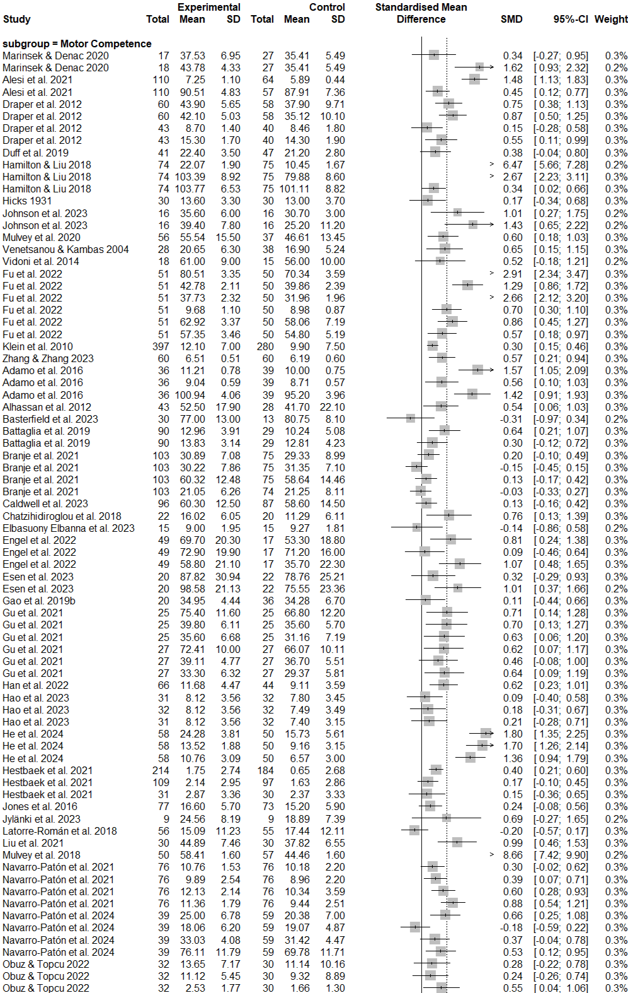
a Forest Plot of Physical Domain in Main Analysis
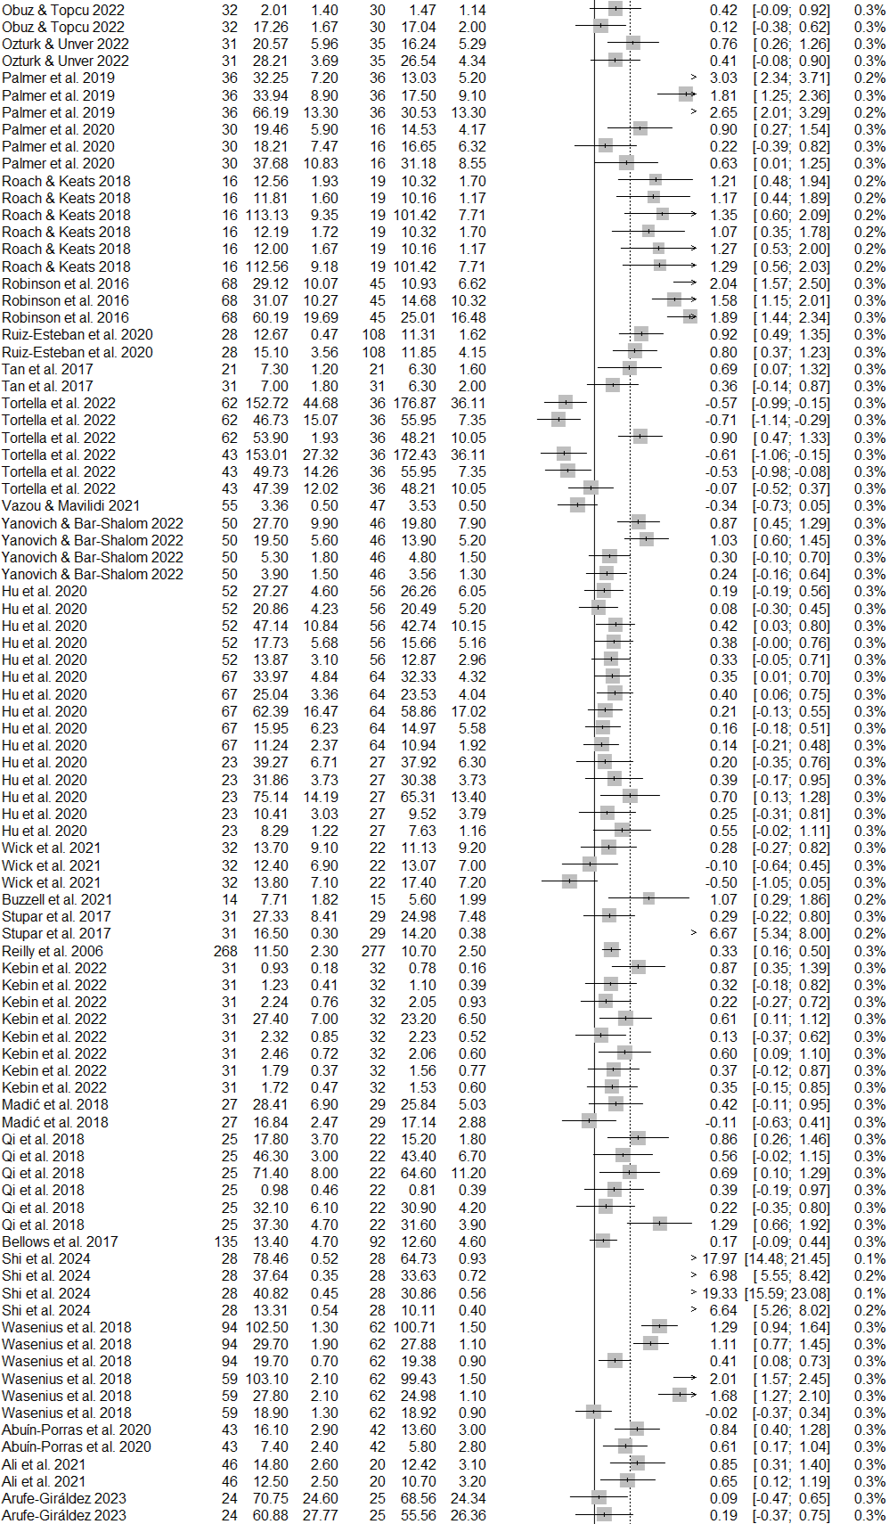
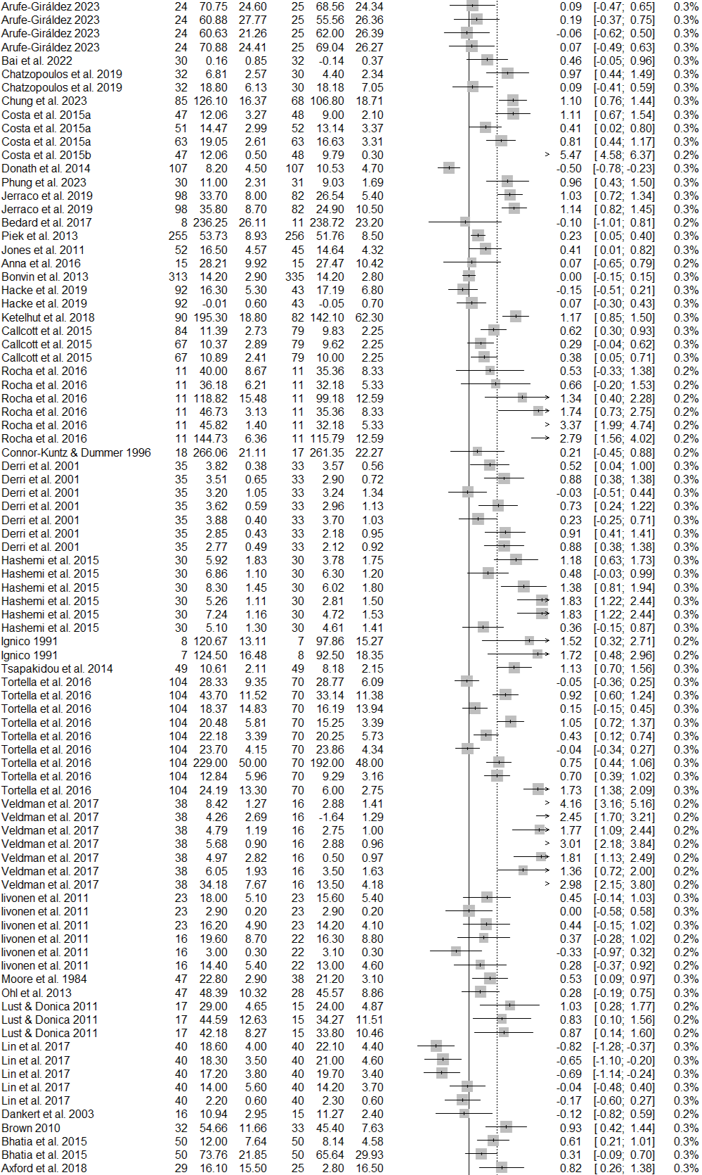
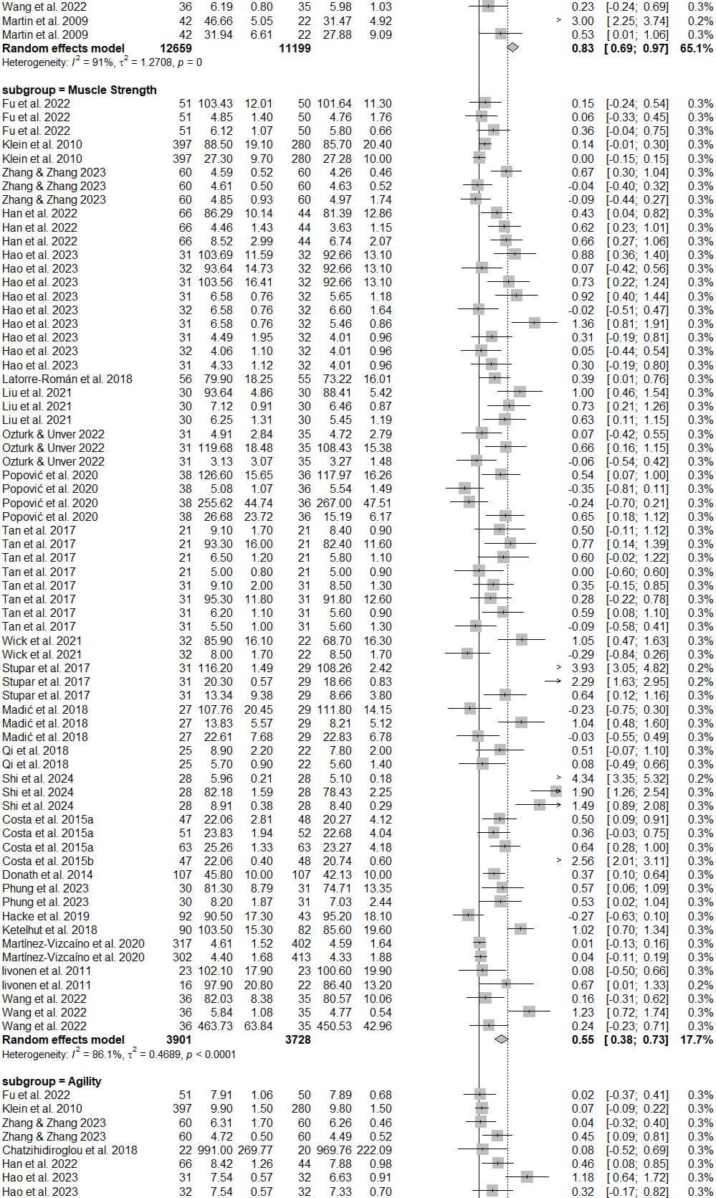
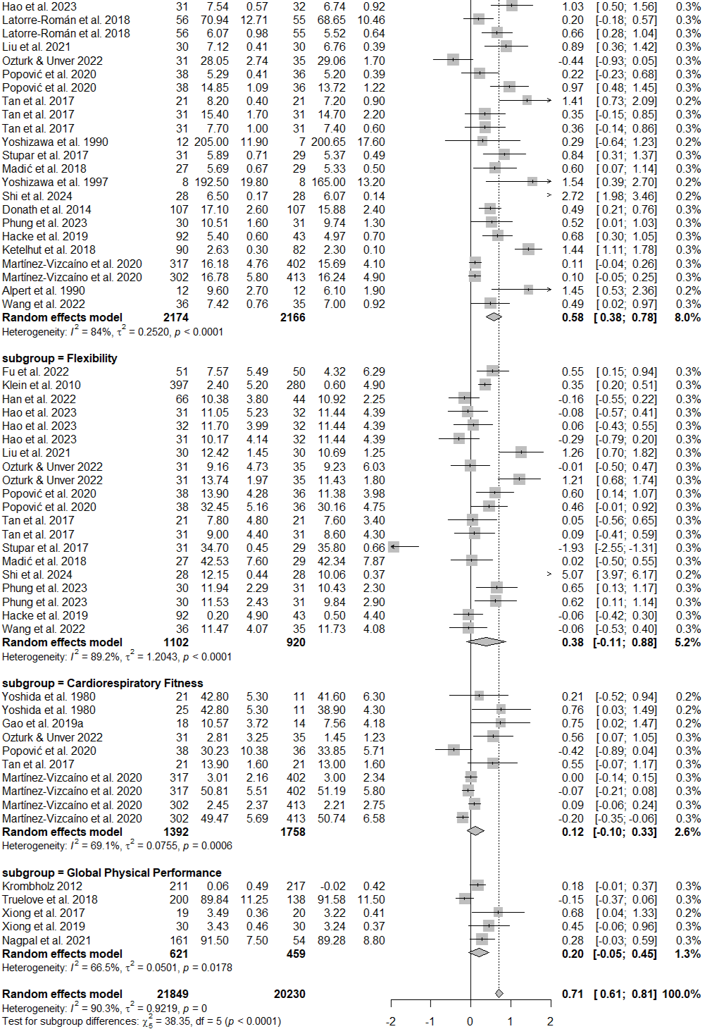
SD standard deviation, CI confidence interval.

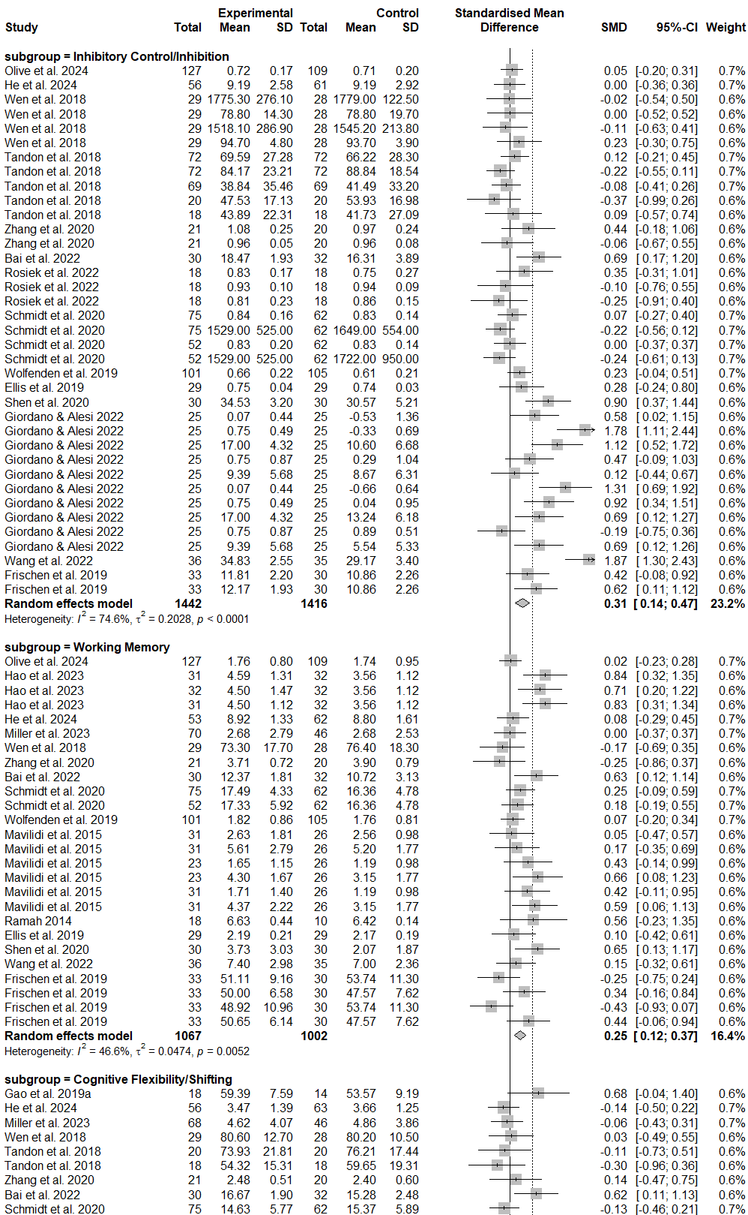
b Forest Plot of Cognitive Domain in Main Analysis
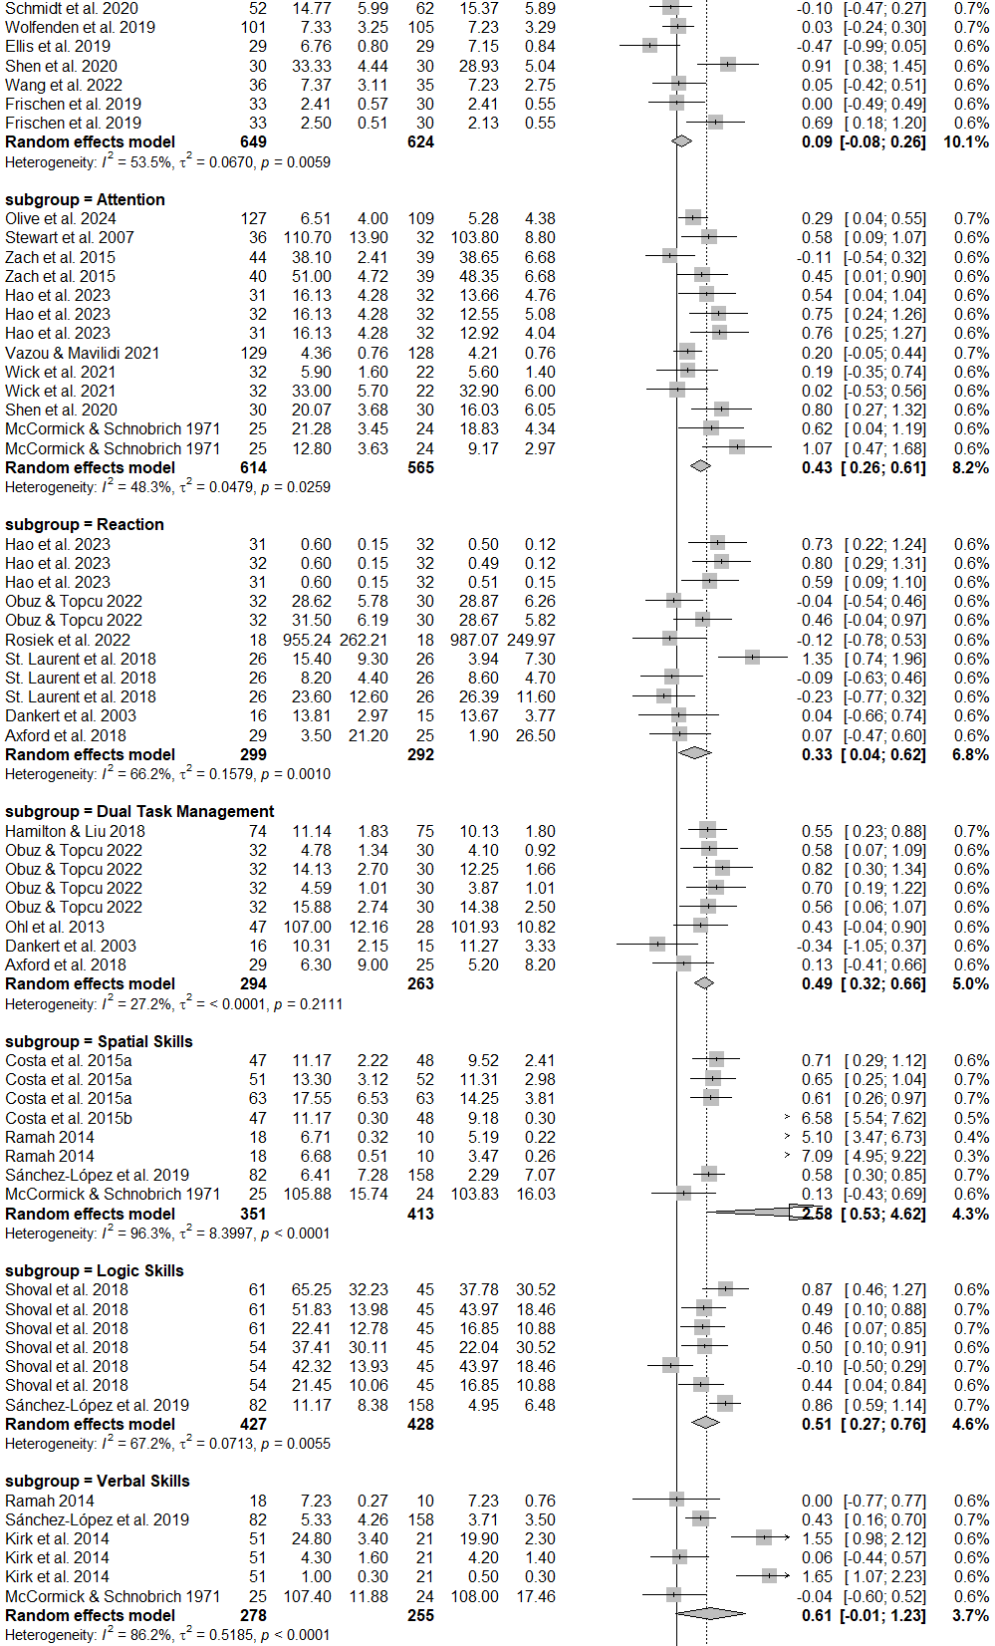
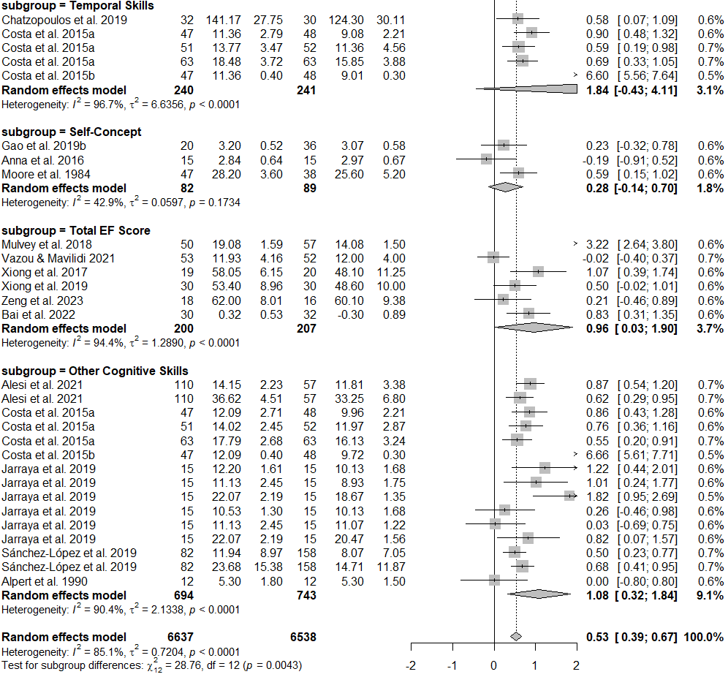
SD standard deviation, CI confidence interval.
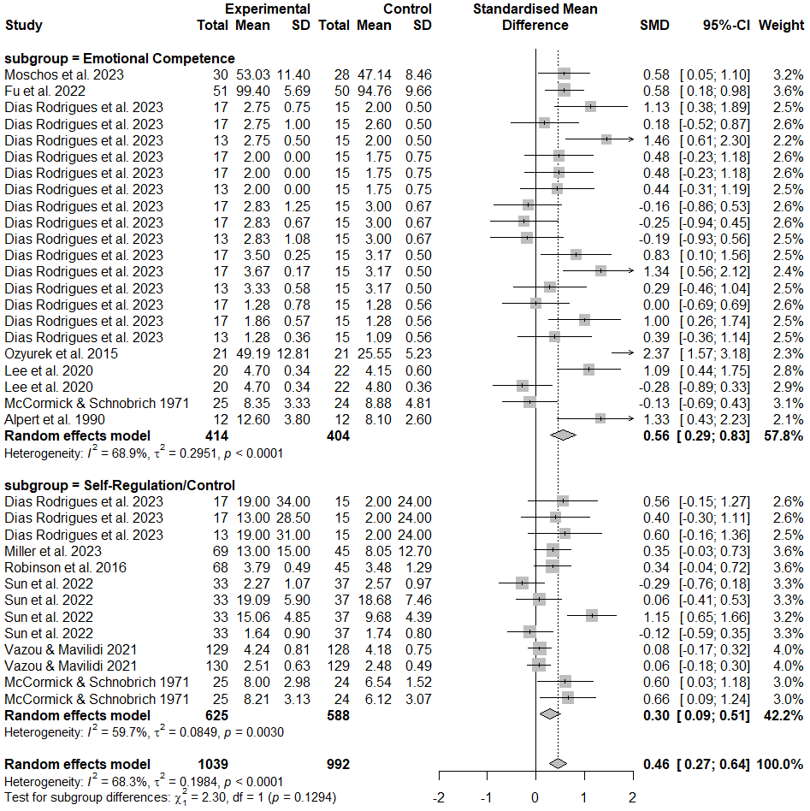
c Forest Plot of Affective Domain in Main Analysis
SD standard deviation, CI confidence interval.
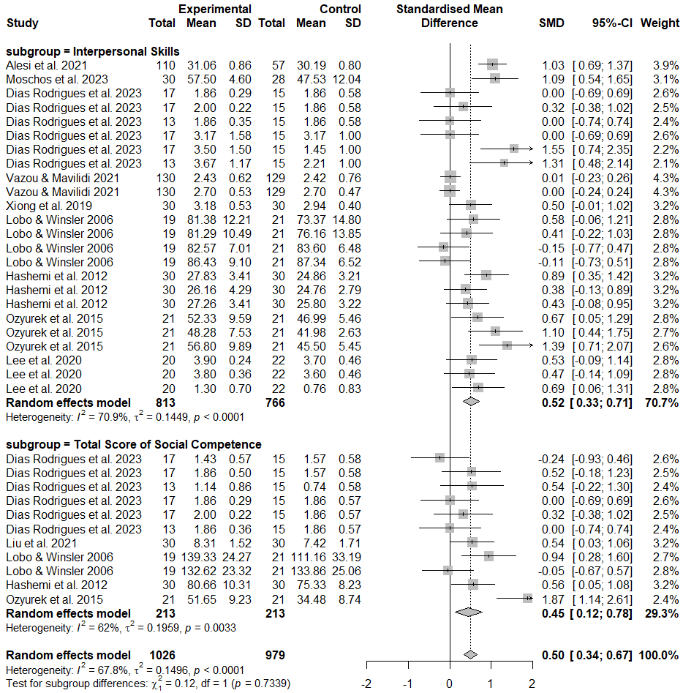
d Forest Plot of Social Domain in Main Analysis
SD standard deviation, CI confidence interval.
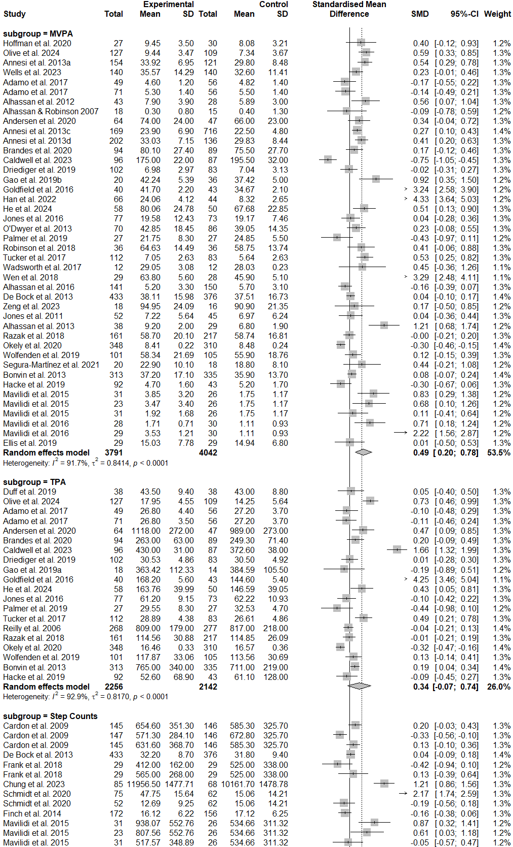
e Forest Plot of Behavioural Domain in Main Analysis
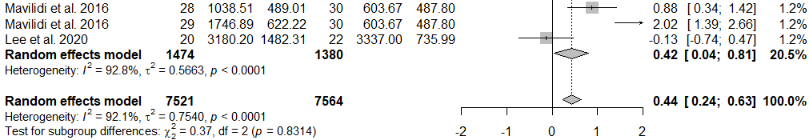
SD standard deviation, CI confidence interval.

Fig. S2 Funnel Plots of Publication Bias
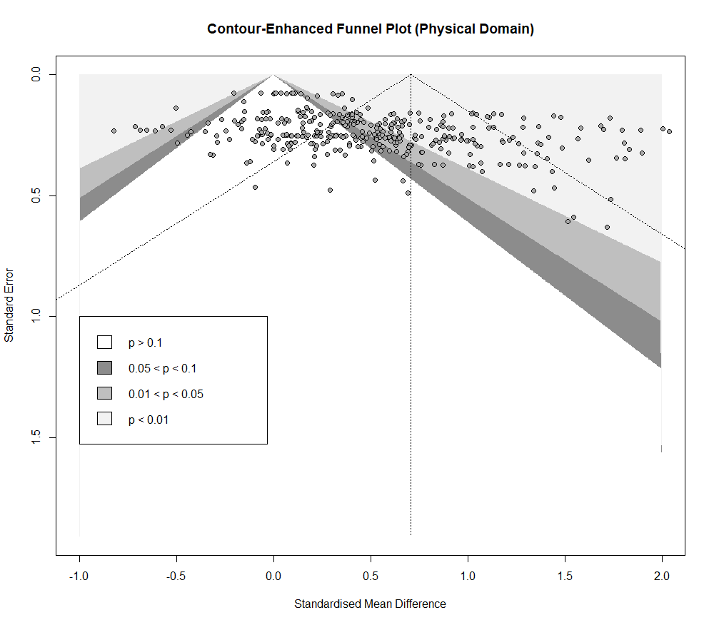
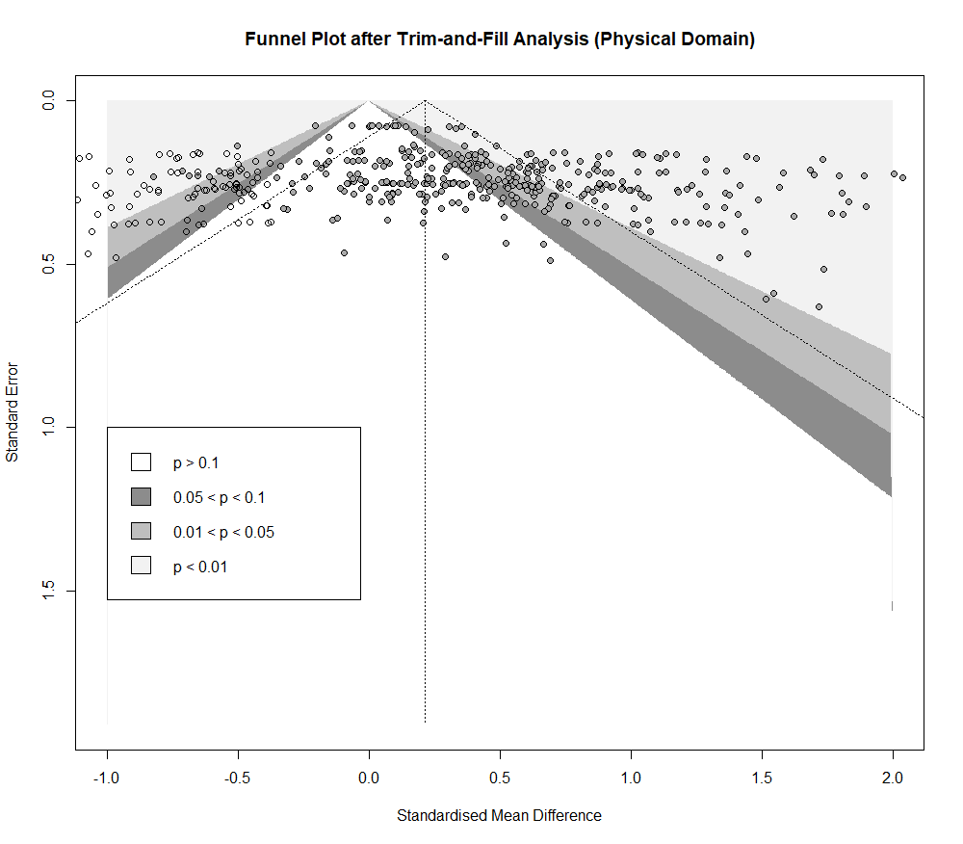
a Publication Bias Analyses under the Physical Domain
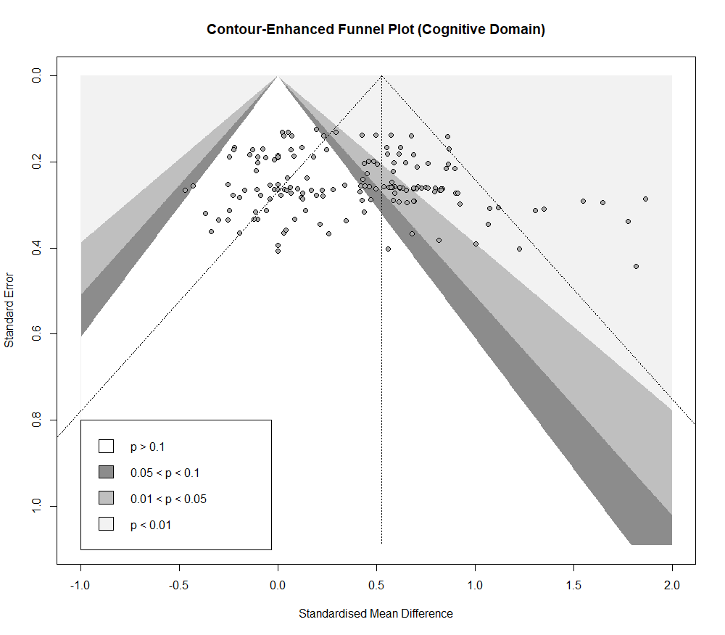
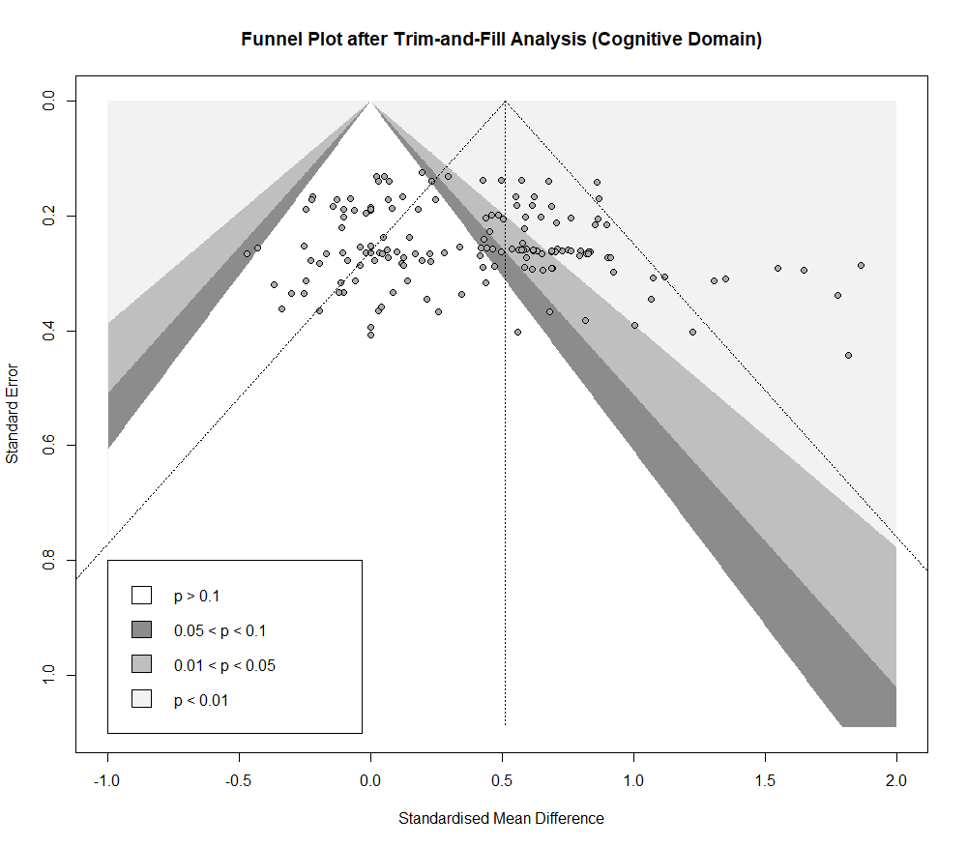
b Publication Bias Analyses under the Cognitive Domain

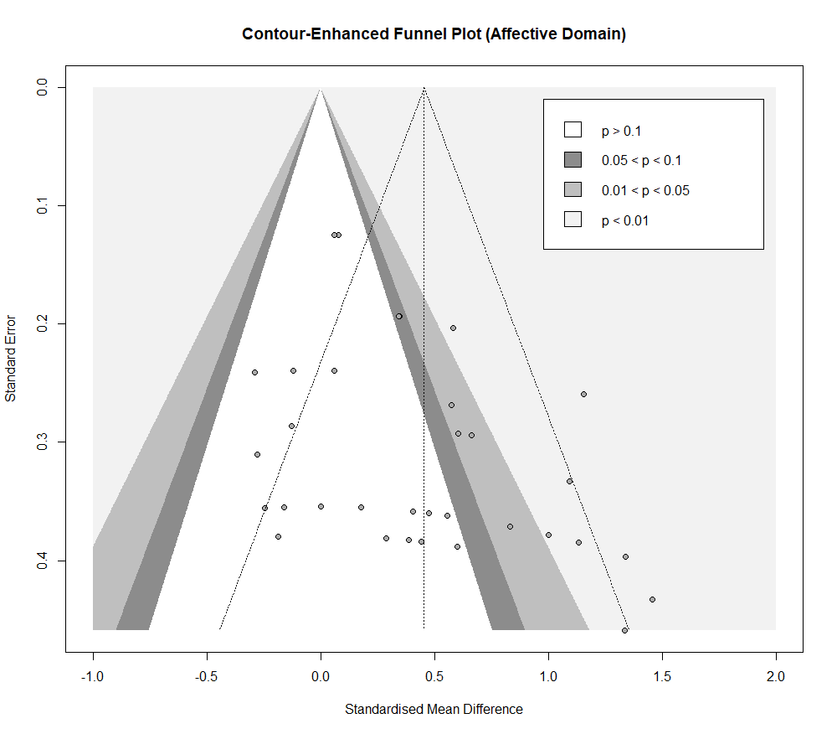
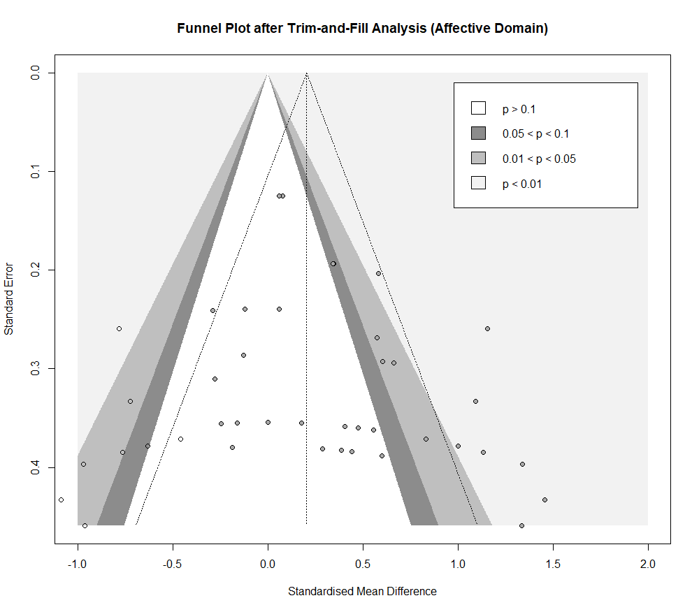
c Publication Bias Analyses under the Affective Domain

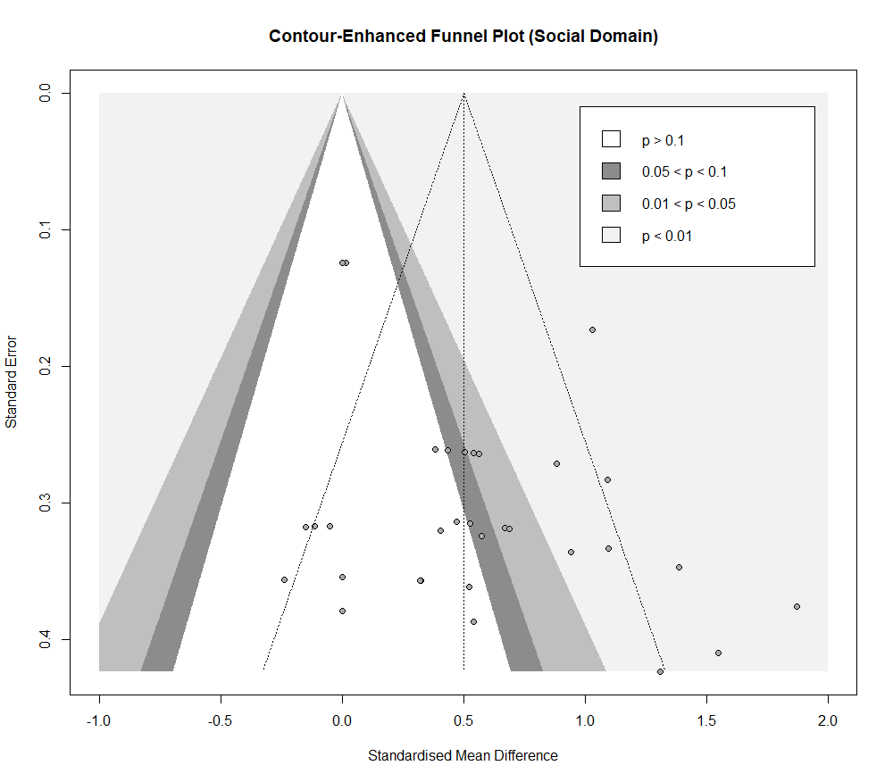
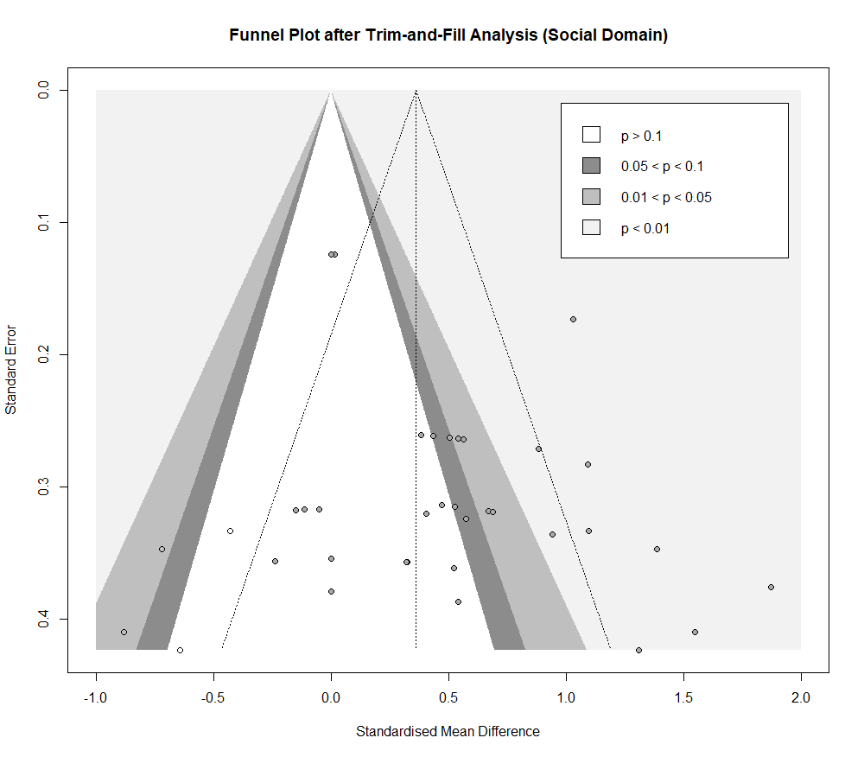
d Publication Bias Analyses under the Social Domain

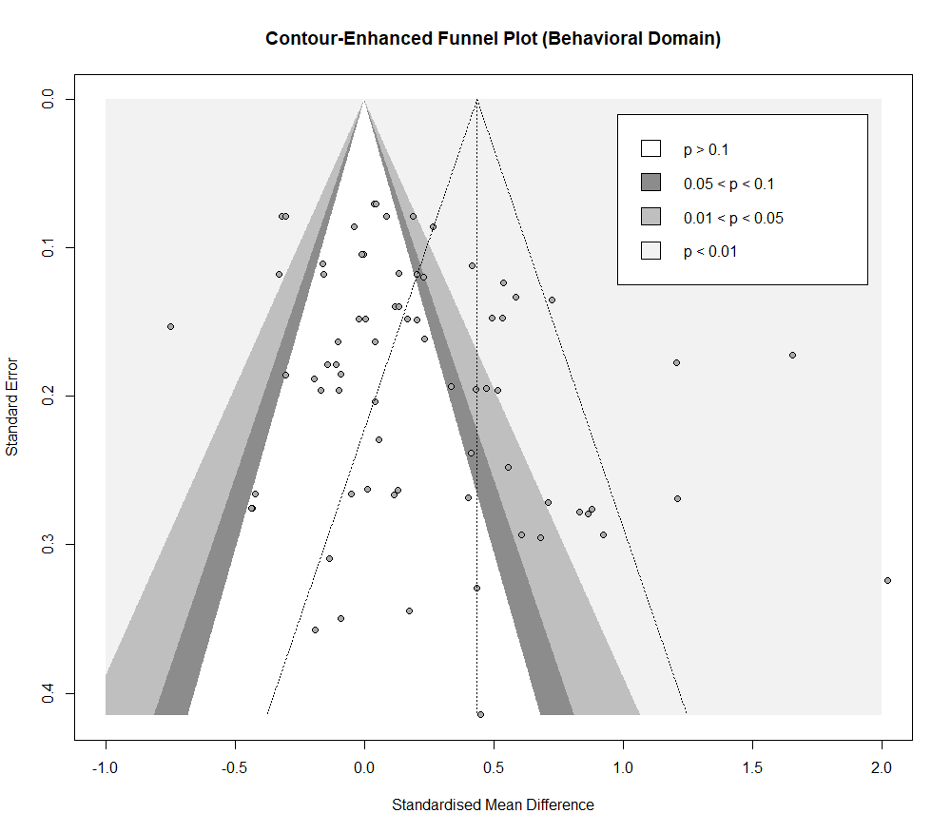
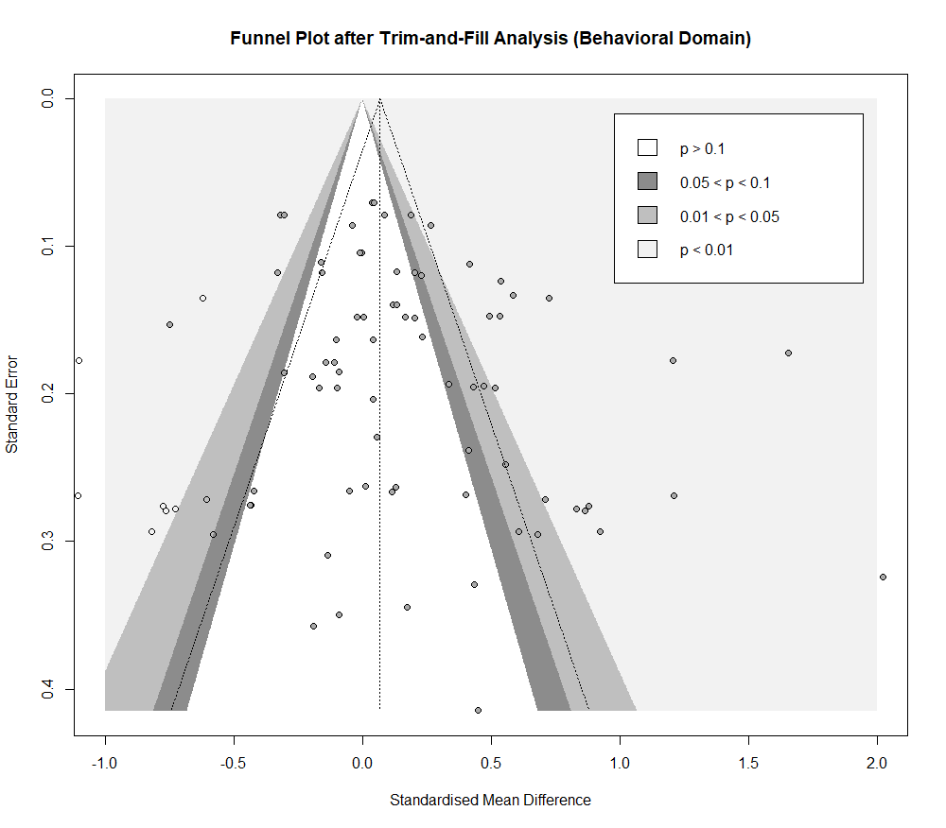
e Publication Bias Analyses under the Behavioral Domain

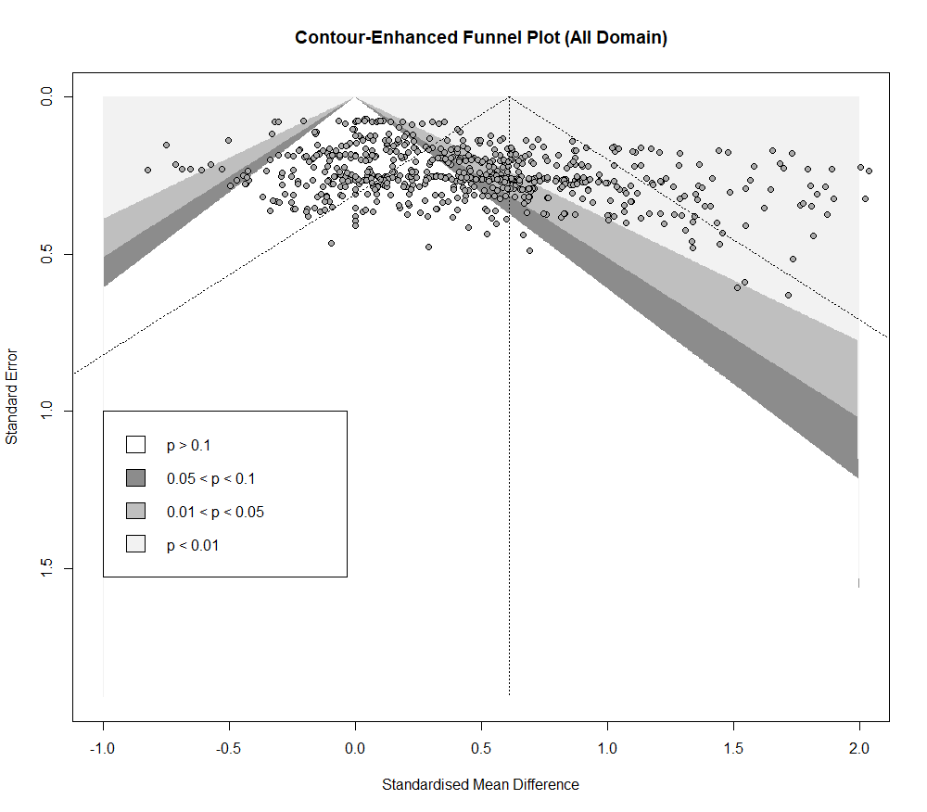
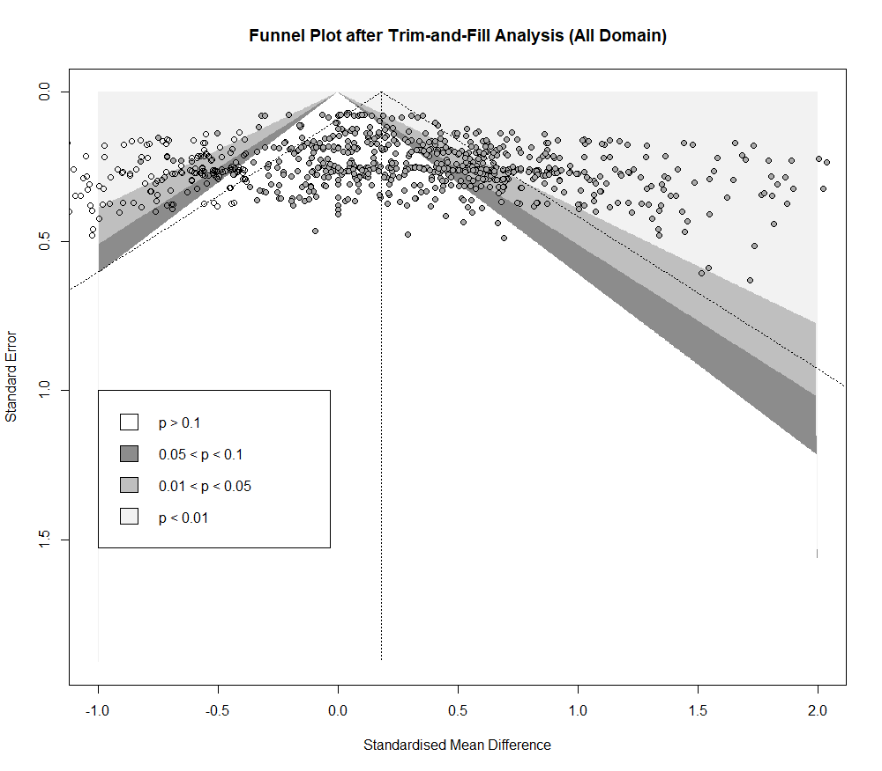
f Publication Bias Analyses under All Domains

References
1. Thomas BH, Ciliska D, Dobbins M, Micucci S. A process for systematically reviewing the literature: providing the research evidence for public health nursing interventions. Worldviews Evid Based Nurs. 2004;1(3):176-84.
2. Page MJ, McKenzie JE, Bossuyt PM, Boutron I, Hoffmann TC, Mulrow CD, et al. The PRISMA 2020 statement: an updated guideline for reporting systematic reviews. Bmj. 2021;372:n71.
3. Adamo KB, Wilson S, Harvey AL, Grattan KP, Naylor PJ, Temple VA, et al. Does Intervening in Childcare Settings Impact Fundamental Movement Skill Development? Med Sci Sports Exerc. 2016;48(5):926-32.
4. Adamo KB, Wasenius NS, Grattan KP, Harvey ALJ, Naylor PJ, Barrowman NJ, et al. Effects of a Preschool Intervention on Physical Activity and Body Composition. J Pediatr. 2017;188:42-9.e2.
5. Alesi M, Sebastiano C, Antonino B, and Pepi A. A teacher-led motor programme to enhance pre-literacy and motor skills in kindergarten children. European Journal of Developmental Psychology. 2021;18(3):367-81.
6. Alhassan S, Nwaokelemeh O, Ghazarian M, Roberts J, Mendoza A, Shitole S. Effects of locomotor skill program on minority preschoolers' physical activity levels. Pediatr Exerc Sci. 2012;24(3):435-49.
7. Ali A, McLachlan C, Mugridge O, McLaughlin T, Conlon C, Clarke L. The Effect of a 10-Week Physical Activity Programme on Fundamental Movement Skills in 3–4-Year-Old Children within Early Childhood Education Centres. Children. 2021;8(6):440.
8. Arufe-Giráldez V. Can the Doman method improve motor competence in children of 4 years of age? A quasi-experimental study of two Physical Education programmes in preschool education. Journal of Human Sport and Exercise. 2023;18.
9. Basterfield L, Machaira T, Jones D, Rapley T, Araujo-Soares V, Cameron N, et al. Early Years Physical Activity and Motor Skills Intervention-A Feasibility Study to Evaluate an Existing Training Programme for Early Years Educators. Children (Basel). 2023;10(1).
10. Battaglia G, Alesi M, Tabacchi G, Palma A, Bellafiore M. The Development of Motor and Pre-literacy Skills by a Physical Education Program in Preschool Children: A Non-randomized Pilot Trial. Front Psychol. 2019;9:2694.
11. Branje K, Stevens D, Hobson H, Kirk S, Stone M. Impact of an outdoor loose parts intervention on Nova Scotia preschoolers' fundamental movement skills: a multi-methods randomized controlled trial. Aims Public Health. 2022;9(1):194-215.
12. Caldwell HAT, Spencer RA, Joshi N, Branje K, Cawley J, Hobson H, et al. Impact of an outdoor loose parts play intervention on Nova Scotian preschoolers’ physical literacy: a mixed-methods randomized controlled trial. BMC Public Health. 2023;23(1):1126.
13. Callcott D, Hammond L, Hill S. The Synergistic Effect of Teaching a Combined Explicit Movement and Phonological Awareness Program to Preschool Aged Students. Early Childhood Education Journal. 2015;43(3):201-11.
14. Cardon G, Labarque V, Smits D, De Bourdeaudhuij I. Promoting physical activity at the pre-school playground: the effects of providing markings and play equipment. Prev Med. 2009;48(4):335-40.
15. Costa H, Abelairas-Gómez C, Arufe-Giráldez V, Pazos C, Barcala Furelos R. Influence of a physical education plan on psychomotor development profiles of preschool children. Journal of Human Sport and Exercise. 2015;10:126-40.
16. Costa HJT, Barcala-Furelos R, Abelairas-Gomez C, Arufe-Giraldez V. The Influence of a Structured Physical Education Plan on Preschool Children's Psychomotor Development Profiles. Australasian Journal of Early Childhood. 2015;40(2):68-77.
17. Derri V, Aggeliki T, Evridiki Z, and Kioumourtzoglou E. Effect of a Music and Movement Programme on Development of Locomotor Skills by Children 4 to 6 Years of Age. European Journal of Physical Education. 2001;6(1):16-25.
18. Dias Rodrigues A, Marmeleira J, Pomar C, Lamy E, Guerreiro D, Veiga G. Body-oriented interventions to promote preschoolers' social-emotional competence: a quasi-experimental study. Front Psychol. 2023;14:1198199.
19. Donath L, Imhof K, Roth R, Zahner L. Motor Skill Improvement in Preschoolers: How Effective Are Activity Cards? Sports. 2014;2(4):140-51.
20. Draper CE, Masturah A, Jared F, and Lambert EV. Impact of a community-based programme for motor development on gross motor skills and cognitive function in preschool children from disadvantaged settings. Early Child Development and Care. 2012;182(1):137-52.
21. Finch M, Wolfenden L, Morgan PJ, Freund M, Jones J, Wiggers J. A cluster randomized trial of a multi-level intervention, delivered by service staff, to increase physical activity of children attending center-based childcare. Prev Med. 2014;58:9-16.
22. Frischen U, Schwarzer G, Degé F. Comparing the Effects of Rhythm-Based Music Training and Pitch-Based Music Training on Executive Functions in Preschoolers. Front Integr Neurosci. 2019;13:41.
23. Fu T, Zhang D, Wang W, Geng H, Lv Y, Shen R, et al. Functional Training Focused on Motor Development Enhances Gross Motor, Physical Fitness, and Sensory Integration in 5-6-Year-Old Healthy Chinese Children. Front Pediatr. 2022;10:936799.
24. Gao Z, Lee JE, Zeng N, Pope ZC, Zhang Y, Li X. Home-Based Exergaming on Preschoolers' Energy Expenditure, Cardiovascular Fitness, Body Mass Index and Cognitive Flexibility: A Randomized Controlled Trial. J Clin Med. 2019;8(10).
25. Giordano G, Alesi M. Does Physical Activity Improve Inhibition in Kindergarteners? A Pilot Study. Perceptual and Motor Skills. 2022;129:1001-13.
26. Goldfield GS, Harvey ALJ, Grattan KP, Temple V, Naylor PJ, Alberga AS, et al. Effects of Child Care Intervention on Physical Activity and Body Composition. Am J Prev Med. 2016;51(2):225-31.
27. Hacke C, Ketelhut S, Wendt U, Müller G, Schlesner C, Ketelhut K. Effectiveness of a physical activity intervention in preschoolers: A cluster-randomized controlled trial. Scand J Med Sci Sports. 2019;29(5):742-52.
28. Johnson JL, Rudisill ME, Hastie P, Wadsworth D, Strunk K, Venezia A, et al. Changes in Fundamental Motor-Skill Performance Following a Nine-Month Mastery Motivational Climate Intervention. Res Q Exerc Sport. 2019;90(4):517-26.
29. Klein D, De Toia D, Weber S, Wessely N, Koch B, Dordel S, et al. Effects of a low threshold health promotion intervention on the BMI in pre-school children under consideration of parental participation. e-SPEN, the European e-Journal of Clinical Nutrition and Metabolism. 2010;5(3):e125-e31.
30. Lee RLT, Lane SJ, Tang ACY, Leung C, Louie LHT, Browne G, et al. Effects of an Unstructured Free Play and Mindfulness Intervention on Wellbeing in Kindergarten Students. Int J Environ Res Public Health. 2020;17(15).
31. Lobo Y, Winsler A. The Effects of a Creative Dance and Movement Program on the Social Competence of Head Start Preschoolers. Social Development. 2006;15:501-19.
32. Madić D, Cvetković M, Popović B, Marinkovic D, Radanović D, Trajković N. EFFECTS OF DEVELOPMENTAL GYMNASTICS ON MOTOR FITNESS IN PRESCHOOL GIRLS. Facta Universitatis, Series: Physical Education and Sport. 2018;16:11-8.
33. Martin EH, E. RM, and Hastie PA. Motivational climate and fundamental motor skill performance in a naturalistic physical education setting. Physical Education and Sport Pedagogy. 2009;14(3):227-40.
34. Martínez-Vizcaíno V, Pozuelo-Carrascosa DP, García-Prieto JC, Cavero-Redondo I, Solera-Martínez M, Garrido-Miguel M, et al. Effectiveness of a school-based physical activity intervention on adiposity, fitness and blood pressure: MOVI-KIDS study. Br J Sports Med. 2020;54(5):279-85.
35. Mavilidi M-F, Okely AD, Chandler P, Cliff DP, Paas F. Effects of Integrated Physical Exercises and Gestures on Preschool Children’s Foreign Language Vocabulary Learning. Educational Psychology Review. 2015;27(3):413-26.
36. Mulvey KL, Taunton S, Pennell A, Brian A. Head, Toes, Knees, SKIP! Improving Preschool Children's Executive Function Through a Motor Competence Intervention. J Sport Exerc Psychol. 2018;40(5):233-9.
37. Nagpal TS, Goldfield GS, da Silva DF, Souza S, Burhunduli P, Liu RH, et al. The effects of intervening with physical activity in the early years (ages 3-5) on health-related quality of life: a secondary analysis of the Activity Begins in Childhood (ABC) trial. Qual Life Res. 2021;30(1):221-7.
38. Navarro-Patón R, Brito-Ballester J, Villa SP, Anaya V, Mecías-Calvo M. Changes in Motor Competence after a Brief Physical Education Intervention Program in 4 and 5-Year-Old Preschool Children. Int J Environ Res Public Health. 2021;18(9).
39. Navarro-Patón R, Canosa-Pasantes F, Mecías-Calvo M, Arufe-Giráldez V. Is It Possible to Improve Motor Competence through a Structured Balance Bike Program in Preschool Children Aged 3 to 6 Years? Sports (Basel). 2024;12(3).
40. Okely AD, Stanley RM, Jones RA, Cliff DP, Trost SG, Berthelsen D, et al. 'Jump start' childcare-based intervention to promote physical activity in pre-schoolers: six-month findings from a cluster randomised trial. Int J Behav Nutr Phys Act. 2020;17(1):6.
41. Ozturk N, Unver F. The effects of pilates on posture and physical fitness parameters in 5-6 years old children: A non-randomized controlled study. J Bodyw Mov Ther. 2022;31:153-8.
42. Ozyurek A, Özkan İ, Begde Z, Yavuz N. Effects of Physical Training on Social Skill Levels of Preschool Children. Journal of Sports Science. 2015;3.
43. Piek JP, McLaren S, Kane R, Jensen L, Dender A, Roberts C, et al. Does the Animal Fun program improve motor performance in children aged 4-6 years? Hum Mov Sci. 2013;32(5):1086-96.
44. Popović B, Cvetković M, Mačak D, Šćepanović T, Čokorilo N, Belić A, et al. Nine Months of a Structured Multisport Program Improve Physical Fitness in Preschool Children: A Quasi-Experimental Study. Int J Environ Res Public Health. 2020;17(14).
45. Ramah N. The effects of square-stepping exercises on cognitive skills for kindergarten age children. Science, Movement and Health. 2014;14(1):126-30.
46. Razak LA, Yoong SL, Wiggers J, Morgan PJ, Jones J, Finch M, et al. Impact of scheduling multiple outdoor free-play periods in childcare on child moderate-to-vigorous physical activity: a cluster randomised trial. Int J Behav Nutr Phys Act. 2018;15(1):34.
47. Reilly JJ, Kelly L, Montgomery C, Williamson A, Fisher A, McColl JH, et al. Physical activity to prevent obesity in young children: cluster randomised controlled trial. Bmj. 2006;333(7577):1041.
48. Robinson LE, Palmer KK, Bub KL. Effect of the Children's Health Activity Motor Program on Motor Skills and Self-Regulation in Head Start Preschoolers: An Efficacy Trial. Front Public Health. 2016;4:173.
49. Rocha H, Marinho D, Jidovtseff B, Silva A, Costa A. Influence of regular soccer or swimming practice on gross motor development in childhood. Motricidade. 2017;12:33.
50. Sánchez-López M, Cavero-Redondo I, Álvarez-Bueno C, Ruiz-Hermosa A, Pozuelo-Carrascosa DP, Díez-Fernández A, et al. Impact of a multicomponent physical activity intervention on cognitive performance: The MOVI-KIDS study. Scand J Med Sci Sports. 2019;29(5):766-75.
51. Schmidt M, Mavilidi MF, Singh A, Englert C. Combining physical and cognitive training to improve kindergarten children’s executive functions: A cluster randomized controlled trial. Contemporary Educational Psychology. 2020;63:101908.
52. Shi Z, Yang X, Zhang X, Zhu W, Dai Y, Li J. An empirical study of the flag rugby game programme to promote gross motor skills and physical fitness in 5-6 year old preschool children. Heliyon. 2024;10(8):e29200.
53. Shoval E, Sharir T, Arnon M, Tenenbaum G. The Effect of Integrating Movement into the Learning Environment of Kindergarten Children on their Academic Achievements. Early Childhood Education Journal. 2018;46(3):355-64.
54. St. Laurent CW, Burkart S, Alhassan S. Effect of a School-Based Physical Activity Intervention on Number and Letter Recognition in Preschoolers. International Journal of Exercise Science. 2018;11(5):168-78.
55. Stupar D, Popovic B, Romanov R, Jankovic M, Jezdimirovic T, Medjedovic B. The Effects of Specific Exercise Program on Anthropometric Characteristics and Motor Abilities of Preschool Children. International Journal of Morphology. 2017;35:1050-7.
56. Sun B, Quan H, Zhang Y. The effect of intergenerational rearing on young children's self-control: The intervention effect of sports games. Front Psychol. 2022;13:1051341.
57. Tortella P, Haga M, Loras H, Sigmundsson H, Fumagalli G. Motor Skill Development in Italian Pre-School Children Induced by Structured Activities in a Specific Playground. PLoS One. 2016;11(7):e0160244.
58. Tortella P, Haga M, Lorås H, Fumagalli GF, Sigmundsson H. Effects of Free Play and Partly Structured Playground Activity on Motor Competence in Preschool Children: A Pragmatic Comparison Trial. Int J Environ Res Public Health. 2022;19(13).
59. Tucker P, Vanderloo LM, Johnson AM, Burke SM, Irwin JD, Gaston A, et al. Impact of the Supporting Physical Activity in the Childcare Environment (SPACE) intervention on preschoolers' physical activity levels and sedentary time: a single-blind cluster randomized controlled trial. Int J Behav Nutr Phys Act. 2017;14(1):120.
60. Vazou S, Mavilidi MF. Cognitively Engaging Physical Activity for Targeting Motor, Cognitive, Social, and Emotional Skills in the Preschool Classroom: The Move for Thought preK-K Program. Front Psychol. 2021;12:729272.
61. Veldman SL, Palmer KK, Okely AD, Robinson LE. Promoting ball skills in preschool-age girls. J Sci Med Sport. 2017;20(1):50-4.
62. Wadsworth DD, Rudisill ME, Hastie PA, Irwin JM, Rodriguez-Hernandez MG. Preschoolers' Physical Activity Participation Across a Yearlong Mastery-Motivational Climate Intervention. Res Q Exerc Sport. 2017;88(3):339-45.
63. Wasenius NS, Grattan KP, Harvey ALJ, Naylor PJ, Goldfield GS, Adamo KB. The effect of a physical activity intervention on preschoolers' fundamental motor skills - A cluster RCT. J Sci Med Sport. 2018;21(7):714-9.
64. Wick K, Kriemler S, Granacher U. Effects of a Strength-Dominated Exercise Program on Physical Fitness and Cognitive Performance in Preschool Children. J Strength Cond Res. 2021;35(4):983-90.
65. Wolfenden L, Jones J, Parmenter B, Razak LA, Wiggers J, Morgan PJ, et al. Efficacy of a free-play intervention to increase physical activity during childcare: a randomized controlled trial. Health Educ Res. 2019;34(1):84-97.
66. Yanovich E, Bar-Shalom S. Static and Dynamic Balance Indices among Kindergarten Children: A Short-Term Intervention Program during COVID-19 Lockdowns. Children (Basel). 2022;9(7).
67. Yoshizawa S, Honda H, Urushibara M, Nakamura N. Effects of endurance run on circulorespiratory system in young children. J Hum Ergol (Tokyo). 1990;19(1):41-52.
68. Zach S, Inglis V, Fox O, Berger I, Stahl A. The effect of physical activity on spatial perception and attention in early childhood. Cognitive Development. 2015;36:31-9.
69. Zhang B, Liu Y, Zhao M, Meng X, Deng Y, Zheng X, et al. Differential effects of acute physical activity on executive function in preschoolers with high and low habitual physical activity levels. Mental Health and Physical Activity. 2020;18:100326.
70. Alhassan S, Sirard JR, Robinson TN. The effects of increasing outdoor play time on physical activity in Latino preschool children. Int J Pediatr Obes. 2007;2(3):153-8.
71. Alpert B, Field T, Goldstein S, Perry S. Aerobics enhances cardiovascular fitness and agility in preschoolers. Health Psychol. 1990;9(1):48-56.
72. Liu ML, Wu L, Ming QS. How Does Physical Activity Intervention Improve Self-Esteem and Self-Concept in Children and Adolescents? Evidence from a Meta-Analysis. Plos One. 2015;10(8).
73. Anna M, Papavasileiou GE, Dania A, Venetsanou F. Effect of a psychomotor program on the motor proficiency and self-perceptions of preschool children. Journal of Physical Education and Sport. 2016;16:1365-71.
74. Rodrigues AD, Cruz-Ferreira A, Marmeleira J, Veiga G. Effects of Body-Oriented Interventions on Preschoolers' Social-Emotional Competence: A Systematic Review. Frontiers in Psychology. 2022;12.
75. Wick K, Leeger-Aschmann CS, Monn ND, Radtke T, Ott LV, Rebholz CE, et al. Interventions to Promote Fundamental Movement Skills in Childcare and Kindergarten: A Systematic Review and Meta-Analysis. Sports Med. 2017;47(10):2045-68.
76. Elbasuony Elbanna ST, Kamal HM, Maksoud Mahgoub EA, Elshennawy S. Effect Of Brain GYM Exercises On Balance In Preschool Children: A Randomized Controlled Trail. J Pak Med Assoc. 2023;73(Suppl 4)(4):S17-s21.
77. Ellis YG, Cliff DP, Howard SJ, Okely AD. The Acute Effects of a "Reduced Sitting Preschool Day" on Executive Function and Musculoskeletal Health in Preschoolers: A Randomized Cross-Over Study. Pediatr Exerc Sci. 2019;31(4):505-13.
78. Song HQ, Wang JJ, Zhang BR, Shi L, Lau PWC. Do acute and chronic physical activity interventions affect the cognitive function of preschool children? A meta-analysis. Psychology of Sport and Exercise. 2023;67.
79. Fischer U, Moeller K, Bientzle M, Cress U, Nuerk HC. Sensori-motor spatial training of number magnitude representation. Psychon Bull Rev. 2011;18(1):177-83.
80. Jylänki P, Mbay T, Hakkarainen A, Sääkslahti A, Aunio P. The effects of motor skill and physical activity interventions on preschoolers' cognitive and academic skills: A systematic review. Preventive medicine. 2022;155:106948.
81. Vasilopoulos F, Jeffrey H, Wu Y, Dumontheil I. Multi-Level Meta-Analysis of Physical Activity Interventions During Childhood: Effects of Physical Activity on Cognition and Academic Achievement. Educational Psychology Review. 2023;35(2):1-38.
82. Gu Y, Chen Y, Ma J, Ren Z, Li H, Kim H. The Influence of a Table Tennis Physical Activity Program on the Gross Motor Development of Chinese Preschoolers of Different Sexes. Int J Environ Res Public Health. 2021;18(5).
83. Hamilton M, Liu T. The effects of an intervention on the gross and fine motor skills of Hispanic pre-K children from low SES backgrounds. Early Childhood Education Journal. 2018;46(2):223-30.
84. Hao L, Fan Y, Zhang X, Rong X, Sun Y, Liu K. Functional physical training improves fitness and cognitive development in 4~5 years old children. Front Psychol. 2023;14:1266216.
85. Hashemi M, Roonasi A, Sabounchi R, Salehian MH. Effect of Selected Physical Activities on Social Skills among 3-6 years old Children. Life Science Journal. 2012;9:4267-71.
86. Hu X, Jiang GP, Ji ZQ, Pang B, Liu J. Effect of Novel Rhythmic Physical Activities on Fundamental Movement Skills in 3- to 5-Year-Old Children. Biomed Res Int. 2020;2020:8861379.
87. Hudson KN, Ballou HM, Willoughby MT. Short report: Improving motor competence skills in early childhood has corollary benefits for executive function and numeracy skills. Dev Sci. 2021;24(4):e13071.
88. Jarraya S, Wagner M, Jarraya M, Engel FA. 12 Weeks of Kindergarten-Based Yoga Practice Increases Visual Attention, Visual-Motor Precision and Decreases Behavior of Inattention and Hyperactivity in 5-Year-Old Children. Front Psychol. 2019;10:796.
89. Johnson JL, Carroll AV, Wadsworth DD, Sassi J, Merritt M, Morris M, et al. Towards Identifying a Dosage Effect for Improving Fundamental Motor Skills of Preschool Children with a Mastery Motivational Climate Intervention. Percept Mot Skills. 2023;130(4):1453-71.
90. Jones RA, Okely AD, Hinkley T, Batterham M, Burke C. Promoting gross motor skills and physical activity in childcare: A translational randomized controlled trial. J Sci Med Sport. 2016;19(9):744-9.
91. Latorre-Román PA, Mora-López D, García-Pinillos F. Effects of a physical activity programme in the school setting on physical fitness in preschool children. Child Care Health Dev. 2018;44(3):427-32.
92. Lemos A, G, Avigo E, L , Barela J, A. Physical Education in Kindergarten Promotes Fundamental Motor Skill Development. Advances in Physical Education. 2012;02:17-21.
93. Li B, Liu J, Ying BB. Physical education interventions improve the fundamental movement skills in kindergarten: a systematic review and meta-analysis. Food Science and Technology. 2022;42.
94. Liu J, Gao F, Yuan L. Effects of Diversified Sports Activity Module on Physical Fitness and Mental Health of 4-5-Year-Old Preschoolers. Iran J Public Health. 2021;50(6):1233-40.
95. Carson V, Lee EY, Hewitt L, Jennings C, Hunter S, Kuzik N, et al. Systematic review of the relationships between physical activity and health indicators in the early years (0-4 years). BMC Public Health. 2017;17(Suppl 5):854.
96. Zeng N, Ayyub M, Sun HC, Wen X, Xiang P, Gao Z. Effects of Physical Activity on Motor Skills and Cognitive Development in Early Childhood: A Systematic Review. Biomed Research International. 2017;2017.
97. Mavillidi M, Okely A, Paul C, Paas F. Infusing Physical Activities Into the Classroom: Effects on Preschool Children’s Geography Learning. Mind Brain and Education. 2016;10.
98. Mavilidi MF, Pesce C, Mazzoli E, Bennett S, Paas F, Okely AD, et al. Effects of Cognitively Engaging Physical Activity on Preschool Children's Cognitive Outcomes. Res Q Exerc Sport. 2023;94(3):839-52.
99. Mostafavi R, Ziaee V, Akbari H, Haji-Hosseini S. The Effects of SPARK Physical Education Program on Fundamental Motor Skills in 4-6 Year-Old Children. Iran J Pediatr. 2013;23(2):216-9.
100. Navarra GA, Scardina A, Thomas E, Battaglia G, Agnese M, Proia P, et al. How Does the Amount of a Physical Education Intervention Affect Gross Motor Coordination in Early Childhood? J Funct Morphol Kinesiol. 2022;7(4).
101. Obuz T, Topcu ZG. The effects of exercises with a Pilates ball on balance, reaction time and dual-task performance of kindergarten children. J Comp Eff Res. 2022;11(8):583-93.
102. Qi Y, Tan S, Sui M, Wang J. SUPERVISED PHYSICAL TRAINING IMPROVES FINE MOTOR SKILLS OF 5-YEAR-OLD CHILDREN. Revista Brasileira de Medicina do Esporte. 2018;24.
103. Robinson LE, Palmer KK, Webster EK, Logan SW, Chinn KM. The Effect of CHAMP on Physical Activity and Lesson Context in Preschoolers: A Feasibility Study. Res Q Exerc Sport. 2018;89(2):265-71.
104. Shen K, Liu Y. Effects of Soccer Exercise on Balance Ability and Kinesthesia of the Lower Limb Joints in Children Aged 5-6 Years. Motor Control. 2022;26(2):213-25.
105. Tan S, Chen C, Sui M, Xue L, Wang J. Exercise Training Improved Body Composition,Cardiovascular Function, and Physical Fitness of 5-Year-Old Children With Obesity or Normal Body Mass. Pediatr Exerc Sci. 2017;29(2):245-53.
106. Trost SG, Brookes DSK. Effectiveness of a novel digital application to promote fundamental movement skills in 3- to 6-year-old children: A randomized controlled trial. J Sports Sci. 2021;39(4):453-9.
107. Wang JH-T. A Study on Gross Motor Skills of Preschool Children. Journal of Research in Childhood Education. 2004;19(1):32-43.
108. Wang H, Ge W, Zhu C, Sun Y, Wei S. How pom cheerleading improves the executive function of preschool children: the mediating role of speed and agility. BMC Psychology. 2022;10(1):234.
109. Morales JS, del Rio EA, Valenzuela PL, Martinez-de-Quel O. Physical Activity and Cognitive Performance in Early Childhood: A Systematic Review and Meta-Analysis of Randomized Controlled Trials. Sports Medicine. 2024.
110. Wen X, Zhang Y, Gao Z, Zhao W, Jie J, Bao L. Effect of Mini-Trampoline Physical Activity on Executive Functions in Preschool Children. Biomed Res Int. 2018;2018:2712803.
111. Zeng N, Lee JE, Gao Z. Effects of home-based exergaming on preschool children’s cognition, sedentary behavior, and physical activity: A randomized crossover trial. Brain Behavior and Immunity Integrative. 2023;1:100002.
112. Alhassan S, Ogechi N, Kate L, TaShauna G, and Mendoza A. A Pilot Study to Examine the Effect of Additional Structured Outdoor Playtime on Preschoolers' Physical Activity Levels. Child Care in Practice. 2013;19(1):23-35.
113. Feng J, Huang WY, Zheng C, Jiao J, Khan A, Nisar M, et al. The Overflow Effects of Movement Behaviour Change Interventions for Children and Adolescents: A Systematic Review and Meta-Analysis of Randomised Controlled Trials. Sports Medicine. 2024;54(12):3151-67.
114. Alhassan S, Nwaokelemeh O, Mendoza A, Shitole S, Puleo E, Pfeiffer KA, et al. Feasibility and Effects of Short Activity Breaks for Increasing Preschool-Age Children's Physical Activity Levels. J Sch Health. 2016;86(7):526-33.
115. Andersen E, Øvreås S, Jørgensen KA, Borch-Jenssen J, Moser T. Children’s physical activity level and sedentary behaviour in Norwegian early childhood education and care: effects of a staff-led cluster-randomised controlled trial. BMC Public Health. 2020;20(1):1651.
116. Annesi JJ, Smith AE, Tennant G. Cognitive-behavioural physical activity treatment in African-American pre-schoolers: Effects of age, sex, and BMI. Journal of Paediatrics and Child Health. 2013;49(2):E128-E32.
117. Annesi JJ, Smith AE, Tennant GA. Reducing high BMI in African American preschoolers: effects of a behavior-based physical activity intervention on caloric expenditure. South Med J. 2013;106(8):456-9.
118. Annesi JJ, Smith AE, Tennant GA. Effects of the Start For Life treatment on physical activity in primarily African American preschool children of ages 3-5 years. Psychol Health Med. 2013;18(3):300-9.
119. Bai J, Huang H, Ouyang H. Effects of Group-Play Moderate to Vigorous Intensity Physical Activity Intervention on Executive Function and Motor Skills in 4- to 5-Year-Old Preschoolers: A Pilot Cluster Randomized Controlled Trial. Front Psychol. 2022;13:847785.
120. Bonvin A, Barral J, Kakebeeke TH, Kriemler S, Longchamp A, Schindler C, et al. Effect of a governmentally-led physical activity program on motor skills in young children attending child care centers: a cluster randomized controlled trial. Int J Behav Nutr Phys Act. 2013;10:90.
121. Branje K, Stevens D, Hobson H, Kirk S, Stone M. Impact of an outdoor loose parts intervention on Nova Scotia preschoolers' fundamental movement skills: a multi-methods randomized controlled trial. AIMS Public Health. 2021;9(1):194-215.
122. Brown CG. Improving fine motor skills in young children: an intervention study. Educational Psychology in Practice. 2010;26(3):269-78.
123. Strooband KFB, Rosnay M, Okely AD, Veldman SLC. Systematic Review and Meta-Analyses: Motor Skill Interventions to Improve Fine Motor Development in Children Aged Birth to 6 Years. J Dev Behav Pediatr. 2020;41(4):319-31.
124. Carroll AV, Spring KE, Wadsworth DD. The effect of a teacher-guided and -led indoor preschool physical activity intervention: A feasibility study. Early Childhood Education Journal. 2022;50(8):1475-83.
125. Chatzihidiroglou P, Chatzopoulos D, Lykesas G, Doganis G. Dancing Effects on Preschoolers' Sensorimotor Synchronization, Balance, and Movement Reaction Time. Percept Mot Skills. 2018;125(3):463-77.
126. De Bock F, Genser B, Raat H, Fischer JE, Renz-Polster H. A participatory physical activity intervention in preschools: a cluster randomized controlled trial. Am J Prev Med. 2013;45(1):64-74.
127. De Craemer M, Verloigne M, De Bourdeaudhuij I, Androutsos O, Iotova V, Moreno L, et al. Effect and process evaluation of a kindergarten-based, family-involved cluster randomised controlled trial in six European countries on four- to six-year-old children's steps per day: the ToyBox-study. Int J Behav Nutr Phys Act. 2017;14(1):116.
128. Fynn JF, Hardeman W, Milton K, Murphy J, Jones A. A systematic review of the use and reporting of evaluation frameworks within evaluations of physical activity interventions. International Journal of Behavioral Nutrition and Physical Activity. 2020;17(1):107.
129. Donath L, Faude O, Hagmann S, Roth R, Zahner L. Fundamental movement skills in preschoolers: a randomized controlled trial targeting object control proficiency. Child Care Health Dev. 2015;41(6):1179-87.
130. Driediger M, Truelove S, Johnson AM, Vanderloo LM, Timmons BW, Burke SM, et al. The Impact of Shorter, More Frequent Outdoor Play Periods on Preschoolers' Physical Activity during Childcare: A Cluster Randomized Controlled Trial. Int J Environ Res Public Health. 2019;16(21).
131. Duff C, Issartel J, O'Brien W, Belton S. Kids active: Evaluation of an educator-led active play and fundamental movement skill intervention in the Irish preschool setting. Journal of Motor Learning and Development. 2019;7(3):389-407.
132. Duncan M, Cunningham A, Eyre E. A combined movement and story-telling intervention enhances motor competence and language ability in pre-schoolers to a greater extent than movement or story-telling alone. European Physical Education Review. 2019;25(1):221-35.
133. Engel A, Broderick C, van Doorn N, Hardy L, Ward R, Kwai N, et al. Effect of a Fundamental Motor Skills Intervention on Fundamental Motor Skill and Physical Activity in a Preschool Setting: A Cluster Randomized Controlled Trial. Pediatr Exerc Sci. 2022;34(2):57-66.
134. Hnatiuk JA, Brown HE, Downing KL, Hinkley T, Salmon J, Hesketh KD. Interventions to increase physical activity in children 0–5 years old: a systematic review, meta-analysis and realist synthesis. Obesity Reviews. 2019;20(1):75-87.
135. Martín-García A, Rico-González M. The effect of free play on preschoolers' physical activity level and motor, cognitive, and socioemotional competences: a systematic review of randomized controlled trials. European Early Childhood Education Research Journal. 2023.
136. García-Hermoso A, Alonso-Martinez AM, Ramírez-Vélez R, Izquierdo M. Effects of Exercise Intervention on Health-Related Physical Fitness and Blood Pressure in Preschool Children: A Systematic Review and Meta-Analysis of Randomized Controlled Trials. Sports medicine (Auckland, NZ). 2020;50(1):187-203.
137. He C, Peng X, Zhang J, Cheng W, Guo S, Hu W, et al. Effects of 12-week aerobic exercise with different frequencies on executive function in preschool children: a cluster randomized controlled trial. Psychol Health. 2024:1-16.
138. He Q, Ha ASC, Zheng B, Okely AD. Feasibility and potential efficacy of a family-based intervention on promoting physical activity levels and fundamental movement skills in preschoolers: A cluster randomised controlled trial. Applied Psychology: Health and Well-Being. 2024;16(3):1266-88.
139. Hestbaek L, Vach W, Andersen ST, Lauridsen HH. The Effect of a Structured Intervention to Improve Motor Skills in Preschool Children: Results of a Randomized Controlled Trial Nested in a Cohort Study of Danish Preschool Children, the MiPS Study. Int J Environ Res Public Health. 2021;18(23).
140. Hirata G. Improving children’s executive functions: evidence from capoeira. Oxford Economic Papers. 2023;75(2):490-506.
141. Hoffman JA, Schmidt EM, Arguello DJ, Eyllon MN, Castaneda-Sceppa C, Cloutier G, et al. Online preschool teacher training to promote physical activity in young children: A pilot cluster randomized controlled trial. Sch Psychol. 2020;35(2):118-27.
142. Jones RA, Riethmuller A, Hesketh K, Trezise J, Batterham M, Okely AD. Promoting fundamental movement skill development and physical activity in early childhood settings: a cluster randomized controlled trial. Pediatr Exerc Sci. 2011;23(4):600-15.
143. Kippe K, Lagestad P. Activity Videos Effect on Four-, Five- and Six-Year-Olds' Physical Activity Level in Preschool. Sports (Basel). 2023;11(3).
144. Mavilidi MF, Okely A, Chandler P, Louise Domazet S, Paas F. Immediate and delayed effects of integrating physical activity into preschool children's learning of numeracy skills. J Exp Child Psychol. 2018;166:502-19.
145. Miller AL, Palmer KK, Wang L, Wang C, Riley HO, McClelland MM, et al. Mastery-oriented motor competence intervention improves behavioral but not cognitive self-regulation in head start preschoolers: Randomized controlled trial results. Scand J Med Sci Sports. 2023;33(5):725-36.
146. Mulvey KL, Miedema ST, Stribing A, Gilbert E, Brian A. SKIPing together: A motor competence intervention promotes gender-integrated friendships for young children. Sex Roles: A Journal of Research. 2020;82(9-10):550-7.
147. O'Dwyer MV, Fairclough SJ, Knowles Z, Stratton G. Effect of a family focused active play intervention on sedentary time and physical activity in preschool children. Int J Behav Nutr Phys Act. 2012;9:117.
148. O'Dwyer MV, Fairclough SJ, Ridgers ND, Knowles ZR, Foweather L, Stratton G. Effect of a school-based active play intervention on sedentary time and physical activity in preschool children. Health Educ Res. 2013;28(6):931-42.
149. Olive LS, Telford RM, Westrupp E, Telford RD. Physical activity intervention improves executive function and language development during early childhood: The active early learning cluster randomized controlled trial. Child Development. 2024;95(2):544-58.
150. Palma M, Pereira B, Valentini N. Guided play and free play in an enriched environment: Impact on motor development. Motriz: Revista de Educação Física. 2014;20:177-85.
151. Palmer KK, Chinn KM, Robinson LE. The effect of the CHAMP intervention on fundamental motor skills and outdoor physical activity in preschoolers. J Sport Health Sci. 2019;8(2):98-105.
152. Palmer KK, Miller AL, Meehan SK, Robinson LE. The Motor skills At Playtime intervention improves children's locomotor skills: A feasibility study. Child Care Health Dev. 2020;46(5):599-606.
153. Pate RR, Brown WH, Pfeiffer KA, Howie EK, Saunders RP, Addy CL, et al. An Intervention to Increase Physical Activity in Children: A Randomized Controlled Trial With 4-Year-Olds in Preschools. Am J Prev Med. 2016;51(1):12-22.
154. Lum M, Wolfenden L, Jones J, Grady A, Christian H, Reilly K, et al. Interventions to Improve Child Physical Activity in the Early Childhood Education and Care Setting: An Umbrella Review. International journal of environmental research and public health. 2022;19(4).
155. Roach L, Keats M. Skill-Based and Planned Active Play Versus Free-Play Effects on Fundamental Movement Skills in Preschoolers. Percept Mot Skills. 2018;125(4):651-68.
156. Roth K, Kriemler S, Lehmacher W, Ruf KC, Graf C, Hebestreit H. Effects of a Physical Activity Intervention in Preschool Children. Med Sci Sports Exerc. 2015;47(12):2542-51.
157. Muir RA, Howard SJ, Kervin L. Interventions and Approaches Targeting Early Self-Regulation or Executive Functioning in Preschools: A Systematic Review. Educational Psychology Review. 2023;35(1):27.
158. Telford RM, Olive LS, Telford RD. A peer coach intervention in childcare centres enhances early childhood physical activity: The Active Early Learning (AEL) cluster randomised controlled trial. International Journal of Behavioral Nutrition and Physical Activity. 2021;18(1):37.
159. Buckler EJ, Faulkner GE, Beauchamp MR, Rizzardo B, DeSouza L, Puterman E. A Systematic Review of Educator-Led Physical Literacy and Activity Interventions. American Journal of Preventive Medicine. 2023;64(5):742-60.
160. Telford RM, Olive LS, Telford RD. The effect of a 6-month physical literacy intervention on preschool children's gross and fine motor skill: The Active Early Learning randomised controlled trial. J Sci Med Sport. 2022;25(8):655-60.
161. Toumpaniari K, Loyens S, Mavilidi M-F, Paas F. Preschool Children’s Foreign Language Vocabulary Learning by Embodying Words Through Physical Activity and Gesturing. Educational Psychology Review. 2015;27(3):445-56.
162. Trost SG, Fees B, Dzewaltowski D. Feasibility and efficacy of a "move and learn" physical activity curriculum in preschool children. J Phys Act Health. 2008;5(1):88-103.
163. Truelove S, Johnson AM, Vanderloo LM, Driediger M, Burke SM, Irwin JD, et al. Preschoolers' health-related quality of life following the implementation of a childcare physical activity intervention. Appl Physiol Nutr Metab. 2018;43(5):453-9.
164. Vidoni C, J. LD, and de Paleville DT. Incorporating a movement skill programme into a preschool daily schedule. Early Child Development and Care. 2014;184(8):1211-22.
165. Wang G, Zeng D, Zhang S, Hao Y, Zhang D, Liu Y. The Effect of Different Physical Exercise Programs on Physical Fitness among Preschool Children: A Cluster-Randomized Controlled Trial. Int J Environ Res Public Health. 2023;20(5).
166. Wells NM, Cosco NG, Hales D, Monsur M, Moore RC. Gardening in Childcare Centers: A Randomized Controlled Trial Examining the Effects of a Garden Intervention on Physical Activity among Children Aged 3-5 Years in North Carolina. Int J Environ Res Public Health. 2023;20(11).
167. Abuín-Porras V, Jiménez Antona C, Blanco-Morales M, Palacios A, Romero-Morales C, López-López D, et al. Could a Multitask Balance Training Program Complement the Balance Training in Healthy Preschool Children: A Quasi-Experimental Study. Applied Sciences. 2020;10(12):4100.
168. Annesi JJ, Smith AE, Tennant GA. Effects of a cognitive-behaviorally based physical activity treatment for 4- and 5-year-old children attending US preschools. Int J Behav Med. 2013;20(4):562-6.
169. Axford C, Joosten AV, Harris C. iPad applications that required a range of motor skills promoted motor coordination in children commencing primary school. Aust Occup Ther J. 2018;65(2):146-55.
170. Balali M, Mohammad V, Abdollah G, and Parvinpour S. Effects of challenging games on manipulative motor skills of 4–6 years old children: an application of challenge point framework. Early Child Development and Care. 2019;189(5):697-706.
171. Bedard C, Bremer E, Campbell W, Cairney J. A Quasi-Experimental Study of a Movement and Preliteracy Program for 3- and 4-Year-Old Children. Front Pediatr. 2017;5:94.
172. Bedard C, Emily B, and Cairney J. Evaluation of the Move 2 Learn program, a community-based movement and pre-literacy intervention for young children. Physical Education and Sport Pedagogy. 2020;25(1):101-17.
173. Bellows LL, Davies PL, Courtney JB, Gavin WJ, Johnson SL, Boles RE. Motor skill development in low-income, at-risk preschoolers: A community-based longitudinal intervention study. J Sci Med Sport. 2017;20(11):997-1002.
174. Bhatia P, Alan D, and Shamas-Brandt E. Educational Gymnastics: The Effectiveness of Montessori Practical Life Activities in Developing Fine Motor Skills in Kindergartners. Early Education and Development. 2015;26(4):594-607.
175. Biino V, Valeria T, Federica B, and Pesce C. Cognitively enriched physical activity may foster motor competence and executive function as early as preschool age: a pilot trial. Physical Education and Sport Pedagogy. 2023;28(4):425-43.
176. Brandes B, Buck C, Wright MN, Pischke CR, Brandes M. Impact of "JolinchenKids-Fit and Healthy in Daycare" on Children's Objectively Measured Physical Activity: A Cluster-Controlled Study. J Phys Act Health. 2020;17(10):1025-33.
177. Buzzell K, Jenna F, Lauren G, Sara M, Stacey W, and Herlache-Pretzer E. Effects of occupational therapy - led fine motor centers on fine motor skills of preschool-aged children: An evidence-based program evaluation. Journal of Occupational Therapy, Schools, & Early Intervention. 2021;14(3):248-56.
178. Byun W, Lau EY, Brusseau TA. Feasibility and Effectiveness of a Wearable Technology-Based Physical Activity Intervention in Preschoolers: A Pilot Study. Int J Environ Res Public Health. 2018;15(9).
179. Chatzopoulos D, George D, and Kollias I. Effects of creative dance on proprioception, rhythm and balance of preschool children. Early Child Development and Care. 2019;189(12):1943-53.
180. Chung HL, Cheah WL, Hazmi H. Physical Activity and Fundamental Motor Skill Outcome: A Quasi-Experimental Study Among Rural Pre-schoolers in Kuching, Sarawak. International Journal of Early Childhood. 2023;55(1):155-67.
181. Connor-kuntz F, Dummer GM. Teaching across the Curriculum: Language-Enriched Physical Education for Preschool Children. Adapted Physical Activity Quarterly. 1996;13:302-15.
182. Van Capelle A, Broderick CR, van Doorn N, Ward RE, Parmenter BJ. Interventions to improve fundamental motor skills in pre-school aged children: A systematic review and meta-analysis. Journal of Science and Medicine in Sport. 2017;20(7):658-66.
183. Dankert HL, Davies PL, Gavin WJ. Occupational therapy effects on visual-motor skills in preschool children. Am J Occup Ther. 2003;57(5):542-9.
184. Deli E, Bakle I, Zachopoulou E. implementing intervention movement programs for kindergarten children. Journal of Early Childhood Research. 2006;4(1):5-18.
185. Dibek E. Implementation of Visual Motor Ability Enhancement Program for 5 Years Old. Procedia - Social and Behavioral Sciences. 2012;46:1924-32.
186. Esen HT, Güçlüöver A, Kurnaz M, Altinkök M. The impact of coordination-based movement education model on balance development of 5-year-old children. Front Psychol. 2023;13:1045155.
187. Frank ML, Flynn A, Farnell GS, Barkley JE. The differences in physical activity levels in preschool children during free play recess and structured play recess. J Exerc Sci Fit. 2018;16(1):37-42.
188. Gao Z, Zeng N, Pope ZC, Wang R, Yu F. Effects of exergaming on motor skill competence, perceived competence, and physical activity in preschool children. J Sport Health Sci. 2019;8(2):106-13.
189. Han X, Tian Z, Zhao M, Zhou Z. An Intervention Pattern of Family Parent-Child Physical Activity Based on a Smartphone App for Preschool Children during COVID-19. Biomed Res Int. 2022;2022:2777079.
190. Hashemi M, Khameneh NN, Salehian MH. Effect of selected games on the development of manipulative skills in 4-6 year-old preschool girls. Medicina dello sport; rivista di fisiopatologia dello sport. 2015;68:49-55.
191. Hicks JA. The acquisition of motor skill in young children. Child Development. 1931;1:90-105.
192. Ignico A, A. Effects of a Competency-Based Instruction on Kindergarten Children's Gross Motor Development. Physical Educator. 1991;48(4):188.
193. Iivonen S, A. S, and Nissinen K. The development of fundamental motor skills of four‐ to five‐year‐old preschool children and the effects of a preschool physical education curriculum. Early Child Development and Care. 2011;181(3):335-43.
194. Zhang D, Soh KG, Chan YM, Zaremohzzabieh Z. Effect of intervention programs to promote fundamental motor skills among typically developing children: A systematic review and meta-analysis. Children and Youth Services Review. 2024;156:107320.
195. Jylänki P, Sipinen E, Mbay T, Sääkslahti A, Aunio P. Combining Numerical Relational and Fundamental Motor Skills to Improve Preschoolers' Early Numeracy: A Pilot Intervention Study. Int J Early Child. 2023;55(1):131-54.
196. Kelly LE, Dagger J, Walkley J. THE EFFECTS OF AN ASSESSMENT-BASED PHYSICAL EDUCATION PROGRAM ON MOTOR SKILL DEVELOPMENT IN PRESCHOOL CHILDREN. Education and Treatment of Children. 1989;12(2):152-64.
197. Ketelhut K, Mohasseb I, Ketelhut RG. Two years of regular exercise decreases blood pressure and improves motor skills in early childhood. Sport Sciences for Health. 2018;14(3):571-8.
198. Kirk SM, Kirk EP. Sixty Minutes of Physical Activity per Day Included Within Preschool Academic Lessons Improves Early Literacy. J Sch Health. 2016;86(3):155-63.
199. Kirk SM, Vizcarra CR, Looney EC, Kirk EP. Using Physical Activity to Teach Academic Content: A Study of the Effects on Literacy in Head Start Preschoolers. Early Childhood Education Journal. 2014;42(3):181-9.
200. Krombholz H. The impact of a 20-month physical activity intervention in child care centers on motor performance and weight in overweight and healthy-weight preschool children. Percept Mot Skills. 2012;115(3):919-32.
201. Lin LY, Cherng RJ, Chen YJ. Effect of Touch Screen Tablet Use on Fine Motor Development of Young Children. Phys Occup Ther Pediatr. 2017;37(5):457-67.
202. Lindsay AR, Starrett A, Brian A, Byington TA, Lucas J, Sigman-Grant M. Preschoolers Build Fundamental Motor Skills Critical to an Active Lifestyle: The All 4 Kids(©) Intervention Study. Int J Environ Res Public Health. 2020;17(9).
203. Lust CA, Donica DK. Effectiveness of a handwriting readiness program in head start: a two-group controlled trial. Am J Occup Ther. 2011;65(5):560-8.
204. Marinsek M, Denac O. The effects of an integrated programme on developing fundamental movement skills and rhythmic abilities in early childhood. Early Childhood Education Journal. 2020;48(6):751-8.
205. Logan SW, Robinson LE, Wilson AE, Lucas WA. Getting the fundamentals of movement: a meta-analysis of the effectiveness of motor skill interventions in children. Child: Care, Health and Development. 2012;38(3):305-15.
206. McCormick CC, Schnobrich JN. Perceptual-motor training and improvement in concentration in a Montessori preschool. Percept Mot Skills. 1971;32(1):71-7.
207. Moore JB, Guy LM, Reeve TG. Effects of the Capon Perceptual-Motor Program on Motor Ability, Self-Concept, and Academic Readiness. Perceptual and Motor Skills. 1984;58(3):711-4.
208. Moschos G, Elizana P, Antonis K, and Bekiari A. The effect of psychomotor intervention program on emotional competence and behaviour problems in children four to five years of age. Body, Movement and Dance in Psychotherapy. 2023;18(3):187-200.
209. Ohl AM, Graze H, Weber K, Kenny S, Salvatore C, Wagreich S. Effectiveness of a 10-week tier-1 response to intervention program in improving fine motor and visual-motor skills in general education kindergarten students. Am J Occup Ther. 2013;67(5):507-14.
210. Dias Rodrigues A, Cruz-Ferreira A, Marmeleira J, Laranjo L, Veiga G. Which Types of Body-Oriented Interventions Promote Preschoolers' Social-Emotional Competence? A Systematic Review. Healthcare (Basel, Switzerland). 2022;10(12).
211. Padial-Ruz R, García-Molina R, Puga-González E. Effectiveness of a Motor Intervention Program on Motivation and Learning of English Vocabulary in Preschoolers: A Pilot Study. Behav Sci (Basel). 2019;9(8).
212. Palmer K, Matsuyama A, Robinson L. Impact of Structured Movement Time on Preschoolers’ Physical Activity Engagement. Early Childhood Education Journal. 2017;45.
213. Phung DX, Nguyen VQ, Tran DQ, Duong TN. The Effects of 12 Weeks Yoga Training on 4-5-Year-Old Preschoolers’ Fitness Components. Annals of Applied Sport Science. 2023;11(2):0.
214. Pienaar A, Van Rensburg E, Smit A. Effect of a kinderkinetics programme on components of children's perceptual-motor and cognitive functioning. South African Journal for Research in Sport, Physical Education and Recreation. 2011;33:113-28.
215. Rosiek MA, Etnier JL, Willoughby MT. A Comparison of the Effects of Outdoor Physical Activity and Indoor Classroom-Based Activities on Measures of Executive Function in Preschoolers. International Journal of Early Childhood. 2022;54(2):203-15.
216. Ruiz-Esteban C, Terry Andrés J, Méndez I, Morales Á. Analysis of Motor Intervention Program on the Development of Gross Motor Skills in Preschoolers. Int J Environ Res Public Health. 2020;17(13).
217. Segura-Martinez P, Molina-Garcia J, Queralt A, del Mar Bernabe-Villodre M, Martinez-Bello DA, Martinez-Bello VE. An indoor physical activity area for increasing physical activity in the early childhood education classroom: An experience for enhancing young children's movement. Early Childhood Education Journal. 2021;49(6):1125-39.
218. Al-Walah MA, Donnelly M, Cunningham C, Heron N. Which behaviour change techniques are associated with interventions that increase physical activity in pre-school children? A systematic review. BMC public health. 2023;23(1):2013.
219. Shen Y, Zhao Q, Huang Y, Liu G, Fang L. Promotion of Street-Dance Training on the Executive Function in Preschool Children. Front Psychol. 2020;11:585598.
220. Stewart RA, Rule AC, Giordano DA. The effect of fine motor skill activities on kindergarten student attention. Early Childhood Education Journal. 2007;35(2):103-9.
221. Tandon PS, Klein M, Saelens BE, Christakis DA, Marchese AJ, Lengua L. Short term impact of physical activity vs. sedentary behavior on preschoolers' cognitive functions. Mental Health and Physical Activity. 2018;15:17-21.
222. Tsapakidou A, Stefanidou S, Tsompanaki E. Locomotor Development of Children Aged 3.5 to 5 Years in Nursery Schools in Greece. Review of European Studies. 2014;6:1-.
223. Uzunović S, Đorđević N, Nikolić D, Stosic D, Marković J, Petrović V, et al. THE EFFECTS OF KINDERGARTEN SPORTS SCHOOL ON BILATERAL COORDINATION OF PRESCHOOL AGE CHILDREN. Facta Universitatis, Series: Physical Education and Sport. 2017;15:481.
224. Venetsanou F, and Kambas A. How can a traditional Greek dances programme affect the motor proficiency of pre‐school children? Research in Dance Education. 2004;5(2):127-38.
225. Xiong S, Li X, Tao K. Effects of Structured Physical Activity Program on Chinese Young Children's Executive Functions and Perceived Physical Competence in a Day Care Center. Biomed Res Int. 2017;2017:5635070.
226. Xiong S, Zhang P, Gao Z. Effects of Exergaming on Preschoolers' Executive Functions and Perceived Competence: A Pilot Randomized Trial. J Clin Med. 2019;8(4).
227. Yoshida T, Ishiko I, Muraoka I. Effect of Endurance Training on Cardiorespiratory Functions of 5-Year-Old Children. Int J Sports Med. 1980;01(02):91-4.
228. Yoshizawa S, Honda H, Nakamura N, Itoh K, Watanabe N. Effects of an 18-Month Endurance Run Training Program on Maximal Aerobic Power in 4- to 6-Year-Old Girls. Pediatric Exercise Science. 1997;9(1):33-43.
229. Zhang Y-m, Zhang G-h. Effects of integrated sports games on motor training of children. Revista Brasileira de Medicina do Esporte. 2023;29(e2023_0027).
230. Zhang JY, Shen QQ, Wang DL, Hou JM, Xia T, Qiu S, et al. Physical activity intervention promotes working memory and motor competence in preschool children. Front Public Health. 2022;10:984887.

