Supplementary material:
Kankaanpää et al.
The causal relationships between leisure-time physical activity and body mass index in adulthood: a triangulation study
Figures:
Supplementary Fig. S1 Path diagrams of the direction of causation (DoC) and Mendelian Randomisation (MR)-DoC twin models: A) bidirectional DoC model, B) unidirectional DoC model adjusted for genetic correlation, C) MR-DoC model, pleiotropic path constrained to zero, and D) MR-DoC model, pleiotropic path c estimated. 3
Supplementary Fig. S2 Sensitivity analysis: Estimation results of the random-intercept cross-lagged panel models (RI-CLPMs) using three measurement points in full cohort (N = 22,696).. 4
Supplementary Fig. S3 Sensitivity analysis: Estimation results of the random-intercept cross-lagged panel models (RI-CLPMs) among paticipants aged 18−40 years at baseline (N = 18,612). 5
Supplementary Fig. S4 Estimation results of the random-intercept cross-lagged panel models (RI-CLPMs) in A) men (n = 11,282) and B) women (n = 11,414). 6
Supplementary Fig. S5 The Pearson’s correlation coefficients among the study variables in subsample having measured genetic data (n = 8,527). Pairwise complete observations were used. 7
Supplementary Fig. S6 The Pearson’s correlations among the study variables in A) men (n = 4,062) and B) women (n = 4,465). 8
Supplementary Fig. S7 The associations between the polygenic score for body mass index (PGS BMI) with BMI in A) all, B) men and C) women. 9
Supplementary Fig. S8 The associations between the polygenic scores (PGSs) with leisure-time physical activity (LTPA) in all participants. 10
Supplementary Fig. S9 The associations between the polygenic scores (PGSs) with leisure-time physical activity (LTPA) in men. 11
Supplementary Fig. S10 The associations between the polygenic scores (PGSs) with leisure-time physical activity (LTPA) in women. 12
Supplementary Fig. S11 Replication using data from twin 2: The associations between the polygenic scores (PGSs) with leisure-time physical activity (LTPA) in all participants. 13
Supplementary Fig. S12 Scatter plot illustrating the associations of SNPs included in the polygenic score for exposure with measured exposure (G1, x axis) and measured outcome (G2, y axis). 14
Supplementary Fig. S13 Replication using data from twin 2: Mendelian randomisation (MR) estimates (95% confidence intervals) for the effect of A) body mass index (BMI) on leisure-time physical activity (LTPA) and B) LTPA on BMI, estimated using several MR methods. 15
Supplementary Fig. S14 Sex-stratified analysis: Mendelian randomisation (MR) estimates (95% confidence intervals) for effect of A) body mass index (BMI) on leisure-time physical activity (LTPA) and B) LTPA on BMI in men, estimated using several MR methods. 16
Supplementary Fig. S15 Sex-stratified analysis: Mendelian randomisation (MR) estimates (95% confidence intervals) for effect of A) body mass index (BMI) on leisure-time physical activity (LTPA) and B) LTPA on BMI in women, estimated using several MR methods. 17
Supplementary Fig. S16 Sex-stratified analysis: Scatter plot illustrating the associations of SNPs included in the polygenic score for body mass index (PGS BMI) with BMI (G1, x axis) and leisure-time physical activity (LTPA) (G2, y axis). 18
Supplementary Fig. S17 Sex-stratified analysis: Scatter plot illustrating the associations of SNPs included in the polygenic score for moderate-to-vigorous physical activity MVPA (PGS MVPA) with leisure-time physical activity (LTPA) (G1, x axis) and body mass index (BMI) (G2, y axis). 19
Supplementary Fig. S18 Sex-stratified analysis: Direction of Causation (DoC) and Mendelian Randomisation (MR)-DoC twin model based estimates for the effect of A) body mass index (BMI) on leisure-time physical activity (LTPA) and B) LTPA on BMI in years 1975, 1981, 1990 and 2011 in men. 20
Supplementary Fig. S19 Sex-stratified analysis: Direction of Causation (DoC) and Mendelian Randomisation (MR)-DoC twin model based estimates for the effect of A) body mass index (BMI) on leisure-time physical activity (LTPA) and B) LTPA on BMI in years 1975, 1981, 1990 and 2011 in women. 21
Supplementary Fig. S20 Estimated horizontal pleiotropy from polygenic score for body mass index (PGS BMI) to leisure-time physical activity (LTPA) estimated using MR-DoC model in A) all, B) men and C) women. Standardised regression coefficients (95% confidence intervals) are presented. 22
Supplementary Fig. S21 Estimated horizontal pleiotropy from polygenic score for moderate-to-vigorous physical activity (PGS MVPA) to body mass index (BMI) estimated using MR-DoC model in A) all, B) men and C) women. Standardised regression coefficients (95% confidence intervals) are presented. 23

Tables:
Supplementary Table S1. The candidate instrumental variables for LTPA. 24
Supplementary Table S2. Sex-stratified analysis: Descriptive statistics of the study variables in full cohort and subsample of twin individuals having measured genetic data available. 25
Supplementary Table S3. Correlations for all twins and stratified by sex. 26
Supplementary Table S4. Genetic and unique environmental correlations between body mass index and leisure-time physical activity estimated using bivariate Cholesky twin model. 28
Supplementary Table S5. Model-fit of the bidirectional Direction of Causation models in comparison to the models with constrained causal paths. 29

Supplementary Fig. S1 Path diagrams of the direction of causation (DoC) and Mendelian Randomisation (MR)-DoC twin models: A) bidirectional DoC model, B) unidirectional DoC model adjusted for genetic correlation, C) MR-DoC model, pleiotropic path constrained to zero, and D) MR-DoC model, pleiotropic path c estimated.
Note. Double-headed arrows represent genetic correlations. ra, cross-trait additive genetic correlation. Models B‒D were also applied in the reverse direction to estimate the causal effect of LTPA on BMI.

.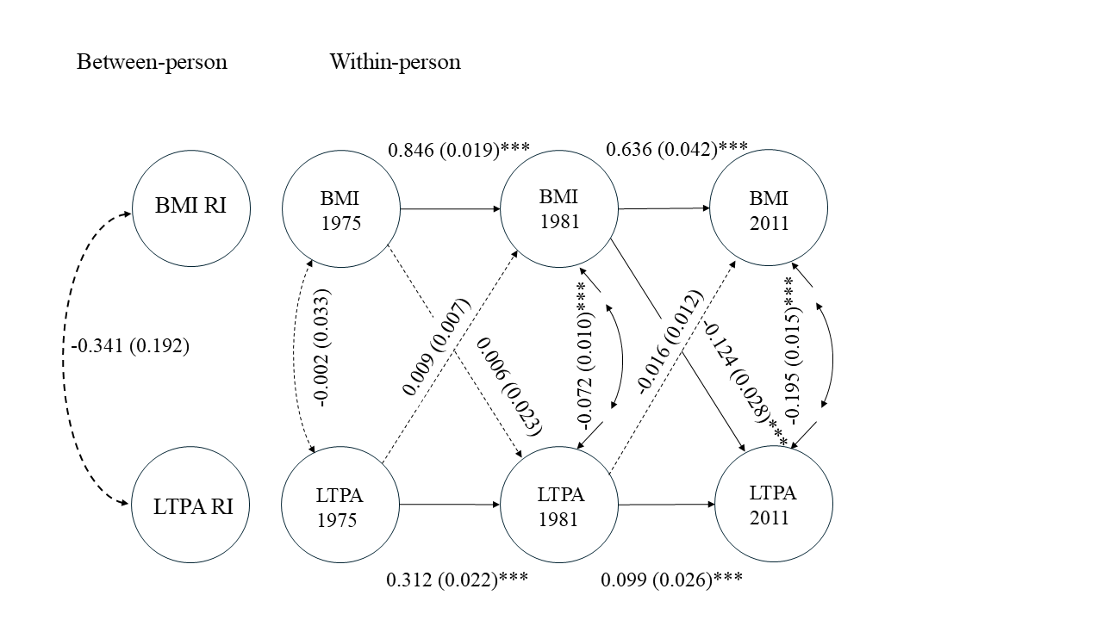
Supplementary Fig. S2 Sensitivity analysis: Estimation results of the random-intercept cross-lagged panel models (RI-CLPMs) using three measurement points in full cohort (N = 22,696). The circles denote latent variables and the dashed lines denote associations with no statistical significance (p > 0.05). Standardised estimates (standard errors) are presented. ***p < 0.001, **p < 0.01, *p < 0.05.

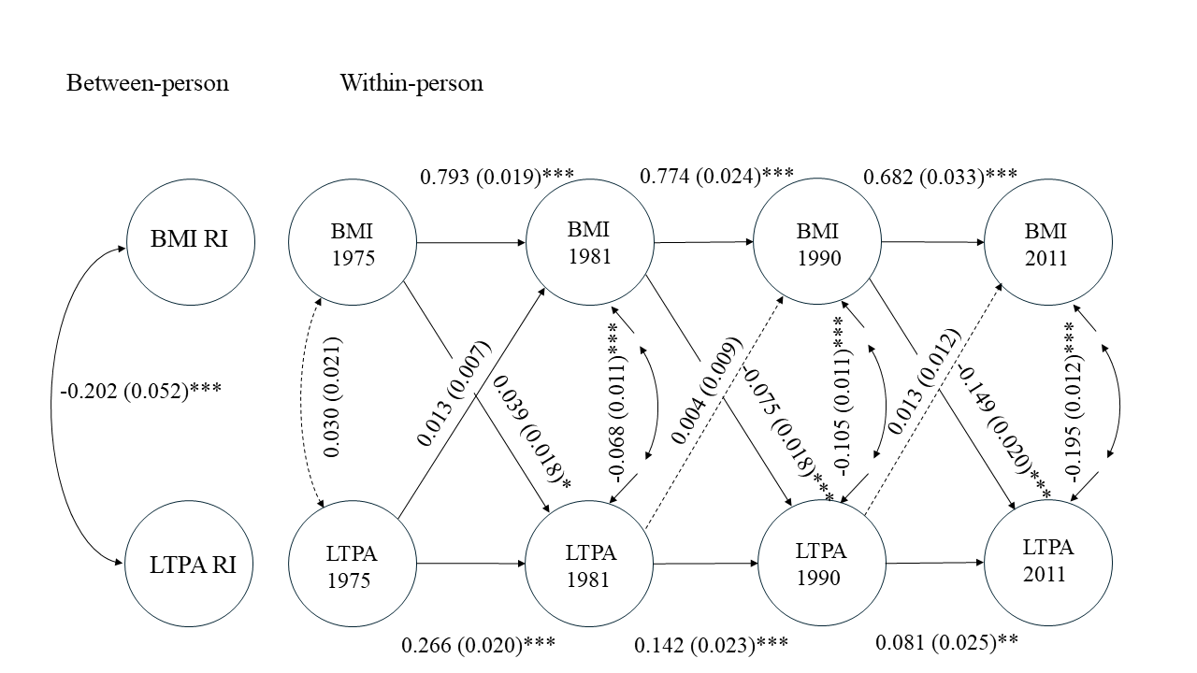
Supplementary Fig. S3 Sensitivity analysis: Estimation results of the random-intercept cross-lagged panel models (RI-CLPMs) among paticipants aged 18−40 years at baseline (N = 18,612). The circles denote latent variables and the dashed lines denote associations with no statistical significance (p > 0.05). Standardised estimates (standard errors) are presented. ***p < 0.001, **p < 0.01, *p < 0.05.

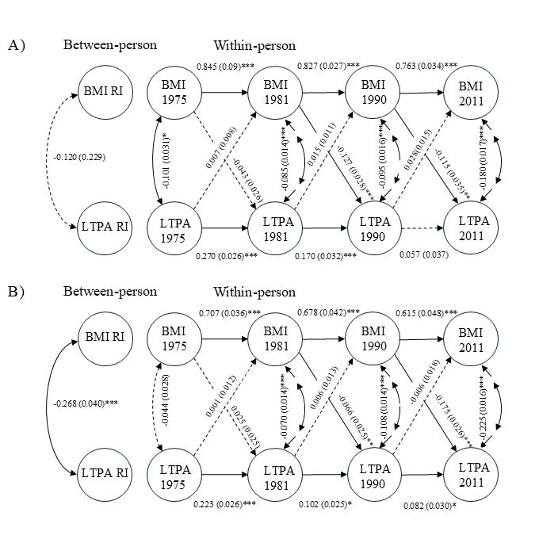
Supplementary Fig. S4 Estimation results of the random-intercept cross-lagged panel models (RI-CLPMs) in A) men (n = 11,282) and B) women (n = 11,414).
The circles denote latent variables. Standardised estimates (standard errors) are presented. ***p < 0.001, **p < 0.01, * p < 0.05.

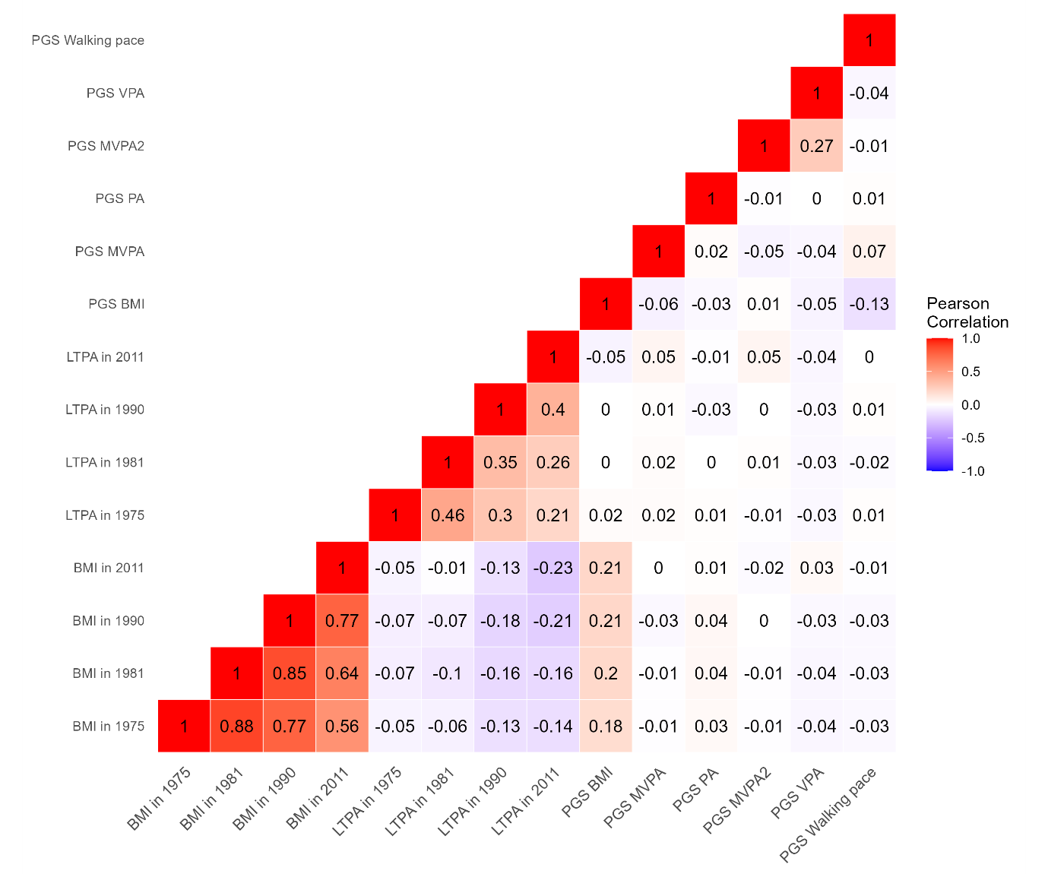
Supplementary Fig. S5 The Pearson’s correlation coefficients among the study variables in subsample having measured genetic data (n = 8,527). Pairwise complete observations were used.

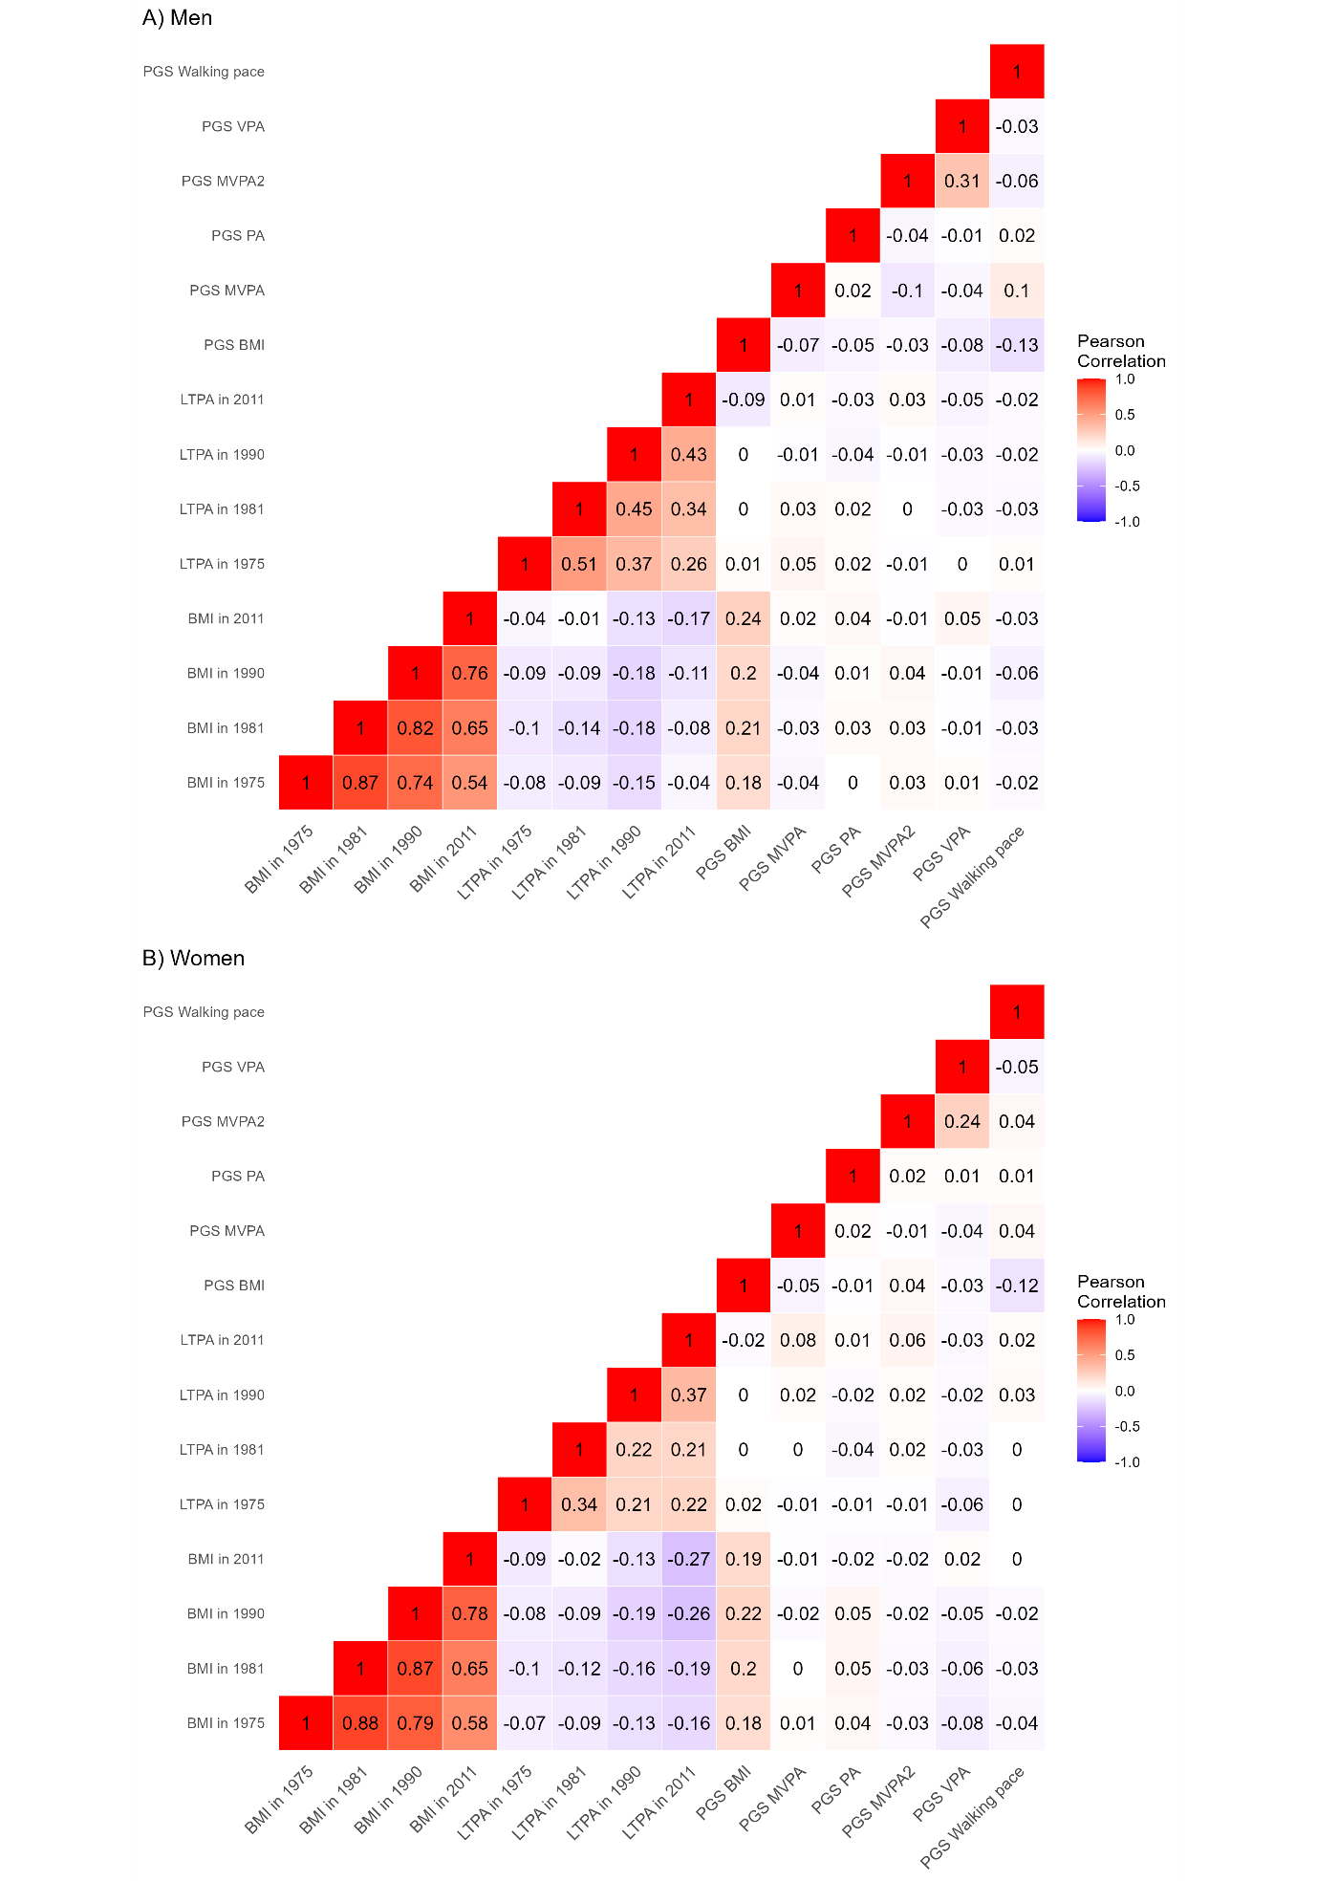
Supplementary Fig. S6 The Pearson’s correlations among the study variables in A) men (n = 4,062) and B) women (n = 4,465).
Pairwise complete observations were used.

Supplementary Fig. S7 The associations between the polygenic score for body mass index (PGS BMI) with BMI in A) all, B) men and C) women.
Unstandardised regression coefficients (95% Confidence Intervals) and F statistics are presented. Sample sizes at the four time points were A) all participants (n = 3,513; 3,452; 2,744 and 1,247), B) men (n = 1,609; 1,573; 1,224 and 552) and C) women (n = 1,904; 1,879; 1,520 and 695).

Supplementary Fig. S8 The associations between the polygenic scores (PGSs) with leisure-time physical activity (LTPA) in all participants.
Sample sizes at the four time points were n = 3,525; 3,472; 2,730 and 1,242. Unstandardised regression coefficients (95% Confidence Intervals) and F statistics are presented. SBaysR, genome-wide PGS.

Supplementary Fig. S9 The associations between the polygenic scores (PGSs) with leisure-time physical activity (LTPA) in men.
Sample sizes at the four time points were n = 1,607; 1,578; 1,223 and 556. Unstandardised regression coefficients (95% Confidence Intervals) and F statistics are presented.

Supplementary Fig. S10 The associations between the polygenic scores (PGSs) with leisure-time physical activity (LTPA) in women.
Sample sizes at the four time points were n = 1,918; 1,894; 1,507 and 686. Unstandardised regression coefficients (95% Confidence Intervals) and F statistics are presented.

Supplementary Fig. S11 Replication using data from twin 2: The associations between the polygenic scores (PGSs) with leisure-time physical activity (LTPA) in all participants.
Sample sizes at the four time points were n = 3,546; 3,435; 2,736 and 1,259. Unstandardised regression coefficients (95% Confidence Intervals) and F statistics are presented. SBaysR, genome-wide PGS.
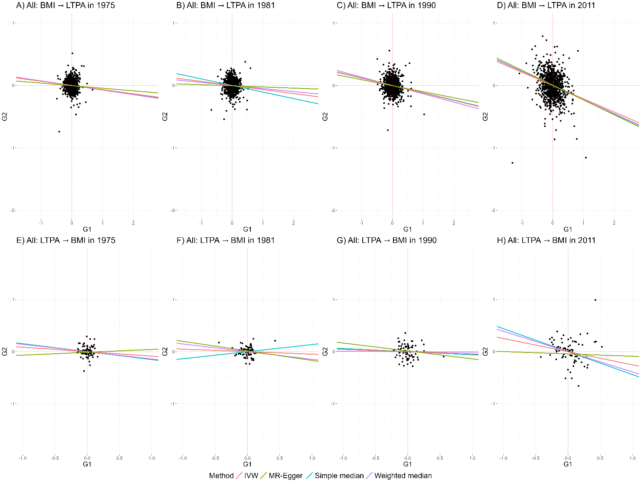
Supplementary Fig. S12 Scatter plot illustrating the associations of SNPs included in the polygenic score for exposure with measured exposure (G1, x axis) and measured outcome (G2, y axis).
The slopes of the lines correspond to the causal estimates of BMI on LTPA (A‒D) and LTPA on BMI (E‒H) assessed using different Mendelian Randomisation (MR) methods. IVW, inverse variance weighted.

Supplementary Fig. S13 Replication using data from twin 2: Mendelian randomisation (MR) estimates (95% confidence intervals) for the effect of A) body mass index (BMI) on leisure-time physical activity (LTPA) and B) LTPA on BMI, estimated using several MR methods.
CI, Confidence Interval; IVR, Instrumental Variable Regression; IVW, Inverse Variance Weighted. Unstandardised coefficients are presented. Sample sizes at the four time points were: 3,517; 3,416; 2,715 and 1,234 respectively. Note. a PGS MVPA was a poor instrument for LTPA.

Supplementary Fig. S14 Sex-stratified analysis: Mendelian randomisation (MR) estimates (95% confidence intervals) for effect of A) body mass index (BMI) on leisure-time physical activity (LTPA) and B) LTPA on BMI in men, estimated using several MR methods.
CI, Confidence Interval; IVR, Instrumental Variable Regression; IVW, Inverse Variance Weighted. Unstandardised coefficients are presented. Sample sizes at the four time points were: 1,603; 1,569; 1,217 and 538, respectively. Note. a PGS MVPA was a poor instrument for LTPA.

Supplementary Fig. S15 Sex-stratified analysis: Mendelian randomisation (MR) estimates (95% confidence intervals) for effect of A) body mass index (BMI) on leisure-time physical activity (LTPA) and B) LTPA on BMI in women, estimated using several MR methods.
CI, Confidence Interval; IVR, Instrumental Variable Regression; IVW, Inverse Variance Weighted. Unstandardised coefficients are presented. Sample sizes at the four time points were: 1,900; 1,878; 1,494 and 678, respectively. Note. ª PGS MVPA was a poor instrument for LTPA.
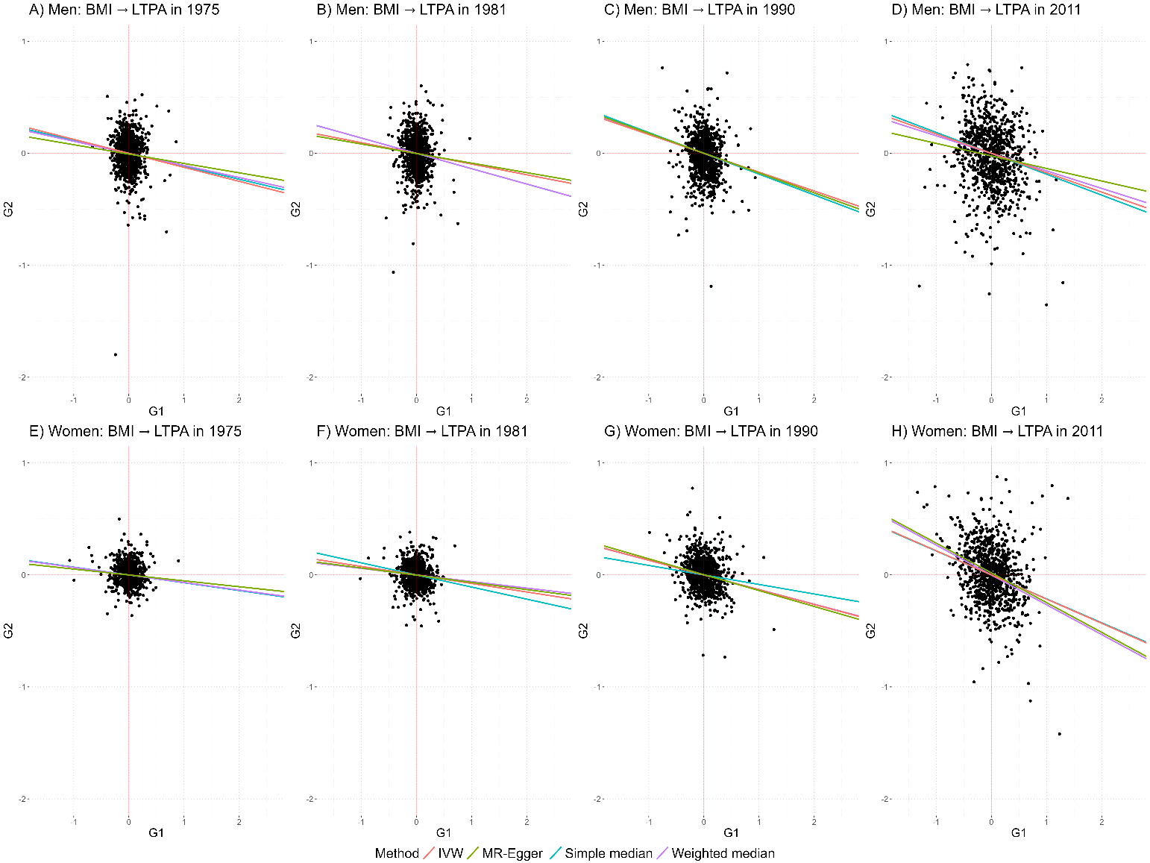
Supplementary Fig. S16 Sex-stratified analysis: Scatter plot illustrating the associations of SNPs included in the polygenic score for body mass index (PGS BMI) with BMI (G1, x axis) and leisure-time physical activity (LTPA) (G2, y axis).
The slopes of the lines correspond to the causal estimates of BMI on LTPA assessed using different Mendelian Randomisation (MR) methods in men (A‒D), and women (E‒H). IVW, inverse variance weighted.
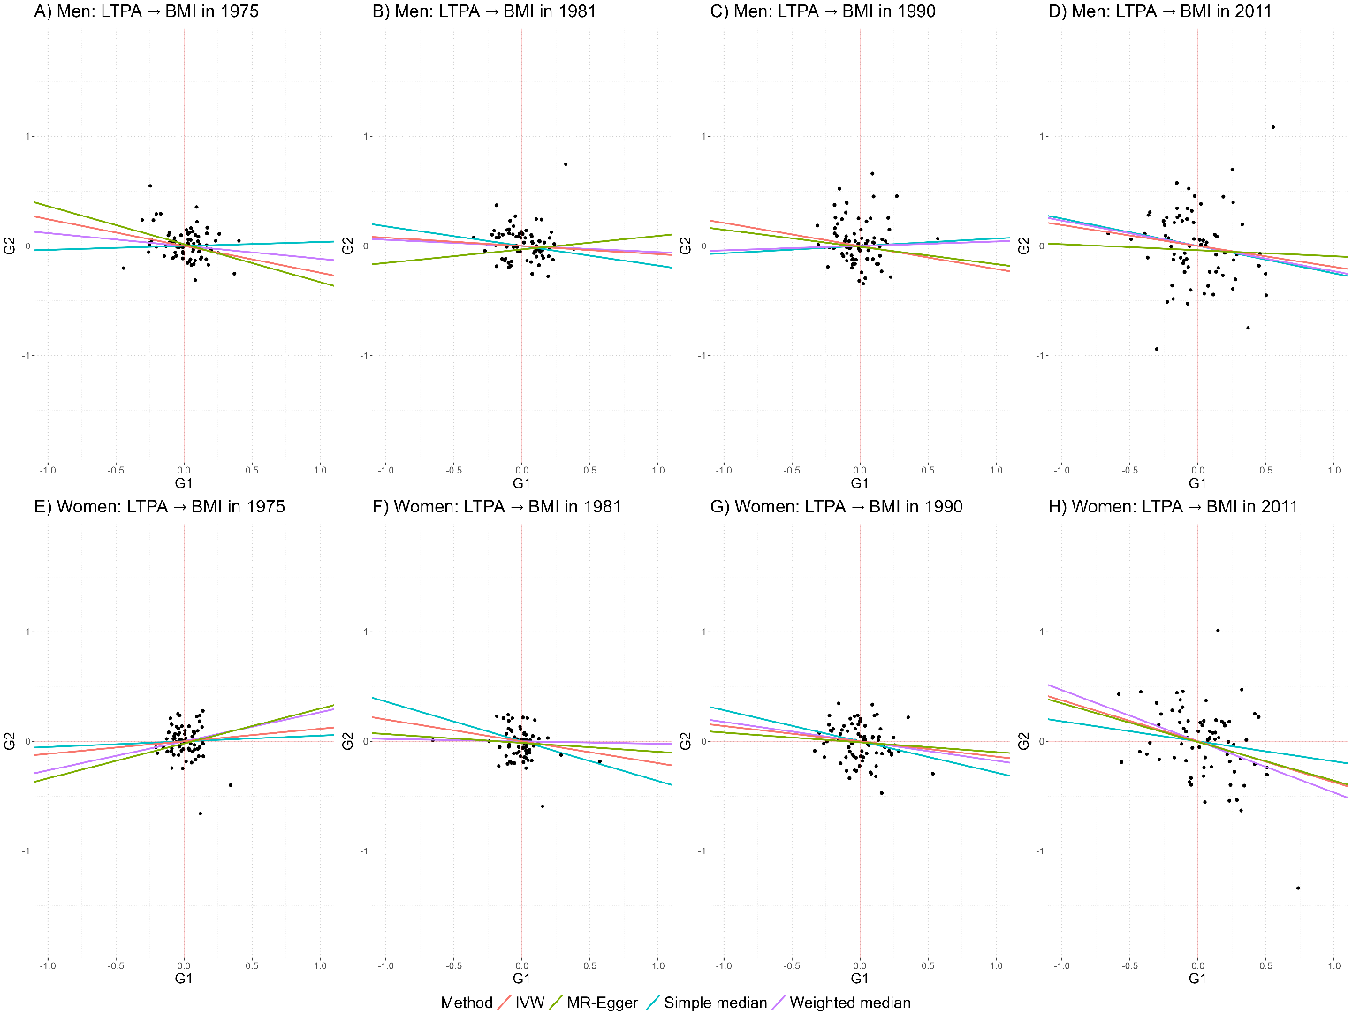
Supplementary Fig. S17 Sex-stratified analysis: Scatter plot illustrating the associations of SNPs included in the polygenic score for moderate-to-vigorous physical activity MVPA (PGS MVPA) with leisure-time physical activity (LTPA) (G1, x axis) and body mass index (BMI) (G2, y axis).
The slopes of the lines correspond to the causal estimates of LTPA on BMI assessed using different Mendelian Randomisation (MR) methods in men (A‒D), and women (E‒H). IVW, inverse variance weighted.
Supplementary Fig. S18 Sex-stratified analysis: Direction of Causation (DoC) and Mendelian Randomisation (MR)-DoC twin model based estimates for the effect of A) body mass index (BMI) on leisure-time physical activity (LTPA) and B) LTPA on BMI in years 1975, 1981, 1990 and 2011 in men.
Standardised coefficients (95% confidence intervals) are presented. MZ, monozygotic; DZ, dizygotic.
Model 1, bidirectional DoC twin model.
Model 2, unidirectional DoC model adjusted for genetic correlation.
Model 3, MR-DoC model, no horizontal pleiotropy assumed.
Model 4, MR-DoC model, horizontal pleiotropy estimated.
Supplementary Fig. S19 Sex-stratified analysis: Direction of Causation (DoC) and Mendelian Randomisation (MR)-DoC twin model based estimates for the effect of A) body mass index (BMI) on leisure-time physical activity (LTPA) and B) LTPA on BMI in years 1975, 1981, 1990 and 2011 in women.
Standardised coefficients (95% confidence intervals) are presented. MZ, monozygotic; DZ, dizygotic.
Model 1, bidirectional DoC twin model.
Model 2, unidirectional DoC model adjusted for genetic correlation.
Model 3, MR-DoC model, no horizontal pleiotropy assumed.
Model 4, MR-DoC model, horizontal pleiotropy estimated.
Supplementary Fig. S20 Estimated horizontal pleiotropy from polygenic score for body mass index (PGS BMI) to leisure-time physical activity (LTPA) estimated using MR-DoC model in A) all, B) men and C) women. Standardised regression coefficients (95% confidence intervals) are presented.

Supplementary Fig. S21 Estimated horizontal pleiotropy from polygenic score for moderate-to-vigorous physical activity (PGS MVPA) to body mass index (BMI) estimated using MR-DoC model in A) all, B) men and C) women. Standardised regression coefficients (95% confidence intervals) are presented.

Supplementary Table S1. The candidate instrumental variables for LTPA.
Polygenic score | Reference | Outcome | Number of SNPs ª
PGS MVPA | Wang et al., 2022 | Self-reported MVPA | 76 ^{b}
PGS PA | Doherty et al., 2018 | Accelerometer assessed overall PA | 2
PGS MVPA2 | Klimentidis et al., 2018 | Self-reported MVPA | 8
PGS VPA | Klimentidis et al., 2018 | Self-reported VPA | 5
PGS Walking pace | Timmins et al., 2020 | Walking pace | 65
MVPA, moderate-to-vigorous-physical activity; VPA, vigorous physical activity.
ª Number of SNPs included in the PGS. SNPs were also limited to have a minor allele frequency greater than 1% and imputation quality (INFO score) better than 0.8.
^{b} The included SNPs were those that were significant either for sedentary time or MVPA, or both.

Supplementary Table S2. Sex-stratified analysis: Descriptive statistics of the study variables in full cohort and subsample of twin individuals having measured genetic data available.
 | Full cohort |  |  |  | Subsample with genetic data
 | Men (n = 11,282) |  | Women (n = 11,414) |  | Men (n = 4,062) |  | Women (n = 4,465)
 | n | Mean (SD) or % | n | Mean (SD) or % | n | Mean (SD) or % | n | Mean (SD) or %
Zygosity | 11,282 |  | 11,414 |  | 4,062 |  | 4,465
Unsure | 1,021 | 9.0 | 858 | 7.5 | - |  | -
Monozygotic | 2,987 | 26.5 | 3,462 | 30.3 | 1,295 | 31.9 | 1,595 | 35.7
Dizygotic | 7,274 | 64.5 | 7,094 | 62.2 | 2,767 | 68.1 | 2,870 | 64.3
Age at baseline
in 1975 | 11,282 | 30.5 (8.9) | 11,414 | 30.1 (8.5) | 4,062 | 32.9 (8.4) | 4,310 | 33.0 (8.7)
in 1981 | 9,956 | 36.7 (8.9) | 10,506 | 36.2 (8.6) | 3,806 | 39.0 (8.4) | 4,140 | 39.2 (8.8)
in 1990 | 5,692 | 44.8 (7.7) | 6,801 | 44.2 (7.8) | 2,807 | 47.4 (7.7) | 3,284 | 47.1 (7.8)
in 2011 | 3,699 | 60.4 (3.7) | 4,633 | 60.1 (3.7) | 1,277 | 60.6 (3.7) | 1,478 | 60.4 (3.7)
Body mass index (kg/m²)
in 1975 | 10,287 | 23.6 (3.0) | 10,556 | 22.0 (3.6) | 3,898 | 24.0 (2.9) | 4,151 | 22.5 (3.2)
in 1981 | 9,768 | 24.4 (3.0) | 10,306 | 22.7 (3.7) | 3,762 | 24.7 (3.0) | 4,087 | 23.3 (3.5)
in 1990 | 5,660 | 25.4 (3.3) | 6,729 | 24.0 (3.6) | 2,790 | 25.6 (3.2) | 3,254 | 24.6 (4.2)
in 2011 | 3,628 | 26.7 (3.9) | 4,536 | 25.8 (2.9) | 1,246 | 26.9 (4.0) | 1,452 | 26.1 (4.7)
Leisure-time physical activity
Metabolic equivalent (MET) index (MET h/day)
in 1975 | 10,309 | 2.7 (3.6) | 10,636 | 2.1 (2.5) | 3,900 | 2.6 (3.3) | 4,184 | 2.0 (2.2)
in 1981 | 9,780 | 2.8 (3.7) | 10,366 | 2.3 (2.5) | 3,766 | 2.8 (3.6) | 4,104 | 2.3 (2.3)
in 1990 | 5,620 | 3.2 (3.6) | 6,690 | 3.3 (3.2) | 2,786 | 3.1 (3.4) | 3,225 | 3.1 (3.0)
in 2011 | 3,609 | 3.3 (3.7) | 4,514 | 3.6 (3.4) | 1,247 | 3.0 (3.5) | 1,482 | 3.5 (3.3)
SD, standard deviation

Supplementary Table S3. Correlations for all twins and stratified by sex.
r (95% CI) ^{a,b}
 | LTPA in 1975 | LTPA in 1981 | LTPA in 1990 | LTPA in 2011 | BMI in 1975 | BMI in 1980 | BMI in 1991 | BMI in 2011
All twins
LTPA
in 1975 | 1
in 1981 | 0.44 (0.41, 0.47) | 1
in 1990 | 0.26 (0.23, 0.29) | 0.35 (0.32, 0.37) | 1
in 2011 | 0.22 (0.19, 0.24) | 0.27 (0.24, 0.30) | 0.31 (0.27, 0.34) | 1
BMI
in 1975 | -0.05 (-0.07, -0.04) | -0.05 (-0.06, -0.03) | -0.11 (-0.12, -0.09) | -0.12 (-0.14, -0.09) | 1
in 1981 | -0.05 (-0.06, -0.03) | -0.08 (-0.09, -0.06) | -0.13 (-0.14, -0.11) | -0.15 (-0.18, -0.13) | 0.86 (0.86, 0.87) | 1
in 1990 | -0.05 (-0.07, -0.04) | -0.07 (-0.08, -0.05) | -0.16 (-0.17, -0.14) | -0.17 (-0.20, -0.15) | 0.74 (0.73, 0.75) | 0.84 (0.83, 0.85) | 1
in 2011 | -0.06 (-0.07, -0.04) | -0.08 (-0.09, -0.06) | -0.12 (-0.14, -0.10) | -0.24 (-0.26, -0.22) | 0.57 (0.55, 0.59) | 0.67 (0.65, 0.68) | 0.77 (0.75, 0.79) | 1
Men
LTPA
in 1975 | 1
in 1981 | 0.45 (0.42, 0.49) | 1
in 1990 | 0.28 (0.24, 0.32) | 0.39 (0.35, 0.42) | 1
in 2011 | 0.23 (0.19, 0.27) | 0.30 (0.26, 0.35) | 0.30 (0.25, 0.35) | 1
BMI
in 1975 | -0.10 (-0.12, -0.08) | -0.07 (-0.09, -0.05) | -0.11 (-0.14, -0.09) | -0.06 (-0.10, -0.03) | 1
in 1981 | -0.08 (-0.10, -0.06) | -0.10 (-0.12, -0.08) | -0.14 (-0.16, -0.11) | -0.09 (-0.13, -0.06) | 0.85 (0.84, 0.86) | 1
in 1990 | -0.07 (-0.09, -0.04) | -0.07 (-0.09, -0.05) | -0.16 (-0.18, -0.13) | -0.12 (-0.15, -0.08) | 0.72 (0.70, 0.74) | 0.83 (0.82, 0.85) | 1
in 2011 | -0.06 (-0.09, -0.03) | -0.07 (-0.09, -0.04) | -0.10 (-0.13, -0.07) | -0.19 (-0.22, -0.16) | 0.53 (0.51, 0.56) | 0.64 (0.61, 0.66) | 0.77 (0.75, 0.79) | 1
Women
LTPA
in 1975 | 1
in 1981 | 0.39 (0.36, 0.43) | 1
in 1990 | 0.24 (0.20, 0.28) | 0.30 (0.27, 0.33) | 1
in 2011 | 0.21 (0.17, 0.25) | 0.23 (0.20, 0.27) | 0.30 (0.26, 0.34) | 1
BMI
in 1975 | -0.07 (-0.08, -0.05) | -0.07 (-0.09, -0.05) | -0.11 (-0.13, -0.08) | -0.15 (-0.18, -0.11) | 1
in 1981 | -0.07 (-0.09, -0.05) | -0.11 (-0.12, -0.09) | -0.13 (-0.15, -0.10) | -0.18 (-0.22, -0.15) | 0.86 (0.85, 0.87) | 1
in 1990 | -0.08 (-0.10, -0.06) | -0.10 (-0.12, -0.08) | -0.16 (-0.18, -0.14) | -0.21 (-0.23, -0.18) | 0.75 (0.73, 0.77) | 0.84 (0.83, 0.86) | 1
in 2011 | -0.09 (-0.09, -0.05) | -0.10 (-0.12, -0.07) | -0.13 (-0.16, -0.10) | -0.28 (-0.30, -0.25) | 0.62 (0.59, 0.64) | 0.71 (0.69, 0.73) | 0.79 (0.77, 0.82) | 1
ª CIs were corrected for family relatedness.
^{b} The correlations were estimated using full information maximum likelihood in full cohort (n = 22,696) and in men (n = 11,282) and women (n = 11,414).

Supplementary Table S4. Genetic and unique environmental correlations between body mass index and leisure-time physical activity estimated using bivariate Cholesky twin model.
 | r (95% CI) ^{a,b} | Number of  MZ / DZ pairs | r_{A} (95% CI) | r_{E} (95% CI)
All
in 1975 | -0.05 (-0.07, -0.04) | 2,750 / 5,909 | -0.06 (-0.09, -0.03) | -0.05 (-0.08, -0.02)
in 1981 | -0.08 (-0.09, -0.06) | 2,578 / 5,340 | -0.06 (-0.09, -0.02) | -0.10 (-0.15, -0.06)
in 1990 | -0.16 (-0.17, -0.14) | 1,553 / 2,937 | -0.22 (-0.28, -0.17) | -0.12 (-0.16, -0.08)
in 2011 | -0.24 (-0.26, -0.22) | 985 / 1,713 | -0.29 (-0.36, -0.22) | -0.19 (-0.24, -0.13)
Men
in 1975 | -0.10 (-0.12, -0.08) | 1,231 / 2,851 | -0.12 (-0.16, -0.08) | -0.06 (-0.10, -0.02)
in 1981 | -0.10 (-0.12, -0.08) | 1,120 / 2,511 | -0.13 (-0.18, -0.07) | -0.08 (-0.14, -0.01)
in 1990 | -0.16 (-0.18, -0.13) | 638 / 1,291 | -0.23 (-0.32, -0.15) | -0.11 (-0.17, -0.05)
in 2011 | -0.19 (-0.22, -0.16) | 391 / 694 | -0.17 (-0.30, -0.04) | -0.19 (-0.28, -0.10)
Women
in 1975 | -0.07 (-0.08, -0.05) | 1,519 / 3,058 | -0.09 (-0.13, -0.05) | -0.02 (-0.07, 0.03)
in 1981 | -0.11 (-0.12, -0.09) | 1,458 / 2,829 | -0.11 (-0.16, -0.05) | -0.12 (-0.17, -0.07)
in 1990 | -0.16 (-0.18, -0.14) | 915 / 1,646 | -0.22 (-0.29, -0.15) | -0.13 (-0.19, -0.08)
in 2011 | -0.28 (-0.30, -0.25) | 594 / 1,014 | -0.36 (-0.44, -0.27) | -0.19 (-0.27, -0.12)
r, phenotypic correlation; CI, Confidence Interval; MZ, monozygotic; DZ, dizygotic;
r_{A}, genetic correlation; r_{E}, unique environmental correlation.
ª CIs were corrected for family relatedness.
^{b} The correlations were estimated using full information maximum likelihood in full cohort (n = 22,696) and in men (n = 11,282) and women (n = 11,414).

Supplementary Table S5. Model-fit of the bidirectional Direction of Causation models in comparison to the models with constrained causal paths.
 |  | BIC | Chi-squared | df | p | SC | CFI | TLI | RMSEA | SRMR | Chi-squared difference test (df=1)ª | p
All
In 1975  (8,659 pairs) | Model 1: Bidirectional | 171532 | 97.97 | 20 | <0.001 | 2.41 | 0.98 | 0.99 | 0.030 | 0.062
In 1975  (8,659 pairs) | g1 = 0 (causal effect LTPA → BMI estimated) | 171526 | 102.27 | 21 | <0.001 | 2.33 | 0.98 | 0.99 | 0.030 | 0.062 | 3.00 | 0.083
In 1975  (8,659 pairs) | g2 = 0 (causal effect BMI → LTPA estimated) | 171524 | 101.24 | 21 | <0.001 | 2.33 | 0.98 | 0.99 | 0.030 | 0.062 | 0.00 | 1.000
In 1981  (7,918 pairs) | Model 1: Bidirectional | 159370 | 52.67 | 20 | <0.001 | 2.2 | 0.99 | 0.99 | 0.020 | 0.043
In 1981  (7,918 pairs) | g1 = 0 (causal effect LTPA → BMI estimated) | 159361 | 53.97 | 21 | <0.001 | 2.16 | 0.99 | 0.99 | 0.020 | 0.043 | 0.52 | 0.473
In 1981  (7,918 pairs) | g2 = 0 (causal effect BMI → LTPA estimated) | 159373 | 59.35 | 21 | <0.001 | 2.16 | 0.99 | 0.99 | 0.021 | 0.044 | 9.06 | 0.003
In 1990  (4,490 pairs) | Model 1: Bidirectional | 94649 | 19.93 | 20 | 0.463 | 1.99 | 1.00 | 1.00 | 0.000 | 0.036
In 1990  (4,490 pairs) | g1 = 0 (causal effect LTPA → BMI estimated) | 94663 | 32.13 | 21 | 0.057 | 1.94 | 0.99 | 1.00 | 0.015 | 0.041 | 24.12 | < 0.001
In 1990  (4,490 pairs) | g2 = 0 (causal effect BMI → LTPA estimated) | 94641 | 20.86 | 21 | 0.468 | 1.94 | 1.00 | 1.00 | 0.000 | 0.036 | 0.86 | 0.354
In 2011  (2,698 pairs) | Model 1: Bidirectional | 58747 | 27.87 | 20 | 0.113 | 1.62 | 0.99 | 1.00 | 0.017 | 0.061
In 2011  (2,698 pairs) | g1 = 0 (causal effect LTPA → BMI estimated) | 58757 | 39.30 | 21 | 0.009 | 1.60 | 0.97 | 0.98 | 0.015 | 0.041 | 15.55 | < 0.001
In 2011  (2,698 pairs) | g2 = 0 (causal effect BMI → LTPA estimated) | 58740 | 28.92 | 21 | 0.468 | 1.94 | 1.00 | 1.00 | 0.000 | 0.056 | 0.93 | 0.335
Men
In 1975  (4,082 pairs) | Model 1: Bidirectional | 82460 | 79.08 | 20 | <0.001 | 1.99 | 0.97 | 0.98 | 0.038 | 0.082
In 1975  (4,082 pairs) | g1 = 0 (causal effect LTPA → BMI estimated) | 82463 | 86.88 | 21 | <0.001 | 1.94 | 0.96 | 0.98 | 0.039 | 0.085 | 11.88 | 0.001
In 1975  (4,082 pairs) | g2 = 0 (causal effect BMI → LTPA estimated) | 82452 | 81.4 | 21 | <0.001 | 1.94 | 0.97 | 0.98 | 0.038 | 0.082 | 0.582 | 0.446
In 1981  (3,631 pairs) | Model 1: Bidirectional | 74384 | 37.83 | 20 | 0.0093 | 1.92 | 0.99 | 0.99 | 0.022 | 0.093
In 1981  (3,631 pairs) | g1 = 0 (causal effect LTPA → BMI estimated) | 74382 | 41.34 | 21 | 0.0051 | 1.9 | 0.98 | 0.99 | 0.023 | 0.095 | 3.94 | 0.047
In 1981  (3,631 pairs) | g2 = 0 (causal effect BMI → LTPA estimated) | 74376 | 38.4 | 21 | 0.0116 | 1.9 | 0.99 | 0.99 | 0.021 | 0.093 | 0.22 | 0.641
In 1990  (1,929 pairs) | Model 1: Bidirectional | 39909 | 15.08 | 20 | 0.771 | 1.79 | 1.00 | 1.01 | 0.000 | 0.055
In 1990  (1,929 pairs) | g1 = 0 (causal effect LTPA → BMI estimated) | 39911 | 21.00 | 21 | 0.459 | 1.75 | 1.00 | 1.00 | 0.000 | 0.056 | 10.27 | 0.001
In 1990  (1,929 pairs) | g2 = 0 (causal effect BMI → LTPA estimated) | 39902 | 15.46 | 21 | 0.799 | 1.75 | 1.00 | 1.01 | 0.000 | 0.055 | 0.07 | 0.799
In 2011  (1,085 pairs) | Model 1: Bidirectional | 23714 | 25.40 | 20 | 0.187 | 1.61 | 0.98 | 0.99 | 0.022 | 0.102
In 2011  (1,085 pairs) | g1 = 0 (causal effect LTPA → BMI estimated) | 23708 | 26.22 | 21 | 0.198 | 1.58 | 0.98 | 0.99 | 0.021 | 0.102 | 0.52 | 0.470
In 2011  (1,085 pairs) | g2 = 0 (causal effect BMI → LTPA estimated) | 23709 | 26.74 | 21 | 0.180 | 1.58 | 0.98 | 0.99 | 0.022 | 0.103 | 1.37 | 0.242
Women
In 1975  (4,577 pairs) | Model 1: Bidirectional | 86974 | 41.73 | 20 | 0.003 | 2.85 | 0.99 | 0.99 | 0.022 | 0.073
In 1975  (4,577 pairs) | g1 = 0 (causal effect LTPA → BMI estimated) | 86973 | 45.51 | 21 | 0.002 | 2.76 | 0.99 | 0.99 | 0.023 | 0.074 | 7.00 | 0.008
In 1975  (4,577 pairs) | g2 = 0 (causal effect BMI → LTPA estimated) | 86967 | 43.22 | 21 | 0.003 | 2.77 | 0.99 | 0.99 | 0.022 | 0.073 | 0.67 | 0.412
In 1981  (4,287 pairs) | Model 1: Bidirectional | 82829 | 19.66 | 20 | 0.479 | 2.09 | 1.00 | 1.00 | 0.000 | 0.047
In 1981  (4,287 pairs) | g1 = 0 (causal effect LTPA → BMI estimated) | 82824 | 21.69 | 21 | 0.418 | 2.04 | 1.00 | 1.00 | 0.004 | 0.047 | 3.04 | 0.081
In 1981  (4,287 pairs) | g2 = 0 (causal effect BMI → LTPA estimated) | 82827 | 23.04 | 21 | 0.342 | 2.05 | 1.00 | 1.00 | 0.007 | 0.048 | 4.91 | 0.027
In 1990  (2,561 pairs) | Model 1: Bidirectional | 54342 | 20.13 | 20 | 0.450 | 2.11 | 1.00 | 1.00 | 0.002 | 0.048
In 1990  (2,561 pairs) | g1 = 0 (causal effect LTPA → BMI estimated) | 54346 | 26.28 | 21 | 0.196 | 2.05 | 0.99 | 1.00 | 0.014 | 0.051 | 13.41 | < 0.001
In 1990  (2,561 pairs) | g2 = 0 (causal effect BMI → LTPA estimated) | 54335 | 21.23 | 21 | 0.445 | 2.05 | 1.00 | 1.00 | 0.003 | 0.048 | 1.23 | 0.267
In 2011  (1,613 pairs) | Model 1: Bidirectional | 34917 | 31.15 | 20 | 0.053 | 1.61 | 0.98 | 0.99 | 0.026 | 0.079
In 2011  (1,613 pairs) | g1 = 0 (causal effect LTPA → BMI estimated) | 34932 | 45.42 | 21 | 0.002 | 1.59 | 0.96 | 0.98 | 0.038 | 0.087 | 17.83 | < 0.001
In 2011  (1,613 pairs) | g2 = 0 (causal effect BMI → LTPA estimated) | 34910 | 31.60 | 21 | 0.064 | 1.59 | 0.98 | 0.99 | 0.025 | 0.079 | 0.188 | 0.665
BIC, Bayesian information criterion; df, degrees-of-freedom; SC, scaling correction; CFI, the comparative fit index; TLI, the Tucker–Lewis index; RMSEA, the root mean square error of approximation; SRMR, the standardised root-mean-square residual.
g1 = 0: Causal path from BMI to LTPA was set to zero.
g2 = 0: Causal path from LTPA to BMI was set to zero.
ª Model fit was compared to the model-fit of the bidirectional model.

