Figure S2: Gating of CD15⁺/CD66b⁺ population
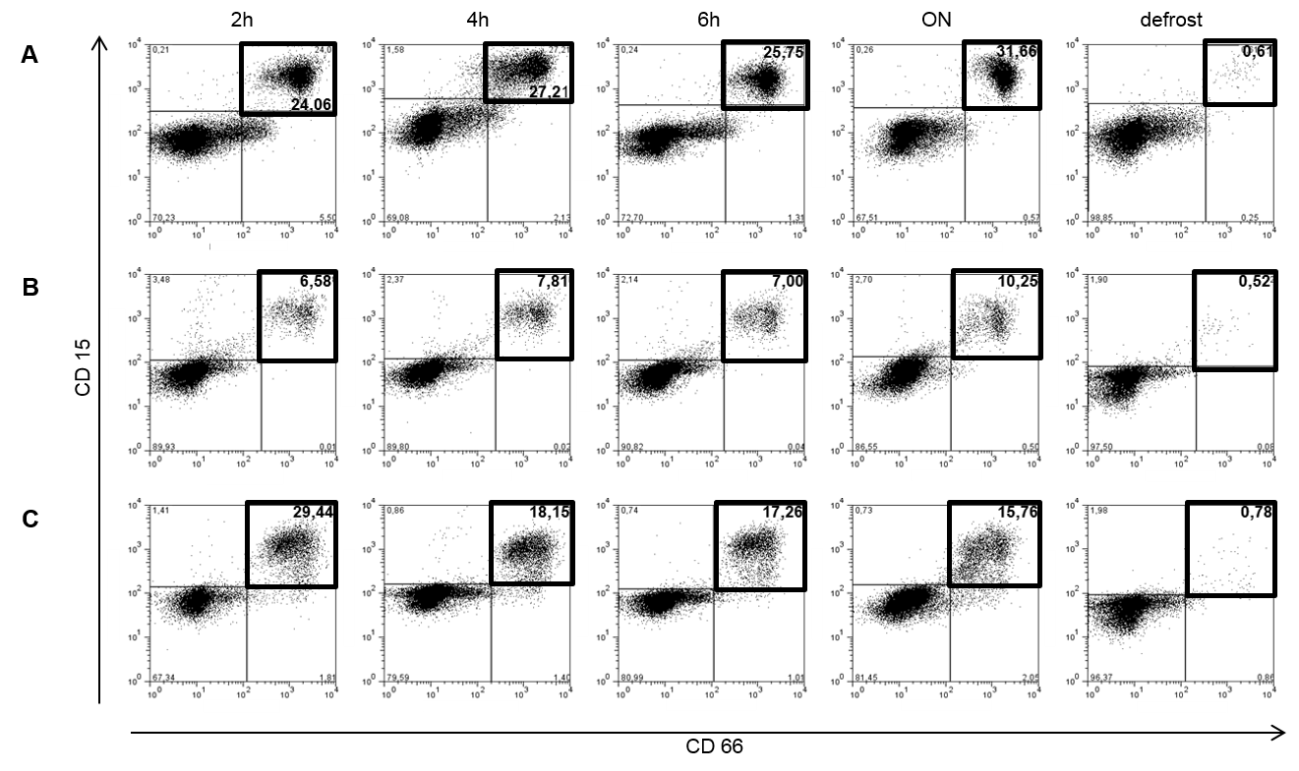
Representative dot plots of gMDSC of 3 HIV patients gated on CD15⁺/CD66b⁺ (rectangle gate).
Comparable to the CD11b⁺/CD14⁻ population, the majority of the CD15⁺/CD66b⁺ remained similar after 2h, 4h and 6h with a slight increase after ON (A and B). Again, the population disappeared after freezing/thawing procedure. The third panel (C) shows a minor divergent presentation with decreased gMDSC frequencies after 4h, 6h and ON compared to 2h time point.

