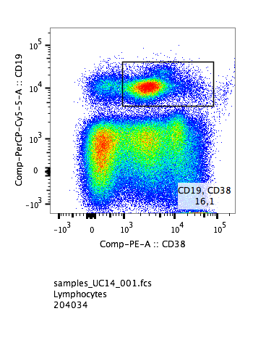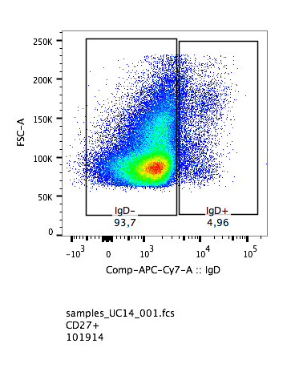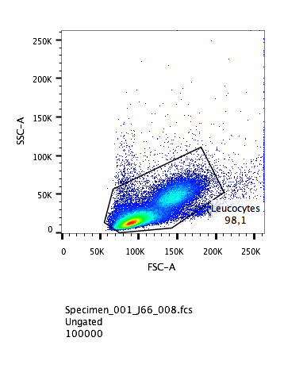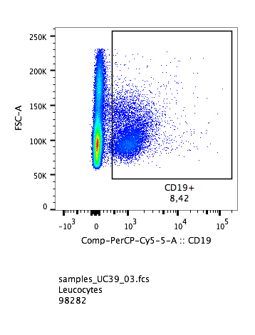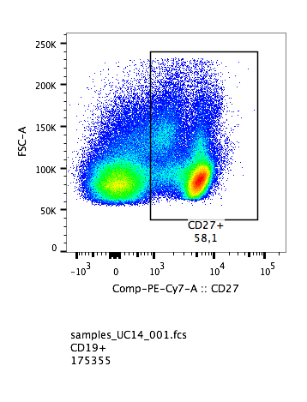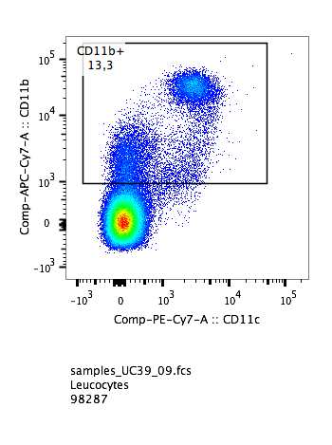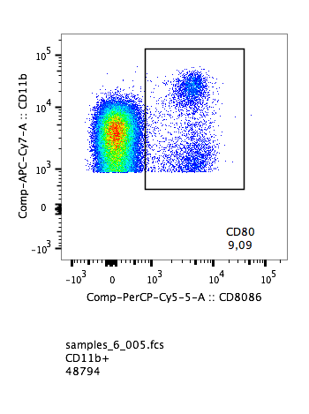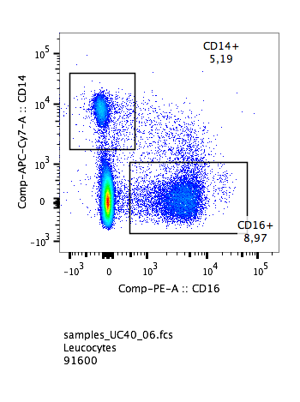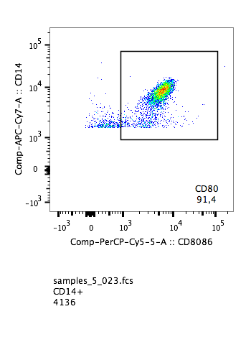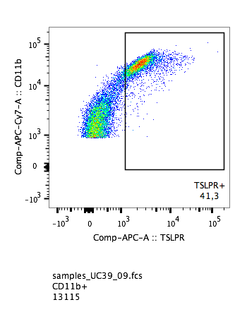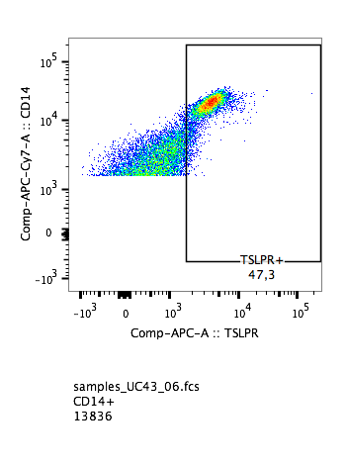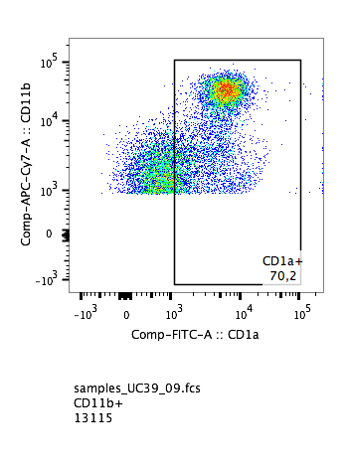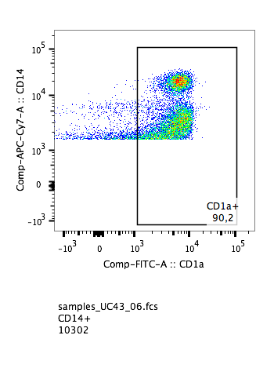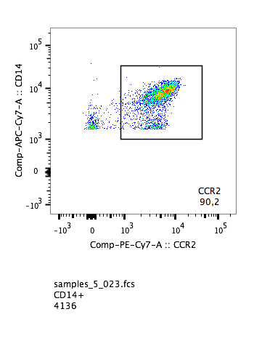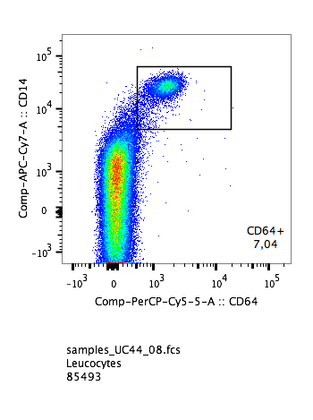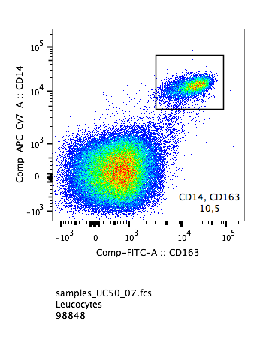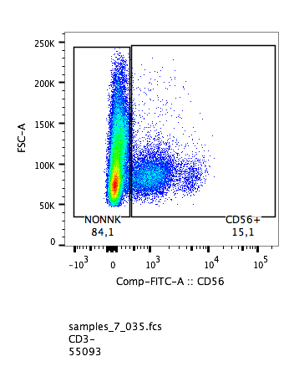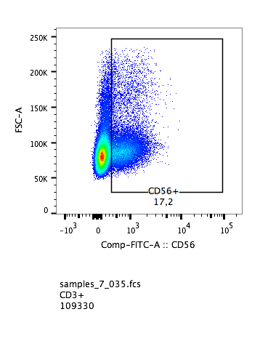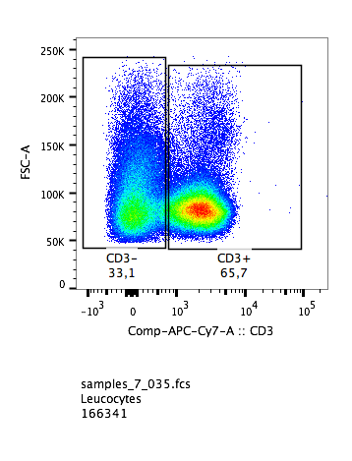
Gate 1
CD19+ CD38+
CD19+
CD19+ CD27+
CD19+ CD27+ IgD±
Gate 1
CD11b+
CD11b+ CD1a+
CD11b+ TSLPR+
CD11b+ CD80+
Gate 1
CD14+ /CD16+
CD14+ CD1a+
CD14+ TSLPR+
CD14+ CD80+
CD14+ CCR2+
CD14+ CD64+
CD14+ CD163+
Gate 1
CD3±
CD3- CD56±
CD3+ CD56±
Gate 1
Fig. S1. Gating stategy for isolated human PBMC.

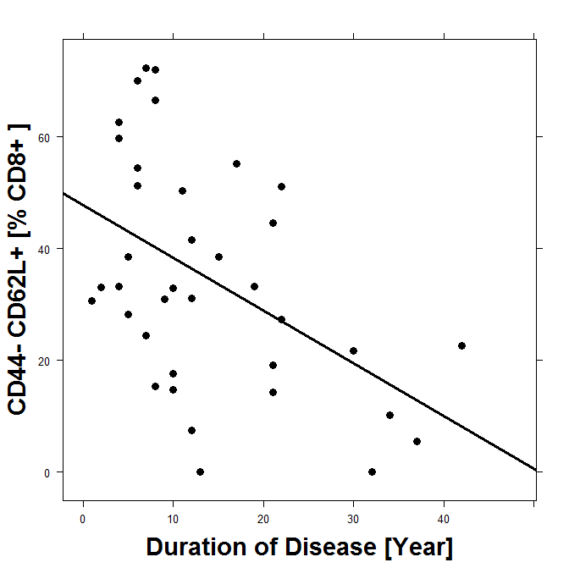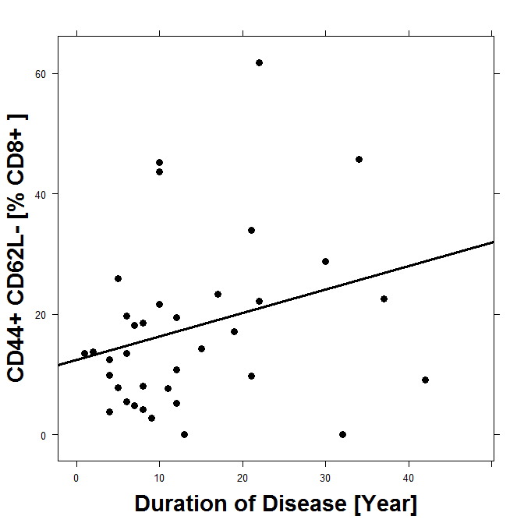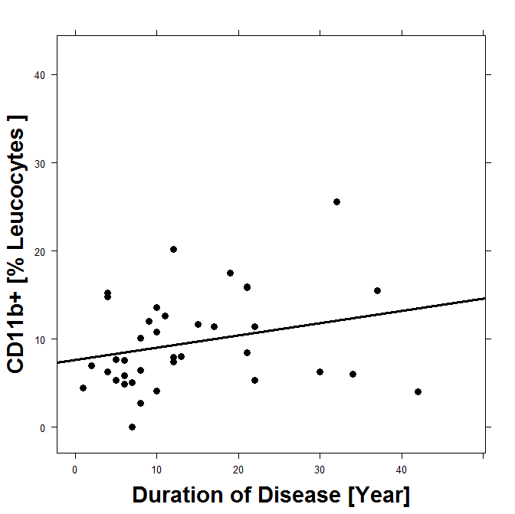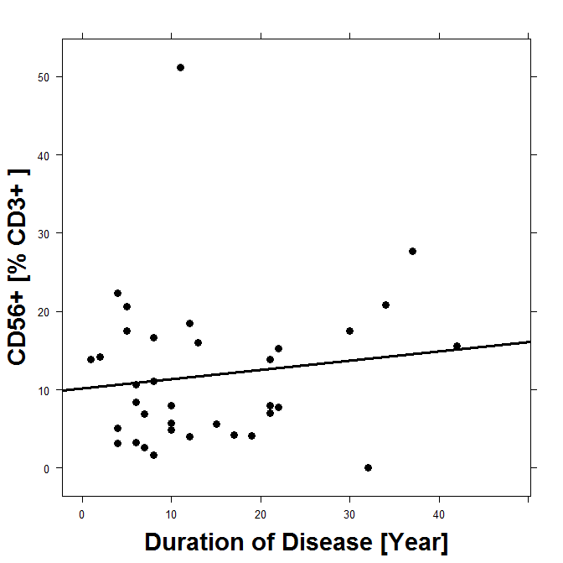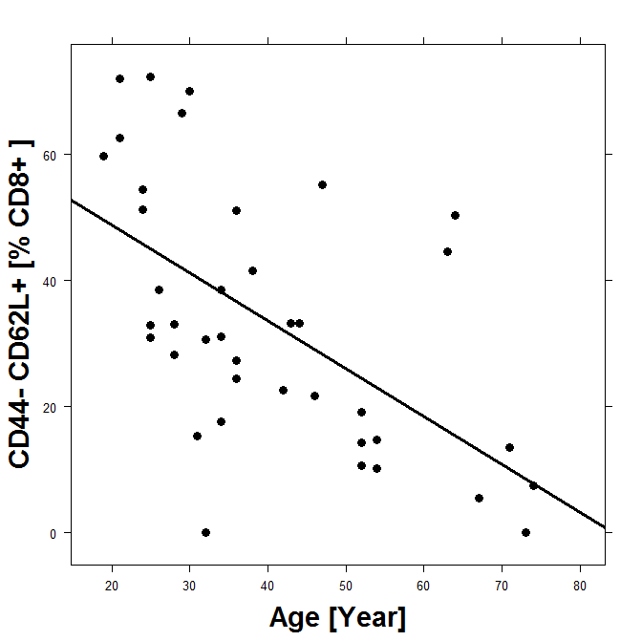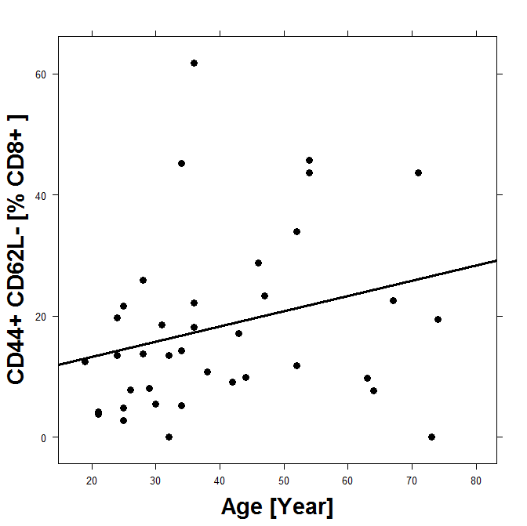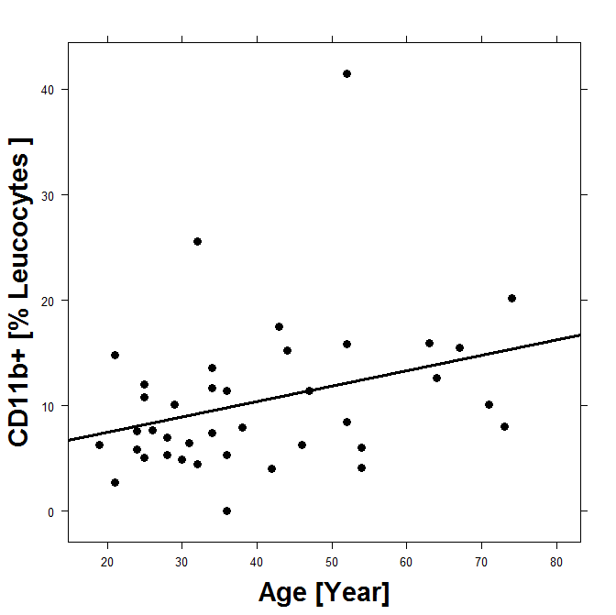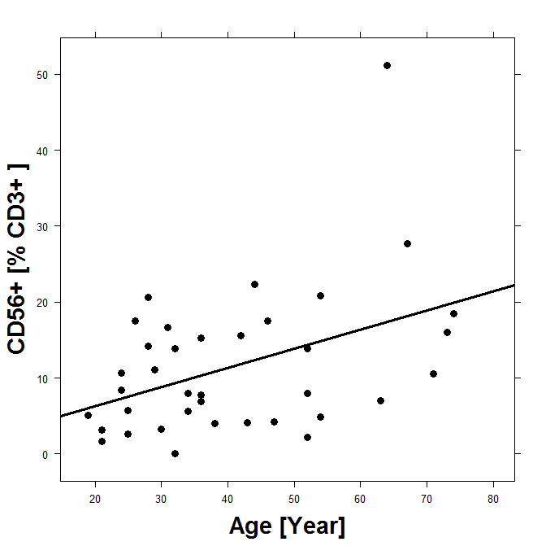
rho= -0.61
p= 1.4e-05
rho= 0.35
p= 0.01
rho= -0.48
p= 0.001
rho= 0.3
p= 0.03
rho= 0.29
p= 0.04
rho= 0.35
p= 0.01
rho= 0.36
p= 0.01
Fig. S2. Age and duration of disease affects subtypes of leucocytes in UC patients. Correlation analysis depicted as xyplots. Spearman rank-order correlation coefficients rho and p-values. Sample size: CD3+ 56+NK T-cells n=35, CD8+ CD44- CD62L+ -, CD8+ CD44+ CD62L, CD11b+ macrophages n=37.
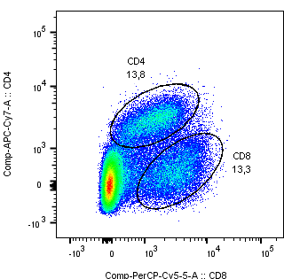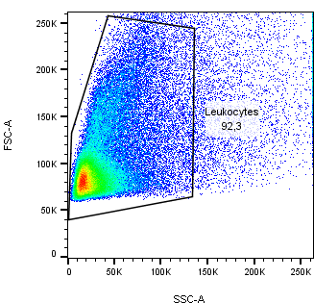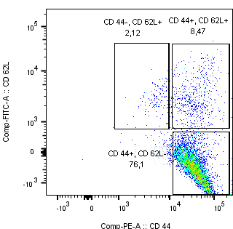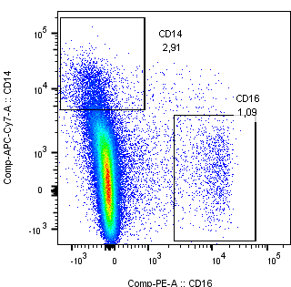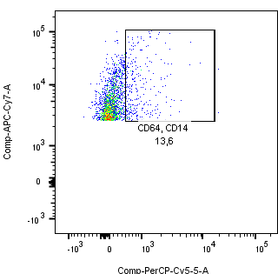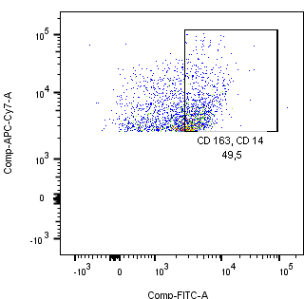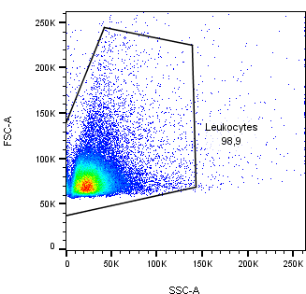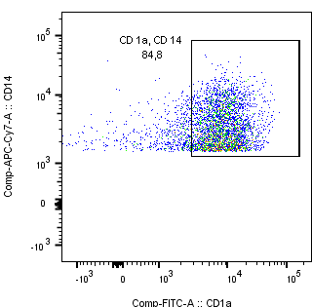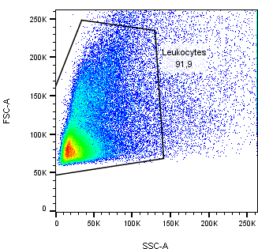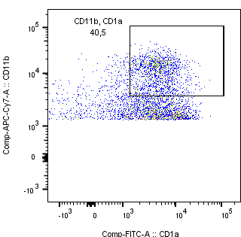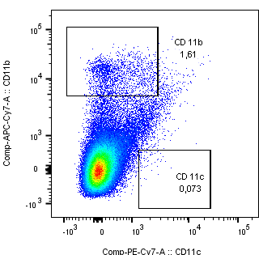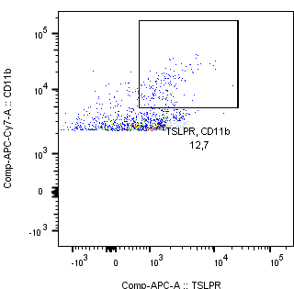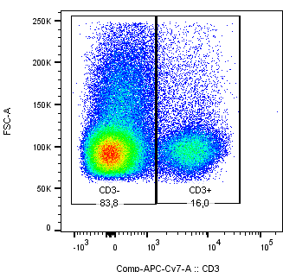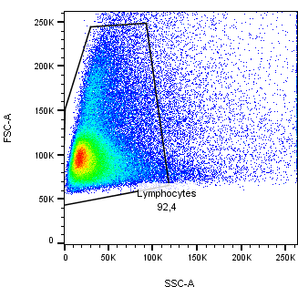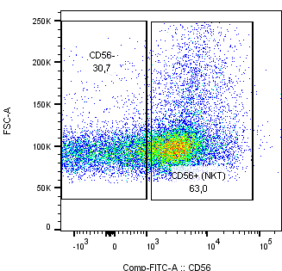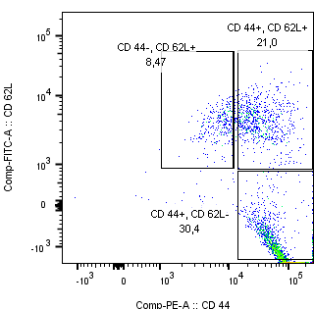
CD4+ CD44± CD62L±
CD11b+ CD11c+
CD11b+ CD1a+
CD11b+ TSLPR+
CD8+ CD8+
CD14+ CD16+
CD14+ CD64
CD14+ CD163
CD14+ CD1a
CD3±
CD3+ CD56+
CD8+ CD44± CD62L±
Fig. S3. Gating strategy for human leucocytes isolated from human colon.

Table S1 Data set for the flow cytometric analysis of PBMC and serum levels of HGF, TARC, TGFß1 and periostin.
Table S1A UC patients / Non UC donors
 | Mean |  | SD |  | IQR |  | n |  | Δ | p-value | 95% CI
Leukocytes [FoP] | Non UC | UC | Non UC | UC | Non UC | UC | Non UC | UC | Δ | p-value | 95% CI
CD19+ | 25,56 | 16,76 | 17,37 | 20,34 | 26,84 | 7,63 | 31 | 40 | -8,80 | 0,05 | -0,1 - 17,7
CD19+CD27+ IgD+ | 24,22 | 18,15 | 20,72 | 18,01 | 28,69 | 20,80 | 15 | 40 | -6,07
CD19+ CD27+ IgD- | 67,01 | 77,58 | 27,69 | 22,85 | 35,95 | 25,52 | 15 | 40 | 10,57
CD19+ CD38+ | 60,70 | 23,60 | 32,25 | 29,26 | 52,20 | 40,36 | 31 | 40 | -37,10 | 5E-03 | 23,4 - 52,5
CD4+ | 32,72 | 24,16 | 12,62 | 12,56 | 16,90 | 16,24 | 30 | 40 | -8,56 | 0,006 | 2,7 - 14,9
CD4+ CD25+ | 12,17 | 5,01 | 6,83 | 6,03 | 7,98 | 1,17 | 30 | 40 | -7,16 | 3E-05 | 4,1 - 10,4
CD8+ | 16,54 | 16,35 | 7,77 | 10,13 | 7,20 | 13,15 | 30 | 40 | -0,19
CD11b+ | 17,18 | 10,87 | 10,92 | 7,68 | 8,60 | 7,91 | 31 | 40 | -6,31 | 0.005 | 2,1 - 11,2
CD11b+ TSLPR+ | 15,14 | 18,87 | 14,36 | 23,99 | 13,54 | 16,78 | 15 | 40 | 3,73
CD11b+ CD1a+ | 5,07 | 22,80 | 17,97 | 23,33 | 0,87 | 27,39 | 31 | 40 | 17,73 | 0.0005 | -27,9 - -8,3
CD11b+ CD80/86+ | 11,30 | 10,33 | 17,67 | 17,93 | 14,86 | 5,98 | 31 | 39 | -0,97
CD11c+ | 1,43 | 0,87 | 0,67 | 0,68 | 0,76 | 0,83 | 31 | 40 | -0,56 | 0.0002 | 0,3 - 0,9
CD14+ | 6,00 | 5,86 | 4,18 | 6,37 | 6,73 | 6,53 | 30 | 40 | -0,14
CD14+ CCR2+ | 61,67 | 77,25 | 42,61 | 24,44 | 90,76 | 20,55 | 30 | 40 | 15,58
CD14+ CD80/86+ | 48,01 | 37,32 | 47,13 | 35,31 | 94,51 | 72,67 | 30 | 40 | -10,69
CD14+ TSLPR+ | 3,16 | 6,69 | 4,63 | 8,54 | 1,50 | 6,91 | 15 | 40 | 3,53 | 0.03 | -8,4 - -0,5
CD14+ CD1a+ | 59,36 | 79,71 | 22,41 | 22,80 | 30,6 | 7,40 | 9 | 27 | 20,35 | 0.02 | -40,8 - -4,5
CD14+ CD64+ | 10,97 | 1,10 | 6,69 | 1,34 | 7,38 | 0,55 | 4 | 25 | -9,87 | 0,06
CD14+ CD163+ | 6,08 | 2,54 | 4,80 | 2,31 | 7,73 | 2,68 | 10 | 26 | -3,54 | 0.05 | 6,0 - 2,5
CD3- CD56+ | 13,27 | 12,62 | 12,56 | 12,57 | 9,12 | 12,30 | 13 | 38 | -0,65
CD3+ CD56+ | 5,64 | 11,99 | 3,64 | 9,96 | 2,53 | 11,52 | 13 | 38 | 6,35 | 0.001 | -10,3 - -2,6
CD3+ CD56+ KIR+ | 61,00 | 27,12 | 43,49 | 20,09 | 88,50 | 30,42 | 13 | 38 | -33,88 | 0.01 | 7,7 - 61,5
ILC2 | 2,05 | 1,33 | 1,30 | 0,87 | 1,20 | 0,93 | 13 | 38 | -0,72 | 0.08
Factors [ng / ml]
TARC | 5.222,43 | 7.009,40 | 2.935 | 6.169 | 4.020 | 9.160 | 26 | 41 | 1786,97
HGF | 868,44 | 2.278,55 | 876 | 2.191 | 463 | 2.743 | 27 | 39 | 1410,11 | 0.0006 | -2190,8 - -629,3
TGFß1 | 23534,53 | 40298,48 | 14004,41 | 30694,27 | 15958,18 | 49604,05 | 23 | 42 | 16763,95 | 0.003 | 23534,5 - 38143,0
Periostin | 74.066,78 | 60.635,67 | 39631,19 | 38621,69 | 31787,63 | 38485,27 | 17 | 36 | -13431,11

Table S1B. UC Patients treated with TNFα blockers / all other patients
 | Mean |  | SD |  | IQR |  | n |  | Δ | p-value | 95% CI
Leukocytes [FoP] | TNFa-blocker | other | TNFa-blocker | other | TNFa-blocker | other | TNFa-blocker | No TNFa-blocker | Δ | p-value | 95% CI
CD19+ | 11,80 | 22,58 | 15,50 | 23,14 | 4,63 | 25,22 | 21 | 20 | -10,78
CD19+ CD27+ IgD+ | 20,46 | 14,96 | 17,63 | 18,23 | 18,27 | 19,75 | 21 | 20 | 5,50
CD19+ CD27+ IgD- | 79,31 | 75,85 | 12,06 | 30,11 | 20,85 | 28,17 | 20 | 20 | 3,47
CD19+ 38+ | 9,87 | 39,69 | 19,02 | 30,64 | 1,83 | 47,04 | 21 | 20 | -29,82 | 8 E-4 | -45,8 - -13,2
CD4+ | 24,94 | 22,94 | 11,93 | 13,72 | 16,70 | 18,50 | 21 | 20 | 2,00
CD4+ CD25+ | 3,92 | 6,12 | 1,61 | 8,34 | 0,98 | 2,38 | 21 | 20 | -2,20
CD8+ | 13,97 | 18,72 | 8,49 | 11,24 | 12,02 | 13,70 | 21 | 20 | -4,75
CD11b+ | 8,81 | 12,93 | 4,01 | 9,80 | 5,27 | 10,94 | 21 | 20 | -4,12
CD11b+ TSLPR+ | 10,96 | 26,32 | 13,18 | 29,77 | 9,99 | 25,81 | 21 | 20 | -15,36 | 0.04 | -30,26 - -0,44
CD11b+ CD1a+ | 24,85 | 20,75 | 23,19 | 23,88 | 24,47 | 26,59 | 21 | 20 | 4,10
CD11b+ CD80+ | 5,37 | 18,23 | 3,66 | 26,54 | 3,35 | 14,14 | 21 | 20 | -12,86 | 0.04 | -25,3 - -0,35
CD11c+ | 0,64 | 1,10 | 0,46 | 0,80 | 0,57 | 1,03 | 21 | 20 | -0,46
CD14+ | 5,43 | 6,29 | 4,48 | 7,90 | 6,19 | 6,88 | 21 | 20 | -0,86
CD14+ CCR2+ | 74,36 | 80,14 | 25,84 | 23,25 | 20,32 | 17,15 | 21 | 20 | -5,78
CD14+ CD80/86+ | 42,03 | 34,00 | 36,07 | 36,22 | 76,47 | 61,17 | 21 | 20 | 8,03
CD14+ TSLPR+ | 10,74 | 4,00 | 11,93 | 5,06 | 5,85 | 5,66 | 21 | 20 | 6,74 | 0.03 | 0,8 - 12,4
CD14+ CD1a+ | 84,95 | 78,04 | 11,34 | 29,60 | 6,30 | 7,80 | 18 | 9 | 6,91
CD14+ CD64+ | 1,09 | 1,23 | 1,58 | 0,64 | 0,18 | 1,01 | 17 | 8 | -0,14
CD14+ CD163+ | 2,68 | 2,53 | 2,49 | 2,09 | 2,59 | 3,11 | 18 | 9 | 0,15
CD3- CD56+ | 12,99 | 13,57 | 7,94 | 10,51 | 8,73 | 11,69 | 21 | 18 | -0,58
CD3+ CD56+ | 11,32 | 12,73 | 8,06 | 11,93 | 10,11 | 12,82 | 21 | 18 | -1,41
ILC2 | 1,46 | 1,18 | 0,97 | 0,77 | 0,94 | 0,99 | 20 | 18 | 0,28
Factors [ng / ml]
TARC | 3.257,75 | 9.945,47 | 4.064 | 5.993 | 3.225 | 9.095 | 18 | 23 | -6687,72 | 0.0001 | 3257,7 - 9945,4
HGF | 1.084,54 | 3.109,16 | 1.393 | 2.283 | 545 | 3.062 | 16 | 23 | 2024,62 | 0.001 | -3220,3 - -828,84
TGFß1 | 52.946,12 | 30.812,75 | 20043,09 | 34109,48 | 15021,03 | 41763,36 | 18 | 24 | -22133,37 | 0.01 | 52946,1 - 30812,8
Periostin | 72.395,26 | 51.229,01 | 47663,26 | 27287,68 | 27740,2 | 37911,48 | 16 | 20 | -21166,25

Table S1C UC Patients treated with glucocorticoids/ all other patients
 | Mean |  | SD |  | IQR |  | n |  | Δ | p-value | 95% CI
Leukocytes [FoP] | Glucocorticoids | other | Glucocorticoids | other | Glucocorticoids | other | Glucocorticoids | No Glucocorticoids | Δ | p-value | 95% CI
CD19+ | 34 | 10,35 | 27,81 | 11,36 | 50,9 | 6,65 | 11 | 30 | 24,07 | 0.01 | 5,1 - 43,0
CD19+ CD27+ IgD+ | 7,77 | 21,44 | 11,84 | 18,54 | 1,9 | 21,32 | 11 | 30 | -13,67 | 0,009 | -23,74 - 3,58
CD19+ CD27+ IgD- | 90,32 | 71,67 | 12,32 | 23,77 | 1,95 | 21,32 | 11 | 30 | 18,65 | 0.002 | 7,0 - 30,27
CD19+ 38+ | 35,09 | 20,34 | 16,82 | 31,86 | 14,4 | 38,53 | 11 | 30 | 14,75 | 0,06
CD4+ | 22,15 | 24,86 | 11,03 | 13,2 | 11,6 | 15,7 | 11 | 29 | -2,71
CD4+ CD25+ | 4,52 | 5,2 | 1,51 | 7,05 | 0,83 | 1,07 | 11 | 30 | -0,68
CD4+ CD294+ | 2,24 | 1,39 | 1,94 | 1,35 | 1,09 | 0,66 | 11 | 29 | 0,85
CD8+ | 17,29 | 15,99 | 7,69 | 11,02 | 11,72 | 13,56 | 11 | 30 | 1,30
CD11b+ | 12,72 | 9,87 | 10,52 | 5,57 | 8,15 | 6,66 | 11 | 30 | 2,85
CD11b+ TSLPR+ | 35,92 | 12 | 31,07 | 17,11 | 31,7 | 8,42 | 11 | 30 | 23,92 | 0.03 | 2,4 - 45,3
CD11b+ CD1a+ | 13,63 | 26,28 | 22,76 | 22,96 | 13,77 | 16,3 | 11 | 30 | -12,65
CD11b+ CD80+ | 11,92 | 11,54 | 22,72 | 18,74 | 5,19 | 4,32 | 11 | 30 | 0,38
CD11c+ | 0,81 | 0,89 | 0,72 | 0,68 | 0,96 | 0,67 | 11 | 30 | -0,08
CD14+ | 6,13 | 5,76 | 9,88 | 4,64 | 4,54 | 7,15 | 11 | 30 | 0,37
CD14+ CCR2+ | 85,77 | 74,02 | 11,72 | 27,27 | 10,95 | 23,3 | 11 | 30 | 11,75
CD14+ CD80/86+ | 18,85 | 45,56 | 30,33 | 35 | 23,6 | 77,56 | 11 | 30 | -26,71 | 0.03 | -49,95 - -3,4
CD14+ TSLPR+ | 7,9 | 6,23 | 14,8 | 4,76 | 6,12 | 6,44 | 11 | 29 | 1,67
CD14+ CD1a+ | 86,7 | 82,32 | 6,36 | 19,8 | 4,5 | 6,9 | 2 | 25 | 4,38
CD14+ CD64+ | 0,665 | 1,17 | 0,5 | 1,39 | 0,35 | 0,65 | 2 | 23 | -0,51
CD14+ CD163+ | 0,7 | 2,73 | 0,1 | 2,33 | 0,07 | 2,76 | 2 | 25 | -2,03
CD3- CD56+ | 14,64 | 12,84 | 12,33 | 8,1 | 8,28 | 10,76 | 9 | 30 | 1,80
CD3+ CD56+ | 8,22 | 13,16 | 7,26 | 10,49 | 10,62 | 11,67 | 9 | 30 | -4,94
ILC2 | 1,13 | 1,39 | 0,86 | 0,89 | 0,25 | 0,88 | 9 | 30 | -0,26
Factors [ng / ml]
TARC | 10.224 | 5.973 | 7324,3 | 5486,49 | 10771,67 | 7852,48 | 10 | 31 | 4250,95
HGF | 3.856 | 1.805 | 2319,14 | 1959,63 | 3231,06 | 1275,04 | 9 | 30 | 2050,34 | 0.03 | 188,9 - 3911,7
TGFß1 | 21895,4 | 46049,44 | 26881,83 | 29880,88 | 4840,78 | 45612,05 | 10 | 32 | -24154,04 | 0.03 | -45311 - -2997,0
Periostin | 37400,04 | 67274,43 | 244446,18 | 39660,93 | 32104,36 | 34488,32 | 8 | 28 | -29874,39 | 0.02 | -5384,7 - -5907,06

Table S1D Patients treated with Mesalazine / all other patients
 | Mean |  | SD |  | IQR |  | n |  | Δ | p-value | 95% CI
Leukocytes [FoP] | Mesalazine | other | Mesalazine | other | Mesalazine | other | Mesalazine | No Mesalazine
CD19+ | 15,35 | 19,34 | 19,91 | 22,43 | 8 | 9 | 26 | 15 | -3,99
CD19+ CD27+ IgD+ | 20,14 | 13,67 | 20,48 | 11,93 | 22,35 | 21,07 | 26 | 15 | 6,47
CD19+ CD27+ IgD- | 76,1 | 77,66 | 22,08 | 24,63 | 26,55 | 26,4 | 26 | 15 | -1,56
CD19+ 38+ | 22,79 | 26,89 | 26 | 34,74 | 43,23 | 48,97 | 26 | 15 | -4,10
CD4+ | 21,29 | 27,93 | 13,03 | 11,15 | 11,7 | 14,6 | 26 | 15 | -6,64
CD4+ CD25+ | 3,97 | 6,61 | 1,9 | 8,68 | 11,59 | 9,85 | 26 | 15 | -2,64
CD8+ | 16,76 | 15,79 | 9,44 | 11,26 | 13,08 | 13,61 | 23 | 17 | 0,97
CD11b+ | 9,62 | 12,55 | 7,85 | 7,33 | 5,96 | 8,24 | 26 | 15 | -2,93
CD11b+ TSLPR+ | 18,48 | 18,4 | 23,25 | 25,54 | 16 | 15,71 | 26 | 15 | 0,08
CD11b+ CD1a+ | 26,58 | 17,82 | 25,25 | 18,68 | 29,15 | 26,48 | 26 | 15 | 8,76
CD11b+ CD80+ | 15 | 5,83 | 24 | 3,2 | 7,9 | 4,97 | 26 | 15 | 9,17
CD11c+ | 0,67 | 1,14 | 0,46 | 0,85 | 0,6 | 1,1 | 26 | 15 | -0,47 | 0.05 | -1,0 - -0,0
CD14+ | 5,62 | 6,45 | 7,3 | 4 | 6,59 | 4,04 | 26 | 15 | -0,83
CD14+ CCR2+ | 75,76 | 76,81 | 23 | 29,14 | 24,87 | 21,05 | 26 | 15 | -1,05
CD14+ CD80/86+ | 37,64 | 39,71 | 34,33 | 38,75 | 70,13 | 79,7 | 26 | 15 | -2,07
CD14+ TSLPR+ | 8,15 | 6,36 | 11,58 | 5,36 | 6,58 | 7,9 | 26 | 15 | 1,79
CD14+ CD1a+ | 85,25 | 78,85 | 12,06 | 25,62 | 5,25 | 6,1 | 16 | 17 | 6,40
CD14+ CD64+ | 0,84 | 1,5 | 0,63 | 1,88 | 0,39 | 1,14 | 16 | 11 | -0,66
CD14+ CD163+ | 2,63 | 2,63 | 2,42 | 2,25 | 3,43 | 1,31 | 16 | 11 | 0,00
CD3- CD56+ | 12,59 | 15,18 | 8 | 11,47 | 7,7 | 18,2 | 25 | 14 | -2,59
CD3+ CD56+ | 13,38 | 10,16 | 10,87 | 7,71 | 12,63 | 7 | 25 | 14 | 3,22
ILC2 | 1,34 | 1,32 | 0,66 | 1,15 | 0,87 | 0,79 | 22 | 16 | 0,02
Factors [ng / ml]
TARC | 6420,27 | 7762,17 | 6579,27 | 5698,28 | 8362,69 | 8039,47 | 23 | 18 | -1341,90
HGF | 2230,49 | 2340,73 | 2050,61 | 2424,52 | 3270,27 | 2310,66 | 22 | 17 | -110,24
TGFß1 | 38428,65 | 42791,59 | 27745,81 | 34916,53 | 43445,65 | 49557,92 | 24 | 18 | -4362,94
Periostin | 60023,99 | 61492,03 | 47670,45 | 21939,75 | 42211,91 | 24219,64 | 21 | 15 | -1468,04
Table S1E. Patients treated with immuno-suppressive drugs / all other patients.
 | Mean |  | SD |  | IQR |  | n |  | Δ | p-value | 95% CI
Leukocytes [FoP] | Immuno-suppressives | other | Immuno-suppressives | other | Immuno-suppressives | other | Immuno-suppressives | No Immuno-suppressives
CD19+ | 38 | 12,15 | 29 | 14,74 | 51,35 | 6,99 | 7 | 34 | 25,85 | 0,05 | -1,0 - 52,78
CD19+ CD27+ IgD+ | 6,17 | 22,44 | 9,99 | 22,58 | 3,41 | 23,65 | 7 | 34 | -16,27 | 0.006 | -27,45 - -5,08
CD19+ CD27+ IgD- | 91,81 | 71,45 | 10,91 | 26,19 | 6,1 | 26,19 | 7 | 34 | 20,36 | 0.002 | 7,82 - 32,88
CD19+ 38+ | 48,76 | 20,77 | 29,24 | 27,95 | 25,1 | 32,75 | 7 | 34 | 27,99 | 0.05 | 0,46 - 55,5
CD4+ | 31,08 | 22,45 | 7,72 | 12,61 | 7,95 | 13,15 | 7 | 34 | 8,63 | 0.03 | 0,8 - 16,4
CD4+ CD25+ | 9,43 | 3,9 | 13,75 | 2,02 | 3,3 | 1,18 | 7 | 34 | 5,53
CD8+ | 25,92 | 14,32 | 8,28 | 9,37 | 7,85 | 10,96 | 7 | 34 | 11,60 | 0.008 | 4,0 -19,78
CD11b+ | 10,31 | 11,17 | 6,56 | 7,81 | 9,75 | 7,64 | 7 | 34 | -0,86
CD11b+ TSLPR+ | 37,7 | 14,15 | 32,37 | 19,98 | 46,85 | 12,2 | 7 | 34 | 23,55
CD11b+ CD1a+ | 17,57 | 24,16 | 32,3 | 21,15 | 12,81 | 21,95 | 7 | 34 | -6,59
CD11b+ CD80+ | 14,85 | 10,9 | 32,23 | 16,54 | 3,27 | 4,99 | 7 | 34 | 3,95
CD11c+ | 1,32 | 0,77 | 0,85 | 0,61 | 1,02 | 0,68 | 7 | 34 | 0,55
CD14+ | 5,57 | 6,24 | 4,8 | 6,64 | 6,08 | 7,69 | 7 | 34 | -0,67
CD14+ CCR2+ | 77,75 | 76,16 | 18,9 | 26,08 | 27 | 19,85 | 7 | 34 | 1,59
CD14+ CD80/86+ | 20,52 | 41,49 | 24,19 | 36,27 | 41,56 | 77,67 | 7 | 34 | -20,97
CD14+ TSLPR+ | 9,84 | 6,84 | 18,13 | 7,29 | 6,8 | 6,78 | 7 | 34 | 3,00
CD14+ CD1a+ | 83,4 | 79,64 |  | 24,55 |  | 7,4 | 1 | 26 | 3,76
CD14+ CD64+ | 1,61 | 1,11 |  | 1,36 |  | 0,49 | 1 | 26 | 0,50
CD14+ CD163+ | 2 | 2,99 |  | 2,9 | 0 | 3,47 | 1 | 26 | -0,99
CD3- CD56+ | 17,65 | 13,26 | 13,71 | 8,48 | 20,46 | 10,9 | 6 | 33 | 4,39
CD3+ CD56+ | 8,36 | 12,72 | 7,11 | 11,16 | 10,49 | 14,22 | 6 | 33 | -4,36
ILC2 | 0,91 | 1,41 | 0,48 | 0,92 | 0,52 | 0,93 | 6 | 32 | -0,50 | 0.07
Factors [ng / ml]
TARC | 12055,61 | 6144,33 | 3077,32 | 6174,33 | 2684,63 | 6640,84 | 6 | 35 | 5911,28 | 3E-03 | 2392,1 - 9430,4
HGF | 3697,63 | 2069,85 | 2225,27 | 2139,94 | 2969,18 | 2340,91 | 5 | 34 | 1627,78
TGFß1 | 17610,67 | 44079,78 | 25195,68 | 30166,39 | 4610,11 | 49344,76 | 6 | 36 | -26469,11 | 0.05 | -53106,6 - 168,3
Periostin | 45944,37 | 63005,24 | 15079,72 | 40842,95 | 10212,66 | 37427,42 | 5 | 31 | -17060,87

Table S2 Analysis of human Colon
Diagnosis | Leucocyte | mean | sd | IQR | n | Δ | p-value | 95% CI
Non UC | CD4+ | 2,93 | 1,51 | 1 | 5 | 4,46
UC | CD4+ | 7,39 | 5,21 | 7,3 | 4 | 4,46
Non UC | CD8+ | 4,19 | 2,8 | 2,8 | 5 | 0,85
UC | CD8+ | 5,04 | 6,2 | 4,5 | 4 | 0,85
Non UC | CD11b+ | 1,53 | 0,85 | 0,95 | 5 | 4,87
UC | CD11b+ | 6,4 | 7 | 7,31 | 4 | 4,87
Non UC | CD11c+ | 0,28 | 0,15 | 0,22 | 5 | -0,25
UC | CD11c+ | 0,03 | 0,04 | 0,05 | 4 | -0,25
Non UC | CD14+ | 1,9 | 1,37 | 2 | 5 | 0,7
UC | CD14+ | 2,6 | 0,48 | 0,79 | 4 | 0,7
Non UC | CD3+ CD56+ | 31,63 | 23,04 | 25,5 | 5 | 40,74 | 0,01 | -68,9 - -12,5
UC | CD3+ CD56+ | 72,37 | 6 | 3,8 | 4 | 40,74 | 0,01 | -68,9 - -12,5
Non UC | CD3- CD56+ | 36,68 | 19,13 | 16,1 | 4 | 22,72
UC | CD3- CD56+ | 59,4 | 28,54 | 17,1 | 5 | 22,72
Non UC | CD11b+ CD1a+ | 22,54 | 11,65 | 14,8 | 5 | 59,36 | 0,0002 | -78,3 - -40,5
UC | CD11b+ CD1a+ | 81,9 | 11,78 | 8,87 | 4 | 59,36 | 0,0002 | -78,3 - -40,5
Non UC | CD11b+ TSLPR+ | 3,56 | 2,86 | 2,3 | 5 | 7,44
UC | CD11b+ TSLPR+ | 11 | 11 | 7,35 | 4 | 7,44
Non UC | CD14+ CD1a+ | 34,8 | 11,8 | 10,3 | 5 | 39,2 | 0,08
UC | CD14+ CD1a+ | 74 | 32 | 26,9 | 4 | 39,2 | 0,08
Non UC | CD14+ CD64+ | 34,2 | 38,7 | 58,46 | 5 | 16,6
UC | CD14+ CD64+ | 50,8 | 25,27 | 36,3 | 4 | 16,6
Non UC | CD14+ TSLPR+ | 7,17 | 9,11 | 8,32 | 5 | 5,59
UC | CD14+ TSLPR+ | 12,76 | 18,82 | 17,78 | 4 | 5,59
Non UC | CD14+ CD163+ CD206+ | 42,72 | 49,71 | 87,87 | 5 | -15,26
UC | CD14+ CD163+ CD206+ | 27,46 | 20,84 | 15,93 | 4 | -15,26

Table S4. Antibodies used in flow cytometric analysis
Surfacemarker (anti human) | Colour | Clone
CD19 | Peridine-chlorophyll-protein complex cyanine dye (PerCP-CyTM 5.5) | HIB19
CD38 | Phycoerythrin (PE) | HB-7
CD27 | Phycoerythrin cyanin (Pe-Cy7) | LG.3A10
IgD | Fluorescin isothiocyanate (FITC) | LA6-2
CD4 | Allophycocyanin (APC)- Cy7 | OKT4
CD44 | PE | BJ18
CD62L | FITC | DREG-56
CD8 | PerCP-CyTM 5.5 | HIT8a
CD103 | APC | Ber-ACT8
CD25 | PE-Cy7 | BC96
CD294 (CRTH2) | APC | BM16
CD14 | APC-Cy7 | HCD14
CCR2 | PE-Cy7 | K036C2
CD80/86 | PerCP-CyTM 5.5 | IT2.2
TSLPR | APC | 1B4
CD1a (biotin)/secundary Ab streptavidin | FITC | HI149
CD64 | PerCP-CyTM 5.5 | 10.1
CD163 | FITC | GHI/61
CD16 | PE | 3G8
CD11b | APC-Cy7 | M1/70
CD11c | PE-Cy7 | 3.9
CD3 | APC-Cy7 | HIT3a
CD56 | FITC | HCD56
CD94 | PE | DX22
KIR | PE-Cy7 | DX27
CD127 | PerCP-CyTM 5.5 | A019D5

