Supplementary Table S1. Characterization of BRAF and NRAS genotypes in tumor biopsies obtained from primary melanomas.

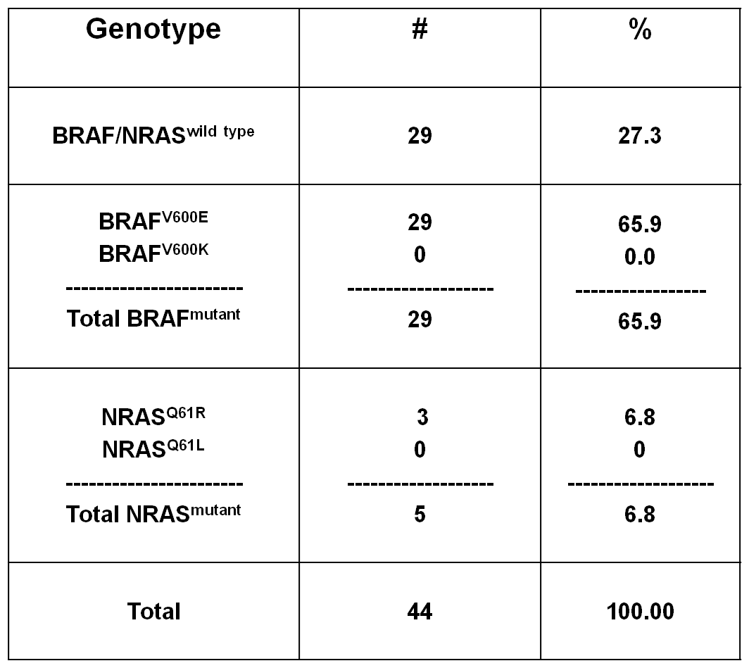

Supplementary Table S2. Characterization of BRAF and NRAS genotypes in tumor biopsies obtained from metastatic melanoma lymph nodes.
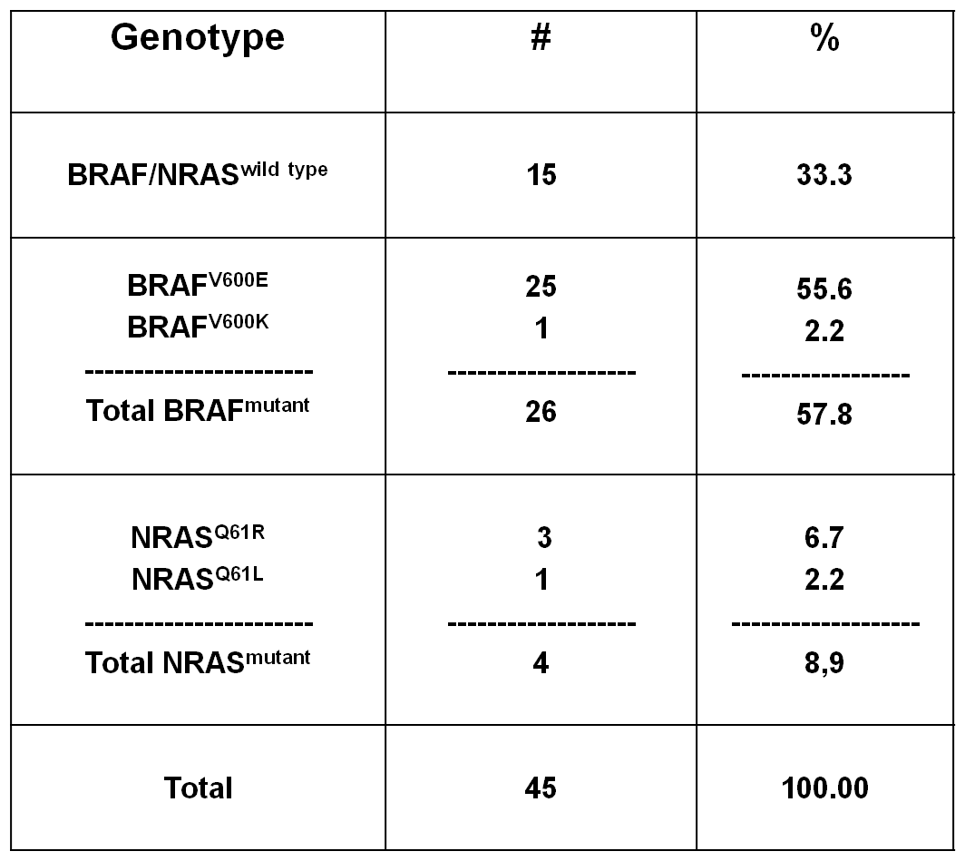

Supplementary Data
Supplementary Figure S1. Negative controls of representative immunofluorescent staining patterns of FFPE primary (left panel) and not matched metastatic lymph node (right panel) of melanoma tumors. A cocktail of goat anti-mouse IgG dylight 488 (green) and goat anti-rabbit IgG dylight 594 (red) were used as a negative controls. Nuclei were stained by DAPI (blue). Arrows indicate examples of melanoma cells. Magnification is indicated.

Supplementary Figure S2. BRAF^{V600E} A375 and NRAS^{Q61R} SK-MEL-2 melanoma cells were seeded at the density of 4 x 10⁵ per well in a 75 cm² tissue culture flask and incubated with celecoxib (60 uM). Untreated cells were used as a control. DMSO (vehicle of vemurafenib) concentration was maintained at 0.02% in all wells. Following a 24 h incubation at 37°C in a 5% CO₂ atmosphere, cells were harvested and lysed. Cell lysates were analyzed by western blot with the Bcl-2-specific mAb. β-actin was used as a loading control. Representative results are shown (upper panel). The levels of Bcl-2 normalized to β-actin are plotted and expressed as mean ± SD of the results obtained in two independent experiments (bottom panel). *** indicate P= 0.03

